In [3]:

*#* 연습문제 *4 p243, node (12)* **import** numpy **as** np **from** scipy **import** stats

x **=** [4.6, 3.6, 4.0, 6.1, 8.8, 5.3, 1.2, 5.6, 3.3, 1.6]

x_mean **=** np**.**mean(x) s **=** np**.**std(x, ddof**=**1)

sem **=** s **/** np**.**sqrt(len(x))

t_value **=** stats**.**t**.**ppf((1 **+** 0.90) **/** 2, len(x) **-** 1) margin_of_error **=** t_value **\*** sem

ci_lower **=** x_mean **-** margin_of_error ci_upper **=** x_mean **+** margin_of_error

print(f"90%에 대한 모평균 뮤의 신뢰구간 : ({ci_lower:.2f} < mu < {ci_upper:.2f})")

90%에 대한 모평균 뮤의 신뢰구간 : (3.12 < mu < 5.70)

In [6]:

*#* 연습문제 *4 p243, node (12) +* 시각화 **import** matplotlib.pyplot **as** plt **import** numpy **as** np

x **=** np**.**linspace(0, 10, 1000)

sample **=** [4.6, 3.6, 4.0, 6.1, 8.8, 5.3, 1.2, 5.6, 3.3, 1.6]

sample_mean **=** np**.**mean(sample) s **=** np**.**std(sample, ddof**=**1)

pdf **=** (1 **/** (s **\*** np**.**sqrt(2 **\*** np**.**pi))) **\*** np**.**exp(**-**0.5 **\*** ((x **-** sample_mean) **/** s) **\*\*** 2)

plt**.**plot(x, pdf, color**=**'blue')

plt**.**fi**l**_between(x, pdf, where**=**(x **>** 3.12) **&** (x **<** 5.70), color**=**'blue', alpha**=**0.3) plt**.**xlabel('years')

plt**.**axvline(3.12, color**=**"red", linestyle**=**"--") plt**.**axvline(5.70, color**=**"red", linestyle**=**"--") plt**.**title('3.12 < mu < 5.70')

plt**.**show()

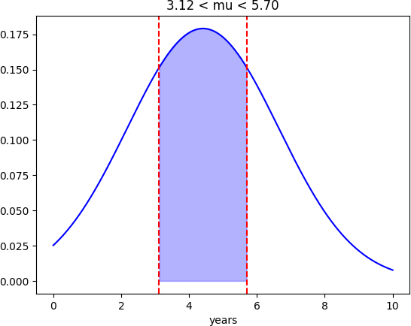

Loading [MathJax]/jax/output/CommonHTML/fonts/TeX/fontdata.js