In [3]:

*#* 연습문제 *5 p244, node (18)* **import** numpy **as** np **from** scipy **import** stats

man **=** [52, 60, 55, 46, 33, 75, 58, 45, 57, 88]

girl **=** [62, 58, 65, 56, 53, 45, 56, 65, 77, 47]

man_mean **=** np**.**mean(man) girl_mean **=** np**.**mean(girl)

man_std **=** np**.**std(man, ddof**=**1) girl_std **=** np**.**std(girl, ddof**=**1)

pooled_std **=** np**.**sqrt(((len(man) **-** 1) **\*** man_std **\*\***2 **+** (len(girl) **-**1) **\*** girl_std **\*\***2) **/** (len(man) **+** len(girl) **-**2)) sem **=** pooled_std **\*** np**.**sqrt(1 **/** len(man) **+**1 **/** len(girl))

t_value **=** stats**.**t**.**ppf((1 **+**0.90) **/**2 , len(man) **+** len(girl) **-**2)

margin_of_error **=** t_value **\*** sem

ci_lower **=** (man_mean **-** girl_mean) **-** margin_of_error ci_upper **=** (man_mean **-** girl_mean) **+** margin_of_error

print(f"합동표준편차 : {pooled_std:.2f}")

print(f"평균생존연령의 차이에 대한 90% 신뢰구간 : ({ci_lower:.2f} < mu < {ci_upper:.2f})")

합동표준편차 : 12.83

평균생존연령의 차이에 대한 90% 신뢰구간 : (-11.45 < mu < 8.45)

In [5]:

*#* 연습문제 *5 p244, node (18) +* 시각화 **import** matplotlib.pyplot **as** plt **import** numpy **as** np

x **=** np**.**linspace(**-**20, 20, 1000)

man **=** [52, 60, 55, 46, 33, 75, 58, 45, 57, 88]

girl **=** [62, 58, 65, 56, 53, 45, 56, 65, 77, 47]

man_mean **=** np**.**mean(man) man_std **=** np**.**std(man, ddof**=**1) girl_mean **=** np**.**mean(girl) girl_std **=** np**.**std(girl, ddof**=**1)

pooled_std **=** np**.**sqrt(((len(man) **-** 1) **\*** man_std **\*\***2 **+** (len(girl) **-**1) **\*** girl_std **\*\***2) **/** (len(man) **+** len(girl) **-**2)) sem **=** pooled_std **\*** np**.**sqrt(1 **/** len(man) **+**1 **/** len(girl))

pdf **=** (1 **/** (sem **\*** np**.**sqrt(2 **\*** np**.**pi))) **\*** np**.**exp(**-**0.5 **\*** ((x **-** (man_mean **-** girl_mean)) **/** sem) **\*\*** 2) plt**.**plot(x, pdf, color**=**'blue')

plt**.**fi**l**_between(x, pdf, where**=**(x **> -**11.45) **&** (x **<** 8.45), color**=**'blue', alpha**=**0.3) plt**.**axvline(**-**11.45, color**=**"red", linestyle**=**"--")

plt**.**axvline(8.45, color**=**"red", linestyle**=**"--") plt**.**title('-11.45 < mu < 8.45')

plt**.**show()

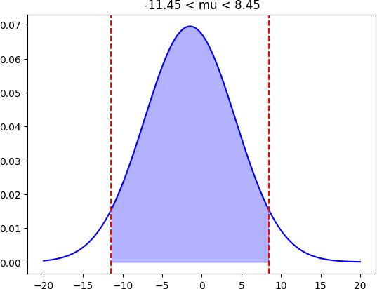

Loading [MathJax]/jax/output/CommonHTML/fonts/TeX/fontdata.js