In [4]:

*#* 연습문제 *6 p245, node (21)* **import** numpy **as** np **from** scipy **import** stats

data **=** [[1, 34400, 36700], [2, 45500, 46800], [3, 36700, 37700], [4, 32000, 31100], [5, 48400, 47800], [6, 32800, 36400], [7, 38100, 3890

di **f**erences **=** [row[1] **-** row[2] **for** row **in** data] d_mean **=** np**.**mean(di **f**erences)

s **=** np**.**std(di **f**erences, ddof**=**1) sem **=** s **/** np**.**sqrt(len(di **f**erences))

t_value **=** stats**.**t**.**ppf((1 **+** 0.99) **/** 2, len(di **f**erences) **-** 1) margin_of_error **=** t_value **\*** sem

ci_lower **=** d_mean **-** margin_of_error ci_upper **=** d_mean **+** margin_of_error

print(f"mu(d) 의 99% 신뢰구간 : ({round((ci_lower), 1)}km< mu(d) < {round((ci_upper), 1)}km)")

mu(d) 의 99% 신뢰구간 : (-2912.1km < mu(d) < 687.1km)

In [7]:

*#* 연습문제 *6 p245, node (21) +* 시각화 **import** matplotlib.pyplot **as** plt **import** numpy **as** np

x **=** np**.**linspace(**-**4000, 2000, 1000)

data **=** [[1, 34400, 36700], [2, 45500, 46800], [3, 36700, 37700], [4, 32000, 31100], [5, 48400, 47800], [6, 32800, 36400], [7, 38100, 3890

di **f**erences **=** [row[1] **-** row[2] **for** row **in** data] d_mean **=** np**.**mean(di **f**erences)

s **=** np**.**std(di **f**erences, ddof**=**1)

sem **=** s **/** np**.**sqrt(len(di **f**erences))

pdf **=** (1 **/** (sem **\*** np**.**sqrt(2 **\*** np**.**pi))) **\*** np**.**exp(**-**0.5 **\*** ((x **-** d_mean) **/** sem) **\*\*** 2) plt**.**plot(x, pdf, color**=**'blue')

plt**.**axvline(**-**2912.1, color**=**"red", linestyle**=**"--") plt**.**axvline(687.1, color**=**"red", linestyle**=**"--")

plt**.**fi**l**_between(x, pdf, where**=**(x **> -**2912.1) **&** (x **<** 687.1), color**=**'blue', alpha**=**0.3)

plt**.**title('-2912.1 < mu(d) < 687.1') plt**.**show()

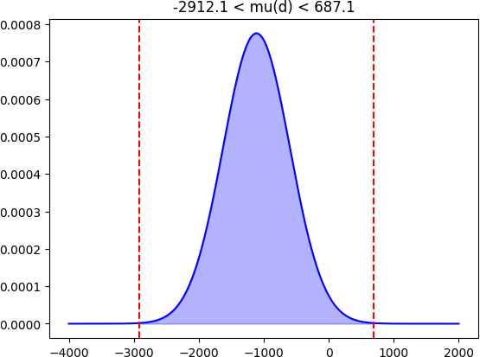

Loading [MathJax]/jax/output/CommonHTML/fonts/TeX/fontdata.js