In [3]:

*#* 연습문제 *7 p246, node (23)* **import** numpy **as** np **from** scipy **import** stats

SBP **=** [35, 48, 65, 33, 61, 54, 49, 37, 58, 65]

conventional **=** [33, 40, 55, 41, 62, 54, 40, 35, 59, 56]

SBP_mean **=** np**.**mean(SBP) conventional_mean **=** np**.**mean(conventional)

SBP_std **=** np**.**std(SBP, ddof**=**1) conventional_std **=** np**.**std(conventional, ddof**=**1)

pooled_std **=** np**.**sqrt(((len(SBP) **-** 1) **\*** SBP_std **\*\***2 **+** (len(conventional) **-**1) **\*** conventional_std **\*\***2) **/** (len(SBP) **+** len(conventional) **-**2)) sem **=** pooled_std **\*** np**.**sqrt(1 **/** len(SBP) **+**1 **/** len(conventional))

t_value **=** stats**.**t**.**ppf((1 **+**0.98) **/**2 , len(SBP) **+** len(conventional) **-**2) margin_of_error **=** t_value **\*** sem

ci_lower **=** (SBP_mean **-** conventional_mean) **-** margin_of_error ci_upper **=** (SBP_mean **-** conventional_mean) **+** margin_of_error

print(f"450g당 비타민 양의 평균차이에 대한 98% 신뢰구간 : ({round((ci_lower), 1)} < mu < {round((ci_upper), 1)})")

450g당 비타민 양의 평균차이에 대한 98% 신뢰구간 : (-10.1 < mu < 16.1)

In [5]:

*#* 연습문제 *7 p246, node (23) +* 시각화 **import** matplotlib.pyplot **as** plt **import** numpy **as** np

x **=** np**.**linspace(**-**20, 30, 1000)

SBP **=** [35, 48, 65, 33, 61, 54, 49, 37, 58, 65]

conventional **=** [33, 40, 55, 41, 62, 54, 40, 35, 59, 56]

SBP_mean **=** np**.**mean(SBP) SBP_std **=** np**.**std(SBP, ddof**=**1)

conventional_mean **=** np**.**mean(conventional) conventional_std **=** np**.**std(conventional, ddof**=**1)

pooled_std **=** np**.**sqrt(((len(SBP) **-** 1) **\*** SBP_std **\*\***2 **+** (len(conventional) **-**1) **\*** conventional_std **\*\***2) **/** (len(SBP) **+** len(conventional) **-**2)) sem **=** pooled_std **\*** np**.**sqrt(1 **/** len(SBP) **+**1 **/** len(conventional))

pdf **=** (1 **/** (sem **\*** np**.**sqrt(2 **\*** np**.**pi))) **\*** np**.**exp(**-**0.5 **\*** ((x **-** (SBP_mean **-** conventional_mean)) **/** sem) **\*\*** 2)

plt**.**plot(x, pdf, color**=**'blue')

plt**.**fi**l**_between(x, pdf, where**=**(x **> -**10.1) **&** (x **<** 16.1), color**=**'blue', alpha**=**0.3)

plt**.**axvline(**-**10.1, color**=**"red", linestyle**=**"--") plt**.**axvline(16.1, color**=**"red", linestyle**=**"--") plt**.**title('-10.1 < mu < 16.1')

plt**.**show()

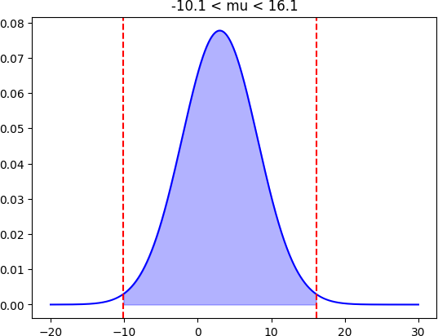

Loading [MathJax]/jax/output/CommonHTML/fonts/TeX/fontdata.js