Iteration 2 – Group Wolf

Black Box Tests:
- Admin login authorization and access control
- Test ID: BB_testAdminLoginAuthorization
- Short description: Verify that only an authorized administrator can successfully log in through the admin login option, while all unauthorized login attempts are rejected.
- Selected requirement: When using the admin login option, the system shall authenticate the entered credentials and allow access only if all the following conditions are satisfied:
- The entered official name belongs to an existing registered user.
- The entered password matches the registered password of that user.
- The user is assigned the admin role.
If any of these conditions are not met, the system shall deny access and prevent navigation to the main menu.
- Equivalence classes:

variable | Valid EC + Boundaries | Representative valid values | Invalid ECs | Representative invalid values
Admin username | EC_1: registered username. | “Haneen” (registered user) | EC_i1: user not found (unregistered) | “Jake” (not registered)
Admin password | EC_2: correct password for that username. | “1997” (matches the registered password for that username) | EC_i2: wrong password for existing name | “UI789” (mismatched password)
Admin role | EC_3: account has admin role | “adminUser” (administrator account) | EC_i3: valid credentials but role not admin | “Layla” (non-admin account)

- Test case:
- Input:
- Admin username = “Haneen”, (Haneen is a registered admin).
- Admin password = “1997”, (1997 is the correct password for user Haneen)
- Expected output:
- Login succeeds.
- System navigates to main menu.
- Equivalence class mapping:

- Admin username = “Haneen” EC_1
- Admin password = “1997” EC_2
- Account privilege: Haneen is an admin EC_3
- Developer: Layla

- Accept question submission when all required inputs are valid:
- Test ID: BB_testValidateForm
- Short description: Verify system behavior when validating add question form that should validate this:all required inputs are filled and valid and if so, it returns true
- Selected requirement: The system shall allow saving a question only if: a difficulty is selected, a correct answer is selected, question text is not empty and not only spaces, all four options A/B/C/D are filled, and the options are all distinct ignoring case. Otherwise, it shall show an error and return false.
- Equivalence classes: In general, this is the list of the ECs –
Inputs variables are: difficultySelected, correctSelected, questionText, optionsFilled, optionsDistinct
EC1: difficulty not selected
EC2: correct answer not selected
EC3: question empty
EC4: one or more options empty
EC5: options not distinct
EC6: all valid
To specify more:

variable | Valid EC + Boundaries | Representative valid values | Invalid ECs | Representative invalid values
difficultySelected | EC_D1: selected (not null) Boundaries: N/A | "1" (or "Easy")  "2" (or "Medium")  "3" (or "Hard")  "4" (or "Expert") | EC_Di1: not selected (null) | null
correctSelected | EC_C1: selected and in {A,B,C,D} Boundaries: A/B/C/D only | "A" (or "1" )  "B" (or "2" )  "C" (or "3" )  "D" (or "4" ) | EC_Ci1: not selected (null) EC_Ci2: invalid value | null
questionText | EC_Q1: non-empty Boundaries: "", " " | A question text filled, such as: "What is software engineering" | EC_Qi1: empty string  EC_Qi2: whitespace only | ""  " "
optionsFilled (A,B,C,D) | EC_O1: all four filled (each non-empty & not whitespace) Boundaries: any option at "" or " " | Answers filled, for Example: A="Writing code...", B="Fixing hardware...", C="Designing websites...", D="Applying engineering principles..." | EC_Oi1: one or more options empty  EC_Oi2: one or more options whitespace only | A="", others filled  B=" ", others filled  C="", others filled  D=" ", others filled
optionsDistinct (case-insensitive) | EC_DI1: all distinct ignoring case  Boundaries: duplicates like "System" vs "SYSTEM" | A="Writing code...", B="Fixing hardware...", C="Designing websites...", D="Applying engineering principles..." | EC_DIi1: duplicates exist (ignoring case) | A=" System",  B=" SYSTEM", C="RAM", D="Software"

- Test case:
- Input:
- Difficulty = selected – Easy -> EC_D1
- Correct answer = selected – D -> EC_C1
- Question = "What is software engineering" -> EC_Q1
- Options – " Writing code as fast as possible without planning. ", " Fixing computer hardware and installing operating systems.", " Designing websites using only graphic tools.", " Applying engineering principles to design, develop, test, and maintain software." -> EC_O1
- All answers options are filled and distinct -> EC_DI1
- Expected output: returns true (no error)
- Equivalence class mapping: all inputs belong to valid Ecs so overall:EC6 (all valid)
- Developer: Jihad

- Enable Background Music Setting via Filters Screen
- Test ID: BB-FLT-01
- Short description: This test verifies that when the user enables the Music toggle on the Filters screen, the system correctly saves the configuration so that music is set to Enabled in the game settings.
- Selected Requirement – Full Formulation: on the filters screen, when the user changes the state of the Music toggle, the system must:
- Update the “Music Enabled” configuration value in the system settings (SysData) according to the toggle state.
- Ensure that the new state is saved and correctly displayed the next time the Filters screen is opened or when the settings are reloaded.
- Equivalence Classes:
- Main Input Variable:
Music Toggle State – the state of the Music toggle as set by the user.
- Valid Equivalence Classes:
- EC1 (Music = ON): The user selects/presses the Music toggle so that it becomes ON.
- EC2 (Music = OFF): The user selects/presses the Music toggle so that it becomes OFF.
- Test case:
- Input (Complete Input):
- The user is on the Filters screen.
- Action: The user clicks the Music toggle to set it to ON.
- Equivalence Class Mapping:
- Music Toggle State = ON → belongs to EC1.
- Expected Output:
- The “Music Enabled” setting is saved as Enabled / True (i.e., music is enabled in the system settings).
- If the user exits the screen and returns to it (or reopens the Filters screen), the Music toggle is displayed as ON.
- Developer: Aya

- Enable pause/unpause game via boards screen :

- Test ID : BB-PG-ONPAUSE-01
- Short Description :
Verify that clicking Pause toggles the game pause state, dims both boards, and pauses the timer (when the timer feature is enabled).
- Selected Requirement – Full Formulation
1. The game shall toggle the internal pause state (paused ↔ unpaused).
2. While paused, the boards shall appear dimmed (opacity reduced) and the game timer shall not advance (timer is paused).
3. When unpaused, the boards shall return to normal opacity and the timer shall resume only if the timer feature is enabled.
- Equivalence Classes
- Main Input Variable:
Pause button activation state (number of onPauseGame() invocations + timer-enabled setting).

- Valid Equivalence Classes:
EC1: Timer Enabled (SysData.timerEnabled = true) + First call to onPauseGame() (game transitions to Paused)
EC2: Timer Enabled (SysData.timerEnabled = true) + Second call to onPauseGame() (game transitions to Resumed)
EC3: Timer Disabled (SysData.timerEnabled = false) + call to onPauseGame() from Paused → Resumed (timer must stay paused)
To specify more :
variable | Valid EC + Boundaries | Representative valid values | Invalid ECs | Representative invalid values
Pause state (isPaused) | EC₁: First click when isPaused = false → should switch to true (Paused) | isPaused=false then click Pause → isPaused=true | EC₁₁: Invalid “toggle input” (no click / event not triggered) | No user action / pause handler not called
Board opacity (visual effect) | EC₂: When Paused → both boards opacity becomes 0.6 | player1Grid.opacity=0.6, player2Grid.opacity=0.6 | EC₂₁: Boards are null (no UI references) → opacity cannot be applied | player1Grid=null and/or player2Grid=null
Timer behavior (SysData.timerEnabled) | EC₃: Unpause when timerEnabled=true → timer resumes (RUNNING) | Pause → Unpause with SysData.timerEnabled=true → timer RUNNING | EC₃₁: Unpause when timerEnabled=false → timer must remain PAUSED | Pause → set SysData.timerEnabled=false → Unpause → timer stays PAUSED

- Test Case
- Test Case ID: BB-PG-ONPAUSE-01-EC1
- Input (Complete Input):
Precondition: Game is running (not gameOver), isPaused = false
SysData.timerEnabled = true
Timer exists and is running (timer.status = RUNNING)
User action: click on pause button to invoke onPauseGame() once

- Equivalence Class Mapping:
EC1 (Timer Enabled + First call → Pause)
- Expected Output:
isPaused = true
player1Grid.opacity = 0.6
player2Grid.opacity = 0.6
timer.status = PAUSED
Pause button icon switches to “Play” icon

- Test Dsigner : Adan

White Box Tests:
- Grant admin access only when username, password, and role conditions are met
- Test ID: WB_testAdminLoginAuthorization
- Short description: Verify that the admin login flow correctly grants access only when the username exists, the password matches, and the account has an admin role.
- Selected code slice:

String adminName = adminNameField.getText() == null ? "" : adminNameField.getText().trim();
String adminPass = adminPasswordField.getText() == null ? "" : adminPasswordField.getText().trim();

Player admin = SysData.getInstance().findPlayerByOfficialName(adminName);

if (admin == null || !admin.checkPassword(adminPass)) {
showError("Login failed", "Invalid Name or Password.");
return;
}
if (!admin.isAdmin()) {
showError("Login failed", "Not a saved Admin.");
return;
}

SessionManager.setLoggedInUser(admin);
goToMainPage(true);

- Graphical description:
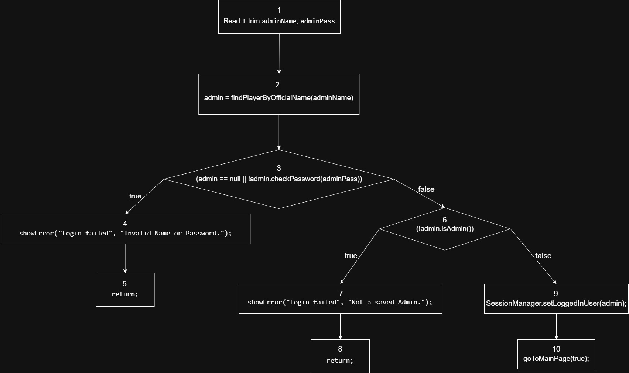

- Type of coverage: passage coverage (path coverage for a chosen route).
Transitions covered in this test:
- 1-2-3- 4-5
- 1-2-3-6-7-8
- 1-2-3-6-9-10 (tested)
- Test case:
- Input:
- adminNameField = "Layla" (is a registered user (not admin)).
- adminPasswordField = "212212" (the correct password for user “Layla”).
- Expected output:
- showError method is triggered.
- error popup is shown stating “login failed, not a saved admin.”.
- Graph’s route: 1-2-3-6-7-8
- Developer: Layla

- Validate adding question form - fails on duplicated options case
- Test ID: WB_testValidateForm
- Short description: All required fields are present, but options are not distinct (case-insensitive). It should fail only at allDistinctIgnoreCase.
- Selected Code/Function:
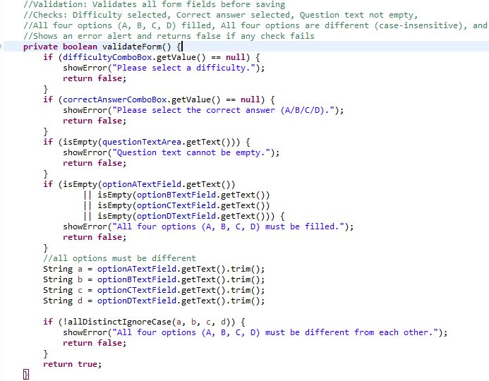

- Graphical Description:
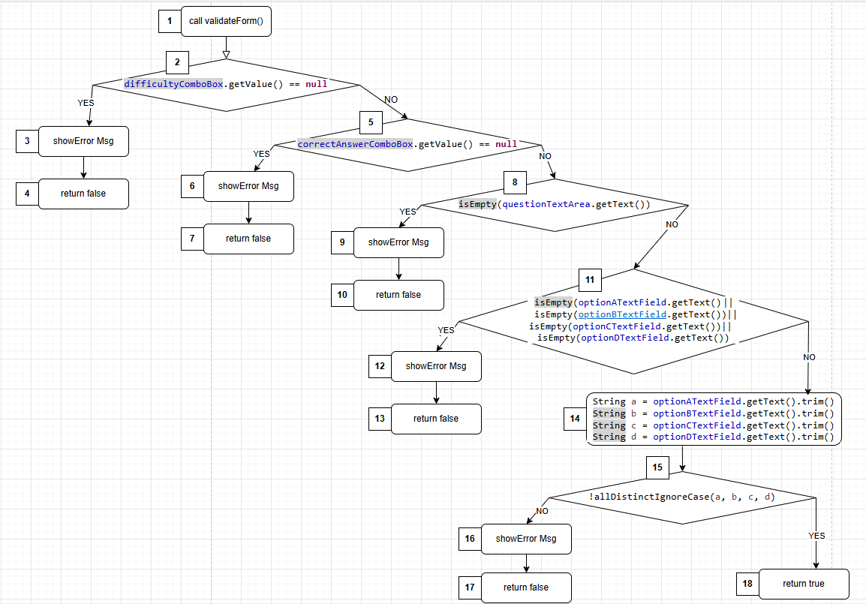

- Coverage type/ transitions: Transition/edge coverage – Edges covered:

- 1-2-3-4 (Difficulty is not selected – return false)
- 1-2-5-6-7 (Difficulty selected but correct answer is not selected – return false)
- 1-2-5-8-9-10 (Difficulty selected, correct answer selected but question area is empty – return false)
- 1-2-5-8-11-12-13 (Difficulty selected, correct answer selected, question area is filled but one or more answer option is empty – return false)
- 1-2-5-8-11-14-15-16-17 (Difficulty selected, correct answer selected, question area is filled, all answers options are filled but answers options are not distinct – return false)
- 1-2-5-8-11-14-15-18 (Difficulty selected, correct answer selected, question area is filled, all answers options are filled, all answers options are distinct – return true)

- Test case:
- Input:
- Difficulty = selected – 1
- Correct answer = selected - 4
- Question = "What is software engineering"
- Options – " Writing code as fast as possible without planning. ", " Writing code as fast as possible without planning.", " Designing websites using only graphic tools.", " Applying engineering principles to design, develop, test, and maintain software."
- Expected output: returns false and error message that says " All four options (A, B, C, D) must be different from each other."
- Graph Path: 1-2-5-8-11-14-15-16-17 (Difficulty selected, correct answer selected, question area is filled, all answers options are filled but answers options are not distinct – return false)
- Developer: Jihad

- Synchronize Music Toggle State with System Configuration
- Test ID: WB-FLT-01
Short description: When the user enables the Music option (enabled = true) while the actual background music is currently turned off (currentlyOn = false), the system must:
- Update the configuration by calling SysData.setMusicEnabled(true).
- Detect a real state change (enabled != currentlyOn).
- Invoke SoundManager.toggleMusic() exactly once in order to synchronize the actual music state with the selected option.
- Code Segment Tested:
@FXML
private void onMusicToggled() {
SoundManager.playClick();

boolean enabled = musicToggle.isSelected();

// Save global setting
SysData.setMusicEnabled(enabled);

// Keep real background music in sync with the toggle
boolean currentlyOn = SoundManager.isMusicOn();
if (enabled != currentlyOn) {
// Only toggle if there is a real change
SoundManager.toggleMusic();
}
}

- Graphical Description:
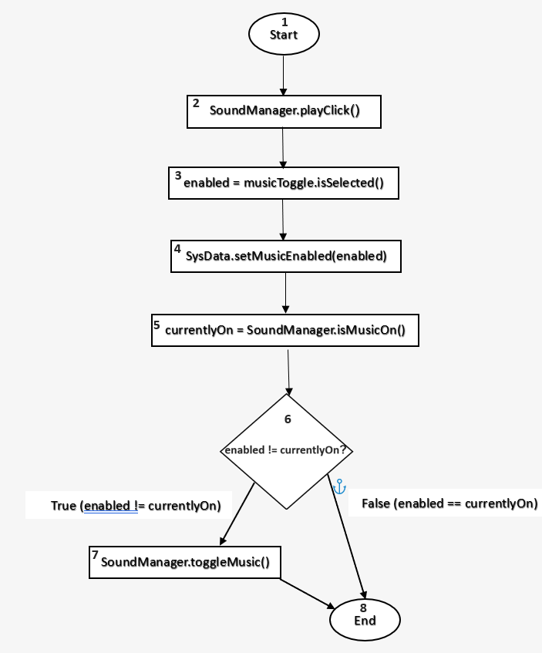

- Coverage Type: Transition Coverage, In this test, only the transitions along the True branch are covered.
The transition (6→8) corresponding to the False branch is not covered in this test.
Specifically:
- Covered transitions:
(1→2), (2→3), (3→4), (4→5), (5→6), (6→7), (7→8)
- Not covered (in this test):
(1→2), (2→3), (3→4), (4→5), (5→6),(6→8)
- Test case:
- Preconditions: SoundManager.isMusicOn() = false
- Input: musicToggle.isSelected() = true
- Expected output:
  - SysData.setMusicEnabled(true) is executed (therefore SysData.isMusicEnabled() == true)
  - SoundManager.toggleMusic() is called exactly once
  - SoundManager.playClick() is called exactly once
- Path: 1–2–3–4–5–6–7–8
- Edges: (1→2), (2→3), (3→4), (4→5), (5→6), (6→7), (7→8)
- Developer: Aya

- Pause game toggle state and timer :

- Test ID : WB-GAME-PAUSE-01
- Short Description :
This test verifies that when the user clicks Pause, the system:
- Toggles the paused state (isPaused becomes true).
- Updates the pause button icon to play-button.
- Sets both boards opacity to 0.6.
- Pauses the timer by calling pauseTimer().

- Code Segment tested :
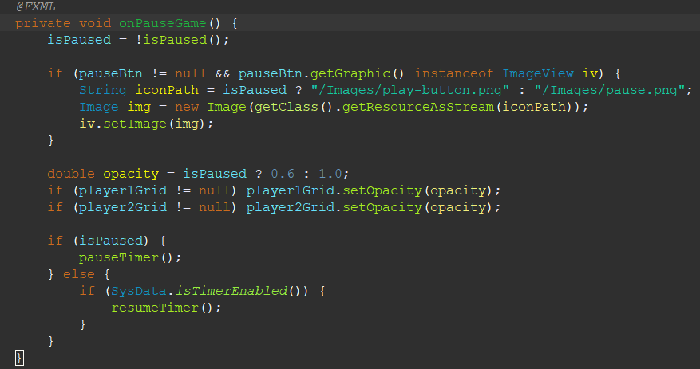

- Graphic description :

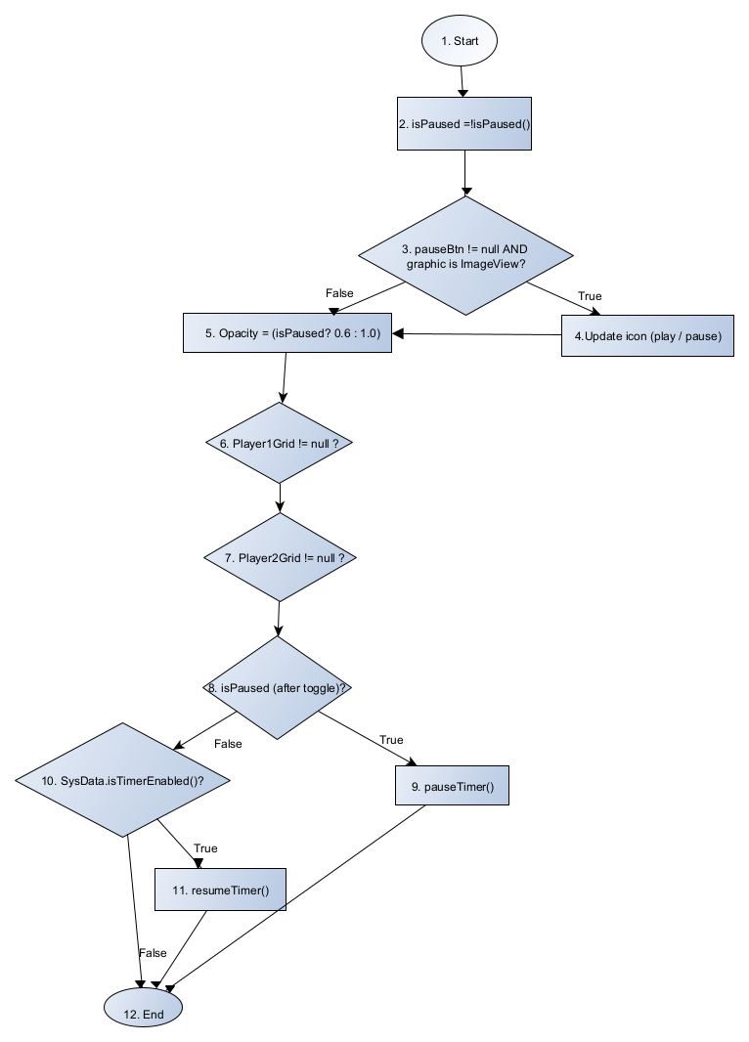
- Coverage Type
Transition Coverage :
In this test we cover the Pause branch (isPaused = true).
- Test Case
- Test Case: WB-GAME-PAUSE-01-TC1 (Pause ON)
- Preconditions:
- isPaused = false
- pauseBtn != null
- pauseBtn.getGraphic() is an ImageView
- player1Grid != null, player2Grid != null
- timer != null (timer is running)
- Input:
- Action: User clicks Pause button → triggers onPauseGame()
- Expected Output:
- isPaused == true
- Pause button icon changes to /Images/play-button.png
- player1Grid.opacity == 0.6
- player2Grid.opacity == 0.6
- pauseTimer() is executed once
- resumeTimer() is NOT executed
- Covered path (nodes):
1 → 2 → 3(True) → 4 → 5 → 6(True) → 7(True) → 8(True) → 9 → 12
- Covered transitions (edges):
- (1→2), (2→3), (3True→4), (4→5), (5→6), (6True→7), (7True→8), (8True→9), (9→End)

- Developer Name : Adan

JUnit Tests:
Test ID | Description | Expected Value | Actual Value | Result | Developer
TC-01 | Verify timer setting toggles from OFF to ON when onTimerToggled() is invoked | SysData.isTimerEnabled()== true | true | pass | Aya
TC-02 | Verify timer setting toggles from ON to OFF when onTimerToggled() is invoked | SysData.isTimerEnabled()== false | false | pass | Aya
JU-ADI-1 | allDistinctIgnoreCase with all different values: "Software", "Hardware", "Maintenance", "Development" | true | true | pass | jihad
JU-ADI-2 | Case-insensitive duplicate: "Software", "SOFTWARE", "Maintenance", "Development" | false | false | pass |  | jihad
JU-ADI-3 | Exact duplicate: "Software", "Software", "Maintenance", "Development" | false | false | pass | jihad
JU-ALA-1 | Wrong name | false | false | pass | Layla
JU-ALA-2 | Wrong pass | false | false | pass | Layla
JU-ALA-3 | Not admin | false | False | Pass | Layla
JU-ALA-4 | All valid | true | true | pass | Layla
JU-ADN-1 | First click on Pause: isPaused becomes true, both boards opacity becomes 0.6, and timer status becomes PAUSED | true (paused + dim + PAUSED) | true | pass | Adan
JU-AND-2 | Second click (Pause → Play) with timer enabled: isPaused becomes false, opacity becomes 1.0, timer status becomes RUNNING | true (resume + restore + RUNNING) | true | pass | Adan
JU-ADN-3 | Unpause when timer feature disabled: pause once, set SysData.timerEnabled=false, unpause → timer should stay PAUSED | PAUSED | PAUSED | pass | Adan

