**Assignment 3 Report**

**1.Problem：**

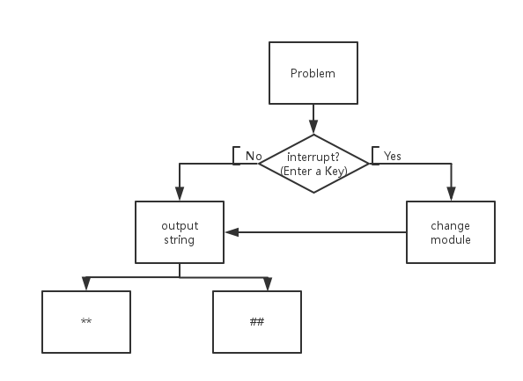

**2.Main Idea:**

**（1）Interrupt_Service Routine**

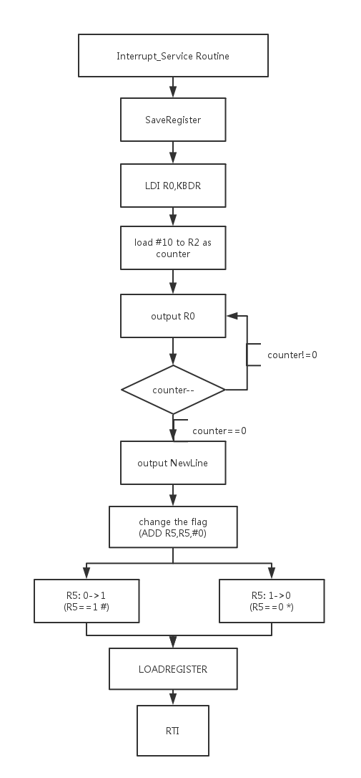

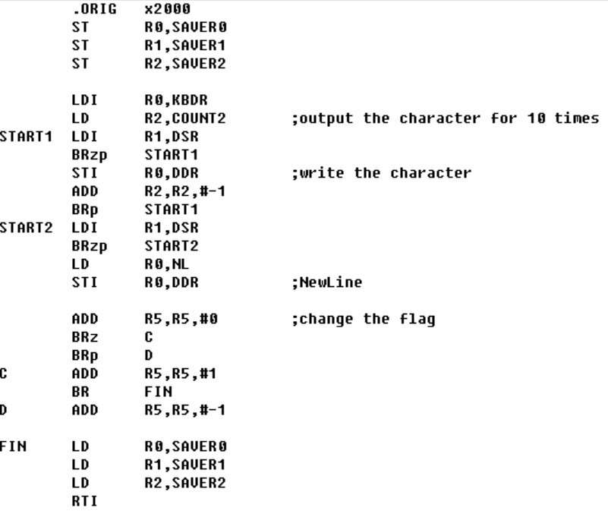

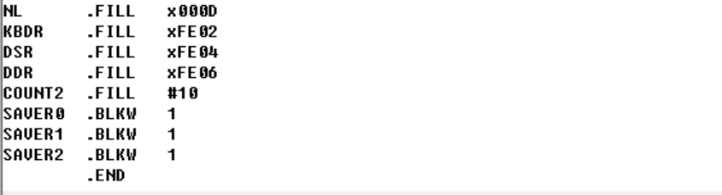

**（2）Interrupt_Service Routine**

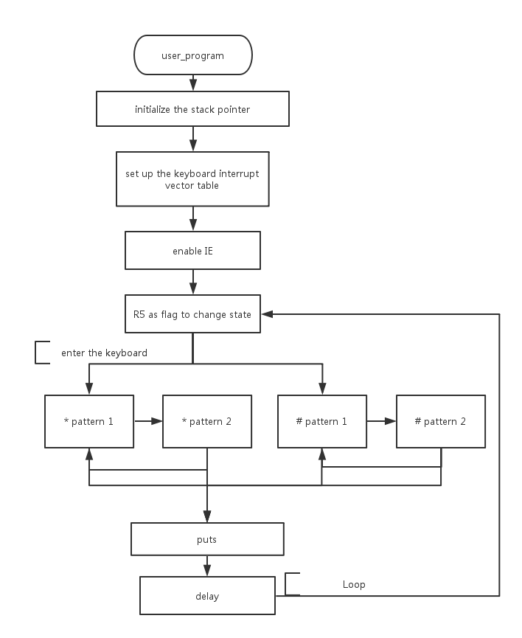

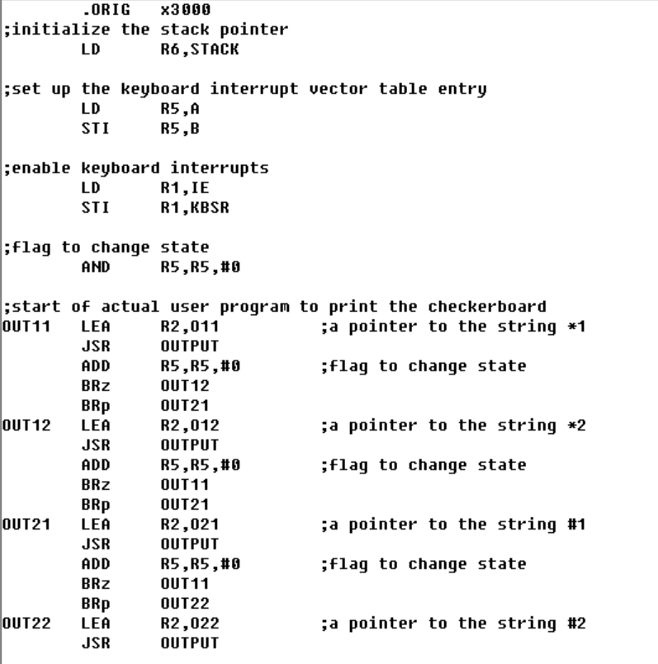

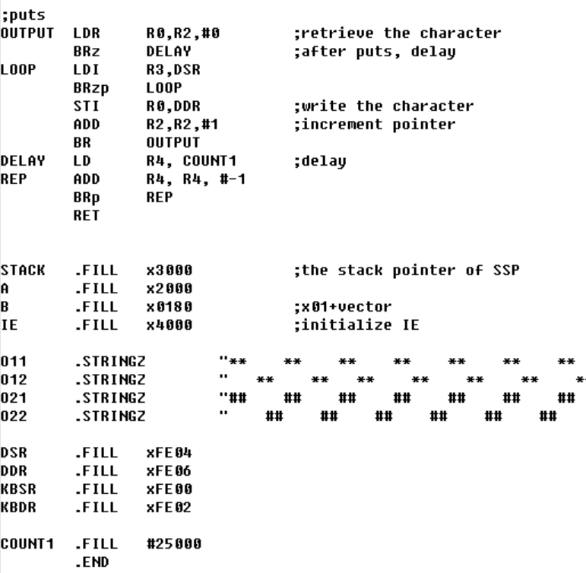

1.It’s necessary to initialize the stack pointer which is SSP, otherwise it’s will point to USP and the interruption can’t be executed.

2.Use flag which store in R5 to show states. And every time the user enter the key, based on the old state which showed in R5.

**5.Result：**

