**Assignment 5 Report**

**1.Problem：**

Each input contains one test case. For each case, the first line contains a positive integer N (<=10000) which is the total number of professors. Then N blocks follow, each contains the information of a professor in 3 lines:

Line #1: the last-name of the professor

Line #2: the first-name of the professor

Line #3: room-number of the room where the professor stays

After the directory information, there is a line containing a positive integer M (<=1000) which is the number of user’s search queries. Then M lines follow, each is a string of length between 1 and 15 (inclusive).

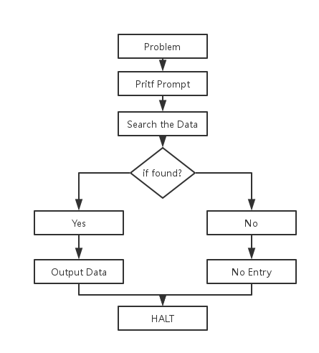

**2.Main Idea:**

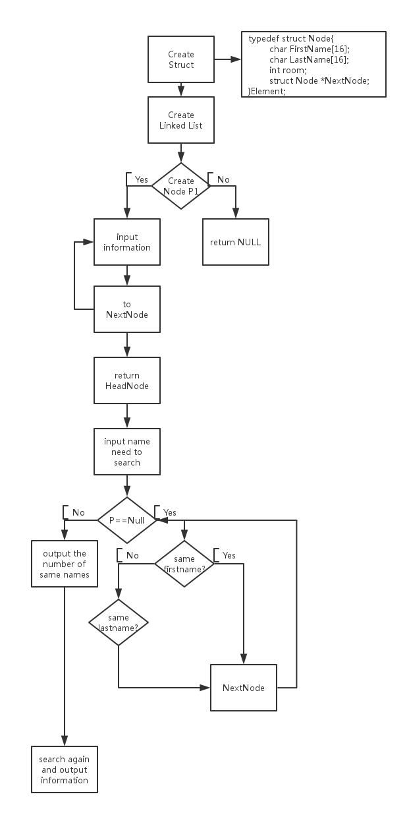

**3.Details about the program:**

1. **Input:**

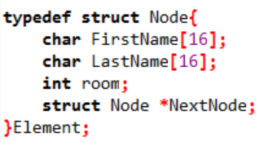

Use “struct Node” to store every professor’s information.

1. **Create Linked List:**

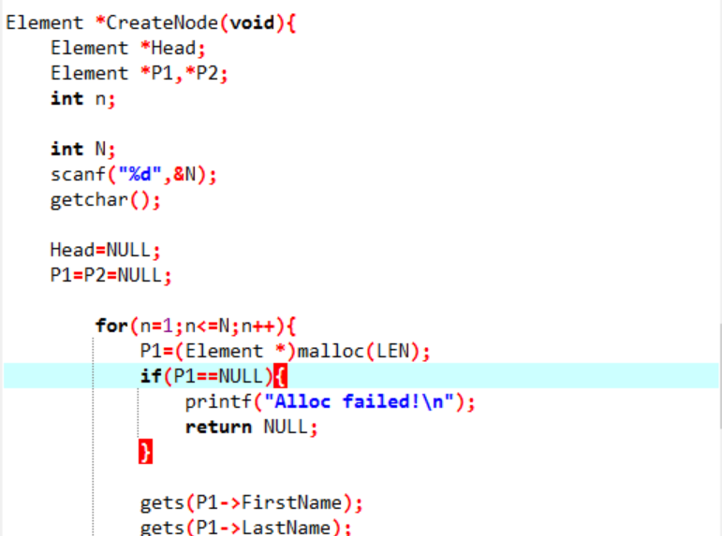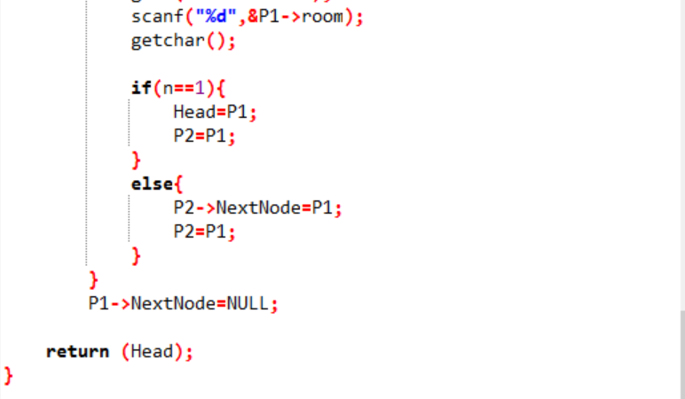

1. The order to Search:

Headnode🡪Node1(Firstname’s node🡪Lastname’s node)🡪Node2(…)🡪……🡪NodeN🡪NULL

1. When NextNode is NULL, that’s means program is performing to the end of the directory.
2. In a linked list, use the linked list name as a parameter and P1&P2 to create a new linked list.
3. When creating a new linked list, don’t forget to give memory space to a new Node.
4. **Input Name:**

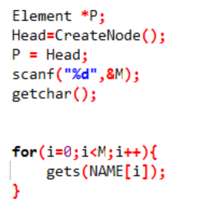

Use array to store the name user input which are needed to search in the directory.

1. **Count:**

When the first time to search in the directory, store the total amount of the same name in the directory.

1. **Output:**

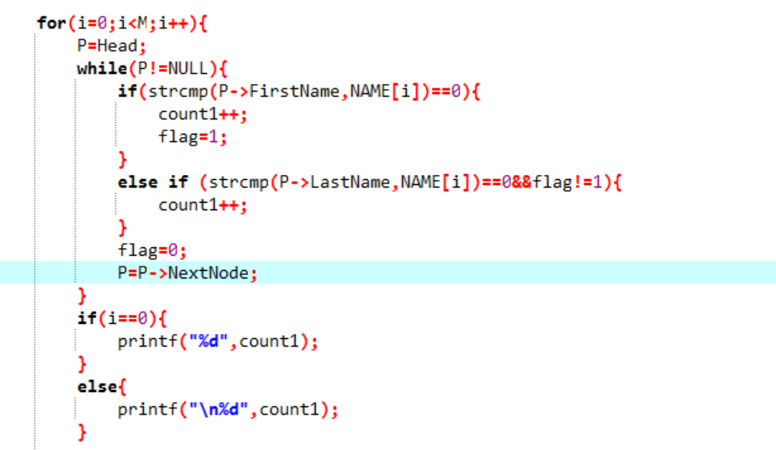

1. Search again, and this time output information from the directory and end when P == NULL which means the end of the directory.
2. Because it is required that the last row should not be nothing, the program change the way to output return.

**5.Result：**

