Pumpkins Write Up

TASK ONE – Read in the csv file

My individual data set was the first csv file (01). Below is the code used to read in the file and also import the libraries needed throughout the rest of the code.

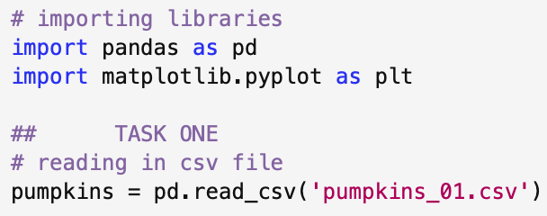

TASK TWO – Identify the heaviest pumpkin

Using the sort_values function, I listed the weights from heaviest to lightest and then printed the required information (variety, location and year) as well as including the id and the weight of the pumpkin as well. Using the iloc⁽¹⁾ function to select only the first row (index 0) to print.

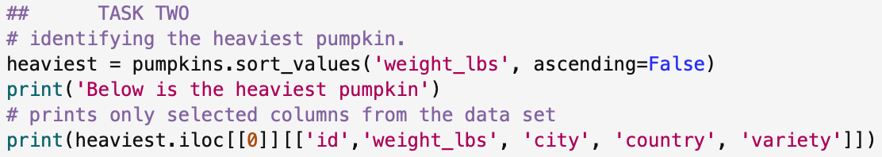

TASK THREE – Converting pounds to kilos

Used a function for the conversion and then created a new column with the new weights in kilograms.

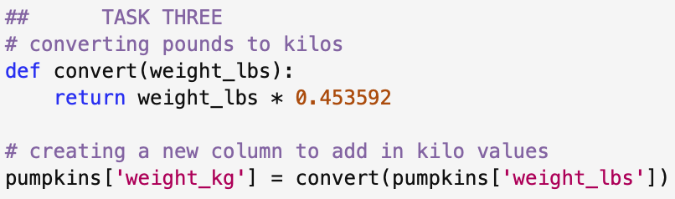

- Convert pounds → kilograms (weight_kg column)
- Add a weight_class column (light / medium / heavy)
- Plot estimated vs actual weight (coloured by class)
- Filter for three countries and save (pumpkins_filtered.csv)
- Summarise mean weights by country and variety
- Create a boxplot for the three countries
- Create a faceted plot by variety

