Gene Expression Write Up

Tasks:
- Summary Statistics
- Plots
- Significant Gene Lists

TASK ONE
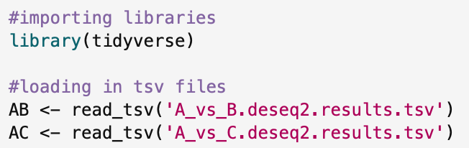
Imported libraries needed for the code and loaded in my data sets (set 1) of the two tsv files.

Looking at the A v B file first. Below is the code for counting the number of significantly upregulated or downregulated genes.
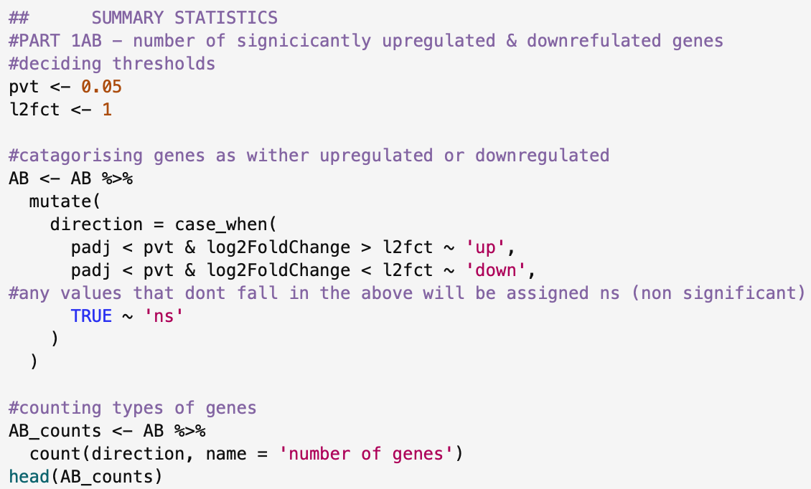
I defined the significance threshold for both the p values and the log2 fold change values as variables, this way in the future if we wanted to test different significant values they can be easily changed. Then to categorise the genes, I used the case_when function ^{[1]} to assign the values of either up, down or ns. Ns is assigned to non-significant values based on the assigned thresholds. Then to count the types of genes I then used the count function, and it then prints a tibble as seen below.
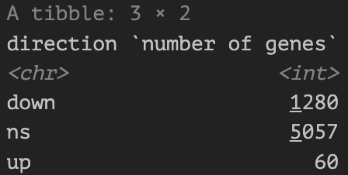

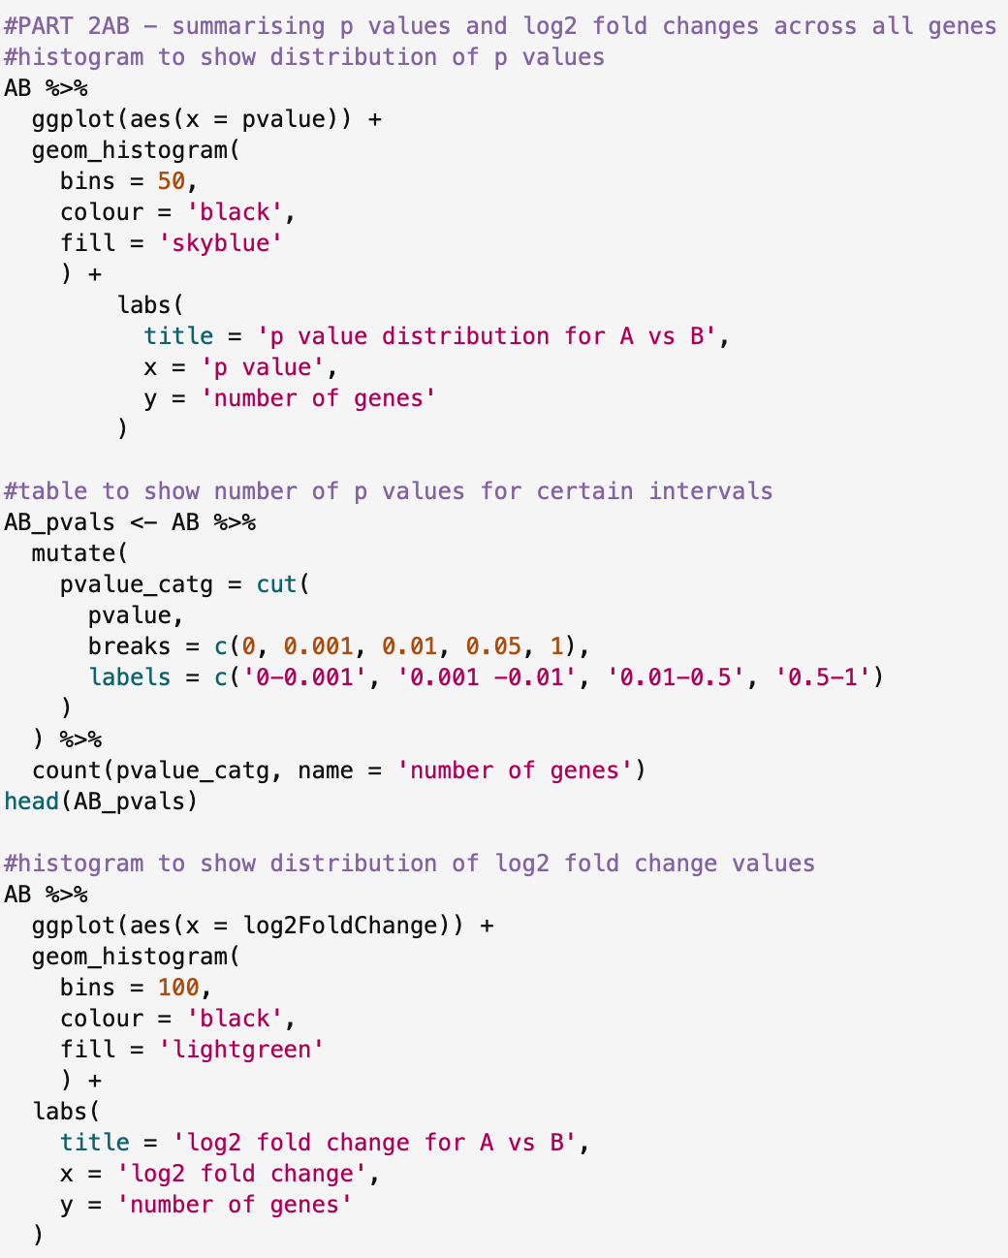
To then create a summary of values the code below was used.

I firstly created a histogram to show the spread of p-values as seen below.
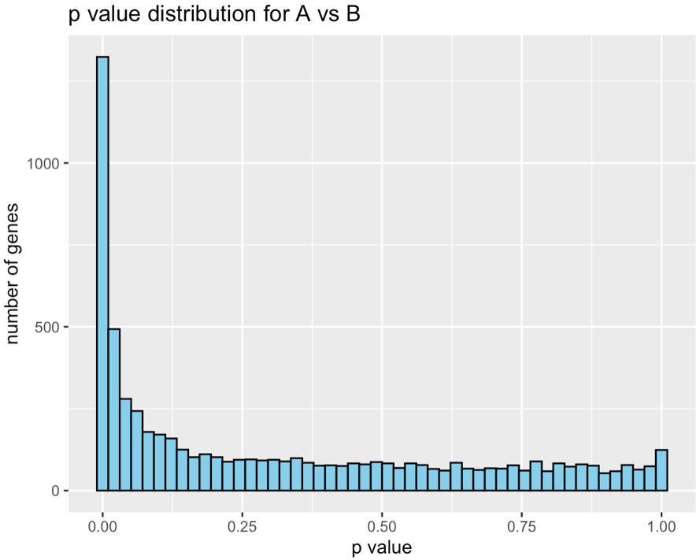

Figure 1: Histogram to show spread of p-values for the A vs B data set

I then created a table to show the counts of p values for certain defined intervals to allow for a different way to see the spread of data. Below is the code and output for this.
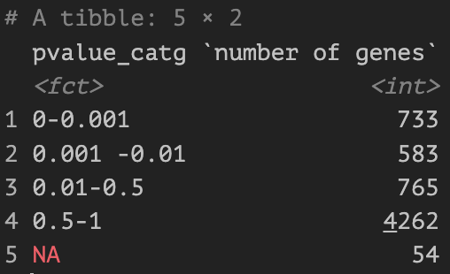
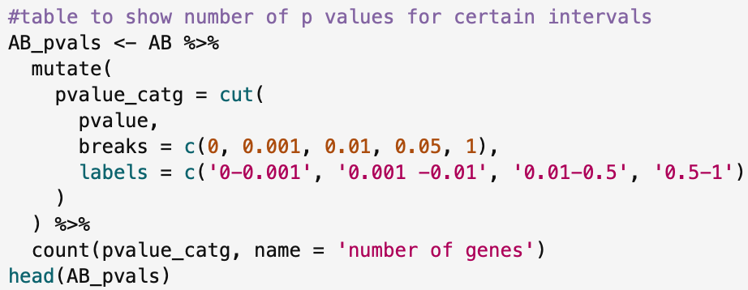

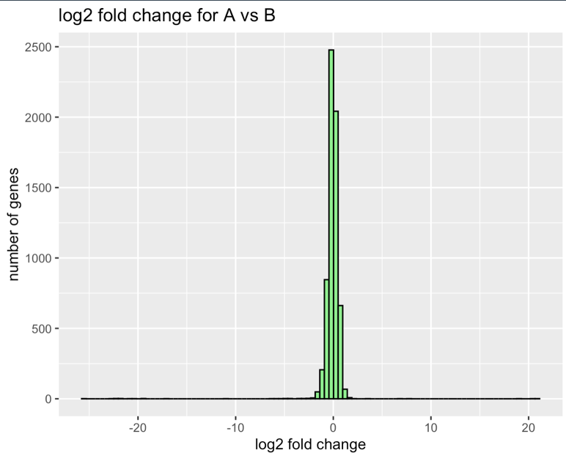
Similarly, for the log2 fold change values I created a histogram. The code and graph can be seen below.
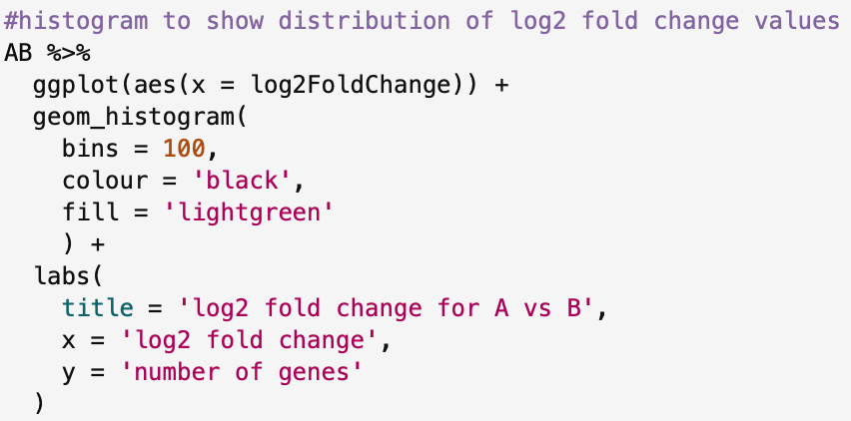

Figure 2: Histogram to show spread of log2 fold change values for the A vs B data set

To look at the A vs C file, I used the exact same code, just changing variable names. Code and output can be seen below.

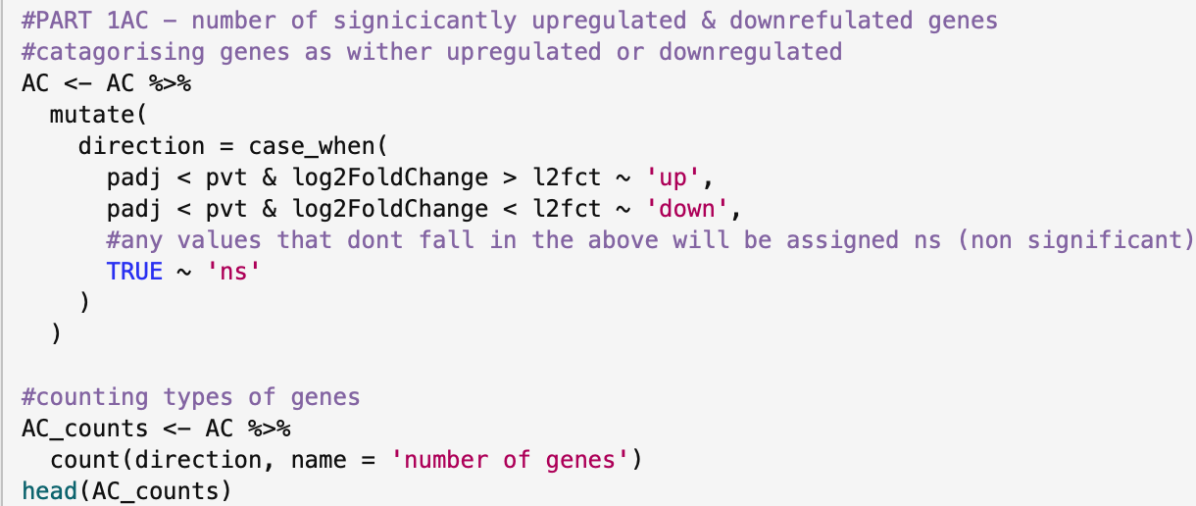

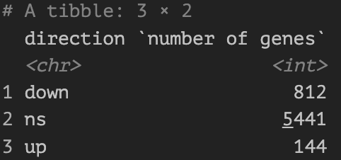

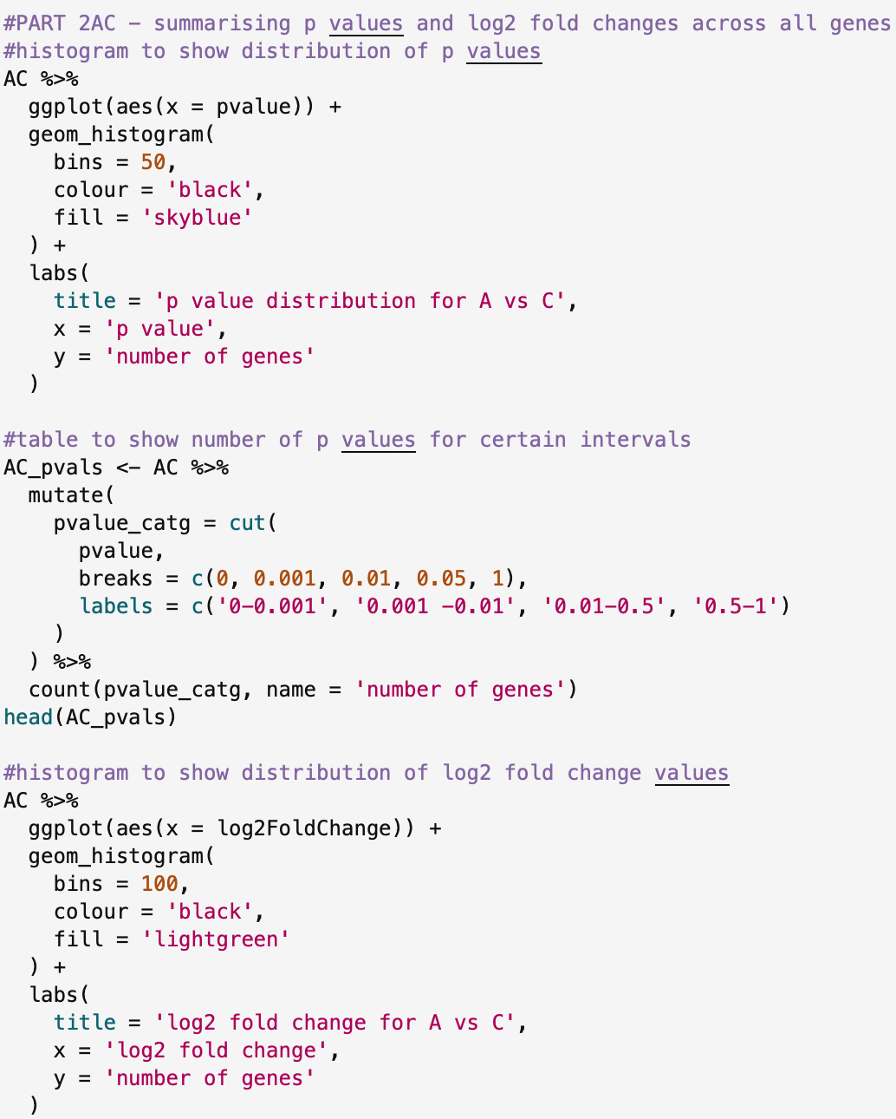

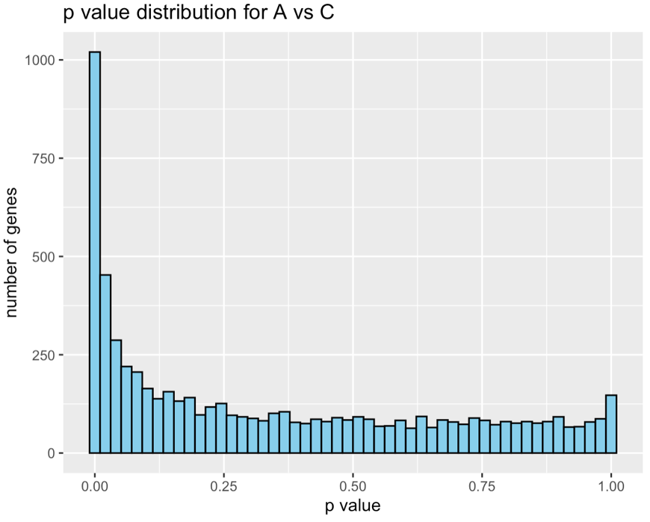

Figure 3: Histogram to show spread of p-values for the A vs C data set

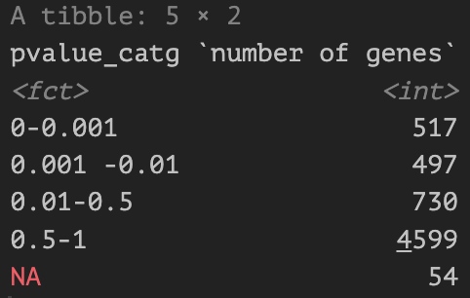

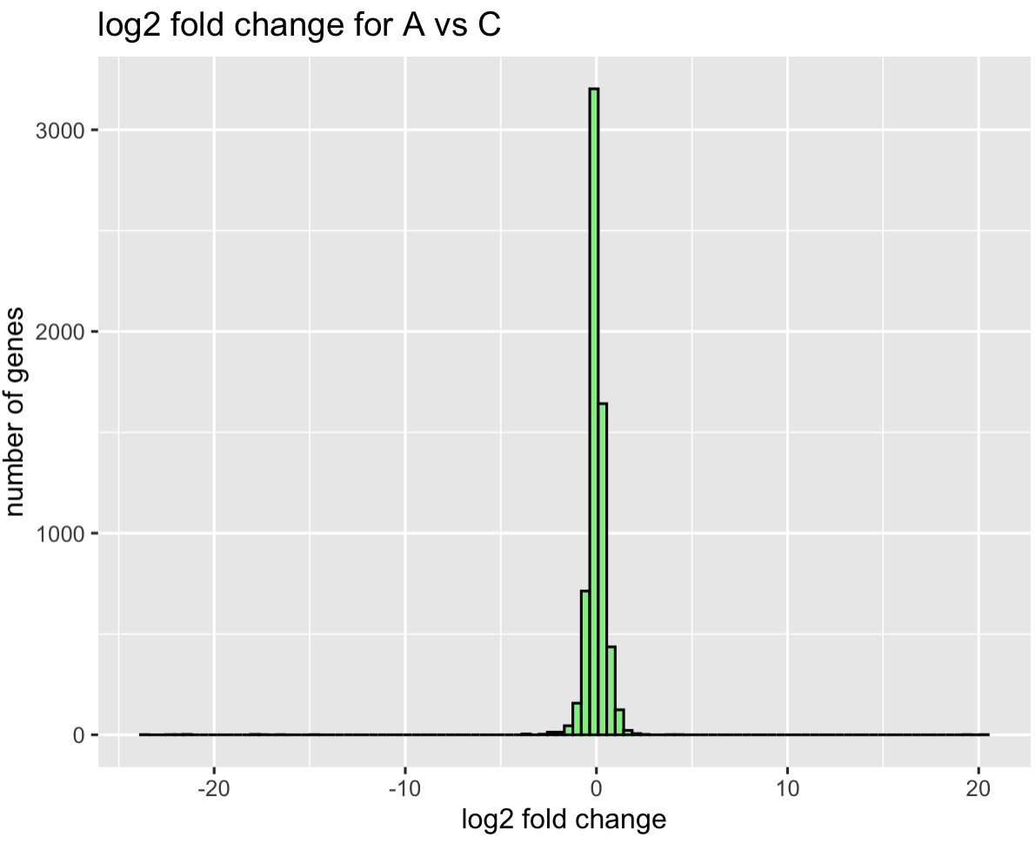
Figure 4: Histogram to show spread of log2 fold change values for the A vs C data set

TASK TWO

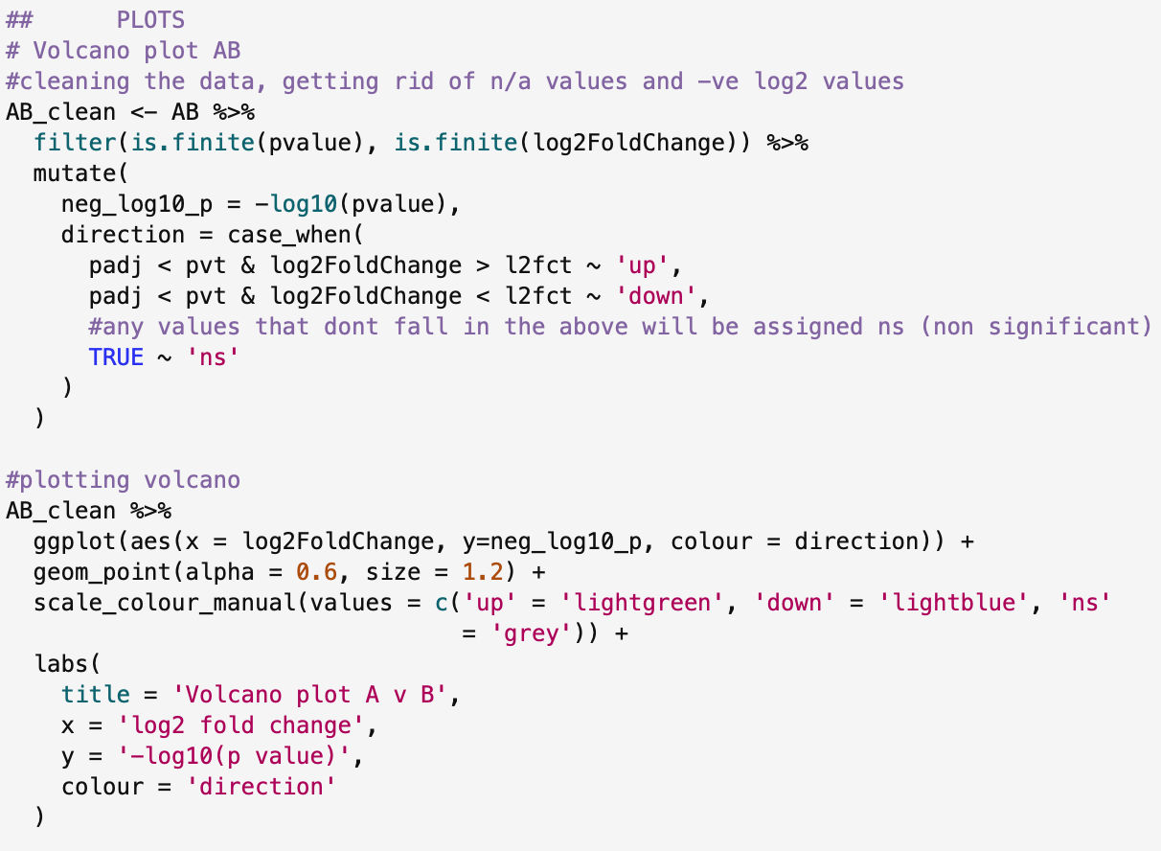

First, I cleaned the data getting rid of any n/a values and any negative values by using the is.finite ^{[2]} function and still kept my categories for the upregulated and downregulated genes. I then plotted the volcano plot as seen below.

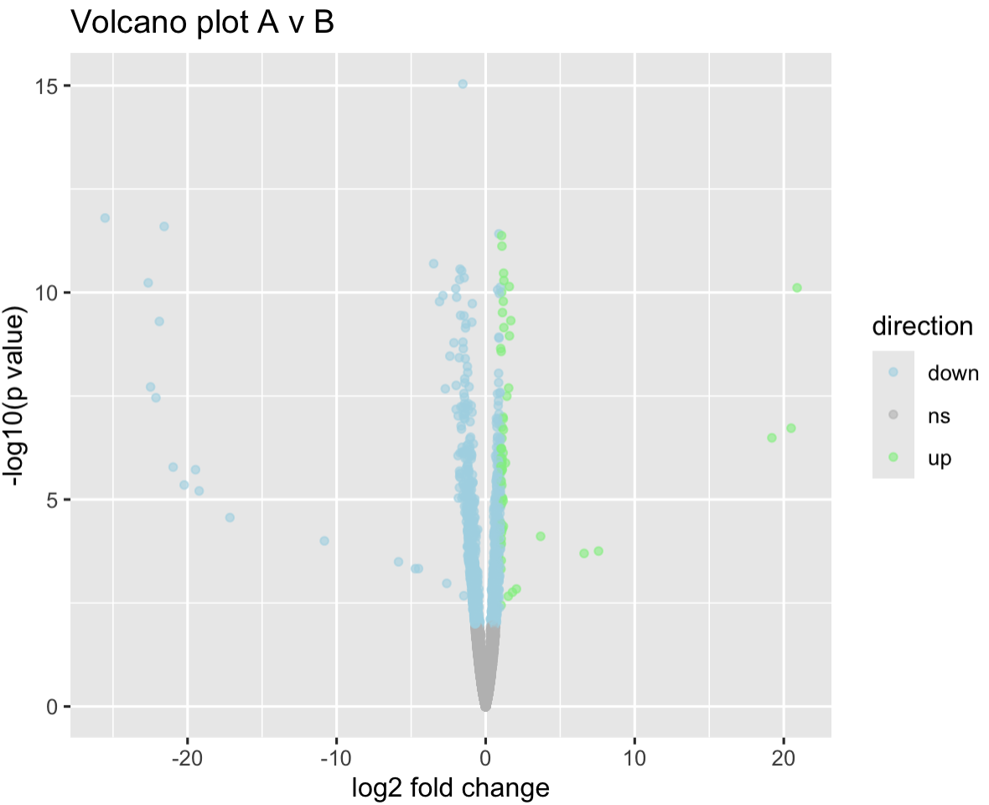
Figure 5: Volcano plot of differential expression of A v B

For the MA plot, I created a new data set for the plot to clean the data needed as it is different to the previous tasks. and then plotted the graph. The code can be seen below as well as the output.

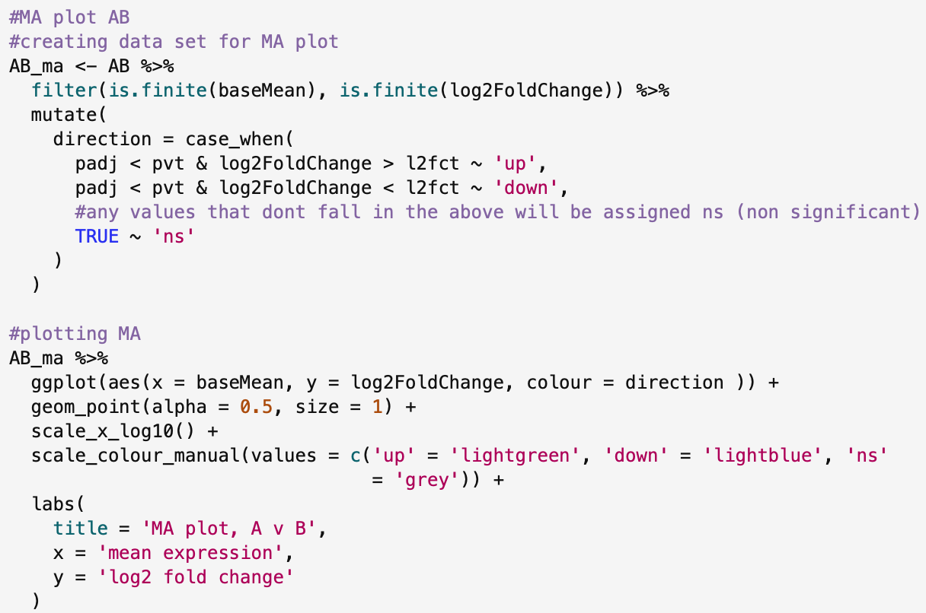

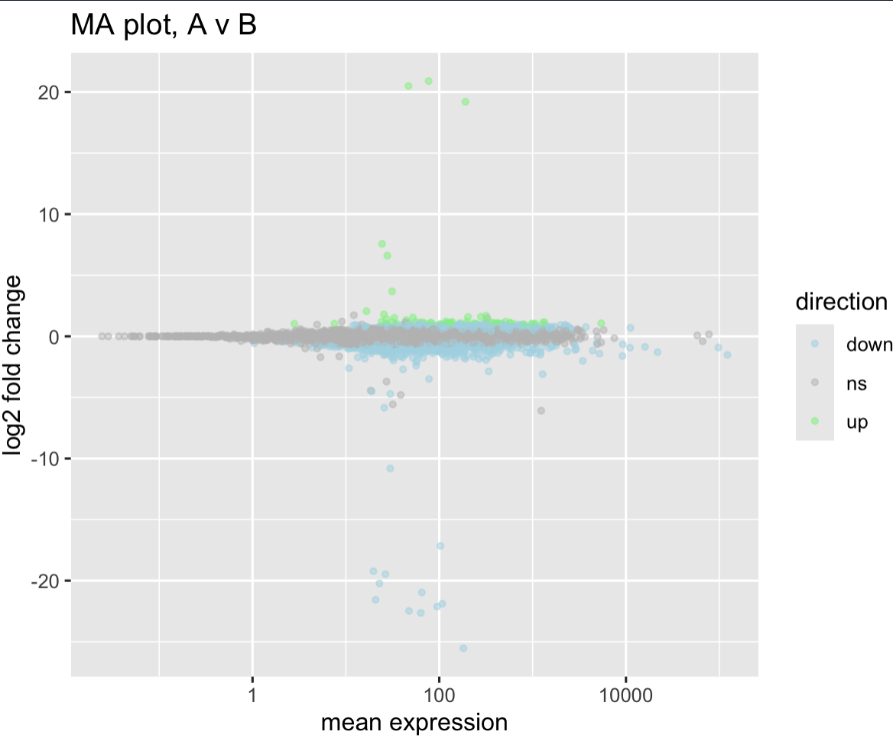
Figure 6: MA plot of mean expression of A v B
Lastly, for the histogram I reused the same code I had written from before, as seen below.
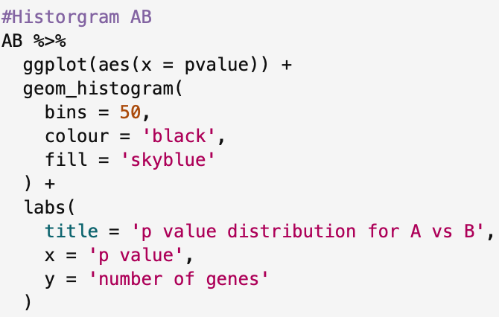

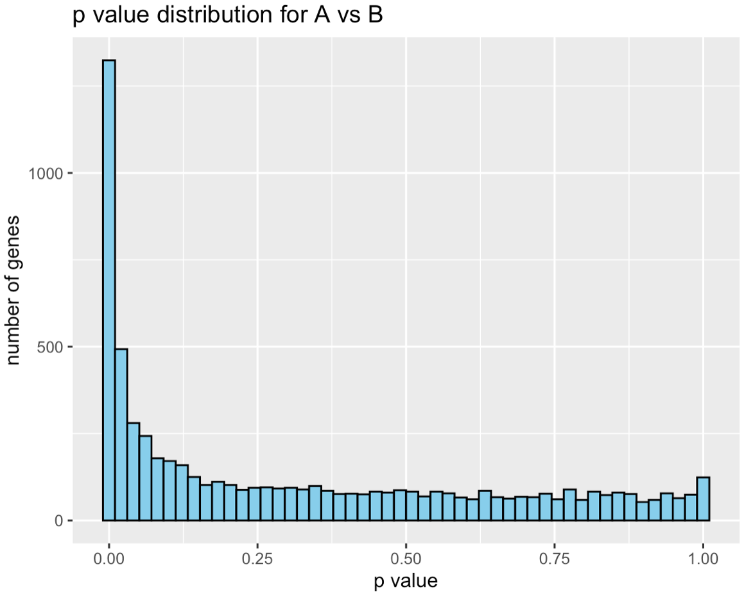

Figure 7: Histogram to show spread of p-values for the A vs B data set

I then repeated the exact same codes, with changed variables for the A vs C file. Code and outputs all below.

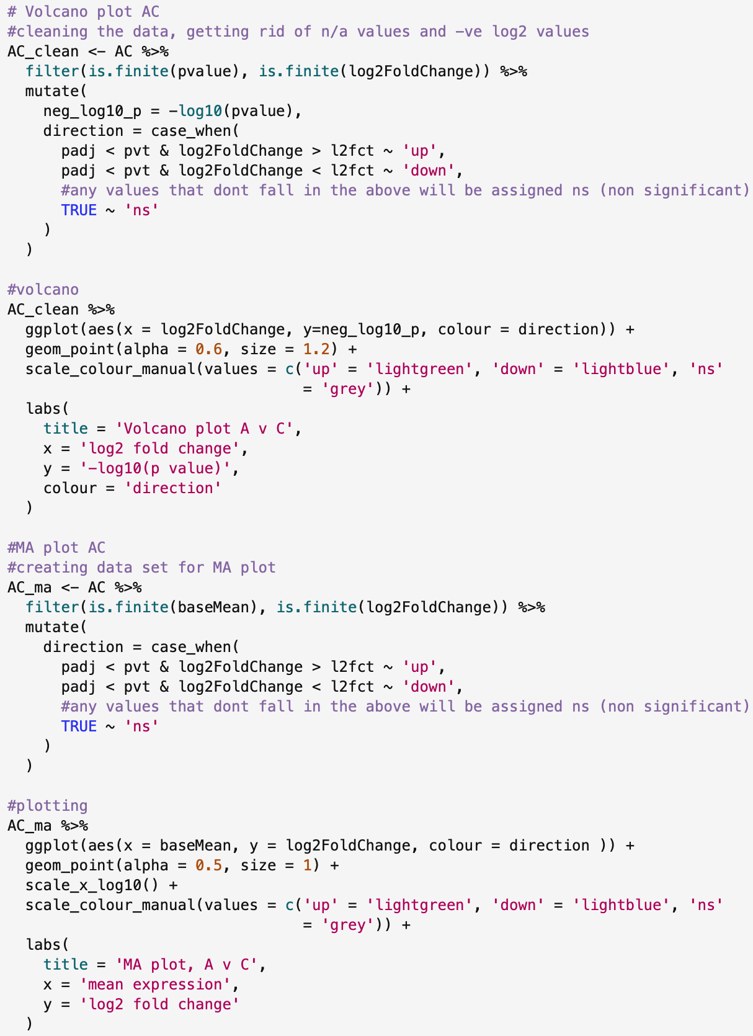

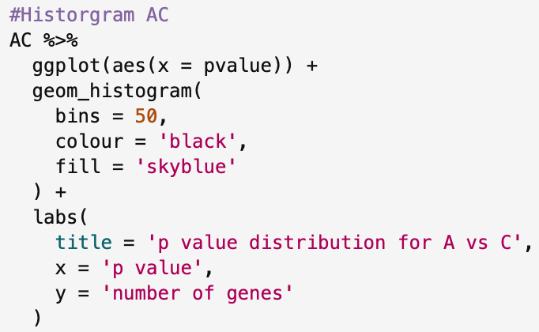

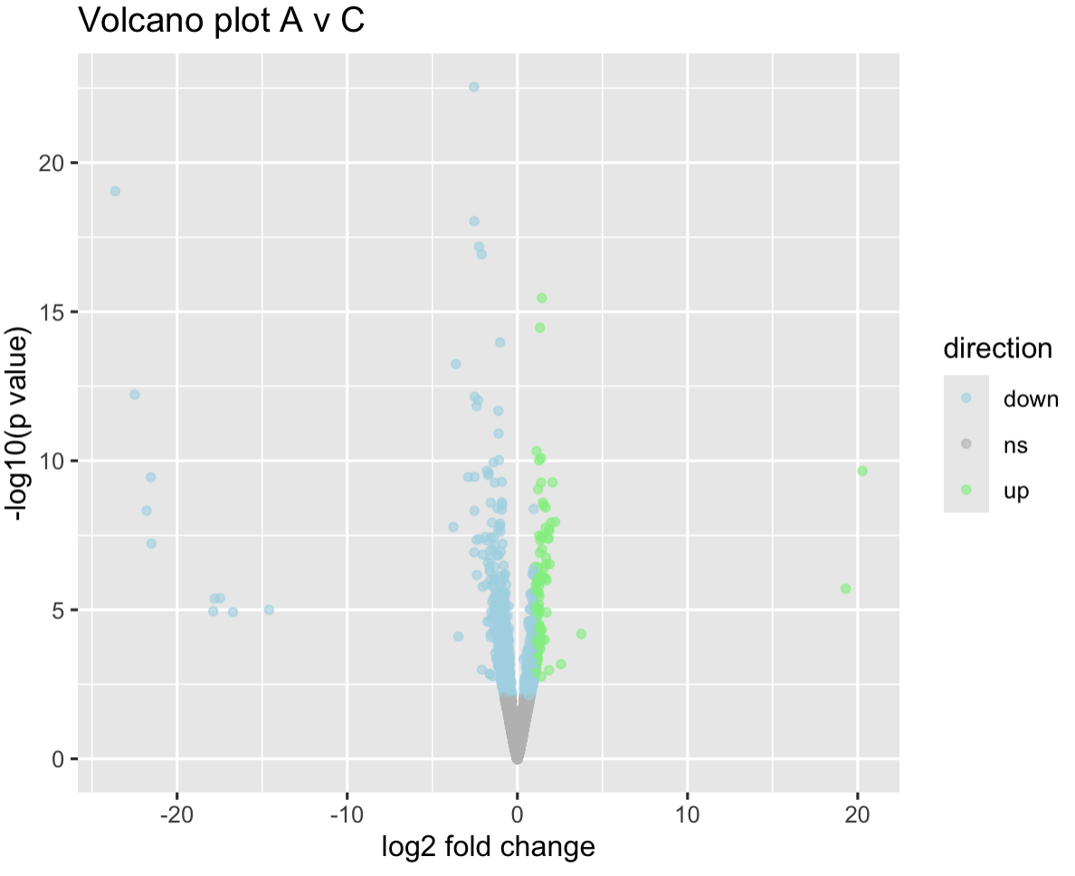
Figure 8: Volcano plot of differential expression of A v C
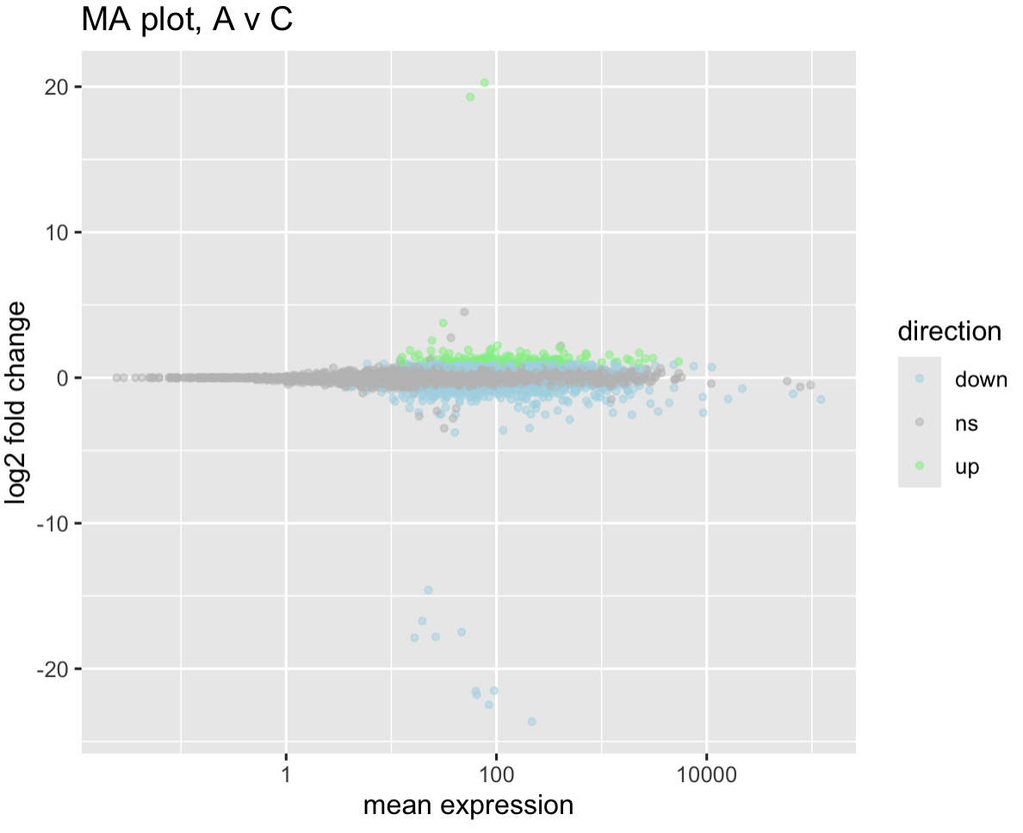
Figure 9: MA plot of mean expression of A v C

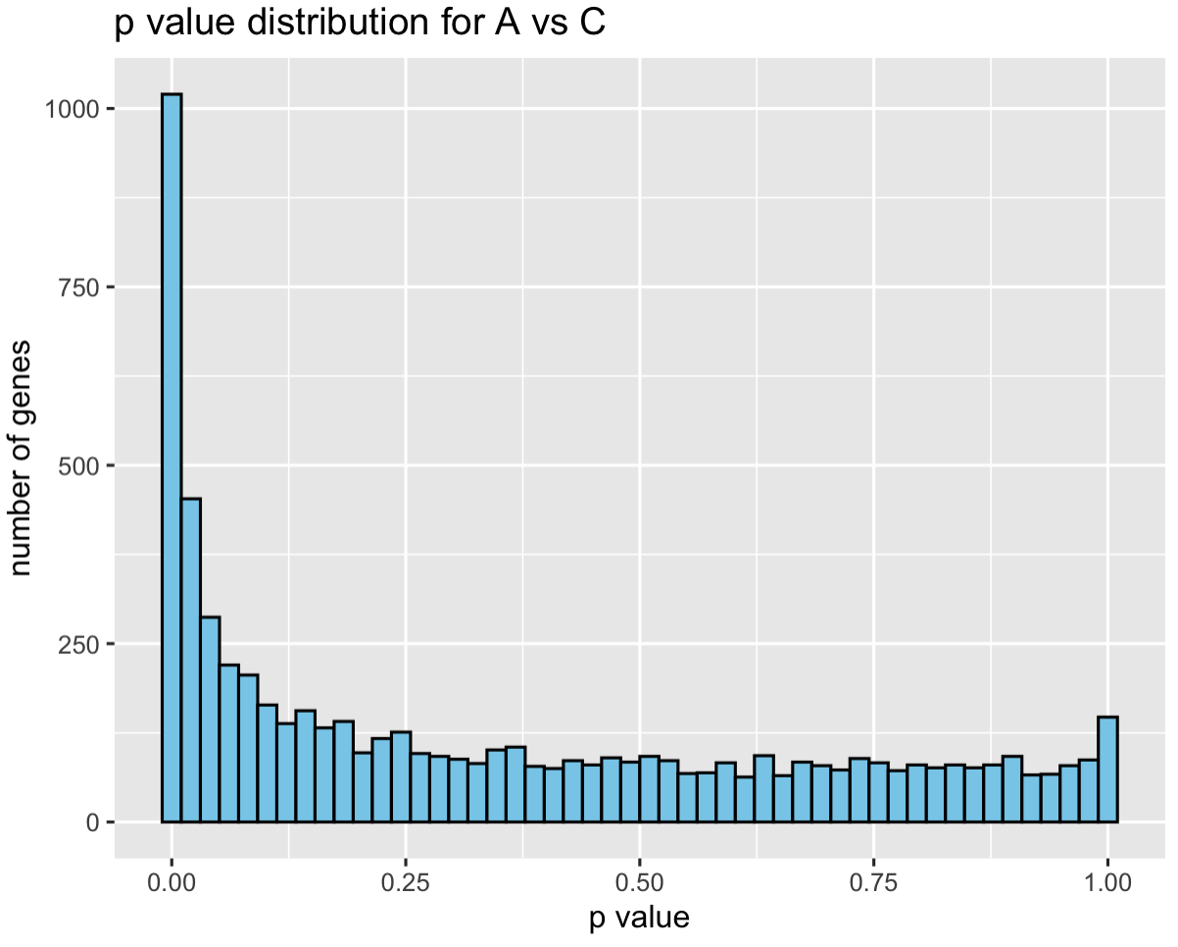

Figure 10: Histogram to show spread of p-values for the A vs C data set

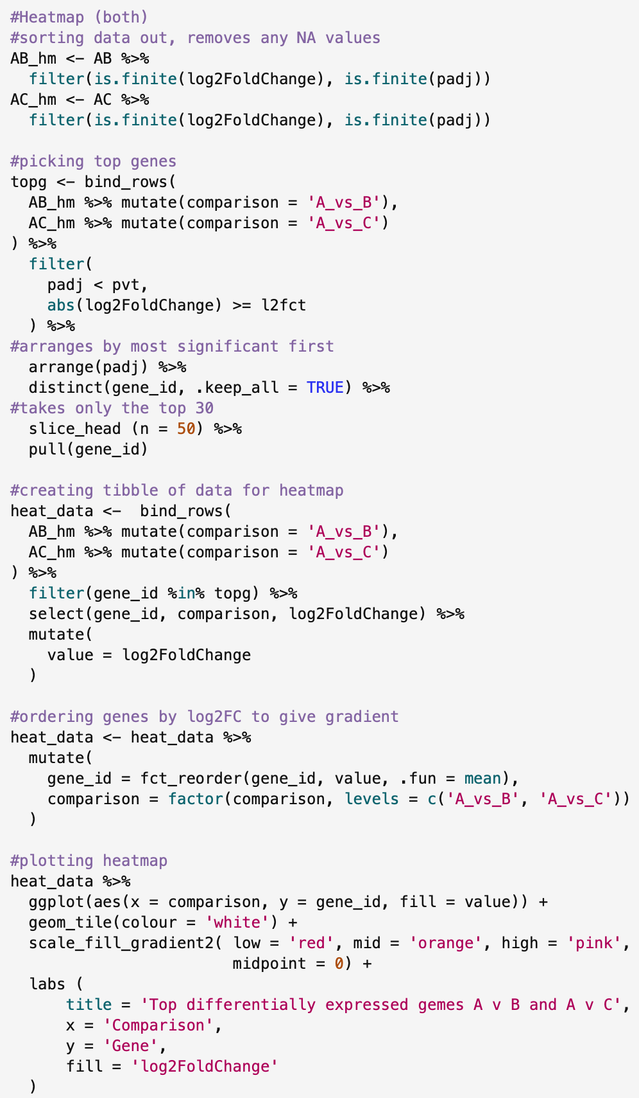
For the last plot, the Heatmap below is the code used and plot generated.

Firstly, cleaned both sets of data and created new datasets specific for the heat map. I then picked the top 50 genes that are considered the most significant based on their p values and log 2 fold change values. Using the abs function ^{[3]} to remove any negative signs and just return the magnitude.

I then combined all this information into one tibble that would provide all the data for the heatmap using bind_rows and then filtering making sure to select the necessary information.

I decided to then order the genes by their log2FC value, to give the graph a nice gradient.

Then used geom_tile^{[4,5]} to plot the actual heatmap as seen below.

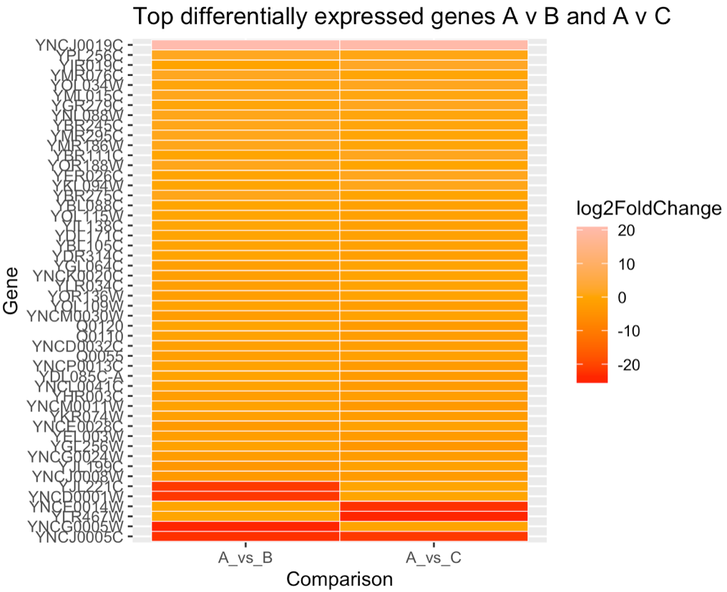

Figure 11: Heatmap to show top differentially expressed genes A v B and A v C.
TASK TWO

To create a list of significant genes below is the code for both A vs B and A vs C. I filtered based on the categories given to them at the beginning either ‘up’ or ‘down’ and then created new data sets for each one.
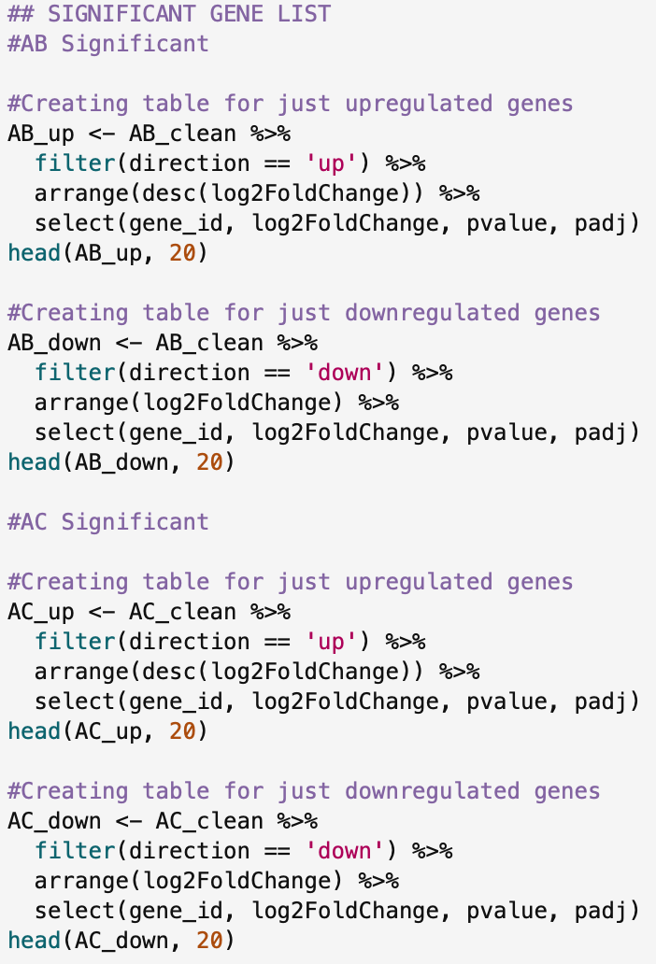

The outputs are below.

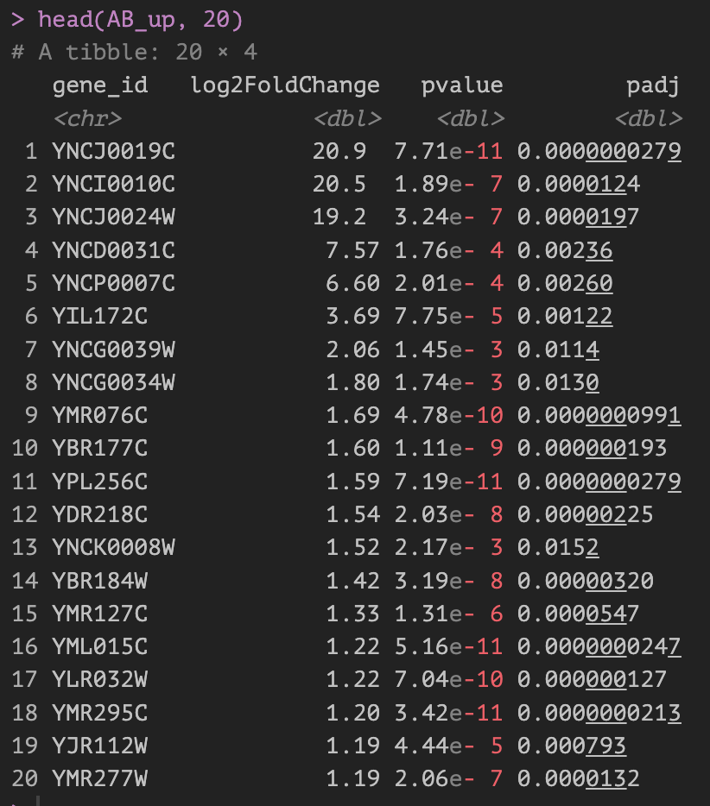
A v B, most significant up regulated genes

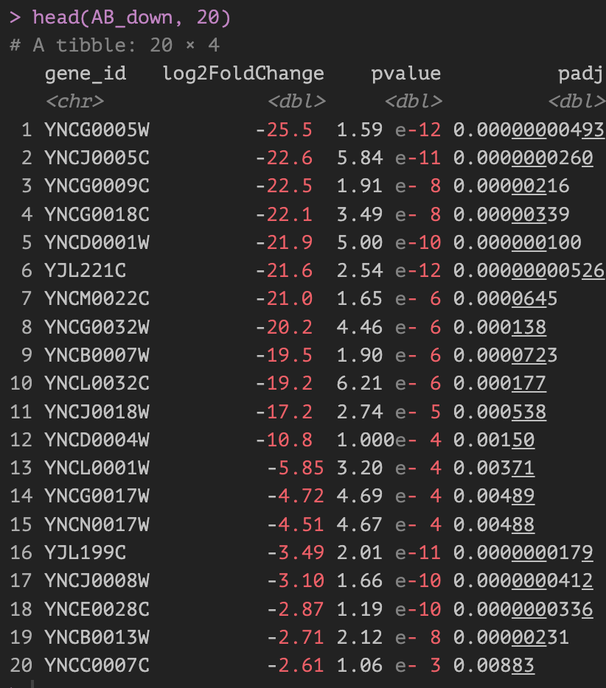
A v B, most significant down regulated genes

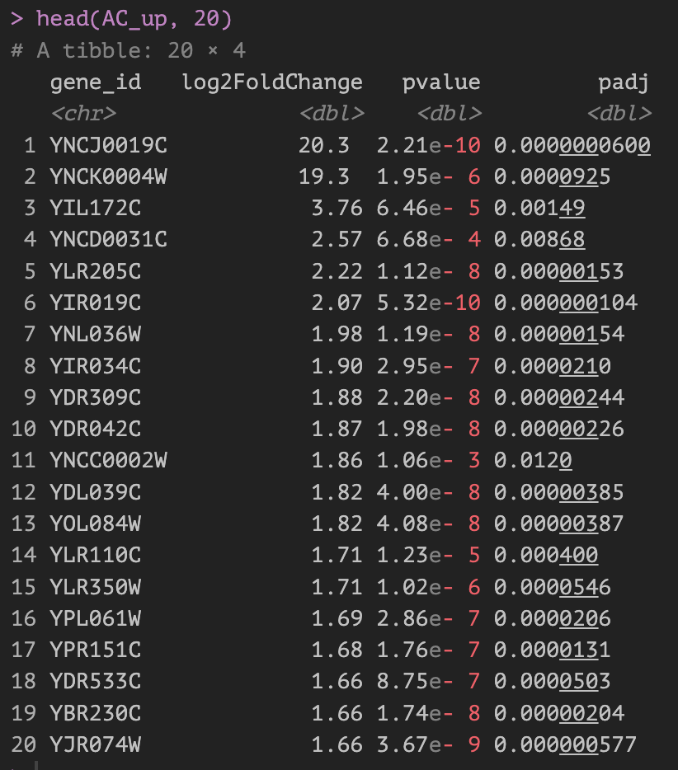
A v C, most significant up regulated genes

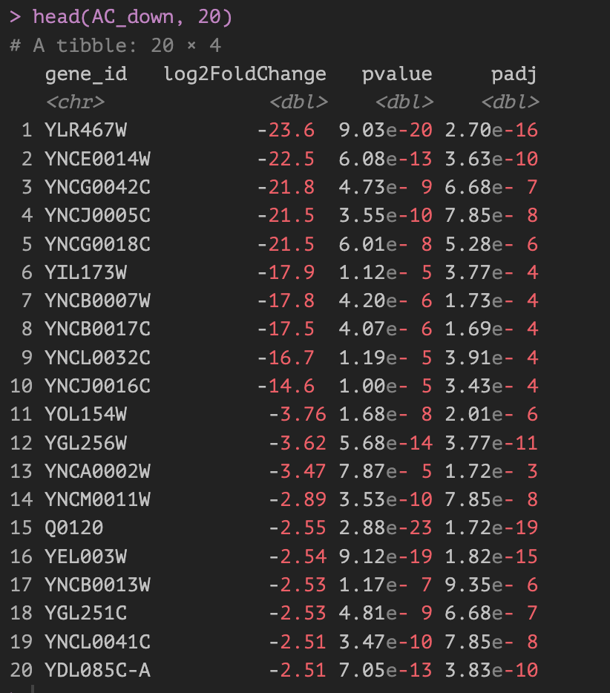
A v C, most significant down regulated genes

REFERNECES

1.
case_when in mutate pipe [Internet]. Stack Overflow. Available from: https://stackoverflow.com/questions/38649533/case-when-in-mutate-pipe
2.
utah johnny. R Locating Finite Values in Dataset [Internet]. Stack Overflow. 2016. Available from: https://stackoverflow.com/questions/37820653/r-locating-finite-values-in-dataset
3.
SQLPad. Absolute Value Calculations in R - Unlock the Essentials of Calculating Absolute Values in R with This Comprehensive guide, Featuring step-by-step Tutorials and Code Examples for beginners. - SQLPad.io [Internet]. Sqlpad.io. 2024 [cited 2025 Dec 9]. Available from: https://sqlpad.io/tutorial/absolute-calculations/
4.
Heat map in ggplot2 [Internet]. R CHARTS | A collection of charts and graphs made with the R programming language. 2021. Available from: https://r-charts.com/correlation/heat-map-ggplot2/
5.
Holtz Y. ggplot2 heatmap [Internet]. www.r-graph-gallery.com. Available from: https://r-graph-gallery.com/79-levelplot-with-ggplot2.html

