Pumpkins Write Up

Tasks:
- Read in pumpkins.csv
- Identify the heaviest pumpkin (variety, location, year)
- Convert pounds → kilograms (weight_kg column)
- Add a weight_class column (light / medium / heavy)
- Plot estimated vs actual weight (coloured by class)
- Filter for three countries and save (pumpkins_filtered.csv)
- Summarise mean weights by country and variety
- Create a boxplot for the three countries
- Create a faceted plot by variety

TASK ONE
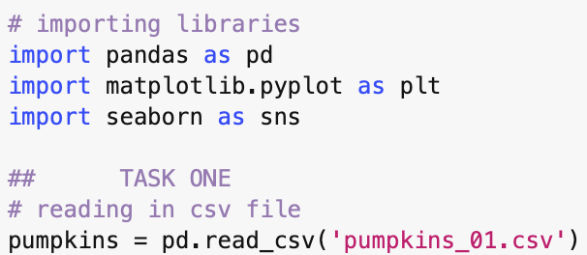
My individual data set was the first csv file (01). Above is the code used to read in the file and also import the libraries needed throughout the rest of the code.

TASK TWO

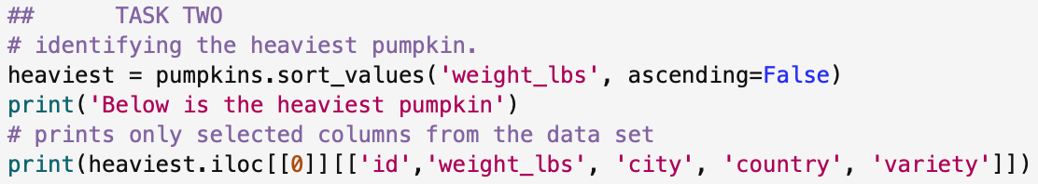
Using the sort_values function, I listed the weights from heaviest to lightest and then printed the required information (variety, location and year) as well as including the id and the weight of the pumpkin as well. Using the iloc^{[1]} function to select only the first row (index 0) to print. Below is the output of the code.

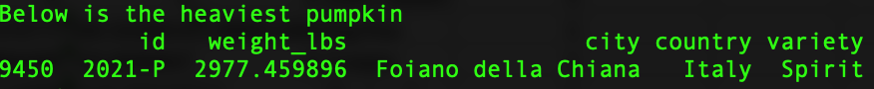
The heaviest pumpkin is of the Spirit variety and was grown in Foiano della Chiana in Italy grown in 2021.

TASK THREE
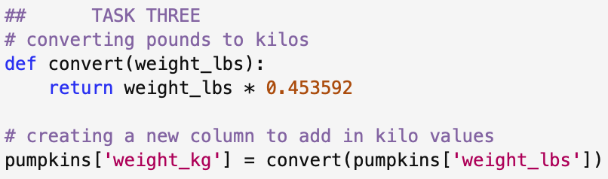
Used a function for the conversion and then created a new column ^{[2]} with the new weights in kilograms.

TASK FOUR
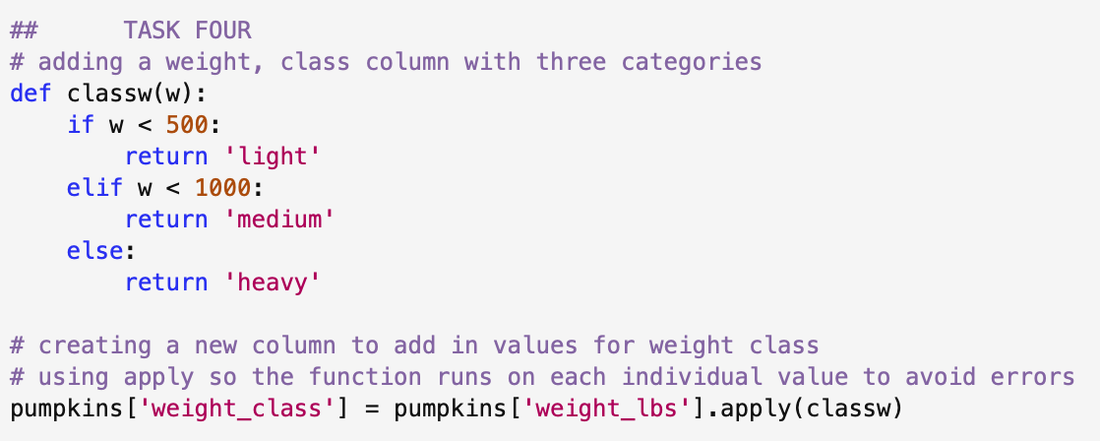
Used a function with if, elif and else to assign the classes for the different weights. Then used the apply function to ensure that the function is applied to every single value throughout the dataset. At first, I didn’t have the apply function and I struggled to get the line of code to work as I wanted it too but found that as a solution. ^{[3]}

TASK FIVE
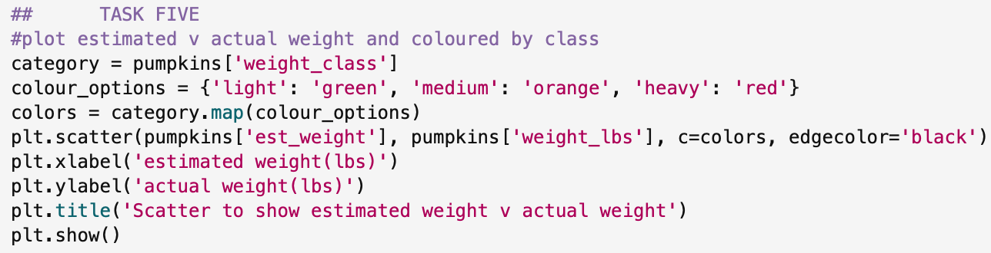
Used matplotlib to plot the scatter plot. Used a range of different functions ^{[4]} and variables to colour each point depending on the weight class. I chose three different colours (green, orange and red) and assigned them to each class from the previous task. I used some of the other aesthetic options in matplot to outline each individual data point as well as giving the graph axis titles and a main title. Below is the graph that was produced.

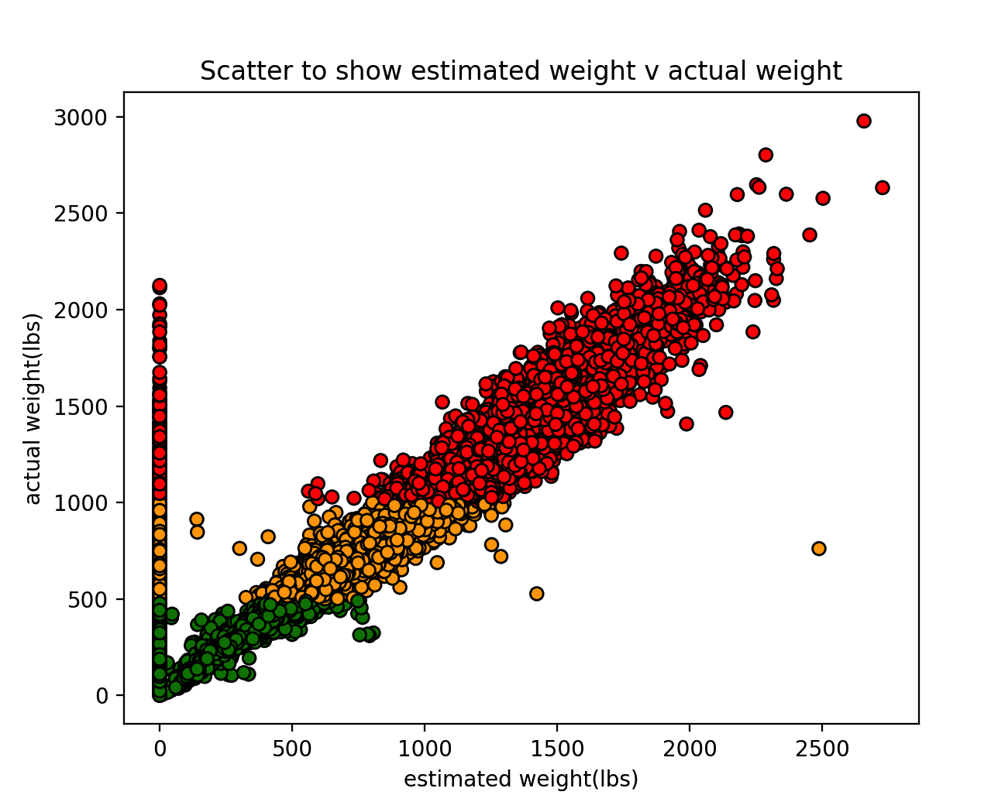
Figure 1: Scatter plot to show estimated weight (lbs) against actual weight (lbs) of pumpkins, coloured by their weight class

TASK SIX
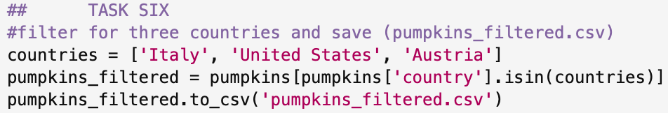
Defined my chosen countries as a variable (Italy, United States and Austria) and then used the isin function ^{[5]} to filter in the ‘country’ column for my chosen countries. I then wrote this to a new csv file that saves into my coursework folder.

TASK SEVEN
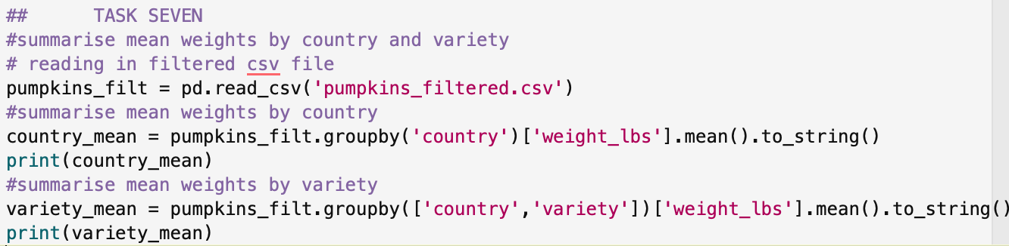
Read in the new filtered csv file and then used the same code to filter and group for both categories. I used the to_string() function ^{[6]} to get rid of the text that gets added on the bottom that states the name and data type of the variable being summarised.
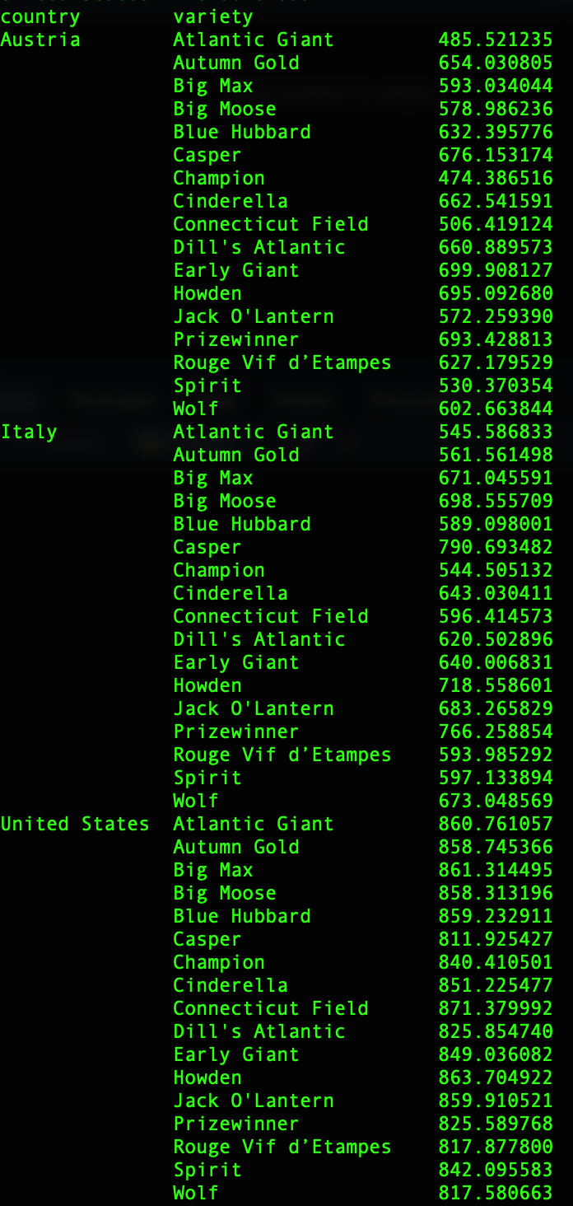
This is the output of the code.

The country that had the highest mean pumpkin weight from my filtered data set was the United States. The country that had the lowest mean weight for a particular variety is Austria with the Atlantic Giant.

TASK EIGHT
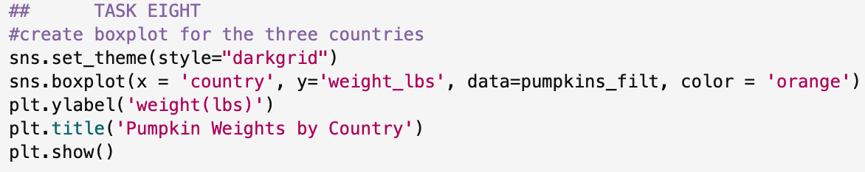
Used seaborn this time to create the boxplot, used some of the aesthetic options to change the colours and themes. Below is the graph that is produced.

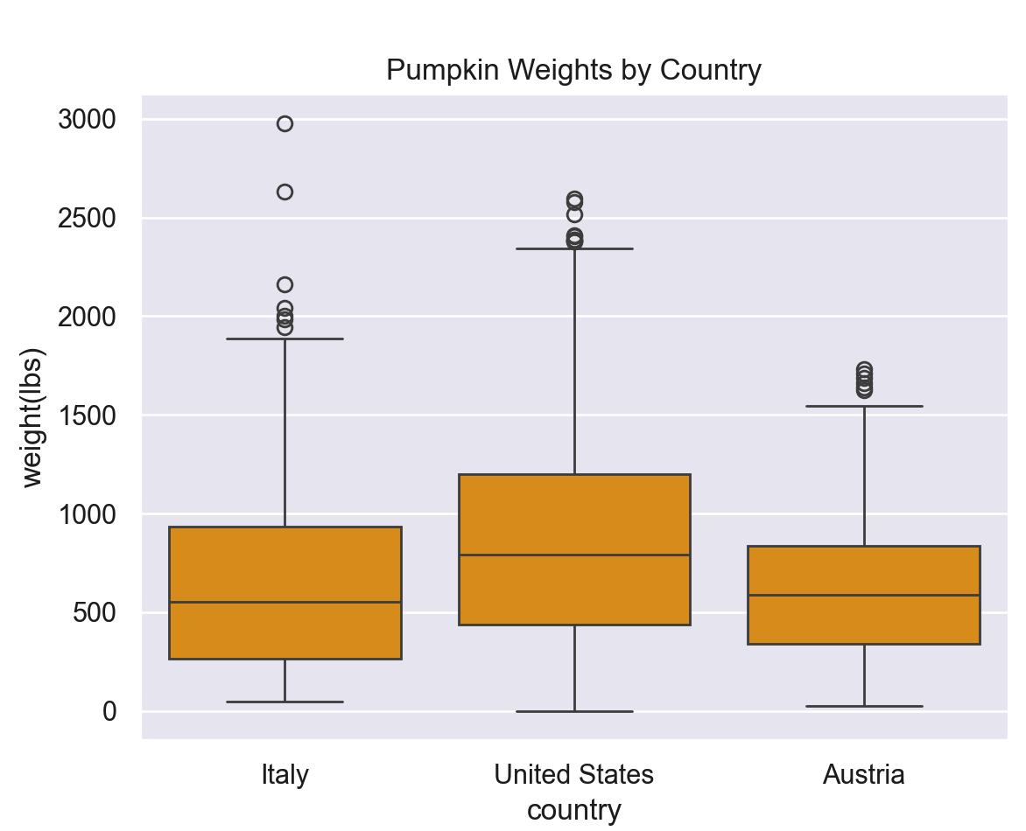
Figure 2: Box plot to show distribution of weight(lbs) of pumpkins across three different countries

TASK NINE

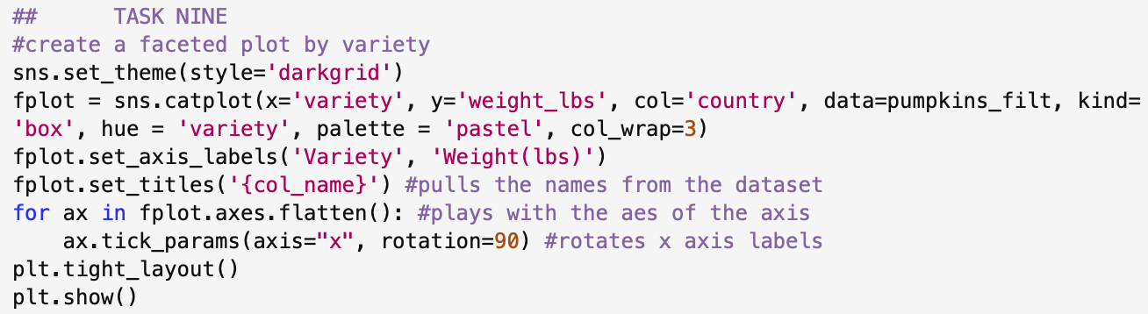
Using the seaborn catplot options ^{[7]} to create the faceted plot. I decided to create one for each country as well, so the graphs weren’t as busy. I used some of the axis aesthetic options ^{[7]} to make the layout neater and easier to read. Below is the graph produced.

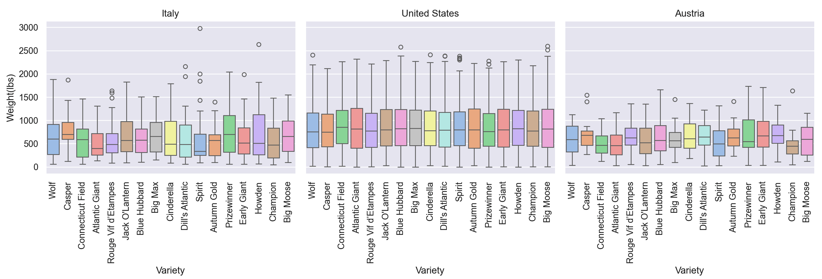
Figure 3: Facet plot to show distribution of weight (lbs) across each variety of pumpkin across three different countries

REFERENCES

1.
Farnschläder T. ILoc Vs Loc in Pandas: a Guide with Examples [Internet]. Datacamp.com. DataCamp; 2024 [cited 2025 Nov 20]. Available from: https://www.datacamp.com/tutorial/loc-vs-iloc
2.
Michael. Applying function with multiple arguments to create a new pandas column [Internet]. Stack Overflow. 2013. Available from: https://stackoverflow.com/questions/19914937/applying-function-with-multiple-arguments-to-create-a-new-pandas-column
3.
Lotfinejad M. Learn How to Use the Apply Method in Pandas with This Tutorial [Internet]. Dataquest. 2022. Available from: https://www.dataquest.io/blog/tutorial-how-to-use-the-apply-method-in-pandas/
4.
How to color a MatPlotLib scatter plot based on a list of categories [Internet]. Stack Overflow. 2023. Available from: https://stackoverflow.com/questions/76096801/how-to-color-a-matplotlib-scatter-plot-based-on-a-list-of-categories
5.
LondonRob. How to filter Pandas dataframe using “in” and “not in” like in SQL [Internet]. Stack Overflow. 2013. Available from: https://stackoverflow.com/questions/19960077/how-to-filter-pandas-dataframe-using-in-and-not-in-like-in-sql
6.
How to Remove Name and Dtype from Output code? [Internet]. Stack Overflow. 2023. Available from: https://stackoverflow.com/questions/74696163/how-to-remove-name-and-dtype-from-output-code
7.
GeeksforGeeks. How to Make Simple Facet Plots with Seaborn Catplot in Python? [Internet]. GeeksforGeeks. 2020 [cited 2025 Dec 4]. Available from: https://www.geeksforgeeks.org/python/how-to-make-simple-facet-plots-with-seaborn-catplot-in-python/
8.
seaborn.FacetGrid — Seaborn 0.12.0 Documentation [Internet]. seaborn.pydata.org. Available from: https://seaborn.pydata.org/generated/seaborn.FacetGrid.html

