Pumpkins Write Up

Tasks:

- Read in pumpkins.csv
- Identify the heaviest pumpkin (variety, location, year)
- Convert pounds → kilograms (weight_kg column)
- Add a weight_class column (light / medium / heavy)
- Plot estimated vs actual weight (coloured by class)
- Filter for three countries and save (pumpkins_filtered.csv)
- Summarise mean weights by country and variety
- Create a boxplot for the three countries
- Create a faceted plot by variety

TASK ONE

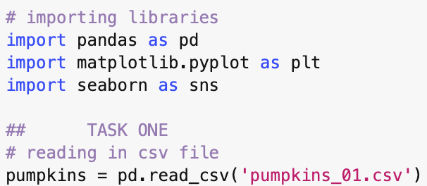

My individual data set was the first csv file (01). Above is the code used to read in the file and also import the libraries needed throughout the rest of the code.

TASK TWO

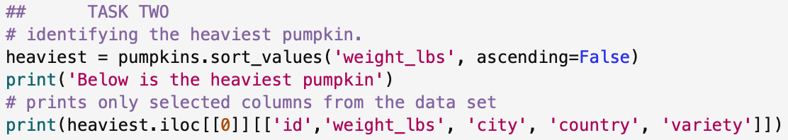

Using the sort_values function, I listed the weights from heaviest to lightest and then printed the required information (variety, location and year) as well as including the id and the weight of the pumpkin as well. Using the iloc^{[1]} function to select only the first row (index 0) to print. Below is the output of the code.

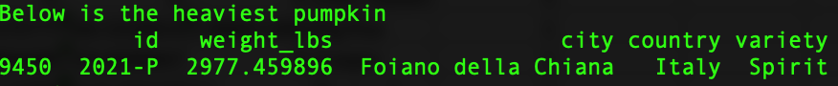

TASK THREE

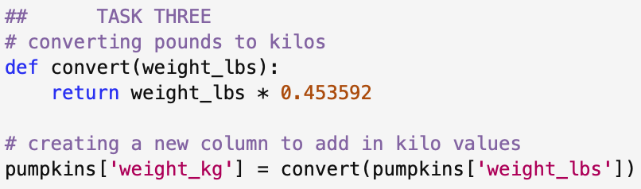

Used a function for the conversion and then created a new column ^{[2]} with the new weights in kilograms.

TASK FOUR

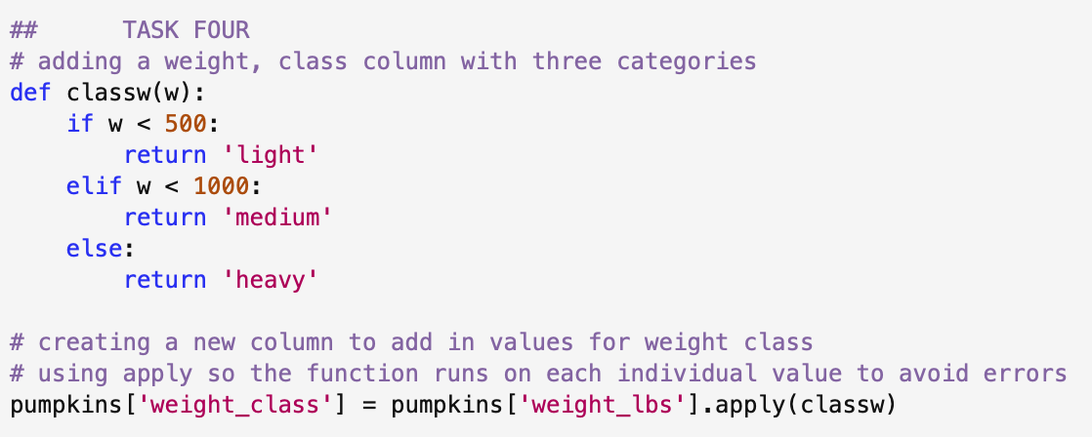

Used a function with if, elif and else to assign the classes for the different weights. Then used the apply function to ensure that the function is applied to every single value throughout the dataset. At first, I didn’t have the apply function and I struggled to get the line of code to work as I wanted it too but found that as a solution. ^{[3]}

TASK FIVE

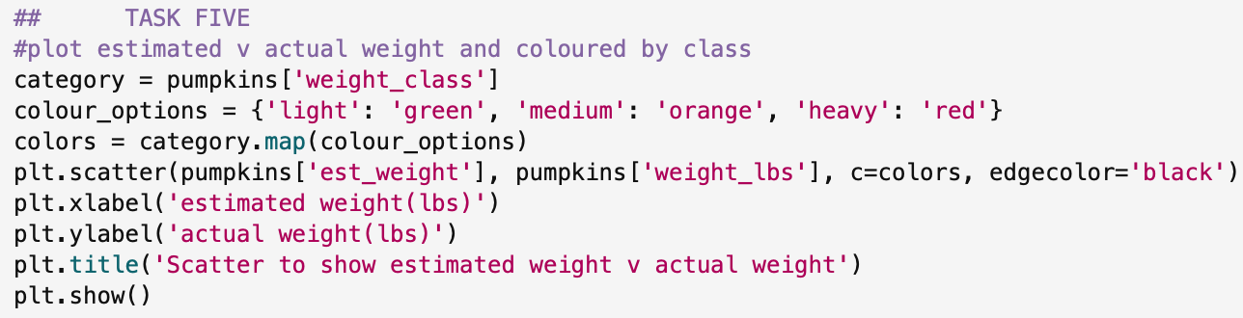

Used matplotlib to plot the scatter plot. Used a range of different functions ^{[4]} and variables to colour each point depending on the weight class. I chose three different colours (green, orange and red) and assigned them to each class from the previous task. I used some of the other aesthetic options in matplot to outline each individual data point as well as giving the graph axis titles and a main title. Below is the graph that was produced.

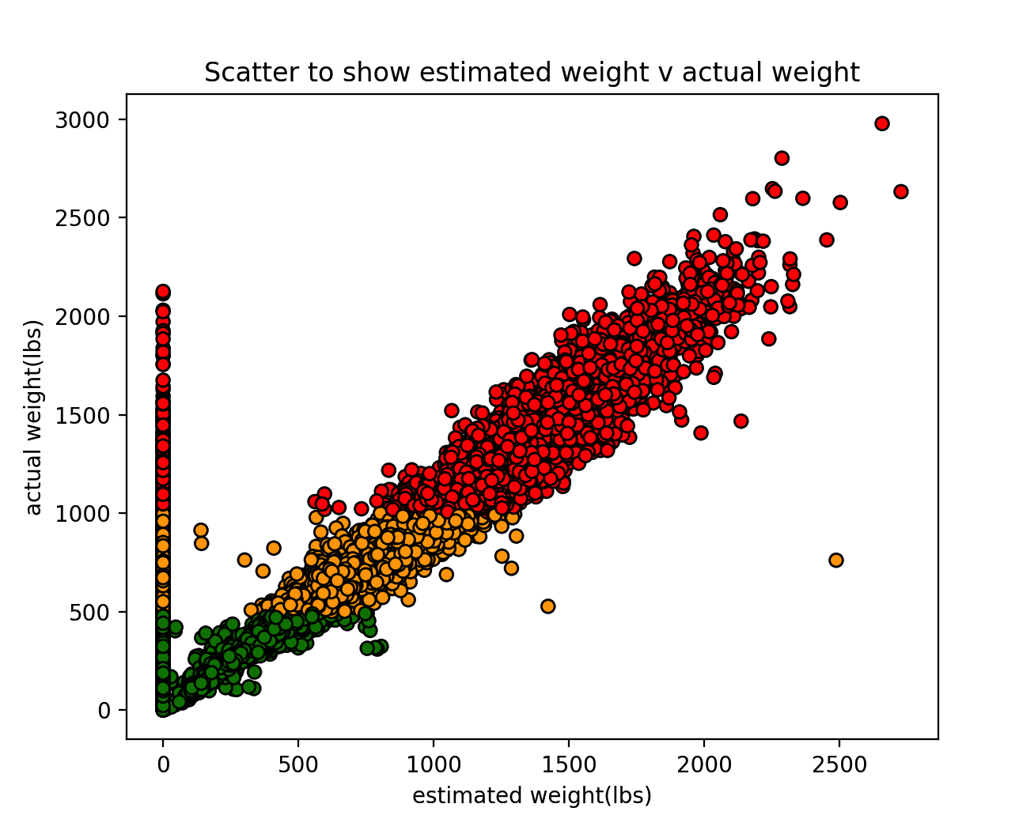

TASK SIX

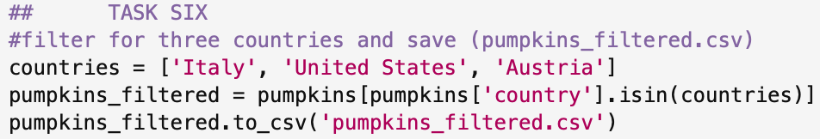

Defined my chosen countries as a variable (Italy, United States and Austria) and then used the isin function ^{[5]} to filter in the ‘country’ column for my chosen countries. I then wrote this to a new csv file that saves into my coursework folder.

TASK SEVEN

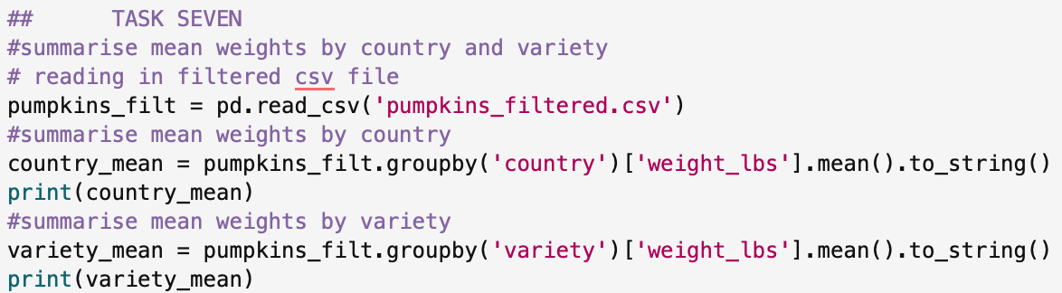

Read in the new filtered csv file and then used the same code to filter and group for both categories. I used the to_string() function ^{[6]} to get rid of the text that gets added on the bottom that states the name and data type of the variable being summarised.

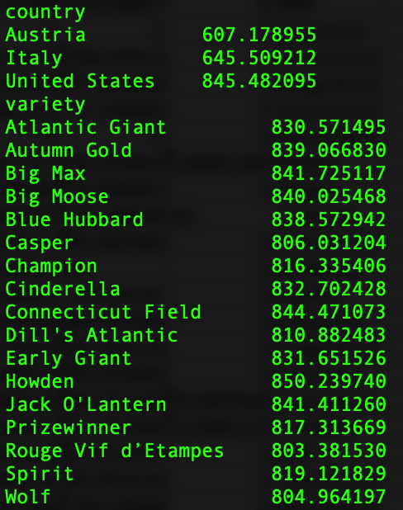
This is the output of the code.

TASK EIGHT

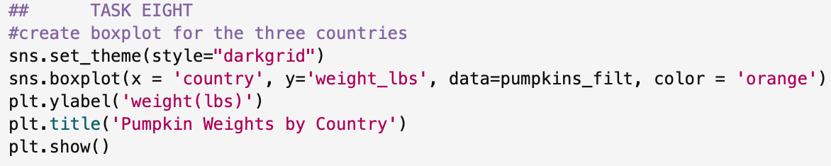

Used seaborn this time to create the boxplot, used some of the aesthetic options to change the colours and themes. Below is the graph that is produced.

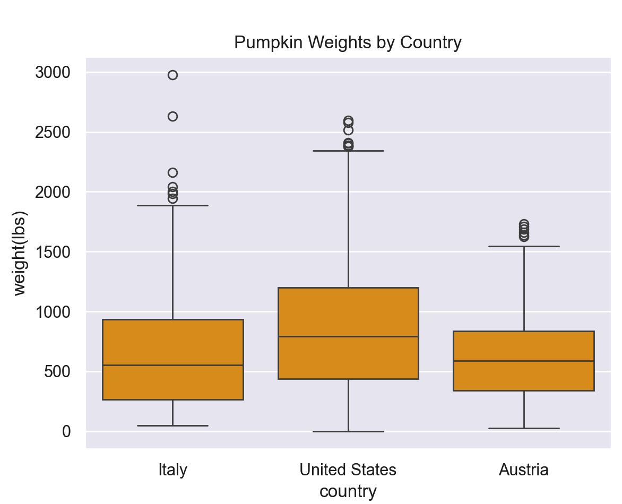

TASK NINE

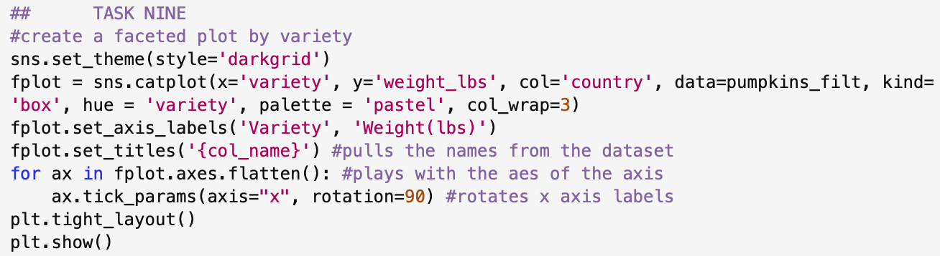

Using the seaborne catplot options ^{[7]} to create the faceted plot. I decided to create one for each country as well, so the graphs weren’t as busy. I used some of the axis aesthetic options ^{[7]} to make the layout neater and easier to read. Below is the graph produced.

