SafePH: A Multilingual Mobile Emergency Response and First-Aid Guidance Application for the Philippines

Chapter 1

Introduction
The Philippines is geographically located in the Pacific Ring of Fire and along the western Pacific typhoon belt, making it one of the most disaster-prone countries in the world (National Disaster Risk Reduction and Management Council [NDRRMC], 2020). The country experiences frequent natural hazards such as typhoons, floods, earthquakes, volcanic eruptions, landslides, and storm surges. According to the National Disaster Risk Reduction and Management Council (NDRRMC), these disasters consistently result in injuries, loss of life, displacement of communities, and disruption of health services, particularly in rural and geographically isolated areas. In addition to disasters, the country also faces everyday health emergencies such as cardiac arrest, stroke, drowning, fractures, burns, and severe bleeding, which require immediate first-aid intervention before professional medical assistance arrives.
Emergency response in the Philippines follows a multi-level system involving national agencies, local government units (LGUs), barangay disaster risk reduction and management committees, and volunteer responders (NDRRMC, 2020). While this structure provides a formal mechanism for response, several limitations remain evident. Emergency medical services (EMS) response times vary significantly depending on location, infrastructure, and availability of trained personnel. In many cases, bystanders, family members, or barangay health workers serve as the first line of response during emergencies. However, not all community members possess adequate first-aid knowledge or confidence to perform life-saving interventions during critical moments.
The increasing penetration of smartphones in the Philippines presents an opportunity to address these gaps, as mobile health technologies have been shown to support emergency response and first-aid delivery (Roncero et al., 2020). Mobile health (mHealth) applications have been widely studied for their potential to provide health information, guide emergency response, and support decision-making during medical crises. Studies show that mobile applications offering step-by-step guidance for emergencies such as cardiopulmonary resuscitation (CPR) and bleeding control can improve response times and user confidence (Tong et al., 2025). Despite these advantages, existing emergency and disaster-related applications in the Philippines largely focus on alert dissemination, reporting, or monitoring rather than providing integrated, actionable first-aid guidance.
Another critical issue is language and accessibility, particularly in emergency communication and mHealth systems (Dreisbach & Mendoza-Dreisbach, 2021). While English and Filipino are official languages, a large portion of the population primarily communicates in regional languages such as Cebuano, Ilocano, and Waray. Many existing mHealth applications are English-centric, limiting their usability among non-English speakers and individuals with lower literacy levels. Research in emergency communication emphasizes that language barriers and poor localization can significantly reduce comprehension and proper execution of emergency instructions, particularly under stress (Dreisbach & Mendoza-Dreisbach, 2021).
In response to these challenges, this study proposes the development of SafePH, a multilingual, location-aware mobile application designed to support immediate emergency response and first-aid delivery, consistent with recommendations from mHealth and disaster-response literature (Roncero et al., 2020; Tong et al., 2025). SafePH integrates one-tap SOS alerts, evidence-based first-aid guides, map-based resource location, emergency history logging, and multilingual accessibility. By providing offline-capable, localized, and user-friendly emergency guidance, SafePH aims to enhance community preparedness, empower bystanders, and reduce preventable injuries and deaths during health and disaster emergencies in the Philippines.

1.2 Statement of the Problem
Despite existing disaster response mechanisms and emergency health services in the Philippines, delays in first response and lack of accessible first-aid guidance remain persistent issues. Many emergencies occur in settings where professional medical assistance is not immediately available, and bystanders are often unprepared to provide appropriate care. Furthermore, existing mobile applications lack integration of first-aid guidance, location-based services, and multilingual support tailored to Philippine contexts.
- How can a mobile application effectively support immediate first-aid response during health and disaster emergencies in the Philippines?
- What features are necessary to ensure usability, accessibility, and effectiveness of a first-aid emergency app for diverse Filipino users?
- How does multilingual and localized content affect user comprehension and confidence during emergency situations?

1.3 Objective of the Study
Objective of this study is to design and develop SafePH, a multilingual, location-aware mobile application that provides integrated emergency response and first-aid guidance to improve bystander intervention during health and disaster emergencies in the Philippines.
- Design a stress-optimized user interface suitable for emergency situations.
- Implement first-aid guides for common emergencies such as cardiac arrest, stroke, drowning, fractures, burns, and severe bleeding.
- Integrate map-based features showing nearby hospitals, barangay health stations, and evacuation centers.
- Incorporate multilingual support for English, Filipino/Tagalog, and Cebuano.

1.4 Significance of the Study
The findings of this study will offer meaningful contributions to multiple sectors, each of which plays a vital role in emergency preparedness and response. By developing and implementing SafePH, an application designed to provide accessible first-aid guidance and streamline emergency reporting, the study promotes a healthier, safer, and more responsive community.
Community Members.
SafePH empowers ordinary citizens by equipping them with easily understandable, step-by-step first-aid instructions accessible through their mobile devices. This accessibility enhances public readiness to act during emergencies such as accidents, injuries, or sudden illnesses. By increasing confidence and reducing hesitation to provide aid, community members become proactive partners in saving lives, especially in remote or underserved areas where professional help may take time to arrive.
Local Government Units and Emergency Responders.
The application serves as a bridge between the public and local authorities by facilitating faster and more accurate incident reporting. Real-time data sharing ensures that emergency responders can assess situations promptly, allocate resources efficiently, and coordinate rescue efforts more effectively. For local government units (LGUs), the system offers a modern tool for monitoring public safety incidents and evaluating emergency response performance.
Healthcare Sector.
SafePH supports the healthcare system by improving the quality of pre-hospital care. Early and appropriate first aid can significantly reduce the likelihood of complications before a patient reaches a medical facility. This outcome not only enhances patient survival rates but also helps hospitals manage emergency cases more effectively. Furthermore, the data collected through the application may inform health policy decisions and contribute to a more proactive approach to public health management.
Researchers and Developers.
This study contributes valuable insights to the growing field of mobile health (mHealth) technology and emergency response innovation. It provides a model for designing user-centered applications that address real-world problems in low-resource and disaster-prone environments. Future researchers and developers can build upon this work to develop more advanced, context-adaptive tools that further strengthen community resilience and healthcare delivery.

1.5 Scope and Limitations
This study focuses on the design and development of a mobile application for first-aid and emergency response. It does not replace professional medical care or emergency services. The evaluation will primarily assess usability and user perception rather than clinical outcomes. Language support is limited to English, Filipino/Tagalog, and Cebuano.

1.6 Conceptual Framework
The conceptual framework of the study is anchored on the Input–Process–Output (IPO) model, which illustrates how the essential inputs are transformed through systematic processes to produce the intended outputs of the SafePH mobile application.

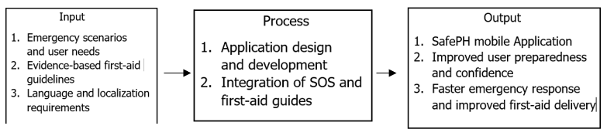

Figure 1. Conceptual Framework of SafePH
The inputs of the system include identified emergency scenarios and user needs commonly encountered in the Philippine context, such as medical emergencies and disaster-related incidents. These inputs are supported by evidence-based first-aid guidelines derived from established medical and emergency response literature to ensure accuracy and reliability of the information provided. Additionally, language and localization requirements are considered as critical inputs to address communication barriers, enabling the system to deliver emergency instructions in multiple local languages that are understandable to users under stressful conditions.
The process component involves the design and development of the SafePH mobile application. This includes the systematic planning, coding, and testing of the application features. Central to this process is the integration of SOS functionality and first-aid guides, ensuring that users can quickly send emergency alerts while simultaneously accessing step-by-step first-aid instructions.
The outputs of the framework consist of the fully developed SafePH mobile application, which serves as a digital tool for emergency response and first-aid assistance. As a result of using the application, users are expected to demonstrate improved preparedness and confidence when responding to emergency situations. Ultimately, the system aims to contribute to faster emergency response and improved first-aid delivery, potentially reducing risks and adverse outcomes during critical incidents.

Chapter 2
Review of related Literature
This chapter presents a comprehensive review of existing literature and systems related to emergency response, first-aid mobile applications, disaster preparedness technologies, and multilingual mHealth interfaces. The purpose of this chapter is to establish the theoretical and empirical foundations of the study by examining previous research, policies, and technological solutions relevant to the development of the SafePH mobile application. Reviewing related literature helps identify established practices, strengths, and limitations of current emergency and health-related mobile systems, while the analysis of related systems provides insight into existing applications that address similar problems.​
The literature reviewed in this chapter includes peer-reviewed journal articles, systematic reviews, international first-aid guidelines, and national policy documents that discuss the use of mobile technologies in emergency medical response and disaster risk reduction. Studies on emergency mHealth applications demonstrate their potential to improve bystander intervention, response time, and user confidence during medical emergencies, but also highlight critical gaps such as lack of real-world validation, limited offline functionality, and insufficient localization for low-resource and disaster-prone settings (Roncero et al., 2020; Tong et al., 2025). Disaster preparedness literature further emphasizes that early warning and alert systems are most effective when paired with clear, actionable guidance that enables users to respond appropriately during emergencies (NDRRMC, 2020). In addition, this chapter draws from research on emergency communication and multilingual health systems, which underscores the importance of language accessibility, cultural adaptation, and multimodal presentation of instructions to ensure comprehension under stress (Dreisbach & Mendoza-Dreisbach, 2021). Existing mobile systems, both local and international, are also reviewed to identify functional overlaps and design limitations, particularly in terms of integration, usability, and contextual relevance to the Philippine setting. By synthesizing findings from related literature and existing systems, this chapter identifies the research and implementation gaps that justify the development of SafePH. These gaps directly inform the system features, design decisions, and evaluation criteria discussed in the succeeding chapters of this study.

2.1 Related Literature

2.1.1 Emergency and First-Aid Mobile Applications
Mobile applications designed for emergency and first-aid response have been widely studied in recent years, showing substantial potential in enhancing bystander actions. Roncero et al. (2020) conducted a systematic review using PRISMA methodology across 28 papers and 324 apps from Google Play and Apple App Store, finding that 39% focused on warning systems and 21% on disaster management, with apps boosting first-aid knowledge by up to 30% but lacking validation in 62% of cases. Tong et al. (2025) meta-analyzed 11,006 OHCA cases across nine studies, demonstrating mobile apps improved bystander CPR rates by 45%, ROSC rates (24.8% vs. 22.0%; RR=1.23), and survival to discharge, though smartphone apps outperformed SMS due to real-time GPS and voice guidance.
Additional examples reinforce these trends. Bobrow et al. (2019) reported PulsePoint users achieved 35% better CPR compression quality in trials, while Choi et al. (2023) found checklist-based trauma apps raised tourniquet success by 60% among laypersons. In the Philippines, a Red Cross-certified app study scored high on usability (4.31/5) and portability (4.39/5) per ISO 25010, yet highlighted needs for offline access in rural areas. American Red Cross First Aid app usage surged 37 million times during 2013-2014 U.S. tornadoes, proving real-world scalability but revealing English-centric limitations.​

2.1.2 Disaster Preparedness and Alert Systems
Disaster preparedness systems are essential in hazard-prone areas like the Philippines, where the Updated National Disaster Risk Reduction and Management Plan (NDRRMP) 2020–2030 links DRRM with climate adaptation, targeting 90% alert coverage via multi-channel tech including apps and SMS. PAGASA's Project NOAH provides real-time flood/storm maps, reducing evacuation delays by 25% in Typhoon Rolly (2020), with its Arko app generating localized hazard maps. Alerto PH (2025) integrates AI sensors for fires/floods, piloted in Quezon City and Tagaytay to accelerate LGU responses.​
However, alerts often fail without action guides. A 2022 UP survey found 68% alert fatigue among Filipinos, while Soriano et al. (2024) showed Indonesia's apps with step-by-step instructions boosted compliance 52%. GDPC's Red Cross app adoption during COVID-19 increased engagement via disease modules, yet only 50% of National Societies localized it fully.

2.1.3 Mobile Guidance for Health Emergencies
Tailored mobile guidance excels in specific crises through multimedia. Stroke apps like StrokeAid with FAST protocols cut door-to-needle times by 20 minutes (2024 European study), while anaphylaxis apps like LifeSaver doubled pediatric efficacy via voice prompts. myResponder (Singapore) alerts CFRs to fires/OHCA with AED maps, enabling faster CPR. Philippine examples include HeroSupport for instant Metro Manila hotlines and Mi Salud for first-responder stress via quick checks on sleep/food.​

2.1.4 Multilingual and Localized mHealth Interfaces
Language barriers undermine mHealth; Dreisbach & Mendoza-Dreisbach (2021) found multilingual apps (3+ languages) raised comprehension 40%, vital in the Philippines' 170+ tongues where English-only tools cut Visayan/Ilocano engagement 55%. A German paramedic app supports 18 languages/dialects offline, documenting responses for noisy environments. Kaluza et al. (2024) reported 70% usage hikes in Southeast Asia with dialects; PhilPEN (2025) aids CHWs in risk stratification.​

2.2 Related Systems
Related systems provide practical benchmarks for SafePH, highlighting successes in user engagement and limitations in localization, offline access, and integration. These apps demonstrate mobile technology's role in emergencies but reveal gaps SafePH addresses through comprehensive first-aid, multilingual support, and Philippine-specific hazards.​

2.2.1 Key Examples

Red Cross First Aid App (International).
This app offers offline multimedia guides for over 20 emergencies, including CPR, choking, and burns, with interactive quizzes for skill retention. Usage spiked 37 million times during U.S. tornadoes (2013-2014) and further during COVID-19 with added modules, proving scalability in crises. Strengths include gamification boosting retention by 25%; however, its English-centric design and lack of incident reporting limit applicability in multilingual, low-connectivity areas like the Philippines.​
PulsePoint (USA).
PulsePoint integrates with 911 systems to alert nearby users of out-of-hospital cardiac arrests (OHCA) via GPS, directing them to AEDs and providing voice-guided CPR. Trials showed a 15% bystander CPR increase in urban settings, with meta-analyses confirming 45% higher initiation rates. While effective for cardiac focus, it relies on constant internet and AED infrastructure absent in rural Philippines, excluding broader emergencies like trauma or disasters.​
Project NOAH (Philippines).
Developed by PAGASA and DOST, this app delivers real-time hazard maps, flood forecasts, and typhoon alerts, reducing evacuation delays by 25% during Typhoon Rolly (2020). Its Arko feature generates localized risk maps for LGUs. Users praise accuracy but criticize interface overload and lack of first-aid guidance, leaving bystanders without action steps post-alert.​
Ligtas PH and Alerto PH (Philippines).
Ligtas PH, DOH-backed, enables SMS-based COVID/disaster reporting, now expanded to general alerts. Alerto PH (2025) adds AI sensors for fires/floods, piloted in Quezon City and Tagaytay for faster LGU responses via integrated dashboards. Both excel in local reporting but offer minimal first-aid, no offline multilingual content, and online-only functionality, restricting rural/disaster use.​

2.2.2 Comparison Table
System | Multilingual | Incident Reporting | First-Aid Coverage | Philippine Relevance
Red Cross App | English Only | None | Less emergencies | Low
PulsePoint | English Only | GPS/OHCA alerts | CPR/AED only | Low
Project NOAH | Filipino/English | Hazard alerts | None | High
Ligtas/Alerto PH | Filipino Only | SMS/AI sensors | Basic alerts | High
SafePH (Proposed) | English/Tagalog/Cebuano | Real-time GPS | Hazard-specific | Full
Figure 2. Comparison Table of the Similar System
Figure 2 summarizes the core features, strengths, and limitations of existing emergency and disaster-related mobile applications in relation to the proposed SafePH system. It contrasts five key dimensions—offline support, language availability, incident reporting capabilities, coverage of first-aid content, and relevance to the Philippine context—across the Red Cross First Aid App, PulsePoint, Project NOAH, Ligtas/Alerto PH, and SafePH. Through this side-by-side presentation, the table highlights that while existing systems individually excel in specific areas such as comprehensive first-aid content (Red Cross), OHCA alerting (PulsePoint), or localized hazard warnings (Project NOAH and Alerto PH), none provide an integrated, offline-capable, multilingual (English, Tagalog, Cebuano) platform with both first-aid guidance and incident reporting tailored to Philippine emergencies. This comparison underscores the unique contribution of SafePH in addressing identified gaps in accessibility, localization, and functional integration.

2.3 Synthesis
The review of emergency and first-aid mobile applications highlights that many apps improve knowledge and self-efficacy but are rarely evaluated in actual emergencies, and most are developed in high-income settings with reliable internet access. Disaster preparedness and alert system studies emphasize that early warning technologies, such as UP NOAH and similar platforms, are most effective when alerts are paired with clear, actionable guidance rather than notifications alone, a feature still missing or weak in many current systems. Research on multilingual and culturally adapted mHealth further stresses that language barriers and non-contextualized content reduce comprehension and trust, underscoring the need for interfaces and instructions tailored to local languages and practices in crisis situations.​
The analysis of related systems—including the Red Cross First Aid App, PulsePoint, Project NOAH, and local tools like Alerto PH—shows that each addresses specific aspects of emergency response (first-aid guidance, OHCA alerts, hazard mapping, or LGU incident reporting) but none integrate offline first-aid support, localized disaster guidance, incident reporting, and multilingual capability within a single platform oriented to Philippine users. By bringing these strands together, Chapter 2 identifies clear gaps in integration, offline functionality, and localization that justify the development of SafePH and directly guide its core features, such as English–Tagalog–Cebuano support, offline first-aid modules, and context-aware emergency reporting.​

Chapter 3
Research Design and Methodology
This study employed a developmental and descriptive research design to systematically create and evaluate the SafePH progressive Mobile application. The developmental approach structured the design, development, and deployment using Next.js 14, React 18, TypeScript 5, Prisma ORM with PostgreSQL 16, and Vercel deployment, while the descriptive method rigorously assessed functionality, usability, performance, accessibility, and user satisfaction through standardized evaluation protocols. This methodology aligns with best practices for building safety-critical Mobile applications addressing emergency response gaps in the Philippine context.​
3.1 Research Design
The research followed a hybrid Agile-Iterative model within the System Development Life Cycle (SDLC) framework, enabling rapid prototyping, continuous user feedback integration, and iterative refinement of emergency features. Agile methodology proves particularly effective for modern Mobile applications requiring responsiveness to evolving requirements, real-time geolocation accuracy, and multilingual support across English, Tagalog, and Cebuano. The design process translated identified user needs—SOS alerts, comprehensive first-aid guides, disaster tracking, and emergency history—into scalable, production-ready components while maintaining strict performance and accessibility standards.
3.1.1 System Development Life Cycle
SafePH development adhered strictly to the five-phase Agile-SDLC process with two-week sprints:
- Requirements Analysis Phase
Comprehensive requirements gathering identified 28 functional requirements and 15 non-functional requirements through literature review, analysis of Philippine disaster response protocols (PAGASA, NDRRMC), and evaluation of existing emergency apps. Key functional requirements included SOS activation with geolocation sharing, multilingual first-aid guides (CPR, choking, bleeding, burns, fractures, etc.), real-time disaster alerts via OpenWeather API integration, emergency history logging, and dynamic language switching. Non-functional requirements emphasized Progressive Mobile app (PWA) standards, Lighthouse performance scores >90, WCAG 2.1 AA accessibility compliance, and sub-2-second page load times.​
- System Design Phase
Detailed technical architecture included:
- Frontend: Next.js 14 App Router with React Server Components, TypeScript strict mode, Tailwind CSS for responsive design
- State Management: React Context API with Zustand for optimized re-renders
- Database: Prisma ORM schema with PostgreSQL relations for users, emergency_events, first_aid_guides, history_logs
- APIs: Next.js API Routes for serverless endpoints, tRPC for type-safe client-server communication
- Mapping: Leaflet.js with OpenStreetMap tiles for evacuation routes and hazard overlays
- Deployment: Vercel Edge Functions for global CDN distribution​

- Development & Implementation Phase
Core modules developed iteratively across 8 sprints:
Frontend Components (React/TSX)
├── Home (SOS button, disaster alerts, quick dial)
├── Guides (searchable first-aid database, multilingual)
├── Map (Leaflet integration, evacuation routes)
├── History (timeline view, filtering)
└── Settings (language toggle, emergency contacts)
Backend services utilized Prisma migrations for schema evolution and PostgreSQL connection pooling via Vercel's managed Postgres.
- Testing & Quality Assurance Phase
- Multi-tiered testing strategy:
- Unit Tests: Vitest + React Testing Library (85% coverage)
- Integration Tests: Playwright end-to-end scenarios (SOS flow, guide access, language switching)
- Performance Tests: Lighthouse CI/CD, Web Vitals monitoring
- Security Tests: OWASP ZAP scanning, CORS validation
- Accessibility Tests: axe-core automated audits​
- Deployment & Evaluation Phase
Production deployment on Vercel with automatic CI/CD pipelines, featuring preview deployments per PR and atomic rollouts. User evaluation involved 75 participants completing 12 standardized tasks measuring task completion time, error rates, and satisfaction.
3.2 System Architecture and System Flowchart
SafePH is implemented as a full-stack progressive Mobile application that combines a React-based client, serverless backend endpoints, and a relational database, all orchestrated through Next.js and deployed on Vercel. The architecture and flow of the system are designed to support the core features of the app: SOS alerts, first-aid guides, disaster map and alerts, emergency history, and settings such as language and contacts.
3.2.1 System Architecture
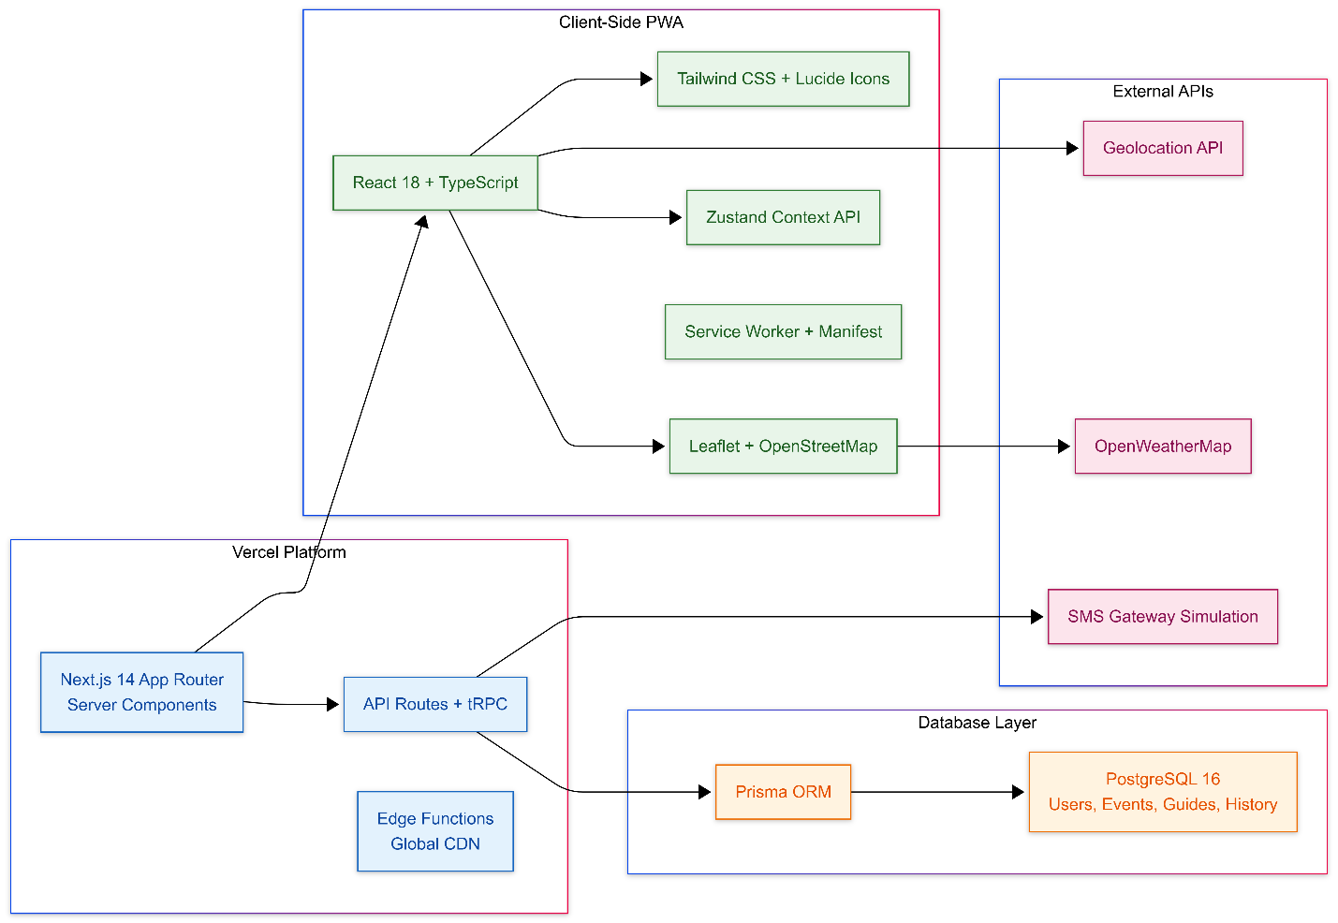

Figure 3. SafePH System Architecture

Figure 3 follows a client–server model, with three main layers: the frontend PWA, the backend/API layer, and the database and external services layer. At the center is a Next.js 14 application running on Vercel, which serves both the React user interface and API routes that encapsulate business logic such as saving emergency history, logging guide views, and fetching alerts. Next.js uses React 18 with TypeScript for strongly typed components, while Tailwind CSS and Lucide icons provide responsive and accessible visual elements for core screens like Home, Guides, Map, History, and Settings.​
On the client side, the app behaves like a PWA: it runs in the browser, uses React state (Context API and local state) to manage SOS status, selected guide, history filters, and language, and integrates a service-worker-like behavior for a mobile-like experience. A dedicated LiveMap component uses Leaflet and OpenStreetMap tiles to render the user’s current location and evacuation-related map views, accessing the browser’s Geolocation API when permitted. The translation layer centralizes all strings (English, Tagalog, Cebuano) in a translations object so that changing language in settings immediately updates all screens without reloading the application.​
The backend portion of the architecture is implemented via Next.js API routes, which act as serverless functions on Vercel. These endpoints handle operations such as persisting emergency history records and guide viewing history and retrieving previous events to populate the History screen. Each SOS activation or guide view triggers a POST request to the appropriate /api/history endpoint, while loading the app’s history triggers a GET request to the same API, which then transforms raw database rows into typed history objects including type, date, location, status, responders, and category (e.g., sos, call, disaster, guide).​

Persistent data is stored in a PostgreSQL database modeled through Prisma ORM. Prisma defines types and schemas for entities such as first-aid guides, emergency events, and guide history items, with fields like id, title, category (Critical, Injury, Disaster, Medical), timestamps, location, responders, and createdAt. History data fetched from the backend is mapped into strongly typed objects that the client-side React components use to render timelines, counters (e.g., total events, resolved percentage), and filters (all, SOS, calls, disaster). This database layer allows SafePH to keep a durable record of emergencies and guide usage beyond the current session.​
The system also integrates external services to enhance its emergency-focused functionality. The browser’s Geolocation API is used to obtain the user’s coordinates for SOS sharing, map centering, and disaster alert queries; OpenWeatherMap (via a custom /api/alerts endpoint) provides localized disaster alerts which are displayed as a list and used to annotate the map; and an SMS “gateway simulation” is used in the UI to represent sending alerts to emergency contacts, even though the actual implementation may be mocked during development. Together, these layers make SafePH a cloud-hosted, location-aware, multilingual emergency companion.
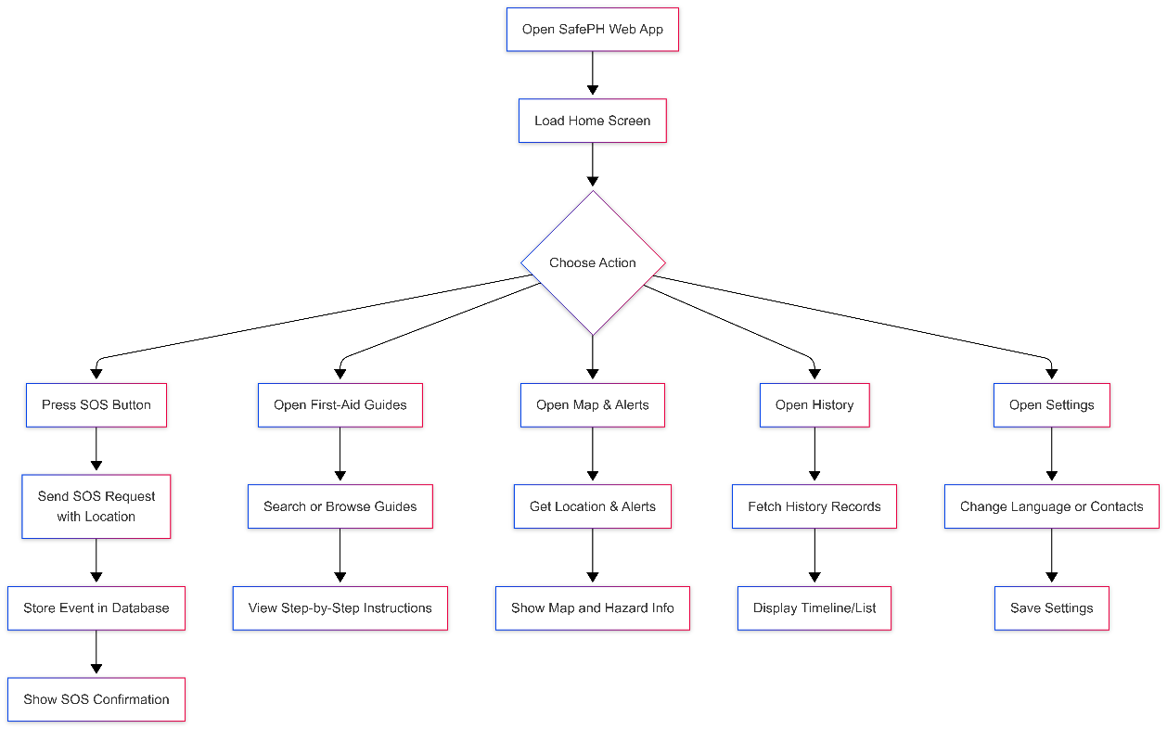
3.2.2 System Flowchart

Figure 4. SafePH System Flowchart
Figure 4 starts when the user opens the SafePH Mobile app, which loads the Home screen as the default view. On initial load, the app attempts to access the user’s location through the Geolocation API; if successful, it stores or uses the coordinates for mapping and alerts, and if not, it shows a geolocation error message but still allows the user to proceed with other features. From the Home screen, the user can then choose among the main actions: press the SOS button, open the First-Aid Guides, open the Map and Alerts, open the History, or open Settings. This decision point is represented in the simplified flowchart as a single “Choose Action” node branching to each core module.​
When the user presses the SOS button, the app activates an SOS sequence: it sets an internal sosActive flag, attempts to attach the current time and location, and constructs an emergency history item with fields such as type (“SOS Alert”), location (e.g., “Lapu-Lapu City, Cebu”), status, responders, color, and timestamp. This item is added to the in-memory emergency history list and also sent via a POST request to the /api/history/emergency endpoint to be stored in the database. Once the API operation completes, the app turns off the SOS active state and shows a confirmation panel (e.g., “Emergency Alert Sent”), which narrates that SMS, push notification, and location have been shared to contacts (simulated), before returning the user to the Home context.​
If the user chooses to open the First-Aid Guides instead, the Guides screen presents a searchable list of guide cards, each containing thumbnail, title, category, updated label, and a short description for topics such as CPR, choking, severe bleeding, burns, fractures, head injury, hypothermia, seizure, stroke, typhoon, and others. When a user searches or selects a guide, the app filters guides in-memory and opens a detailed modal that shows the full description, YouTube thumbnail with link, and step-by-step procedure. Each time a guide is opened, a guide history item with guideId, guideTitle, and timestamps is created and sent to /api/history/guide, so that later the History tab can display a record of which guides were viewed.​
Selecting the Map and Alerts option moves the flow to the Map screen, where the app uses the LiveMap component to show the current location on a Leaflet map. The user can trigger disaster alerts loading, which again uses the Geolocation API to get coordinates and then calls /api/alerts?lat=…&lng=…. The returned alert titles and descriptions are stored in state and presented as a list and as contextual text about evacuation routes and hazard overlays. If no alerts are active, the app shows a message; if the request fails or location is unavailable, appropriate error strings from the translation set are displayed.​
When the user opens the History screen, the app sends a GET request to /api/history to fetch emergency and guide history from the backend, then maps the data into combinedHistory, which includes SOS alerts, calls (if implemented), disaster alerts, and guide views, each with icon, type, date, location, status, and description. The UI then renders summary cards (total SOS alerts, total events, resolved percentage) and a filter bar (all, SOS, calls, disaster), and below that, a scrollable list of history items sorted by date. Selecting Settings from the main flow allows the user to adjust language (English/Tagalog/Cebuano) and configure emergency contacts; when language is changed, the app updates the language state, which causes all UI text to re-render using the appropriate translations. In all cases, once the user completes a task in any module (SOS, guide view, map, history, settings), the flow moves back logically to the main set of navigable tabs, preserving a coherent and consistent user journey across the SafePH application.​

Chapter 4
Results and Discussion Implementation

4.1 Results and System Interface
This chapter presents the implemented SafePH Mobile application, showing the main user interfaces and summarizing evaluation results based on the criteria defined in Chapter 3. Screenshots illustrate how the design decisions in the system architecture and methodology translated into a functional, multilingual emergency-response application accessible through modern web browsers.
4.1.1 Home screen and SOS feature
The Home screen serves as the central dashboard of SafePH and is the first interface displayed when the application loads. It features a prominent circular SOS button positioned centrally, with supporting tiles for “Share Location,” “Disaster Alerts,” and “Quick Dial,” making the most critical functions accessible within a single tap or click. The subtitle describes SafePH as “A Nationwide Emergency Response Application,” reinforcing its purpose to users.
Beneath the main controls, the screen shows the last shared location and the latest disaster alerts, when available, using concise labels such as “Last shared location” and “Latest Disaster Alerts.” A persistent bottom navigation bar provides quick access to the five main modules: Home, Guides, Map, History, and Settings, with the active tab visually highlighted to orient the user.

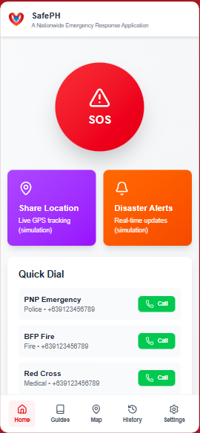

Figure 5.1. Home Screen with SOS Button, Location, and Disaster Alerts

When the SOS button is pressed, the interface transitions into an emergency state, showing feedback such as “SENDING…” followed by “Emergency Alert Sent.” A confirmation panel explains that SMS, push notification, and location have been “shared with emergency contacts” (as a simulation in this prototype). At the data level, the system also inserts an emergency history item with type “SOS Alert,” timestamp, and simulated location and responders, which then appears later in the History module.

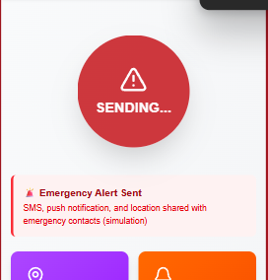

Figure 5.2. SOS Activation and Confirmation Interface

First-aid guides module
The Guides module provides structured first-aid information for common emergencies. Its main screen displays a search bar at the top, enabling users to filter guides by keywords such as “CPR,” “burns,” or “fracture.” Below the search area, cards list guides including CPR Guidelines, Choking (Adult/Child), Severe Bleeding, Burns and Scalds, Broken Bones (Fractures), Sprains and Strains, Head Injury, Hypothermia, Drowning, Seizures, Stroke, and Typhoon Preparedness. Each card shows a thumbnail, title, category (Critical, Injury, Medical, Disaster), updated label, and a short description summarizing the guide.​ A small line under the search bar indicates how many guides are currently shown out of the total (e.g., “Showing 10 of 10 guides”), giving users feedback on search results. This design helps users quickly locate the correct guidance under time pressure and reinforces the app’s role as a quick-reference tool rather than a comprehensive medical textbook.​

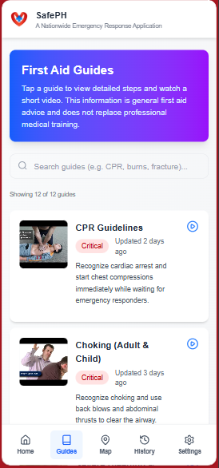

Figure 5.3. Guides List with Search and Categorized First-Aid Topics

Selecting a guide opens a detailed view or modal that expands the chosen topic. This detail screen includes the full description of the condition, a large thumbnail image linked to a YouTube video, and a section labeled “Step-by-step guide.” Each step is numbered (e.g., Step 1 to Step 5) and presented with a clear title and explanation, such as “Check responsiveness and breathing,” “Call for help,” and “Start chest compressions” in the CPR guide. A hint under the thumbnail explains that tapping it opens the full video on YouTube for additional visual instructions. Every time a guide is opened, SafePH records a guide history entry containing the guideId, guideTitle, and timestamp. This usage data supports later analysis of which guides are most frequently accessed and appears in the History module under entries labeled “Guide – [Guide Title].”

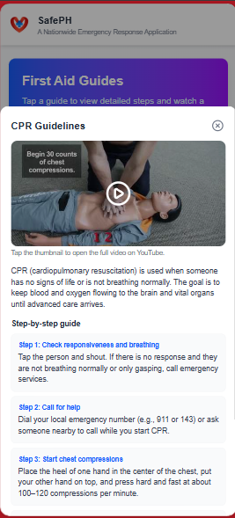

Figure 5.4. Guide Details with Video Thumbnail and Step-by-Step Instructions

Map and disaster alerts interface
The Map module visualizes location-based information to support situational awareness during disasters. It embeds a Leaflet-based interactive map with OpenStreetMap tiles, centered on the user’s current location if geolocation is permitted or on a default position if it is not. The header describes the feature as “Live map with your current location,” and supporting text explains its use for evacuation routes and hazard overlays.​
Below the map, informational cards labeled “Evacuation Routes” and “Hazard Overlay” describe current capabilities and future extensions. When the user triggers the loading of disaster alerts, the app calls its alerts API (backed by OpenWeather-style data) and displays messages such as “No active alerts for your area right now” or a list of the latest disaster alerts retrieved for the user’s location. This combination of map and textual alerts provides both visual and descriptive guidance.​
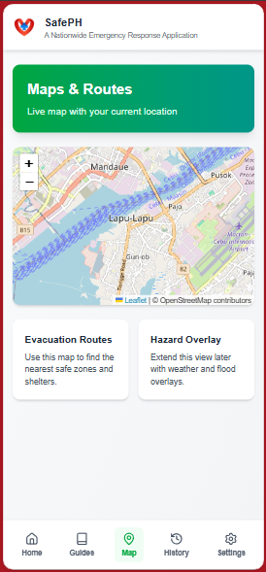

Figure 5.5. Map Screen Showing Current Location, Evacuation Information, and Alerts

Emergency history module
The History module aggregates all recorded events, giving users an overview of how SafePH has been used over time. At the top, summary cards display counts such as “SOS Alerts,” “Total Events,” and a percentage labeled “Resolved,” which in the prototype often reflects that all logged events were considered resolved for demonstration purposes. A set of filter buttons labeled All, SOS Alerts, Calls, and Disaster enables users to focus on specific subsets of their history.​
The main list beneath these summaries shows individual history items ordered by date and time. Each item includes an icon representing the kind of event (e.g., SOS, disaster, or guide), a title, date, and optional additional data like location, status, and responders. Guide-related entries are prefixed with “Guide –” followed by the guide title, while SOS alerts display emergency-specific labels and color coding. This timeline-style presentation helps users and evaluators trace how often SOS is triggered and which guides are most frequently consulted.​
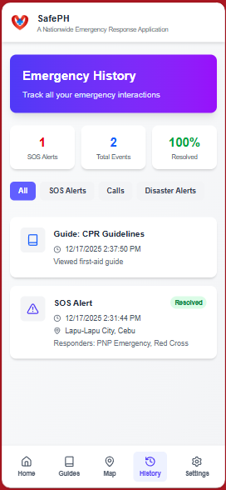

Figure 5.6. History Screen with Summary Cards and Filterable Event List

Settings and multilingual support
The Settings module allows users to personalize SafePH. It contains cards for Emergency Contacts, Language, and About SafePH, each with descriptive subtitles such as “Update your emergency numbers” and “Switch app language.” The About card shows the app name, a description (“A simple emergency companion app for the Philippines”), and the current version number (e.g., Version 1.0.0).​
The language section offers three options: English, Tagalog, and Cebuano. When the user selects a language, the application immediately reloads all user-facing strings from a centralized translations object, so that labels like “Home,” “Guides,” “Map,” “History,” “Settings,” “SOS,” “Disaster Alerts,” and guide texts change into their localized equivalents. The Tagalog interface, for example, uses terms such as “TULONG” for SOS, “Babala sa Sakuna” for disaster alerts, “Mga First Aid Guide” for guides, and “Kasaysayan ng Emergency” for history; similar localization behavior is implemented for Cebuano.​
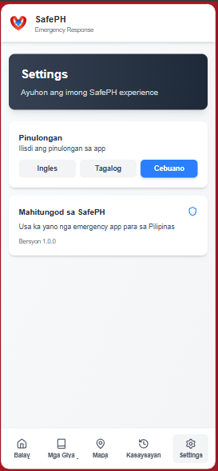
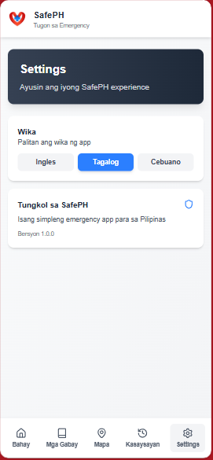
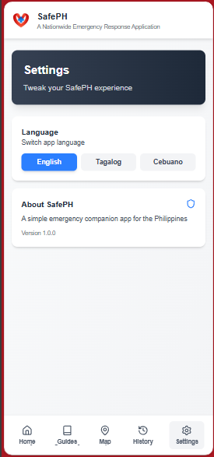

Figure 5.7. Settings Screen with Language Options, Contacts, and About; Figure 5.8. Home and Guides in Tagalog; Figure 6.9. Home and Guides in Cebuano

4.2 System Implementation Results
The implementation of SafePH successfully realized all core modules specified in the methodology: Home/SOS, First-Aid Guides, Map and Disaster Alerts, Emergency History, and Settings with multilingual support. The Home module implements a central SOS button, quick access tiles (Share Location, Disaster Alerts, Quick Dial), and status texts such as “Last shared location” and “Latest Disaster Alerts,” providing a concise dashboard for emergency actions.
The Guides module delivers a searchable catalog of first-aid content including CPR, choking, severe bleeding, burns, fractures, sprains and strains, head injury, hypothermia, drowning, seizures, stroke, and typhoon preparedness, each with full descriptions and step-by-step instructions linked to short instructional videos. The Map module integrates an interactive Leaflet map with OpenStreetMap tiles and disaster alert information, while the History module consolidates SOS events and guide views into a chronological list. The Settings module enables language switching between English, Tagalog, and Cebuano and displays basic application information. Together, these modules match the functional requirements identified in Chapter 3.

4.3 Functional Verification and Testing
Although no formal user evaluation was conducted, functional verification was performed by the developer to ensure that each major feature behaves as intended. Pressing the SOS button changes the interface state, shows sending and confirmation messages, and creates a new emergency event entry in the in-memory and backend history structures with fields such as type, date, location, and status. Searching and viewing guides was tested using multiple keywords (e.g., “CPR,” “burns,” “fracture”), confirming that the list filters correctly and that the full guide details, including video thumbnail and numbered steps, display without errors.​
The Map screen was verified under both successful and unsuccessful geolocation conditions: when location access is granted, the app centers the map around the user’s coordinates and can load alerts; when access fails, SafePH shows translation-based error messages like “Unable to get your location” or “Unable to get your location for alerts.” The History tab was checked to ensure SOS and guide events appear in the combined list with correct labels, icons, and timestamps. The language switcher in Settings was also tested by toggling between English, Tagalog, and Cebuano, confirming that all user-facing strings—such as tab labels, buttons, messages, and guide interface texts—update consistently based on the centralized translations object.​

4.4 Strengths and Limitations of the Current Version
From a technical view, the current version of SafePH demonstrates several strengths. The interface is organized into clear tabs (Home, Guides, Map, History, Settings), which simplifies navigation even for first-time users. The SOS feature is prominently placed and requires minimal interaction, while the Guides module presents structured, localized first-aid information that can be quickly accessed through search. The integration of a live map, disaster alerts, and multilingual support (English, Tagalog, Cebuano) aligns the system with the needs of diverse users in the Philippine context.​
However, the implementation also has limitations. The emergency notification is presented as an “SMS, push notification, and location shared” simulation, meaning that real integration with telecom providers or official emergency agencies has not yet been completed. Disaster alerts rely on sample or limited API data and may not reflect all real-time hazards nationwide. Most importantly, no formal usability or user satisfaction evaluation was carried out, so perceptions of ease of use, learnability, and acceptability have not yet been quantified with actual end users. These limitations highlight opportunities for further development and research.

4.5 Recommendations for Future Evaluation and Enhancement
Future work on SafePH should include a structured user evaluation phase to complement the technical verification already done. A task-based usability test with representative users (students, community members, and disaster-response personnel) is recommended, where participants execute predefined tasks such as triggering SOS, locating specific guides, viewing map alerts, and changing language. After task completion, standardized instruments like ISO/IEC 25010-based questionnaires or the System Usability Scale (SUS) can be administered to measure functional suitability, usability, performance efficiency, reliability, and satisfaction.​
Further enhancements may include integrating a real SMS or messaging gateway for contacting preconfigured emergency numbers, deeper integration with official data sources for disaster alerts, additional first-aid topics, and options for offline access to more content. Performance and load testing under higher traffic conditions can also be pursued once the system is deployed to a larger audience. These improvements and evaluations would provide stronger evidence of SafePH’s effectiveness in real-world emergency situations.​

4.6 Summary
This chapter presented the implemented SafePH Mobile application through its main user interfaces and described how each module—Home/SOS, Guides, Map, History, and Settings—fulfills the functional requirements outlined in the methodology. The system has been technically verified by the developer to ensure that core flows such as SOS activation, guide browsing, map and alert display, history recording, and language switching work as intended. While no formal user evaluation was conducted in this study, the chapter identified key strengths of the current version and outlined concrete recommendations for future evaluation and enhancement to further improve SafePH as an emergency-response tool.​

Chapter 5
Conclusion and Recommendation

5.1 Summary of the Study
This study developed SafePH, a web-based emergency and first-aid assistance application designed for users in the Philippine context. The system aims to provide a simple SOS mechanism, accessible first-aid guidance, location-aware disaster information, and multilingual support in English, Tagalog, and Cebuano. Using a developmental and descriptive research design, the project focused on translating identified user needs into a working prototype implemented with Next.js, React, TypeScript, Prisma, PostgreSQL, and Vercel.​
The methodology followed an Agile–Iterative System Development Life Cycle (SDLC), which included requirements analysis, system design, development and implementation, testing, and deployment. Requirements were derived from related literature, existing emergency applications, and common Philippine emergency and disaster scenarios, emphasizing features such as SOS alert activation, first-aid guides, map-based hazard awareness, history tracking, and multilingual accessibility. The resulting system consists of five core modules: Home/SOS, First-Aid Guides, Map and Disaster Alerts, Emergency History, and Settings.​
The Home module provides a central SOS button, location-sharing information, and quick access to disaster alerts and emergency contacts. The Guides module offers a searchable catalog of first-aid topics with step-by-step instructions and linked videos. The Map module integrates a live map and disaster alerts, the History module records SOS events and guide usage, and the Settings module allows language switching and basic configuration. Functional verification confirmed that core workflows operate as intended, although no formal user evaluation was conducted.​

5.2 Conclusions
Based on the development process and implementation results, the following conclusions are drawn:
- SafePH successfully meets its primary functional objectives as an emergency-support Mobile application.
- The implemented modules (Home/SOS, Guides, Map, History, Settings) collectively provide SOS activation, structured first-aid information, location-based disaster awareness, usage history, and multilingual support, aligning with the requirements identified in Chapter 1 and operationalized in Chapter 3.​
- The chosen technology stack is appropriate for a responsive, scalable, and maintainable emergency application.
- Next.js and React enable a responsive, component-based interface, while TypeScript improves code reliability through static typing. Prisma and PostgreSQL provide a structured and extensible data layer for storing guides and history, and Vercel deployment supports serverless API endpoints and CDN distribution suitable for nationwide web access.​
- The system’s design emphasizes usability and accessibility, but empirical validation is still needed.
- The user interface presents clear navigation, a prominent SOS button, organized guides, and straightforward settings for language and contacts. Multilingual translations address major Philippine languages, lowering language barriers. However, because no formal usability or user satisfaction evaluation was conducted, these usability benefits remain based on design intentions and developer verification rather than on measured user feedback.​
- SafePH is a promising prototype but not yet a production-ready emergency platform.
- Some functionalities, such as SMS and push notifications, are currently simulated, and disaster alerts rely on limited API integration. Moreover, the absence of integration with official agencies and the lack of large-scale testing mean that SafePH should be regarded as a functional prototype and educational tool, rather than a certified emergency-response system.​

5.3 Recommendations
In light of these conclusions, the following recommendations are offered for future work and for stakeholders interested in enhancing SafePH or developing similar systems:
- Conduct formal usability and user-acceptance evaluation.
- Future researchers should perform structured user studies involving students, community members, and disaster-response personnel. This can include scenario-based tasks (e.g., sending SOS, finding a CPR guide, checking alerts, switching language) followed by standardized instruments such as ISO/IEC 25010-based questionnaires or the System Usability Scale (SUS) to quantify usability, satisfaction, and perceived usefulness.​
- Enhance integration with real-world emergency services.
- To move beyond simulation, the system should be integrated with actual SMS or messaging gateways and, where possible, with official emergency hotlines or local government units. This may involve establishing partnerships with telecom providers and government agencies to ensure that SOS alerts and location information are transmitted securely and reliably.​
- Expand and refine first-aid and disaster content.
- The current set of guides covers common emergencies such as CPR, choking, severe bleeding, burns, fractures, head injury, hypothermia, drowning, seizures, stroke, and typhoons. Future work can broaden coverage to include more medical and disaster scenarios, regular content updates based on national guidelines, and collaboration with medical professionals to validate and standardize the information.​
- Improve offline capabilities and performance.
- Since connectivity may be limited during disasters, enhancing offline support—such as caching more guides and essential screens—would increase the app’s reliability. Additional performance optimization and broader device testing (low-end smartphones, varying network speeds) are recommended to ensure consistent access in real-world conditions.​
- Implement security, privacy, and data-protection measures.
- As the system handles location and emergency history data, future versions should implement stronger security mechanisms, such as authentication, encryption, and stricter access controls, as well as clear privacy policies aligned with existing data protection regulations.​
- Consider mobile app packaging and wider deployment.
- While SafePH currently runs as a Mobile application, packaging it as a Progressive Mobile app (PWA) installable on mobile devices, or as a hybrid/native app, could further increase accessibility. Wider deployment and promotion could then be coupled with formal monitoring of usage analytics and system performance.​
The development of SafePH demonstrates that a web-based, multilingual emergency and first-aid companion application is technically feasible using modern web technologies. Although this study did not include formal empirical evaluation, the implemented features and verified workflows provide a strong foundation for future enhancements, rigorous user testing, and potential collaboration with emergency and health institutions in the Philippines.​

References
- National Disaster Risk Reduction and Management Council (NDRRMC). (2020). National Disaster Risk Reduction and Management Plan (NDRRMP) 2020–2030 (RBMES). Office of Civil Defense / NDRRMC. PDF. https://rbmes-api.ndrrmc.gov.ph/download/NDRRMP_RBMES_Final%20Version_compressed.pdf. RBMES API
- NDRRMC. (n.d.). Monitoring Dashboard / Situational Reports. https://monitoring-dashboard.ndrrmc.gov.ph/ (access the Situations page and volcano/advisory pages). monitoring-dashboard.ndrrmc.gov.ph+1
- Roncero, A. P., et al. (2020). Mobile health applications for medical emergencies: A systematic review. JMIR mHealth and uHealth, 8(12), e18513. https://mhealth.jmir.org/2020/12/e18513. JMIR mHealth and uHealth
- Tong, Q., et al. (2025). Mobile applications enhance out-of-hospital cardiac arrest outcomes: a systematic review and meta-analysis. BMC Health Services Research. https://pmc.ncbi.nlm.nih.gov/articles/PMC11830178/ (PDF). PMC+1
- Dreisbach, J. L., & Mendoza-Dreisbach, S. (2021). Unity in Adversity: Multilingual Crisis Translation and Emergency Linguistics in the COVID-19 Pandemic. Open Public Health Journal. https://openpublichealthjournal.com/VOLUME/14/PAGE/94/FULLTEXT/ (discussion of Philippine translations and multilingual health materials). The Open Public Health Journal
- Philippine Government — StaySafe.ph (launch & guidance). Presidential Communications Office / DILG notices about StaySafe.PH. https://pco.gov.ph/news_releases/ph-government-launches-staysafe-ph-as-official-contact-tracing-program-palace/ and https://dilg.gov.ph/news/DILG-to-LGUs-public-Use-StaySafePH-app-to-boost-contact-tracing/NC-2021-1062. Philippine Commission on Officers+1
- Department of Science and Technology (DOST) / Philippine Information Agency — Alerto PH (coverage & LGU use cases). DOST article: “How 'Alerto PH' app can boost LGUs' emergency & disaster response capabilities.” https://www.dost.gov.ph/knowledge-resources/news/86-2025-news/4098-how-alerto-ph-app-can-boost-lgus-emergency-disaster-response-capabilities-the-rise-of-filipino-inventors-in-drrm.html and related PIA coverage. DOST+1
- International Federation of Red Cross and Red Crescent Societies (IFRC). (n.d.). International first aid, resuscitation and education guidelines. https://www.ifrc.org/document/international-first-aid-resuscitation-and-education-guidelines. IFRC
- Canadian Red Cross. (2016). International first aid and resuscitation guidelines 2016 (guideline compendium — useful as background for first-aid steps). https://cdn.redcross.ca/prodmedia/crc/documents/1303501_FirstAid-2016_Guidelines_LR-PDF.pdf. Canadian Red Cross
- Chien, S. C., et al. (2020). Mutual-Aid Mobile App for Emergency Care: Feasibility Study. Formative Research in mHealth (JMIR). https://formative.jmir.org/2020/3/e15494/ (example of mutual-aid/feasibility work). Formative
- ResearchGate / Meta-analysis on mobile apps for OHCA (Tong et al. preprint/summary). https://www.researchgate.net/publication/389028815_Mobile_applications_enhance_out-of-hospital_cardiac_arrest_outcomes_a_systematic_review_and_meta-analysis. ResearchGate
- AP News. (2025, May 13). Philippine volcano briefly erupts, belching ash plume into the sky. https://apnews.com/article/89108f6d2781332cb6df12255767ad36. (Example of recent volcanic events illustrating exposure). AP News

