Mini UPS

Name: Longhao Zhu Net ID: lz238

Name: Yousha Wang Net ID: yw531

1. Developed a secure web application

Passwords are encrypted using the SHA-256 hash algorithm and a randomly generated salt. The generateSalt() method generates a random 16-byte byte array salt and converts it to a string using Base64 encoding. The hashPassword() method uses the MessageDigest class and the SHA-256 algorithm to calculate the hash of the password. It passes the salt as an input parameter to the hash function to increase the difficulty and security of the hash. Finally, it converts the hashed byte array to a string using Base64 encoding and returns the result.

In signup page, the format of user Id, email and password is required. Username length should be between 3 and 20, Password length should be between 6 and 20.

1. Developed a user-friendly UI.

For order information, when there is too much horizontal content, the ship Id and button are fixed.



1. Different interfaces for different authentications.

Logged-in and non-logged-in users have different permissions and different functions, so their directories are menu interface. Also shows the security of the website.

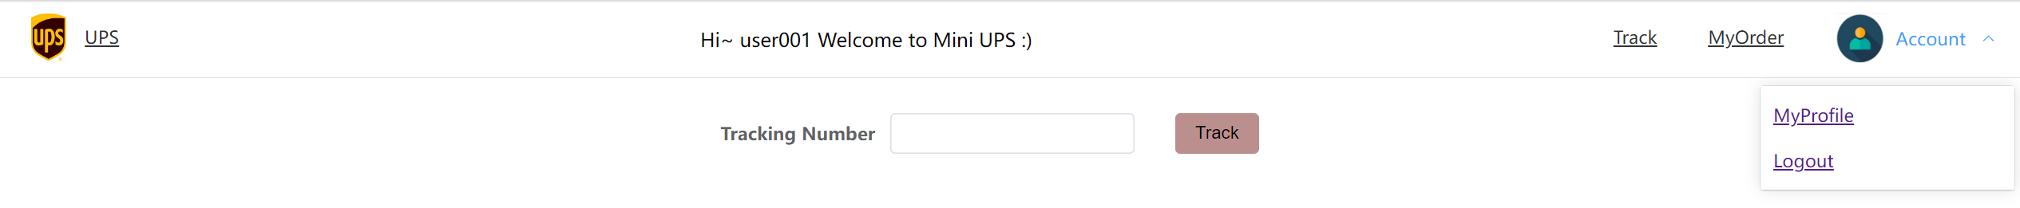



1. Track the truck address if truck information is added to this order.

1. Users can see their profiles. User information including email address and password could be changed by the user later.

1. Created a cancel button, but due to the protocol limitation, users are not allowed to cancel orders.
2. Only the owner instead of everyone who queries the order can change the destination of orders when orders are available to edit (status other than out for delivery and delivered).

图形用户界面

1. The timeline of an order is shown as a line. Users can get information on the status of the order.

1. Users can sign up for our system with userId and email. He/She will get an email notification.

1. Allow Amazon user to associate their orders with UPS ID after placing orders.