PANCAKE BOT 3000
An Automatic Food Maker
3-D Design • 4th Grade Class Project
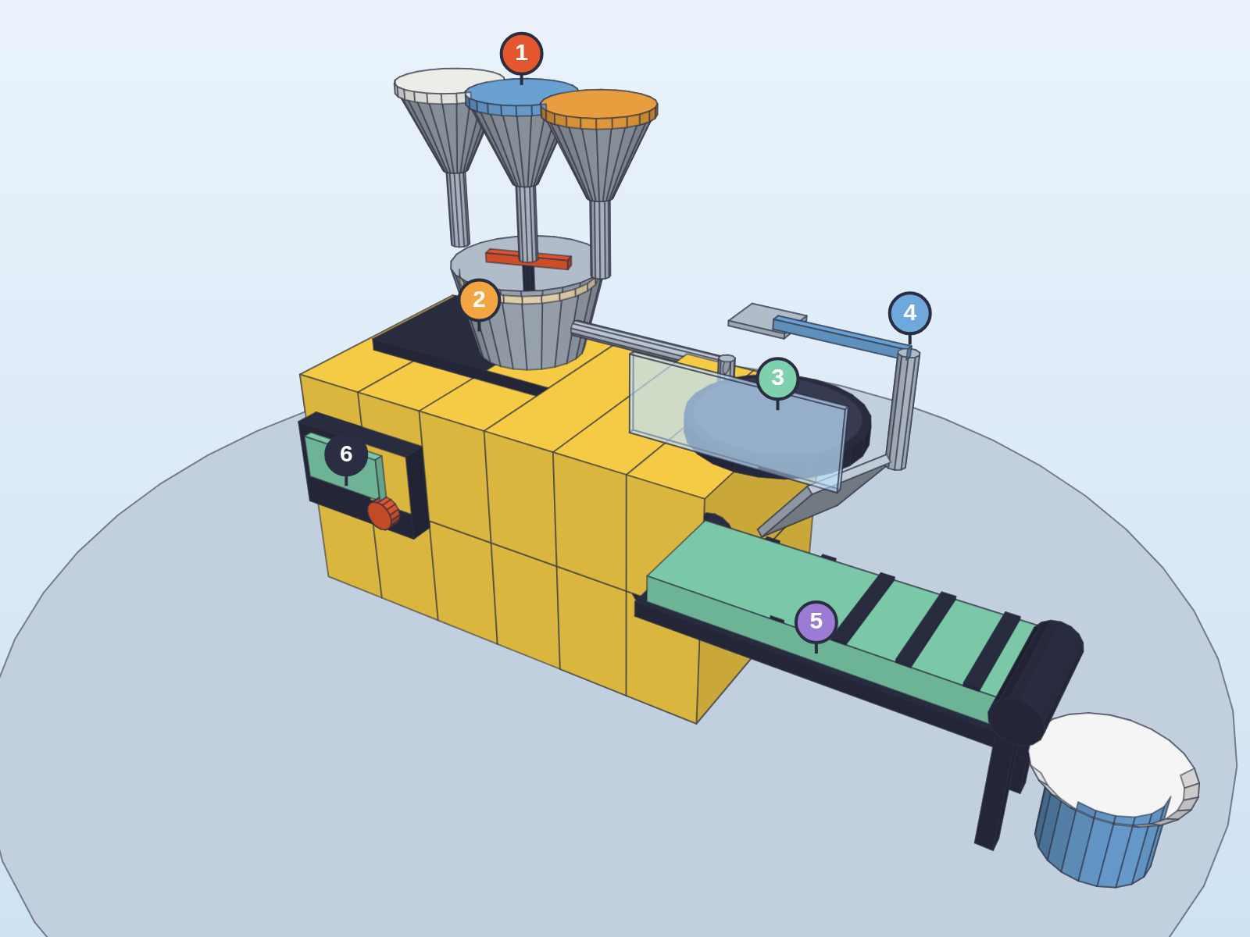
Figure 1. The Pancake Bot 3000 from the front. Numbers show the order the food travels.
Name: ______________________ Class: ____________ Date: ____________

What is it?
The Pancake Bot 3000 is a machine that makes pancakes all by itself. You press one button, and the machine measures the ingredients, mixes the batter, cooks the pancake, flips it, and delivers it to your plate. Nobody has to touch the hot parts.
I designed it in 3-D on the computer so you can see it from every side. The yellow box is the body of the machine. Everything that is hot or spinning sits on top, behind a clear shield.

The parts
# | Part | What it does
1 | Ingredient hoppers | Three funnels on top hold flour (white), milk (blue) and eggs (orange). A little door opens and drops the right amount.
2 | Mixing bowl | A spinning red paddle stirs the ingredients into smooth batter.
3 | Hot griddle | Batter flows down a pipe onto a round hot plate. It glows orange when it is on. A clear shield keeps hands away.
4 | Flipper arm | A robot arm with a spatula slides under the pancake and flips it so both sides cook.
5 | Conveyor belt | The cooked pancake slides down a ramp onto a moving green belt that carries it to the plate.
6 | Control panel | The computer "brain." The green button starts the machine. The big red button stops everything right away.

Views from every side
A 3-D design lets you turn the machine around. Here it is from four different directions.
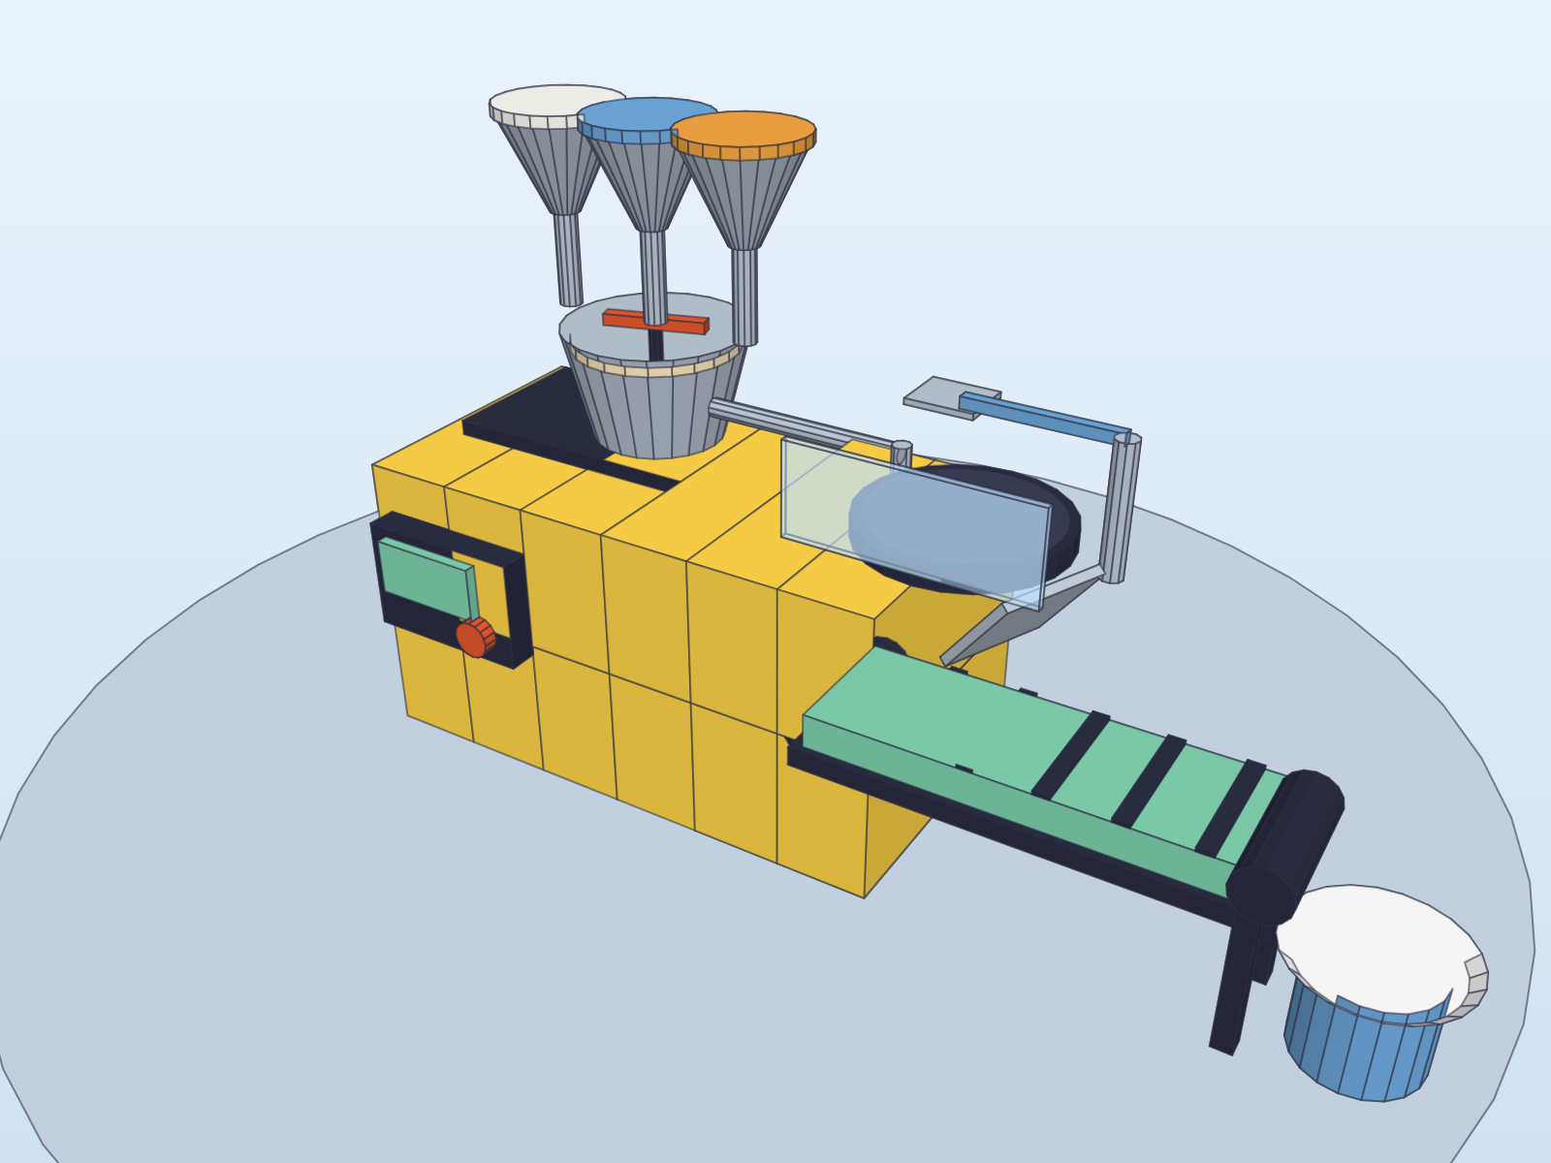  Front view | 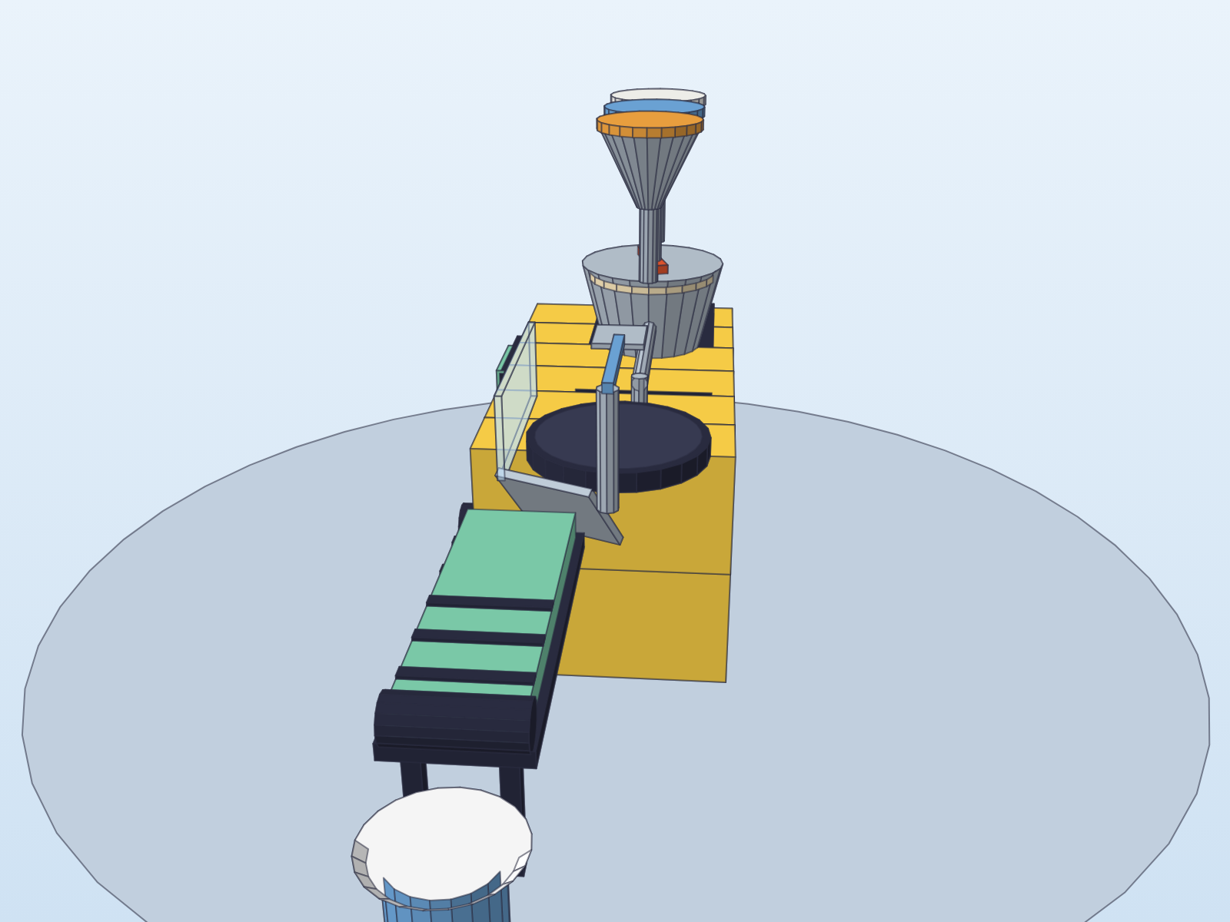  Side view (from the plate end)
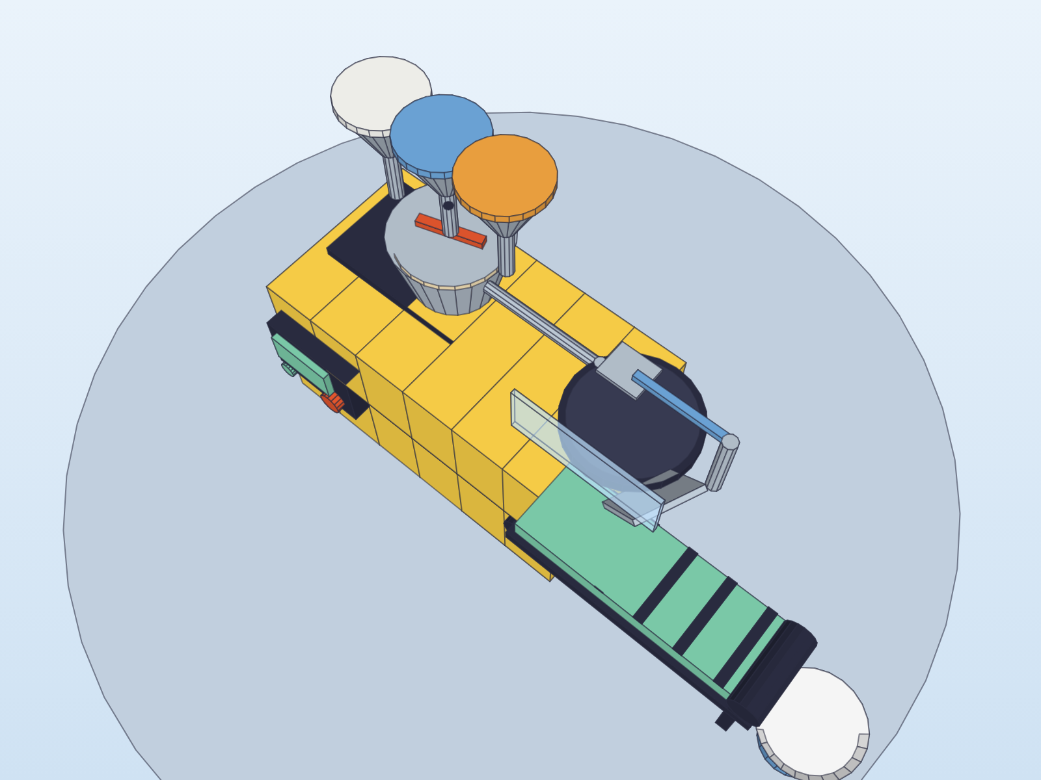  Top view | 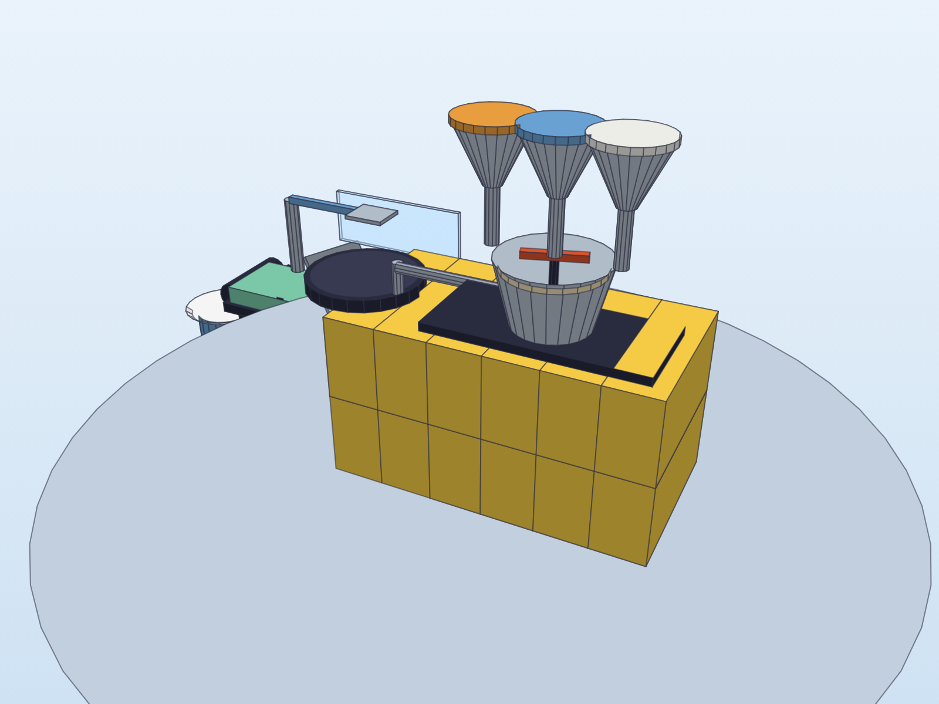  Back view

How it makes a pancake
- Press the green START button on the control panel.
- The hoppers drop flour, milk and eggs into the mixing bowl.
- The paddle spins for 10 seconds and makes batter.
- A pump pushes batter through the pipe onto the hot griddle.
- The griddle cooks the pancake for 1 minute.
- The flipper arm flips the pancake and it cooks for 30 more seconds.
- The pancake slides down the ramp onto the conveyor belt.
- The belt carries the pancake to the plate. Ready to eat!
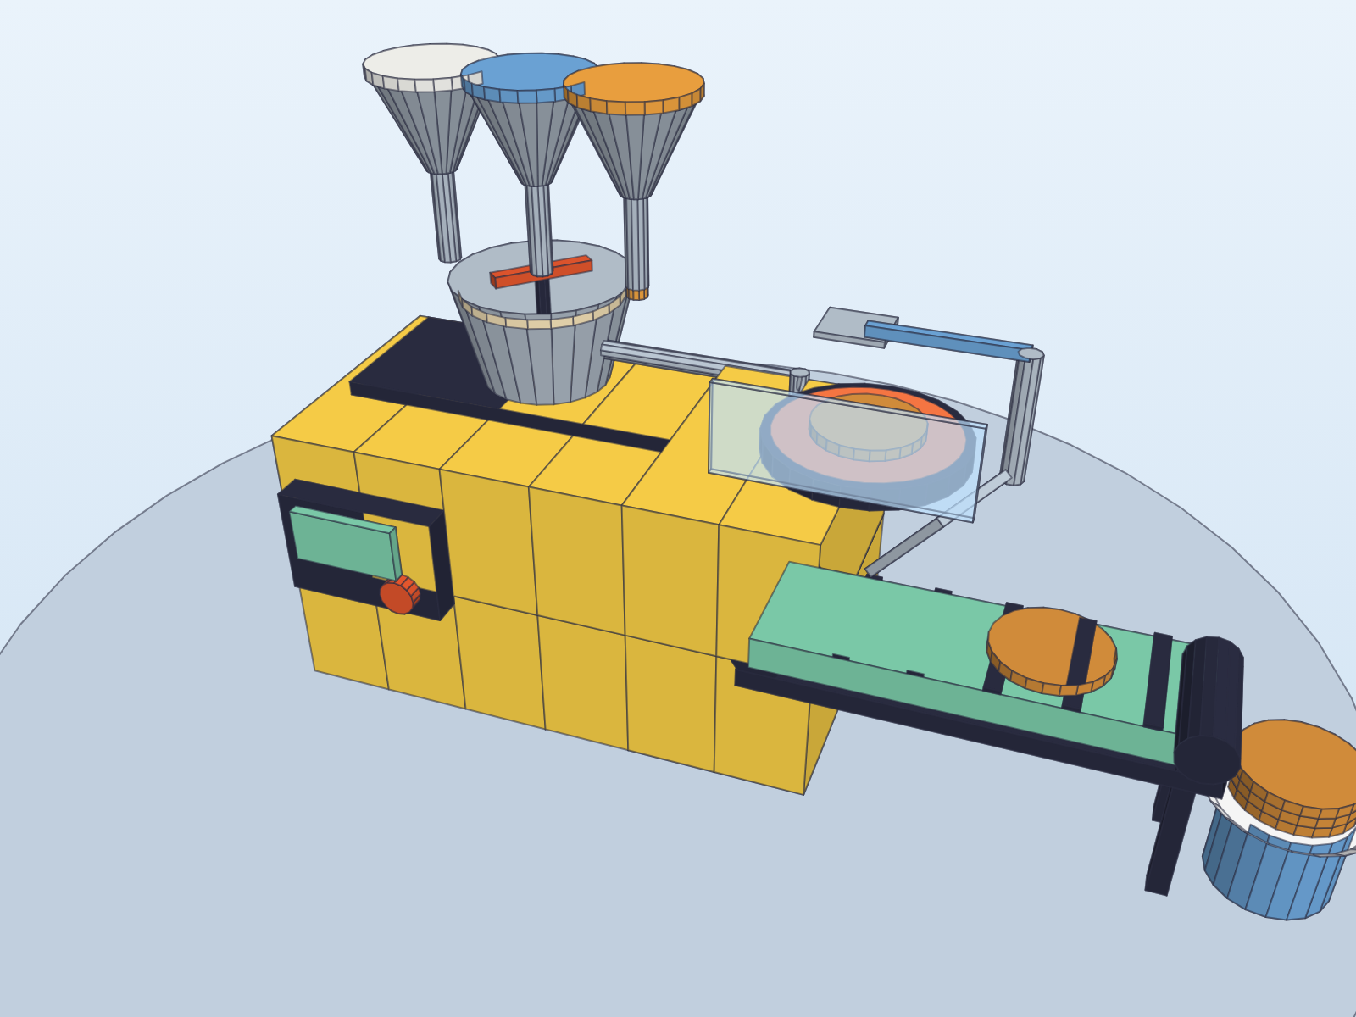
Figure 2. The machine in action: ingredients dropping, griddle glowing, a pancake on the belt, and three on the plate.

Facts about the machine
How tall | About 1 meter (39 inches). As tall as a 4th grader's shoulder.
How wide | About 1.5 meters (5 feet) including the conveyor belt.
Power | Plugs into a regular wall outlet, like a toaster.
Speed | 2 pancakes every minute. 30 pancakes for the whole class in 15 minutes!
Materials | Metal body painted yellow, steel bowl and griddle, rubber belt, plastic buttons.
Safety | Clear shield in front of the hot griddle. Red stop button. Hot parts are on top, away from small hands.

Why I designed it this way
- Gravity does the work. The ingredients are on top so they fall into the bowl without a pump.
- Hot things stay high and behind a shield, so the machine is safe for kids.
- Bright colors show what each part does: white, blue and orange lids match flour, milk and eggs; the red button always means STOP.
- The conveyor belt means you never reach toward the griddle to get your food.

