PENETRATION TESTING REPORT
EXPLOITATION & WEB APPLICATION PENTEST
W4-PM-FINAL | CYBERSECURITY | NETWORKWALKS
Pentester Name (Cybersecurity Professional) | Balogun Esther
Program / Batch | B083 – Networkwalks
Date | 01 Octoberb 2026
Milestones completed | M1 - Initial Access (retrieve 3 patient PDF reports)  M2 - Data Extraction (crack the 3 files)  M3 - Attack (staff salaries & shareholder details)  M4 - Penetration Testing Report
Client / Target | Mediroza General Hospital  https://medirozahospital.com  (black-box, authorized lab target)
Permission secured from client? | Yes. This engagement was performed under written authorization from Networkwalks. Testing was limited to the target domain only; no denial-of-service and no social engineering were performed.
Phases covered | Reconnaissance, Content Discovery, Exploitation, Post-exploitation, Reporting
1. Liability Disclaimer
I have performed these activities only on the target I was authorized to test. The Mediroza target and all materials were provided by Networkwalks for this exercise, under written permission, and are for education only. Do not use anything from here to break the law. The instructor, the authors and Networkwalks are not responsible for what you do with this knowledge. Unauthorized access to systems you do not own is a crime in most countries even when nothing is damaged.
2. Introduction
This report covers the Week 4 capstone of my Networkwalks cybersecurity internship: a full black-box penetration test of Mediroza General Hospital's public web application. The engagement had four milestones - gain initial access and retrieve three confidential patient PDF reports (M1), crack the encryption on those files (M2), locate the hospital's staff salaries and shareholder details (M3), and produce this professional report (M4).
The assessment found the application to be critically insecure: a publicly exposed database backup and a SQL-injection authentication bypass each allow a complete compromise of confidential data. All four milestones were achieved. Sensitive answer values (the exact injection payload and the recovered file passwords) are redacted in the screenshots below so the report can be shared without giving away the lab solution.
3. Tools Used
The table below lists each tool used in this engagement and its purpose.
Tool | Purpose
Whois | Query the public domain registration record (registrar, dates, DNSSEC).
Nslookup | Resolve the domain to its IP address.
Whatweb | Fingerprint web technologies (server, CMS).
Nikto | Scanned the web server for potentially interesting files, configurations, and known issues
wafw00f | Detect whether a Web Application Firewall protects the site.
Dnsrecon | Enumerate the DNS footprint (NS, MX, SPF, DMARC, DNSSEC).
Web browser + DevTools | Content discovery, form/source inspection, and manual exploitation.
robots.txt | Reviewed the site’s robots exclusion file for potentially exposed paths and resources
Networkwalks Hash Calculator / Password Cracker | Extract the PDF hash and crack it in the browser.

4. Activities Performed
4.1 Reconnaissance (Footprinting)
Passive and light reconnaissance was performed to fingerprint the target before any attack.
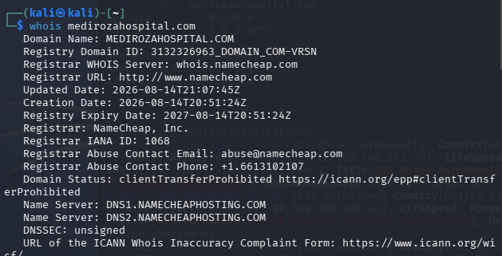
Figure 1 - whois: registrar Namecheap; DNSSEC unsigned.
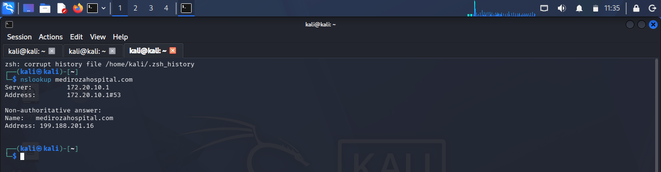
Figure 2 - nslookup: target resolves to 199.188.201.16.
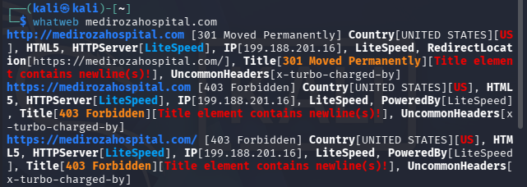
Figure 3 - whatweb: LiteSpeed web server; site fingerprint.
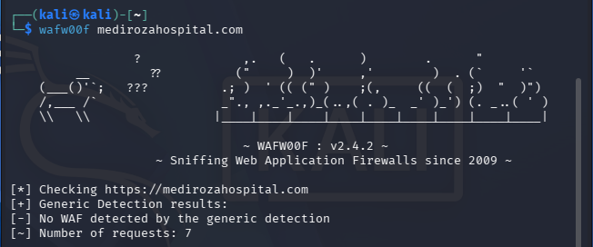
Figure 4 - wafw00f: no Web Application Firewall detected.
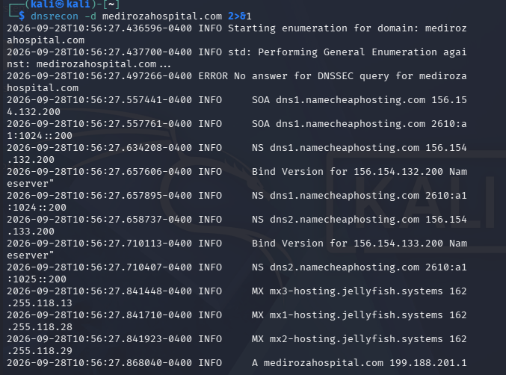
Figure 5 - dnsrecon: NS/MX; SPF ~all (softfail); DMARC p=none.
Key facts: IP 199.188.201.16 (Namecheap shared hosting); LiteSpeed server with an OpenResty/CDN front; Mediroza CMS 1.4.2; no WAF; SPF ~all and DMARC p=none (e-mail spoofing exposure); DNSSEC unsigned.

4.2 Milestone 3 –Attack(Cracking)
robots.txt discloses a hidden /old/ directory. Directory listing is enabled there, exposing a full SQL backup of the HR database, downloadable with no authentication.
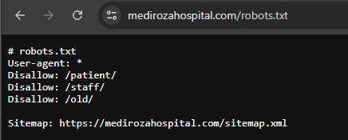
Figure 6 - robots.txt discloses /old/, /patient/, /staff/.
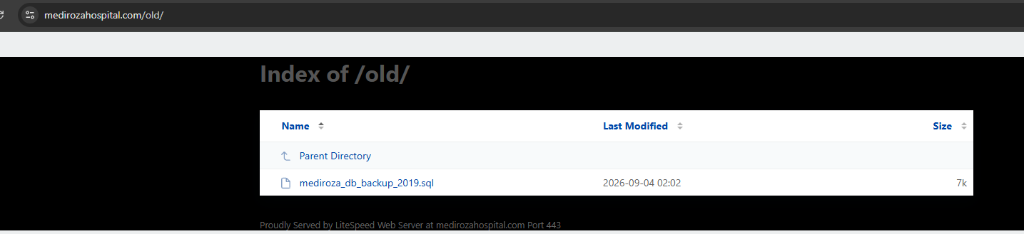
Figure 7 - Directory listing of /old/ exposing the database backup.
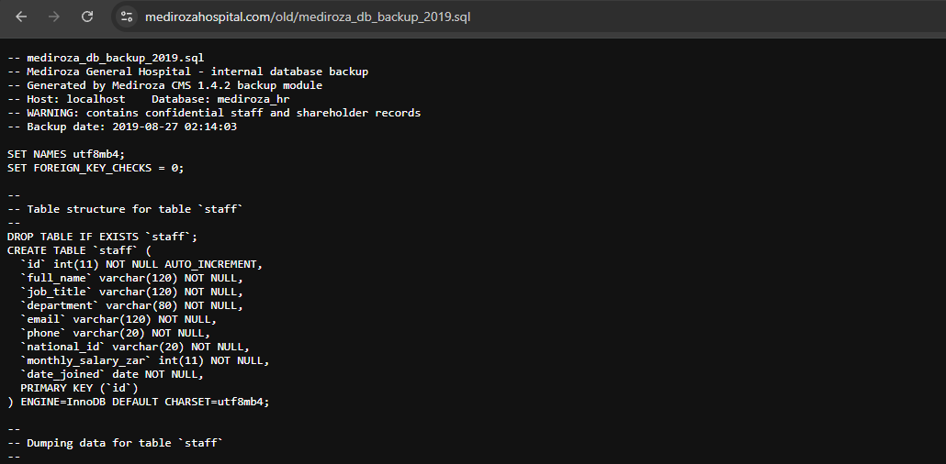
Figure 8 - The exposed backup: staff records incl. national ID and salary.

The backup exposes 30 staff records (name, title, department, e-mail, phone, national ID, monthly salary) and the full shareholder register - satisfying Milestone 3. Highest salaries and top shareholders are summarized in Section 5.

4.3 Milestone 1 - Patient Portal and Authentication Testing
I tested the patient portal identified during reconnaissance.

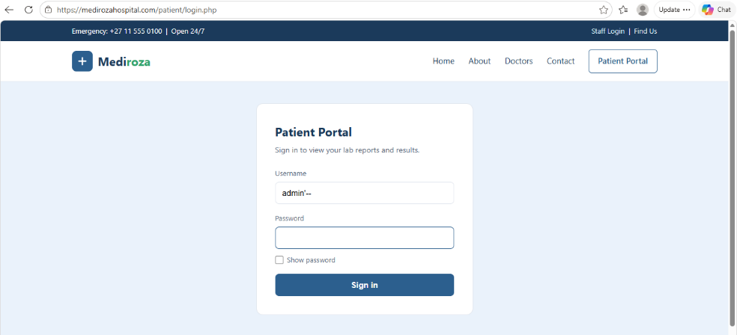
Figure 9- Patient portal.

The portal contained three password-protected/encrypted patient laboratory reports.

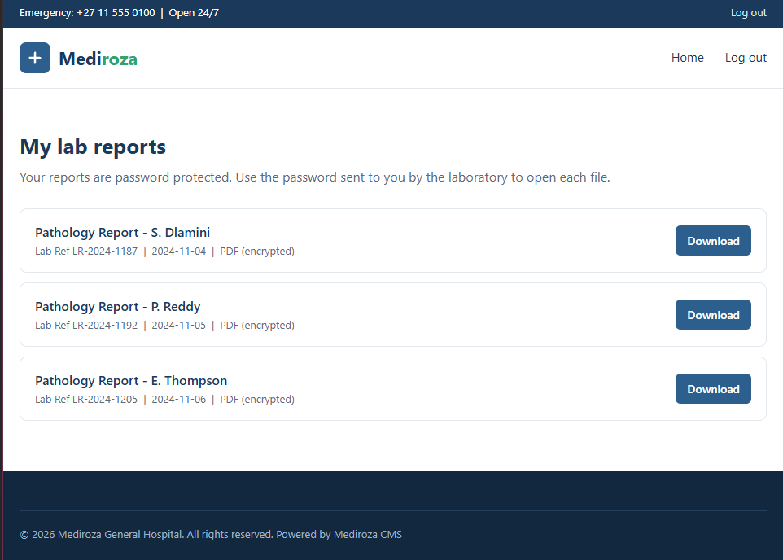
Figure 10- Authentication bypassed: access to "My lab reports" and the 3 confidential patient PDFs.

Result: full authentication bypass and unauthorized access to another user's confidential lab reports - satisfying Milestone 1.

4.4 Milestone 2 - Cracking the Encrypted Files
After downloading the three encrypted patient reports, I used the NetworkWalks Hash Calculator to extract crackable hashes from the three encrypted PDFs.
The Hash Calculator generated crackable hashes in pdf2john / hashcat-compatible format.
All three passwords were extremely weak and were recovered against a wordlist in seconds. The recovered passwords are below.
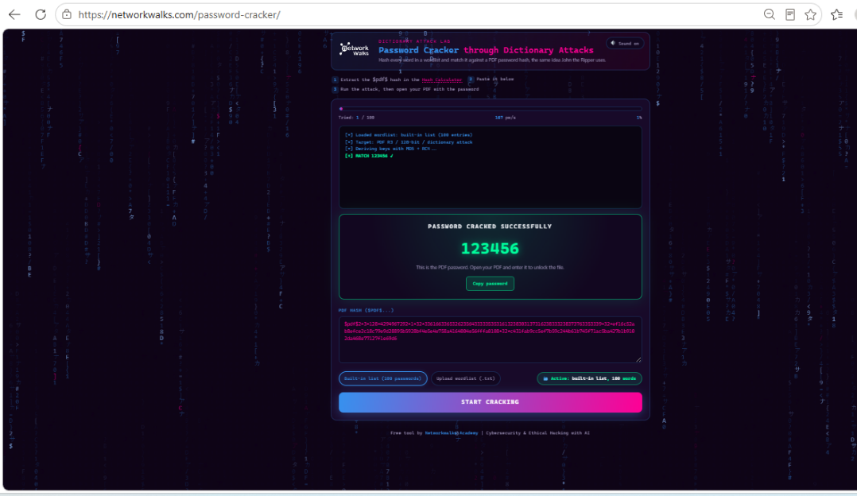
Figure 11 - Report 1 (Dlamini) password cracked .
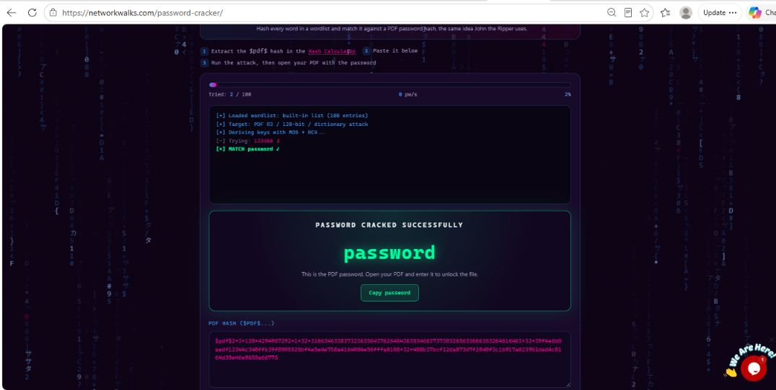
Figure 12 - Report 2 (Reddy) password cracked .
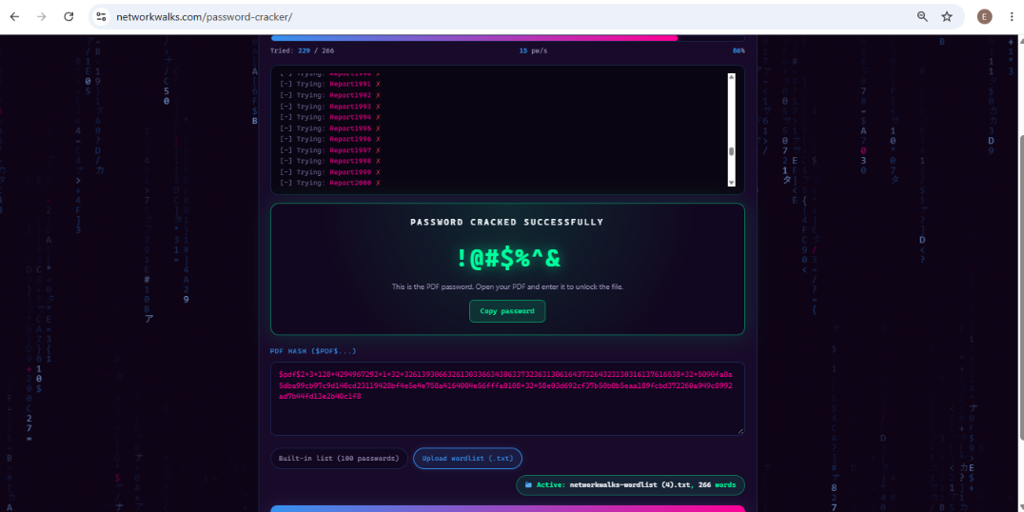
Figure 13 - Report 3 (Thompson) password cracked

Lesson: the generic list missed the symbol password, but a targeted keyboard-pattern wordlist recovered it immediately - the right wordlist is what matters. All three passwords were weak patterns present in public lists - satisfying Milestone 2.

5. Recovered Confidential Data
5.1 Patient reports (M1 & M2)
File | Patient | Lab Ref | Password
report 1 | Sipho Dlamini (MG-P-10231) | LR-2024-1187 | ********
report 2 | Priya Reddy (MG-P-10244) | LR-2024-1192 | ********
report 3 | Emily Thompson (MG-P-10258) | LR-2024-1205 | ********
(Passwords redacted. All three were weak and recovered in seconds.)
5.2 Staff salaries - highest paid (M3)
Name | Role | Salary (ZAR/mo)
Dr. Johan van der Merwe | Medical Director | 160,000
Sarah Botha | Chief Financial Officer | 152,000
Dr. Rajesh Naidoo | Chief Pathologist | 138,000
Dr. Vikram Chetty | Anesthetist | 135,000
Dr. Anita Naicker | Consultant Cardiologist | 132,000
Dr. Suresh Moodley | Consultant Radiologist | 130,000
(30 staff records exposed in total, including national ID numbers.)
5.3 Shareholders (M3)
Shareholder | Share % | Class
Dr. Rajesh Naidoo | 18% | Ordinary
Cedar Health Holdings (Pty) Ltd | 15% | Ordinary
Dr. Johan van der Merwe | 12% | Ordinary
Reddy Family Trust | 11% | Ordinary
Thabo Molefe | 10% | Ordinary
Sarah Botha | 9% | Ordinary
Dr. Ahmed Kara | 8% | Preferential
Naledi Zulu | 7% | Ordinary
Michael Roberts | 6% | Ordinary
Dr. Vikram Chetty | 4% | Preferential

6. Risk Analysis
ID | Finding | Rating
F1 | Public database backup (staff PII, salaries, shareholders) | CRITICAL
F2 | SQL injection - authentication bypass | CRITICAL
F3 | Weak encryption passwords on patient files | HIGH
F4 | Directory listing enabled | MEDIUM
F5 | Username enumeration on patient login | MEDIUM
F6 | E-mail spoofing exposure (SPF ~all / DMARC p=none) | MEDIUM
F7 | Sensitive path disclosure via robots.txt | LOW
F8 | No WAF / no DNSSEC / exposed error log | LOW

7. Recommendations & Remediation
Immediate (Critical)
- Remove confidential patient reports from publicly accessible locations and require authentication and authorization before allowing access.
- Ensure sensitive patient, staff and shareholder information is nit exposed through publicly accessible web resources.
- Replace weak or predictable document passwords with strong, unique passwords that are resistant to dictionary attacks.
- Review and revoke any credentials that may have been exposed during the assessment.
Short term (High / Medium)
- Store patient reports outside the web root and serve them only after verifying that the requesting user us authorized to access the specific document.
- Implement proper access controls for staff salary and shareholder information.
- Disable directory listing on web-server directories.
- Review robots.txt and ensure that sensitive resources are protected by authentication rather than relying on robots.txt to hide them
- Conduct regular password-strength reviews and enforce strong password policies.
General hardening (Low)
- Perform regular vulnerability assessments and penetration tests.
- Move the error log out of the web root; enable DNSSEC; consider a WAF.
- Maintain secure backups outside publicly accessible directories.
8. Conclusion
The Mediroza Hospital web application and associated resources demonstrated significant security weaknesses during this assessment. The testing identified exposed resources that allowed the retrieval of three confidential patient laboratory reports, while the password protection on all three documents was successfully recovered using dictionary-based password testing. The assessment also identified access to sensitive staff salary and shareholder information within the authorized lab environment. These findings demonstrate the importance of strong access controls, secure document protection, and strong password policies.
All four engagement milestones were addressed, with supporting evidence collected throughout the assessment and documented in this report.

