-- 16、检索"01"课程分数小于60，按分数降序排列的学生信息

select s.*,s2.s_score from Student s join score s2 on s.s_id=s2.s_id where s2.c_id='01' and s2.s_score<60;

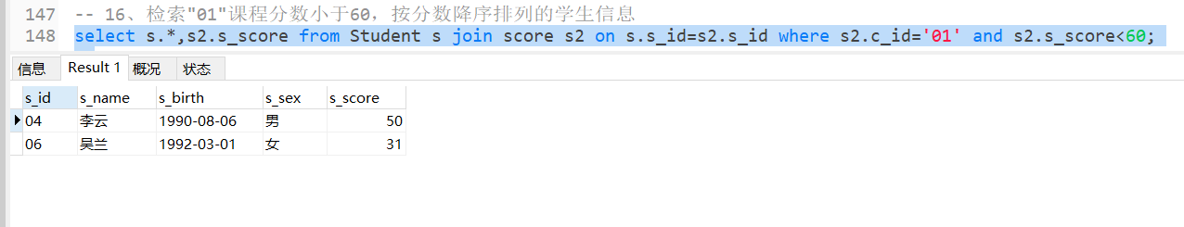

-- 17、按平均成绩从高到低显示所有学生的所有课程的成绩以及平均成绩

select s2.s_score as suos,(select avg(score.s_score) as a from score ORDER BY a desc) as avgs from score s2 order by suos desc;

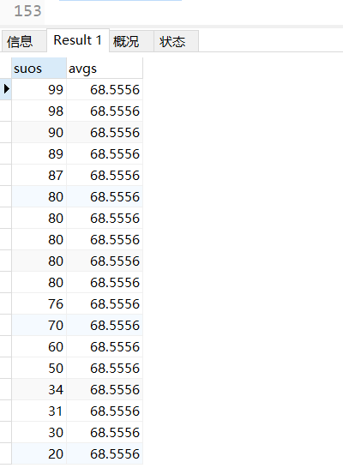

-- 18.查询各科成绩最高分、最低分和平均分：以如下形式显示：课程ID，课程name，最高分，最低分，平均分，及格率，中等率，优良率，优秀率

--及格为>=60，中等为：70-80，优良为：80-90，优秀为：>=90

select distinct c.c_id,c.c_name,B.maxS,B.minS,B.avgS,b.jige from Course c left join (select avg(sc.s_score) as avgS,max(sc.s_score) as maxS,min(sc.s_score) as minS,c_id, CONCAT(round(sum(case when s_score>=60 then 1 else 0 end)/count(*)*100,2),'%') as jige from Score sc group by sc.c_id) B on c.c_id=B.c_id;

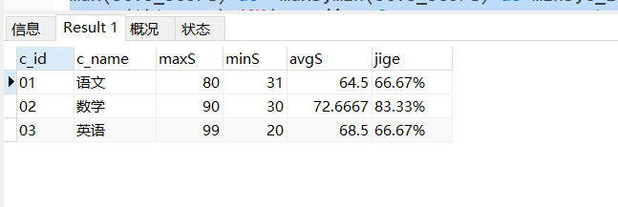

-- 19、按各科成绩进行排序，并显示排名

select a.s_name,b.s_score,b.c_id,(select count(c.s_score)+1 from (select c.s_score,count(c.s_score) from Score c group by c.s_score order by c.s_score desc) c where c.s_score > b.s_score) as '排名' from (select s_id,s_name from student) a left join score b on a.s_id=b.s_id where b.s_score>0 order by b.c_id,b.s_score desc;

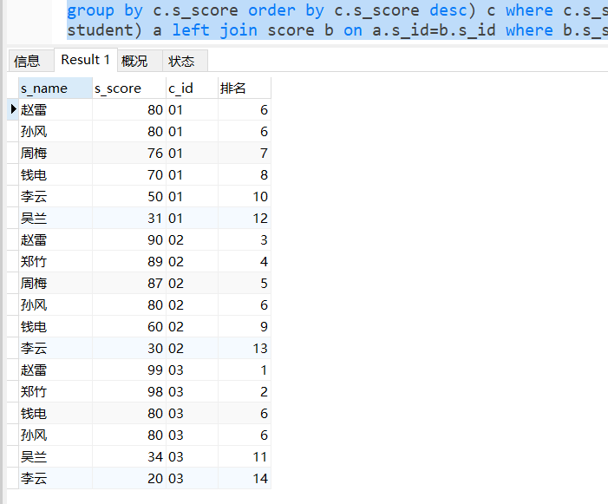

-- 20、查询学生的总成绩并进行排名

select s.s_name,sum(s2.s_score) zongsc from student s left join score s2 on s.s_id=s2.s_id group by s.s_id order by zongsc desc;

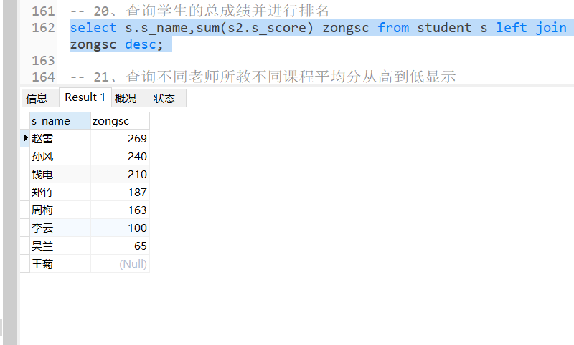

-- 21、查询不同老师所教不同课程平均分从高到低显示

select b.t_id,b.t_name,a.c_name,a.c_id,AVG(c.s_score)'avgsc' from course as a inner join teacher as b on a.t_id=b.t_id inner join score as c on c.c_id=a.c_id group by c.c_id order by avgsc desc;

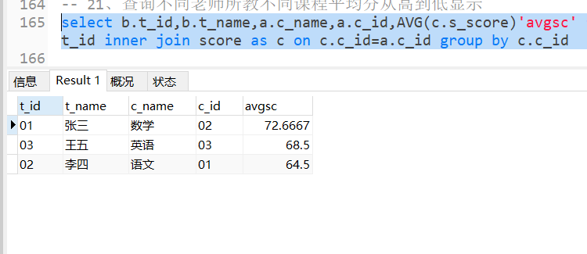

-- 22、查询所有课程的成绩第2名到第3名的学生信息及该课程成绩

select a.* from (

select st.*,c.c_id,c.c_name,sc.s_score from student st

left join score sc on sc.s_id=st.s_id

inner join course c on c.c_id =sc.c_id and c.c_id="01"

order by sc.s_score desc LIMIT 1,2 ) a

union all

select b.* from (

select st.*,c.c_id,c.c_name,sc.s_score from student st

left join score sc on sc.s_id=st.s_id

inner join course c on c.c_id =sc.c_id and c.c_id="02"

order by sc.s_score desc limit 1,2) b

union all

select c.* from (

select st.*,c.c_id,c.c_name,sc.s_score from student st

left join score sc on sc.s_id=st.s_id

inner join course c on c.c_id =sc.c_id and c.c_id="03"

order by sc.s_score desc limit 1,2) c

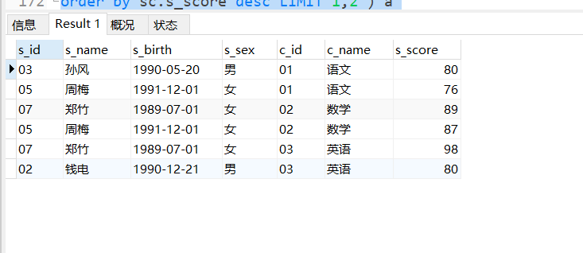

-- 23、统计各科成绩各分数段人数：课程编号,课程名称,[100-85],[85-70],[70-60],[0-60]及所占百分比

select sc.c_id,co.c_name,SUM(case when sc.s_score<=100 and sc.s_score>=85 then 1 else 0 end)'[100-85]',

SUM(case when sc.s_score<=85 and sc.s_score>=70 then 1 else 0 end)'[85-70]',

COUNT(case when sc.s_score<=70 and sc.s_score>=60 then 521 else null end)'[70-60]',

SUM(case when sc.s_score<=60 then 1 else 0 end)'[0-60]'

from

score as sc

inner join

course as co on sc.c_id=co.c_id

group by sc.c_id,co.c_name;

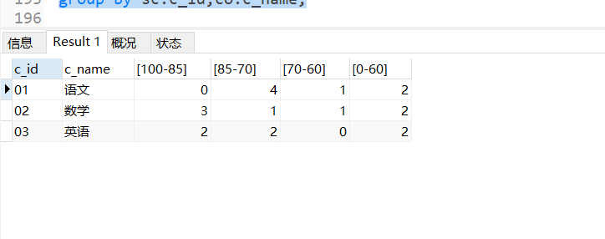

-- 24、查询学生平均成绩及其名次

select s_id,avg(s_score) as Savg from score group by s_id order by Savg asc;

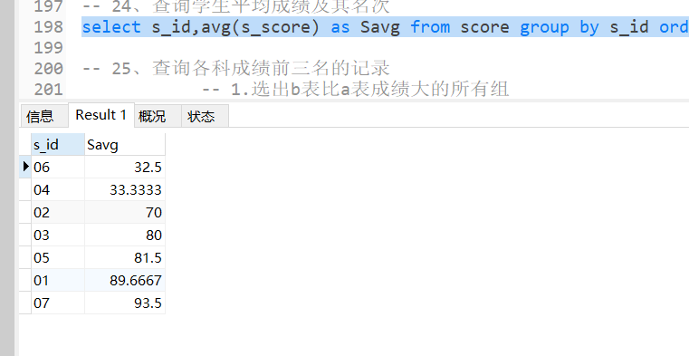

-- 25、查询各科成绩前三名的记录

-- 1.选出b表比a表成绩大的所有组

-- 2.选出比当前id成绩大的 小于三个的

select a.* from (

select st.s_id,st.s_name,c.c_id,c.c_name,sc.s_score from student st

left join score sc on sc.s_id=st.s_id

inner join course c on c.c_id=sc.c_id and c.c_id='01'

order by sc.s_score desc limit 0,3) a

union all

select b.* from (

select st.s_id,st.s_name,c.c_id,c.c_name,sc.s_score from student st

left join score sc on sc.s_id=st.s_id

inner join course c on c.c_id=sc.c_id and c.c_id='02'

order by sc.s_score desc limit 0,3) b

union all

select c.* from (

select st.s_id,st.s_name,c.c_id,c.c_name,sc.s_score from student st

left join score sc on sc.s_id=st.s_id

inner join course c on c.c_id=sc.c_id and c.c_id='03'

order by sc.s_score desc limit 0,3) c

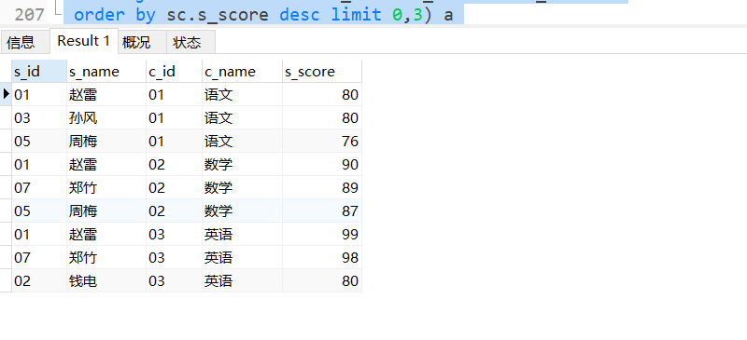

-- 26、查询每门课程被选修的学生数

select c_id,count(s_id)'人数' from score group by c_id;

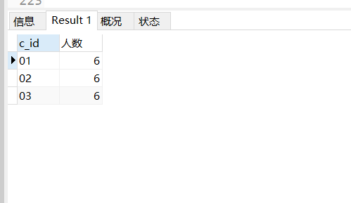

-- 27、查询出只有两门课程的全部学生的学号和姓名

select st.s_id,st.s_name,count(sc.c_id)'选修课程数两门'from

student as st

inner join

score as sc on st.s_id=sc.s_id

group by st.s_id having count(distinct sc.c_id)=2;

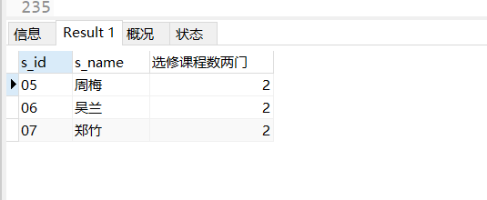

-- 28、查询男生、女生人数

select s_sex, count(distinct s_id) from student group by s_sex;

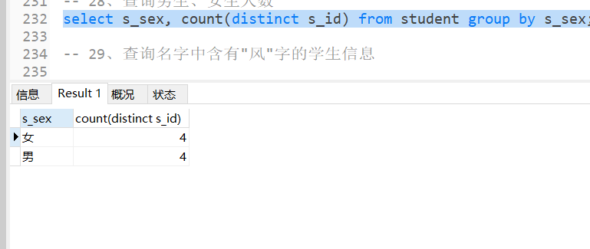

-- 29、查询名字中含有"风"字的学生信息

select * from Student where s_name like "%风%";

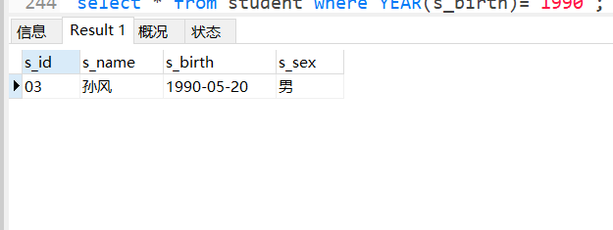

-- 30、查询同名同性学生名单，并统计同名人数

select st.*,count(1) from student st group by st.s_name,st.s_sex having count(1)>1;

-- 31、查询1990年出生的学生名单

select * from student where YEAR(s_birth)='1990';

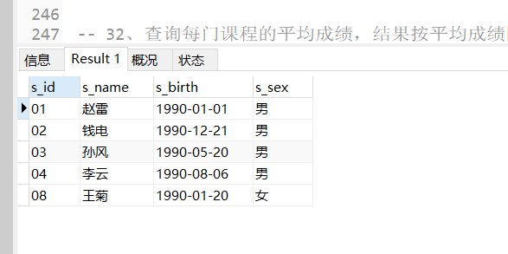

-- 32、查询每门课程的平均成绩，结果按平均成绩降序排列，平均成绩相同时，按课程编号升序排列

select c_id,avg(s_score) as avgS from score group by c_id order by avgS desc,c_id asc;

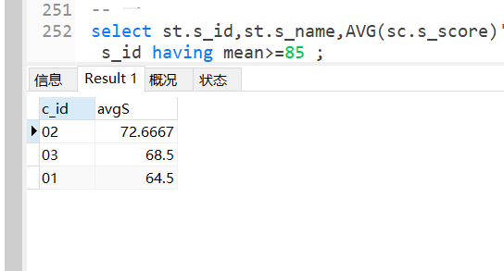

-- 33、查询平均成绩大于等于85的所有学生的学号、姓名和平均成绩

-- 一

select st.s_id,st.s_name,AVG(sc.s_score)'mean' from student as st inner join score as sc on st.s_id=sc.s_id group by s_id having mean>=85 ;

-- 二

select s.s_id,s.s_name,b.avgS from student s join (select s_id,avg(s_score) avgS from score group by s_id) b on s.s_id=b.s_id where b.avgS>=85;

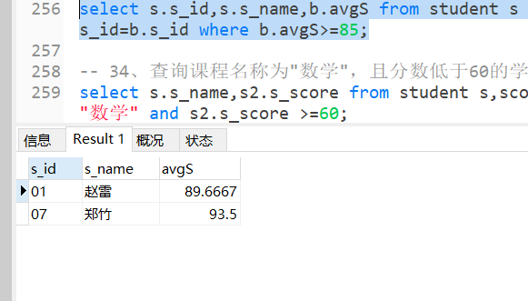

-- 34、查询课程名称为"数学"，且分数低于60的学生姓名和分数

select s.s_name,s2.s_score from student s,score s2,course c where s.s_id=s2.s_id and c.c_id=s2.c_id and c.c_name="数学" and s2.s_score >=60;

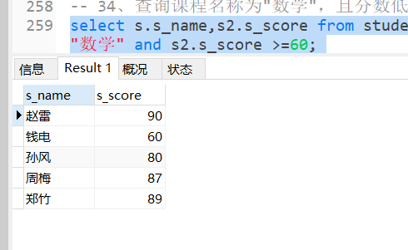

-- 35、查询所有学生的课程及分数情况；

select st.s_id,st.s_name

,MAX(case when co.c_name='语文' then sc.s_score else null end) as '语文'

,MAX(case when co.c_name='数学' then sc.s_score else null end) as '数学'

,MAX(case when co.c_name='英语' then sc.s_score else null end) as '英语'

from

student as st

join

score as sc on st.s_id=sc.s_id

join

course as co on sc.c_id=co.c_id

group by st.s_id,st.s_name;

-- 二

select st.s_id,st.s_name,c.c_name,sc.s_score from student st

left join score sc on sc.s_id=st.s_id

left join course c on c.c_id =sc.c_id

order by st.s_id,c.c_name;

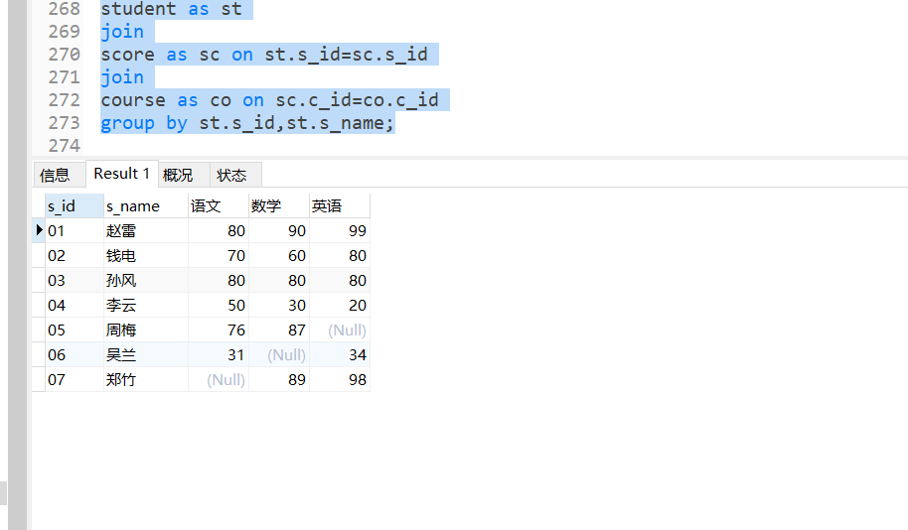

-- 36、查询任何一门课程成绩在70分以上的姓名、课程名称和分数；

select s.s_name,c.c_name,s2.s_score from student s,course c,score s2 where s.s_id=s2.s_id and c.c_id=s2.c_id and s2.s_score >=70;

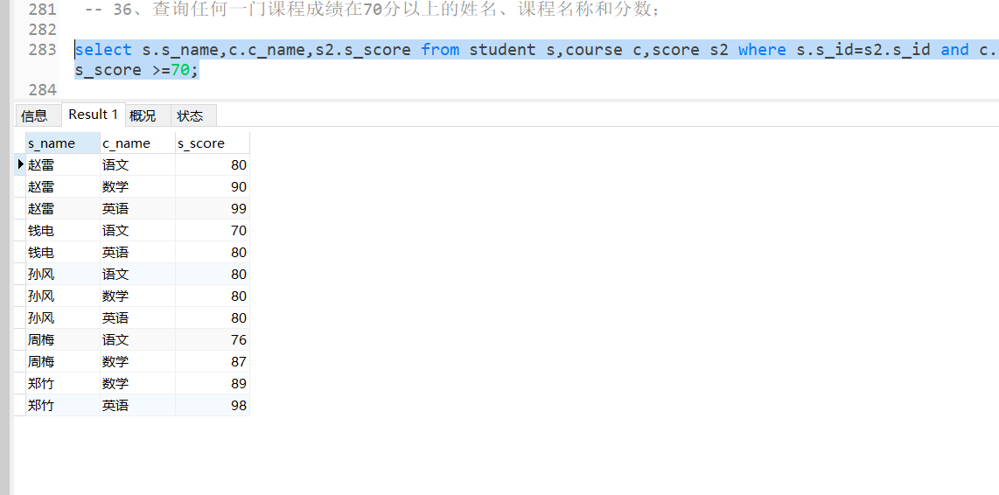

-- 37、查询不及格的课程

select * from score where s_score <60;

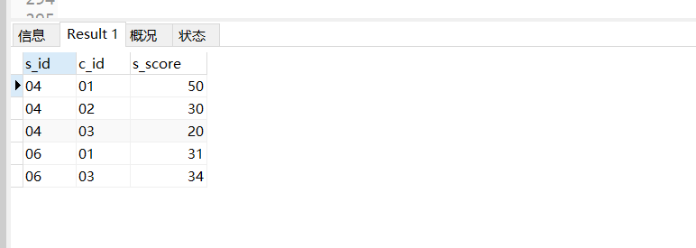

-- 38、查询课程编号为01且课程成绩在80分以上的学生的学号和姓名；

select s.s_id,s.s_name from student s join score s2 on s.s_id=s2.s_id where s2.c_id=01 and s2.s_score >=80;

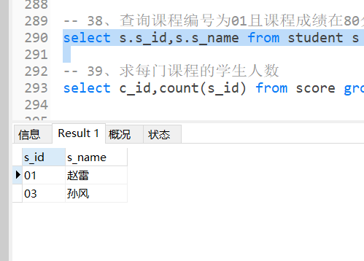

-- 39、求每门课程的学生人数

select c_id,count(s_id) from score group by c_id;

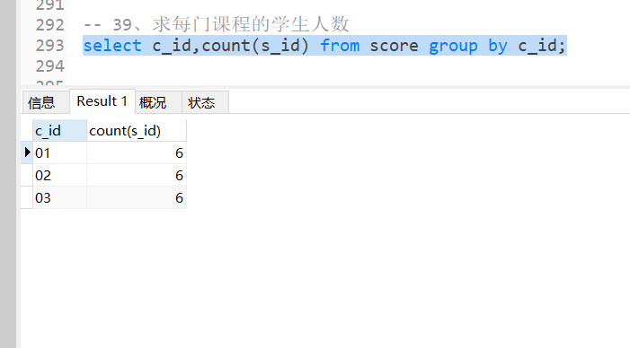

-- 40、查询选修"张三"老师所授课程的学生中，成绩最高的学生信息及其成绩

-- 查询老师id

-- 查询最高分（可能有相同分数）

-- 查询信息

select st.*,c.c_name,sc.s_score,t.t_name from student st

inner join score sc on sc.s_id=st.s_id

inner join course c on c.c_id=sc.c_id

inner join teacher t on t.t_id=c.t_id and t.t_name="张三"

order by sc.s_score desc limit 0,1 ;

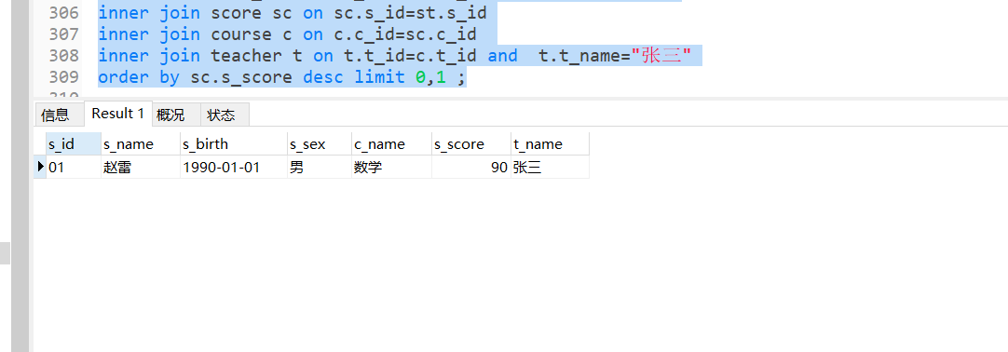

-- 41、查询不同课程成绩相同的学生的学生编号、课程编号、学生成绩

select st.s_id,st.s_name,sc.c_id,sc.s_score from student st

left join score sc on sc.s_id=st.s_id

left join course c on c.c_id=sc.c_id

where (select COUNT(1) from student st2

left join score sc2 on sc2.s_id=st2.s_id

left join course c2 on c2.c_id=sc2.c_id

where sc.s_score=sc2.s_score and c.c_id!=c2.c_id )>1;

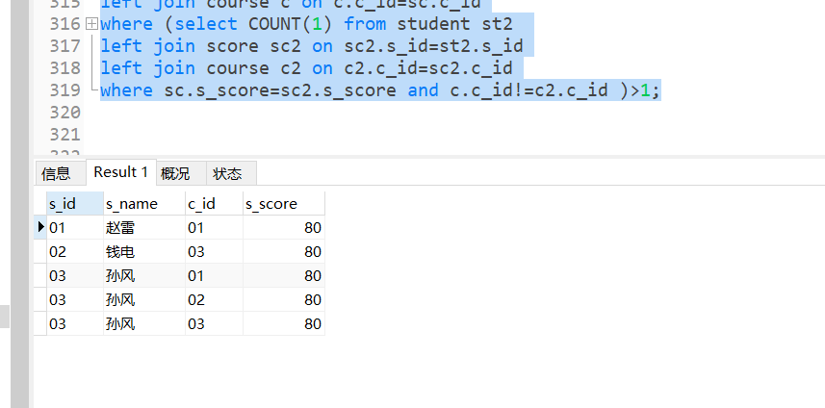

-- 42、查询每门功成绩最好的前两名

select sc.c_id,sc.s_score from score sc where (select COUNT(*) from score where sc.c_id = score.c_id and sc.s_score<score.s_score)<2 order by sc.c_id asc,sc.s_score desc;

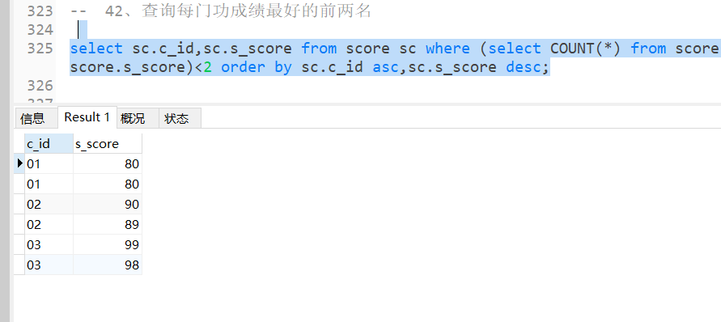

-- 43、统计每门课程的学生选修人数（超过5人的课程才统计）。要求输出课程号和选修人数，查询结果按人数降序排列，若人数相同，按课程号升序排列

select c_id, COUNT( distinct s_id) as num from score group by c_id having num>5 order by num desc,c_id asc;

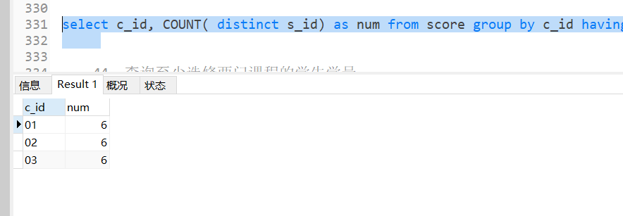

-- 44、查询至少选修两门课程的学生学号

select s_id,COUNT(distinct c_id) from score group by s_id having COUNT(distinct c_id)>=2;

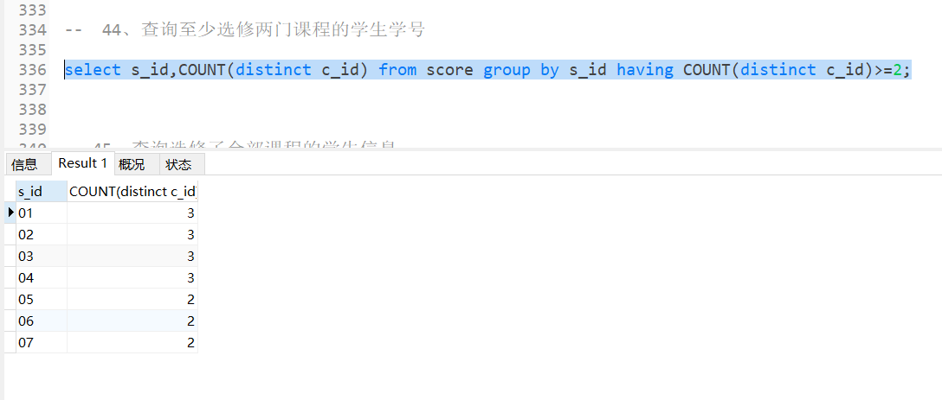

-- 45、查询选修了全部课程的学生信息

select s_id,COUNT(c_id) from score group by s_id having COUNT(c_id)=3;

-- 方法二适应性更强

select s_id,COUNT(c_id) from score group by s_id having COUNT(c_id)=(select COUNT(c_id) from course);

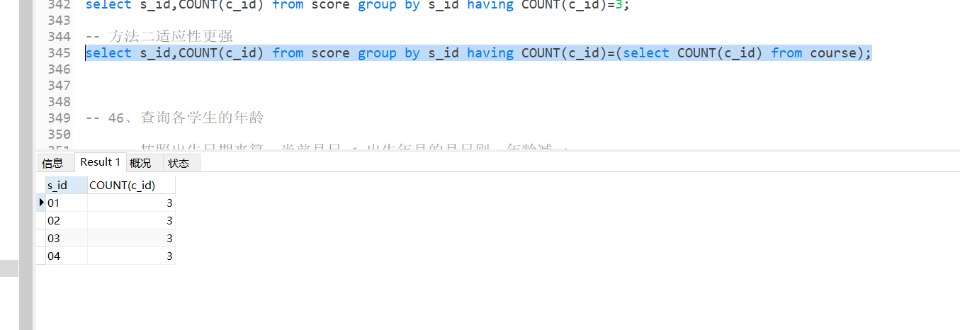

-- 46、查询各学生的年龄

-- 按照出生日期来算，当前月日 < 出生年月的月日则，年龄减一

select *,(case when convert(int,'1'+substring(convert(varchar(10),s_birth,112),5,8))<convert(int,'1'+substring(convert(varchar(10),getDate(),112)，5，8))then datediff(yy,s_birth,getdate()) else datediff(yy,sage,getdate())-1

end) s_birth from student;

-- 47、查询本周过生日的学生

select st.* from student st where week(now())=week(date_format(st.s_birth,'%Y%m%d'));

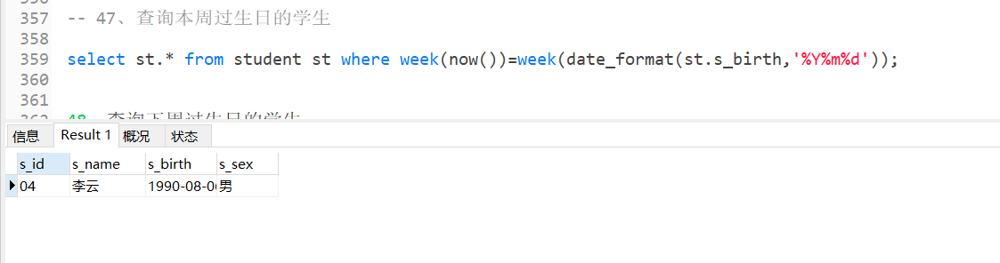

48、查询下周过生日的学生

select st.* from student st where week(now())+1=week(date_format(st.s_birth,'%Y%m%d'));

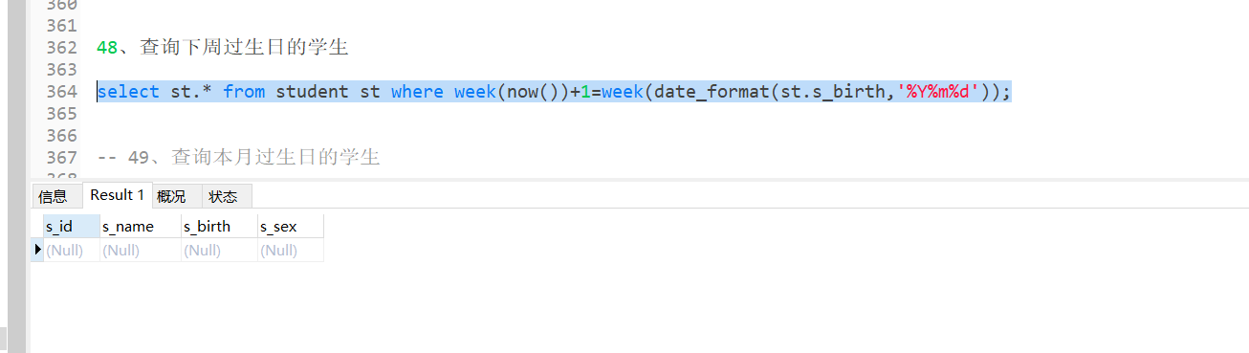

-- 49、查询本月过生日的学生

select st.* from student st where month(now())=month(date_format(st.s_birth,'%Y%m%d'));

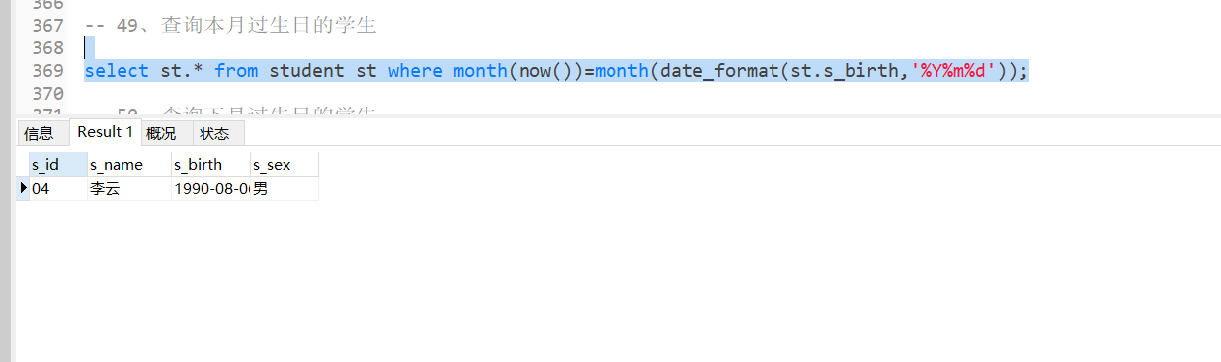

-- 50、查询下月过生日的学生

select st.* from student st where month(timestampadd(month,1,now()))=month(date_format(st.s_birth,'%Y%m%d'));

-- 或

select st.* from student st where (month(now()) + 1) mod 12 = month(date_format(st.s_birth,'%Y%m%d'));

