# **PUBLIC HEALTH AWARENESS**

**PHASE 2: INNOVATION**

INTRODUCTION**:**

Mental health is a critical aspect of overall well-being, and the importance of addressing mental health issues on a public health scale cannot be overstated. To effectively raise public awareness and provide timely support to those in need, classification algorithms have emerged as invaluable tools in the realm of mental health. These algorithms harness the power of data and artificial intelligence to categorize and predict various aspects of mental health, enabling early intervention, targeted interventions, and the promotion of mental well-being on a broader scale.classification algorithms serve as a bridge between the wealth of available data and the development of actionable insights and strategies for public health awareness campaigns. These algorithms can be used for a variety of purposes within the mental health domain are Diagnosis and Risk Assessment Sentiment Analysis Resource Allocations Monitoring and Intervention.

CLASSIFICATION:

In the field of mental health, various types of classification algorithms are used, and the choice of algorithm depends on the specific task and the characteristics of the data. While there is no one-size-fits-all answer, some classification algorithms are more commonly used than others due to their effectiveness in addressing certain mental health-related challenges. classification algorithms play a pivotal role in the field of mental health for public health awareness by harnessing data-driven insights to diagnose, assess risk, allocate resources, monitor individuals, and reduce stigma. These powerful tools have the potential to revolutionize the way we approach mental health on a broader scale, ultimately leading to improved well-being for individuals and communities alike.

* Data Collection: Classification algorithms use patient data, including medical records, surveys, and clinical assessments, to gather relevant information about an individual's mental health status.
* Feature Extraction: Features like demographic information, symptoms, and behavioral patterns are extracted from the data to build a comprehensive dataset.
* Model Training: Algorithms like logistic regression, decision trees, or support vector machines are trained on this dataset to classify individuals into different categories, such as specific mental health disorders or risk levels.
* Prediction: Once trained, these models can predict whether an individual has a particular mental health condition or assess their risk of developing one.

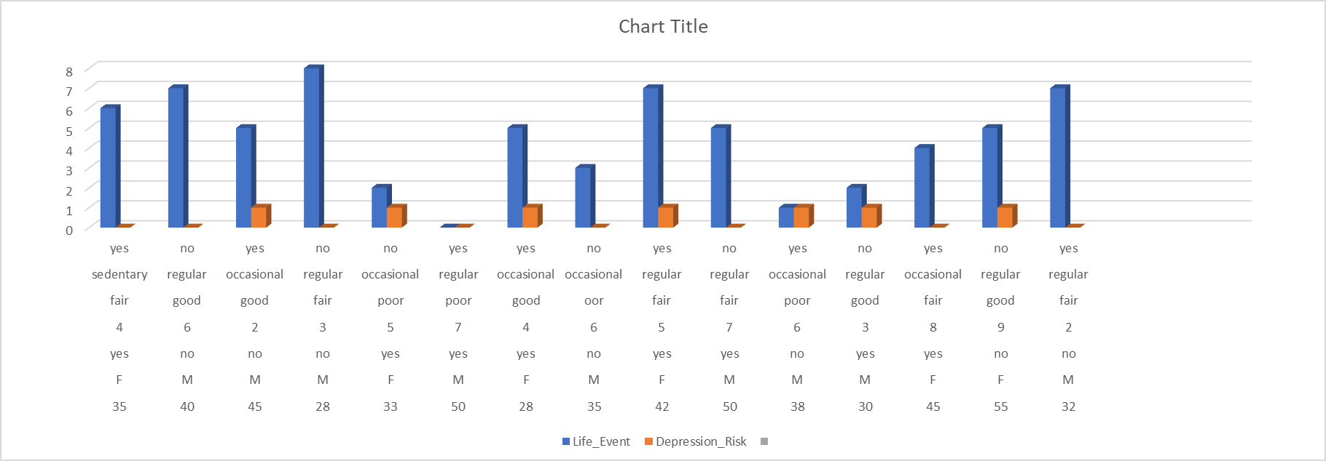

LOGISTIC REGESSION:

Logistic regression is a statistical modeling technique used in mental health for various purposes, including risk assessment, outcome prediction, and understanding the factors associated with mental health conditions.

* Risk Assessment:Outcome Prediction Logistic regression can be employed to predict the risk of developing a specific mental health condition or experiencing adverse mental health outcomes. It uses input variables such as demographic information, family history, lifestyle factors, and previous mental health history to calculate the probability of an individual falling into a particular risk category.
* Suicide Risk Assessment: Logistic regression models can assess the risk of suicide attempts or self-harm based on a combination of risk factors, including depression scores, previous suicide attempts, and social support.
* Diagnosis:Binary Diagnosis In some cases, logistic regression can be used for binary classification to diagnose whether an individual has a specific mental health disorder or not. Input features may include symptom profiles, diagnostic criteria, or questionnaire responses.
* Identifying Factors Associated with Mental Health Determining Risk Factors: Logistic regression can help identify the factors that are most strongly associated with the presence of a mental health condition. This information is valuable for understanding the etiology of mental health disorders and designing targeted interventions.
* Sentiment Analysis:Emotion Classification in sentiment analysis related to mental health, logistic regression models can classify text data (e.g., social media posts, survey responses) into categories such as positive, negative, or neutral sentiment. This information can provide insights into the emotional state and sentiment of individuals regarding mental health topics.
* Evaluating Treatment Outcomes Assessing Treatment Efficacy: Logistic regression can be used to evaluate the effectiveness of mental health treatments and interventions. By analyzing pre- and post-treatment data, it can assess whether individuals are more or less likely to experience positive outcomes.
* Resource Allocation Allocating Mental Health Resources: Logistic regression models can help public health organizations allocate mental health resources, such as counseling services or support programs, to individuals who are at higher risk of experiencing mental health issues.
* Public Health Research: Logistic regression is used in epidemiological studies to examine the relationships between various factors (e.g., genetics, environment, lifestyle) and the occurrence of mental health disorders within populations.
* Stigma Reduction: Logistic regression can be employed to analyze factors associated with mental health stigma, helping researchers and advocates understand which demographics or attitudes are more likely to stigmatize mental health issues.

In all these applications, logistic regression provides valuable insights into the likelihood of specific mental health outcomes or the relationship between independent variables (risk factors, symptoms, demographic variables) and mental health conditions. These insights can inform clinical decision-making, public health policies, and targeted interventions to improve mental well-being and raise awareness of mental health issues.

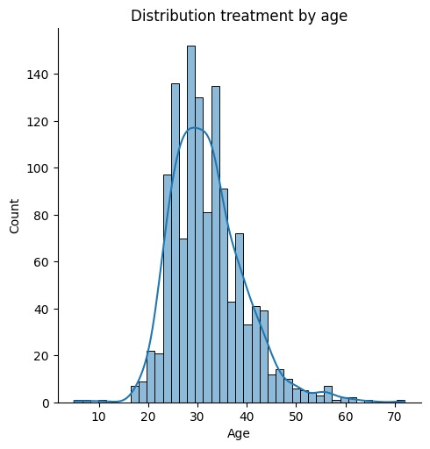

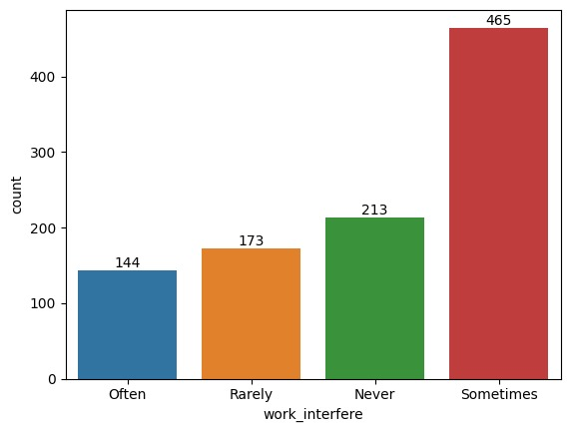

CONCLUSION:

Mental health is a vital component of our overall health and quality of life. It requires a collective effort from individuals, communities, governments, and healthcare systems to promote awareness, reduce stigma, provide access to care, and foster a society where everyone can thrive mentally and emotionally. By working together, we can create a world where mental health is valued, protected, and prioritized.