**Address of courses**

<https://github.com/laythinfo/DEPT-Fuel.class1>

**CLS**

**Internal - DOS 2.0 and above**

**Clears the screen**

………………………………………………………………………………………………………

**DATE**

**External - DOS 1.0**

**Internal - DOS 1.1 and above**

Displays or sets the date

**DEL or ERASE**

**Internal - DOS 1.0 and above**

Deletes one or more files

**DELTREE**

**External - DOS 6.0 and above**

Deletes a directory and all the subdirectories and files within it.

To Delete one or more directories:

DELTREE [/Y] [drive:]path [[drive:]path[...]]

/Y Suppresses prompting to confirm whether you want todelete the subdirectory.

[drive:]path Specifies the name of the directory you want to delete.

Note: Use DELTREE with caution. Every file and subdirectory within the

specified directory will be deleted.

**DIR**

**Internal - DOS 1.0 and above**

Displays a list of files and subdirectories in a directory.

DIR [drive:][path][filename] [/P] [/W] [/A[[:]attribs]] [/O[[:]sortord]]

[/S] [/B] [/L]

[drive:][path][filename] Specifies drive, directory, and files to list

**EXIT**

**Internal - DOS 2.0 and above**

Quits the COMMAND.COM program (command interpreter).

HELP

External - DOS 5.0 and above

Displays command help.

**LABEL**

**External - DOS 3.0 and above**

Creates, changes, or deletes the volume label of a disk.

LABEL [drive:][label]

**MEM**

**External - DOS 4.0 and above**

Displays the amount of used and free memory in your system.

Note not work for windows 64bit

**MKDIR or MD**

**Internal - DOS 2.0 and above**

Creates a directory.

MKDIR [drive:]path

MD [drive:]path

**PAUSE**

**Internal - DOS 1.0 and above**

Suspends processing of a batch program and displays the message "Press any key to continue...." (For DOS

4.01 and above) or "Strike a key when ready..." (For DOS 4.0 and below).

**TREE**

**External - DOS 2.0 and above**

Graphically displays the directory structure of a drive or path.

TREE [drive:][path] [/F] [/A]

/F Displays the names of the files in each directory.

**TYPE**

**Internal - DOS 1.0 and above**

Displays the contents of a text file.

TYPE [drive:][path]filename

**VER**

**Internal - DOS 2.0 and above**

Displays the DOS version.

**ECHO**

**Internal - DOS 2.0 and above**

Displays messages, or turns command-echoing on or off.

ECHO [ON | OFF]

ECHO [message]

type ECHO without parameters to display the current echo setting

**copy con [file .txt].**

**type copy con to create file txt**

**…………………………………………….**

**EXAMPLE**

**What is the commands that used en ms-dos OS to create the following tree?justify your answer.**

**C:\cours>**

**C1**

**Lesson1…page.txt**

**C2**

**Lesson2**

**C3**

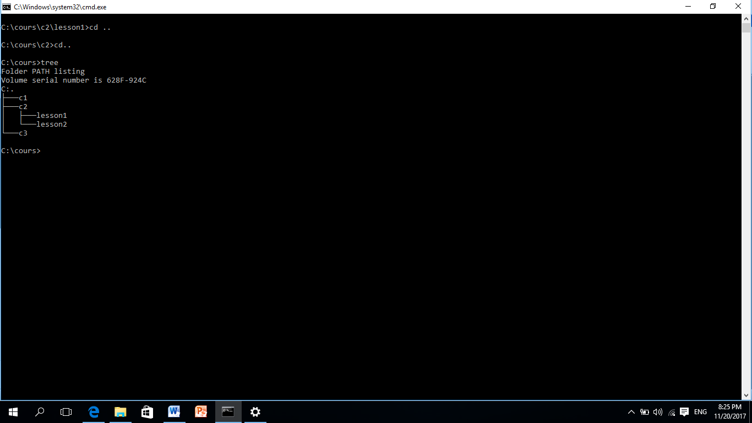

C:\ MD COURS

C:\ CD COURS

C:\COURS>MD C1

C:\COURS>MD C2

C:\COURS>MD C3

C:\COURS>CD C2

C:\COURS\CD2>MD LESSON1

C:\COURS\CD2>MD LESSON2

C:\COURS\CD2>CD LESSON1

C:\COURS\CD2\LESSON1>COPY CON PAGE.TXT

Note/enter the content of your file (page.txt) then press

CTRl+Z from keyboard to exit