**Q1/locking Your Workstation in O.S windows?**

**When you leave your workstation temporarily, it is important that you lock it so that no-one else can access the system using your username and password. To lock your workstation use the same keys that you used to log on ie CTRL, ALT and DELETE keys.**

**• press the CTRL, ALT and DELETE keys**

**simultaneously;**

**• the Windows Security dialog box will appear;**

**• Click on LOCK COMPUTER**

**• OR PRESS  + L.**

**NOTE: Remember, it is always best to lock your workstation when you leave it unattended so that no-one else can use your username and password**

* **Show this windows then show Task manager.**



**Press alt+ctrl+Delete.**

**Q2/what version of operating system do you have in your pc ?**

**From windows run write winver.**

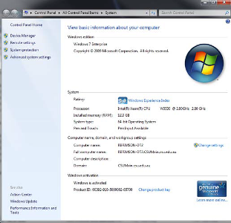

**Or You can tell what version you have (either at work, or at home) by:**

**1. Find the MY COMPUTER icon on the desktop;**

**2. Right mouse click on this icon and select PROPERTIES from the shortcut menu. The SYSTEM PROPERTIES dialog box will appear. This shows what version of Windows you are currently operating in.**

**Introduction to desktop?**

**Q1/ How can you open any icons in desktop?**

**To open an icon you point to it with your mouse and then double-click on it using the left mouse button.**

**Q 2/Change the desktop background from this path C:\users\public \pictures**

**Q3/change the screen saver to be Bubbles.**

**Q4/how much Ram that installed on this Computer?**

**Q5/change default keyboard to English or Arabic?**

**Q 6/Use Help Function to find information about print picture.**

**Q7/Display recent items that has been accessed by this pc.**

**Q 8/shut down not responding application for current user.**

**Q 9/use Start menu to open paint application.**

**Q 10/open word application from menu start**

**Q 11/create new rich text Document Rtf on desktop**

**Q12/ navigateتنقل between opened files or folder in Desktop.**

**Q13/ move window that has been opened to upper left corner**

**Q14/ view icons in desktop in small view**

**Q15/ create new folder and change its icons.**

**Q 16/Create two folders and one file in Users in this path C:\users**

**Q17/ empty recycle bin on this pc.**

**Q18/ Create hidden folder in desktop then show it.**

**Q19/ Select all icons in desktop from keyboard .**

**Q20/ Create new folder and move it to users folder.**

**21/Create new folder and rename it to Fuel .**

**22/show windows as cascade.**

**23/change the time from The notification area.**

**24/Sort(رتب) and View the content of folder program files by list then by size.**

**25/Sort all folder program files descending order by date modify .**

**26/Use search to find word pad application .**

**27/minimize windows of calculator application.**

**28/Create shortcut for calculator application on desktop.**

**29/Change resolution desktop windows to be 1024*768.**

**30/show gadgets clock on desktop.**