Dynamic Routing Protocol Simulator & Visualizer
Computer Networks Project Report
Submitted By
Laiba Bint-e-Zia
23k-0006

Layyana Junaid
23k-0056

FAST School of Computing National University of Computer & Emerging Sciences

1. Motivation
Network protocols are foundational to modern computing, yet their internal mechanics remain opaque to most students and practitioners who learn about them only through static diagrams and theoretical descriptions. Understanding how routing decisions are made in real time and how the network adapts when links fail requires more than textbook knowledge. This project was motivated by the need to bridge that gap: to create an interactive, visual platform where users can directly observe how RIP, OSPF, EIGRP, and BGP operate, converge, and respond to topology changes. By making the invisible visible, this simulator transforms abstract algorithmic concepts into concrete, observable network behaviour.

2. Overview
This project presents a full stack simulation platform designed to visualize and analyze the behaviour of four primary dynamic routing protocols: RIP, OSPF, EIGRP, and BGP. The application provides a real time, interactive environment where users can configure network topologies, simulate link failures, and observe how routing algorithms adapt dynamically. By integrating a FastAPI backend with a React based visualization layer, the project bridges the gap between theoretical protocol mechanics and practical network behaviour. It supports both an internal academic simulation engine and professional-grade emulation via GNS3 REST API integration.

3. Significance of the Project
Dynamic routing protocols are at the core of how the Internet functions. Despite their importance, most educational tools present them only in static or highly simplified forms. This project is significant because it:
- Implements real mathematical algorithms (Bellman-Ford, Dijkstra, DUAL, Path Vector) not animated fakes.
- Provides side-by-side protocol comparison using measurable KPIs: convergence time, control message overhead, and packet loss.
- Bridges academic simulation and professional network engineering through GNS3 integration.
- Offers zero setup learning with a built-in simulation engine, making it immediately accessible to students.
- Enables educators to demonstrate protocol behaviour live in the classroom without requiring physical network hardware.

4. Description of the Project
The Dynamic Routing Protocol Simulator & Visualizer is a web application that allows users to construct virtual network topologies and run discrete time simulations of four major routing protocols. Users can select from pre-built topologies (e.g., a 6-router mesh, a BGP 3-AS topology, or a GNS3-imported lab) or design their own. Once a simulation is started, the platform streams live routing events to a React frontend via WebSockets, animating packet flows, routing table changes, and convergence indicators in real time. A failure injection mechanism allows users to take links offline mid simulation and observe how each protocol detects and recovers from the disruption

5. Background of the Project
Dynamic routing protocols automate the process of path selection in IP networks. Each protocol family uses a distinct algorithmic approach:
- RIP (Routing Information Protocol): Uses the Bellman-Ford algorithm with hop count as the metric. Simple but limited to small networks (max 15 hops) and slow to converge.
- OSPF (Open Shortest Path First): A link-state protocol that runs Dijkstra's SPF algorithm. Routers maintain a full topology map (LSDB) and compute shortest paths independently. Scales well and converges quickly.
- EIGRP (Enhanced Interior Gateway Routing Protocol): A Cisco hybrid protocol using the DUAL algorithm with a composite metric of bandwidth and delay. Maintains pre-computed backup paths (feasible successors) for fast failover.
- BGP (Border Gateway Protocol): The inter-domain routing protocol of the Internet. Uses path-vector routing with rich policy attributes (AS_PATH, Local Preference, MED) to make routing decisions across Autonomous Systems.

6. Project Category
This project is a Product based project. It delivers a fully functional, web application that can be used for educational purposes in university Computer Networks courses. It also incorporates Research based elements through the implementation of actual protocol algorithms from first principles and the comparative performance analysis of routing protocols under controlled simulation conditions.

7. Features / Scope / Modules

7.1 Real-Time Protocol Visualization
The most distinctive feature of the platform is its live, animated visualization of routing protocol behaviour. When a simulation runs, users observe colour coded animated packets travelling between routers, routing tables updating in real time, red failure markers appearing on broken links, and a convergence indicator signalling when all routers have stabilized. This makes abstract algorithmic concepts immediately tangible.

7.2 Four Protocol Implementations (Ground-Up)
Each protocol is implemented as a true discrete-step simulation engine. RIP implements Bellman-Ford with split-horizon, poison-reverse, triggered updates, and the count-to-infinity demonstration. OSPF implements LSA flooding, a full LSDB, and per-router SPF computation. EIGRP implements DUAL with successor/feasible-successor management and the feasibility condition. BGP implements eBGP peering, AS_PATH loop prevention, and the full BGP decision process.

7.3 Performance Metrics & Protocol Comparison
Three KPIs are tracked and graphed in real-time: convergence time (how quickly the network stabilizes), control message overhead (the number of protocol packets generated), and packet loss (traffic dropped during the instability window). A side-by-side comparison tab shows all four protocols simultaneously, enabling direct quantitative comparison.

7.4 Failure Injection
Users can select any link from a dropdown and take it offline mid-simulation. The system immediately triggers protocol-specific failure handling RIP sends triggered updates and may exhibit count-to-infinity; OSPF floods updated LSAs and recomputes SPF; EIGRP switches to its feasible successor if available; BGP withdraws affected routes and re-advertises alternatives.

7.5 GNS3 Integration
Advanced users can connect the application to a live GNS3 server to import real topologies, mirror link failures to actual router interfaces via the GNS3 REST API, and use the web UI as a dashboard for GNS3 labs. When no GNS3 server is detected, the app automatically falls back to the built-in simulator.

7.6 Modular, Extensible Architecture
Each protocol is a self contained Python class with a standardized interface, making it straightforward to add new protocols (e.g., IS-IS, RIPng) without modifying the core simulation engine. The frontend reacts to a unified WebSocket event stream, so new protocol visualizations can be added with minimal frontend changes.

9. Protocol Implementations
Each protocol is implemented as a real discrete step simulation engine grounded in its actual algorithm.

9.1 RIP Distance Vector / Bellman-Ford
- Metric: Hop count with a maximum of 15 (metric 16 = unreachable).
- Periodic updates broadcast to all direct neighbours every X simulation steps.
- Split-horizon and poison-reverse implemented to prevent routing loops.
- Count-to-infinity problem simulated to illustrate RIP's key limitation.
- Triggered updates fire immediately on link failure, bypassing the periodic timer.

9.2 OSPF Link-State / Dijkstra
- Metric: Cost, calculated as Reference Bandwidth ÷ Interface Bandwidth.
- Link State Advertisements (LSAs) flooded across the entire topology.
- Every router maintains a full Link State Database (LSDB) for complete network visibility.
- Each router runs Dijkstra's SPF algorithm locally to build its own shortest path tree.
- Rapid reconvergence on failure significantly faster than RIP.

9.3 EIGRP DUAL Algorithm
- Metric: Composite, based on Bandwidth and Delay.
- Successor (best path) and Feasible Successor (pre-computed backup) maintained per destination.
- Feasibility Condition (AD < FD) strictly enforced to guarantee loop-free backup paths.
- Active Query-Reply phase triggered only when no feasible successor is available.
- Partial updates sent on topology change no periodic full-table broadcasts.

9.4 BGP Path Vector
- Metric: Path attributes AS_PATH, Local Preference, and MED.
- Simulates inter-AS routing across multiple independent Autonomous Systems.
- Loop prevention via AS_PATH: routes containing the local AS are discarded.
- eBGP peering, route advertisement, and withdrawal messages all modeled.
- BGP decision process: Local Pref → AS_PATH length → MED → eBGP over iBGP.

11. Project Planning
The project was completed in three phases over the course of the semester:

Phase | Tasks | Weeks
Phase 1: Design | Requirements analysis, system architecture design, technology selection, protocol research | Weeks 1–3
Phase 2: Implementation | Backend protocol engines (RIP, OSPF, EIGRP, BGP), WebSocket manager, React frontend, GNS3 client | Weeks 4–10
Phase 3: Testing & Report | Integration testing, performance benchmarking, GNS3 validation, documentation | Weeks 11–14

Laiba Zia was primarily responsible for the backend simulation engine and protocol implementations. Layyana Junaid led the React frontend, WebSocket integration, and GNS3 client development.

12. Project Feasibility

12.1 Technical Feasibility
The project is fully realized using mature, widely-supported technologies: Python 3 with FastAPI for the backend, React with React Flow and Recharts for the frontend, and WebSockets for real-time communication. All four routing algorithms are well-documented in networking literature. The GNS3 REST API is publicly documented and stable. No proprietary or unavailable technology was required.

12.2 Economic Feasibility
All technologies used are open-source and free of charge. Development required only standard personal computers with Python and Node.js installed. GNS3, React Flow, FastAPI, and all supporting libraries are available at no cost. Deployment requires only a basic web server. The total development cost is effectively zero beyond student time.

12.3 Schedule Feasibility
The project was completed within the allocated 14-week semester timeline. The phased approach (design, implementation, testing) allowed incremental progress with clear milestones. The modular architecture meant that protocol implementations could be developed and tested independently, reducing integration risk.

13. Hardware and Software Requirements

Software
- Python 3.10+ with FastAPI, uvicorn, websockets
- Node.js 18+ with React, React Flow, Recharts, Framer Motion, Zustand
- GNS3 (for advanced emulation mode)
- Any modern web browser (Chrome, Firefox, Edge)

Hardware
- Standard development machine: 8GB RAM, quad-core CPU (minimum)
- 16GB RAM recommended when running GNS3 with router images
- No specialized networking hardware required for the built-in simulation mode

10. Diagrammatic Representation of the Overall System
The following figures illustrate the key functional components of the simulator as captured from the live application. 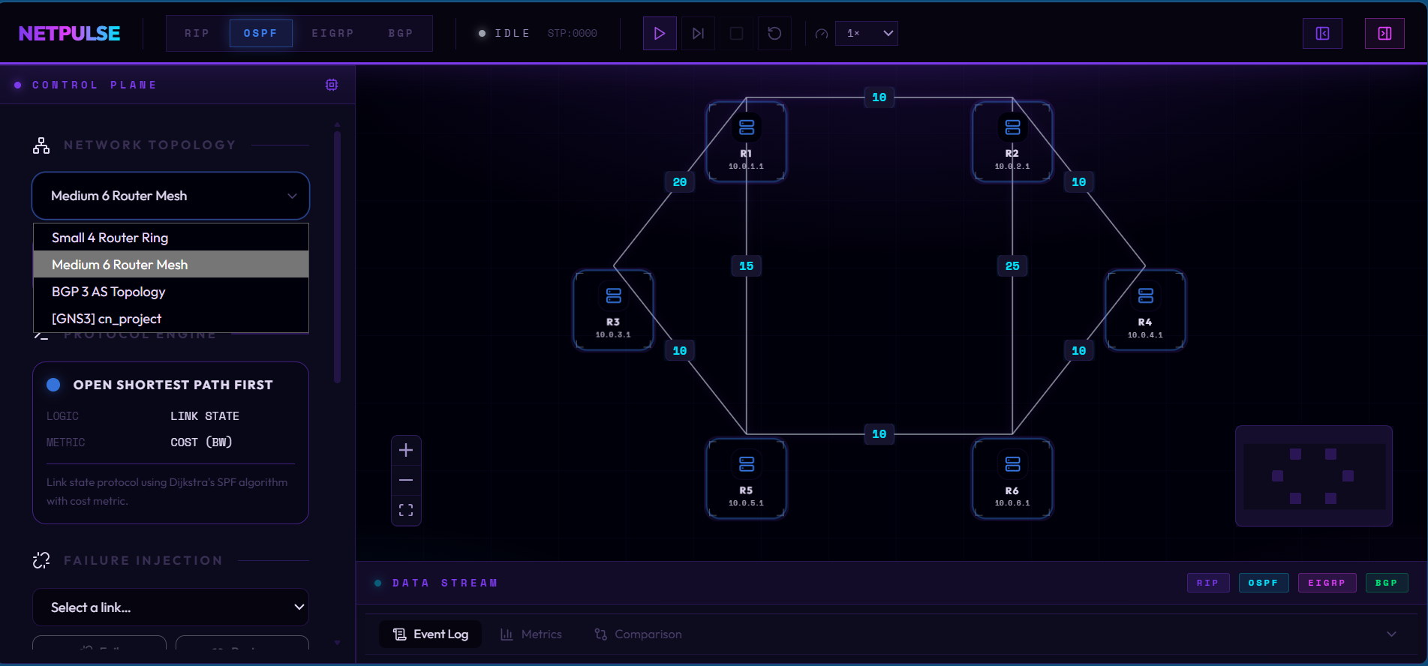
Figure 1. NETPULSE Main Application UI showing the topology canvas with a 6-router mesh network (R1–R6, each with a /24 subnet), the OSPF protocol engine selected in the left Control Plane panel, and link cost labels displayed on each connection. The network topology dropdown is open, showing available presets: Small 4 Router Ring, Medium 6 Router Mesh, BGP 3 AS Topology, and [GNS3] cn_project. The simulation is in IDLE state (STP:0000) awaiting user-initiated start.
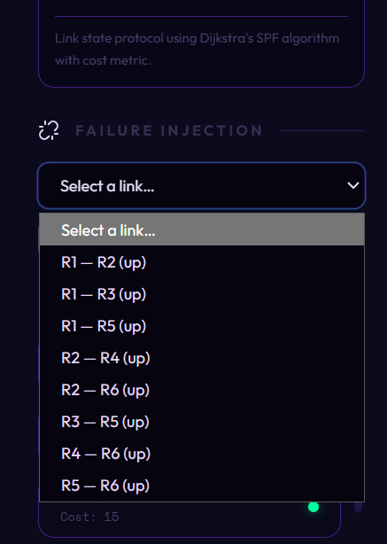
Figure 2. Failure Injection Panel showing the link selection dropdown expanded for the 6-router mesh topology. All active links between routers are listed (R1–R2, R1–R3, R1–R5, R2–R4, R2–R6, R3–R5, R4–R6, R5–R6), each marked '(up)' to indicate they are currently operational. Selecting any link from this list and clicking 'Fail' removes it from the simulation, triggering protocol-specific failure recovery. The cost label at the bottom (Cost: 15) corresponds to the highlighted R1–R3 link.

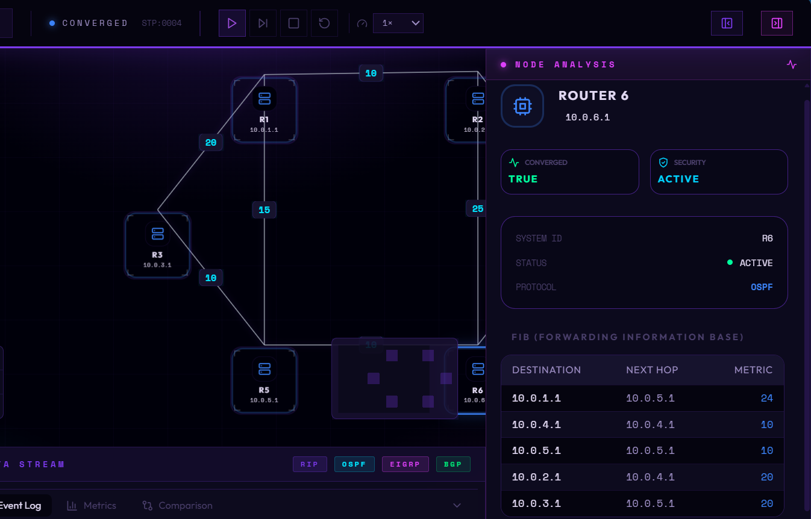
Figure 3. Node Analysis Panel for Router 6 (IP: 10.0.6.1) after OSPF convergence (STP:0004). The panel confirms the router has converged (CONVERGED: TRUE) and is in ACTIVE security state, running the OSPF protocol. The Forwarding Information Base (FIB) table shows Router 6's computed routing table entries: destination 10.0.1.1 via next-hop 10.0.5.1 (metric 24), 10.0.4.1 via 10.0.4.1 (metric 10), 10.0.5.1 via 10.0.5.1 (metric 10), 10.0.2.1 via 10.0.4.1 (metric 20), and 10.0.3.1 via 10.0.5.1 (metric 20) all consistent with Dijkstra's shortest-path calculation from R6's perspective.

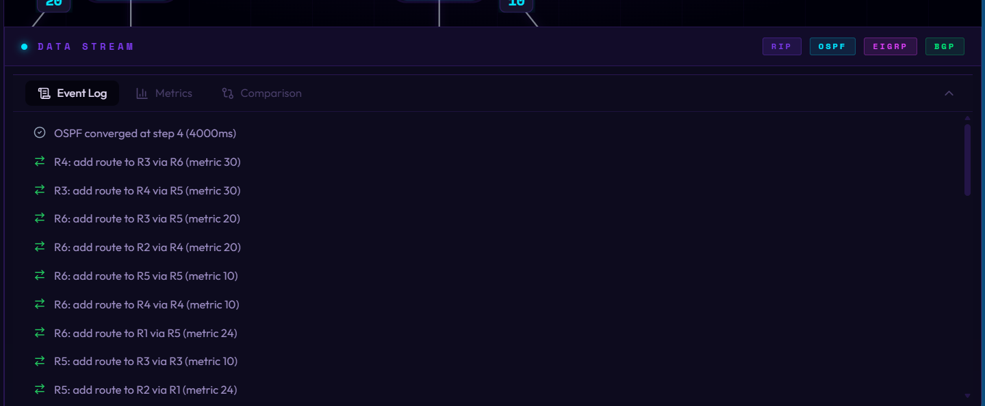
Figure 4. Data Stream — Event Log tab showing the real-time routing event feed during an OSPF simulation run. The top entry confirms OSPF converged at simulation step 4 (4000ms). The subsequent entries show the route-addition events that occurred during convergence: R4 learns a route to R3 via R6 (metric 30); R3 learns a route to R4 via R5 (metric 30); R6 learns routes to R3 via R5 (metric 20), to R2 via R4 (metric 20), to R5 via R5 (metric 10), to R4 via R4 (metric 10), and to R1 via R5 (metric 24); R5 learns routes to R3 via R3 (metric 10) and to R2 via R1 (metric 24). This log provides a step-by-step audit trail of the SPF computation propagating through the network.

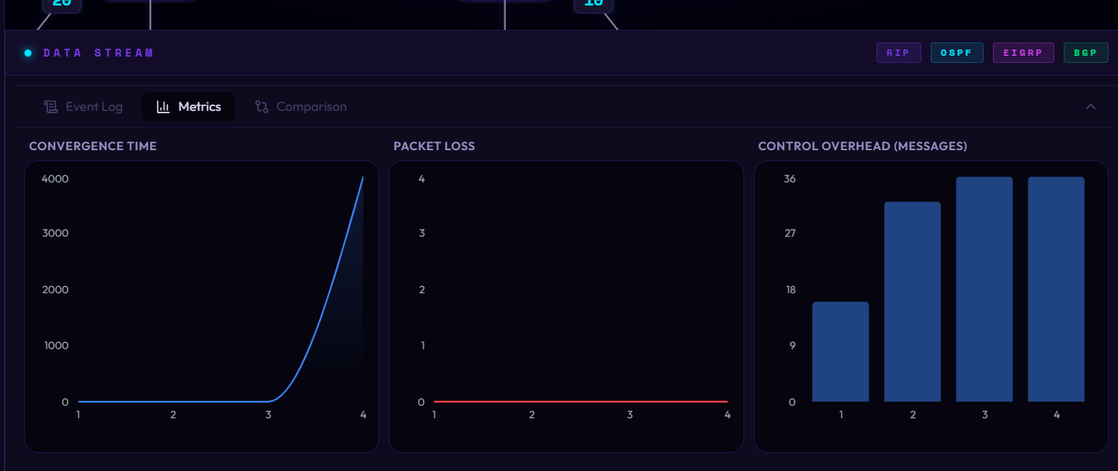
Figure 5. Data Stream Metrics tab displaying three real-time KPI charts for OSPF across four simulation steps. The Convergence Time chart (left) shows a steep exponential-like curve peaking at 4000ms at step 4, reflecting the cumulative time for all LSAs to flood the topology and SPF to complete on every router. The Packet Loss chart (centre) shows a flat line at zero throughout — consistent with OSPF's rapid reconvergence minimizing the instability window. The Control Overhead chart (right) shows a stepped bar graph with message counts of approximately 16 (step 1), 33 (step 2), 36 (step 3), and 36 (step 4), representing the cumulative LSA flood messages generated to achieve full network convergence.

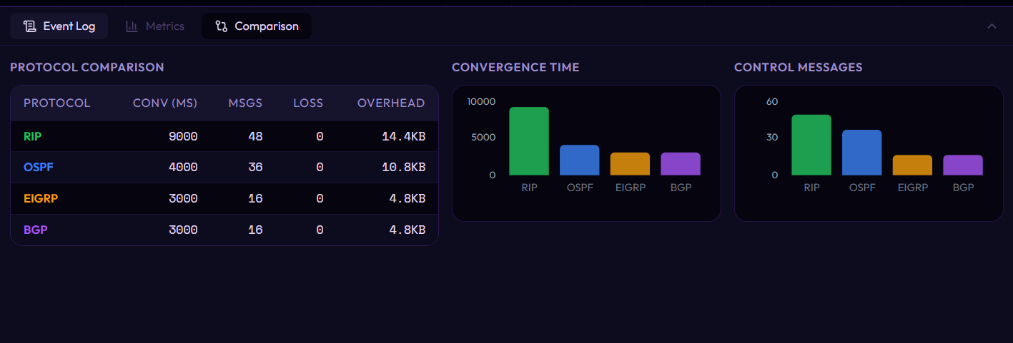
Figure 6. Data Stream Comparison tab providing a side-by-side protocol comparison table and bar charts for all four protocols. RIP exhibits the worst performance: convergence time of 9000ms, 48 control messages, and 14.4KB overhead a direct consequence of its slow periodic-update mechanism. OSPF improves significantly at 4000ms convergence, 36 messages, and 10.8KB overhead, thanks to LSA flooding and Dijkstra's fast path computation. EIGRP and BGP both achieve the best convergence time of 3000ms with only 16 messages and 4.8KB overhead each — EIGRP due to its pre-computed feasible successors enabling immediate failover, and BGP due to its targeted path-vector update propagation. All protocols recorded zero packet loss in this test scenario. The bar charts on the right visually confirm RIP's dominance in both convergence time and control message count.

15. Conclusion
This project successfully demonstrates the complexities of modern network routing by implementing real mathematical algorithms Bellman-Ford, Dijkstra, DUAL, and Path Vector and exposing their behaviour through a rich, real-time visual interface. Abstract protocol mechanics become concrete and observable, directly supporting deeper learning in Computer Networks courses.

The modular backend architecture ensures that additional protocols such as IS-IS or RIPng can be incorporated with minimal effort. The GNS3 integration further extends the platform's relevance beyond the classroom, bridging academic simulation and professional network engineering. The comparative analysis clearly demonstrates the trade-offs between simplicity (RIP), scalability (OSPF), fast failover (EIGRP), and policy-rich inter-domain routing (BGP).

16. References
[1] B. A. Forouzan, Data Communications and Networking, 5th ed. McGraw-Hill, 2012.
[2] A. S. Tanenbaum, Computer Networks, 5th ed. Pearson, 2010.
[3] GNS3 REST API Documentation. [Online]. Available: https://docs.gns3.com/
[4] React Flow Library. [Online]. Available: https://reactflow.dev/
[5] FastAPI Documentation. [Online]. Available: https://fastapi.tiangolo.com/

