EECS 3311 Course Project - Stage 1 Design Report

AI Cycling Training Coach

Project Overview
  - Project Description
Problem:
As sports training becomes more science-based, cycling training has also become more structured and data-driven. Cycling includes many different types of training, each designed to improve different aspects of performance. It is impossible to fit all these types of training into a cyclist’s plan, and without a professional, it is also difficult to know which type of training is needed most.
One common measurement used in cycling is Functional Threshold Power (FTP). FTP is an estimate of the highest average power, measured in watts, that a cyclist can sustain for about one hour. It is commonly used as a benchmark for cycling fitness and data-driven training.
Recreational and amateur cyclists have limited time and energy to dedicate to training, and many are unsure how to train effectively, what type of workout to perform, when to recover, or how to fit structured training into their daily lives. Although cycling training information is available from many sources, interpreting that information and turning it into a plan is difficult without access to a personal coach.
The AI Cycling Training Coach is intended to help cyclists organize their training by analyzing the rider’s performance data, health data, training history, goals, and weekly schedule. This system will provide tailored plans for cyclists, suggestions the best workouts to improve, and explain questions that the cyclist might have about their training.

Target Users:
Target users are recreational and amateur cyclists who have a clear training goal, such as improving fitness, or becoming healthier. These users are expected to record training data with devices such as bike computers, heart rate monitor, or power meter.

Agent Capabilities:
The AI Cycling Training Coach will analyze a rider’s training data, fitness data, goals, and weekly schedule to provide personalized training guidance. The agent can generate training plans, recommend workouts, analyze completed rides, identify areas for improvement, suggest recovery when needed, and answer natural-language questions about the rider’s training. The agent can also adjust future recommendations based on the rider’s needs.
Why an AI Agent is Appropriate:
An AI agent is appropriate for this project because there are many factors that can affect a cyclist’s training, such as their health, fitness, fatigue, and how much time they have available. A program based on fix rules is not enough to look at all these factors of the rider’s situations. The AI agent can interpret all the rider’s data, answer the rider’s questions, explain training workouts, and adjust training to the rider’s progress and needs.
Planned AI/LLM Model:
This project plans to use a DeepSeek LLM through the DeepSeek API as the AI model.
AI Interaction with the Software System:
The application will send relevant rider data and questions to the DeepSeek LLM through its API, and the model’s response will be returned to the application and shown to the user.

  - Feature Specification
Feature ID and name:
F01 – Rider Profile Setup
Description: Allows the cyclist to create a profile that stores information needed for personalized training.
User Interaction: The user enters or edits the information through a profile page.
Input: Weight, FTP, maximum heart rate, resting heart rate, available training days, target weight, target FTP, main goal (short text).
Output: Saved rider profile.
AI Involvement: Deterministic.
Workflow: The cyclist enters the information and saves the profile.
Error Case: Invalid or missing values are rejected.

F02 – Ride Data Import
Description: Allows rider to upload a .csv file from a completed ride.
User Interaction: the user uploads a .csv file through an upload page.
Input: CSV file.
Output: store data such as date, duration, power, heart rate, and cadence.
AI Involvement: Deterministic.
Workflow: The cyclist uploads the file, the system parses it, and the data is saved in the rider’s history.
Error Case: if the uploaded file is invalid, missing required data, or cannot be read, the system shows an error message.

F03 – AI Ride Analysis
Description: Analyze one completed ride and provide a summary of the rider’s performance.
User Interaction: the user selects a ride from their ride history and clicks analyze.
Input: Data from ride history and user profile.
Output: AI-generated ride summary and observations.
AI Involvement: Hybrid.
Workflow: The system retrieves the data and sends the information to LLM. The LLM analyzes the ride and returns a summary.
Error Case: If the ride data is missing or incomplete, the system shows an error message.

F04 – Weekly Training Plan Generation
Description: Use LLM and rider’s information to generate a weekly training plan.
User Interaction: The user clicks generate button.
Input: Rider’s profile and rider’s ride history.
Output: A weekly training plan with recommended workouts and recovery for each training day.
AI Involvement: Hybrid
Workflow: The system collects the rider’s information and sends it to LLM. The LLM returns a weekly training plan, and the system displays it to the user.
Error Case: If the ride data is missing or incomplete, the system shows an error message.

F05 – AI Chat
Description: Allows the rider to ask questions about their training.
User Interaction: The user types a question into a chat page.
Input: Rider’s question, rider’s profile, and ride history.
Output: AI-generated answer.
AI Involvement: Hybrid.
Workflow: The system receives the rider’s questions, collects recent ride history, sends them to the LLM, and displays the response.
Error Case: If the LLM does not respond or data is unavailable, the system shows an error message.

F06 – Progress Tracking
Description: Shows how the rider’s performance changes over time and comparison to their goal.
User Interaction: the user opens a progress page.
Input: Saved FTP, weight, ride history, and goals.
Output: Progress charts or trend information over time.
AI Involvement: Deterministic.
Workflow: The system reads the rider’s saved data and displays changes over time.
Error Case: if there is not enough data, the system informs the user.

F07 – Weakness/Improvement Detection
Description: Uses the user’s training history to identify areas of improvement
User Interaction: The user clicks an Analyze Progress button.
Input: Rider’s profile and ride history.
Output: AI-generated feedback for improvement.
AI Involvement: Hybrid.
Workflow: The system uses AIChatService with a predefined prompt. The LLM analyzes the data and respond.
Error Case: If there is not enough training data, the system tells the user that more data is needed.

F08 – Weekly Training Summary
Description: Provides a summary of the rider’s ride history of the past week.
User Interaction: the user opens the weekly summary page.
Input: Rider’s profile and ride history.
Output: Weekly training summary.
AI Involvement: Hybrid.
Workflow: The system uses AIChatService with a predefined prompt. The LLM analyzes the data and respond.
Error Case: If there are no rides in the past week, the system will show an error message.

F09 – Ride Comparison
Description: Compares the data from two rides in the ride history.
User Interaction: the user clicks the compare button in ride history and then selects another ride in the ride history.
Input: Ride history.
Output: Comparison of values such as duration, power, heart rate and cadence.
AI Involvement: Deterministic.
Workflow: The system collects the two selected rides, compares their data, and displays the difference.
Error Case: if there is missing data from the ride, the system shows an error message.

F10 – Workout Calendar
Description: Displays the rider’s planned and completed workouts on a calendar.
User Interaction: the user opens the calendar page.
Input: Weekly training plan and completed ride history.
Output: Display a calendar of planned workouts and completed rides.
AI Involvement: Deterministic.
Workflow: The system collects the rider’s weekly training plan and completed rides, then display them in a calendar.
Error Case: If there are no completed rides or plans, the calendar is empty.

F11 – Personal Berst
Description: Displays the rider’s best performance values from ride history in the past month.
User Interaction: the user opens the personal best page.
Input: Ride History.
Output: Best values such as longest distance, highest average power, highest maximum power, and fastest average speed.
AI Involvement: Deterministic.
Workflow: The System compares the rider’s stored rides and finds the best values for each category.
Error Case: If there are no completed rides, the system tells the user that no personal bests are available.

2.1 Class Diagram
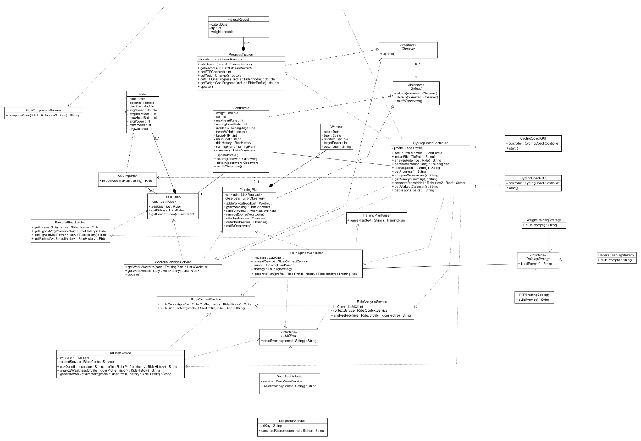
2.1.1 Adapter Pattern
This pattern is used to connect the application with the DeepSeek service without making the rest of the system dependent on DeepSeek. With the use of the adapter DeepSeekAdapter, DeepSeek specific code is hidden from classes such as AIChatService, RideAnalysisService, and TrainingPlanGenerator. LLMClient is the target interface, DeepSeekAdaptor is the adapter, and DeepSeekService is the adaptee that contains the DeepSeek implementation. The adapter allows the code to be more flexible and easier to maintain because the rest of the system only depends on the LLMClient interface. If another LLM provider is used in the future, a new adapter can be created without changing the other AI-related classes.
2.1.2 Façade Pattern
The Façade Pattern is used with the controller. It allows the GUI and CLI to have a single point of entry to the application and its features. The GUI and CLI communicate with CyclingCoachController instead of directly communicating with backend classes such as CSVImporter, AIChatService, and other service classes. CyclingCoachController acts as the façade, while the backend classes form the subsystem. This pattern reduces the amount of backend detail that the GUI and CLI need to know and makes the system easier to maintain and modify.
2.1.3 Observer Pattern
The Observer Pattern is used to keep related data automatically updated. In this project, RiderProfile and TrainingPlan act as subjects. Changes to them can automatically notify ProgressTracker and WorkoutCalendarService, which act as observers. This allows related data to be updated when changes occur. The pattern also reduces coupling because the subjects do not need to know the classes that are observing them. They only communicate through the Observer interface, which makes it easier to add or remove observers later.
2.1.4 MVC Pattern
This pattern is used to separate the user interface from the backend classes and logic. CyclingCoachGUI and CyclingCoachCLI act as the View, CyclingCoachController acts as the Controller, and backend classes such as AIChatService and RideHistory make up the Model. By separating the system into these parts, it allows the GUI and CLI to change without requiring major changes to the backend logic. It also allows both interfaces to reuse the same controller and model classes, which reduces duplication and makes the system easier to maintain.
2.1.5 Strategy Pattern
The strategy pattern is used to change how weekly training plan is generated based on what the main goal of the rider is. TrainingStrategy is the strategy interface, and FTPTrainingStrategy, WeightTrainingStrategy, and GeneralTrainingStrategy is the concret strategies. When a training plan is generated, the prompt will differ base on the rider’s main goal. This pattern makes the training plan generation more flexible and easy to extend.

2.2 Use Case Description
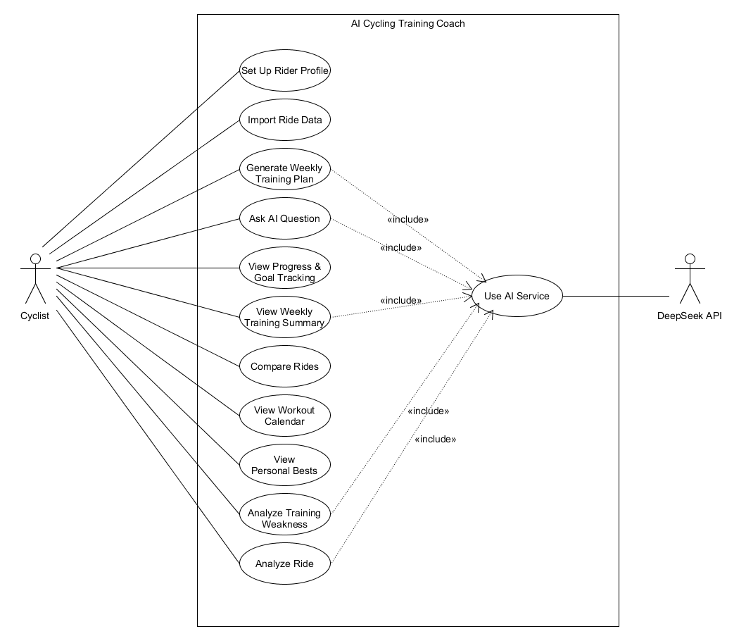
UC01 – Set Up Rider Profile
Actor: Cyclist
Goal: Create or update the rider’s profile
Preconditions: the application is running
Trigger: The rider selects rider profile setup
Main Success Scenario:
- The rider opens rider profile
- The rider enters all data
- The rider select save
- The GUI sends the profile to CyclingCoachController
- The controller updates RiderProfile
- RiderProfile notifies its observer of the change
- The system confirm that the profile is saved
Exception:
- If not all data is filled in, the system display an error message
- If a value enter is invalid, the system rejects and ask for correction
Postconditions: The rider profile contains the updated rider information.
Related Feature: F01 – Rider Profile Setup
UC02 – Import Ride Data
Actor: Cyclist
Goal: Import a completed ride data from a CSV file to RideHistory
Preconditions: the application is running and csv File is valid and formatted correctly.
Trigger: The rider selects upload ride.
Main Success Scenario:
- The rider selects a csv file
- The GUI sends the filepath to CyclingCoachController
- The controllers uses CSVImporter
- CSVImporter reads the csv file and create Ride object
- The controller adds the new Ride object to RideHistory
- The system confirm that the ride is imported
Exception:
- If file is missing or cannot be opened, the system display an error
- If csv format is invalid or data is missing, the system rejects the file
- If the ride cannot be parsed correctly, no ride is added to RideHistory
Postconditions: The ride is stored in RideHistory
Related Feature: F02 – Ride Data Import
UC03 – Analyze Ride
Actor: Cyclist
Goal: Analyze a selected completed ride from RideHistory and receive an AI-generated summary
Preconditions: the application is running, the rider have profile, and one completed ride in RideHistory
Trigger: The rider selects a ride and choose the Analyze Ride Option
Main Success Scenario:
- The rider slects a completed ride from RideHistory
- The GUI sends the selected ride to CyclingCoachController
- The controller calls RideAnalysisService
- RideAnalysisService use RideContextService to prepare rider and ride’s information
- The returned prompt is sent to DeepSeekAdaptor then to DeepSeekService
- DeepSeek generates a response
- The response is returned to the controller
- The GUI displays the response
Exception:
- If no ride is selected, the system ask the rider to select a ride
- If the AI service is unavailable, the system display an error message
- If the ride data is incomplete, the system informs rider that the ride cannot be analyzed.
Postconditions: The cyclist receives an AI generated response of the ride
Related Feature: F03 – Rider Profile Setup
UC04 – Generate Weekly Training Plan
Actor: Cyclist
Goal: generate a weekly training plan
Preconditions: the application is running, and rider profile is created
Trigger: The rider selects generate a weekly training plan
Main Success Scenario:
- The GUI sends the request to CyclingCoachController
- The controller calls TrainingPlanGenerator
- TrainingPlanGenerator checks the rider’s main goal, choose the right TrainingStrategy, return prompt
- RiderContextService turns rider’s profile and ride history into another prompt, and return
- Combine both prompt and it is send through DeepSeekAdaptor to DeepSeekService
- DeepSeek returns a generated weekly training plan
- TrainingPlanParser converts the response into a TraingingPlan object
- TrainingPlanGenerator notifies its observers that the plan has changed
- WorkoutCalendarService receives the update and refresh the calendar
- The training plan is returned to the controller.
- The GUI displays the generated training plan
Exception:
- If rider profile is incomplete, the system ask the cyclist to complete the missing information
- If DeepSeek is unavailable, the system displays an error
- If the generated response cannot be parsed into a valid training plan, the system reports the error and does not save the plan
Postconditions: a new weekly training plan is available for the cyclist
Related Feature: F04 – Weekly Training Plan Generation
UC05 – Ask AI Question
Actor: Cyclist
Goal: allows the cyclist to ask AI question and get an AI response based on rider’s information
Preconditions: the application is running, and rider profile is complete
Trigger: The rider types a question in the AI chat and sends it
Main Success Scenario:
- The cyclist enters a question in the AI chat
- The GUI sends the question to CyclingCoachController
- The controller calls AIChatService
- AIChatService uses RiderContextService to prepare rider profile and ride history
- The question and rider context is sent through DeepSeekAdaptor to DeepSeekService
- DeepSeek returns an AI generated response
- The response is returned through AIChatService and CyclingCoachController
- The Gui display the response to the cyclist
Exception:
- If the question is empty, the system ask the rider to enter a question
- If AI service is unavailable, the system display an error message
- If rider’s information is unavailable, the system ask the cyclist to complete the information
Postconditions:The cyclist receives a response to their question
Related Feature: F05 – AI Chat
UC06 – View Progress & Goal Tracking
Actor: Cyclist
Goal: shows the cyclist changes in FTP and weight and see progress toward target FTP and target weight
Preconditions: the application is running, rider profile exist, ProgressTracker is not empty
Trigger: The rider selects the progress & goal option
Main Success Scenario:
- Cyclist select progress & goal option
- The GUI sends the request to CyclingCoachController
- The controller request progress information from ProgressTracker
- ProgressTracker calculates FTP change and weight change
- ProgressTracker compares the current value with target values that is stored in rider’s profile
- The calculated information is returned to the controller
- The GUI displays the information for the cyclist
Exception:
- If rider’s profile is missing values, the system asks the cyclist to complete
- If there is not enough fitness records, the system display the current values instead
Postconditions: The rider can value their progession towards the selected goal
Related Feature: F06 – Progress Tracking
UC07 – Analyze Weakness
Actor: Cyclist
Goal: Return an AI response of the cyclist’s weakness based on their information
Preconditions: the application is running, and rider’s profile is complete
Trigger: The rider selects analyze weakness
Main Success Scenario:
- The cyclist select analyze weakness
- The GUI sends the request to CyclingCoachController
- The controller calls AIChatService and runs analyzeWeakness()
- AIChatService uses RiderContextService to prepare the rider profile and ride history information.
- The rider’s context is combine with predefined prompt for weakness analysis
- The prompt goes through DeepSeekAdaptor to DeepSeekService
- DeepSeek returns a response
- The response is returned to the controller
- The GUI displays the response to the cyclist
Exception:
- If rider’s profile is incomplete, the system ask the rider to complete it
- If AI service is unavailable, the system displays an error message
Postconditions: The rider receive an AI generated response on their weakness
Related Feature: F07 – Weakness/Improvement Dectection
UC08 – View Weekly Training Summary
Actor: Cyclist
Goal: Provides the cyclist with a summary of their past week of training
Preconditions: the application is running, the rider’s profile is complete, and RideHistory contains ride data from the recent week
Trigger: The rider selects weekly training summary option
Main Success Scenario:
- The cyclist select weekly training summary option
- The GUI sends the request to CyclingCoachController
- The controller calls AIChatService.generateWeeklySummary()
- AIChatService calls RiderContextService to prepare rider’s information
- The information is combined with preexisting prompt
- The prompt is sent through DeepSeekAdaptor to DeepSeekService
- DeepSeek returns a summary
- The summary is returned back to the controller
- The GUI displays the summary for the cyclist
Exception:
- If there is no ride data from the recent week, the system informs the cyclist that there is not enough data
- If AI service is unavailable, then system displays an error message
Postconditions: The rider receives an summary based on their recent week of performance
Related Feature: F08 – Weekly Training Summary
UC09 – Compare Rides
Actor: Cyclist
Goal: Compare two completed ride from RideHistory
Preconditions: at least two rides are stored in RideHistory
Trigger: The rider selects one ride, choose compare, then chooses another
Main Success Scenario:
- The rider opens the ride history
- The rider selects the first ride
- The rider selects compare option
- The rider selects another ride
- The GUI or CLI sends both selected ride object to CyclingCoachController
- The controller calls RideComparisonService
- RideCOmparisonService compares values such as distance, duration, average speed, average heart rate, and average power.
- The comparison result is returned to the controller
- The GUI or CLI displays the comparison to the cyclist
Exception:
- If fewer than two ride is available in RideHistory, the system tell cyclist that two rides is required
- If cyclist selects the same ride twice, the system ask the cyclist to select a different second ride
- If some ride data is missing, the system compares the available values
Postconditions: The cyclist receives a comparison of the two selected ride
Related Feature: F09 – Ride Comparison
UC10 – View Workout Calendar
Actor: Cyclist
Goal: allows the cyclist to see planned workouts and past rides in one calendar view
Preconditions: the application is running, the rider’s profile is complete, and A TrainingPlan and/or completed ride is available
Trigger: The rider selects the workout calendar option
Main Success Scenario:
- The cyclist opens the workout calendar
- The GUI sends the request to CyclingCoachController
- The controller calls WorkoutCalendarService
- WorkoutCalendarService retrieves planned workout and completed rides from TrainingPlan and RideHistory
- The planned workouts and completed rides are combined into the calendar view
- The GUI display the calendar to the cyclist
Exception:
- If no training plan exist, the calendar shows only completed rides
- If no completed rides exist, the calendar shows only planned workout
- If there are no workouts or rides, the system display an empty calendar
Postconditions: The rider can view a calendar of their rides and planned workouts
Related Feature: F10 – Workout Calendar
UC11 – View Personal Bests
Actor: Cyclist
Goal: allows cyclist to view their best performance from their completed rides.
Preconditions: the application is running, and at least one ride in RideHistory
Trigger: The rider selects personal bests option
Main Success Scenario:
- The cyclist selects personal best option
- The GUI sends the request to CyclingCoachController
- The controller calls PersonalBestService
- PersonalBestService reads the rides stored in RideHistory
- The service identifies records such as longest distance, highest average power, highest maximum power, and fastest average speed
- The personal best results are returned to the controller
- The GUI displays the results to the cyclist
Exception:
- If there is no ride in RideHistory, the system informs the rider that no personal best is available
- If some ride data is missing, the system only return records of data that is available
Postconditions: The rider receives the personal best results
Related Feature: F11 – Personal Best Detection

  - Sequence Diagram
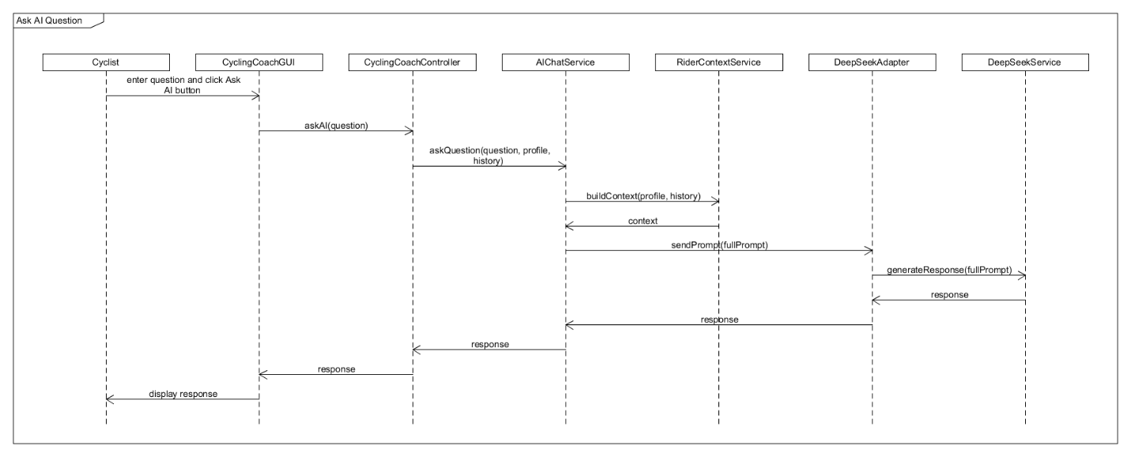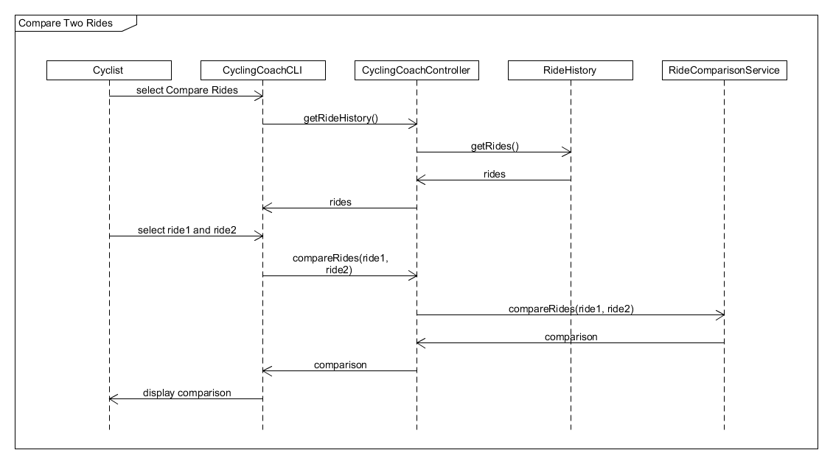
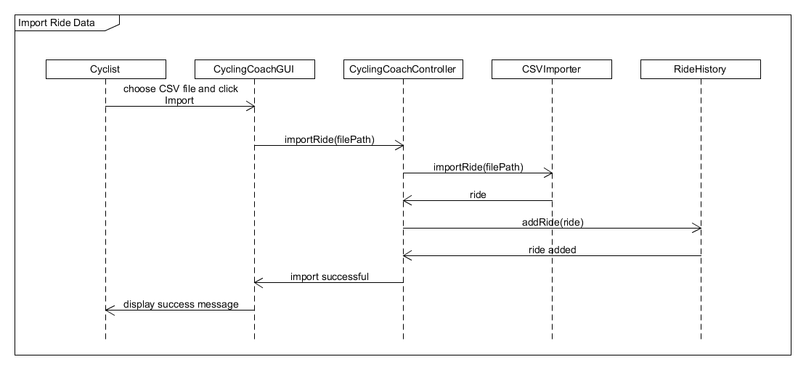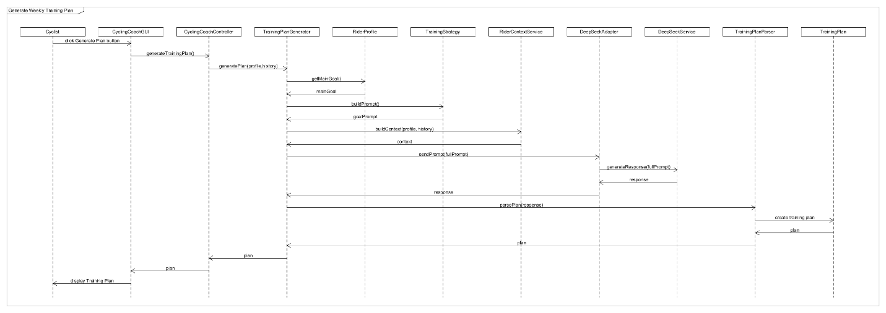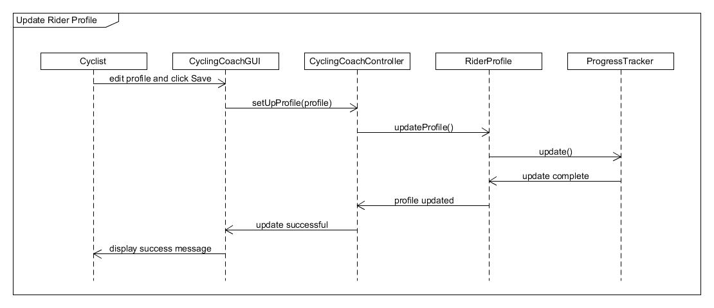

3 Feature to Design Traceability Table
Feature | Description | Type | Use Case | Main Classes | Key Methods | Sequence Diagram | Design Pattern
F01 | Rider Profile Setup | Deterministic | UC01 Set Up Rider Profile | CyclingCoachGUI, CyclingCoachController, RiderProfile, ProgressTracker | setUpProfile(), updateProfile(), notifyObservers(), update() | SD04 Update Rider Profile | MVC, Facade, Observer
F02 | Ride Data Import | Deterministic | UC02 Import Ride Data | CyclingCoachGUI, CyclingCoachController, CSVImporter, RideHistory | importRide(), addRide() | SD03 Import Ride Data | MVC, Facade
F03 | AI Ride Analysis | Hybrid | UC03 Analyze Ride | CyclingCoachGUI, CyclingCoachController, RideAnalysisService, RiderContextService, DeepSeekAdapter, DeepSeekService | analyzeRide(), buildRideContext(), sendPrompt(), generateResponse() | no SD | MVC, Facade, Adapter
F04 | Weekly Training Plan Generation | Hybrid | UC04 Generate Weekly Training Plan | CyclingCoachGUI, CyclingCoachController, TrainingPlanGenerator, TrainingStrategy, RiderContextService, DeepSeekAdapter, DeepSeekService, TrainingPlanParser, TrainingPlan | generateTrainingPlan(), generatePlan(), buildPrompt(), buildContext(), sendPrompt(), generateResponse(), parsePlan() | SD01 Generate Weekly Training Plan | MVC, Facade, Strategy, Adapter, Observer
F05 | AI Chat | Hybrid | UC05 Ask AI Question | CyclingCoachGUI, CyclingCoachController, AIChatService, RiderContextService, DeepSeekAdapter, DeepSeekService | askAI(), askQuestion(), buildContext(), sendPrompt(), generateResponse() | SD02 Ask AI Question | MVC, Facade, Adapter
F06 | Progress Tracking | Deterministic | UC06 View Progress & Goal Tracking | CyclingCoachController, ProgressTracker, FitnessRecord, RiderProfile | getProgress(), getFTPChange(), getWeightChange(), getFTPGoalProgress(), getWeightGoalProgress() | SD04 partly covers update | Facade, Observer, MVC
F07 | Weakness Detection | Hybrid | UC07 Analyze Weaknesses & Improvements | CyclingCoachController, AIChatService, RiderContextService, DeepSeekAdapter, DeepSeekService | analyzeWeaknesses(), buildContext(), sendPrompt(), generateResponse() | SD02 shared AI flow | Facade, Adapter, MVC
F08 | Weekly Training Summary | Hybrid | UC08 View Weekly Training Summary | CyclingCoachController, AIChatService, RideHistory, RiderContextService, DeepSeekAdapter, DeepSeekService | getWeeklySummary(), generateWeeklySummary(), buildContext(), sendPrompt(), generateResponse() | SD02 shared AI flow | Facade, Adapter, MVC
F09 | Ride Comparsion | Deterministic | UC09 Compare Rides | CyclingCoachCLI, CyclingCoachController, RideHistory, RideComparisonService | getRides(), compareRides() | SD05 Compare Two Rides | MVC, Facade
F10 | Workout Calendar | Deterministic | UC10 View Workout Calendar | CyclingCoachController, WorkoutCalendarService, TrainingPlan, RideHistory | getWorkoutCalendar(), getWeekWorkouts(), getWeekRides(), update() | SD04 shows Observer mechanism | Observer, Facade, MVC
F11 | Personal Best Detection | Deterministic | UC11 View Personal Bests | CyclingCoachController, PersonalBestService, RideHistory | getPersonalBests(), getLongestRide(), getHighestAvgPower(), getHighestMaxPower(), getFastestAvgSpeed() | No dedicated SD | Facade, MVC

4 Explain Each Feature
F01 — Rider Profile Setup
Related Use Case: UC01 — Set Up Rider Profile
Related Sequence Diagram: SD04 — Update Rider Profile
Classes involved: CyclingCoachGUI, CyclingCoachController, RiderProfile, ProgressTracker
Important methods: setUpProfile(), updateProfile(), notifyObservers(), update()
Execution: The cyclist enters their profile information in CyclingCoachGUI and selects save. The GUI sends the profile to CyclingCoachController using setUpProfile(). The controller updates RiderProfile using updateProfile(). After the profile is updated, RiderProfile calls notifyObservers(). ProgressTracker, which is an observer, receives the update through update(). The updated rider information is then stored and can be used by other features.
F02 — Ride Data Import
Related Use Case: UC02 — Import Ride Data
Related Sequence Diagram: SD03 — Import Ride Data
Classes involved: CyclingCoachGUI, CyclingCoachController, CSVImporter, Ride, RideHistory
Important methods: importRide(), addRide()
Execution: The cyclist selects a CSV file in the GUI. The filepath is sent to CyclingCoachController, which calls CSVImporter.importRide(). CSVImporter reads the CSV data and creates a Ride object. The ride is returned to the controller and added into RideHistory using addRide(). The ride can then be used by other features such as AI analysis, weekly summary, comparison, and personal best detection.
F03 — AI Ride Analysis
Related Use Case: UC03 — Analyze Ride
Related Sequence Diagram: Shared AI interaction flow
Classes involved: CyclingCoachGUI, CyclingCoachController, RideAnalysisService, RiderContextService, DeepSeekAdapter, DeepSeekService
Important methods: analyzeRide(), buildRideContext(), sendPrompt(), generateResponse()
Execution: The cyclist selects a completed ride and chooses Analyze Ride. The GUI sends the selected ride to CyclingCoachController, which calls RideAnalysisService.analyzeRide(). RideAnalysisService uses RiderContextService.buildRideContext() to convert the rider profile and selected ride into information that can be used in a prompt. The prompt is sent through DeepSeekAdapter to DeepSeekService. DeepSeek generates the analysis and the response is returned through the controller to the GUI for the cyclist to view.
F04 — Weekly Training Plan Generation
Related Use Case: UC04 — Generate Weekly Training Plan
Related Sequence Diagram: SD01 — Generate Weekly Training Plan
Classes involved: CyclingCoachGUI, CyclingCoachController, TrainingPlanGenerator, TrainingStrategy, RiderContextService, DeepSeekAdapter, DeepSeekService, TrainingPlanParser, TrainingPlan, WorkoutCalendarService
Important methods: generateTrainingPlan(), generatePlan(), buildPrompt(), buildContext(), sendPrompt(), generateResponse(), parsePlan(), notifyObservers(), update()
Execution: When the cyclist selects Generate Weekly Training Plan, the GUI sends the request to CyclingCoachController. The controller calls TrainingPlanGenerator.generatePlan(). Based on the rider's main goal, the generator uses the correct TrainingStrategy and calls buildPrompt(). RiderContextService also prepares the rider profile and ride history. These two parts are combined and sent through DeepSeekAdapter to DeepSeekService. DeepSeek returns the generated plan, and TrainingPlanParser converts the response into a TrainingPlan containing workouts. After the plan changes, TrainingPlan notifies its observers and WorkoutCalendarService.update() refreshes the calendar.
F05 — AI Chat
Related Use Case: UC05 — Ask AI Question
Related Sequence Diagram: SD02 — Ask AI Question
Classes involved: CyclingCoachGUI, CyclingCoachController, AIChatService, RiderContextService, DeepSeekAdapter, DeepSeekService
Important methods: askAI(), askQuestion(), buildContext(), sendPrompt(), generateResponse()
Execution: The cyclist enters a question in the AI chat. The GUI sends the question to CyclingCoachController.askAI(). The controller calls AIChatService.askQuestion(). RiderContextService prepares the rider profile and ride history, and this information is combined with the cyclist's question. The prompt is sent through DeepSeekAdapter to DeepSeekService. DeepSeek returns a response and the response is returned through the controller to the GUI.
F06 — Progress & Goal Tracking
Related Use Case: UC06 — View Progress & Goal Tracking
Related Sequence Diagram: SD04 partly covers the update process
Classes involved: CyclingCoachController, ProgressTracker, FitnessRecord, RiderProfile
Important methods: getProgress(), getFTPChange(), getWeightChange(), getFTPGoalProgress(), getWeightGoalProgress()
Execution: When the cyclist opens Progress & Goal Tracking, the request is sent to CyclingCoachController. The controller gets the progress information from ProgressTracker. ProgressTracker uses the stored FitnessRecord objects to calculate changes in FTP and weight. It also compares the current FTP and weight with the target values in RiderProfile. The results are returned to the controller and displayed to the cyclist.
F07 — Weakness / Improvement Detection
Related Use Case: UC07 — Analyze Weakness
Related Sequence Diagram: SD02 — Shared AI flow
Classes involved: CyclingCoachController, AIChatService, RiderContextService, DeepSeekAdapter, DeepSeekService
Important methods: analyzeWeaknesses(), buildContext(), sendPrompt(), generateResponse()
Execution: The cyclist selects Analyze Weakness. The request is sent to CyclingCoachController, which calls AIChatService.analyzeWeaknesses(). RiderContextService prepares the rider profile and ride history. The rider context is combined with a predefined prompt for weakness analysis. The prompt is sent through DeepSeekAdapter to DeepSeekService. DeepSeek analyzes the rider information and returns a response showing weaknesses and possible areas for improvement. The result is then displayed to the cyclist.
F08 — Weekly Training Summary
Related Use Case: UC08 — View Weekly Training Summary
Related Sequence Diagram: SD02 — Shared AI flow
Classes involved: CyclingCoachController, AIChatService, RideHistory, RiderContextService, DeepSeekAdapter, DeepSeekService
Important methods: getWeeklySummary(), generateWeeklySummary(), buildContext(), sendPrompt(), generateResponse()
Execution: The cyclist selects Weekly Training Summary. CyclingCoachController calls AIChatService.generateWeeklySummary(). The system uses the recent rides from RideHistory, and RiderContextService prepares the rider information. This information is combined with a predefined weekly summary prompt and sent through DeepSeekAdapter to DeepSeekService. DeepSeek returns a summary of the cyclist's recent week of training, which is returned to the controller and displayed by the GUI.
F09 — Ride Comparison
Related Use Case: UC09 — Compare Rides
Related Sequence Diagram: SD05 — Compare Two Rides
Classes involved: CyclingCoachGUI or CyclingCoachCLI, CyclingCoachController, RideHistory, RideComparisonService, Ride
Important methods: getRides(), compareRides()
Execution: The cyclist opens RideHistory and selects two rides to compare. The selected Ride objects are sent through the GUI or CLI to CyclingCoachController. The controller calls RideComparisonService.compareRides(). The service compares values such as distance, duration, average speed, heart rate, and power. The comparison result is returned to the controller and displayed to the cyclist.
F10 — Workout Calendar
Related Use Case: UC10 — View Workout Calendar
Related Sequence Diagram: SD04 demonstrates the Observer update mechanism
Classes involved: CyclingCoachController, WorkoutCalendarService, TrainingPlan, RideHistory
Important methods: getWorkoutCalendar(), getWeekWorkouts(), getWeekRides(), update()
Execution: When the cyclist opens the Workout Calendar, CyclingCoachController calls WorkoutCalendarService. The service uses getWeekWorkouts() to get planned workouts from TrainingPlan and getWeekRides() to get completed rides from RideHistory. These are combined into the current week's calendar. WorkoutCalendarService is also an observer of TrainingPlan, so when the training plan changes, update() can refresh the calendar automatically.
F11 — Personal Best Detection
Related Use Case: UC11 — View Personal Bests
Related Sequence Diagram: No dedicated sequence diagram
Classes involved: CyclingCoachController, PersonalBestService, RideHistory, Ride
Important methods: getPersonalBests(), getLongestRide(), getHighestAvgPower(), getHighestMaxPower(), getFastestAvgSpeed()
Execution: When the cyclist selects Personal Bests, the GUI sends the request to CyclingCoachController. The controller calls PersonalBestService, which reads the rides stored in RideHistory. The service checks the ride data to find records such as longest ride, highest average power, highest maximum power, and fastest average speed. The results are returned to the controller and displayed to the cyclist.

