Visoka skola strukovnih studija za

informacione i komunikacione

tehnologije

**Zdrava hrana Golubovic**

!!!!!https://romanbc.gitlab.io/tehnoplaneta/

Smer: Internet tehnologije

Modul: Web programiranje

Predmet: Web programiranje 2

Lazar Golubović 26/18

1

**Sadržaj**

1. Uvod.......................................................................................................................................................2

1.1. Korišćeni programski jezici............................................................................................................

1.2. Opis funkcionalnosti.......................................................................................................................

2. Organizacija...........................................................................................................................................7

2.1. Organizaciona šema........................................................................................................................

2.2. Mapa sajta.......................................................................................................................................

2.3. Opis stranica sajta...........................................................................................................................

2.3.1 index.html...............................................................................................................................

2.3.2 prodavnica.html...........................................................................................................................

2.3.3

autor.html...............................................................................................................................

2.3.4 kontakt.html...........................................................................................................................

2.3.5 korpa.html...........................................................................................................................

3. Kodovi..................................................................................................................................................13

3.1. HTML...........................................................................................................................................

3.1.1 index.html.............................................................................................................................

3.1.2 prodavnica.html...........................................................................................................................

3.1.3 autor.html..............................................................................................................................

3.1.4 kontakt.html.............................................................................................................................

3.1.5 korpa.html.............................................................................................................................

3.2. CSS...............................................................................................................................................

3.2.1 style.css.................................................................................................................................

3.2.2 style.scss........................................................................................................................

3.3. JavaScript.....................................................................................................................................

3.3.1 main.js..........................................................................................................................

3.3.2 prodavnica.js..............................................................................................................................

3.3.3 slik.js..................................................................................................................................

3.3.4 vrste.js..............................................................................................................................

3.4. assets(JSON).....................................................................................................................................

3.4.1 kategorije.js..........................................................................................................................

3.4.2 meni.js..............................................................................................................................

3.4.3 proizvodi.js..................................................................................................................................

2

**1. Uvod**

**1.1. Korišćeni programski jezici:**

Za izradu sajta korišćene su sledeće tehnologije:

• HTML 5

• CSS 3

• JavaScript

• jQuery

• JSON

• Visual Studio Code

**1.2. Opis funkcionalnosti:**

Sajt poseduje sledeće funkcionalnosti:

• Dinamičko učitavanje menija na svim straniama sa podatcima iz JSON-a

• Dinamicko ispisivanje side navigacije na svakoj strani (ispod 1000px) podatci sui z JSON

•Umanjenje visine navigacije na skrolovanje

• Pojavljivanje strelice za povratak na vrh strane nakon skrolovanja stranice na dole na svim

Stranama( ispod 1000px)

• Dinamicko ispisivanje proizvoda sa podatcima iz JSON-a

•Sortiranje proizvoda po ceni rastuce I opadajuce,takodje I abecednim redom od a do z I obratno

•filtriranje proizvoda po vrsti proizvoda

•uskladjivanja fitriranja I sortiranja

• Dinamičko učitavanje blokova i njihovih detaljnijih prikaza na strani zones

• Provera tacnosti forme .Ispisisvanje crvenim slovima ispod polja ako se sadrzaj polja ne poklapaju sa regularnim izrazima.

•korpa sa automatskim tabeliranjem proizvoda koji su dodati u korpu

3

**2. Organizacija**

**2.1. Organizaciona šema**

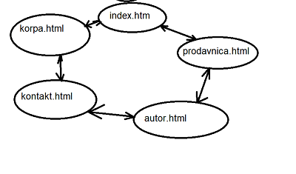

**2.2. Mapa sajta**

<urlset xmlns="http://www.sitemaps.org/schemas/sitemap/0.9">

<url>

<loc>index</loc>

<lastmod>2020-03-27</lastmod>

<changefreq>daily</changefreq>

<priority>1</priority>

</url>

<url>

<loc>prodavnica</loc>

<lastmod>2020-03-27</lastmod>

<changefreq>daily</changefreq>

<priority>1</priority>

</url>

<url>

<loc>Autor</loc>

<lastmod>2020-03-27</lastmod>

<changefreq>yearly</changefreq>

<priority>0.6</priority>

</url>

<url>

<loc>kontakt</loc>

<lastmod>2020-03-27</lastmod>

<changefreq>monthly</changefreq>

<priority>0.7</priority>

</url>

<url>

<loc>korpa</loc>

<lastmod>2020-03-27</lastmod>

<changefreq>weakly</changefreq>

<priority>0.8</priority>

</url>

</urlset>

**2.3. Opis stranica sajta**

**2.3.1 index.html**

9

Po učitavanju početne strane se iz JSON dohvata i ispisuje navigacija u zaglavlju.



Nakon toga se nalazi main koji je ispisan u html I scss-u.

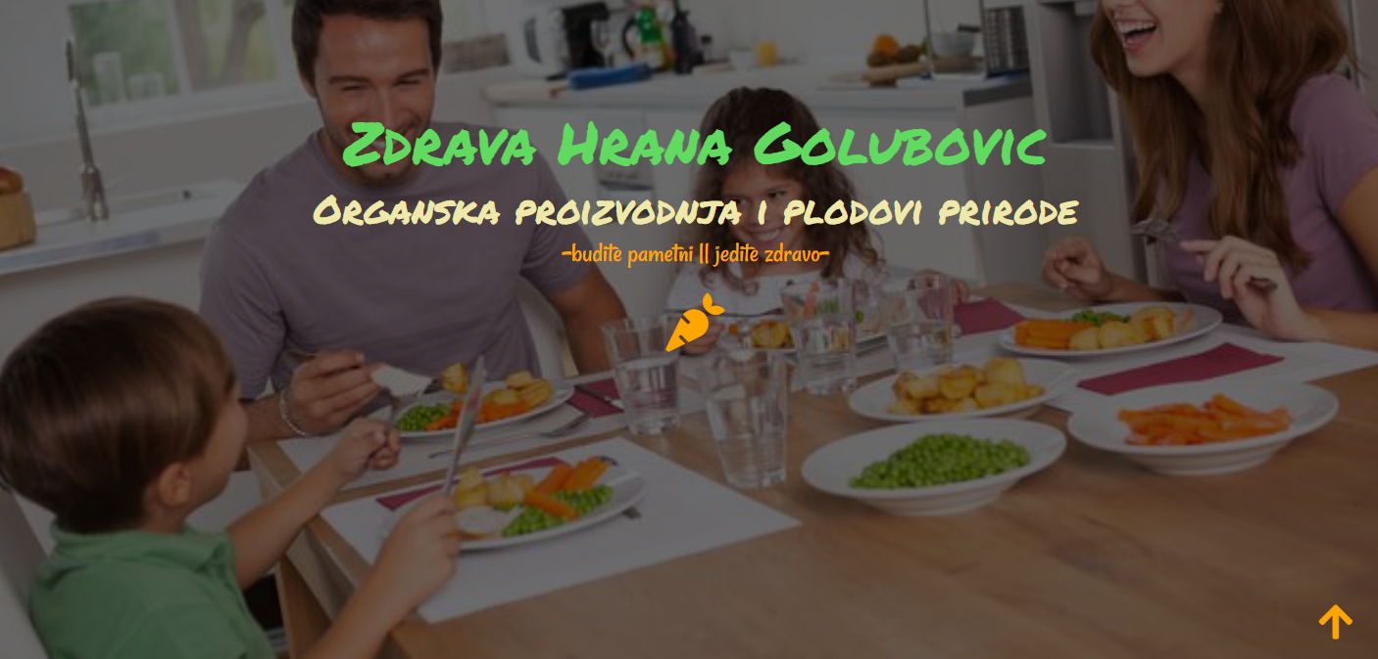

Sledece je deo o kupovini,takodje je ispisano u html I css-u



Ovo je deo u kome se nalazi slajder sa slikama koje predstavljaju najsvezije proizvodem, ucitano je iz JSON fajla.Kada se klikne na kupi odmah, link vodi u prodavnicu.

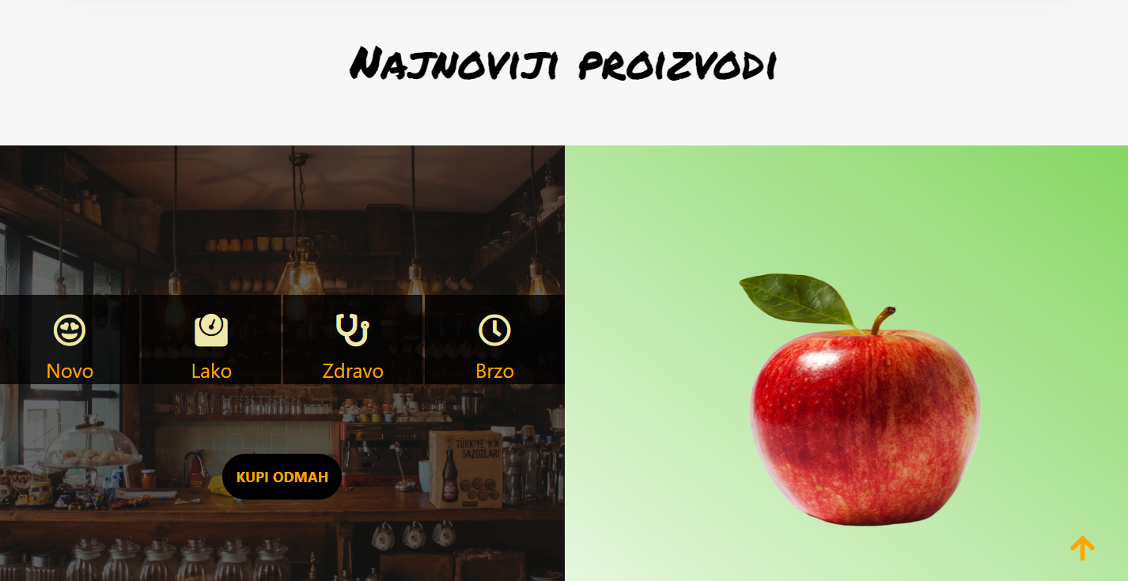

Deo o poslovanju je takodje ispisan u html I scss .Ovo je deo koji govori o nasoj proizvodnji I saradnji.

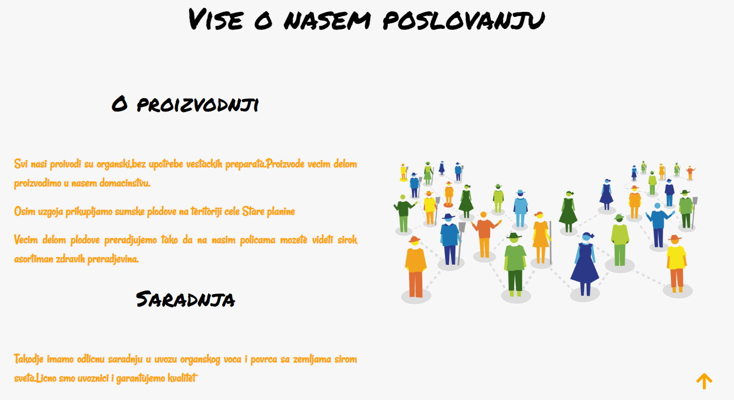

Futer deo se nalazi na svim stranama I on je ispisan u html I css-u.



**2.3.prodavnica.html**

Prodavnica je strana koja je ispsiana dinamicki sa podatcima iz JSON-a. Najvece funkcionalnosti sun a ovoj strain.Filtriranje,sortiranje.

Inicijalno su ispisani svi proizvodi.Izborom kategorije pojavljuje se jos jedna dropdaun lista u kojoj se nalaze tipovi proizvoda.

Takodje se ovde nalazi dropdaun lista za sortiranje proizvoda po ceni I nazivu rastuce I opadajuce.

Obe funkcionalnosti su povezane medjusobno.



Proizvodi sadrze sve podatke iz JSON-a .Klikom na link poruci se proizvod doda u korpu.

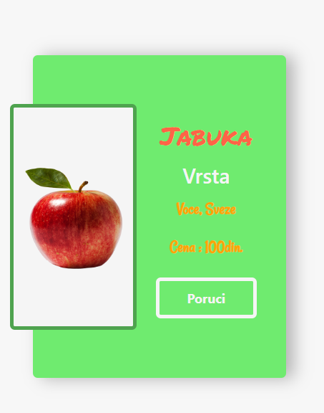

**2.3.3 autor.html**

Na ovoj strain se nalaze podatci o autoru,takodj se nalazi I link koji vodi do portfolio autora.

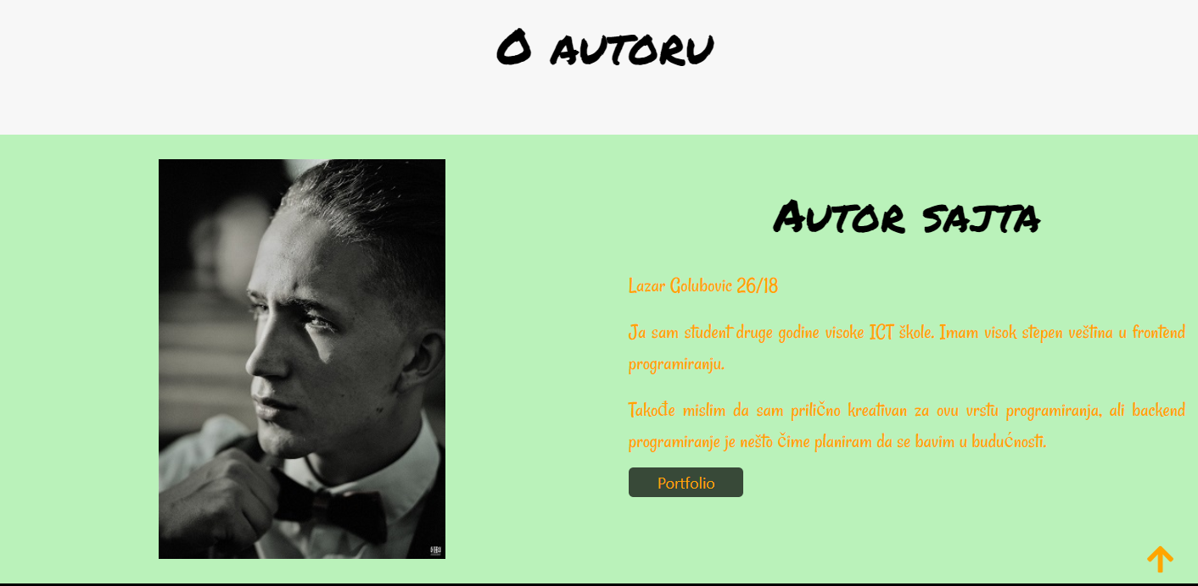

**2.3.3 kontakt.html**

Na ovoj strain se nalazi forma koja je dinamicki uneta . Crvenim slovima se ispisuje ispod polja ako se sadrzaj polja ne poklapa sa regularnim izrazima.

U samom polju se nalazi placeholder koji korisniku pokazuje na pocetku primer pravilnog unosa podataka

Regularni izrazi koji su korisceni:

    var regexIme = /^[A-Z][a-z]+(\s[A-Z][a-z]+)?$/;

    var regexMail = /^[a-z\.\-\/\_\d]+\@[a-z]+(\.[a-z]{2,15}){1,2}$/;

    var regexPoruka = /^.{1,50}$/;

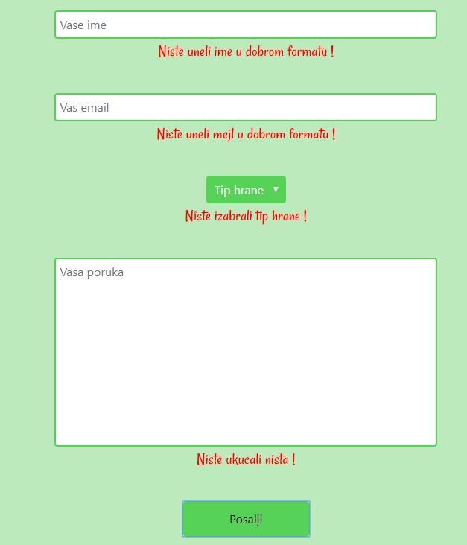

Inicijalno forma je bez crvenog teksta.

U slucaju da korsnik nije uneo nista u formu,takodje I ako podatci nisu ispravno uneti(ne poklapaju se sa podatcima iz placeholdera), prikazace se text crvenih slova koji obavestava da podatci nisu ispravni.

Unosom ispravnih podataka I klikom na posalji, podatci se salju na dalju obradu.

**3. Kodovi**

**3.1. HTML**

**3.1.1 index.html**

<!DOCTYPE html>

<html lang="en">

<head>

<meta charset="UTF-8">

<meta name="decription" content="Kupite najbolje organske proizvode,sveze i preradjene.Samo najbolje sa iz baste i prirode."/>

<meta name="keywords" content="organsko,Stara planina,sveze,zdrava hrana"/>

<meta name="viewport" content="width=device-width, initial-scale=1.0">

<link rel="stylesheet" href="https://stackpath.bootstrapcdn.com/bootstrap/4.4.1/css/bootstrap.min.css" integrity="sha384-Vkoo8x4CGsO3+Hhxv8T/Q5PaXwhQihCFPSNPkwLNBTbVZHUAnYc5iRYaWz9emfjh" crossorigin="anonymous">

<link rel="stylesheet" href="https://use.fontawesome.com/releases/v5.8.2/css/all.css" integrity="sha384-oS3vJWv+0UjzBfQzYUhtDYW+Pj2yciDJxpsK1OYPAYjqT085Qq/1cq5FLXAZQ7Ay" crossorigin="anonymous"/>

<link rel="stylesheet" href="css/slick.css"/>

<link rel="stylesheet" href="css/style.css"/>

<link rel="icon" href="images/logo.png"/>

<title>Zdrava hrana</title>

</head>

<body>

<nav id="navigacija">

<div class="logo"></div>

<div class="meni"></div>

</nav>

<div class="sideNavigation">

<div class="logo">

</div>

<div class="meni">

</div>

</div>

<a href="#" class='pojaviSide'><i class="fas fa-bars"></i></a>

<a href="#" class='backTop'><i class="fas fa-arrow-up"></i></a>

<main>

<div class="zdravaHranaMain">

<h1>Zdrava Hrana Golubovic</h1>

<h2>Organska proizvodnja i plodovi prirode</h2>

<p><strong>-</strong>budite pametni || jedite zdravo<strong>-</strong></p>

<a href="#najnovijiPr"><i class="fas fa-carrot"></i></a>

</div>

</main>

<div class="container oKupovini">

<div class="row transport">

<div class="col-md-3 trIzbori">

<i class="fas fa-truck"></i>

<h4>Besplatna Dostava</h4>

<p>Besplatna dostava za sve proizvode</p>

</div>

<div class="col-md-3 trIzbori">

<i class="fas fa-undo-alt"></i>

<h4>Mogucnost vracanja</h4>

<p>Besplatna postarina za sve proizvode</p>

</div>

<div class="col-md-3 trIzbori">

<i class="fas fa-headset"></i>

<h4>24/7 na usluzi</h4>

<p>Dostupni tokom cele radne nedelje</p>

</div>

<div class="col-md-3 trIzbori">

<i class="fas fa-coins"></i>

<h4>Sigurnst placanja</h4>

<p>Bez rizika zloupotrebe</p>

</div>

</div>

</div>

<h2 id="najnovijiPr">Najnoviji proizvodi</h2>

<div class="container-fluid">

<div class="row noviProizvodi">

<div class="col-md-6 vremeIsteka">

<div class="black">

<div class="row clock-wrap">

<div class="col clockinner1 clockinner">

<h4 class="days"><i class="far fa-grin-hearts"></i></h4>

<span class="smallText">Novo</span>

</div>

<div class="col clockinner1 clockinner">

<h4 class="hours"><i class="fas fa-weight"></i></h4>

<span class="smallText">Lako</span>

</div>

<div class="col clockinner1 clockinner">

<h4 class="minutes"><i class="fas fa-stethoscope"></i></h4>

<span class="smallText">Zdravo</span>

</div>

<div class="col clockinner1 clockinner">

<h4 class="seconds"><i class="far fa-clock"></i></h4>

<span class="smallText">Brzo</span>

</div>

</div>

<div class="kupi">

<a href="prodavnica.html">kupi odmah</a>

</div>

</div>

</div>

<div class="col-md-6 slajderProizvoda">

<button type="button" class="slick-next"></button>

<div class="autoplay">

<div class='pickAuto'><img src="images/apple.png" alt="Alt slike"/></div>

<div class='pickAuto'><img src="images/onions.png" alt="Alt slike"/></div>

<div class='pickAuto'><img src="images/tomato.png" alt="Alt slike"/></div>

<div class='pickAuto'><img src="images/blueberry.png" alt="Alt slike"/></div>

</div>

<button type="button" class="slick-prev"></button>

</div>

</div>

</div>

</div>

<h2>Vise o nasem poslovanju</h2>

<div class="container-fluid poslovanje">

<div class="rowPoslovanje row">

<div id="opisFirme" class="col-md-6">

<h3>O proizvodnji</h3>

<p>Svi nasi proivodi su organski,bez upotrebe vestackih preparata.Proizvode vecim delom proizvodimo u nasem domacinstvu.</p>

<p>Osim uzgoja prikupljamo sumske plodove na teritoriji cele Stare planine</p>

<p>Vecim delom plodove preradjujemo tako da na nasim policama mozete videti sirok asortiman zdravih preradjevina.</p>

<h3>Saradnja</h3>

<p>Takodje imamo odlicnu saradnju u uvozu organskog voca i povrca sa zemljama sirom sveta.Licno smo uvoznici i garantujemo kvalitet</p>

</div>

<div class="col-md-6 basta">

<img src="images/abstract.jpg" class="img-fluid" alt="Poslovanje"/>

</div>

</div>

</div>

<footer>

<div id="copyright">

<p>&copy Golubović 2020/21</p>

</div>

<div id="aboutSite">

<ul>

<li><a href="sitemap.xml">Sitemap</a></li>

<li><a href="css/style.css">css</a></li>

<li><a href="sitemap.xml">scss</a></li>

<li><a href="dokumentacija.pdf" download="download">dokumentacija</a></li>

</ul>

</div>

</footer>

<script src="https://code.jquery.com/jquery-3.4.1.js"></script>

<script src="https://cdn.jsdelivr.net/npm/popper.js@1.16.0/dist/umd/popper.min.js"></script>

<script src="https://stackpath.bootstrapcdn.com/bootstrap/4.4.1/js/bootstrap.min.js"></script>

<script src='js/slick.min.js'></script>

<script src='js/main.js'></script>

<script src='js/slik.js'></script>

</body>

</html>

**3.1.2 prodavnica.html**

<!DOCTYPE html>

<html lang="en">

<head>

<meta charset="UTF-8">

<meta name="decription" content="Prodavnica sa najboljim asortimanom proizvoda u nasoj zemlji."/>

<meta name="keywords" content="voce,povrce,zitarice,sok,kupovina"/>

<meta name="viewport" content="width=device-width, initial-scale=1.0">

<link rel="stylesheet" href="https://stackpath.bootstrapcdn.com/bootstrap/4.4.1/css/bootstrap.min.css" integrity="sha384-Vkoo8x4CGsO3+Hhxv8T/Q5PaXwhQihCFPSNPkwLNBTbVZHUAnYc5iRYaWz9emfjh" crossorigin="anonymous">

<link rel="stylesheet" href="https://use.fontawesome.com/releases/v5.8.2/css/all.css" integrity="sha384-oS3vJWv+0UjzBfQzYUhtDYW+Pj2yciDJxpsK1OYPAYjqT085Qq/1cq5FLXAZQ7Ay" crossorigin="anonymous"/>

<link rel="stylesheet" href="css/style.css"/>

<link rel="icon" href="images/logo.png"/>

<title>Zdrava hrana</title>

</head>

<body>

<nav>

<div class="logo"></div>

<div class="meni"></div>

</nav>

<div class="sideNavigation">

<div class="logo">

</div>

<div class="menu">

</div>

</div>

<section class="prodavnica container-fluid">

<h2>Prodavnica</h2>

<div id="prodavnicaIzbori">

<div id="izborGlavni"></div>

<div id="podKategDrop"></div>

<div id="sortiranje">

<select name="sort" id="sort">

<option value="0">Soritraj po</option>

<option value="asce">Cena : Rastuce</option>

<option value="desc">Cena : Opadajuce</option>

<option value="aToz">Naziv : A-Z</option>

<option value="zToa">Naziv : Z-A</option>

</select>

</div>

</div>

</section>

<section class='shop container-fluid'>

<div class='row rowProd'>

<!-- <div class="col-lg-4 prodCol">

<div class="proizvod">

<div class="pictureProd">

<img src="images/apple.png" class='img-fluid' alt="Apple"/>

</div>

<div class="infoProd">

<h3>Naziv</h3>

<div class="vrsta">

<h4>Vrsta</h4>

<p>Nesto, nesto</p>

</div>

<p>Cena : 100din.</p>

<button class='poruciProd'>Poruci</button>

</div>

</div>

</div> -->

</div>

</section>

<footer>

<div id="copyright">

<p>&copy Golubović 2020/21</p>

</div>

<div id="aboutSite">

<ul>

<li><a href="sitemap.xml">Sitemap</a></li>

<li><a href="css/style.css">css</a></li>

<li><a href="sitemap.xml">scss</a></li>

<li><a href="dokumentacija.pdf" download="download">dokumentacija</a></li>

</ul>

</div>

</footer>

<script src="https://code.jquery.com/jquery-3.4.1.js"></script>

<script src="https://cdn.jsdelivr.net/npm/popper.js@1.16.0/dist/umd/popper.min.js"></script>

<script src="https://stackpath.bootstrapcdn.com/bootstrap/4.4.1/js/bootstrap.min.js"></script>

<script src='js/main.js'></script>

<script src='js/prodavnica.js'></script>

</body>

</html>

**3.1.3 autor.html**

<!DOCTYPE html>

<html lang="en">

    <head>

        <meta charset="UTF-8">

        <meta name="decription" content="Autor stranice i podatci o njemu."/>

        <meta name="keywords" content="autor,Lazar,portfolio"/>

        <meta name="viewport" content="width=device-width, initial-scale=1.0">

        <link rel="stylesheet" href="https://stackpath.bootstrapcdn.com/bootstrap/4.4.1/css/bootstrap.min.css" >

        <link rel="stylesheet" href="https://use.fontawesome.com/releases/v5.8.2/css/all.css" integrity="sha384-oS3vJWv+0UjzBfQzYUhtDYW+Pj2yciDJxpsK1OYPAYjqT085Qq/1cq5FLXAZQ7Ay" crossorigin="anonymous"/>

        <link rel="stylesheet" href="css/style.css"/>

        <link rel="icon" href="images/logo.png"/>

        <title>Zdrava hrana</title>

    </head>

<body>

    <nav id="navigacija">

        <div class="logo"></div>

        <div class="meni"></div>

    </nav>

    <div class="sideNavigation">

        <div class="logo">

        </div>

        <div class="menu">

        </div>

    </div>

    <a href="#" class='pojaviSide'><i class="fas fa-bars"></i></a>

    <a href="#" class='backTop'><i class="fas fa-arrow-up"></i></a>

    <h2 id="autorNaslov">O autoru</h2>

    <section class="container-fluid">

        <div id="drzacAutor" class="row">

            <div id="autor" class="col-md-6">

                <img src="images/autor.jpg" alt="autor">

            </div>

            <div id="sadrzajAutor" class="col-md-6">

                <h3>Autor sajta</h3>

                <p>Lazar Golubovic 26/18</p>

                <p>Ja sam student druge godine visoke ICT škole. Imam visok stepen veština u frontend programiranju.</p>

                <p>Takođe mislim da sam prilično kreativan za ovu vrstu programiranja, ali backend programiranje je nešto čime planiram da se bavim u budućnosti.</p>

                <a href="https://lazargolubovicportfolio.000webhostapp.com/">Portfolio</a>

            </div>

        </div>

    </section>

    <footer>

        <div id="copyright">

            <p>&copy Golubović 2020/21</p>

        </div>

        <div id="aboutSite">

            <ul>

                <li><a href="sitemap.xml">Sitemap</a></li>

                <li><a href="css/style.css">css</a></li>

                <li><a href="sitemap.xml">scss</a></li>

                <li><a href="dokumentacija.pdf" download="download">dokumentacija</a></li>

            </ul>

        </div>

    </footer>

    <script src="https://code.jquery.com/jquery-3.4.1.js"></script>

    <script src="https://cdn.jsdelivr.net/npm/popper.js@1.16.0/dist/umd/popper.min.js"></script>

    <script src="https://stackpath.bootstrapcdn.com/bootstrap/4.4.1/js/bootstrap.min.js"></script>

    <script src='js/slick.min.js'></script>

    <script src='js/main.js'></script>

    <script src='js/slik.js'></script>

</body>

</html>

**3.1.4 kontakt.html**

<!DOCTYPE html>

<html lang="en">

<head>

<meta charset="UTF-8">

<meta name="decription" content="Ostavite nam poruku kako bi smo poboljsali nase poslovanje."/>

<meta name="keywords" content="forma,prijava,registracija,poruka"/>

<meta name="viewport" content="width=device-width, initial-scale=1.0">

<link rel="stylesheet" href="https://stackpath.bootstrapcdn.com/bootstrap/4.4.1/css/bootstrap.min.css" integrity="sha384-Vkoo8x4CGsO3+Hhxv8T/Q5PaXwhQihCFPSNPkwLNBTbVZHUAnYc5iRYaWz9emfjh" crossorigin="anonymous">

<link rel="stylesheet" href="https://use.fontawesome.com/releases/v5.8.2/css/all.css" integrity="sha384-oS3vJWv+0UjzBfQzYUhtDYW+Pj2yciDJxpsK1OYPAYjqT085Qq/1cq5FLXAZQ7Ay" crossorigin="anonymous"/>

<link rel="stylesheet" href="css/style.css"/>

<link rel="icon" href="images/logo.png"/>

<title>Zdrava hrana</title>

</head>

<body>

<nav>

<div class="logo"></div>

<div class="meni"></div>

</nav>

<div class="sideNavigation">

<div class="logo">

</div>

<div class="menu">

</div>

</div>

<h2 id="kontaktNaslov">Kontaktirajte nas</h2>

<section class="formaKontakt">

<form action="index.html" method="POST" onsubmit="return provera()">

<input type="text" placeholder="Vase ime" id="imeKorisnika" class='poljeForme'/>

<p class='greskaForme' id='greska1'>Niste uneli ime u dobrom formatu !</p>

<br/>

<input type="email" id='mailKorisnika' placeholder='Vas email' class='poljeForme'/>

<p class='greskaForme' id='greska2'>Niste uneli mejl u dobrom formatu !</p>

<br/>

<select name="birajVrstu" id="birajVrstu">

</select>

<p class='greskaForme' id='greska3'>Niste izabrali tip hrane !</p>

<br/>

<textarea class='poljeForme' placeholder="Vasa poruka" name="areaKontakt" id="areaKontakt" cols="30" rows="10"></textarea>

<p class='greskaForme' id='greska4'>Niste ukucali nista !</p>

<br/>

<input type="submit" value='Posalji' id='dugmeSaljiForma'/>

<p class='uspeh'>Uspeli ste !</p>

</form>

<img src="images/cont-img.png" alt="">

</section>

<footer>

<div id="copyright">

<p>&copy Golubović 2020/21</p>

</div>

<div id="aboutSite">

<ul>

<li><a href="sitemap.xml">Sitemap</a></li>

<li><a href="css/style.css">css</a></li>

<li><a href="sitemap.xml">scss</a></li>

<li><a href="dokumentacija.pdf" download="download">dokumentacija</a></li>

</ul>

</div>

</footer>

<script src="https://code.jquery.com/jquery-3.4.1.js"></script>

<script src="https://cdn.jsdelivr.net/npm/popper.js@1.16.0/dist/umd/popper.min.js"></script>

<script src="https://stackpath.bootstrapcdn.com/bootstrap/4.4.1/js/bootstrap.min.js"></script>

<script src='js/vrste.js'></script>

<script src='js/main.js'></script>

</body>

</html>

**Nodsv’svvvvvvvvvvvvvvvvvvvvvvvvvvvvvvvvvvvvvvvvvvvvvvvvvvvvvvvvvvvvvvvvvvvvvvvvvvvvvvvvvvvvvvvvvvvvvvvvvvvvvvvvvvvvvvvvvvvvvvvvvvvvvvvvvvvvvvvvvvvvvvvvvvvvvvvvvvvvvvvvvvvvvvvvvvvvvvvvvv**

**3.2. CSS**

**3.2.1 style.css**

@font-face {

  src: url("PermanentMarker-Regular.ttf");

  font-family: 'mojFont1';

}

@font-face {

  src: url("Rancho-Regular.ttf");

  font-family: 'mojFont2';

}

* {

  margin: 0px;

  padding: 0px;

}

html {

  scroll-behavior: smooth;

}

body {

  position: relative;

  background-color: #f7f7f7;

}

body h1 {

  font-family: 'mojFont1';

}

body h2 {

  text-align: center;

  font-family: 'mojFont1';

  margin: 5% 0%;

  font-size: 3.2em;

  color: black;

}

body h3 {

  text-align: center;

  font-family: 'mojFont1';

  margin: 5% 0%;

  font-size: 3em;

  color: black;

}

body p {

  color: orange;

  font-family: 'mojFont2';

  font-size: 1.4em;

}

body nav {

  width: 100%;

  display: -webkit-box;

  display: -ms-flexbox;

  display: flex;

  -ms-flex-pack: distribute;

      justify-content: space-around;

  -webkit-box-align: center;

      -ms-flex-align: center;

          align-items: center;

  position: fixed;

  top: 0;

  z-index: 1003;

  background-color: black;

}

@media (max-width: 1000px) {

  body nav {

    display: none;

  }

}

body nav .logo {

  width: 30%;

}

body nav .logo .logoPic {

  max-width: 100%;

  height: auto;

  width: 170px;

  -webkit-transition: 0.8s;

  transition: 0.8s;

}

body nav .logo .logoPic1 {

  width: 100px;

}

body nav .logo a img {

  width: 160px;

  max-width: 100%;

  height: auto;

}

body .pojaviSide {

  position: fixed;

  z-index: 999;

  top: 4%;

  left: 4%;

  text-decoration: none;

  display: none;

}

@media (max-width: 1000px) {

  body .pojaviSide {

    display: block;

  }

}

body .pojaviSide i {

  color: #37c737;

  font-size: 2em;

}

body .sideNavigation {

  width: 320px;

  position: fixed;

  top: 0px;

  bottom: 0px;

  background: #000;

  display: -webkit-box;

  display: -ms-flexbox;

  display: flex;

  -webkit-box-orient: vertical;

  -webkit-box-direction: normal;

      -ms-flex-direction: column;

          flex-direction: column;

  -webkit-box-align: center;

      -ms-flex-align: center;

          align-items: center;

  -webkit-box-pack: center;

      -ms-flex-pack: center;

          justify-content: center;

  z-index: 999;

  -webkit-transform: translateX(-400px);

          transform: translateX(-400px);

  -webkit-transition: 0.7s;

  transition: 0.7s;

}

body .sideNavigation ul {

  list-style-type: none;

  text-align: center;

}

body .sideNavigation ul li {

  margin: 10% 0%;

}

body .side1 {

  -webkit-transform: translateX(0px);

          transform: translateX(0px);

}

body .meni {

  width: 60%;

}

body .meni ul {

  list-style-type: none;

  margin-bottom: 0px;

  display: -webkit-box;

  display: -ms-flexbox;

  display: flex;

  -ms-flex-pack: distribute;

      justify-content: space-around;

  -webkit-box-align: center;

      -ms-flex-align: center;

          align-items: center;

}

body .meni ul li a {

  font-size: 1.3em;

  text-decoration: none;

  color: white;

  -webkit-transition: 0.6s;

  transition: 0.6s;

}

body .meni ul li a:hover {

  color: #55cf55;

}

body .pojaviSide {

  position: fixed;

  z-index: 999;

  top: 4%;

  left: 4%;

  text-decoration: none;

  display: none;

}

body .pojaviSide i {

  color: #c77037;

  font-size: 2em;

}

body .backTop {

  position: fixed;

  z-index: 999;

  text-decoration: none;

  bottom: 3%;

  right: 3%;

}

body .backTop i {

  color: orange;

  font-size: 2em;

}

body main {

  width: 100%;

  height: 100vh;

  display: -webkit-box;

  display: -ms-flexbox;

  display: flex;

  -webkit-box-pack: center;

      -ms-flex-pack: center;

          justify-content: center;

  -webkit-box-align: center;

      -ms-flex-align: center;

          align-items: center;

  background-image: url("../images/porodica.jpg");

  background-size: cover;

  background-attachment: fixed;

  background-repeat: no-repeat;

  background-position: center;

}

body main .zdravaHranaMain {

  width: 100%;

  height: 100%;

  background-color: rgba(0, 0, 0, 0.548);

  display: -webkit-box;

  display: -ms-flexbox;

  display: flex;

  -webkit-box-orient: vertical;

  -webkit-box-direction: normal;

      -ms-flex-direction: column;

          flex-direction: column;

  -webkit-box-pack: center;

      -ms-flex-pack: center;

          justify-content: center;

  -webkit-box-align: center;

      -ms-flex-align: center;

          align-items: center;

}

body main .zdravaHranaMain h1 {

  color: #60db60;

  font-size: 3em;

  font-family: 'mojFont1';

  text-align: center;

}

body main .zdravaHranaMain h2 {

  font-size: 2em;

  color: palegoldenrod;

  margin: 0;

}

body main .zdravaHranaMain a {

  text-decoration: none;

}

body main .zdravaHranaMain a i {

  color: orange;

  font-size: 3em;

  -webkit-transition: 0.7s;

  transition: 0.7s;

}

body main .zdravaHranaMain a i:hover {

  -webkit-transform: rotate(-44deg);

          transform: rotate(-44deg);

  color: #ffb733;

}

body .transport {

  margin: 5% 0%;

  text-align: center;

  -webkit-box-shadow: 2px 7px 30px #bbb9b9;

          box-shadow: 2px 7px 30px #bbb9b9;

  padding: 1%;

}

body .transport .trIzbori {

  border-right: 2px solid #d6d5d5a9;

}

@media (max-width: 768px) {

  body .transport .trIzbori {

    border-right: none;

    border-bottom: 2px solid #d6d5d5a9;

    padding: 1% 0%;

  }

}

body .transport .trIzbori:last-child {

  border: none;

}

body .transport .trIzbori i {

  color: #74d14c9e;

  font-size: 3em;

  -webkit-transition: 0.7s;

  transition: 0.7s;

}

body .transport .trIzbori i:hover {

  color: #fad694;

}

body .transport .trIzbori h4 {

  font-size: 20px;

  margin: 4% 0%;

}

body .black {

  background-color: rgba(0, 0, 0, 0.582);

  width: 100%;

  height: 100%;

}

body .noviProizvodi {

  background: linear-gradient(217deg, #74d14cdc, white 80.71%);

}

body .noviProizvodi .vremeIsteka {

  padding: 0px;

  background-image: url("../images/shop.jpg");

  background-position: 50% 50%;

  background-repeat: no-repeat;

  background-size: cover;

  height: 70vh;

  text-align: center;

  position: relative;

}

@media (max-width: 530px) {

  body .noviProizvodi .vremeIsteka {

    height: 60vh;

  }

}

body .noviProizvodi .vremeIsteka .clock-wrap {

  position: absolute;

  z-index: 999;

  top: 30%;

  left: 15px;

  color: palegoldenrod;

  width: 100%;

}

body .noviProizvodi .vremeIsteka .clock-wrap h4 {

  font-size: 2.3em;

}

body .noviProizvodi .vremeIsteka .clock-wrap span {

  font-size: 1.4em;

  color: orange;

}

body .noviProizvodi .vremeIsteka .clockinner {

  padding-top: 1em;

  margin-right: 0.4%;

  background-color: rgba(0, 0, 0, 0.781);

}

@media (max-width: 530px) {

  body .noviProizvodi .vremeIsteka .clockinner {

    font-size: 10px;

  }

}

body .noviProizvodi .vremeIsteka .clockinner:last-child {

  margin: 0%;

}

body .noviProizvodi .vremeIsteka .kupi {

  padding-top: 45vh;

}

body .noviProizvodi .vremeIsteka .kupi a {

  background: black;

  text-decoration: none;

  padding: 15px;

  border-radius: 30px;

  text-transform: uppercase;

  font-weight: bold;

  color: orange;

  -webkit-transition: 0.7s;

  transition: 0.7s;

}

body .noviProizvodi .vremeIsteka .kupi a:hover {

  color: #1a1a1a;

  background-color: orange;

}

body .noviProizvodi .slajderProizvoda {

  display: -webkit-box;

  display: -ms-flexbox;

  display: flex;

  -webkit-box-align: center;

      -ms-flex-align: center;

          align-items: center;

  -webkit-box-pack: center;

      -ms-flex-pack: center;

          justify-content: center;

}

@media (max-width: 768px) {

  body .noviProizvodi .slajderProizvoda {

    padding: 5% 0%;

  }

}

body .noviProizvodi .slajderProizvoda .autoplay {

  width: 85%;

  display: -webkit-box;

  display: -ms-flexbox;

  display: flex;

  -webkit-box-pack: center;

      -ms-flex-pack: center;

          justify-content: center;

}

body .noviProizvodi .slajderProizvoda .autoplay .pickAuto {

  height: 90%;

  display: -webkit-box;

  display: -ms-flexbox;

  display: flex;

  -webkit-box-pack: center;

      -ms-flex-pack: center;

          justify-content: center;

  -webkit-box-align: center;

      -ms-flex-align: center;

          align-items: center;

}

body .noviProizvodi .slajderProizvoda .autoplay .pickAuto img {

  max-width: 100%;

  height: auto;

  width: 70%;

}

body .prodavnica {

  background-image: url("../images/background3.jpg");

  background-size: cover;

  background-attachment: fixed;

  background-repeat: no-repeat;

  background-position: 50% 50%;

  width: 100%;

  height: 100%;

  display: -webkit-box;

  display: -ms-flexbox;

  display: flex;

  -webkit-box-orient: vertical;

  -webkit-box-direction: normal;

      -ms-flex-direction: column;

          flex-direction: column;

  -webkit-box-align: center;

      -ms-flex-align: center;

          align-items: center;

  -webkit-box-pack: center;

      -ms-flex-pack: center;

          justify-content: center;

  padding-top: 12%;

}

body .prodavnica h2 {

  color: whitesmoke;

}

body .prodavnica #prodavnicaIzbori {

  width: 100%;

  display: -webkit-box;

  display: -ms-flexbox;

  display: flex;

  -ms-flex-pack: distribute;

      justify-content: space-around;

  background-color: #03050348;

  -webkit-box-align: center;

      -ms-flex-align: center;

          align-items: center;

  padding: 10px 0px;

}

body .prodavnica #prodavnicaIzbori #kategorijeOpcije {

  width: 200px;

  height: 40px;

  color: white;

  background-color: orange;

  border-radius: 5px;

}

@media (max-width: 768px) {

  body .prodavnica #prodavnicaIzbori #kategorijeOpcije {

    width: 140px;

  }

}

@media (max-width: 530px) {

  body .prodavnica #prodavnicaIzbori #kategorijeOpcije {

    width: 100px;

  }

}

body .prodavnica #prodavnicaIzbori #kategorijeOpcijePod {

  width: 200px;

  height: 40px;

  color: white;

  background-color: orange;

  border-radius: 5px;

}

@media (max-width: 768px) {

  body .prodavnica #prodavnicaIzbori #kategorijeOpcijePod {

    width: 140px;

  }

}

@media (max-width: 530px) {

  body .prodavnica #prodavnicaIzbori #kategorijeOpcijePod {

    width: 100px;

  }

}

body .prodavnica #prodavnicaIzbori #sort {

  width: 200px;

  height: 40px;

  color: white;

  background-color: orange;

  border-radius: 5px;

}

@media (max-width: 768px) {

  body .prodavnica #prodavnicaIzbori #sort {

    width: 140px;

  }

}

@media (max-width: 530px) {

  body .prodavnica #prodavnicaIzbori #sort {

    width: 100px;

  }

}

body .shop {

  margin-top: 5%;

}

body .shop .rowProd {

  display: -webkit-box;

  display: -ms-flexbox;

  display: flex;

  -webkit-box-pack: center;

      -ms-flex-pack: center;

          justify-content: center;

  -webkit-box-align: center;

      -ms-flex-align: center;

          align-items: center;

}

body .shop .rowProd .prodCol {

  display: -webkit-box;

  display: -ms-flexbox;

  display: flex;

  -webkit-box-pack: center;

      -ms-flex-pack: center;

          justify-content: center;

  -webkit-box-align: center;

      -ms-flex-align: center;

          align-items: center;

  margin: 3% 0%;

}

body .shop .rowProd .prodCol .proizvod {

  width: 80%;

  background-color: #6feb6f;

  display: -webkit-box;

  display: -ms-flexbox;

  display: flex;

  -webkit-box-pack: center;

      -ms-flex-pack: center;

          justify-content: center;

  -webkit-box-align: center;

      -ms-flex-align: center;

          align-items: center;

  position: relative;

  border-radius: 6px;

  height: 400px;

  -webkit-box-shadow: 10px 1px 20px rgba(0, 0, 0, 0.274);

          box-shadow: 10px 1px 20px rgba(0, 0, 0, 0.274);

}

@media (max-width: 768px) {

  body .shop .rowProd .prodCol .proizvod {

    width: 70%;

  }

}

@media (max-width: 530px) {

  body .shop .rowProd .prodCol .proizvod {

    width: 85%;

  }

}

body .shop .rowProd .prodCol .proizvod .pictureProd {

  width: 50%;

  background-color: whitesmoke;

  border-radius: 6px;

  padding: 3%;

  position: absolute;

  left: -9%;

  top: 15%;

  bottom: 15%;

  border: 4px solid #4fa34f;

  display: -webkit-box;

  display: -ms-flexbox;

  display: flex;

  -webkit-box-align: center;

      -ms-flex-align: center;

          align-items: center;

}

body .shop .rowProd .prodCol .proizvod .pictureProd img {

  max-width: 100%;

  height: auto;

}

body .shop .rowProd .prodCol .proizvod .infoProd {

  width: 40%;

  display: -webkit-box;

  display: -ms-flexbox;

  display: flex;

  text-align: center;

  -webkit-box-orient: vertical;

  -webkit-box-direction: normal;

      -ms-flex-direction: column;

          flex-direction: column;

  -webkit-box-pack: center;

      -ms-flex-pack: center;

          justify-content: center;

  -webkit-box-align: center;

      -ms-flex-align: center;

          align-items: center;

  margin-left: 37%;

  padding: 14% 0%;

  border-radius: 6px;

}

body .shop .rowProd .prodCol .proizvod .infoProd h3 {

  color: tomato;

  font-size: 2em;

}

body .shop .rowProd .prodCol .proizvod .infoProd p {

  font-weight: bold;

  font-size: 1.3em;

}

body .shop .rowProd .prodCol .proizvod .infoProd .poruciProd {

  margin-top: 5%;

  background-color: transparent;

  border: none;

  width: 100%;

  background-color: #6feb6f;

  line-height: 2.7em;

  border-radius: 6px;

  border: 4px solid whitesmoke;

  color: whitesmoke;

  font-weight: bold;

  -webkit-transition: 0.6s;

  transition: 0.6s;

}

body .shop .rowProd .prodCol .proizvod .infoProd .poruciProd:hover {

  background-color: whitesmoke;

  color: #6feb6f;

}

body .shop .rowProd .prodCol .proizvod .infoProd .vrsta {

  width: 100%;

  display: -webkit-box;

  display: -ms-flexbox;

  display: flex;

  -webkit-box-orient: vertical;

  -webkit-box-direction: normal;

      -ms-flex-direction: column;

          flex-direction: column;

  margin-top: 7%;

}

body .shop .rowProd .prodCol .proizvod .infoProd .vrsta h4 {

  color: whitesmoke;

  font-size: 1.6em;

  padding-bottom: 3%;

}

body footer {

  background-color: black;

  display: -webkit-box;

  display: -ms-flexbox;

  display: flex;

  -ms-flex-pack: distribute;

      justify-content: space-around;

  -webkit-box-align: center;

      -ms-flex-align: center;

          align-items: center;

  height: 15vh;

}

body footer #copyright {

  color: #e4a214;

  font-size: 1.4em;

}

@media (max-width: 768px) {

  body footer #copyright {

    font-size: 1em;

  }

}

@media (max-width: 530px) {

  body footer #copyright {

    font-size: 0.7em;

  }

}

body footer #aboutSite {

  display: -webkit-box;

  display: -ms-flexbox;

  display: flex;

  -ms-flex-pack: distribute;

      justify-content: space-around;

  -webkit-box-align: center;

      -ms-flex-align: center;

          align-items: center;

}

body footer #aboutSite ul {

  display: -webkit-box;

  display: -ms-flexbox;

  display: flex;

  -ms-flex-pack: distribute;

      justify-content: space-around;

  -webkit-box-align: center;

      -ms-flex-align: center;

          align-items: center;

}

@media (max-width: 530px) {

  body footer #aboutSite ul {

    padding-right: 20px;

    -webkit-box-orient: vertical;

    -webkit-box-direction: normal;

        -ms-flex-direction: column;

            flex-direction: column;

    text-align: left;

  }

}

body footer #aboutSite ul li {

  padding-left: 20px;

  list-style-type: none;

}

body footer #aboutSite ul li a {

  font-size: 1.2em;

  color: #fff;

}

@media (max-width: 768px) {

  body footer #aboutSite ul li a {

    font-size: 1em;

  }

}

body .poslovanje {

  background-color: #f7f7f7;

}

body .poslovanje .rowPoslovanje {

  margin: 4% 0% 8% 0%;

}

body .poslovanje .rowPoslovanje #opisFirme h3 {

  color: #000;

  font-size: 2.4em;

  padding-bottom: 6%;

}

body .poslovanje .rowPoslovanje #opisFirme p {

  text-shadow: 1px 1px whitesmoke;

  font-weight: bold;

  text-align: justify;

}

body .poslovanje .rowPoslovanje .basta {

  display: -webkit-box;

  display: -ms-flexbox;

  display: flex;

  -webkit-box-align: center;

      -ms-flex-align: center;

          align-items: center;

  -webkit-box-pack: center;

      -ms-flex-pack: center;

          justify-content: center;

}

body #kontaktNaslov {

  padding-top: 10%;

}

@media (max-width: 768px) {

  body #kontaktNaslov {

    font-size: 2.5em;

  }

}

body .formaKontakt {

  margin: 5% 0% 5% 0%;

  background-color: #56d3565e;

  display: -webkit-box;

  display: -ms-flexbox;

  display: flex;

  -ms-flex-pack: distribute;

      justify-content: space-around;

  -webkit-box-align: center;

      -ms-flex-align: center;

          align-items: center;

}

@media (max-width: 768px) {

  body .formaKontakt img {

    display: none;

  }

}

body .formaKontakt form {

  width: 40%;

  display: -webkit-box;

  display: -ms-flexbox;

  display: flex;

  padding: 1% 0%;

  -webkit-box-orient: vertical;

  -webkit-box-direction: normal;

      -ms-flex-direction: column;

          flex-direction: column;

  -webkit-box-pack: center;

      -ms-flex-pack: center;

          justify-content: center;

  -webkit-box-align: center;

      -ms-flex-align: center;

          align-items: center;

}

@media (max-width: 768px) {

  body .formaKontakt form {

    width: 60%;

  }

}

@media (max-width: 530px) {

  body .formaKontakt form {

    width: 80%;

  }

}

@media (max-width: 530px) {

  body .formaKontakt form {

    width: 100%;

  }

}

body .formaKontakt form p {

  color: red;

}

body .formaKontakt form #areaKontakt, body .formaKontakt form #birajVrstu, body .formaKontakt form #mailKorisnika, body .formaKontakt form #imeKorisnika {

  border: 2px solid #56d356;

  border-radius: 4px;

  padding: 5px;

  background-color: white;

}

body .formaKontakt form #birajVrstu {

  background-color: #56d356;

  color: whitesmoke;

}

body .formaKontakt form .greskaForme {

  display: none;

}

body .formaKontakt form .uspeh {

  display: none;

}

body .formaKontakt form .poljeForme {

  width: 90%;

  resize: none;

}

body .formaKontakt form #dugmeSaljiForma {

  background-color: #56d356;

  border: none;

  width: 30%;

  line-height: 3em;

  border-radius: 6px;

}

body #autorNaslov {

  padding-top: 10%;

}

body #drzacAutor {

  background-color: #6feb6f73;

}

body #drzacAutor #autor {

  text-align: center;

  padding: 2% 0%;

}

body #drzacAutor #sadrzajAutor {

  text-align: justify;

  padding: 2%;

  margin: 0px auto;

}

@media (max-width: 768px) {

  body #drzacAutor #sadrzajAutor {

    width: 70%;

  }

}

body #drzacAutor #sadrzajAutor a {

  padding: 5px 30px;

  text-decoration: none;

  color: orange;

  background-color: rgba(0, 0, 0, 0.699);

  border-radius: 5px;

  -webkit-transition: 1s;

  transition: 1s;

}

body #drzacAutor #sadrzajAutor a:hover {

  color: white;

  background-color: #034b03;

}

.slick-prev, .slick-next {

  color: blue !important;

  background-color: red;

  border: none;

  visibility: hidden;

  position: relative;

}

.slick-prev:before, .slick-next:before {

  position: absolute !important;

  content: '<';

  width: 10px;

  height: 20px;

  top: 5%;

  background-color: red;

  color: cyan;

  z-index: 999;

}

/*# sourceMappingURL=style.css.map */

**SCSS**

@font-face {

    src: url("PermanentMarker-Regular.ttf");

    font-family: 'mojFont1';

  }

  @font-face {

    src: url("Rancho-Regular.ttf");

    font-family: 'mojFont2';

  }

$r1: 1200px;

$r2: 1000px;

$r3: 768px;

$r4: 530px;

$r5: 354px;

@mixin r1 {

    @media (max-width: #{$r1}){

        @content;

    }

}

@mixin r2 {

    @media (max-width: #{$r2}){

        @content;

    }

}

@mixin r3 {

    @media (max-width: #{$r3}){

        @content;

    }

}

@mixin r4{

    @media (max-width: #{$r4}){

        @content;

    }

}

@mixin r5{

    @media (max-width: #{$r4}){

        @content;

    }

}

*{

    margin: 0px;

    padding: 0px;

}

html{

    scroll-behavior: smooth;

}

body{

    position: relative;

    background-color: #f7f7f7;

    h1{

        font-family: 'mojFont1';

    }

    h2{

        text-align: center;

        font-family: 'mojFont1';

        margin: 5% 0%;

        font-size: 3.2em;

        color: rgb(0, 0, 0);

    }

    h3{

        text-align: center;

        font-family: 'mojFont1';

        margin: 5% 0%;

        font-size: 3em;

        color: rgb(0, 0, 0);

    }

    p{

        color: orange;

        font-family: 'mojFont2';

        font-size: 1.4em;

    }

    nav{

        width: 100%;

        display: flex;

        justify-content: space-around;

        align-items: center;

        position: fixed;

        top: 0;

        z-index: 1003;

        background-color: black;

        @include r2{

            display: none;

        }

        .logo{

            width: 30%;

                .logoPic{

                    max-width: 100%;

                    height: auto;

                    width: 170px;

                    transition: 0.8s;

                }

                .logoPic1{

                    width: 100px;

                }

            a{

                img{

                    width: 160px;

                    max-width: 100%;

                    height: auto;

                }

            }

        }

    }

    .pojaviSide{

        position: fixed;

        z-index: 999;

        top: 4%;

        left: 4%;

        text-decoration: none;

        display: none;

        @include r2{

            display: block;

        }

        i{

            color: #37c737;

            font-size: 2em;

        }

    }

        .sideNavigation{

            width: 320px;

            position: fixed;

            top: 0px;

            bottom: 0px;

            background: #000;

            display: flex;

            flex-direction: column;

            align-items: center;

            justify-content: center;

            z-index: 999;

            transform: translateX(-400px);

            transition: 0.7s;

            ul{

                list-style-type: none;

                text-align: center;

                li{

                    margin: 10% 0%;

                }

            }

        }

        .side1{

            transform: translateX(0px);

        }

        .meni{

            width: 60%;

            ul{

                list-style-type: none;

                margin-bottom: 0px;

                display: flex;

                justify-content: space-around;

                align-items: center;

                li{

                    a{

                        font-size: 1.3em;

                        text-decoration: none;

                        color: white;

                        transition: 0.6s;

                        &:hover{

                            color: #55cf55;

                        }

                    }

                }

            }

        }

    .pojaviSide{

        position: fixed;

        z-index: 999;

        top: 4%;

        left: 4%;

        text-decoration: none;

        display: none;

        i{

            color: #c77037;

            font-size: 2em;

        }

    }

    .backTop{

        position: fixed;

        z-index: 999;

        text-decoration: none;

        bottom: 3%;

        right: 3%;

        i{

            color: orange;

            font-size: 2em;

        }

    }

    main{

        width: 100%;

        height: 100vh;

        display: flex;

        justify-content: center;

        align-items: center;

        background-image: url('../images/porodica.jpg');

        background-size: cover;

        background-attachment: fixed;

        background-repeat: no-repeat;

        background-position: center;

        .zdravaHranaMain{

            width: 100%;

            height: 100%;

            background-color: rgba(0, 0, 0, 0.548);

            display: flex;

            flex-direction: column;

            justify-content: center;

            align-items: center;

            h1{

                color: rgb(96, 219, 96);

                font-size: 3em;

                font-family: 'mojFont1';

                text-align: center;

            }

            h2{

                font-size: 2em;

                color: palegoldenrod;

                margin: 0;

            }

            a{

                text-decoration: none;

                i{

                    color: orange;

                    font-size: 3em;

                    transition: 0.7s;

                    &:hover{

                        transform: rotate(-44deg);

                        color: lighten(orange, 10%);

                    }

                }

            }

        }

    }

    .transport{

        margin: 5% 0%;

        text-align: center;

        box-shadow: 2px 7px 30px #bbb9b9;

        padding: 1%;

        .trIzbori{

            border-right: 2px solid #d6d5d5a9;

            @include r3{

                border-right: none;

                border-bottom: 2px solid #d6d5d5a9;

                padding: 1% 0%;

            }

            &:last-child{

                border: none;

            }

            i{

                color:#74d14c9e;

                font-size: 3em;

                transition: 0.7s;

                &:hover{

                    color: lighten(rgb(248, 196, 99), 10%);

                }

            }

            h4{

                font-size: 20px;

                margin:4% 0%;

            }

        }

    }

    .black{

        background-color: rgba(0, 0, 0, 0.582);

        width: 100%;

        height: 100%;

    }

    .noviProizvodi{

        background: linear-gradient(217deg, #74d14cdc, rgb(255, 255, 255) 80.71%);

        .vremeIsteka{

            padding: 0px;

            background-image: url("../images/shop.jpg");

            background-position: 50% 50%;

            background-repeat: no-repeat;

            background-size: cover;

            height:70vh ;

        @include r5{

            height: 60vh;

        }

            text-align: center;

            position: relative;

            .clock-wrap{

                position: absolute;

                z-index: 999;

                top: 30%;

                left: 15px;

                color: palegoldenrod;

                width: 100%;

                h4{

                    font-size: 2.3em;

                }

                span{

                    font-size: 1.4em;

                    color: orange;

                }

            }

            .clockinner{

                padding-top: 1em;

                margin-right: 0.4%;

                background-color: rgba(0, 0, 0, 0.781);

                @include r5{

                    font-size: 10px;

                }

                &:last-child{

                    margin: 0%;

                }

            }

            .kupi{

                padding-top: 45vh;

                a{

                    background: rgb(0, 0, 0);

                    text-decoration: none;

                    padding:15px ;

                    border-radius: 30px;

                    text-transform: uppercase;

                    font-weight: bold;

                    color: orange;

                    transition: 0.7s;

                    &:hover{

                        color: lighten(rgb(0, 0, 0), 10%);

                        background-color: orange;

                    }

                }

            }

        }

        .slajderProizvoda{

            display: flex;

            align-items: center;

            justify-content: center;

            @include r3{

                padding: 5% 0%;

            }

            .autoplay{

                width: 85%;

                display: flex;

                justify-content: center;

                .pickAuto{

                    height: 90%;

                    display: flex;

                    justify-content: center;

                    align-items: center;

                    img{

                        max-width: 100%;

                        height: auto;

                        width: 70%;

                    }

                }

            }

        }

}

    .prodavnica{

        background-image: url('../images/background3.jpg');

        background-size: cover;

        background-attachment: fixed;

        background-repeat: no-repeat;

        background-position: 50% 50%;

        width: 100%;

        height: 100%;

        display: flex;

        flex-direction: column;

        align-items: center;

        justify-content: center;

        padding-top: 12%;

        h2{

            color: whitesmoke;

        }

        #prodavnicaIzbori{

            width: 100%;

            display: flex;

            justify-content: space-around;

            background-color: #03050348;

            align-items: center;

            padding:10px 0px ;

            #kategorijeOpcije{

                width: 200px;

                height: 40px;

                color: rgb(255, 255, 255);

                background-color: orange;

                border-radius: 5px;

                @include r3{

                    width: 140px;

                }

                @include r4{

                    width: 100px;

                }

            }

            #kategorijeOpcijePod{

                width: 200px;

                height: 40px;

                color: rgb(255, 255, 255);

                background-color: orange;

                border-radius: 5px;

                @include r3{

                    width: 140px;

                }

                @include r4{

                    width: 100px;

                }

            }

            #sort{

                width: 200px;

                height: 40px;

                color: rgb(255, 255, 255);

                background-color: orange;

                border-radius: 5px;

                @include r3{

                    width: 140px;

                }

                @include r4{

                    width: 100px;

                }

            }

        }

    }

    .shop{

        margin-top: 5%;

        .rowProd{

            display: flex;

            justify-content: center;

            align-items: center;

            .prodCol{

                display: flex;

                justify-content: center;

                align-items: center;

                margin: 3% 0%;

                .proizvod{

                    width: 80%;

                    background-color: #6feb6f;

                    display: flex;

                    justify-content: center;

                    align-items: center;

                    position: relative;

                    border-radius: 6px;

                    height: 400px;

                    box-shadow: 10px 1px 20px rgba(0, 0, 0, 0.274);

                    @include r3{

                        width: 70%;

                    }

                    @include r5{

                        width: 85%;

                    }

                    .pictureProd{

                        width: 50%;

                        background-color: whitesmoke;

                        border-radius: 6px;

                        padding: 3%;

                        position: absolute;

                        left: -9%;

                        top: 15%;

                        bottom: 15%;

                        border: 4px solid #4fa34f;

                        display: flex;

                        align-items: center;

                        img{

                            max-width: 100%;

                            height: auto;

                        }

                    }

                    .infoProd{

                        width: 40%;

                        display: flex;

                        text-align: center;

                        flex-direction: column;

                        justify-content: center;

                        align-items: center;

                        margin-left: 37%;

                        padding: 14% 0%;

                        border-radius: 6px;

                        h3{

                            color: tomato;

                            font-size: 2em;

                        }

                        p{

                            font-weight: bold;

                            font-size: 1.3em;

                        }

                        .poruciProd{

                            margin-top: 5%;

                            background-color: transparent;

                            border: none;

                            width: 100%;

                            background-color: #6feb6f;

                            line-height: 2.7em;

                            border-radius: 6px;

                            border: 4px solid whitesmoke;

                            color: whitesmoke;

                            font-weight: bold;

                            transition: 0.6s;

                            &:hover{

                                background-color: whitesmoke;

                                color: #6feb6f;

                            }

                        }

                        .vrsta{

                            width: 100%;

                            display: flex;

                            flex-direction: column;

                            margin-top: 7%;

                            h4{

                                color: whitesmoke;

                                font-size: 1.6em;

                                padding-bottom: 3%;

                            }

                        }

                    }

                }

            }

        }

    }

    footer{

        background-color: rgb(0, 0, 0);

        display: flex;

        justify-content: space-around;

        align-items: center;

        height: 15vh;

        #copyright{

            color: #e4a214;

            font-size: 1.4em;

            @include r3{

                font-size: 1em;

            }

            @include r4{

                font-size: 0.7em;

            }

        }

        #aboutSite{

            display: flex;

            justify-content: space-around;

            align-items: center;

            ul{

                display: flex;

                justify-content: space-around;

                align-items: center;

                @include r4{

                    padding-right: 20px;

                    flex-direction: column;

                    text-align: left;

                 }

                li{

                    padding-left:20px;

                    list-style-type: none;

                    a{

                        font-size: 1.2em;

                        color: #fff;

                        @include r3{

                            font-size: 1em;

                        }

                    }

                }

                }

            }

    }

    .poslovanje{

        background-color: #f7f7f7;

        .rowPoslovanje{

            margin: 4% 0% 8% 0%;

            #opisFirme{

                h3{

                    color: #000;

                    font-size: 2.4em;

                    padding-bottom: 6%;

                }

                p{

                    text-shadow: 1px 1px whitesmoke;

                    font-weight: bold;

                    text-align: justify;

                }

            }

            .basta{

                display: flex;

                align-items: center;

                justify-content: center;

            }

        }

    }

    #kontaktNaslov{

        padding-top: 10%;

        @include r3{

            font-size: 2.5em;

        }

    }

    .formaKontakt{

        margin: 5% 0% 5% 0%;

        background-color: #56d3565e;

        display: flex;

        justify-content: space-around;

        align-items: center;

        img{

            @include r3{

                display: none;

            }

        }

        form{

            width: 40%;

            display: flex;

            padding:1% 0%;

            flex-direction: column;

            justify-content: center;

            align-items: center;

            @include r3{

                width: 60%;

            }

            @include r4{

                width: 80%;

            }

            @include r5{

                width: 100%;

            }

            p{

                color: red;

            }

            #areaKontakt,#birajVrstu,#mailKorisnika,#imeKorisnika{

                border: 2px solid #56d356;

                border-radius: 4px;

                padding: 5px;

                background-color: rgb(255, 255, 255);

            }

            #birajVrstu{

                background-color: #56d356;

                color: whitesmoke;

            }

            .greskaForme{

                display: none;

            }

            .uspeh{

                display: none;

            }

            .poljeForme{

                width: 90%;

                resize: none;

            }

            #dugmeSaljiForma{

                background-color: #56d356;

                border: none;

                width: 30%;

                line-height: 3em;

                border-radius: 6px;

            }

        }

    }

    #autorNaslov{

        padding-top: 10%;

    }

    #drzacAutor{

        background-color: #6feb6f73;

        #autor{

            text-align: center;

            padding: 2% 0%;

        }

        #sadrzajAutor{

            text-align: justify;

            padding: 2%;

            margin: 0px auto;

            @include r3{

                width: 70%;

            }

            a{

                padding: 5px 30px;

                text-decoration: none;

                color: orange;

                background-color: rgba(0, 0, 0, 0.699);

                border-radius: 5px;

                transition: 1s;

                &:hover{

                    color:white;

                    background-color: #034b03;

                }

            }

        }

    }

}

.slick-prev, .slick-next{

    color: blue !important;

    background-color: red;

    border: none;

    visibility: hidden;

    position: relative;

    &:before{

        position: absolute !important;

        content: '<';

        width: 10px;

        height: 20px;

        top: 5%;

        background-color: red;

        color: cyan;

        z-index: 999;

    }

}

**3. JavaScript**

**3.3.1 main.js**

jQuery(document).ready(function(){

    $.ajax({

        url : 'assets/meni.json',

        method : "GET",

        dataType : 'json',

        success : function(data){

            prikaziMeni(data);

        }

    })

    $('.backTop').click(function(){

        $('html').animate({scrollTop: 0}, 250);

    })

    $('.pojaviSide').click(function(){

        $('.sideNavigation').toggleClass('side1')

    })

    $(window).scroll(function(){

        const motaj = $(this).scrollTop();

        if(motaj > 70) {

            $('.logoPic').addClass('logoPic1');

            $('#navigacija').addClass('bgColor');

        } else {

            $('.logoPic').removeClass('logoPic1');

            $('#navigacija').removeClass('bgColor');

        }

    })

    $(document).on('load','.clockinner',odbrojavanje);

})

function prikaziMeni(meni){

    var navigacija = '<ul>';

    for(let el of meni){

        if(el.id==5){

            navigacija += `<li><a href="${el.href}"><i class="fas fa-shopping-cart"></i></a></li>`;

        }

        else{

        navigacija += `<li><a href="${el.href}">${el.naziv}</a></li>`;

        }

    }

    navigacija += '</ul>';

    var navigacije = document.getElementsByClassName('meni');

    for(let i = 0 ; i < navigacije.length ; i++) {

        navigacije[i].innerHTML = navigacija;

    }

}

var logos = document.getElementsByClassName('logo');

for(let i = 0 ; i < logos.length ; i++) {

    logos[i].innerHTML = '<a href="#!"><img src="images/logo.png" alt="Logo" class="img-fluid logoPic"/></a>';

}

function odbrojavanje(){

    var trenutniDatum=new Date();

    var buduciDatum=new Date(2020,3,20);

    var trenutnoVreme=trenutniDatum.getTime();

    var buducevreme=buduciDatum.getTime();

    var trajanje=buducevreme-trenutnoVreme;

    var s=Math.floor(remTime/1000);

    var m=Math.floor(s/60);

    var h=Math.floor(m/60);

    var d=Math.floor(h/24);

    h%=24;

    m%=60;

    s%=60;

    h=(h<10)? "0" + h:h;

    m=(m<10)? "0" + m:m;

    s=(s<10)? "0" + s:s;

    document.getElementsByClassName("days").textContent=d;

    document.getElementsByClassName("hours").textContent=h;

    document.getElementsByClassName("minutes").textContent=m;

    document.getElementsByClassName("secunds").textContent=s;

    setTimeout(odbrojavanje,1000);

}

function sortFilterByRemembered(products){

    if(!isEmptyStorage()){

        let selection = getStorage();

        console.log(selection)

        if(selection.sort){

            sortProducts(products, selection.sort.sortBy, selection.sort.order);

        }

    }

}

/**

 * Metod za upis u localStorage

 * @param {*sort: { sortBy: string, order: string }}

 * @param {*filter: { category: string, sizes: string[], color: string } }

 */

function rememberSelection(sort = null, filter = null){

    if(!sort && !filter) return;

    let selection = {

        sort: {

            sortBy: null,

            order: null

        },

        filter: {

            category: null,

            sizes: [],

            color: null

        }

    };

    if(!isEmptyStorage()){ // Ako postoji nesto u localStorage

        selection = getStorage();

    }

    if(sort) // ili == null

        selection.sort = sort;

    if(filter){

        if(filter.category)

            selection.filter.category = filter.category;

        if(filter.sizes)

            selection.filter.sizes = filter.sizes;

        if(filter.color)

            selection.filter.color = filter.color;

    }

    setStorage(selection);

}

function getStorage(){

    return JSON.parse(localStorage.getItem('selection'));

}

function setStorage(value){

    return localStorage.setItem('selection', JSON.stringify(value));

}

function isEmptyStorage(){

    return localStorage.getItem('selection') == null; // ili == null

}

}**3.3.2 prodavnica.js**

$(document).ready(function(){

    $(document).on('change','#kategorijeOpcije', prikaziPodKateg);

    $(document).on('change','#kategorijeOpcije', filt);

    $(document).on('change','#sort', finalSort);

    $(document).on('change','#kategorijeOpcijePod', filtPod);

    $.ajax({

        url : "assets/proizvodi.json",

        method : "GET",

        dataType : 'json',

        success : function(data){

            console.log(data);

            proizvodi(data);

        },

        error : function(msg){

            console.log(msg);

        }

    })

})

$.ajax({

    url : 'assets/kategorije.json',

    method : "GET",

    dataType : 'json',

    success : function(data){

        console.log(data);

        prikaziKategorije(data);

    }

})

function prikaziKategorije(data){

    var drop = '<select name="opcijeProdavnica" id="kategorijeOpcije"><option value="0">Izaberite kategoriju</option>';

    for(let el of data){

        drop += `<option value="${el.idGlavneKat}">${el.nazivGlavneKat}</option>`;

    }

    drop += '</select>';

   document.getElementById('izborGlavni').innerHTML += drop;

}

function prikaziPodKateg(){

    var vrednostGlavneKateg = this.value;

    $.ajax({

        url : 'assets/kategorije.json',

        method : "GET",

        dataType : 'json',

        success : function(data){

            if(vrednostGlavneKateg != 0){

                for(let el of data){

                    if(vrednostGlavneKateg == el.id){

                        var drop = '<select name="opcijeProdavnicaPod" id="kategorijeOpcijePod"><option value="0">Izaberite tip</option>';

                            for(let i of el.podKateg){

                                drop += `<option value="${i.idPodKateg}">${i.nazivPodKateg}</option>`;

                            }

                        drop += '</select>';

                    }

                }

                document.getElementById('podKategDrop').innerHTML = drop;

            }

            else{

                document.getElementById('podKategDrop').innerHTML = '';

            }

        }

    })

}

function proizvodi(niz){

    var prod = '';

    for(let i of niz){

        prod += `<div class="col-lg-4 col-md-6 prodCol">

        <div class="proizvod">

            <div class="pictureProd">

                <img src="${i.putanja}" class='img-fluid' alt="${i.naziv}"/>

            </div>

            <div class="infoProd">

                <h3>${i.naziv}</h3>

                <div class="vrsta">

                    <h4>Vrsta</h4>

                    <p>${i.kategorija}, ${i.podKateg}</p>

                </div>

                <p>Cena : ${i.cena}din.</p>

                <button class='poruciProd' data-idProizvod="${i.id}">Poruci</button>

            </div>

        </div>

    </div>`;

    }

    document.querySelector('.rowProd').innerHTML = prod;

}

var niz = [];

var nizPod = [];

function filt(){

    var glavni = document.getElementById('kategorijeOpcije').value;

    var sorted = document.getElementById('sort').value;

    if(document.getElementById('kategorijeOpcijePod') != null){

        var podPolje = document.getElementById('kategorijeOpcijePod').value;

    }

    console.log(podPolje)

    $.ajax({

        url : "assets/proizvodi.json",

        method : "GET",

        dataType : 'json',

        success : function(data){

            if(glavni != '0'){

                    niz = data.filter(el => {

                        if(el.kategId == glavni)return el;

                    })

                podPolje = 0;

                if(podPolje != '0' && podPolje !== undefined){

                    if(sorted == 'asce'){

                        nizPod.sort((a,b) => {

                            if(a.cena > b.cena)return 1;

                            if(a.cena < b.cena)return -1;

                            if(a.cena == b.cena)return 0;

                        })

                    }

                    if(sorted == 'desc'){

                        nizPod.sort((a,b) => {

                            if(a.cena > b.cena)return -1;

                            if(a.cena < b.cena)return 1;

                            if(a.cena == b.cena)return 0;

                        })

                    }

                    if(sorted == 'aToz'){

                        nizPod.sort((a,b) => {

                            if(a.naziv > b.naziv)return 1;

                            if(a.naziv < b.naziv)return -1;

                            if(a.naziv == b.naziv)return 0;

                        })

                    }

                    if(sorted == 'zToa'){

                        nizPod.sort((a,b) => {

                            if(a.naziv > b.naziv)return -1;

                            if(a.naziv < b.naziv)return 1;

                            if(a.naziv == b.naziv)return 0;

                        })

                    }

                    proizvodi(nizPod);

                }

                else{

                    if(sorted == 'asce'){

                        niz.sort((a,b) => {

                            if(a.cena > b.cena)return 1;

                            if(a.cena < b.cena)return -1;

                            if(a.cena == b.cena)return 0;

                        })

                    }

                    if(sorted == 'desc'){

                        niz.sort((a,b) => {

                            if(a.cena > b.cena)return -1;

                            if(a.cena < b.cena)return 1;

                            if(a.cena == b.cena)return 0;

                        })

                    }

                    if(sorted == 'aToz'){

                        niz.sort((a,b) => {

                            if(a.naziv > b.naziv)return 1;

                            if(a.naziv < b.naziv)return -1;

                            if(a.naziv == b.naziv)return 0;

                        })

                    }

                    if(sorted == 'zToa'){

                        niz.sort((a,b) => {

                            if(a.naziv > b.naziv)return -1;

                            if(a.naziv < b.naziv)return 1;

                            if(a.naziv == b.naziv)return 0;

                        })

                    }

                    proizvodi(niz);

                }

            }

            else{

                    if(sorted == 'asce'){

                        data.sort((a,b) => {

                            if(a.cena > b.cena)return 1;

                            if(a.cena < b.cena)return -1;

                            if(a.cena == b.cena)return 0;

                        })

                    }

                    if(sorted == 'desc'){

                        data.sort((a,b) => {

                            if(a.cena > b.cena)return -1;

                            if(a.cena < b.cena)return 1;

                            if(a.cena == b.cena)return 0;

                        })

                    }

                    if(sorted == 'aToz'){

                        data.sort((a,b) => {

                            if(a.naziv > b.naziv)return 1;

                            if(a.naziv < b.naziv)return -1;

                            if(a.naziv == b.naziv)return 0;

                        })

                    }

                    if(sorted == 'zToa'){

                        data.sort((a,b) => {

                            if(a.naziv > b.naziv)return -1;

                            if(a.naziv < b.naziv)return 1;

                            if(a.naziv == b.naziv)return 0;

                        })

                    }

                proizvodi(data);

            }

        },

        error : function(msg){

            console.log(msg);

        }

    })

}

function filtPod(){

    var pod = document.getElementById('kategorijeOpcijePod').value;

    var sorted = document.getElementById('sort').value;

    console.log(pod);

    if(pod != '0'){

        nizPod = niz.filter(el => {

             if(el.podKategId == pod)return el;

        })

        if(sorted == 'asce'){

            nizPod.sort((a,b) => {

                if(a.cena > b.cena)return 1;

                if(a.cena < b.cena)return -1;

                if(a.cena == b.cena)return 0;

            })

        }

        if(sorted == 'desc'){

            nizPod.sort((a,b) => {

                if(a.cena > b.cena)return -1;

                if(a.cena < b.cena)return 1;

                if(a.cena == b.cena)return 0;

            })

        }

        if(sorted == 'aToz'){

            nizPod.sort((a,b) => {

                if(a.naziv > b.naziv)return 1;

                if(a.naziv < b.naziv)return -1;

                if(a.naziv == b.naziv)return 0;

            })

        }

        if(sorted == 'zToa'){

            nizPod.sort((a,b) => {

                if(a.naziv > b.naziv)return -1;

                if(a.naziv < b.naziv)return 1;

                if(a.naziv == b.naziv)return 0;

            })

    }

    proizvodi(nizPod);

}

    else{

        proizvodi(niz);

    }

}

function finalSort(){

    var kateg = document.getElementById('kategorijeOpcije').value

    if(document.getElementById('kategorijeOpcijePod') != null){

        var podKateg = document.getElementById('kategorijeOpcijePod').value

    }

    var sorted = this.value;

    console.log(nizPod)

    console.log(kateg, podKateg, sorted);

    if(sorted != '0'){

        if(kateg != '0' && podKateg != '0' && podKateg != undefined){

            if(sorted == 'asce'){

                nizPod.sort((a,b) => {

                    if(a.cena > b.cena)return 1;

                    if(a.cena < b.cena)return -1;

                    if(a.cena == b.cena)return 0;

                })

            }

            if(sorted == 'desc'){

                nizPod.sort((a,b) => {

                    if(a.cena > b.cena)return -1;

                    if(a.cena < b.cena)return 1;

                    if(a.cena == b.cena)return 0;

                })

            }

            if(sorted == 'aToz'){

                nizPod.sort((a,b) => {

                    if(a.naziv > b.naziv)return 1;

                    if(a.naziv < b.naziv)return -1;

                    if(a.naziv == b.naziv)return 0;

                })

            }

            if(sorted == 'zToa'){

                nizPod.sort((a,b) => {

                    if(a.naziv > b.naziv)return -1;

                    if(a.naziv < b.naziv)return 1;

                    if(a.naziv == b.naziv)return 0;

                })

            }

            proizvodi(nizPod);

        }

        if(kateg != '0' && podKateg == '0'){

            if(sorted == 'asce'){

                niz.sort((a,b) => {

                    if(a.cena > b.cena)return 1;

                    if(a.cena < b.cena)return -1;

                    if(a.cena == b.cena)return 0;

                })

            }

            if(sorted == 'desc'){

                niz.sort((a,b) => {

                    if(a.cena > b.cena)return -1;

                    if(a.cena < b.cena)return 1;

                    if(a.cena == b.cena)return 0;

                })

            }

            if(sorted == 'aToz'){

                niz.sort((a,b) => {

                    if(a.naziv > b.naziv)return 1;

                    if(a.naziv < b.naziv)return -1;

                    if(a.naziv == b.naziv)return 0;

                })

            }

            if(sorted == 'zToa'){

                niz.sort((a,b) => {

                    if(a.naziv > b.naziv)return -1;

                    if(a.naziv < b.naziv)return 1;

                    if(a.naziv == b.naziv)return 0;

                })

            }

            proizvodi(niz);

        }

        if(kateg == '0'){

            $.ajax({

                url : "assets/proizvodi.json",

                method : "GET",

                dataType : 'json',

                success : function(data){

                    if(sorted == 'asce'){

                        data.sort((a,b) => {

                            if(a.cena > b.cena)return 1;

                            if(a.cena < b.cena)return -1;

                            if(a.cena == b.cena)return 0;

                        })

                    }

                    if(sorted == 'desc'){

                        data.sort((a,b) => {

                            if(a.cena > b.cena)return -1;

                            if(a.cena < b.cena)return 1;

                            if(a.cena == b.cena)return 0;

                        })

                    }

                    if(sorted == 'aToz'){

                        data.sort((a,b) => {

                            if(a.naziv > b.naziv)return 1;

                            if(a.naziv < b.naziv)return -1;

                            if(a.naziv == b.naziv)return 0;

                        })

                    }

                    if(sorted == 'zToa'){

                        data.sort((a,b) => {

                            if(a.naziv > b.naziv)return -1;

                            if(a.naziv < b.naziv)return 1;

                            if(a.naziv == b.naziv)return 0;

                        })

                    }

                    proizvodi(data)

                },

                error : function(msg){

                    console.log(msg);

                }

            })

        }

    }

}

**3.3.3 slik.js**

$(document).ready(function(){

    $('.autoplay').slick({

        slidesToShow: 1,

        slidesToScroll: 1,

        autoplay: true,

        autoplaySpeed: 2000,

        arrows: true

      });

})

**3.3.3 vrste.js**

$(document).ready(function(){

    $('#dugmeSaljiForma').click(provera);

})

function provera(){

    var greske = [];

    var ime = document.getElementById('imeKorisnika');

    var mail = document.getElementById('mailKorisnika');

    var tip = document.getElementById('birajVrstu').value;

    var poruka = document.getElementById('areaKontakt');

    var greskaIme = document.getElementById('greska1');

    var greskaMail = document.getElementById('greska2');

    var greskaTip = document.getElementById('greska3');

    var greskaPoruka = document.getElementById('greska4');

    var uspehPoruka = document.querySelector('.uspeh');

    var regexIme = /^[A-Z][a-z]+(\s[A-Z][a-z]+)?$/;

    var regexMail = /^[a-z\.\-\/\_\d]+\@[a-z]+(\.[a-z]{2,15}){1,2}$/;

    var regexPoruka = /^.{1,50}$/;

    function proveriRegex(reg, polje, greska){

        if(reg.test(polje.value)){

            greska.style.display = 'none';

        }

        else{

            greske.push('Greska');

            greska.style.display = 'block';

        }

    }

    proveriRegex(regexIme, ime, greskaIme);

    proveriRegex(regexMail, mail, greskaMail);

    proveriRegex(regexPoruka, poruka, greskaPoruka);

    if(tip == '0'){

        greskaTip.style.display = 'block';

        greske.push('greska');

    }

    else{

        greskaTip.style.display = 'none';

    }

    if(greske.length == 0){

        uspehPoruka.style.display = 'block';

        return true;

    }

    else{

        return false;

    }

}

$.ajax({

    url : 'assets/kategorije.json',

    method : "GET",

    dataType : 'json',

    success : function(data){

        console.log(data);

        ispisiListu(data);

    }

})

function ispisiListu(data){

    var drop = '<option value="0">Tip hrane</option>';

    for(let el of data){

        drop += `<option value="${el.idGlavneKat}">${el.nazivGlavneKat}</option>`;

    }

    drop += '';

   document.getElementById('birajVrstu').innerHTML = drop;

}

**vvvvvvvvvvvvvvvvvvvvvvvvvvvvvvvvvvvvvvvvvvvvvvvvvvvvvvvvvvvvvvvvvvvvvvvvvvvvvvvvvvvvvvvvvvvvvvvvvvvvvvvvvvvvvvvvvvvvvvvvvvvvvvvvvvvvvvvvvvvvvvvvvvvvvvvvvvvvvvvvvvvvvvvvvvvvvvvvvvvvvvvvvvvvvvvvvvvvvv**