Software Requirements Specification
for
Smart Children Monitor
Version 1.0 approved
Prepared by Furtuna Alexandru-Andrei
and Lazăr Alexandru-Constantin

Universitatea ”Alexandru Ioan Cuza” Facultatea de Informatica Iasi
Table of Contents
Table of Contents ii
Revision History ii
1. Introduction 1
1.1 Purpose 1
1.2 Intended Audience and Reading Suggestions 1
1.3 Product Scope 1
1.4 References 1
2. Overall Description 2
2.1 Product Perspective 2
2.2 Product Functions 2
2.3 User Classes and Characteristics 2
2.4 Operating Environment 2
2.5 Design and Implementation Constraints 2
2.6 User Documentation 2
3. External Interface Requirements 3
3.1 User Interfaces 3
3.2 Hardware Interfaces 3
3.3 Software Interfaces 3
3.4 Communications Interfaces 3
4. System Features 4
4.1 Child Monitoring 4
4.2 Administration 4
5. Other Nonfunctional Requirements 4
5.1 Performance Requirements 4
5.2 Safety Requirements 5
5.3 Security Requirements 5
6. Other Requirements 5
Appendix A: Glossary 5
Appendix B: Analysis Models 5
Appendix C: To Be Determined List 6

Introduction

Purpose
The primary purpose of the Smart Children Monitor Web Application is to make monitoring one’s family children an easier task with the help of diverse devices and the support for custom events which will generate alerts for the parents and trusted contacts.

Intended Audience and Reading Suggestions
The target audience for the Smart Children Monitor Application are families with small children who are looking for an alternative to baby surveillance cameras or hiring a babysitter. An example of such demographic could be families where one or both parents conduct their daily activities in a short to medium distance from the children and checking a web camera would be time consuming and insufficient in terms of safety.

Product Scope
The product in its final state will be able to make life easier for families with children by monitoring and automating the process of checking on the state of children. Users will be able to manage their devices, architectural plan and instances in which they wish to be notified by the application.

References
https://profs.info.uaic.ro/~andrei.panu/webprojects.html
https://profs.info.uaic.ro/~busaco/teach/courses/web/index.html
https://developer.mozilla.org/en-US/docs/Web/HTTP/Overview

Overall Description

Product Perspective
<Describe the context and origin of the product being specified in this SRS. For example, state whether this product is a follow-on member of a product family, a replacement for certain existing systems, or a new, self-contained product. If the SRS defines a component of a larger system, relate the requirements of the larger system to the functionality of this software and identify interfaces between the two. A simple diagram that shows the major components of the overall system, subsystem interconnections, and external interfaces can be helpful.>

Product Functions
The Smart Children Monitor Web Application will allow the user to set up an environment where they can monitor the state and actions of their child/children and will be notified if any predefined events occur, based on the information given by 3-rd party monitoring devices.

User Classes and Characteristics
Our intention is to create a Web Application which would appeal to as many types of people as possible. For the experimented users, the interaction should be straight forward and easy to manage. Users who are new or have little experience with web applications, there will be a simple guide to make them accommodate with it.

Being a web application, it has the advantage that it can be accessed by a variety of devices starting from desktops and laptops all the way to tablets and mobile phones and any device that can support a web browser.

Operating Environment
The Application will be deployed on a PHP Server with an adequate build environment and will require APIs in order to communicate with devices which will provide the necessary data in order to perform the intended functionality.

Design and Implementation Constraints
The developers will use in the making of the Application, languages such as PHP, HTML, JavaScript and CSS and will follow the industries’ best practices and assure the quality of the final product.
The design of the Web Application will be a minimalist, user-friendly and responsive. The CSS files are written in a utility-oriented manner and will assure an easy development process and clean and uncluttered CSS files.
By making a responsive design, the user will have the convenience to access the application from a variety of devices without sacrificing the functionality

User Documentation
Although the interface will be user friendly, the users will benefit from a simple step-by-step guide in order to familiarize with the application.

External Interface Requirements

User Interfaces
TODO
TODO
TODO

Hardware Interfaces
The functionality of the Smart Child Monitor will be reliant on 3rd party devices which will provide the data necessary in order to do the analysis of current state of users’ children. Such devices may be simulated during the development phase.

Software Interfaces

The application will be build using the MVC pattern.
MVC (Model-View-Controller) is a pattern in software design commonly used to implement user interfaces, data, and controlling logic. It emphasizes a separation between the software's business logic and display. This "separation of concerns" provides for a better division of labor and improved maintenance.
It will store user’s login data and the history of events in a database.
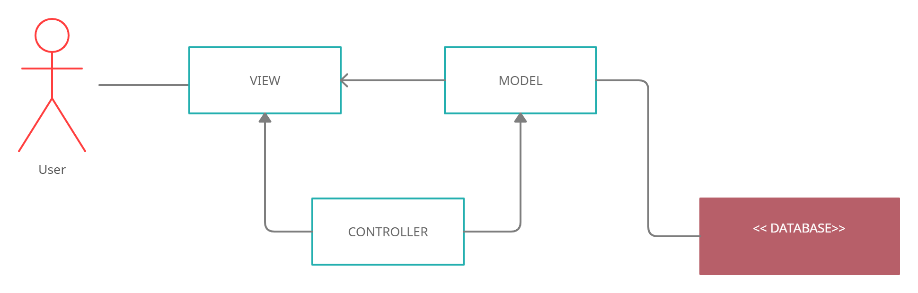

Communications Interfaces
The application will communicate with users through the means of push notifications and/or email, if set up by user. A web browser will be required in order to use the application, and a PWA could provide an expansion to the functionality and accessibility of the application.
The communication standard used is HTTP. HTTP is a protocol for fetching resources such as HTML documents. It is the foundation of any data exchange on the Web and it is a client-server protocol, which means requests are initiated by the recipient, usually the Web browser. A complete document is reconstructed from the different sub-documents fetched, for instance, text, layout description, images, videos, scripts, and more.

System Features

Child Monitoring
4.1.1 Description and Priority
This is the main functionality of the application and is a high priority feature. It uses the most resources because this will be an always-on process which require acquisition of data from connected devices, performing an analyzation of said data and performing actions in necessary
4.1.2 Stimulus/Response Sequences
If the connected devices provide data that matches one of the predefined or user generated cases, it will trigger an event in order to notify the user.
4.1.3 Functional Requirements
The application will send push notifications and/or emails to a list of people, defined by the user in case of an event.

Administration
4.2.1 Description and Priority
This is a low priority task which can be performed at any time by the user and allows them to configure the application parameters in order to suit the user requirements
4.1.2 Functional Requirements
The uses should be able to create, edit and delete different variables such as a list of people to notify in case of an event, the event parameters and the login information of said user.

Other Nonfunctional Requirements

Performance Requirements
Considering the monitoring process will be a real time long term task, it would be ideal that the application would be as efficient as possible in order to provide its functionality in minimal time and be energy efficient.

Safety Requirements
<Specify those requirements that are concerned with possible loss, damage, or harm that could result from the use of the product. Define any safeguards or actions that must be taken, as well as actions that must be prevented. Refer to any external policies or regulations that state safety issues that affect the product’s design or use. Define any safety certifications that must be satisfied.>
The purpose of the application is to ensure safety to children who aren’t in the vicinity of their parents. This task requires a high level of safety measures considering one failure of the system could prove costly. Because the application is heavily dependent on other devices which can malfunction on their part, it is heavily recommended a fallback option to be implemented, for example, missing data from the sensors, loss of connection, invalid data should call for an examination as soon as possible

Security Requirements
Users will need to authenticate with a username and password and the users’ data will be stored in a database with adequate security protocols.

Other Requirements
<Define any other requirements not covered elsewhere in the SRS. This might include database requirements, internationalization requirements, legal requirements, reuse objectives for the project, and so on. Add any new sections that are pertinent to the project.>
Appendix A: Glossary
<Define all the terms necessary to properly interpret the SRS, including acronyms and abbreviations. You may wish to build a separate glossary that spans multiple projects or the entire organization, and just include terms specific to a single project in each SRS.>

