Cafe Chain Management System
ADBS2 Project Documentation

1. Project Statement
This project implements a web-based management system for a small cafe chain with multiple locations. The application allows managers to oversee operations across all branches from a single interface, while individual employees can log in to manage orders and view their own cafe's inventory.
The core idea is straightforward: a cafe chain needs more than a spreadsheet. Orders have to be tracked in real time, stock levels need to be visible per location, and managers need to see how each branch is performing without having to call in every morning.

The system is built with Flask and SQLite and runs as a web application. It introduces two user roles: administrators, who are managers with full access to all data and settings, and employees, who can log in to create orders and view their cafe's menu and stock.
Administrators can add and remove cafes, manage employees, build out the product catalog, and assign products to individual cafe menus with separate stock counts. They also get a dashboard overview showing revenue by location, open orders, and any products running low across the chain — with a one-click refill button.
Employees see a simpler view: their cafe's details, a list of their own orders, and the current stock situation for their location. They cannot access other cafes or modify system-level data.

2. Entity-Relationship Diagram

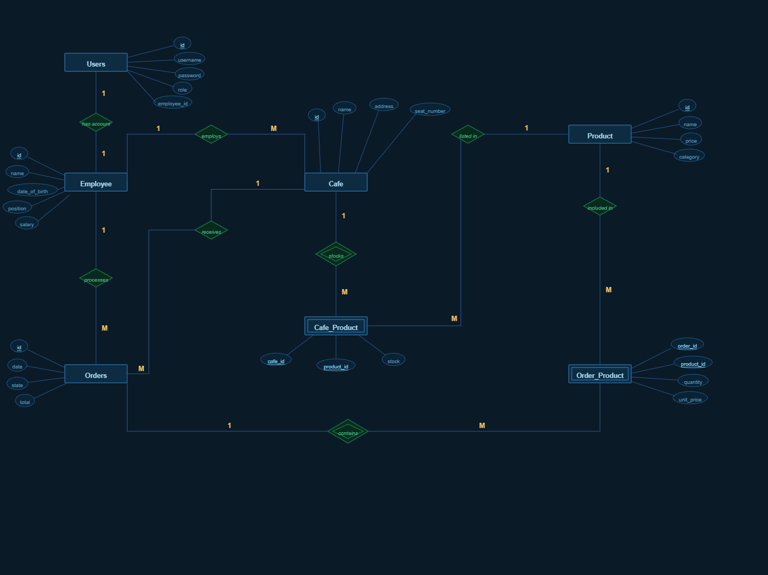

2.1 Entities
The system has five main entities. Cafe represents a physical location and holds the name, address, and seating capacity. Employee is a member of staff who works at one cafe and may have a login account. Product is an item in the global catalog with a price and category. Orders is a transaction placed at a cafe by an employee on a given date, with a status and a total value. Users is the authentication table, storing usernames, hashed passwords, and roles, linked one-to-one with an Employee where applicable.
Two additional tables handle many-to-many relationships. Order_Product sits between Orders and Product, storing the quantity and the price at the time of the order. Cafe_Product sits between Cafe and Product, recording which products are available at each cafe and how many units are in stock at that location.

2.2 Relationships
An employee works at exactly one cafe, while a cafe can have many employees. An employee manages many orders over time, and each order is linked to the employee who created it. An order is always placed at a specific cafe. Orders and products have a many-to-many relationship resolved through Order_Product. Products can be available at multiple cafes and each cafe can carry many products, resolved through Cafe_Product, which also stores the per-cafe stock count.

3. Database Structure
The database is stored in a single SQLite file called cafe_chain.db. It is created automatically the first time the application runs, along with a set of sample data to make it easier to explore the system immediately.

3.1 Tables and Attributes

Cafe
Stores the details of each physical location. The id is the primary key. name and address are plain text. seat_number is an integer representing how many customers the location can accommodate.

Employee
Holds staff records. Each employee has a name, date_of_birth, position (such as Manager or Barista), and a monthly salary. The cafe_id is a foreign key linking the employee to their assigned location.

Product
The global product catalog. Each product has a name, a price, and a category such as Drinks or Food. This table does not store stock — that information lives in Cafe_Product so that each cafe can have its own count.

Cafe_Product
The junction table between Cafe and Product. The composite primary key is made up of cafe_id and product_id. The stock column stores how many units of that product are currently available at that specific cafe. When an order is placed, stock is reduced here; when an order is deleted or a manual refill is performed, stock is increased.

Orders
Records each sales transaction. date is stored as a text string in ISO format. state can be one of four values: pending, in-progress, completed, or cancelled. total is the sum of all items in the order, calculated at the time of saving. cafe_id and employee_id are foreign keys.

Order_Product
The junction table between Orders and Product. It stores the quantity of each item in an order and the unit_price at the time the order was created. Storing the price here means historical totals remain accurate even if the product price changes later.

users
Handles authentication. Each row has a username, a SHA-256 hashed password, and a role of either admin or employee. The employee_id column is a nullable foreign key — admin accounts are not linked to any employee record.

4. Application Structure
The application follows a standard Flask layout with all routes and database logic in app.py and HTML templates in a templates folder. Everything is rendered server-side using Jinja2 — there is no separate frontend build step.

4.1 Architecture
The presentation layer consists of HTML pages rendered from Jinja2 templates. Forms submit data via HTTP POST to Flask routes, which validate the input, execute the appropriate SQL, and redirect back with a status message. The data layer is a single SQLite file accessed through Python's built-in sqlite3 module.

4.2 Authentication and Access Control
The system uses Flask sessions to keep users logged in. When a user submits the login form, the application hashes the submitted password and compares it against the stored hash. Two decorators enforce access control. login_required redirects to the login page if there is no active session. admin_required additionally blocks employees from admin-only routes, enforced at the Python level so it cannot be bypassed by manipulating URLs.

4.3 Routes Overview
The dashboard at /dashboard shows a different view depending on the user's role. Admin users see aggregate statistics, revenue by cafe, a low-stock panel with a refill button, and a recent orders table. Employees see their cafe's details, their own order history, the current menu and stock levels, and a list of their colleagues.
The /cafes section covers listing, adding, editing, and deleting cafes. Each cafe also has a dedicated menu management page at /cafes/<id>/menu where stock can be set manually or refilled in one click. The /employees section lists all staff across all locations with options to create accounts, edit records, and delete. The /products section shows the global catalog to admins and the location-specific menu to employees. The /orders section handles the full order lifecycle, updating stock counts on every create, edit, and delete.

5. Setup and Usage

5.1 Running Locally
The application requires Python 3.8 or later and the Flask library. After unzipping the project, install Flask and start the server:
pip install flask
python app.py

The application will be available at http://127.0.0.1:5000. The database is created and populated with sample data automatically on the first run. Delete cafe_chain.db and restart to reset to a clean state.

5.2 Default Accounts
The following accounts are created automatically with the sample data:
- admin / admin — administrator account, not linked to any employee
- alice / alice123 — Manager at Cafe Central
- bob / bob123 — Barista at Cafe Central
- clara / clara123 — Manager at Cafe Riviera
- david / david123 — Barista at Cafe Bohemia
- eva / eva123 — Waiter at Cafe Bohemia

5.3 Sample Data
Three cafes are created on first run: Cafe Central in Prague, Cafe Riviera in Brno, and Cafe Bohemia in Ostrava. The product catalog contains eight items across Drinks and Food categories. Each cafe has a different subset of products on its menu, and several products intentionally start with low stock to demonstrate the low-stock alert and refill functionality on the admin dashboard.

6. Deployment
The application is deployed to Railway, a cloud platform that runs web applications on remote servers and exposes them through a public URL. Railway was chosen because it requires no server configuration and no payment information — deployment is handled by connecting a GitHub repository.

6.1 How It Works
Railway detects that the project is a Python application by looking for a requirements.txt file. It installs the listed packages, then reads the Procfile to know how to start the server. In this case it runs Gunicorn, a production-grade WSGI server, instead of Flask's built-in development server which is not suitable for public traffic.
Three additional files are required in the project root alongside app.py:
- Procfile — one line telling Railway to run: gunicorn app:app
- requirements.txt — lists flask and gunicorn so Railway installs them
- runtime.txt — specifies the Python version, set to python-3.11.9

6.2 Deployment Steps
The following steps are performed once to get the application live. A GitHub account and a Railway account are required. No CLI tools need to be installed.

Create a GitHub repository
Go to github.com, create a new repository named cafe-chain, and upload all project files except cafe_chain.db (the database is created automatically on first run). Commit the files.

Log in
railway.app
This opens a browser window. After signing in, return to the terminal.

Initialise Git in the project folder
git init
git add .
git commit -m "initial commit"

Connect Railway to GitHub
railway.app → New Project → Deploy from GitHub repo
Sign in to Railway with GitHub, select the cafe-chain repository, and click Deploy. Railway reads the Procfile and starts the application automatically.

Deploy

Railway installs the dependencies, builds the application, and starts it. The build log is visible in the Railway dashboard. When the build finishes the application is live.

Open the app

Railway generates a public URL under the Settings → Domains section of the project dashboard, following the pattern https://cafe-chain-yourname.up.railway.app.

6.3 Database Behaviour on Railway
Railway's file system is ephemeral, meaning any file written while the app is running is lost when the container restarts. As a result, the SQLite database file is recreated from scratch on each restart, and the app starts with the default sample data again. The init_db() function is called at module level so the database is always initialised when gunicorn loads the application.
For a student project and demonstration this is acceptable — the app always starts in a known, working state. If persistent storage were required, Railway offers a PostgreSQL plugin, but that would involve replacing the SQLite connection with a PostgreSQL connection string and updating the schema creation logic accordingly.

7. Design Notes
Stock is tracked at the cafe level, not globally. Each row in Cafe_Product has its own count, so selling an espresso at Cafe Central only affects that cafe's stock.
Order totals and line item prices are calculated and stored at the time of saving, so historical records remain accurate even if product prices change later.
All delete operations use manual cascading in Python rather than relying on database-level ON DELETE CASCADE, which ensures consistent behaviour regardless of how SQLite's foreign key settings were initialised.
Passwords are stored as SHA-256 hashes. Admin accounts are not linked to employee records, so removing an employee does not affect the admin login.

