DATA MANIPULATION

&

GRAPH GENERATION

LOGIN

AUTHENTICATION

SPECIFICATIONS OF THE SATELLITE

IN PDF FORMAT

DISPLAY

ERROR PAGE

MARSHALLING SATELLITE DATA

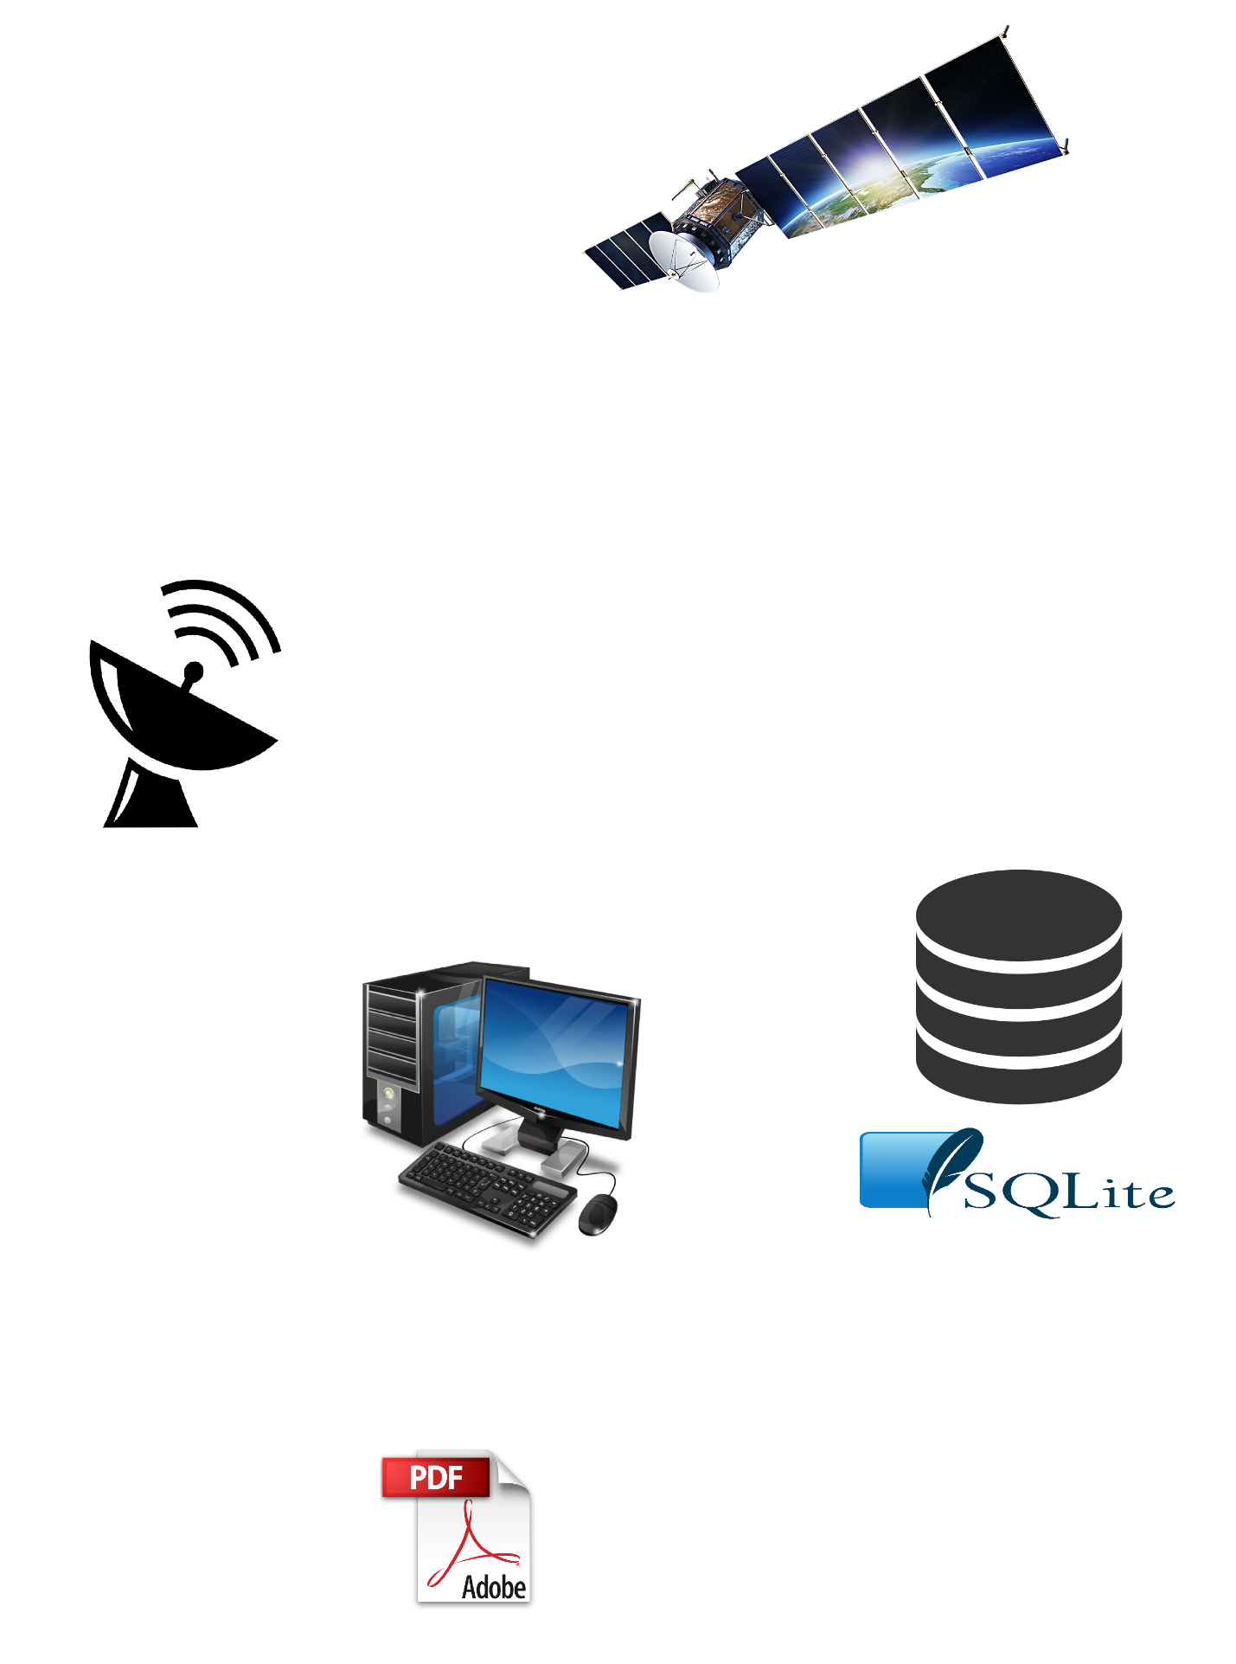

Satellite

Satellite Dish

System

Database