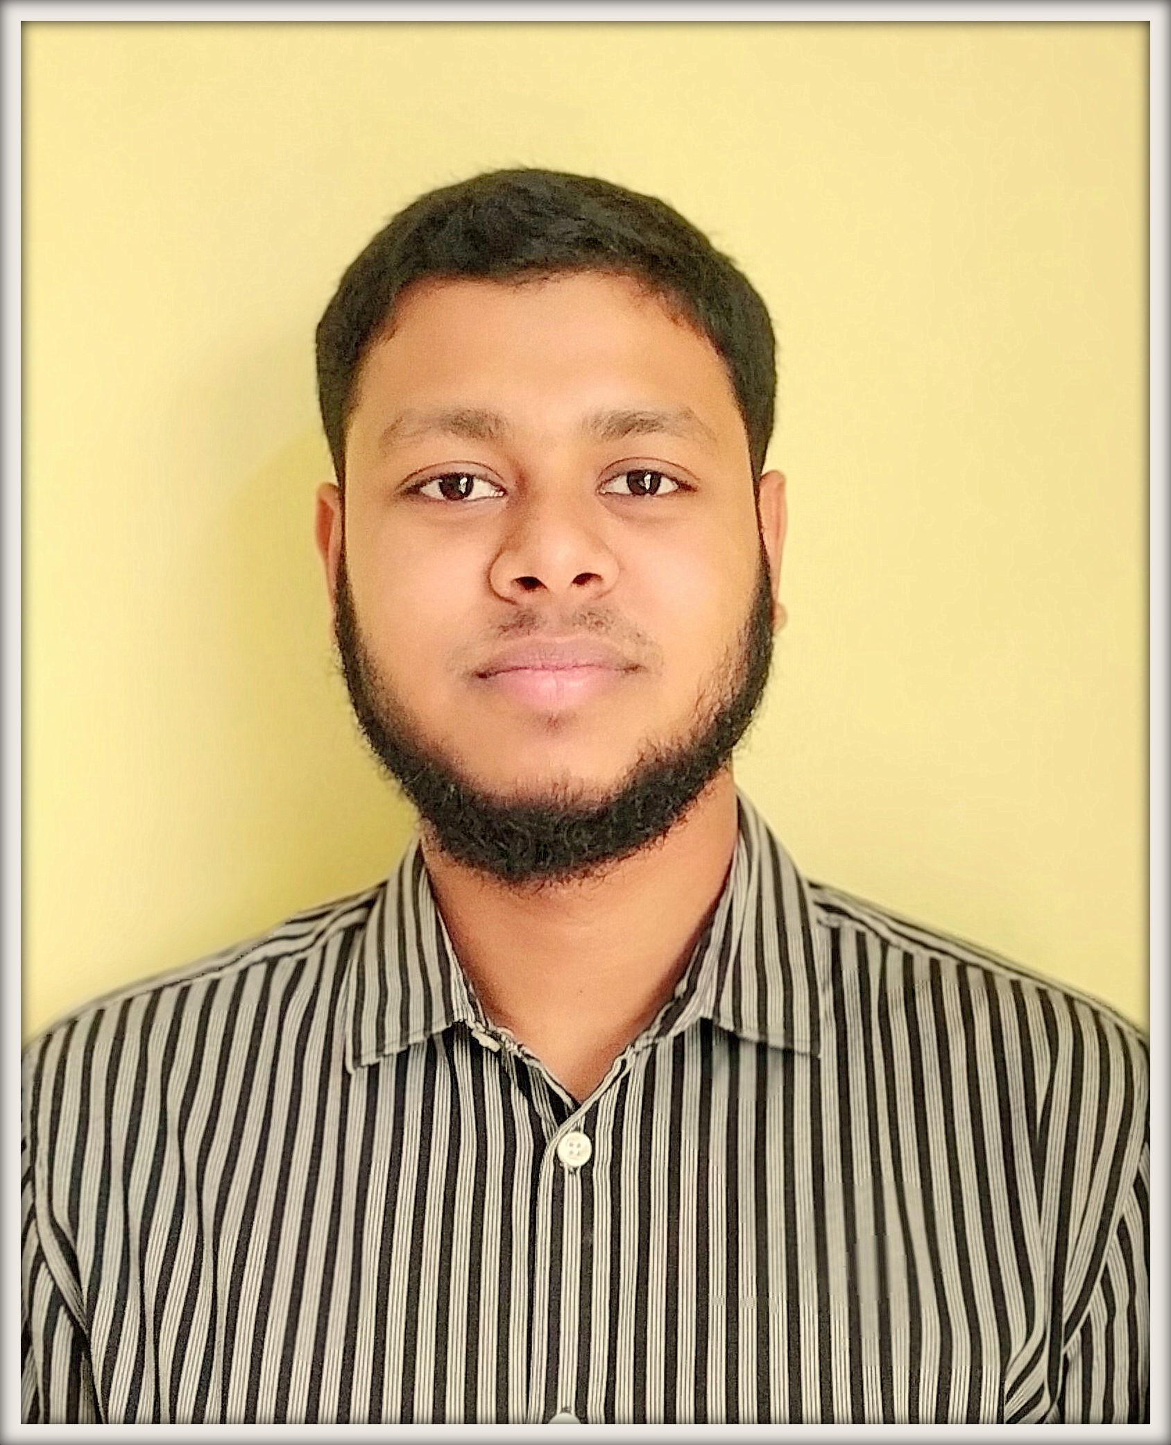**Towfiqul Islam**

+8801823923023 || +8801521487682 || [towfiq.106@gmail.com](mailto:towfiq.106@gmail.com)

https://github.com/laziestcoder

<https://stackoverflow.com/users/6688908/laziestcoder>

# **Professional Experience**

**Software Engineer, Inflack Limited ( Sep’ 2019 – Current )**

***Inflack***, a software consultancy company works both on big scale government & private projects. It operates with the vision at its core to achieve the highest bar on customer collaboration. It belives in quality and passion.

**Key Responsibilities:**

● Developped various Govt and Private Web Application and Services.

● Planned development cycle and collected requirements for developing softwares.

● Managed three members group and delivered task within deadline.

● Worked with **bKash Limited** as **Partner Team** with their **Solution Engineering Team**.

● Learned software design patterns, clean coding, communication and taking ownership.

**Work Highlights**

**AirtimeManagementSystem-AMS**

A project for ***bKash Limited*** developpedin a joint working environment in ***bKash*** premise with their ***Solution Engineering Team***. It’s a software which collects data from provided API source in another system and calculate and generate report automatically and send instruction to configured system for automated recharge. It has many features **i.e.** automated read-write CSV, XLS and PDF, financial calculation, automated email sending for notifying configured responsible person depending on pre-defined conditions.

**Technologies:** JAVA(Spring-Boot), API, JS, MySQL

**Saving-DPS**

A project for ***bKash Limited*** developpedin a joint working environment in ***bKash*** premise with their ***Solution Engineering Team***. A service for **bKash App** which allows customer to open a DPS.

**Technologies:** JAVA (Spring-Boot), API, JS, MySQL, AWS

**MULTIBANK**

A project for ***bKash Limited*** developpedin a joint working environment in ***bKash*** premise with their ***Solution Engineering Team***. It’s a software which collects data from provided files in another system calculate and generate report automatically and send instruction to Configured Banks for automated transaction. It has many features **i.e.** automated SFTP inbound and outbound, read-

write CSV, XLS and PDF, financial calculation, automated email for notifying responsible person.

**Technologies:** JAVA (Spring-Boot), API, JQuery, MySQL, Spring-Integration

**bKash-Distributor-Portal**

A report portal based on Distributor’s transcation. A legacy project.

**Technologies:** JAVA, API, JQuery, Oracle, JSP, Struts

**bKash-Merchant-Portal**

A report portal based on Merchant’s transcation. A legacy project.

**Technologies:** JAVA, API, JQuery, Oracle, JSP, Struts

**bKash-Refund-Tool**

A tool that refunds automatically digital to cash. A legacy project.

**Technologies:** JAVA, API, JQuery, Oracle, JSP, Struts

**bKash-MSF-Report-Tool**

A MSF Report Tool. A legacy project.

**Technologies:** JAVA, API, JQuery, Oracle, JSP, Struts

[**PREVENTO**](https://play.google.com/store/apps/details?id=lt.prevento&hl=en_NZ)

It’s an App where users provide information - gender, age, height, weight, diagnosed illnesses, risk factors - and the app will create a personalized health care plan. The app will be provided tasks each month and Clients of selected medical partners write a message to a doctor and get an answer.

**Technologies:** PHP (Laravel), API, JQuery, MySQL, AWS, Google Analytics.

[**TAXSENSE**](http://www.taxsensebd.com/)

A software based on Tax Calculation and Tax Report Generator for Ahkam and Associates Business Limited.

**Technologies:**PHP (Laravel), Docker, JQuery, MySQL.

[**HR ACR**](http://acr.ict.inflack.com/)

Application developed for Ministry of ICT for generating Annual Confidential Report of employees.

**Technologies:** PHP (Laravel), Docker, JQuery, MySQL.

[**IMS**](http://demo.eti.inflack.com/login)

A software called Inventory Management System for Electoral Training Institute for managing different types of product, stock, purchase and tracking the distributed items.

**Technologies:** PHP (Laravel), Docker, JQuery, MySQL.

# **Professional Skills**

|  |  |  |  |  |  |  |  |  |
| --- | --- | --- | --- | --- | --- | --- | --- | --- |
| Java | PHP | C/C++ | Docker | Bash | GIT | Laravel | AWS | API |
| MySQL | JavaScript | JIRA | JQuery | Spring Boot | Postman | Unix | Maven | Oracle |
| Python | Google  Analytics | DynamoDB | Swagger | Firebase | Hibernate | GlassFish | Tomcat | SFTP |
| IntellijIDEA | PHPStorm |  |  |  |  |  |  |  |

# **Awards & Achievements**

## Team Award as Coach:

## IIUC IUPC 2017, my team CJC_TEAM_1971 Ranked [2nd Position](https://drive.google.com/open?id=1TC8-AII5ER3ntrIl0wB3tU1JNtoU11VA). <https://goo.gl/DJnuAy>

## EDU Programming Contest 2018 , my team CJC_TEAM_1971 Ranked [5th position](https://drive.google.com/open?id=1sg0KEhFqm9TZGdn_XwJFlS-bBWKRP8VN). <https://goo.gl/JTPNuu>

## ACM Profiles:

## 5th Position on CSE Week Programming Contest 2016. <https://algo.codemarshal.org/contests/cseweek-2016/standings>

## Participated in divisional onsite contest: IIUC IUPC 2015,2016, USTC IUPC 2016 Solved 500+ problems in various online judge.

## Virtual Judge ID: UVA: [448714](https://uhunt.onlinejudge.org/id/448714), CF: [laziestcoder](http://codeforces.com/profile/laziestcoder), HR: [Laziest_Coder](https://www.hackerrank.com/Laziest_Coder)

# **Education**

|  |  |  |
| --- | --- | --- |
| B.Sc. Computer Science & Engineering ‘19 | HSC ‘13 | SSC ‘11 |
| Int’l Islamic University Chittagong | Govt. City College Chittagong | Govt. Muslim High School Chittagong |

# **Personal Information**

* **Father’s Name:** Karimul Islam
* **Mother’s Name:** Salina Akter
* **Nationality:** Bangladeshi
* **Present Address:** House-18, Road-23, Pallabi, Mirpur-11.5, Dhaka-1216
* **Permanent Address:** House-106, Road-Kobi Nazrul Islam, Sadarghat, Chittagong-4000

# **Reference**

|  |  |
| --- | --- |
| Professor Mohammed Shamsul Alam | Sahib Bin Mahboob |
| International Islamic University Chittagong | Inflack Limited |
| Professor | CTO |
| Kumira, Chittagong | House#36, Road#1, Block-A Bashundhara R/A, Dhaka |
| +8801711941680 | +8801717065223 |
| alam_cse@yahoo.com | sahib@inflack.com |