JSPM’s
RAJARSHI SHAHU COLLEGE OF ENGINEERING
TATHAWADE, PUNE-33
(An Empowered Autonomous Institute Affiliated to Savitribai Phule Pune University, Pune)

Mini Project
on
“Breast Cancer Detection Using Supervised Machine Learning Algorithms”

-Submitted by-

Lazina S. Shaikh Roll No: CS3264

Class and Division: TY Div B
Course: Machine Learning
Academic Year 2026-27
(Semester-I)
- Title
Breast Cancer Detection Using Supervised Machine Learning Algorithms
- Abstract
Breast cancer is one of the most frequently diagnosed cancers in women worldwide, and early detection significantly improves survival rates. This project develops a machine learning system that classifies a breast tumor as benign or malignant using the Wisconsin Diagnostic Breast Cancer (WDBC) dataset, which contains 569 samples described by 30 features computed from digitized fine needle aspirate (FNA) images of cell nuclei.
After cleaning the data, encoding the diagnosis and scaling the features, three supervised learning algorithms – Logistic Regression, Support Vector Machine (SVM) and Random Forest – were trained on 80% of the data and evaluated on the remaining 20% using accuracy, precision, recall, F1-score, confusion matrix and ROC-AUC. Five-fold stratified cross-validation and hyperparameter tuning with GridSearchCV (using recall as the scoring metric) were used to verify and improve the models.
After tuning, the SVM and Random Forest both achieved an accuracy of 97.37% with 100% precision, 92.86% recall and an AUC of about 0.99. The SVM was selected as the final model; it correctly identified 39 of the 42 malignant tumors in the test set with no false alarms. Feature importance analysis showed that the worst area, worst concave points and worst radius of the cell nuclei are the most influential features. The system is intended as a decision-support tool for doctors and not as a replacement for them.
- Introduction

3.1 Background
Breast cancer occurs when cells in the breast grow abnormally and form a mass called a tumor. Tumors can be benign (non-cancerous and not spreading to other parts of the body) or malignant (cancerous and able to spread). Breast cancer is among the most frequently diagnosed cancers in women worldwide, and detecting it at an early stage significantly improves survival rates [1].
The standard diagnostic process includes physical examination, imaging such as mammography, and a biopsy. In a fine needle aspirate (FNA), a small sample of tissue is taken with a thin needle and examined under a microscope. Interpreting such samples requires an experienced pathologist and can be time-consuming and subjective.

3.2 Role of Machine Learning
Machine learning allows computers to learn patterns from historical data without being explicitly programmed. In supervised learning, the algorithm is trained on examples whose correct answers (labels) are already known, and it then predicts the label for new, unseen examples. Because the WDBC dataset provides the true diagnosis for every patient, breast cancer detection is a natural binary classification problem for supervised learning.
A well-trained model can act as a decision-support tool for doctors by giving a fast and consistent second opinion, helping to reduce human error and to prioritize suspicious cases.
- Problem Statement
To design and develop a machine learning model that can accurately classify a breast tumor as benign or malignant based on features computed from the cell nuclei of an FNA biopsy image, and to compare the performance of multiple supervised learning algorithms in order to identify the most reliable model, with special attention to minimizing the number of missed malignant cases.
- Objectives
- To study and understand the Wisconsin Diagnostic Breast Cancer dataset through exploratory data analysis and visualization.
- To pre-process the data by cleaning, encoding the target variable and scaling the features.
- To implement three supervised learning algorithms: Logistic Regression, Support Vector Machine and Random Forest.
- To evaluate the models using accuracy, precision, recall, F1-score, confusion matrix and ROC-AUC.
- To improve the models using cross-validation and hyperparameter tuning with GridSearchCV.
- To identify the most important features and select the best model for breast cancer detection.
- Data set and Libraries required

6.1 Dataset Description
The dataset used is the Breast Cancer Wisconsin (Diagnostic) Data Set, downloaded from Kaggle [8] (originally from the UCI Machine Learning Repository [3]). Features were computed from a digitized image of an FNA of a breast mass and describe the characteristics of the cell nuclei present in the image.
Table 1: Summary of the dataset
Property | Details
Source | UCI Machine Learning Repository / Kaggle
Number of samples | 569 patients
Number of features | 30 numeric features (after removing id)
Target variable | diagnosis: M = Malignant (1), B = Benign (0)
Class distribution | 357 Benign (62.7%), 212 Malignant (37.3%)
Missing values | None (the empty column Unnamed: 32 was removed)

Ten basic measurements are computed for each cell nucleus, and for each one the mean, the standard error (SE) and the worst (largest) value are recorded, giving 10 x 3 = 30 features.
Table 2: Basic nuclear measurements
Measurement | Meaning
Radius | Mean distance from the centre to points on the boundary
Texture | Standard deviation of gray-scale values
Perimeter | Length of the boundary of the nucleus
Area | Area of the nucleus
Smoothness | Local variation in radius lengths
Compactness | Perimeter squared divided by area, minus 1
Concavity | Severity of concave portions of the contour
Concave points | Number of concave portions of the contour
Symmetry | Symmetry of the nucleus
Fractal dimension | Coastline approximation of the boundary minus 1

6.2 Libraries and Tools Required
The following tools and Python libraries were used to implement the project.
Table 3: Tools used
Tool | Purpose
Python 3 | Programming language
Google Colab | Cloud notebook environment to write and run the code
Pandas and NumPy | Data loading, cleaning and numerical operations
Matplotlib and Seaborn | Data visualization and graphs
Scikit-learn | Preprocessing, models, cross-validation, GridSearchCV and metrics
Joblib | Saving the trained model and scaler

- Approach / Methodology
The project follows the standard machine learning pipeline shown in Figure 1. Each stage is described below.
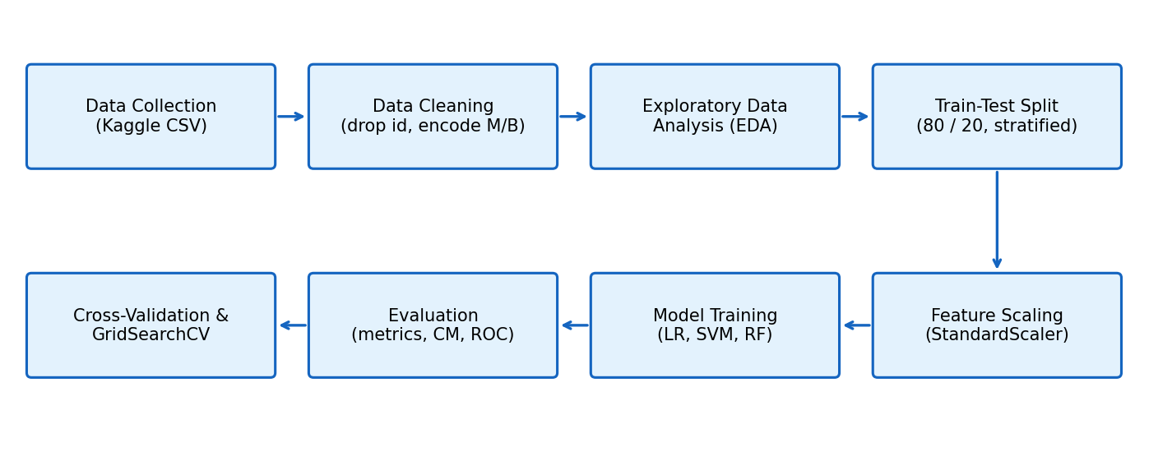
Figure 1: Methodology flowchart of the project

7.1 Data Cleaning
The Kaggle file contains an identifier column (id) that has no predictive value and an empty column (Unnamed: 32) created by a trailing comma in the CSV file. Both were removed. The target column diagnosis, which contains the letters M and B, was converted into numbers (M = 1, B = 0) because machine learning models require numeric input. The data was checked for missing values and duplicate rows, and none were found. The final shape of the data was 569 rows and 31 columns (30 features and 1 target).

7.2 Exploratory Data Analysis
Exploratory analysis was carried out to understand the data. The class distribution, histograms, box plots, correlation heatmap and PCA projection were plotted. These are discussed in Section 9.1.

7.3 Train-Test Split
The data was divided into 80% training data (455 samples) and 20% test data (114 samples). The split was stratified, which keeps the same proportion of benign and malignant cases in both parts, and a fixed random state (42) was used so that the results can be reproduced.

7.4 Feature Scaling
The features have very different ranges; for example, the area is in hundreds while smoothness is below 1. Algorithms such as Logistic Regression and SVM are sensitive to this difference. StandardScaler was therefore applied, which transforms each feature to have zero mean and unit variance. The scaler was fitted on the training data only and then applied to the test data. This avoids data leakage, in which information from the test set would unfairly influence the training process.

7.5 Model Training, Evaluation and Tuning
Logistic Regression, SVM and Random Forest were trained on the scaled training data and evaluated on the unseen test data. Five-fold stratified cross-validation was then used to check the stability of the results, and GridSearchCV was used to find the best hyperparameters for each model, with recall as the scoring metric.

7.6 Algorithms Used

7.6.1 Logistic Regression
Logistic Regression is a linear model for binary classification. It calculates a weighted sum of the input features and passes it through the sigmoid function, which converts it into a probability between 0 and 1:
P(y = 1 | x) = 1 / (1 + e^-(w1x1 + w2x2 + ... + wnxn + b))
If the probability is greater than 0.5, the tumor is classified as malignant; otherwise it is classified as benign. The weights are learned by minimizing the log-loss. The hyperparameter C controls regularization: a small C gives a simpler model, and a large C lets the model fit the training data more closely. It is simple, fast and interpretable, so it is used as the baseline model.

7.6.2 Support Vector Machine (SVM)
SVM finds the decision boundary (hyperplane) that separates the two classes with the largest possible margin, i.e. the greatest distance to the nearest points of each class. These nearest points are called support vectors. With the RBF kernel, SVM can learn curved, non-linear boundaries by implicitly mapping the data into a higher-dimensional space. The main hyperparameters are C (the penalty for misclassified points), kernel (the shape of the boundary) and gamma (how far the influence of a single training point reaches). SVM works very well on datasets with many features and a limited number of samples, such as the WDBC data.

7.6.3 Random Forest
Random Forest is an ensemble method that builds many decision trees, each trained on a random sample of the data (bootstrap sampling) and a random subset of the features. For classification, each tree gives a vote, and the final prediction is the class with the majority of votes. Combining many different trees reduces overfitting and gives more stable predictions than a single tree. Random Forest also provides feature importance scores, showing which features contributed most to the decisions. The main hyperparameters are n_estimators (number of trees), max_depth (maximum depth of each tree) and min_samples_split.
Table 4: Comparison of the three algorithms
Aspect | Logistic Regression | SVM | Random Forest
Type | Linear model | Margin-based model | Ensemble of trees
Complexity | Low | Medium | High
Needs scaling | Yes | Yes | No (but harmless)
Interpretability | High | Medium | Medium (feature importance)
Level in project | Basic | Intermediate | Advanced

- Implementation
The project was implemented in Python 3 using Google Colab. The key steps of the implementation are given below, followed by the metrics used to evaluate the models.

8.1 Key Code Snippets
Data cleaning:
df = pd.read_csv('data.csv')
df = df.drop(columns=['id', 'Unnamed: 32'])
df['diagnosis'] = df['diagnosis'].map({'M': 1, 'B': 0})

Train-test split and scaling:
X = df.drop('diagnosis', axis=1); y = df['diagnosis']
X_train, X_test, y_train, y_test = train_test_split(
X, y, test_size=0.2, random_state=42, stratify=y)
scaler = StandardScaler()
X_train_s = scaler.fit_transform(X_train)
X_test_s = scaler.transform(X_test)

Hyperparameter tuning with GridSearchCV:
grid = {'C': [0.1, 1, 10, 100], 'kernel': ['linear', 'rbf'],
'gamma': ['scale', 'auto']}
gs = GridSearchCV(SVC(probability=True), grid, cv=5, scoring='recall')
gs.fit(X_train_s, y_train)
best_model = gs.best_estimator_

8.2 Evaluation Metrics
The following metrics were used, where TP = true positives (malignant correctly detected), TN = true negatives, FP = false positives (benign wrongly called malignant) and FN = false negatives (malignant wrongly called benign):
Table 5: Evaluation metrics
Metric | Formula | Meaning
Accuracy | (TP + TN) / (TP + TN + FP + FN) | Overall percentage of correct predictions
Precision | TP / (TP + FP) | Of the predicted malignant, how many are truly malignant
Recall | TP / (TP + FN) | Of all malignant cases, how many were detected
F1-score | 2 x (Precision x Recall) / (Precision + Recall) | Balance between precision and recall
ROC-AUC | Area under the ROC curve | Ability to separate the classes (1.0 is perfect)

Importance of recall: In cancer detection, a false negative means a patient with cancer is told she is healthy, which can delay treatment and be life-threatening. A false positive leads only to additional tests. Therefore recall is considered the most important metric in this project.
- Results

9.1 Exploratory Data Analysis
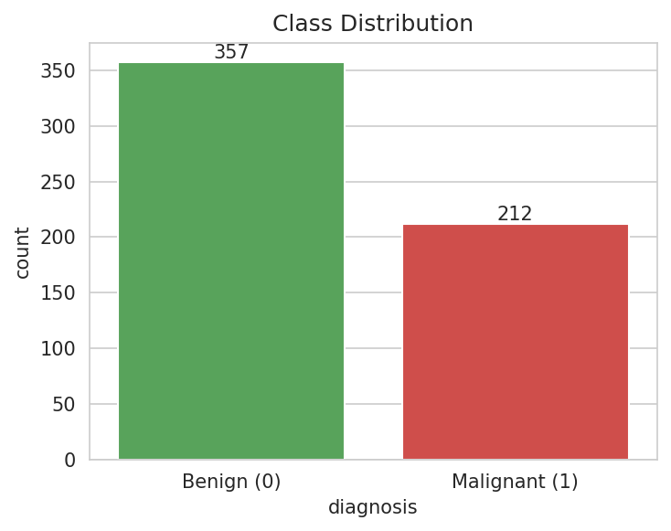
Figure 2: Class distribution of the dataset
Figure 2 shows that the data contains 357 benign and 212 malignant cases. The classes are moderately imbalanced (about 63% to 37%) but not severely, so no resampling was needed; stratified splitting was used to keep the same ratio in the training and test sets.
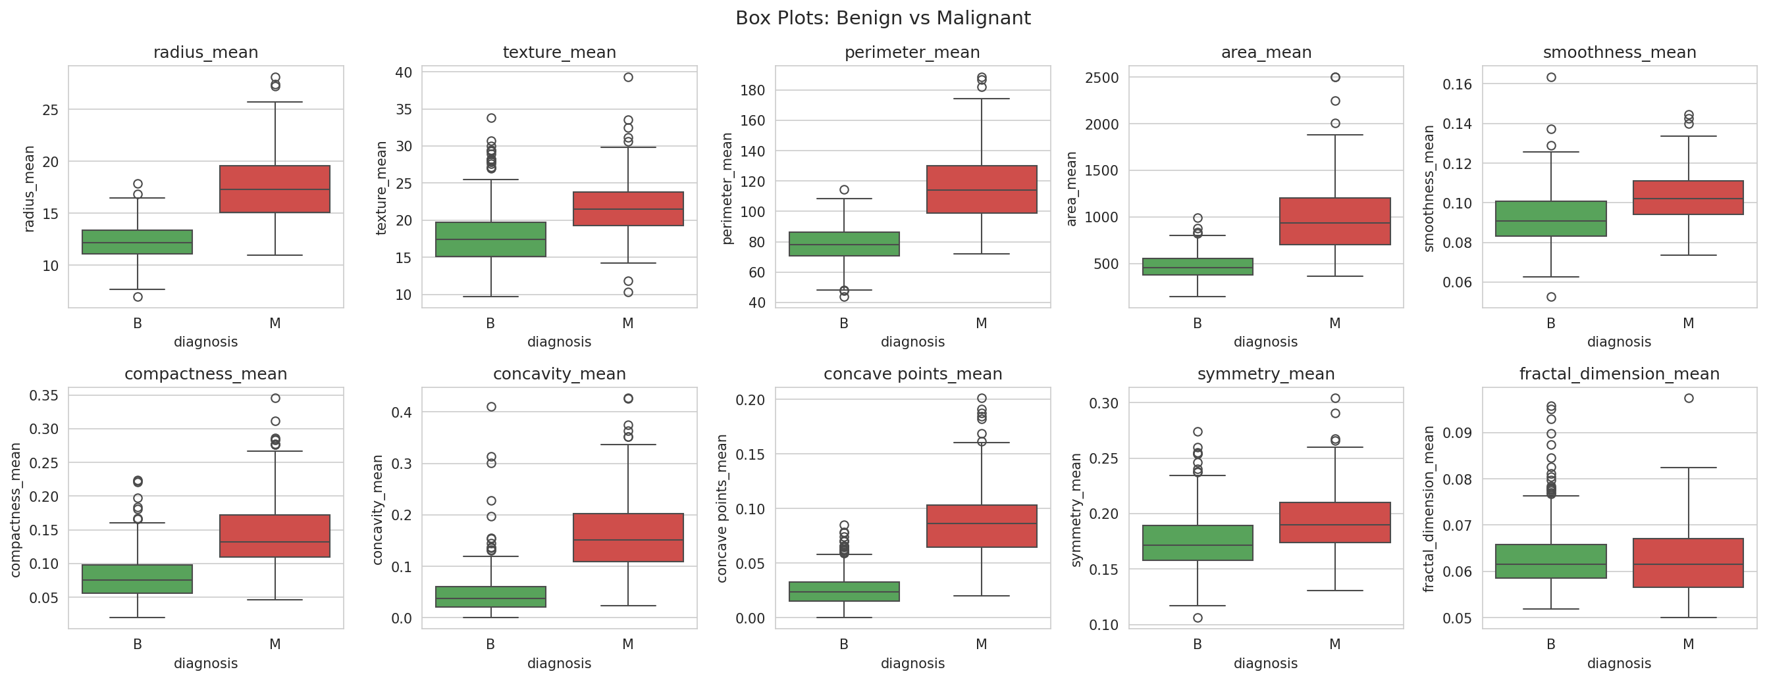
Figure 3: Box plots of mean features for benign (B) and malignant (M) tumors
The box plots show that malignant tumors have clearly higher values of radius, perimeter, area, concavity and concave points than benign tumors, with only a small overlap. This explains why the classes can be separated with high accuracy.
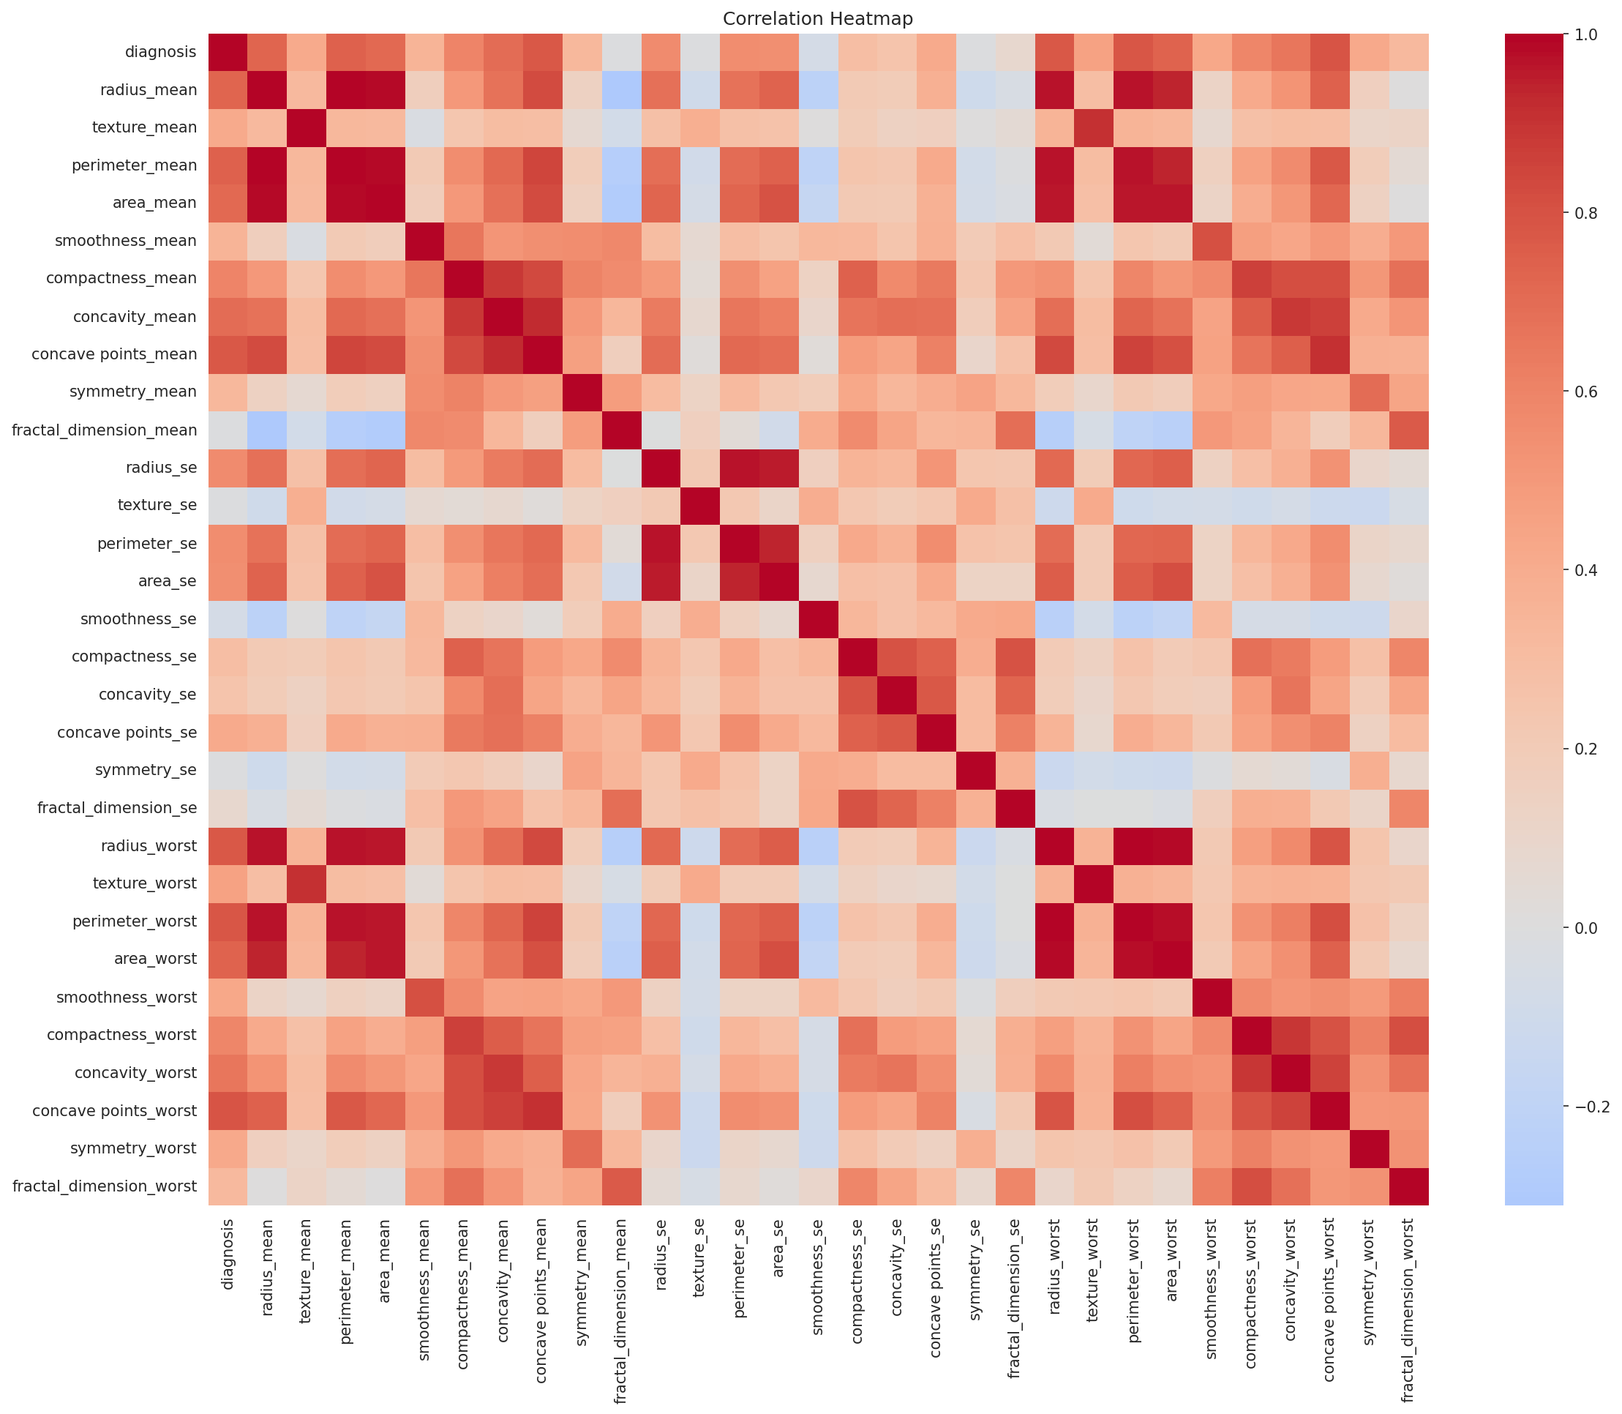
Figure 4: Correlation heatmap of all features
The heatmap shows strong correlation between radius, perimeter and area, which is expected since they all measure the size of the nucleus. The diagnosis is most strongly correlated with the worst concave points, worst perimeter, mean concave points and worst radius (Figure 5).
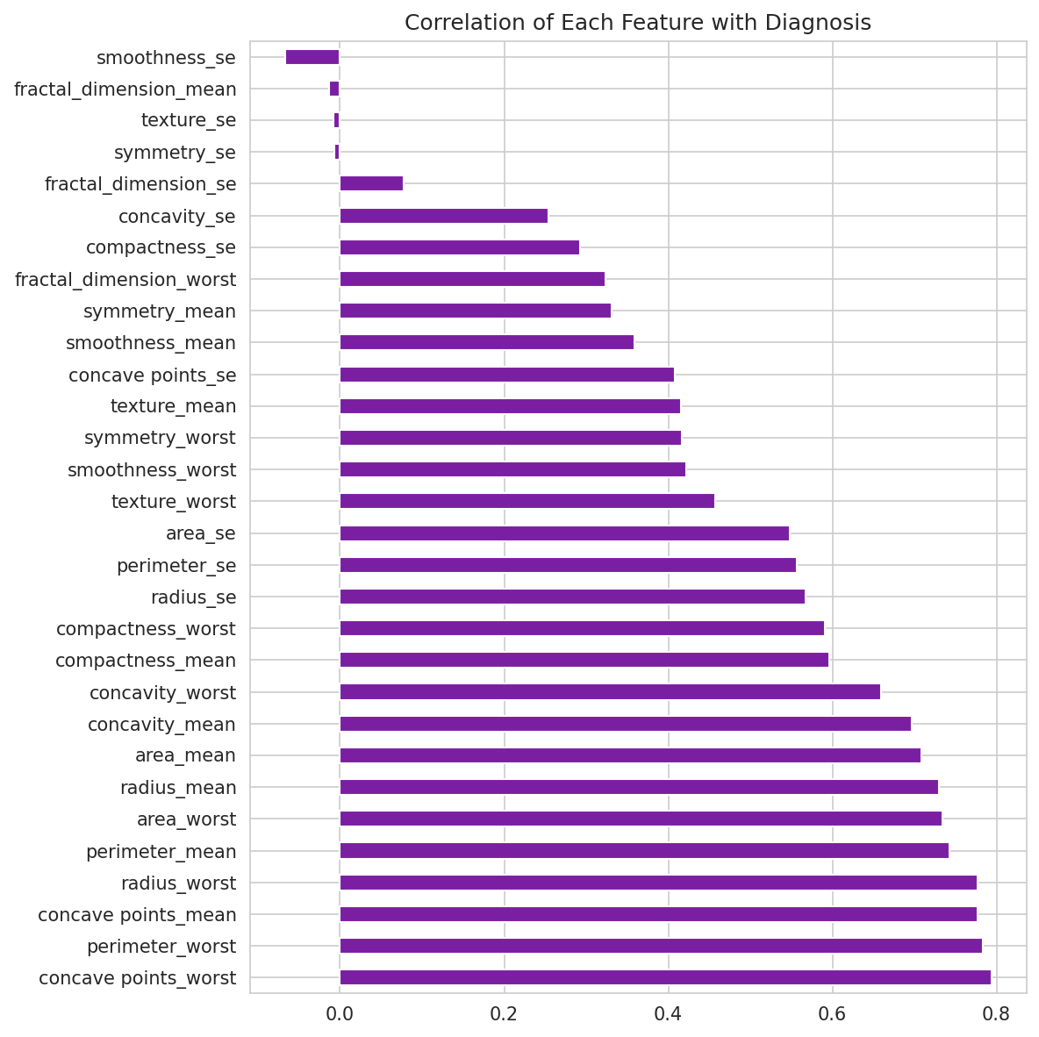
Figure 5: Correlation of each feature with the diagnosis
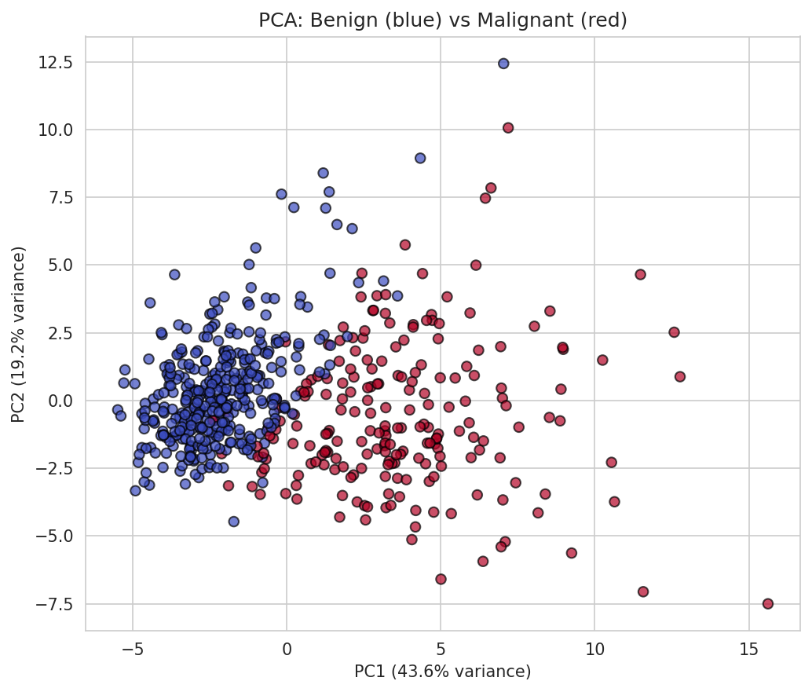
Figure 6: PCA projection of the data into two dimensions
Principal Component Analysis (PCA) reduces the 30 features to two components for visualization. Figure 6 shows that the benign and malignant cases form two largely separate groups, confirming that the features carry strong information about the diagnosis.

9.2 Performance of the Base Models
Table 6 shows the performance of the three models with default settings on the test set of 114 samples (72 benign, 42 malignant).
Table 6: Performance of base models on the test set
Model | Accuracy | Precision | Recall | F1-score | AUC
Logistic Regression | 96.49% | 97.50% | 92.86% | 95.12% | 0.9960
SVM | 97.37% | 100.00% | 92.86% | 96.30% | 0.9947
Random Forest | 96.49% | 100.00% | 90.48% | 95.00% | 0.9942

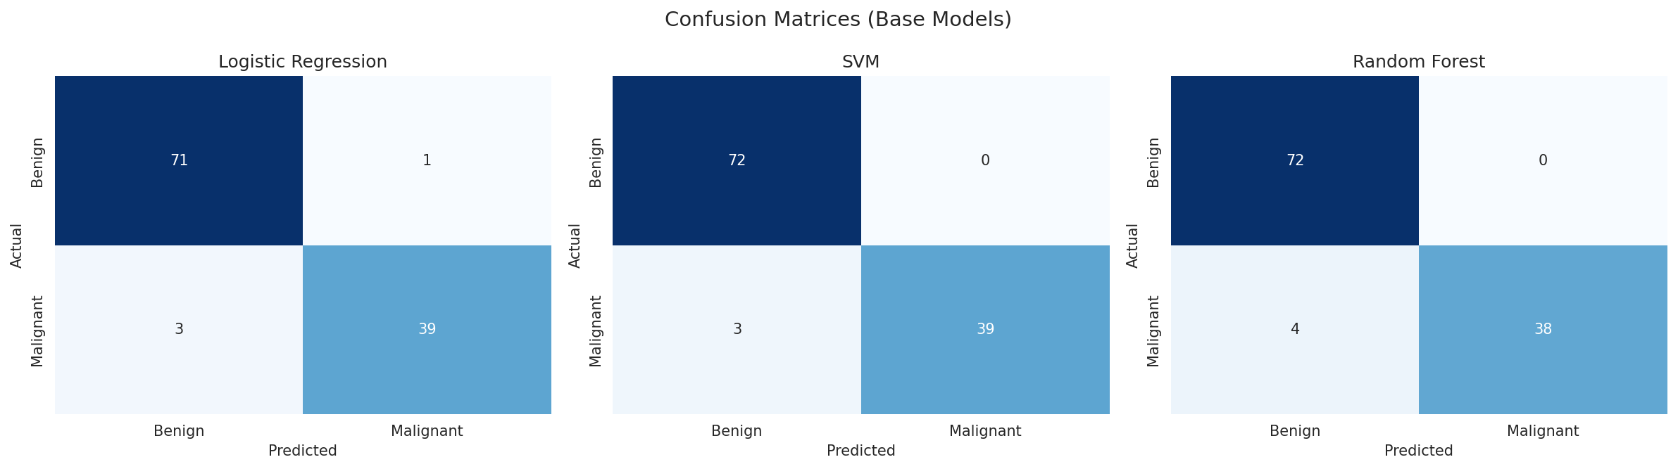
Figure 7: Confusion matrices of the base models
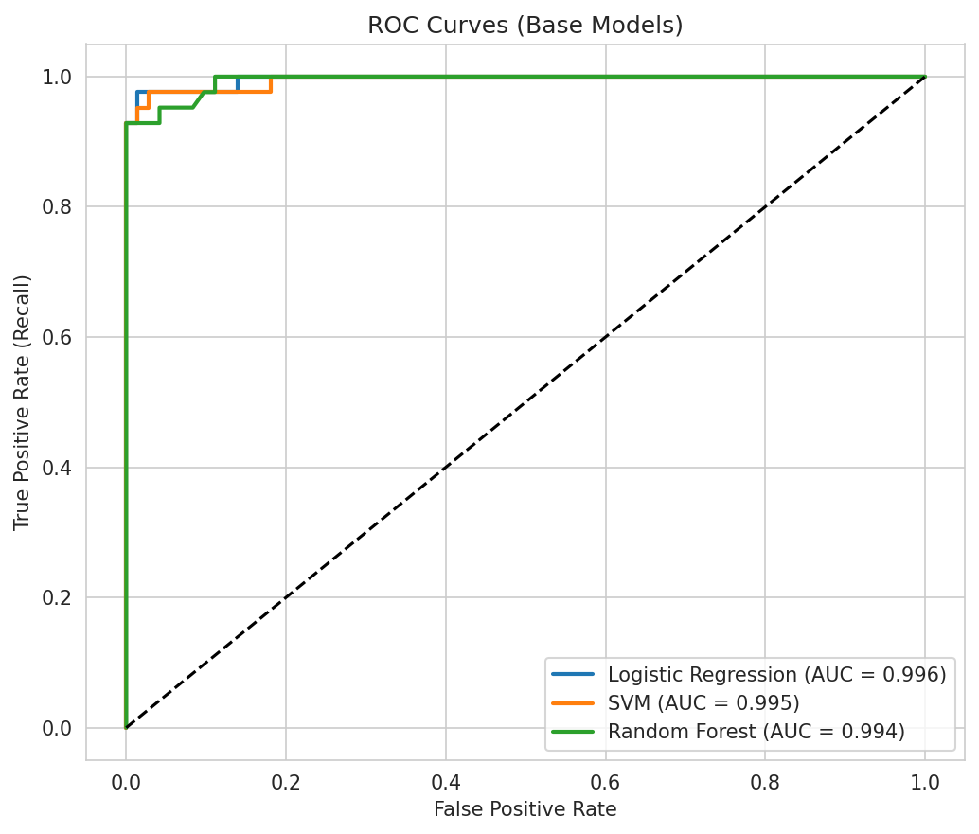
Figure 8: ROC curves of the base models
All three base models performed very well. SVM gave the highest accuracy (97.37%), while Logistic Regression had the highest AUC. Random Forest had the lowest recall (90.48%), meaning it missed 4 of the 42 malignant cases. The ROC curves of all models are very close to the top-left corner, with AUC values above 0.99, which indicates excellent class separation.
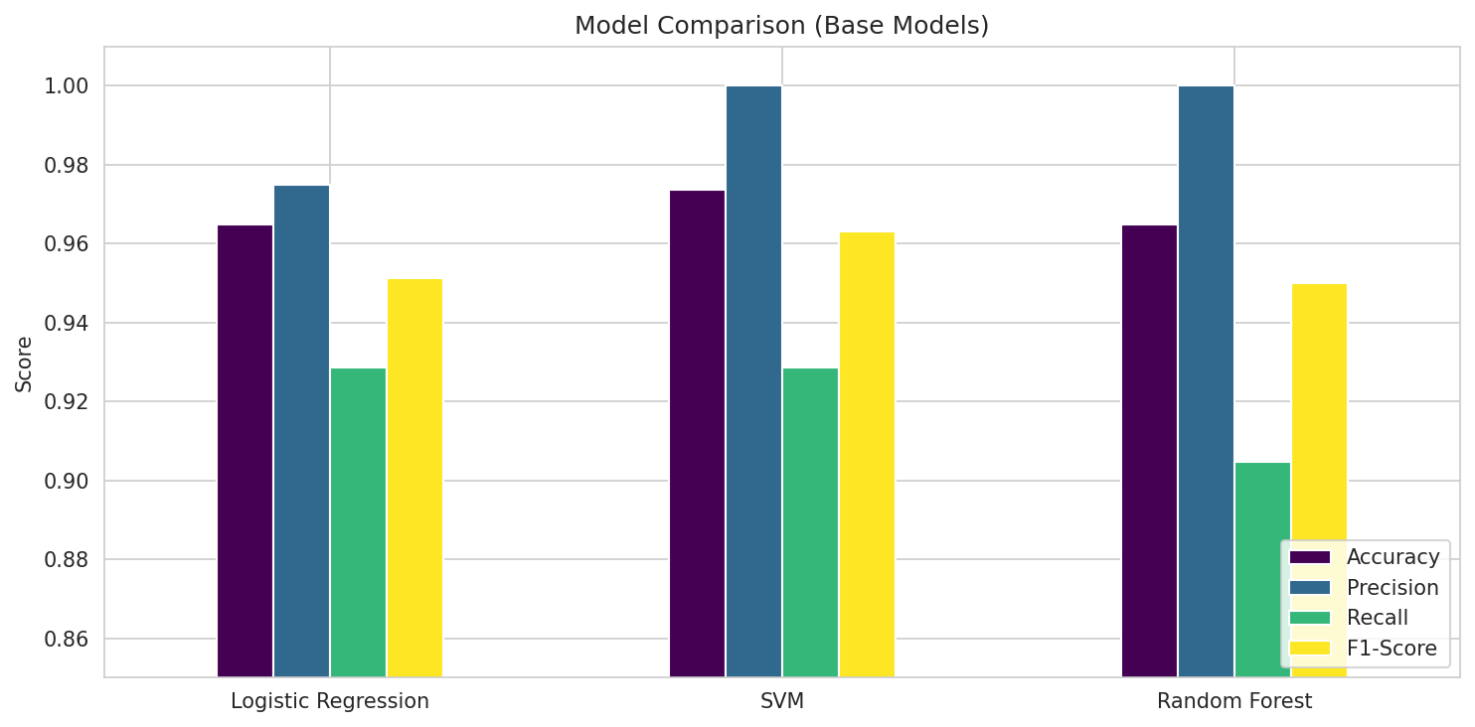
Figure 9: Comparison of the base models

9.3 Cross-Validation
To check that the results do not depend on one lucky split, 5-fold stratified cross-validation was performed on the training data using recall as the metric.
Table 7: 5-fold cross-validation recall
Model | Fold 1 | Fold 2 | Fold 3 | Fold 4 | Fold 5 | Mean
Logistic Regression | 0.882 | 0.971 | 1.000 | 0.941 | 0.971 | 0.953
SVM | 0.912 | 1.000 | 0.941 | 0.912 | 0.971 | 0.947
Random Forest | 0.912 | 1.000 | 0.882 | 0.941 | 0.941 | 0.935

The mean cross-validation recall of all models lies between 0.93 and 0.95, which is consistent with the test results. The fold-to-fold variation is small, so the models are stable and not overfitted to a single split.

9.4 Hyperparameter Tuning
GridSearchCV was used with 5-fold cross-validation and recall as the scoring metric. The best hyperparameters found are shown in Table 8.
Table 8: Best hyperparameters found by GridSearchCV
Model | Best hyperparameters | Best CV recall
Logistic Regression | C = 100, penalty = l2 | 0.9529
SVM | C = 10, kernel = rbf, gamma = scale | 0.9588
Random Forest | n_estimators = 100, max_depth = None, min_samples_split = 2 | 0.9471

Table 9: Performance of tuned models on the test set
Model | Accuracy | Precision | Recall | F1-score | AUC
Logistic Regression | 94.74% | 97.37% | 88.10% | 92.50% | 0.9765
SVM | 97.37% | 100.00% | 92.86% | 96.30% | 0.9927
Random Forest | 97.37% | 100.00% | 92.86% | 96.30% | 0.9929

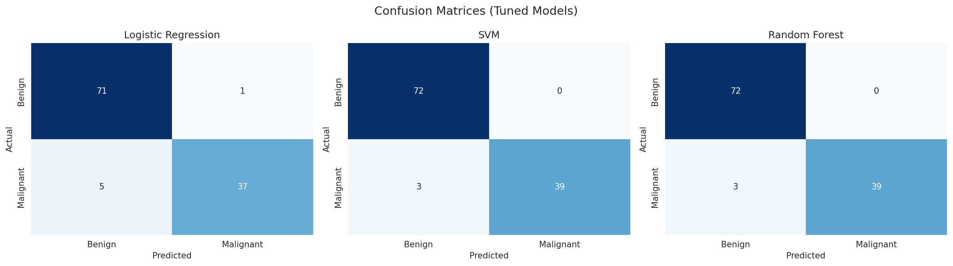
Figure 10: Confusion matrices of the tuned models
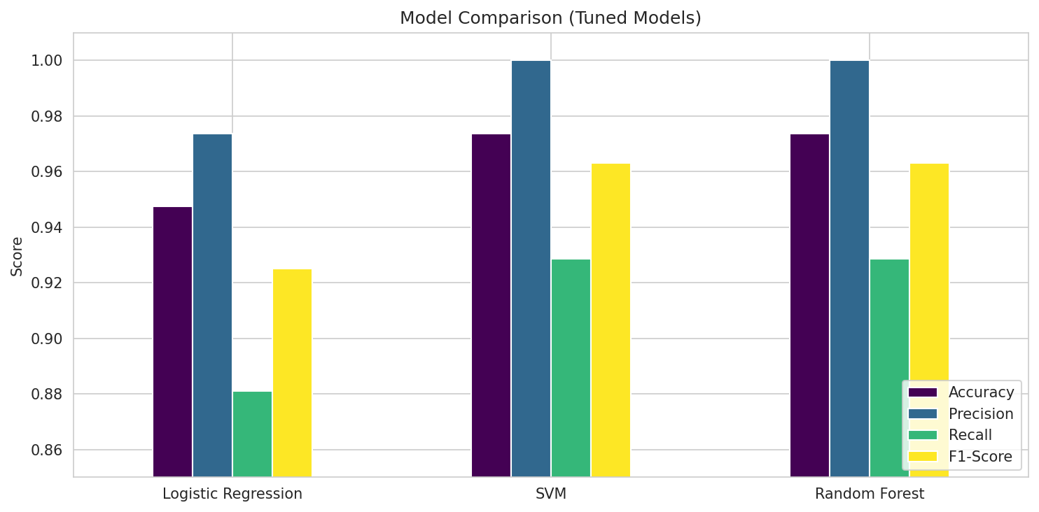
Figure 11: Comparison of the tuned models
After tuning, the recall of Random Forest improved from 90.48% to 92.86% and its accuracy from 96.49% to 97.37%, and the SVM kept its strong performance. The tuned Logistic Regression scored slightly lower on the test set than the base model, because the selected value C = 100 weakens the regularization and makes the model fit the training data more closely. This shows that the best setting on the cross-validation folds does not always give the best result on a small test set of 114 samples, where a single patient changes the recall by more than 2%.

9.5 Best Model
The SVM and the Random Forest tied for the best performance after tuning. The SVM was selected as the final model because it is simpler and faster and had the best cross-validation recall (0.9588). Its confusion matrix on the test set is shown in Table 10.
Table 10: Confusion matrix of the final SVM model
 | Predicted Benign | Predicted Malignant
Actual Benign | 72 (TN) | 0 (FP)
Actual Malignant | 3 (FN) | 39 (TP)

The final model correctly identified 39 of the 42 malignant tumors and all 72 benign tumors, giving no false alarms. Three malignant cases were missed, which is the main weakness and the reason why the model must be used only as an aid to a doctor and not as a replacement.

9.6 Feature Importance
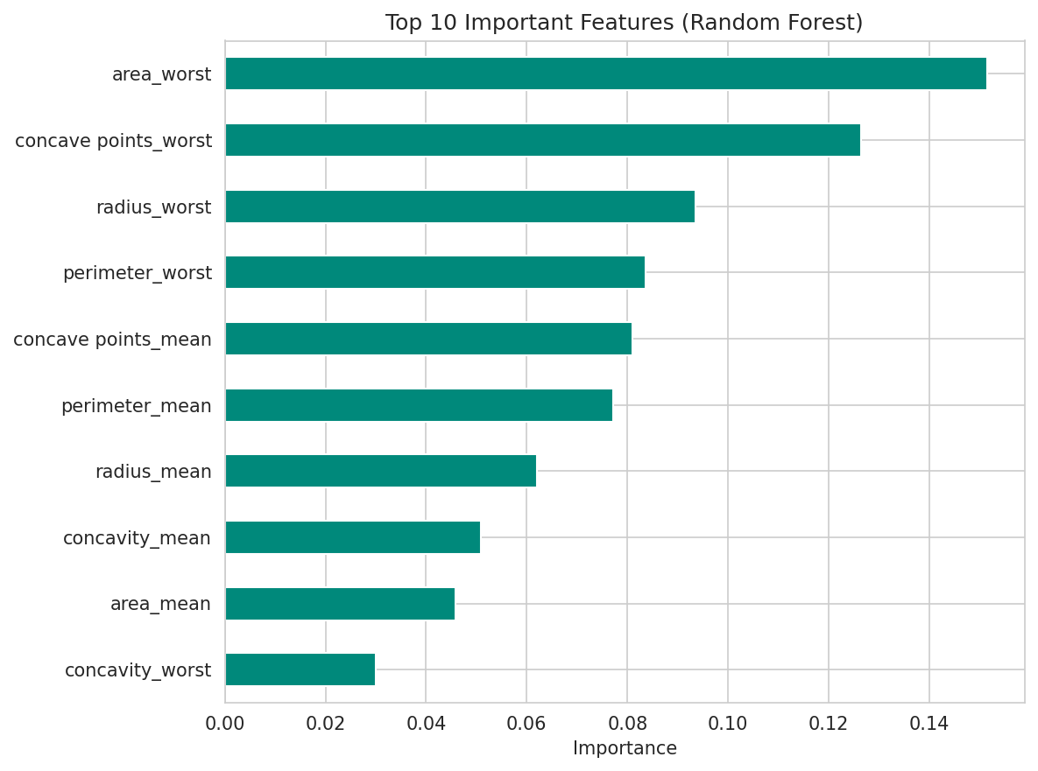
Figure 12: Top 10 important features according to Random Forest
The Random Forest feature importance (Figure 12) shows that area_worst, concave points_worst and radius_worst are the three most important features, followed by perimeter_worst and concave points_mean. In simple words, tumors with large nuclei and a very irregular, indented boundary are more likely to be malignant. This agrees with the box plots and the correlation analysis.
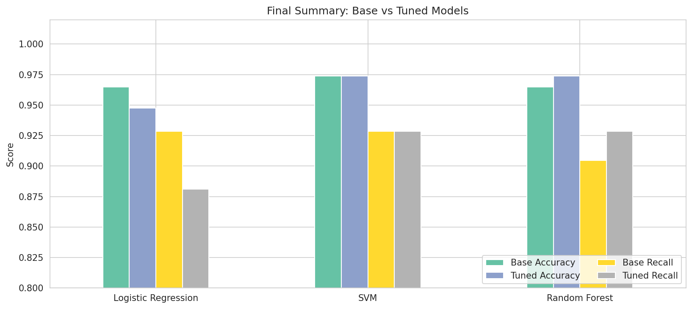
Figure 13: Summary of base and tuned models (accuracy and recall)
- Conclusion
In this project, a breast cancer detection system was developed using three supervised learning algorithms: Logistic Regression, Support Vector Machine and Random Forest. The models were trained on the Wisconsin Diagnostic Breast Cancer dataset containing 569 samples and 30 features, and a complete pipeline of data cleaning, exploratory analysis, scaling, training, evaluation, cross-validation and hyperparameter tuning was carried out.
All three models achieved more than 94% accuracy. After tuning, the SVM and Random Forest models gave the best results, with an accuracy of 97.37%, precision of 100%, recall of 92.86% and an AUC of about 0.99. The SVM was chosen as the final model. Recall was used as the key metric since missing a malignant tumor is more dangerous than a false alarm.
Feature importance analysis showed that the worst area, worst concave points and worst radius of the cell nuclei are the most useful for prediction, which means that larger and more irregular nuclei indicate malignancy. The results show that machine learning can effectively support early breast cancer diagnosis. The system is intended as a decision-support tool and not as a replacement for a doctor.

