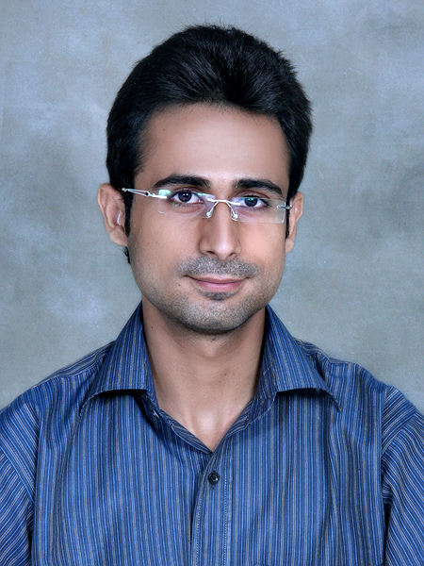
AJAY KUMAR
G-17 - 1/2, Steel Town Bin Qasim TOWN, Karachi-75200
Contact No: +92-333-8869510 | +92-300-2942297
Email: ajay_nedians@yahoo.com
www.ajay.tolico-qatar.com

OBJECTIVE
To obtain a creative and challenging position in a well reputed firm that enables me to gain valuable experience and utilize my skills to create a successful work environment.

EDUCATION
BACHELOR  2009-2012
- BS (BCIT) from NED University of Engineering & Technology (Karachi) in the discipline of Computer Science & Information Technology.
Division: First Percentage : 77% CGPA: 3.4
INTERMEDIATE  2007-2008
- HSC from Government Degree College Naudero, (District Larkana) in Pre-Engineering.
Grade: A+ Percentage : 80.09%
MATRICULATION  2004-2005
- SSC from the Best Academy Boys and Girls Secondary School (Karachi) in Computer Science.
Grade: A+ Percentage : 85.52%


experience
TEN PEARLS
SQA Engineer  July 2013- Present

Test cases planning and test cases execution and participation in QA on following projects.

- Mobeezo ( Web Based Project)
- Olaround ( Mobile Based Project –Nokia App)
- Logo Quiz (Mobile Based Project –Nokia App)
- TNTP ( Web Based Project)
- Access Health Group ( Web Based Project)
- Trial Max ( Desktop Application)
- Razorsight ( Web Based Project)
- RazorInsights ( Mobile App Proto type)
- Discovery Egg Board Widget ( Web Based Project)

MATECH CONSULTING & OUTSOURCING
Jr. SQA Engineer  March 2013- June 2013

Test cases planning and test cases execution and participation in QA on following projects.

- Data Gro ( Data & News Scrapping - Web Based Project)
- Data Recall (Web Based Project)
- Rental (Web Based Project)
interships & achievements
 | SELECTED IN TOP 12 TEAMS  MIC CATALYST  April 2011  - Selected in MIC Catalyst by Microsoft Innovation Centre in top 12 teams from all over Pakistan.  - Also attend 5 days training at MIC.
 | MANAGER  GAMING  ITEC (NEDUET)  July 2012  - Arranging and maintenance of gaming lab.  DEPUTY MANAGER  SYSTEM ANALYST & DESIGN  ITEC (NEDUET)  July 2011  - Arranging lab and giving sessions about system analyst and design.  WINNER SOFTWARE IDEAS  ITEC (NEDUET)  July 2011  VOLUNTEERING EXPERIENCE  ITEC (NEDUET)  May 2009  May 2010
 | INTERNEE  Pakistan Telecommunication Company Limited  from 6th June 2011 to 2nd July 2011

SKILLS
WEB DEVELOPMENT SKILLS
- HTML / HTML 5 / CSS
- ASP.Net
- JQUERY

DATABASE SKILLS
- SQL SERVER

PROGRAMMING SKILLS
- C#.
SOFTWARE SKILLS
- Proficient user of Dreamweaver, Visual Studio 2010 & MS Office 2010.
- Oracle 9i Database & Developer.

QA SKILLS
- Black / White / Gray Box / Regression / Load / Security / Load / UI Testing
- Automation / Manual Testing
- Browser Compatibility Testing
- Mobile App Testing
- Test Cases Planning , Test Execution , Bug Reporting via Jira / Trac / Red Mine
- Acunetix Web Vulnerability Scanner
- Fiddler
- iplotz ( Website wire framing)
- Proto.io (Mobile wire framing)
- Telerik ( Basics)
- Selenium ( Basics)

SYSTEM ADMINISTRATOR SKILLS
- Well in management of system.
- Good at troubleshooting and installation.

TEAM SKILLS
- Ability to lead a team to achieve the objectives with ease and in span of time.
- Ability of building good communication and understanding with team members.
pROJECTS
- ScHOOL ADMISSION SYSTEM  C LANGNAGE
- SUPER MARKET INVENTORY SYSTEM  DATABASE/Oracle Forms
- Car maintenance System  c # / ASP.Net
- Finanicial data & research  c # / ASP.Net ( FINANICAL WEBSITE ON STOCKS, MUTUAL FUNDS AND CAPTIAL MARKET) ( FInal year Project)

pERSONAL INFO
Father’s Name: | Gagan Das | Date of Birth: | November 15, 1988
Gender: | Male | Domicile: | District Larkana
CNICNo: | 42501-8566460-9 | Nationality: | Pakistani
Marital Status: | Single | Languages: | English & Urdu
REFERENCE
Will be furnished on Request.

