**Test Sample Document**

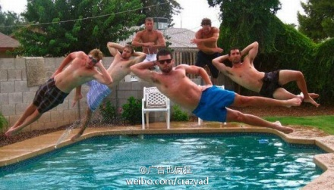 ***<- crazy guys* -_-||**

***--By Mr. WhoAmI***

* ***Section 1: Hello***
  + ***In Chinese,* 你好*。***
  + ***In Japanese,* こんにちは*。***
* ***Section 2: World***