**Course preview.**

**Game Features:**

Prisoner’s Dilemma (PD) Game囚徒困境

Either **confess**, or **Not confess**.

$$M=\left[\begin{matrix}(5,5) & (0,15) \\ (15,0) & (1,1)\end{matrix}\right]$$

**Repetition or not …**

**One-shot**: only one round for players.

**Repeated Games**: Same game, multiple rounds.

**Dynamic Games**: …

Distinction between game type: Knowledge information: Cost of other player?

**Solution concepts,**

* Mathematical rules decide how to play.

* Players are rational, plays optimally. (Maximize expected utility, Minimize expected cost.)

1. **MinMax Solution:**

* Minimize a player’s Maximum (worst) expected cost – Secruity strategy.

^

Prisoner’s Dilemma Game example,

-- matrix are used to evaluate said cost ~~/ utility~~.

1. **Best-response (BR),**

Play the strategy that gives lowest cost given your opponent’s strategy.

For player I, suppose his opponents’ (all expect I ) plays U_i

*J_i (u_i^*,u_(-i) )≤J_i (U_i,u_(-i) )for All u_i taken from Ω_i*

1. **Nash Equilibrium (NE). solution:**

All players play B. Best response to strageties.

(Within PD Game, Matrix readily shows result of Nash Equilibria. )

*Formulation As per Wiki.*

**Example: Battle of Sexes Game**

A couple (2 player) decide to attend opera / football (2 options)

Both have cost matrix respectively,

Two pure strategy Nash equilibria, There is also a Nash Equilibrium in mixed strategies.(randomized) – players go to their preferred event more often than the other.

Nash theorem: Every finite game has a mixed strategy Nash equilibrium.

Classical equilibrium analysis is based on NE, or NE’s further refinements.

Why NE arises? …

**Learning in Games**

1. **Adaptive Learning**

“Myopic”, simple and rule-of-thumb rules.

1. **Evolutionary (Population) Dynamics:**

Selection of strageties according to performance against the aggregate and random mutations.

1. **Bayesian Learning (not covered in course**
2. **CA Games:**

BR play./ dynamics

1. **Population games:**

Imitation Dynamics (ID) & Replicator Dynamics

1. **Dynamic games.**

…

**Evaluations:**

**Problem sets 30%**

**Final Exam 30%**

Last lecture: Nov. 28th ?

**Project / Paper 40%**

Two (2) weeks after Final Exam to finalize.

**Lecture 1 20250905:**

**2 Player Zero-Sum Finite Games (Matrix)** ***“2PZS”***

* Definition, Security Strategy
* MinMax Solution
* No regret property
* Saddle-point equilibrium solution

$$g(I, Ω_{i},J_{i})$$

Action set = Ω (Finite in this case)

Index = I (Finite in this case)

Cost = J_i

Action of player = U_i

P_i = Player “I”.

By definition, J1 = Ω_1 x

By definition, g is a zero-sum game, if $J_{1}\left(u\right)+J_{2}\left(u\right)=0$ (Cost sums to 0.)

For $u_{1} taken from Ω_{1}$

For $u_{2} taken from Ω_{2}$

Thereby: $J_{1}\left(u\right)=-J_{2}\left(u\right)$

Thus, it is to their best intention that:

P1 minimized $J_{1}\left(\right)$ with respect to $\left(u_{1}\right)$

P2 minimized $J_{2}\left(\right)$ with respect to $\left(u_{2}\right)$, or MAXIMIZES $J_{1}\left(\right)$ w.r.t. $\left(u_{2}\right)$

On the empheses of Ω_i being a finite action set:

m_1 = amount of actions. “J” is the index.

Action sets: $\left|Ω_{1}\right|=m_{1}$, Let $M_{1}=\{1,2, …j, …m_{1}\}$ Wherein the jth action of P1, can be notated as:

$$e_{1j}={\left[0 0 0 … 1 … 0\right]}^{T} taken from Real set of dimention m_{1}.$$

$$e_{2k}={\left[0 0 … 1 … 0 0\right]}^{T}taken from Real set of dimention m_{2}.$$

Now, for P1 selecting jth action = u_1 = e_1j,

For P2 selecting kth action = u_2 = e_2k,

There outcomes: $J\left(e_{1j}, e_{2,k}\right)≔a_{jk}$, a real value that belongs to a matrix:

$$A_{m_{1}×m_{2}} :={\left[a_{jk}\right]}_{m_{1}×m_{2}}$$

$A_{m_{1}×m_{2}}$ Is the cost matrix of featured game, with dimention $m_{1}×m_{2}$.

Where Player 1 selects jth action, corresbonding to jth **row** “--”of $A_{m_{1}×m_{2}}$

Where Player 2 selects kth action, corresbonding to jth **column** “ | ” of $A_{m_{1}×m_{2}}$

**Example: Matching pennies:**

Two selectes a pennie’s tail or head, rewarded if of they do not coincide.

P1 selects row, P2 selects column.

$$A_{m_{1}×m_{2}}=\left[\begin{matrix}-1 & 1 \\ 1 & -1\end{matrix}\right]$$

As an example, if P1 selects Head, P2 selects Head, they outcomes -1. Or as formulation:

$$J\left(e_{11}, e_{21}\right)=-1$$

Infact, in terms of matrix multiplication:

$$J\left(e_{11}, e_{21}\right)=-1=e_{11}^{T}A e_{21}$$

This brings us back to the general formulation:

*“There outcomes: $J\left(e_{1j}, e_{2,k}\right)≔a_{jk}$, a real value that belongs to a matrix…”*

$$J\left(e_{1j}, e_{2,k}\right)≔a_{jk}=e_{1j}^{T}A e_{2k}$$

**Definition: Security Strategy**

The Strategy where P1 will pick the action that minimizes its worst(its maximum) cost, that is:

In each row P1 will look at, the maximum outcom of all selected j:

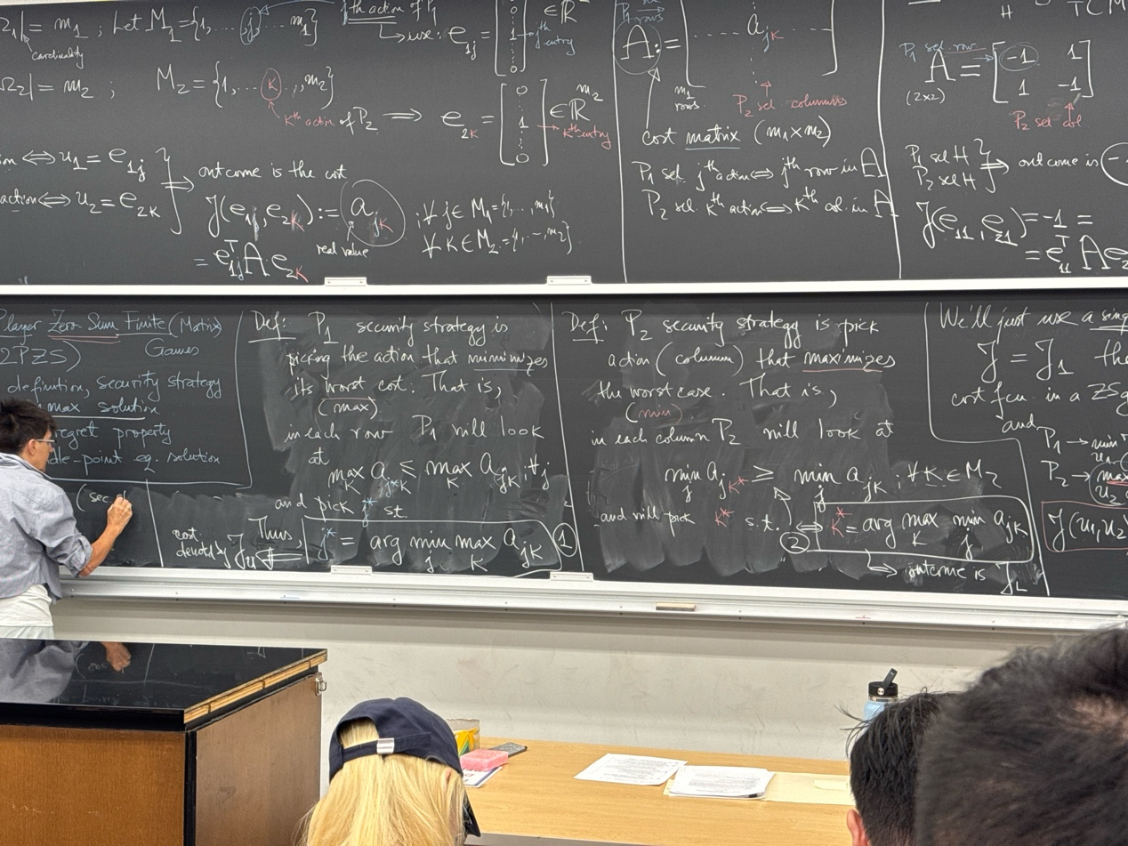

**Definition: MinMax solution**

MinMax Solution is there the set (j, k) are within j = j* and k = k*, as defined within security

And the outcome is : $J_{φ}=a_{i*j*}$

Such outcome, in general, will be between the resolution between result of Security Strategy.

$$J_{L}≤J_{φ}≤J_{U}$$

(“Not equal, in general”)

**Example for Security strategy:**

Outcome matrix:

$$A_{3x3}=\left[\begin{matrix}5 & 3 & -3 \\ 1 & 2 & 0 \\ 3 & 4 & 1\end{matrix}\right]$$

P1 minimizing the overall outcome, while selecting rows.

P2 maximizing the overall outcome, while selecting columns.

For player 1, they looks **j\*** to result for the minimum of the maximum, across rows.

$$A_{3x3}=\left[\begin{matrix}5 & 3 & -3 \\ 1 & 2 & 0 \\ 3 & 4 & 1\end{matrix}\right]$$

For P1, j* = argmin{5,2,4}, which is index **j* = 2**

For player 2, they looks k* to result for the maximum of the minimum, across columns.

For P2, k* = argmax{1 ,2 ,-3 } which is index **k* = 2**.

Therefore, Minmax set is (j,k) = (2,2) and $J_{φ}=2=J_{L}=J_{U}$

Example 2:

$$A_{3x3}=\left[\begin{matrix}4 & 0 & -1 \\ 0 & -1 & 3 \\ 1 & 2 & 1\end{matrix}\right]$$

Working it out: J* = 3, J_u = 2

K* = 1, J_L = 0. -> J_phi = 1

All of the above follows **NO REGRET rule.**

It is worty to discuss **if, both players would regret their decision** given that they could foresee their opponents’ choices?

Does (j*, k*) corresbonds to neigther P1 and P2, regreting their choices?

For example 1:

P1: no regret

P2: no regret

For example 2:

P1: **WILL** regret. If they knew P2 will select the 1st column,

P2: **WILL** regret. If they knew P1 will select the 3rd row,

If both player would regret / not regret, that constitutes the Saddle -point equilibrium?.

