**Unnat Bharat Abhiyan Rithaura Grunt**  
Indian Institute of Technology Roorkee  
Action Plan for Autumn Semester 2023

**About the village**

|  |  |
| --- | --- |
| Location | Rithaura Grunt village is in Bahadarabad block and Hardwar tehsil of Hardwar district. It comes under Daluwala Mazbata gram panchayat. |
| Route Map | https://maps.app.goo.gl/43DtYSLhcQqHxhxz9 |
| Connectivity with Highway | 26km away from district headquarter Hardwar (Rosanabad) |
| Location/ Village Code | 056642 |
| Total Geographic Area | 145 hectares |
| Nearest Major Railway Stations | Haridwar & Roorkee Junction |
| Governance | Governed by Daluwala Mazbata gram panchayat. |
| Population Details | Total Population: 733  • Working Population: 183  • 135 households  • Low women employment |
| Caste Distribution | 100% Hindu population, Majority population belongs to OBC category, General, SCs & STs are minorities. |
| Literacy Rate | 68.15% |
| Occupation | Primarily Agriculture |
| Schools | One primary school |
| Cooperative Groups and SHG’s | * There is a total of 6 SHG’s in the village. * 4 SHG’s (*Ashirwad, Khushi, Saraswati, Gurudev)* are old and 2 newly formed SHG’s (*Khatushyam, Radhe- Radhe*) |
| Condition of Houses | * Almost same number of *kuchha* and *pakka* houses |
| Services | * No Streetlights. * No community healthcare centre and no emergency services available. * No source of renewable energy. |
| Hygiene | The village has moderate sanitation, the villagers segregate their waste, the biodegradable waste is collected in pits and then used in farms whereas the non-biodegradable waste is burnt |
| Initiatives conducted by UBA IIT Roorkee | Water filter, vermicomposting bed set up, Holi colour, computer installation, Health Camp |
| Ongoing Initiatives by UBA IIT Roorkee | Bio enzyme, Gobar Diya, Documentation Drive, Incense stick, Vermicomposting, Paper bag initiative, Candle Making, *Achar papad*, KVKs, Jute bag initiative, Animal Husbandry, sunflower cultivation initiative, |

**Glimpses**

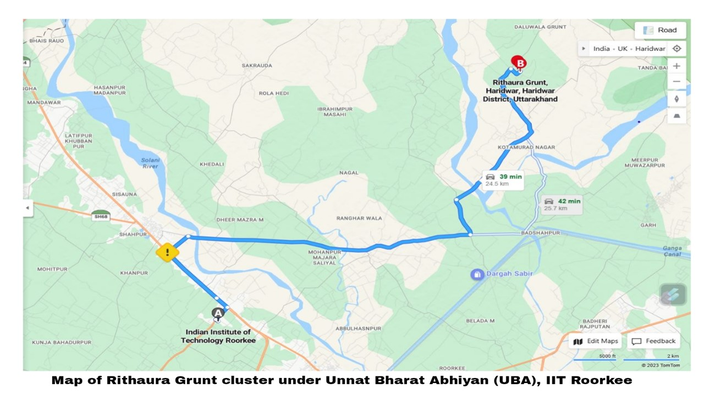

**Following is the tentative action plan for Village Rithaura Grunt, Autumn Semester’23:**

1. **Gobar Diya making initiative:**

Members Involved: Ms Ishika Arya

* *Gobar diya* initiative is an alternative for *mitti diya*. The team contacted Zero Brand pvt. Ltd. The firm agreed to provide the machine as well as training but in return requires 500 *diyas* per day at the cost of Rs 1 per *diya*. The surplus *diya* can be sold in the campus. A

|  |  |
| --- | --- |
| **Date** | **Activity** |
| May 14, 2023 | Convinced SHG women about *gobar diya* and explained the benefits. |
| June 24, 2023 | Received 12k from SHG women as security fee for the machine. |
| July 11, 2023 | Explained the terms and conditions of the agreement to be signed between the company and them. |
| July 29, 2023 | Discussion on deciding the dates of training. |
| August 10, 2023 | Training date |
| October 5, 2023 | Sample sent for testing |
| First week of November | Initiation of making of *diyas* after the conformation from the NGO |

**2. Candle making initiative:**

Members Involved: Ms Radhika Verma and Mr Samarth

* Aims to promote SHG women to produce candles. The candles have a distributed market and great profit margins (greater than 80%) also as Diwali is around the corner (12th November) the candles made can be sold in the IIT Roorkee campus, schools and in the markets of Roorkee owing to the demand.  
  Currently we propose this initiative to be a short-term initiative which will be carried till the time of Diwali only. Thus, we project to start the candle production in bulk so that some considerably good number of candles can be made till 1st of November.
* With this initiative we also aim to brand the candles as an SHG product by the women of Rithaura Grunt, UBA this will help in recognition thus making it easy to market products like paper bags, bio enzyme etc in the market. This will also help us in our future initiatives.

|  |  |
| --- | --- |
| **Date** | **Activity** |
| August 31, 2023 | Purchased course for training of candle making initiative |
| September 21, 2023 | Prepared list of materials to be ordered at what prices and place comparing the quotations and prepared an estimate for the initiative |
| September 25, 2023 | Raw materials (wax, wick, colour, fragrance) ordered |
| October 2, 2023 | Prepared some of the candles by ourselves hence also testing the materials |
| October 8, 2023 | Training provided to women |
| October 10, 2023 | Received positive response with the training also women shared pictures of candles that they made and confirmed the team that they will produce candles |
| Till November 1, 2023 | Focusing more on packaging, branding, and marketing of candles |

**3. Paper Bag initiative:**

Members involved: Ms Radhika Verma

* The initiative proposed aims at financial empowerment of the women of SHG by promoting them to make paper bags. The training can be provided this, the production process involves no use of any machinery, but the knowledge of production processes can help in increasing the productivity as the entire manufacturing process will be done by hands. Manufacturing process majorly includes cutting, folding (precision required), adding support, sticking, attaching the handles.

|  |  |
| --- | --- |
| **Date** | **Activity** |
| Mid November | Conduct market survey of the local markets of Roorkee and analysing it upon various parameters |
| End November | Confirming the raw material providers, thus estimating the costs for production, and presenting the action plan of initiative to the women |
| Mid December | Estimating the market and devising a suitable type of production process for increased profits and efficiency |
| Mid December | Training can be started (we decide to keep the training on hold until the commencement of candle making initiative) |

**4. Bio enzyme:**

Members involved: Ms Radhika Verma, Ms Ishika Arya

* This initiative emphasizes on reusing the food/fruit waste to produce bio enzyme which can act as an organic floor cleaner, thus minimizing the use of normal phenyl or other cleaners which comprises of various chemicals. The tested bio enzyme can be used in the institute hostels. The packaging can be done by reusing the floor cleaner bottles already in use in hostels.

|  |  |
| --- | --- |
| **Date** | **Activity** |
| February 18, 2023 | Convinced the SHG women and showed them online videos about the process. |
| April 2, 2023 | First unit of bio enzyme set up in the village. |
| May 14, 2023 | More units set up and checked the progress of previously set up units. |
| July 1, 2023 | Collected prepared bio enzyme samples for testing. |
| October 9, 2023 | 63 Litre bio enzyme procured |

**5. Documentation Drive**

* The team found out that most of the villagers do not have the most basic documents like *Adhaar* card, caste certificate, birth certificate etc while collecting the documents for RTE (due to which the initiative could not be conducted properly), so the team decided to start a documentation drive. It in the last visit dated July 1, 2023, and the income certificate of 1-2 people were made.

|  |  |
| --- | --- |
| **Date** | **Activity** |
| January 2024 | Contact BMM and people to setup camp in the village, promotions and later execution. |

**6. Blood donation Drive**

* The primary objective of the drive is to collect an adequate and safe supply of blood that can be used to save lives in various medical situations and emergencies.

|  |  |
| --- | --- |
| **Date** | **Activity** |
| January 2024 | Research and survey in the village about participation. |
| February 2024 | Contact a nearby hospital and setting up the camp in the village. |

**7. Jute bag initiative**

Members Involved: Ms Akansha Meena

* The initiative aims to promote self-employment and skill development by manufacturing and selling biodegradable jute bags by SHG women. Jute bags manufacturing is eco-friendly and can replace plastic bags. It is completely reusable, recyclable, and biodegradable it helps the SHG in the empowerment and development of skills. The training can be provided with the use of sewing machine, mostly all the women interested have sewing machines with them (as per the survey conducted by team recently) and process includes cutting of jute rolls, sewing, stitching attaching the handles and zipper and printing of SHG logo on jute bag can make it as a commercial business. The initiate aims to provide training to SHG women.

|  |  |
| --- | --- |
| **Date** | **Activity** |
|  | Previously tried contacting various institutes but due to their requirements for number of days and women, the team decided to look for more institutes |
| September,2023 | Search for the institutes to provide training. |
| September,2023 | Scrapped |

**8. Cattle insurance and Vaccination:**

* This initiative aims to boost the health of the cattle's and protect them from several diseases which are being spread in different seasons in village. The insurance scheme gives the cattle owner a security in case his cattle expire due to some reason.

|  |  |
| --- | --- |
| **Date** | **Activity** |
| Next semester | Talk to the villagers about the health of their cattle's and about the schemes if these were already going on or not. Analysing the visit survey about cattle's, we will take actions and contact to the nearer animal husbandry hospital. |

**9. Science Exhibition Initiative**

Members Involved: Mr Aryan Raj and Ms Ishika Arya

* This initiative targets the students at the secondary school of Daluwala Khurd. The initiative aims to expose the students of class 8th to 10th to the world of science with innovative practicals and models.
* Apart from just being an exhibition of various models, this initiative intends to lessen the gap between the class 10th and 8th students by combining them into teams and organizing it in a competition format.

|  |  |
| --- | --- |
| **Date** | **Activity** |
| September 2023 | Survey in the school regarding the interests of students and teachers about the initiative. |
| October 2023 | Listing out the equipment available in the institute campus and buying the unavailable ones. |
| Last week of October 2023 | The execution of exhibition. |

**10. Quiz Competition Initiative**

Members Involved: Mr Aryan Raj and Ms Ishika Arya

* This initiative intends to act as a follow-up agent for the exposure of students of Daluwala to the national competitions. The quiz competitions will be divided among the classes of 8th, 9th, and 10th and will cover the topics of mostly general knowledge alongside basic mathematics and English comprehension and language.

|  |  |
| --- | --- |
| **Date** | **Activity** |
| November 2023 | Collect data about students interests and aspirations to properly frame the quiz. |
| November 2023 | Provide the students some guidance and resources. |
| Last week of November 2023 | The execution of competition. |

**11. Vermicomposting**

Members Involved: Mr. Sachin Chauhan

* Vermicomposting is an initiative which help in organic waste management and would benefit the farmers economically as well. The villagers are completely unaware about such practices. We installed a bed in Rithaura Grunt a year ago. The bed was not of appropriate dimensions hence manure could not be produced but the worms in the bed are multiplying, and they will be used to set up new beds of appropriate dimensions in further installation.

|  |  |
| --- | --- |
| **Date** | **Activity** |
| October 7, 2023 | Finding suitable place for new bed installation. Got out earthworms from former bed for new bed. Collecting *gobar* for 14-15 days for the bed setup. |
| November 2023 | Installation of the bed(s) |

**Tentative Schedule and Budget**

|  |  |  |  |  |  |  |
| --- | --- | --- | --- | --- | --- | --- |
| **Initiative Name** | **No. of Visits** | **Members Required** | **Estimated Budget** | | | |
| **Log.** | **T.A.** | **D.A.** | **Total** |
| *Gobar Diya* making | 1 | 1 | 23,000 | - | - | 23,000 |
| Candle making initiative | 3-4 | 3 | 14,000 | 1,120 | 2,160 | 17,280 |
| Jute bag initiative | 5 | 1 | 20,000 | - | 900 | 20,900 |
| Paper bag initiative | 4-5 |  | 10,000 | - | 900 | 10,900 |
| Science Exhibition | 3-4 | 3 | 3,500 | 900 | 2160 | 6,560 |
| Quiz Competition | 3 | 2-3 | 3,000 | 900 | 540 | 4,440 |
| Vermicomposting | 3 | 1 | 1,000 | - | 540 | 1,540 |
| Documentation Drive | - | - | - | - | - | - |
| Cattle Vaccination | - | - | - | - | - | - |
| Blood Donation | - | - | - | - | - | - |

**Tentative total budget = Rs 84,620/-**