MOOVON
Website Page Illustrations — Engineer Reference Pack
Visual templates for the public Moovon / SpreadPay website refresh

These illustrations are directional templates, not pixel-for-pixel instructions. Engineering has autonomy to simplify, combine, reposition or improve sections for mobile, desktop, speed and usability, provided the agreed brand, customer journey and regulatory distinctions are preserved.
Brand: Moovon navy • red • white | Customer choice first | Mobile-first | Clean, uncluttered layouts

01 — Home / First Page Reference
Fixed visual reference for the homepage. Use this as the principal benchmark for brand, spacing, Mr. Moovon, vehicle imagery and overall customer-facing style.
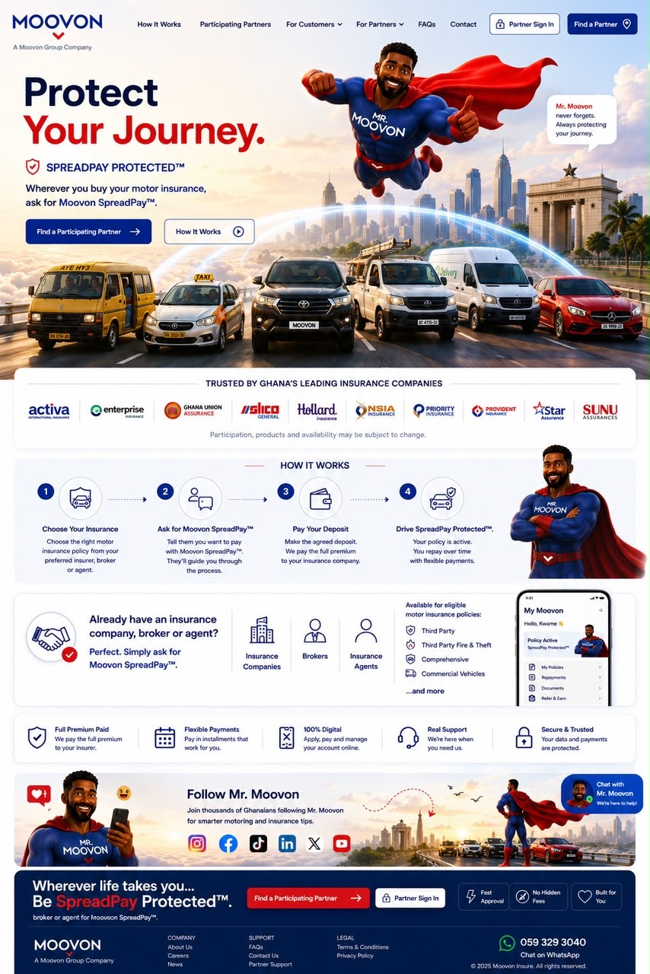

02 — How SpreadPay Works
Customer journey page. Keep the process simple and public-facing; do not expose internal settlement, credit or operational mechanics.
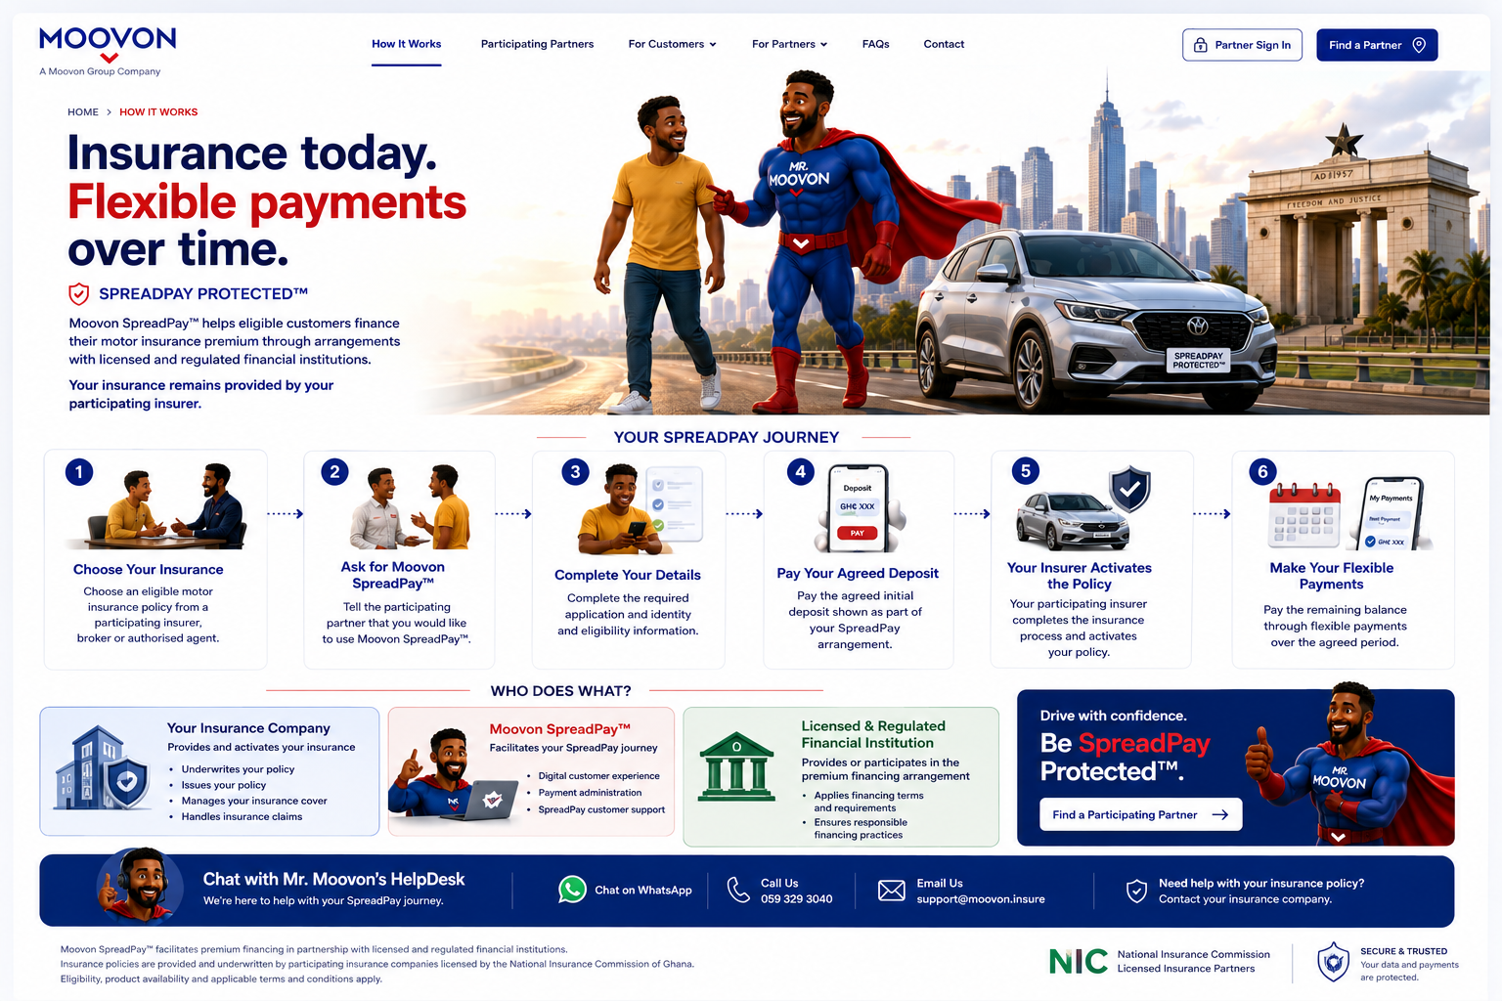

03 — Find a Partner
Participating insurance partner discovery page. Customers choose their preferred participating insurer; Moovon should not recommend one insurer over another.
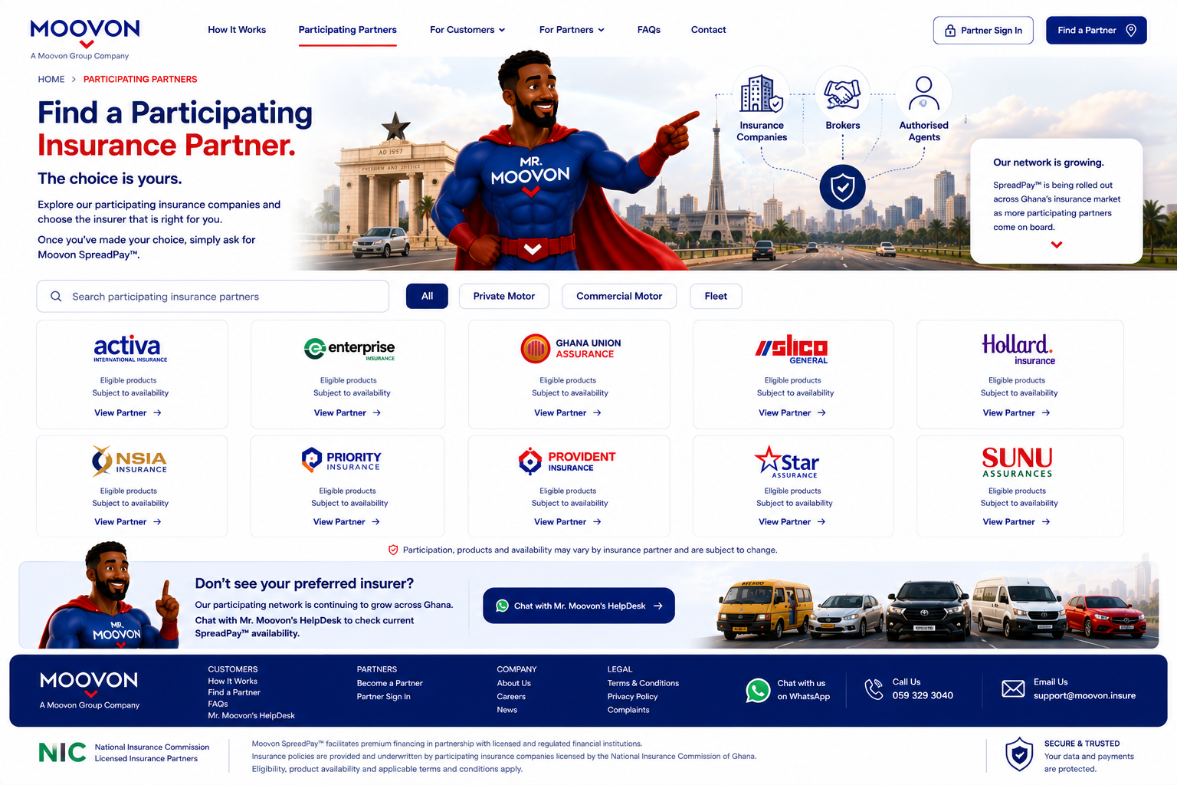

04 — For Customers
Customer education page. Use the illustration as a layout guide, with product/package names secondary and customer benefits, responsible repayment and annual premium settlement made clear.
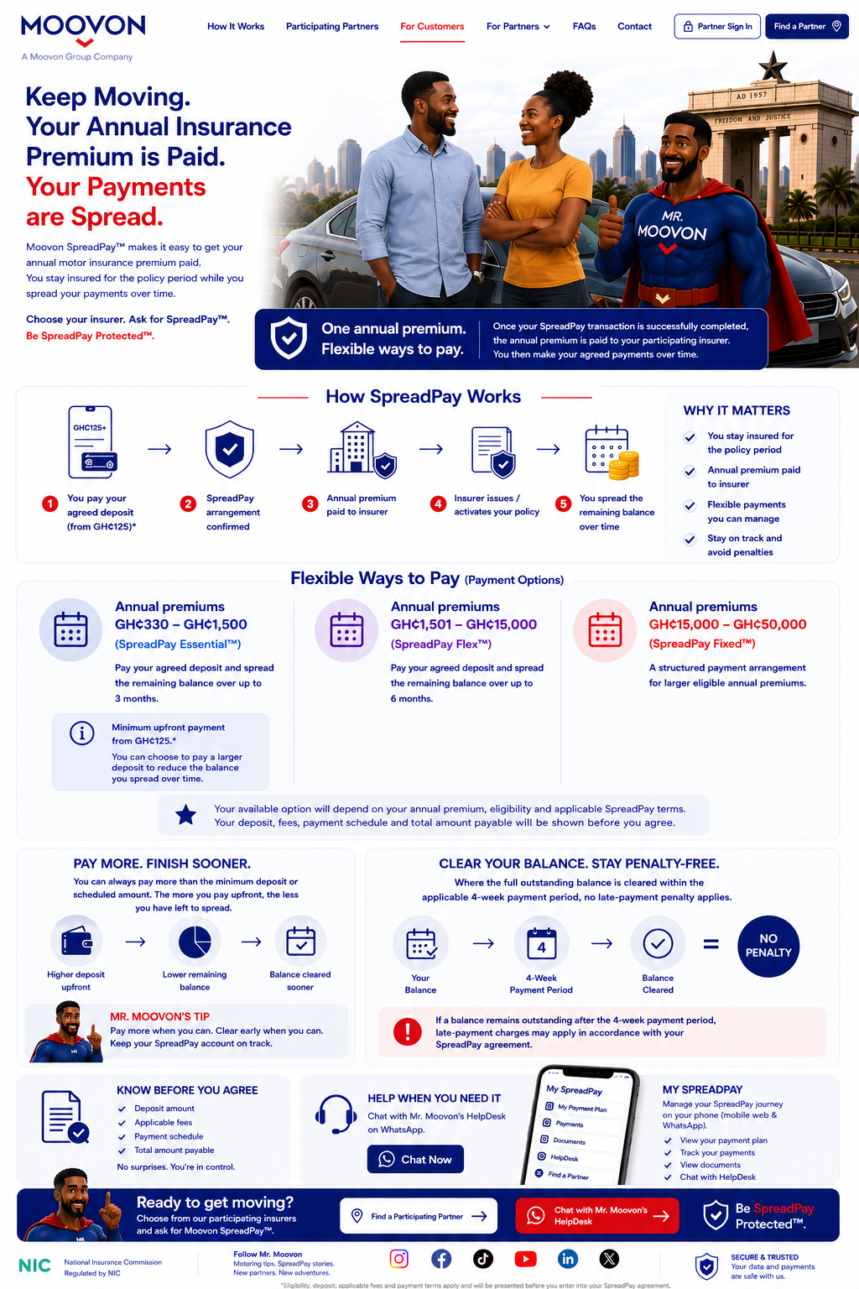

05 — Partner with Moovon
Executive B2B page for insurers, brokers, authorised agents and regulated financial institutions. Detailed operational/commercial information remains behind Partner Sign In.
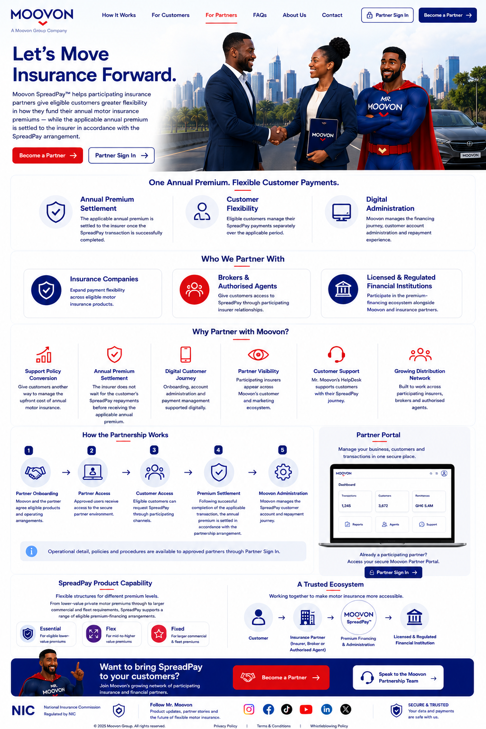

06 — FAQs
Searchable customer FAQ concept. Keep answers practical and avoid presenting Moovon as an insurer or claims handler.
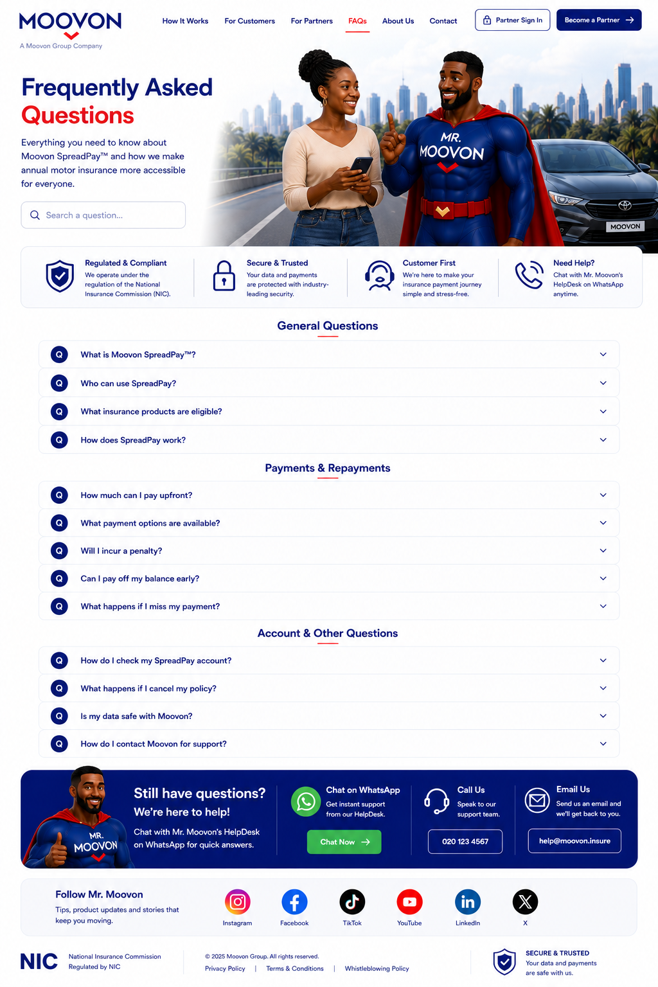

07 — Contact / Mr. Moovon’s HelpDesk
WhatsApp-led customer support concept. Route SpreadPay/account/payment questions to Moovon and insurance policy/claim matters to the customer’s insurer.
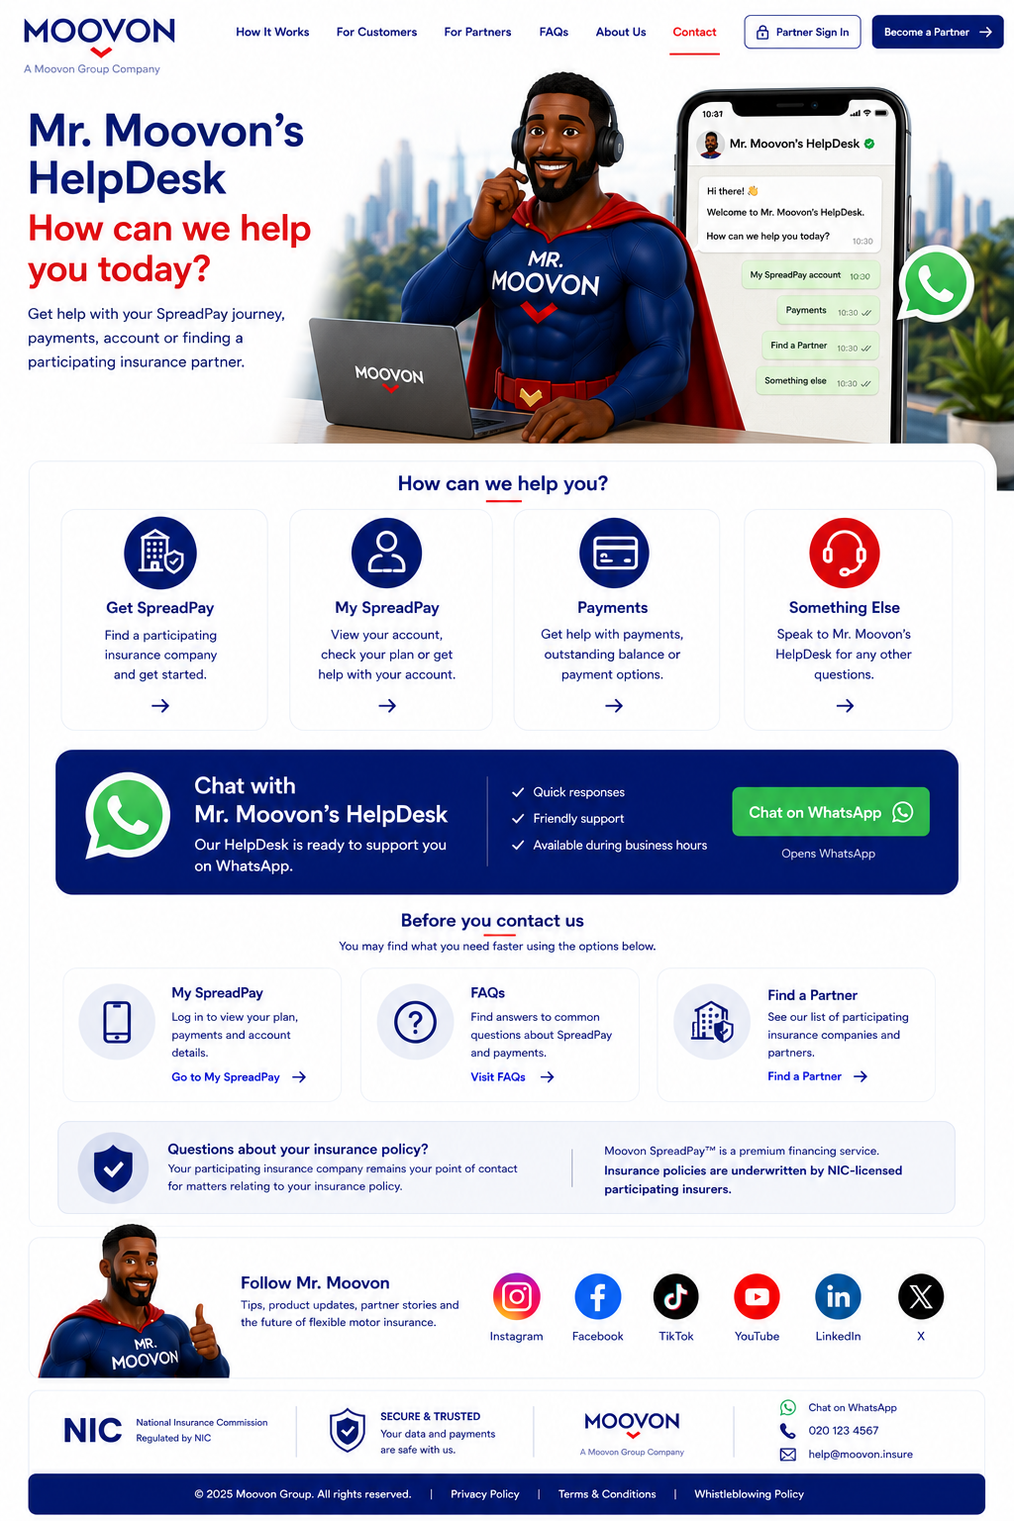

08 — What’s Mooving? / News & Insights
Editorial/news concept. Keep the hero clean with Mr. Moovon and ‘What’s Mooving?’; news, partner announcements and industry updates begin below the hero.
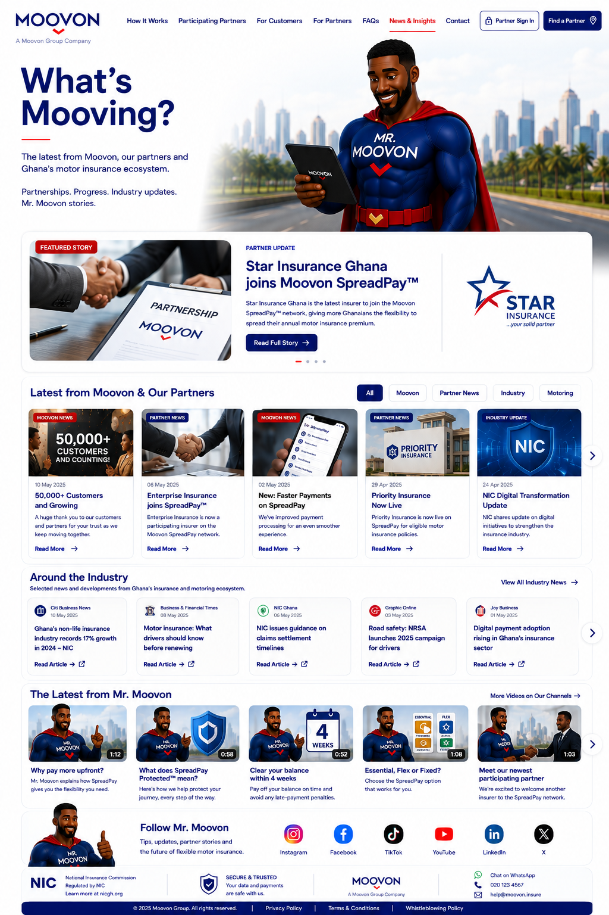

09 — About Moovon
Corporate story page: ‘Built in Ghana. Built for Africa.’ Explain Moovon’s role, mission, ecosystem and African ambition.
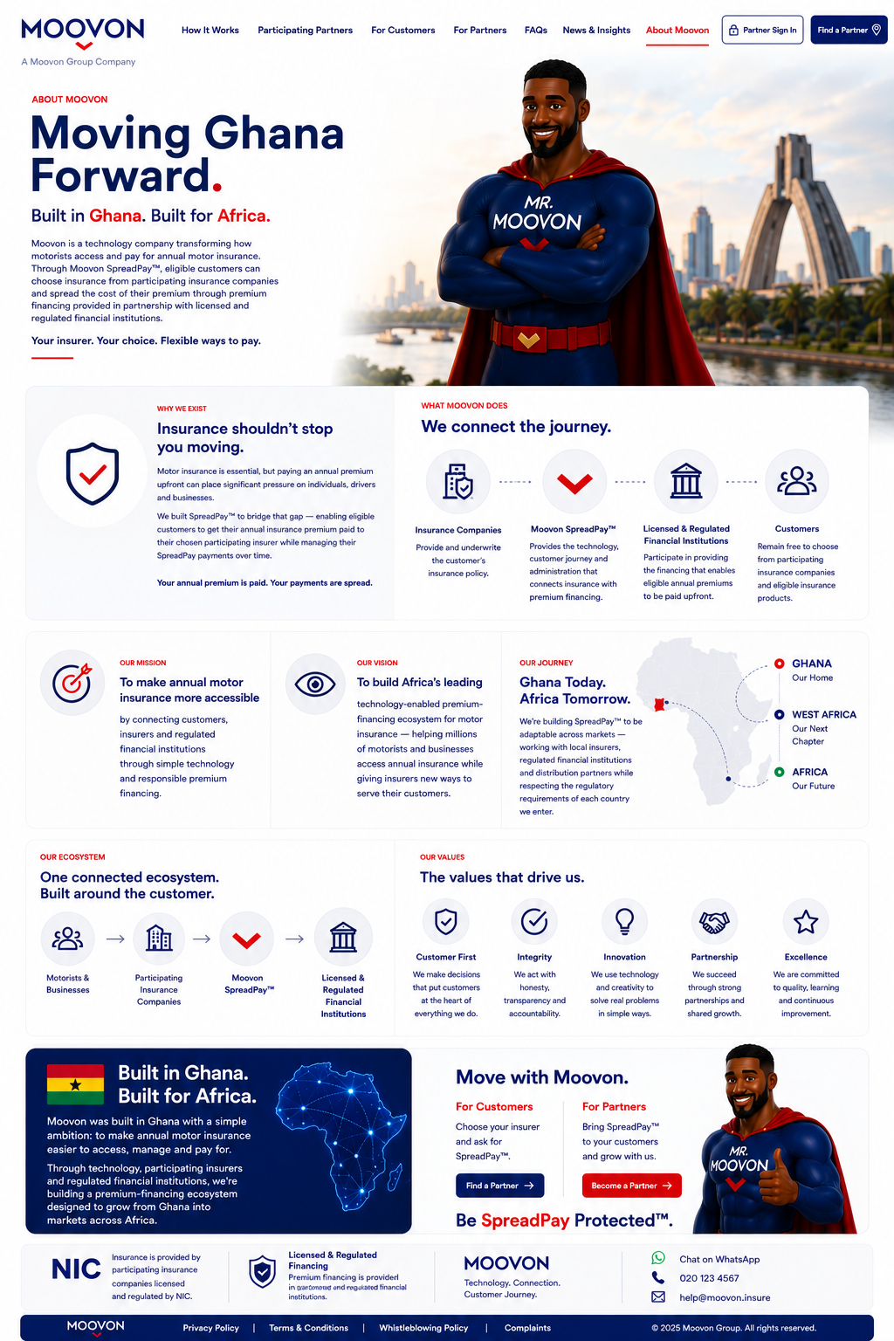

10 — Developers & Integrations
Public integration overview only. Any endpoints shown in the visual are illustrative placeholders. Real API documentation, credentials and sensitive technical information must remain authenticated/private.
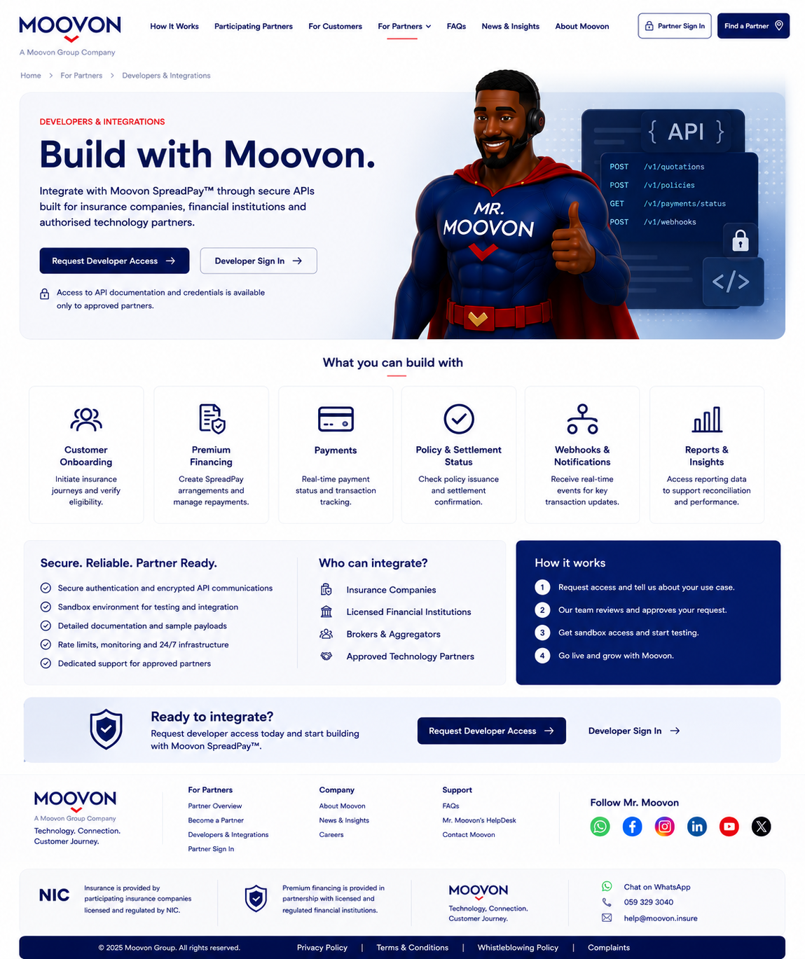

Implementation Notes
- Use the approved homepage as the main visual benchmark across the site.
- Keep Mr. Moovon consistent as a character, but do not overcrowd every page with him.
- Do not introduce green into Moovon’s core brand palette; third-party brand marks may retain their own colours.
- Insurance is provided/underwritten by participating insurers. Moovon should not be presented as handling claims.
- Premium financing should be described as being provided in partnership with licensed and regulated financial institutions.
- Customers choose their participating insurer. Moovon should not recommend or decide the insurer for them.
- Rates, fees and changing product parameters should not be unnecessarily hard-coded into public marketing pages.
- Real API documentation, credentials, endpoints and internal infrastructure must remain behind authenticated developer/partner access.
- A compact ‘Follow Mr. Moovon’ social section should be used consistently across public pages.

