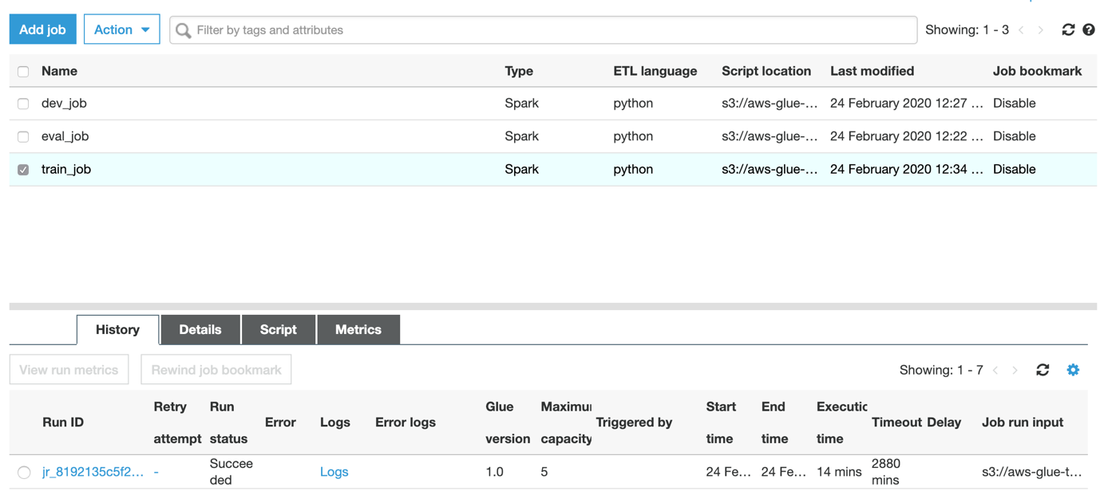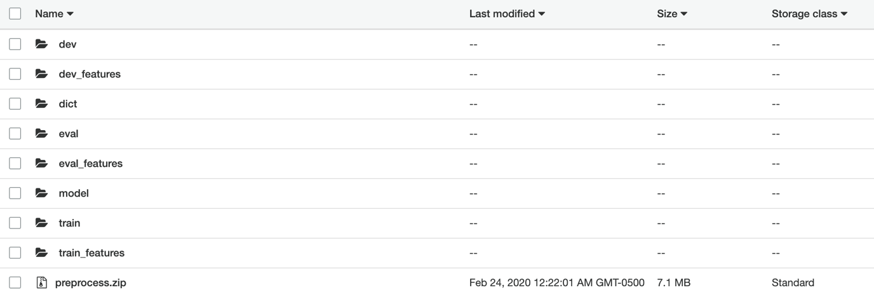

dev features:

<https://asg4.s3.us-east-2.amazonaws.com/dev_features/run-1582564477444-part-r-00000>

eval features:

<https://asg4.s3.us-east-2.amazonaws.com/eval_features/run-1582564452238-part-r-00000>

train features:

<https://asg4.s3.us-east-2.amazonaws.com/train_features/run-1582566355736-part-r-00000>