数据结构与算法分析项目报告

- 项目名称： 简单排课系统

小组编号： 第 20 组
小组成员姓名学号： 许学可 2015141463205
周秦春 2015141463262
李东晋 2015141463085

教师评阅成绩：
教师评阅意见：
.
.
提交报告时间： 年 月 日

- 实验题目:
a simple course schedule system
- 实验内容及要求:
- 输入XX专业课程信息表（见表1）及各学期所要求开的课程数信息表（见表2）
- 利用拓扑排序排出各门课的开设学期, 星期,节次表，要求：
1）每学期所开的课程数之和满足表2要求；
2）各门课必须开在先行课程之后
打印输出XX专业4年8学期的课表（见表3,4示例

- 小组成员分工:
周秦春 大部分代码、文档、单元测试、集成测试、最终测试
许学可 测试
李东晋 一部分代码、最终测试

- 算法描述:

- 程序流程图
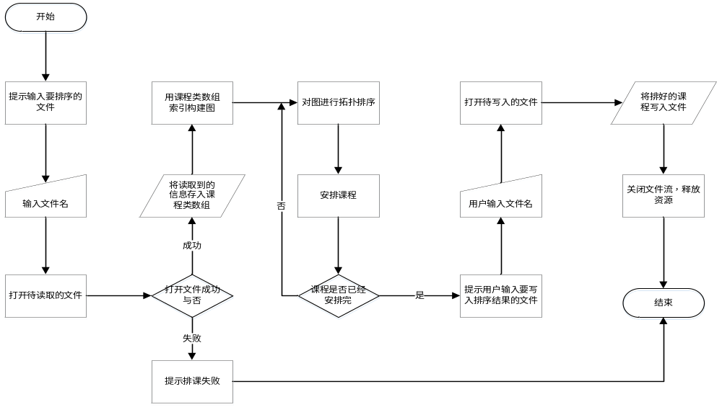
- 类的层次结构，每个类的设计, 包括数据成员和成员函数组成.
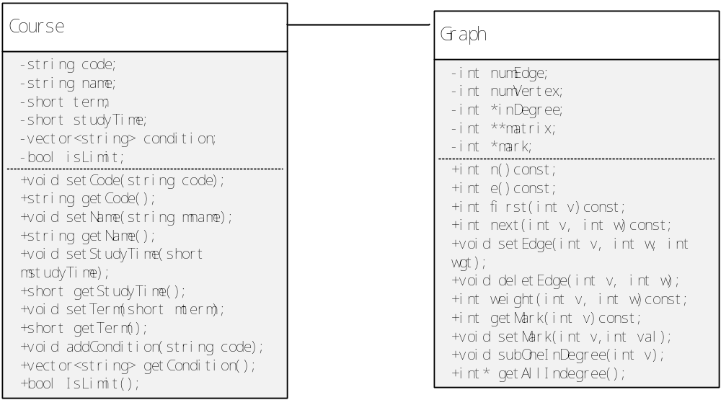
- 源程序清单:
- 添加必要的注释

Course.h文件
#pragma once
#ifndef Course_h
#define Course_h 1

#include<vector>
#include<iostream>

using namespace std;

//测试通过 周秦春
//日期：2016/12/13/19:55
//作者：周秦春
//存储课程信息
class Course
{
public:
Course(string code,string name,short studyTime,short term);
Course();
~Course();

//课程编号
void setCode(string code);
string getCode();
//课程名字
void setName(string mname);
string getName();
//课程学时
void setStudyTime(short mstudyTime);
short getStudyTime();
//课程开始学期
void setTerm(short mterm);
short getTerm();
//课程前置条件
void addCondition(string code);
vector<string> getCondition();

bool IsLimit();
private:
string code;
string name;
short studyTime;
short term;
vector<string> condition;

bool isLimit;//是否有前置条件
};

#endif // !Course.h

Course.cpp文件
#ifndef Course_CPP
#define Course_CPP

#include"Course.h"
Course::Course()
{
}

Course::Course(string mcode, string mname, short mstudyTime, short mterm)
{
isLimit = false;
code = mcode;
name = mname;
studyTime = mstudyTime;
term = mterm;
}

Course::~Course()
{
}

void Course::setCode(string mcode)
{
code = mcode;
}

string Course::getCode()
{
return code;
}

void Course::setName(string mname)
{
name = mname;
}

string Course::getName()
{
return name;
}

void Course::setStudyTime(short mstudyTime)
{
studyTime = mstudyTime;
}

short Course::getStudyTime()
{
return studyTime;
}

void Course::setTerm(short mterm)
{
term = mterm;
}

short Course::getTerm()
{
return term;
}

void Course::addCondition(string code)
{
isLimit = true;
condition.push_back(code);
}

vector<string> Course::getCondition()
{
return condition;
}
bool Course::IsLimit()
{
return isLimit;
}
#endif // !Course_CPP

Graph.cpp文件
#include"Graph.h"

Graph::Graph(int n)
{
numVertex = n;
numEdge = 0;

mark = new int[numVertex];
for (int i = 0; i < numVertex; i++)
{
mark[i] = 0;
}

matrix = new int*[numVertex];
for (int i = 0; i < numVertex; i++)
{
matrix[i] = new int[numVertex];
}

for (int i = 0; i < numVertex; i++)
{
for (int j = 0; j < numVertex; j++)
{
matrix[i][j] = 0;
}
}

//入度
inDegree = new int[numVertex];
for (int i = 0; i < numVertex; i++)
{
inDegree[i] = 0;
}
}

Graph::~Graph()
{

delete mark;
for (int i = 0; i < numVertex; i++)
{
delete matrix[i];
}
delete matrix;
delete inDegree;
}

int Graph::n()const
{
return numVertex;
}

int Graph::e()const
{
return numEdge;
}

int Graph::first(int v)const
{
for (int i = 0; i < numVertex; i++)
{
if (0!=matrix[v][i])
{
return i;
}
}

return numVertex;
}

int Graph::next(int v, int w)const
{
for (int i = w+1; i < numVertex; i++)
{
if (0!=matrix[v][w])
{
return i;
}
}

return numVertex;
}

void Graph::setEdge(int v, int w, int wgt)
{
if (wgt<0)
{
std::cout << "权值不能为0";
}

if (0==matrix[v][w])
{
numEdge++;
inDegree[w]++;
}

matrix[v][w] = wgt;
}

void Graph::deletEdge(int v, int w)
{
if (0!=matrix[v][w])
{
numEdge--;
inDegree[w]--;//入度减1；
matrix[v][w] = 0;
}
}

int Graph::weight(int v, int w)const
{
return matrix[v][w];
}

int Graph::getMark(int v)const
{
if (v<0||v>numVertex)
{
std::cout << "传入点无效";
}
return mark[v];
}

void Graph::setMark(int v, int val)
{
if (v<0 || v>numVertex)
{
std::cout << "传入点无效";
}

mark[v] = val;
}

void Graph::subOneInDegree(int v)
{
for (int i = 0; i < numVertex; i++)
{
if (0!=matrix[v][i])
{
inDegree[i]--;
}
}
}

int * Graph::getAllIndegree()
{
return inDegree;
}

Graph.h文件
#pragma once
#ifndef Graph_H
#define Graph_H 1

#include<iostream>

class Graph
{
public:
Graph(int n);
~Graph();
int n()const;
int e()const;
int first(int v)const;
int next(int v, int w)const;
void setEdge(int v, int w, int wgt);
void deletEdge(int v, int w);
int weight(int v, int w)const;
int getMark(int v)const;
void setMark(int v,int val);
void subOneInDegree(int v);//将与V相邻的点入度减一
int* getAllIndegree();//返回存储入度的数组
private:
int numVertex;
int numEdge;
int **matrix;
int *mark;

int *inDegree;
};

#endif // !Graph_H

main.cpp文件
#include"ReadFile.h"
#include"Graph.h"

#include<queue>
#include<iomanip>

#define h_term_num 8

//C:\Users\asus\Desktop\Sort\course_inf1.txt

//全局变量
queue<int> q[h_term_num + 1];
char course_table[h_term_num + 1][10][6][100];//学期、节次、星期、课程名
int numsOfTerm[h_term_num];

//打印界面
void printMenu(char *fileName);
//建树
void makeGraph(Graph &gra, Course* courses, int numOfCourses);
//拓扑排序
bool topological_order(Graph &gra,Course* courses);
//将入度为0的顶点入对应的队列
void zero_indgree_push(Graph &gra, Course*courses);
//排课
bool range(int num, int term, char* name);
//辅助排课
bool range_one(int &week_day, int term, char* course_name);
bool range_two(int &week_day, int term, char* course_name);
bool range_three(int &week_day, int term, char* course_name);
//查找空课，并返回第一节课的节次
int find_one(int week_day, int term);
int find_two(int week_day, int term);
int find_three(int week_day, int term);

int main()
{
//打印菜单，获取文件名
char fileName[100];
printMenu(fileName);

//读取课程信息
Course *temp = new Course[100];
int allCourse;
allCourse = getAllCourseFromFile(temp,fileName,numsOfTerm);
if (allCourse < 0)
{
cout << "排课失败！" << endl;
return 1;
}

//建图
Graph gra(allCourse);
makeGraph(gra, temp, allCourse);

//清空课表
for (int i = 1; i <=h_term_num; i++) //学期数
for (int j = 1; j <= 9; j++) //节次
for (int k = 1; k <= 5; k++) //星期
strcpy(course_table[i][j][k], "");

//拓补排序
if (!topological_order(gra, temp))
{
//释放资源
delete[]temp;
cout << "排课失败!" << endl;
return 1;
}

cout << endl;
cout << "排课完成！请指定要输入的文件：" << endl;
cin >> fileName;

//输出到文件
fstream outcome(fileName, ios::out);
if (!outcome)
{
cout << "打开文件失败!" << endl;
return 0;
}

for (int i = 1; i <= 8; i++)
{

outcome << '\t' << '\t' << '\t' << '\t' << '\t' << "XX专业第" << i << "学期课表" << endl;
outcome << endl;
outcome <<setw(20)<< "名称";
outcome << setw(20) << "星期一";
outcome << setw(20) << "星期二";
outcome << setw(20) << "星期三";
outcome << setw(20) << "星期四";
outcome << setw(20) << "星期五";
outcome << endl;
for (int j = 1; j <= 9; j++)
{
outcome << setw(20) << "第" << j << "节";
for (int k = 1; k <= 5; k++)
{

outcome << setw(20) << course_table[i][j][k];
}
outcome << endl;
outcome << endl;
}

outcome << endl;
outcome << endl;
outcome << endl;
outcome << endl;
outcome << endl;
outcome << endl;
outcome << endl;
}

cout << "输出完毕!" << endl;
//释放资源
delete[]temp;
outcome.close();
return 0;
}

//测试通过 周秦春
//日期：2016/12/17/11:20
//作者：周秦春
//打印界面，获取要排课的文件名
void printMenu(char *fileName)
{
cout << "******************************************************" << endl;
cout << " 欢迎使用排课系统v1.0:) " << endl;
cout << "******************************************************" << endl;
cout << "请输入课程文件名：" << endl;
cin >> fileName;

return;
}

//根据提供的课程数组创建图
void makeGraph(Graph &gra, Course* courses, int numOfCourses)
{
vector<string> conditions;
for (int i = 0; i < numOfCourses; i++)
{
if (courses[i].IsLimit())
{
conditions = courses[i].getCondition();
for (int j = 0; j < (int)conditions.size(); j++)
{
for (int k = 0; k < numOfCourses; k++)
{
if (courses[k].getCode()==conditions.at(j))
{
gra.setEdge(k, i, 1);
break;
}
}
}
}
}

return;
}

//拓补排序
bool topological_order(Graph &gra, Course* courses)
{

zero_indgree_push(gra, courses);
//对term中对应的课程排课
int v;
int size;
Course course;
char name[100];
for (int term = 1; term <= h_term_num; term++)
{
size = (int)q[term].size();
for (int i = 0; i<size; i++)
{
v = q[term].front();
q[term].pop();
//排课
course = courses[v];
strncpy(name, course.getName().data(), 99);
range(course.getStudyTime(), term,name);

//所有越v相邻的顶点入度减一
gra.subOneInDegree(v);

//入队
int *inDegrees = gra.getAllIndegree();
for (int j = 0; j < gra.n(); j++)
{
if (0 == inDegrees[j]&&(0==courses[j].getTerm()||courses[j].getTerm()>term)&&0==gra.getMark(j))
{
q[courses[j].getTerm()].push(j);
gra.setMark(j, 1);//标记已经访问
}
else if(0 == inDegrees[j] && (courses[j].getTerm()>0 && courses[j].getTerm()<=term)&&0==gra.getMark(j))
{
cout << "课程冲突，排课结束！" << endl;
return false;;
}
//C:\Users\asus\Desktop\Sort\course_inf1.txt
}

}

for (int i = 0;i<numsOfTerm[term-1]-size; i++)
{
v = q[0].front();
q[0].pop();
//排课
course = courses[v];
strncpy(name, course.getName().data(), 99);
range(course.getStudyTime(), term, name);
//所有越v相邻的顶点入度减一
gra.subOneInDegree(v);

//入队
int *inDegrees = gra.getAllIndegree();
for (int j = 0; j < gra.n(); j++)
{
if (0 == inDegrees[j] && (0 == courses[j].getTerm() || courses[j].getTerm()>term) && 0 == gra.getMark(j))
{
q[courses[j].getTerm()].push(j);
gra.setMark(j, 1);//标记已经访问
}
else if (0 == inDegrees[j] && (0 < courses[j].getTerm() && courses[j].getTerm()<=term)&& 0 == gra.getMark(j))
{
cout << "课程冲突，排课结束！" << endl;
return false;
}
}

}
}

for (int i = 0; i < gra.n(); i++)
{
if (0 == gra.getMark(i))
{
cout<<"并未排完所有课程，排课失败！";
return false;
}
}

return true;
}

void zero_indgree_push(Graph &gra,Course*courses)
{
int *inDegrees = gra.getAllIndegree();
//将度为0的点入对应的队列
for (int i = 0; i < gra.n(); i++)
{
if (0 == inDegrees[i])
{
q[courses[i].getTerm()].push(i);
gra.setMark(i, 1);//标记已经访问
}
}
}

//排课
bool range(int num, int term, char* name)
{
int static week_day = 1;

if (num==1)
{
if (range_one(week_day,term,name)==false)
{
return false;
}
else
{
week_day = (week_day < 4) ? (week_day + 2) : (week_day + 2 - 5);
return true;
}
}
else if (num % 3 == 0)
{
for (int i = 0; i < num/3; i++)
{
if (range_three(week_day, term, name) == false)
{
return false;
}
else
{
week_day = (week_day < 4) ? (week_day + 2) : (week_day + 2 - 5);
return true;
}
}
}
else if (num % 2 == 0)
{
for (int i = 0; i < num / 2; i++)
{
if (range_two(week_day, term, name) == false)
{
return false;
}
else
{
week_day = (week_day < 4) ? (week_day + 2) : (week_day + 2 - 5);
return true;
}
}
}
else if (5 == num)
{
if (range_three(week_day, term, name) == false)
{
return false;
}
else
{
week_day = (week_day < 4) ? (week_day + 2) : (week_day + 2 - 5);
if (range_two(week_day, term, name) == false)
{
return false;
}
else
{
week_day = (week_day < 4) ? (week_day + 2) : (week_day + 2 - 5);
return true;
}
}
}
return false;
}

//辅助排课，排一节课
bool range_one(int &week_day, int term, char* course_name)
{
int local;
for (int i = 0; i < 5; i++)
{
local = find_one(week_day, term);
if (-1 == local)
{
week_day = (week_day < 4) ? (week_day + 2) : (week_day + 2 - 5);
}
else
{
strcpy(course_table[term][local][week_day], course_name);
return true;
}
}
return false;
}

//辅助排课，排两节课
bool range_two(int &week_day, int term, char* course_name)
{
int local;
for (int i = 0; i < 5; i++)
{
local = find_two(week_day, term);
if (-1 == local)
{
week_day = (week_day < 4) ? (week_day + 2) : (week_day + 2 - 5);
}
else
{
strcpy(course_table[term][local][week_day], course_name);
strcpy(course_table[term][local+1][week_day], course_name);
return true;
}
}
return false;

}

//辅助排课，排三节课
bool range_three(int &week_day, int term, char* course_name)
{
int local;
for (int i = 0; i < 5; i++)
{
local = find_three(week_day, term);
if (-1 == local)
{
week_day = (week_day < 4) ? (week_day + 2) : (week_day + 2 - 5);
}
else
{
strcpy(course_table[term][local][week_day], course_name);
strcpy(course_table[term][local+1][week_day], course_name);
strcpy(course_table[term][local+2][week_day], course_name);
return true;
}
}
return false;
}

//查找一节空课，并返回第一节课的节次
int find_one(int week_day, int term)
{
for (int i = 1; i <= 9; i++)
{
if (strlen(course_table[term][i][week_day])==0)
{
return i;
}

}
return -1;
}

//查找两节空课，并返回第一节课的节次
int find_two(int week_day, int term)
{
if (strlen(course_table[term][1][week_day]) == 0 && strlen(course_table[term][2][week_day]) == 0 )
{
return 1;
}
if (strlen(course_table[term][3][week_day]) == 0 && strlen(course_table[term][4][week_day]) == 0)
{
return 3;
}
if (strlen(course_table[term][8][week_day]) == 0 && strlen(course_table[term][9][week_day]) == 0)
{
return 8;
}
if (strlen(course_table[term][5][week_day]) == 0 && strlen(course_table[term][6][week_day]) == 0)
{
return 5;
}

return -1;
}

//查找三节空课，并返回第一节课的节次
int find_three(int week_day, int term)
{
if (strlen(course_table[term][5][week_day]) == 0 && strlen(course_table[term][6][week_day]) == 0 &&
strlen(course_table[term][7][week_day]) == 0)
{
return 5;
}
if (strlen(course_table[term][1][week_day]) == 0 && strlen(course_table[term][2][week_day]) == 0 &&
strlen(course_table[term][3][week_day]) == 0)
{
return 1;
}
return -1;
}
readFile.cpp文件
#ifndef readFile_H
#define readFile_H 1

#include"ReadFile.h"

//消除注释，并且存入新临时文件
static void xiao_chu_zhu_shi(fstream &in, fstream &out);
//从临时文件中读取文件的内容
static int du_qu_wen_jian(fstream &in,int*nums,Course*courses);

int getAllCourseFromFile(Course *courses,string fileName,int *nums)
{
//打开文件
fstream readFile(fileName,ios::in);
if (!readFile)
{
cout << "打开文件失败！（readFile.cpp）！" << fileName.data();
return -1;
}
//打开临时文件
string tempFile;
tempFile = fileName;
tempFile += ".temp";
fstream tempOutFile(tempFile, ios::out);
if (!tempOutFile)
{
cout << "打开文件失败！（readFile.cpp）！" << tempFile.data();
return -1;
}

//消除注释
xiao_chu_zhu_shi(readFile, tempOutFile);
tempOutFile.close();

//读取文件
fstream tempInFile(tempFile, ios::in);
if (!tempInFile)
{
cout << "In打开文件失败！（readFile.cpp）！" << tempFile.data();
return -1;
}
int numberOfCourse;
numberOfCourse = du_qu_wen_jian(tempInFile, nums, courses);
tempInFile.close();

//释放资源
readFile.close();
return numberOfCourse;
}

void xiao_chu_zhu_shi(fstream &in, fstream &out)
{
char ch;
char lastCh = 'a';
while (!in.eof())
{

//消除注释行
ch = in.get();
if ('/' == ch)
{
ch = in.get();
if ('/' == ch)
{
while ('\n' != (ch = in.get()));
lastCh = '\n';
continue;
}
else
{
in.putback(ch);
ch = '/';
}
}
//写入临时文件
if (!('\n'==lastCh&&'\n'==ch))
{
out.put(ch);
}
lastCh = ch;
}
}

int du_qu_wen_jian(fstream &in,int *nums,Course* courses)
{
for (int i = 0; i < 8; i++)
{
in >> nums[i];
}

int count = 0;
char *chstemp = new char[50];
char temp;
short numtemp;
while (!in.eof())
{
in >> chstemp;
//由于末尾是空格
if (in.eof())
{
break;
}
courses[count].setCode(chstemp);
in >> chstemp;
courses[count].setName(chstemp);
in >> numtemp;
courses[count].setStudyTime(numtemp);
in >> numtemp;
courses[count].setTerm(numtemp);

while ('\n'!=(temp=in.get()))
{
if (' '!=temp&&'\t'!=temp)
{
in.putback(temp);
in >> chstemp;
courses[count].addCondition(chstemp);
}
}
count++;
}

//释放资源
delete chstemp;

return count;
}
#endif // !readFile_H

ReadFile.h文件
#pragma once
#ifndef ReadFile_h
#define ReadFile_h 1

#include"Course.h"

#include<fstream>

//测试通过 周秦春
//日期：2016/12/13/20:01
//作者：周秦春
//从文件中读取信息，并保存在Course类中,返回读取的课程总数
extern int getAllCourseFromFile(Course *courses,string fileName,int*nums);

#endif // !
- 运行结果:
- 测试数据选择
对course_inf1.txt进行排课。
对course_inf2.txt进行排课
- 测试结果分析
均能正确的排课，并存入用户提供的文件
- 实验运行情况分析(包括算法、运行结果、运行环境等问题的总体讨论)。
  - 收获
      - 对拓扑排序的理解更加深刻
      - 掌握了new分配出的内存有作用域的限制
      - Delete删除对象组成的数组
      - 文件读写更加熟练
      - C++库函数的运用，如string，vector等
      - 程序中如何存储配置文件
      - 流程图的画法更加纯熟。
  - 特色
      - 自己构建图并进行编码。
      - 程序结构很好，将程序头文件与源文件分开
      - 界面美观友好，简洁
      - 运用单独的配置文件存储临时文件，消除注释。
  - 不足
      - 对排课用的文本的格式有要求。
      - 排课后的文本不够美观。

