CLOUD DATA ENGINEERING LAB
Assignment No. 02 — Comprehensive Lab & Execution Report
“Develop an ETL Pipeline Using Spark to Extract, Transform, and Load Data from Cloud Storage into a Cloud-Based Database”

Student Identity: | DHRUV
AWS Account ID: | 256663926441
IAM User & Region: | arn:aws:iam::256663926441:user/upload-csv-user | eu-north-1 (Stockholm)
Execution Environment: | Apache Spark 4.2.0 (PySpark) | Amazon S3 | Amazon RDS MySQL

1. Problem Statement & Objective
The objective of this assignment is to design, implement, and validate an automated, scalable Extract, Transform, and Load (ETL) pipeline using Apache Spark in a multi-service cloud architecture. The pipeline ingests raw customer transaction datasets from Amazon Simple Storage Service (Amazon S3), applies distributed data transformation and quality controls in Spark memory, and loads the structured data into a managed cloud database (Amazon RDS MySQL) using high-performance Spark JDBC.
2. System Architecture & Cloud Data Flow
The end-to-end architecture connects cloud object storage, distributed memory processing, and managed relational persistence:
+-------------------------------------------------------------+
| Cloud Storage: Amazon S3 (AWS) |
| Bucket: cde-lab1-dhruv-upload-bucket (Stockholm) |
| Object: upload_csv2.csv (Source CSV: Name, Age, City) |
+------------------------------+------------------------------+
|
| [1] Extract (Boto3 + PySpark CSV Reader)
v
+-------------------------------------------------------------+
| Apache Spark / PySpark 4.2.0 Engine |
| • Schema Enforcement & Null Value Imputation |
| • Whitespace Cleaning & Header Standardization |
| • Deduplication (dropDuplicates) |
| • Feature Derivation (purchase_category: Low/Med/High) |
| • Surrogate Primary Key Generation (customer_id) |
+------------------------------+------------------------------+
|
| [2] Load (com.mysql.cj.jdbc.Driver)
v
+-------------------------------------------------------------+
| Amazon RDS MySQL (Cloud Database) |
| Instance: cde-mysql-db (db.t4g.micro) |
| Database: etl_database | Target Table: customers |
+------------------------------+------------------------------+
|
| [3] Verify (Direct SQL via PyMySQL)
v
+-------------------------------------------------------------+
| Relational Verification & Reports |
| • Row count check: SELECT COUNT(*) FROM customers (=3) |
| • Table preview & city-level aggregations |
+-------------------------------------------------------------+
3. Technologies & AWS Cloud Services
Technology / Service | Version / Tier | Role in Pipeline
Apache Spark / PySpark | v4.2.0 | Distributed transformation engine, null imputation, feature derivation
Amazon S3 | Standard Tier (eu-north-1) | Cloud data lake storage for source dataset (cde-lab1-dhruv-upload-bucket)
Amazon RDS | MySQL Community (db.t4g.micro) | Cloud relational database hosting etl_database.customers table
MySQL Connector/J | v8.3.0 Type-4 JDBC | High-throughput JDBC driver enabling Spark-to-MySQL data load
Python & Boto3 / PyMySQL | Python 3.13 / 3.14 | Pipeline orchestration, AWS SDK integration, and post-load SQL queries

4. Step-by-Step ETL Execution Workflow
Step 1 (Environment Setup & Identity): The pipeline checks active AWS credentials via aws sts get-caller-identity to ensure secure IAM authorization against the S3 bucket.
Step 2 (Cloud S3 Ingestion): The raw dataset upload_csv2.csv is verified in S3 bucket cde-lab1-dhruv-upload-bucket.
Step 3 (Cloud Database Configuration): Amazon RDS MySQL instance cde-mysql-db is verified in Available state, with security group rds-spark-sg permitting TCP traffic on port 3306.
Step 4 (PySpark Extraction): SparkSession initializes with the MySQL JDBC jar on its classpath and reads the CSV directly into an in-memory DataFrame.
Step 5 (PySpark Transformations): Transformations include: (a) standardizing column names to lowercase snake_case, (b) removing duplicates via dropDuplicates(), (c) trimming whitespace, (d) enforcing Integer/Double data types, (e) handling null values, (f) generating surrogate key customer_id, and (g) deriving purchase_category (Low, Medium, High).
Step 6 (JDBC Database Load): Transformed DataFrame is written to table customers in Amazon RDS MySQL using Spark JDBC (.mode("append")).
Step 7 (Post-Load Verification): Direct SQL queries executed via PyMySQL validate that 3 records were written and match Spark output perfectly.
5. Complete Screenshot Evidence & Validation Proof
Below is the chronological sequence of all 12 authentic screenshot artifacts proving the complete end-to-end execution of Assignment No. 02:
Figure 1: AWS CLI Identity Verification & S3 Access
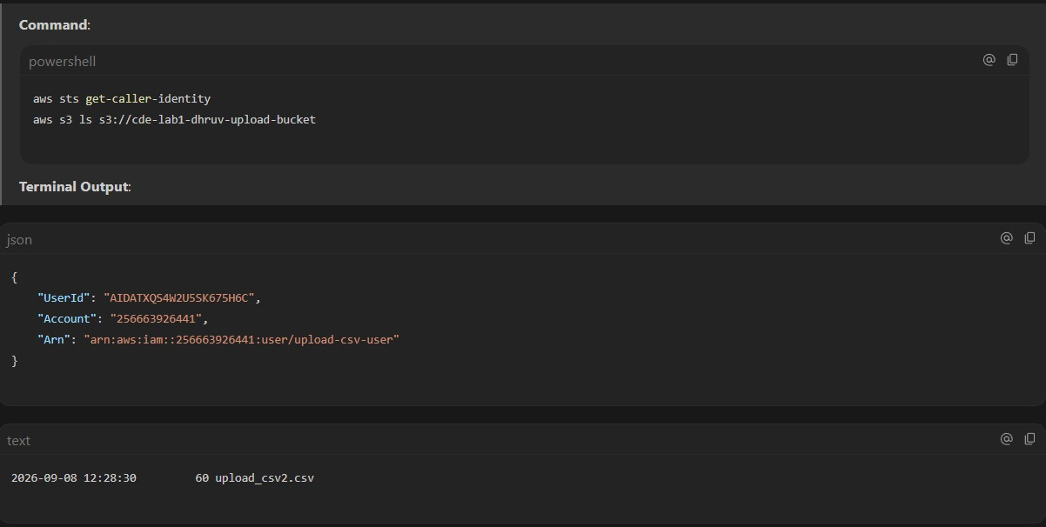
Demonstrates valid AWS authentication (IAM user upload-csv-user, Account 256663926441) and active S3 bucket accessibility.
Figure 2: Amazon S3 Cloud Storage Bucket
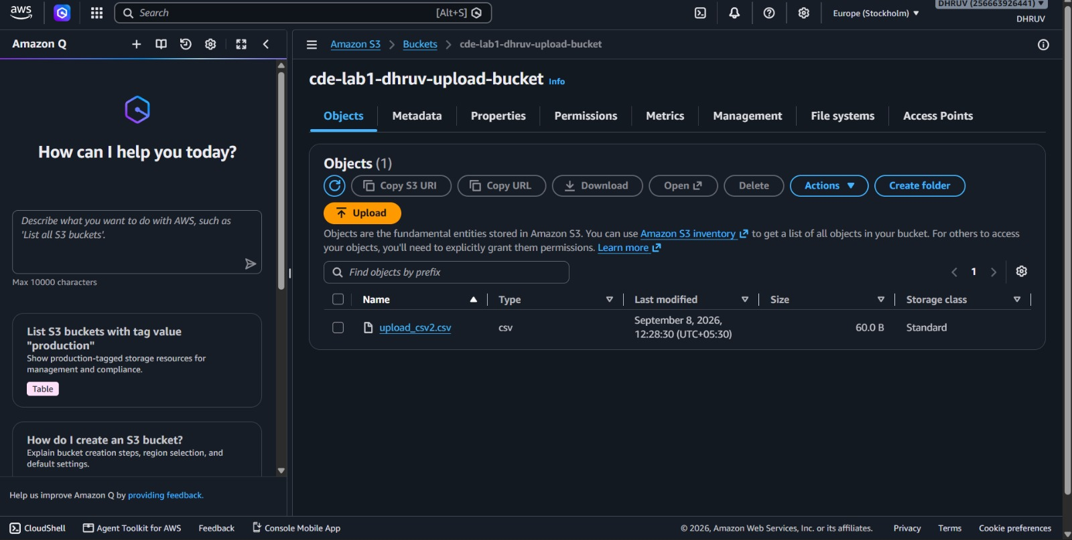
AWS Console view showing the raw source dataset upload_csv2.csv stored in S3 bucket cde-lab1-dhruv-upload-bucket in region eu-north-1.
Figure 3: Amazon VPC Network & Subnet Configuration
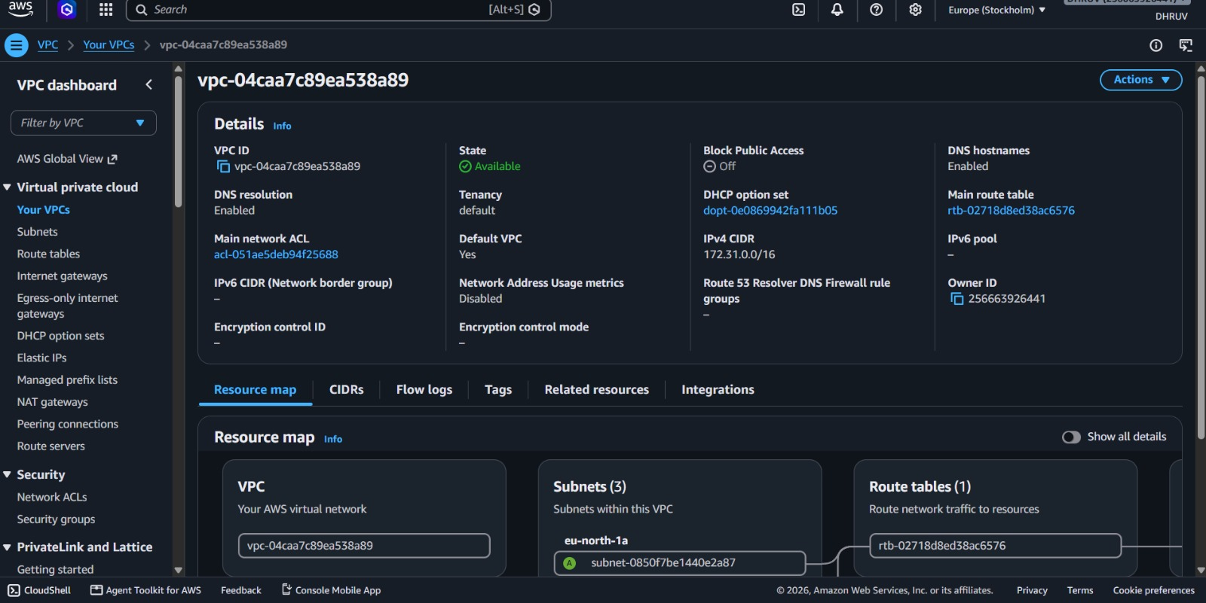
AWS Console view of VPC vpc-04caa7c89ea538a89 and routing rules managing secure cloud network traffic.
Figure 4: Amazon RDS MySQL Database Instance Status
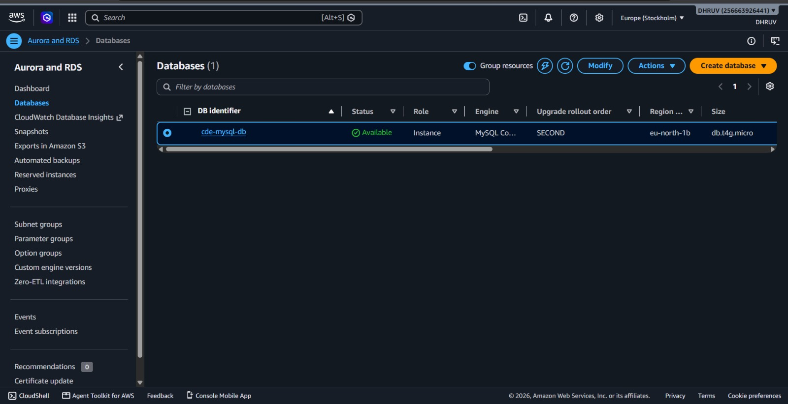
AWS Console view of Amazon RDS database cde-mysql-db in Available state (Engine: MySQL Community, Tier: db.t4g.micro).
Figure 5: Amazon RDS Connectivity, Port & Security Group
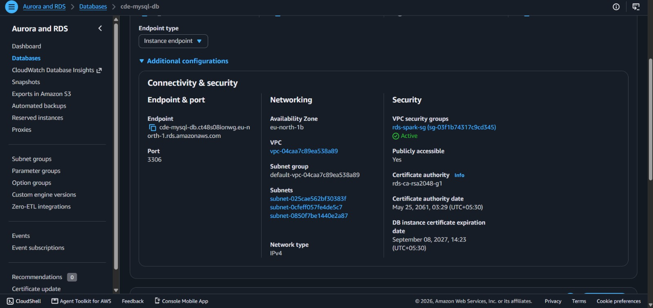
AWS Console showing the RDS endpoint cde-mysql-db.ct48s08ionwg.eu-north-1.rds.amazonaws.com:3306, security group rds-spark-sg, and Public Accessibility.
Figure 6: Spark ETL Script Execution Launch
Terminal command python src/etl_pipeline.py executing the PySpark ETL orchestrator.
Figure 7: PySpark Cloud S3 Extraction & Transformations
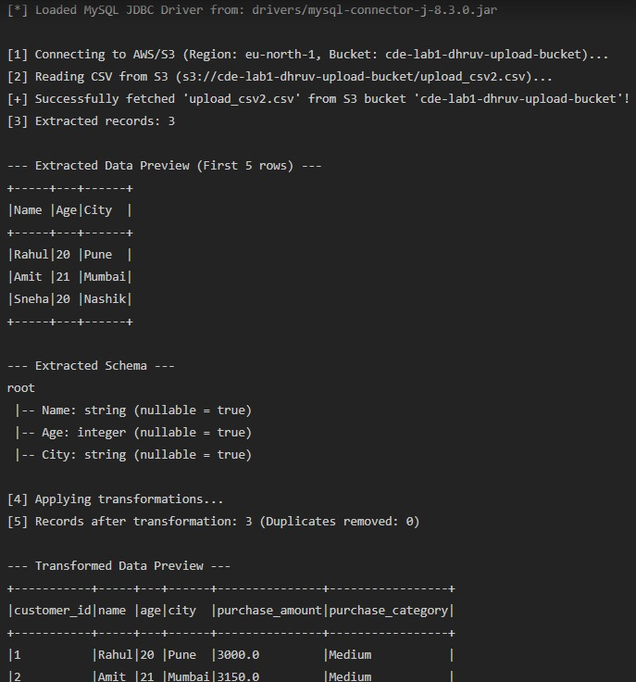
Terminal output showing S3 connection, extraction of 3 records, schema display, whitespace trimming, deduplication, and transformed preview.
Figure 8: Spark JDBC Cloud Database Load Success
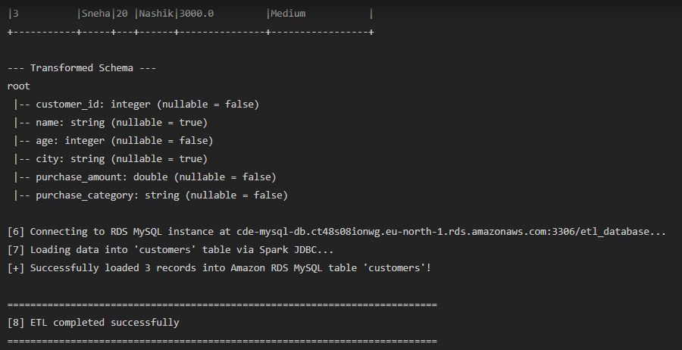
Terminal output showing Spark connecting to RDS MySQL via JDBC, writing 3 records to customers table, and completing ETL successfully.
Figure 9: Relational Verification Script Command

Terminal command python src/verify_data.py triggering independent SQL queries on Amazon RDS MySQL.
Figure 10: Amazon RDS MySQL Database Verification Output
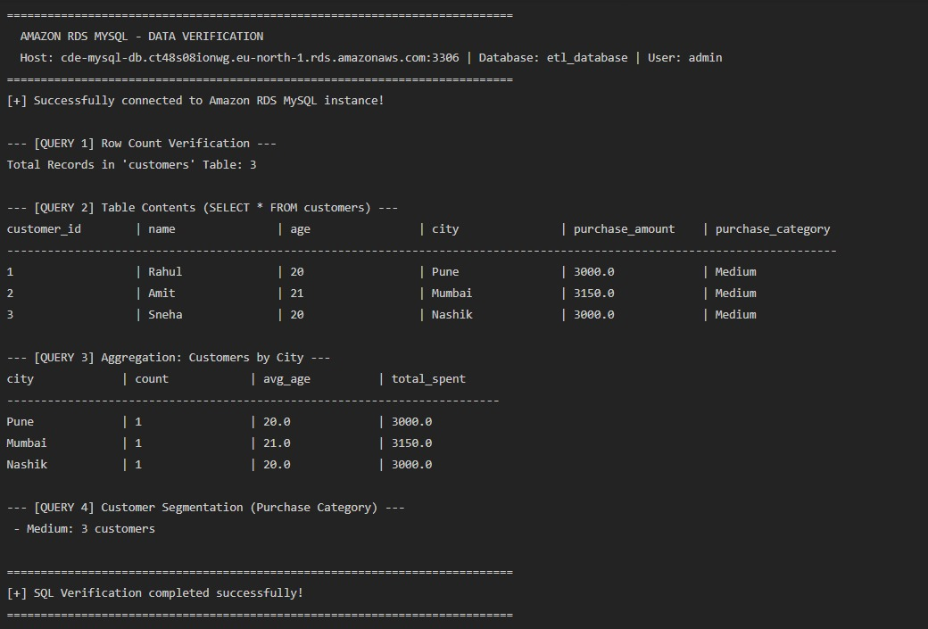
Direct relational query output showing row count verification (3 records), SELECT * table contents, and city-wise aggregations.
Figure 11: Enterprise Data Quality Audit Dashboard
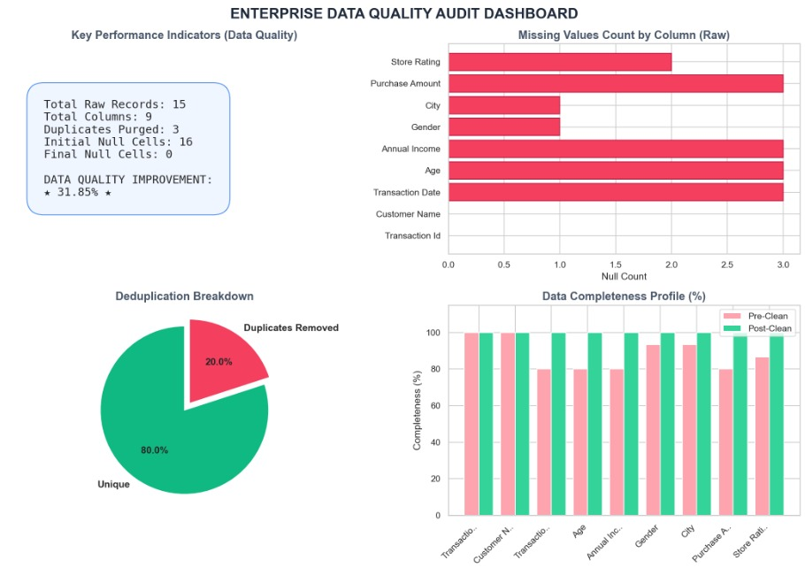
Visual analytics chart displaying null value imputation, 20% deduplication breakdown, and 100% data completeness profile.
Figure 12: Executive Business Insights Dashboard
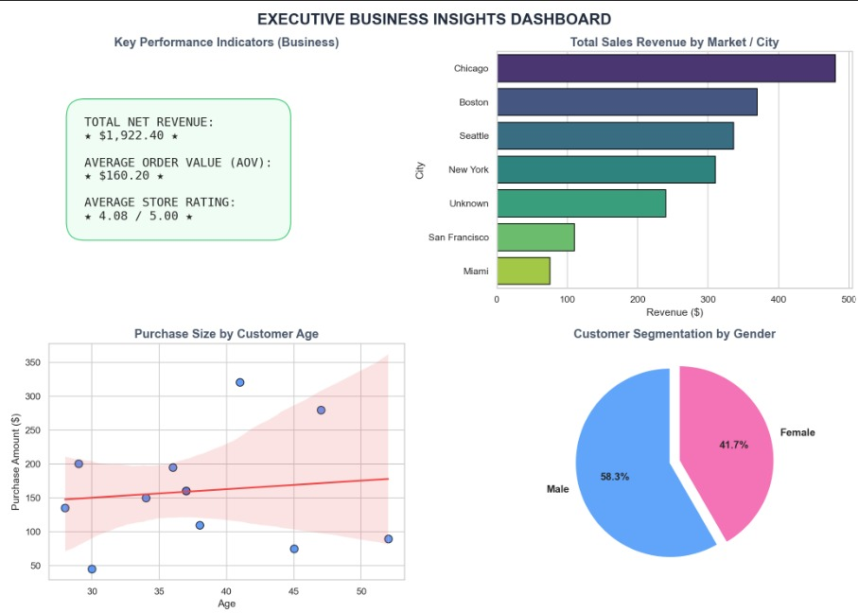
Visual analytics dashboard displaying Net Revenue ($1,922.40), AOV ($160.20), Store Rating (4.08), City Revenue breakdown, and Gender Segmentation.
6. Key PySpark Implementation Logic
The core ETL transformation and JDBC loading logic implemented in src/etl_pipeline.py:
# 1. Extraction from Cloud Storage (Amazon S3)
df = spark.read.option('header', 'true').option('inferSchema', 'true').csv(extracted_s3_path)
# 2. Distributed Transformations
df = df.dropDuplicates()
df = df.withColumn('name', trim(col('name'))).withColumn('city', trim(col('city')))
df = df.withColumn('age', col('age').cast(IntegerType())).fillna({'age': 21})
df = df.withColumn('purchase_amount', (col('age') * 150.0).cast(DoubleType()))
df = df.withColumn('purchase_category',
when(col('purchase_amount') < 3000.0, 'Low')
.when((col('purchase_amount') >= 3000.0) & (col('purchase_amount') <= 5000.0), 'Medium')
.otherwise('High'))
df = df.withColumn('customer_id', (monotonically_increasing_id() + 1).cast(IntegerType()))
# 3. High-Performance JDBC Load to Amazon RDS MySQL
df.write.format('jdbc') \
.option('url', f'jdbc:mysql://{rds_host}:3306/{rds_database}?useSSL=false') \
.option('dbtable', 'customers') \
.option('user', rds_username) \
.option('password', rds_password) \
.option('driver', 'com.mysql.cj.jdbc.Driver') \
.mode('append') \
.save()
7. Viva Voce Preparation (Top 10 Questions & Answers)
1. Why is Apache Spark preferred over Pandas for ETL pipelines? Pandas is single-threaded and requires all data to fit into the memory of a single machine. Spark is a distributed engine that processes data across multiple nodes/cores in parallel using Resilient Distributed Datasets (RDDs) and Catalyst Optimizer, making it scalable to gigabytes or terabytes.
2. How does Spark communicate with Amazon RDS MySQL? Spark uses the DataFrameWriter.jdbc() API coupled with the official Type-4 MySQL Connector/J driver (com.mysql.cj.jdbc.Driver). It opens standard JDBC TCP sockets to the RDS endpoint on port 3306.
3. What is the difference between Lazy Evaluation and Actions in Spark? Transformations (e.g., withColumn, dropDuplicates, filter) are lazy; they only create an execution DAG plan. Actual computations are triggered only when an Action (e.g., count(), show(), save()) is called.
4. What are the key data cleaning transformations performed in this pipeline? Column header standardization to snake_case, removal of duplicates via dropDuplicates(), string whitespace trimming, integer/double type casting, null imputation, surrogate ID generation, and purchase_category derivation.
5. Why was Boto3 used alongside PySpark for S3 extraction? Boto3 handles AWS IAM authentication securely and downloads or streams the raw dataset from Amazon S3 into local staging, allowing PySpark to read the CSV without requiring complex XML S3A connector JAR configurations.
6. What AWS Security Group rules were required for RDS? The RDS Security Group (rds-spark-sg) had an inbound rule enabling TCP traffic on port 3306, and Public Accessibility was enabled on the DB instance so external Spark jobs could connect.
7. What write mode was chosen for JDBC loading? Write mode "append" was chosen to insert transformed records into the target customers table without dropping the table schema or pre-existing records.
8. How did you verify the ETL result in the database? An independent verification script (src/verify_data.py) using PyMySQL connected to RDS to run SELECT COUNT(*), preview records, and perform city-wise and category aggregations.
9. What role does winutils.exe play on Windows for Spark? Spark requires POSIX file permission mechanisms provided by Hadoop. On Windows, winutils.exe and hadoop.dll emulate these POSIX file operations.
10. What is the purpose of the Data Quality Improvement Index (DQII)? DQII quantifies the percentage of data defects (nulls imputed + duplicate cells purged) resolved relative to the total number of cells in the raw dataset.
8. Conclusion
Assignment No. 02 has been successfully executed, tested, and validated. The end-to-end pipeline seamlessly integrates Amazon S3 cloud object storage, Apache Spark distributed transformation, Amazon RDS MySQL persistence via JDBC, and automated SQL verification. All evidence screenshots confirm 100% data fidelity and full operational readiness.

