How to add advertising in the app
INSTALL PLUGIN ADS
- GO to “AD plugin” folder
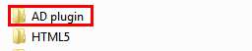

- Open archive “cocoon-plugins-c2-master”
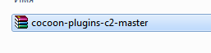
- Go to Construct 2 program folder.
%PROGRAM PATH%\Construct 2\exporters\html5\plugins

- EXPAMPLE:
C:\Program Files\Construct 2\exporters\html5\plugins

- Drag and drop ADS plugin “cocoon-ads” from archive to construct 2 “plugins” folder
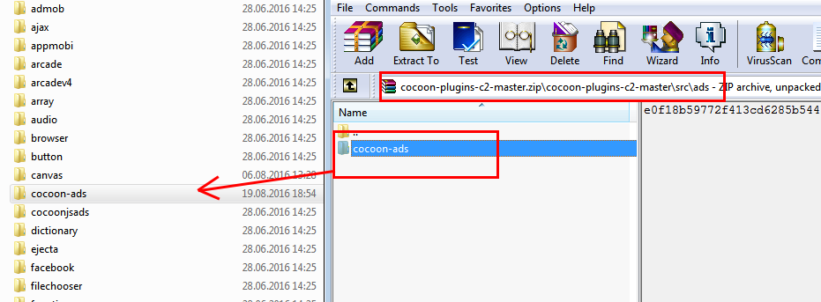

- Excellent! Now the plugin is installed and you can proceed to step 2
AD SETTING
- Open game .CAPX file
- On the right side of the screen, in the tab "Projects" get cocoon ads
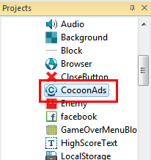

Then you can enter the ID of the banner or interstitial ad
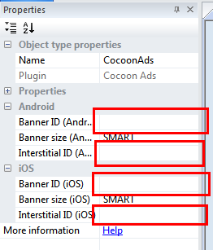

- Go to “MainEvents”


- In group “ADMOB” You can customize the ads by interstitials and banner
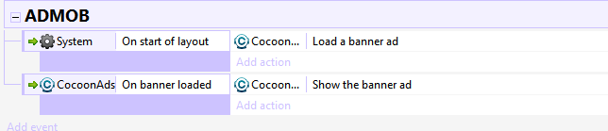

- If you still do not have a key to advertise and you do not know what to do. Go to ADMOB site https://apps.admob.com
- Press button “Monetize new app”
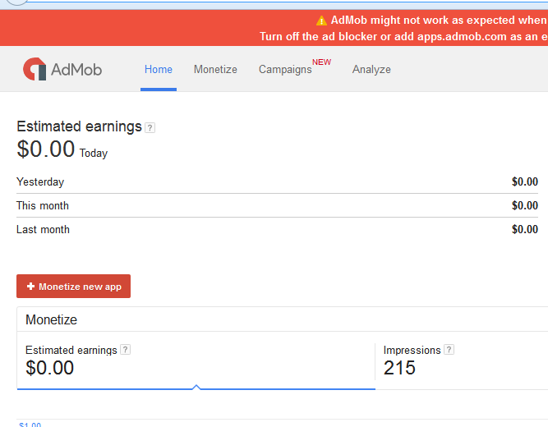

- Insert your data
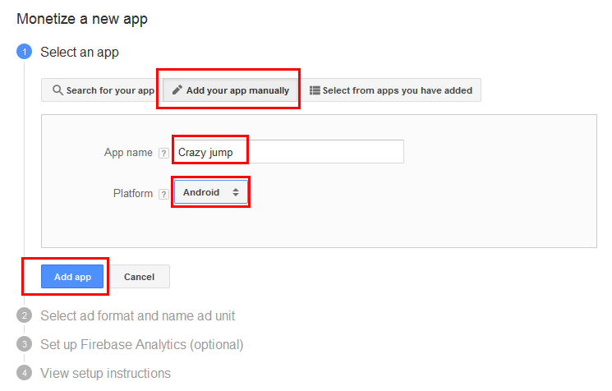
- Setting your baner or interstitial
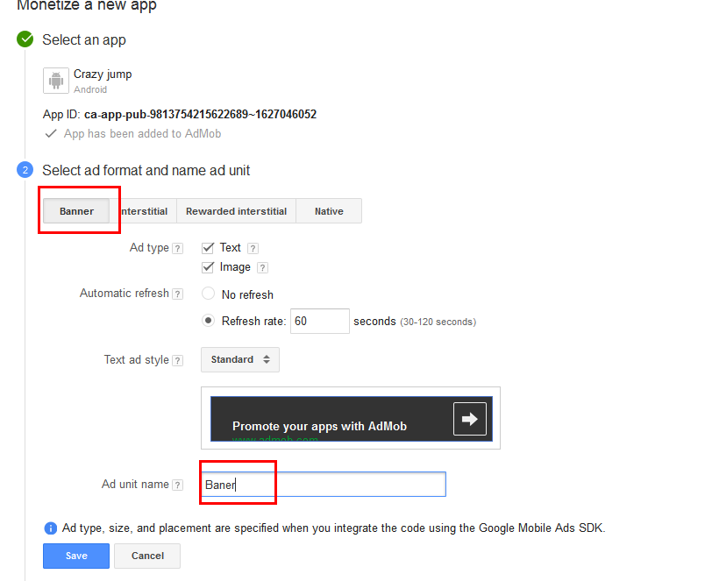

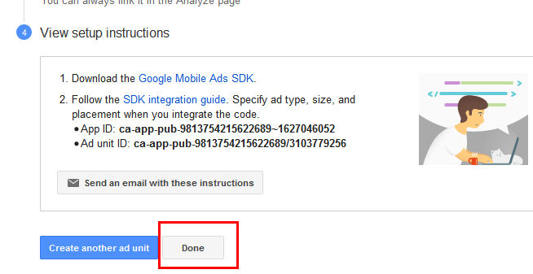

- YOUR BANER ID!
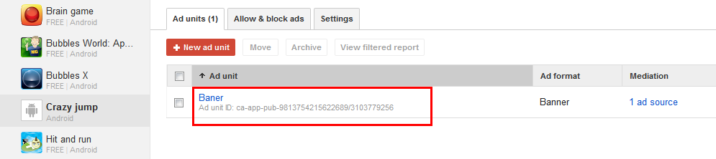
- Copy the code and paste in the construct 2
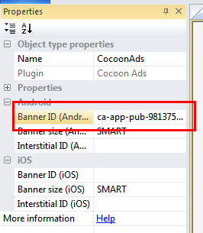
Done! It's time to compile

COMPILE TIME
- Select your project. (At this point it can be another name, namely the name of the project that you have purchased.)
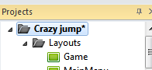
- Complete data
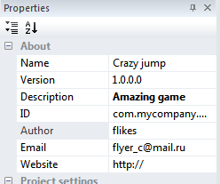
- File – Export – Cordova
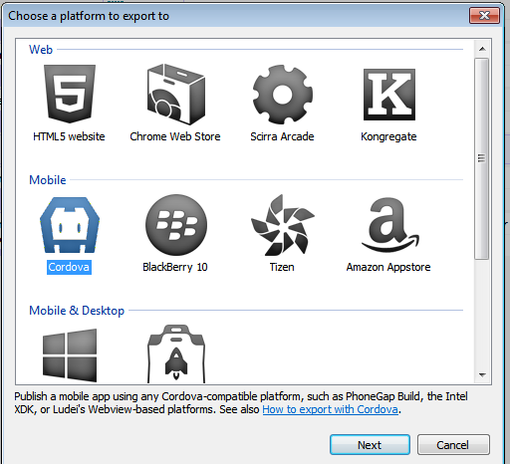

- NEXT. Remove the check mark from the item and next
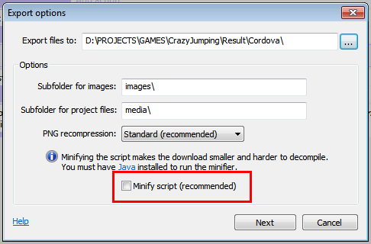
- You can not change anything. EXPORT
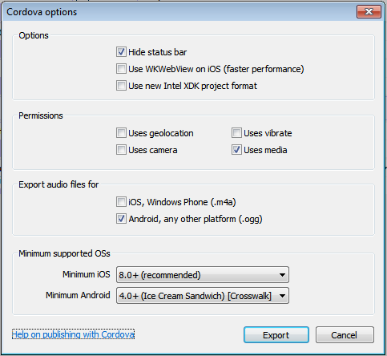

- Open the folder where you have compiled the project. Open the file c2runtime.js notepad ++ or another text editor
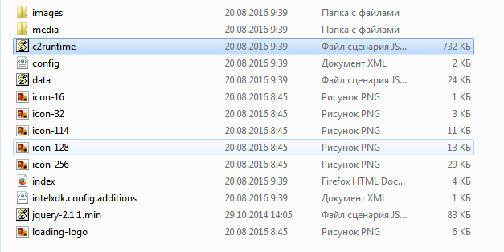
- FIND: “this.isRetina = ((!this.isDomFree || this.isEjecta) && this.useHighDpi && !this.isAndroidStockBrowser);”.
- If not found, then try this.is Retina = ((! This.wisDom Free ||
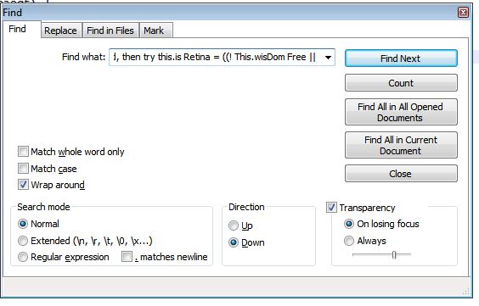
CTRL + F – search

- Search
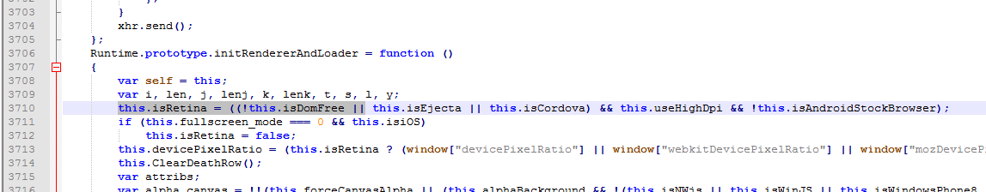
- Replace the string on this.isRetina = ((!this.isDomFree || this.isEjecta || this.isCocoonJs) && this.useHighDpi && !this.isAndroidStockBrowser); AND save file!
- Delete this files
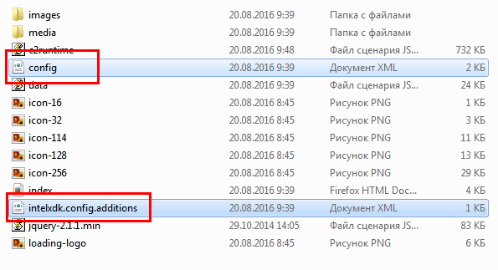
- ADD to archive all files (ZIP)
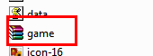

COCOON.IO
- Sign in cocoon.io site
- Drag and drop your archive in area
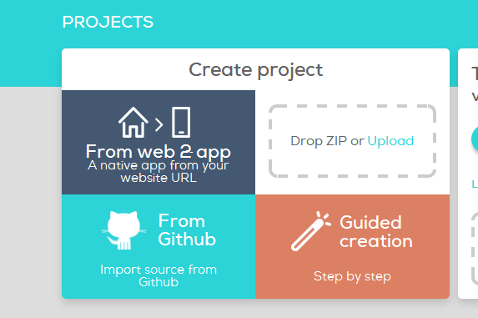
- After upload go to project and search settings. Insert your data.
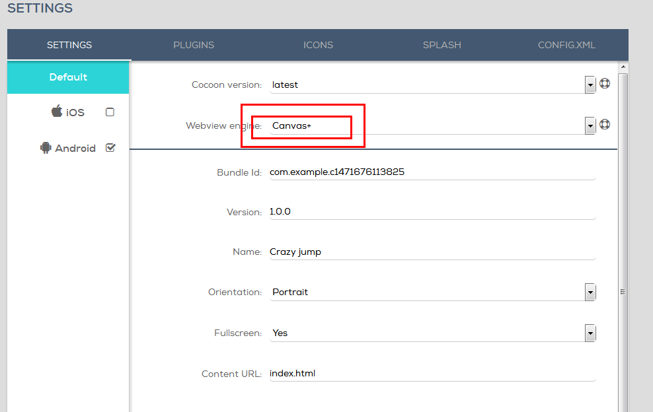
- Install ADS plugin
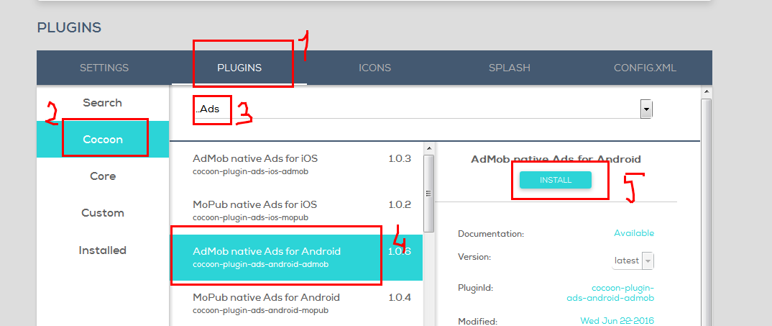
- Insert your ico
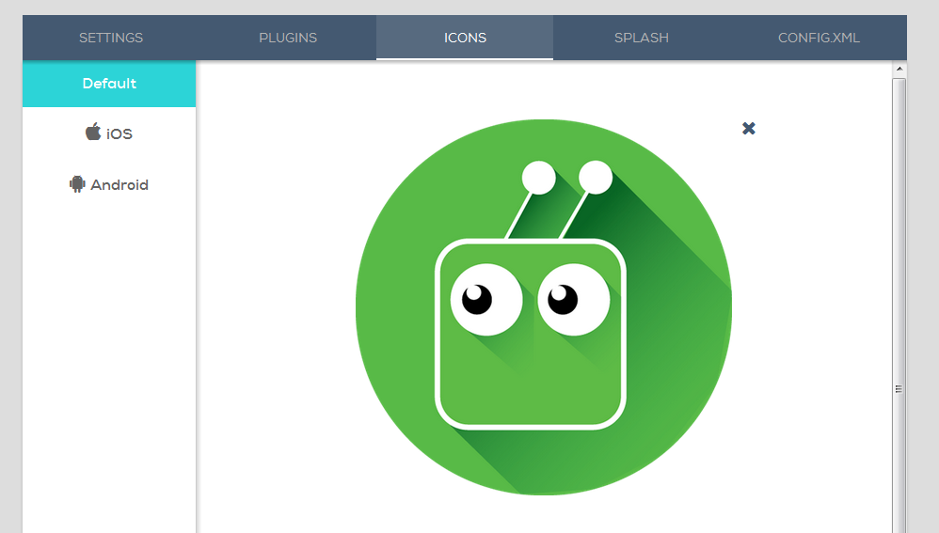
- Save
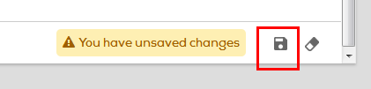

- Compile
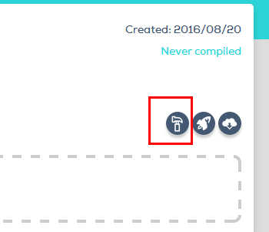
- DOWNLOAD GAME


If you have any questions - please contact us by e-mail flyer_c@mail.ru

