Sweet World

QUICK START
Created: 29/10/2016 | Thank you for purchasing my game. If you have any questions that are beyond the scope of this help file, please feel free to email via my user page contact form here. Thanks so much!
By: Flikes
Email: flyer_c@mail.ru

Quick start guide
Download Construct 2 on the official page: https://www.scirra.com/
Manual:
https://www.scirra.com/manual/1/construct-2

Opening the Project:
Run the Construct 2, go to FILE / OPEN.

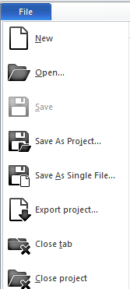
Image 1 – Construct 2 menu
Select the "SweetWorld.capx" file

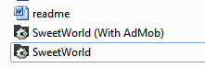
Image 2 – Project file

Knowing the project:
At the top of the desktop we have all the "tabs" of the project.

Image 3 – Project tabs

On the right side of C2, we have the "Layers" field and "Projects".
1 - Layers: are separated by types.
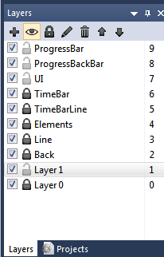
Image 4 - Layers

2 - Projects: Here are all of your project as folders, images, layouts and leaves events
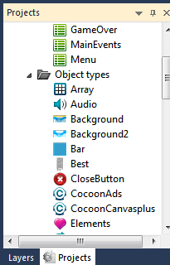
Image 5 – Projects tab
On the left side, is the project properties. With the necessary information of your game,
such as name, version, author, email etc.. Just below the system settings that can be
changed.

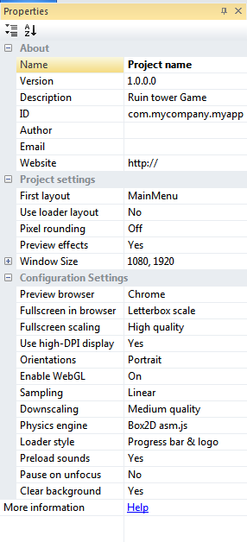

Image 6 – Properties project
Sheet events:
In the "Projects" field in the "Event sheets" folder, double-click the sheet event called
"MainEvents".
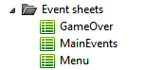
Image 7 – Called “MainEvents”

Open the sheet events of the main events of your game. Here contains all program called the event. Read more on the Construct 2 manual.

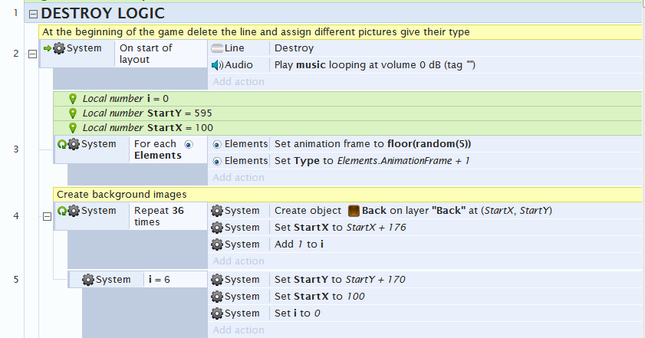
Image 8 – Main events program logic

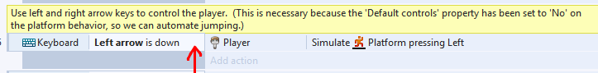
Image 9 – Comment

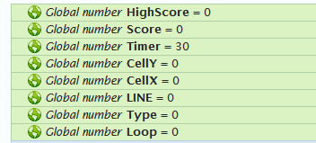
Image 10 – Global variables

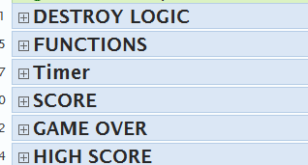
Image 11 – Grouped

Like this? Please rate me



https://codecanyon.net/downloads

Thank you for your purchase, we are very grateful to you! Good luck

https://codecanyon.net/user/flikes

LOOK AT MY OTHER GAMES:
ALT + Left mouse button - View Online

