Curriculum Vitae

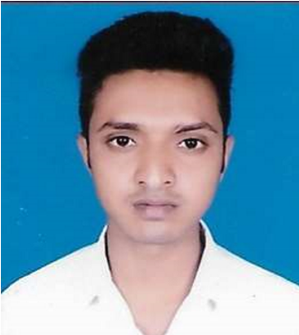

Name:

Brajesh Kumar

Permanent Address:

kushi harpur horil, kanti muzaffarpur bihar 843109

Correspondence Address:

Same as above.

E-mail : brajeshfrombr06@gmail.com

Phone :- 7 4 9 2 9 9 2 5 0 2 , 7 6 3 1 4 0 8 5 8 6

**Personal Profile:**

Date of Birth

:

20/05/1999

Gender

:

MALE

Marital status

:

UNMARRIED

Nationality

:

INDIAN

Father’s Name

:

DEVNATH THAKUR

**Academic Qualifications:**

|  |  |  |  |
| --- | --- | --- | --- |
| Qualification | Percentage (exact to two decimal places) | Institute/Board/  University | Year of Passing |
| 10th | 58.20 | BSEB | 2014 |
| 12th | 57 | BSEB | 2016 |
| Graduation (B.C.A.) | 64.62 | BRABU | 2020 |
| Kushal yuva program | 87 | BSDM | 2021 |
| Front-end web developer | -- | Self | 2021 |
| MS-Office | -- | Self | 2021 |
| Python | -- | Self | 2022 |
| Word press | -- | Self | 2022 |
| React Js developer | -- | Self | 2022 |

**Work Experience, if any:**

* I have done lots of web development project like portfolio (word press), Portfolio (Pure HTML CSS JS), Portfolio (React), food delivery website, real time chat application, gym website, transparent login page, a coaching website with log in and registration form, E-commerce front end page with react etc...

* I have also work with a cyber café as an assistant for 1 year…

**Professional Strengths:**

* Self-motivated
* Honesty
* Loyalty
* Creative
* Eager to learn.

**Skills /coding language known:**

* HTML
* CSS
* JAVASCRIPT
* REACT JS
* PYTHON
* C
* BOOTSTRAP
* HOSTING
* WORDPRESS

➢ MS-OFFICE

**Pursuing:**

* Node.js
* Mongo db (Database)
* Express.js
* Pug
* Socket.io

Languages (Read, Write, and Speak): Hindi & English

Interests: Coding, playing cricket and Traveling

Place:

Date: (Brajesh Kumar)