TRADING STRATEGY DOCUMENT
EMA 9 Support &
Resistance Strategy
───────────────────────
Instrument: All Indices & Stocks | Timeframe: All Timeframes
Version 1.0 | May 2026

1. Strategy Overview
The EMA 9 Support & Resistance Strategy is a price-action-based trading methodology that leverages the 9-period Exponential Moving Average (EMA) applied to both the High and Low of each candle to dynamically identify high-probability support and resistance levels. Unlike static support and resistance methods that rely on fixed horizontal price zones, this strategy uses live EMA bands to confirm key price inflection points through candlestick engulfment patterns.

The core premise is straightforward: when price breaks below the 9 EMA Low band and the very next candle fully engulfs the prior candle and closes green, the low of that breakout candle is validated as a dynamic support level. The opposite logic applies for resistance. This approach eliminates subjectivity and provides clearly defined, rule-based levels applicable across all instruments and timeframes.

Strategy At a Glance
Strategy Name | EMA 9 Support & Resistance Strategy
Core Indicator | 9-Period EMA applied to Candle High and Candle Low
Signal Type | Candlestick Engulfment Pattern following EMA Band Breach
Applicable Instruments | All Indices and Stocks (NSE, BSE, Global Markets)
Applicable Timeframes | All timeframes — 1-min, 5-min, 15-min, 1-hr, Daily, Weekly
Primary Purpose | Dynamic Support & Resistance Level Identification

2. Indicators & Setup
This strategy requires two EMA lines applied to the price chart. Both are derived from the 9-period Exponential Moving Average but calculated on different price data points of each candle:

Indicator | Description | Applied To | Purpose
EMA 9 High | 9-Period EMA of candle High | Candle High price | Upper boundary — Resistance zone
EMA 9 Low | 9-Period EMA of candle Low | Candle Low price | Lower boundary — Support zone

Together, these two lines form an EMA Band around price. This band represents a dynamic equilibrium zone. A confirmed close beyond either boundary — followed by an engulfment candle — is the core trigger of the strategy.

3. Core Strategy Rules
The strategy is governed by two mirror-image rules: one for Support identification (bullish setup) and one for Resistance identification (bearish setup). Both conditions must be met in sequence for a level to be confirmed as valid.

3.1 — Support Level Identification (Bullish Setup)

Rule 1: EMA Low Breach
Condition: A candle closes below the 9 EMA Low line. This candle must be a Red (bearish) candle, confirming downside pressure and a breach of the lower EMA boundary.
Action: Mark this candle. The low of this candle is now a candidate support level pending confirmation.

Rule 2: Bullish Engulfment Confirmation
Condition: The very next candle must be a Green (bullish) candle that fully engulfs the body of the previous red candle — opening at or below the prior close and closing above the prior open.
Action: The low of the breached red candle is now a confirmed Support Level. Draw a horizontal line at this price.

Support Level — Confirmation Checklist
- Price closes below the 9 EMA Low (Red candle breach)
- The very next candle is Green and fully engulfs the previous candle body
- The low of the breach candle = Confirmed Support Level

3.1 — Visual Diagram: Support Level
The diagram below illustrates the exact sequence of events required to confirm a valid Support Level using the EMA 9 Strategy. Study the two highlighted candles and the resulting support line carefully.

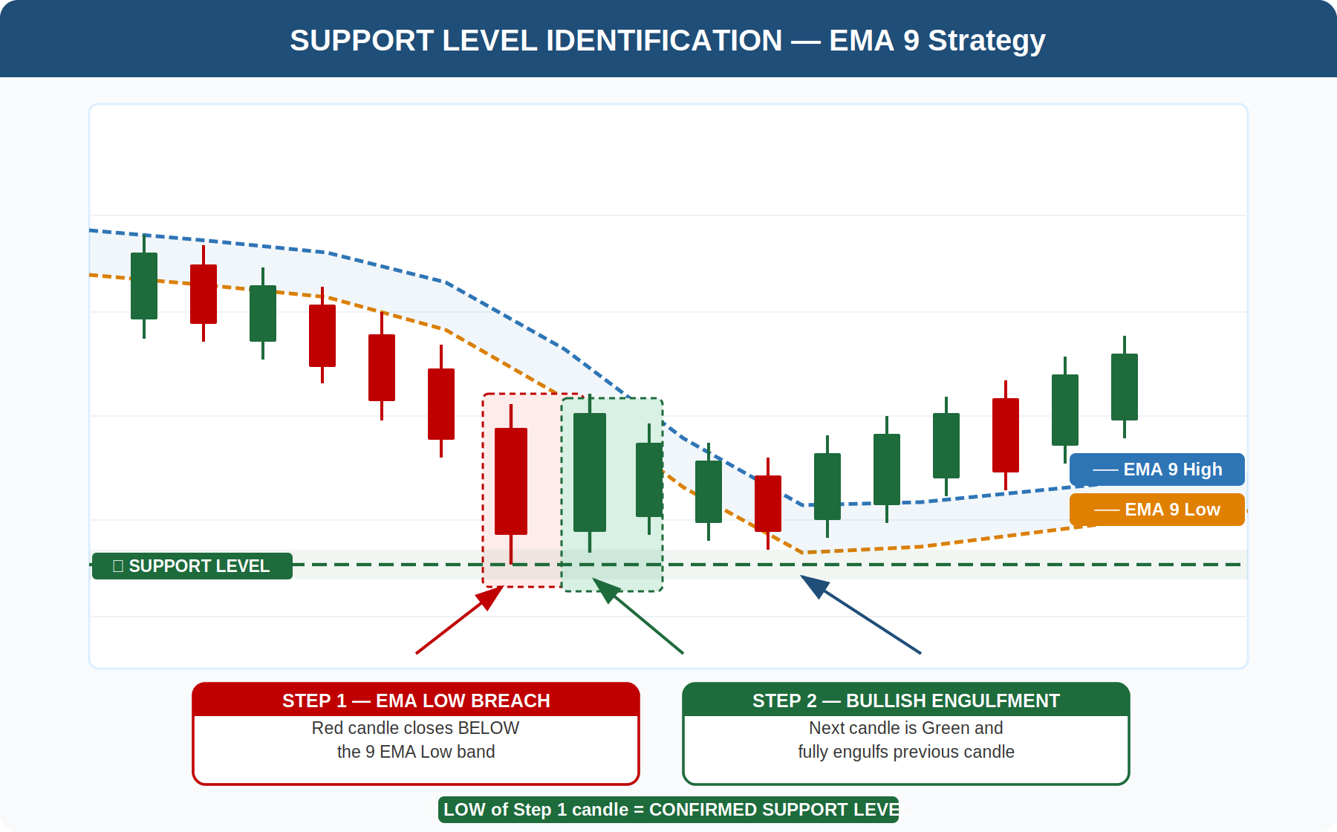
Figure 1 — Support Level Identification: EMA Low Breach followed by Bullish Engulfment

As shown above, the red breach candle closes below the 9 EMA Low band. The immediately following green candle engulfs it entirely, confirming the low of the breach candle as a valid Support Level. This level is then plotted as a horizontal line for future reference.

3.2 — Resistance Level Identification (Bearish Setup)

Rule 1: EMA High Breach
Condition: A candle closes above the 9 EMA High line. This candle must be a Green (bullish) candle, confirming upside pressure and a breach of the upper EMA boundary.
Action: Mark this candle. The high of this candle is now a candidate resistance level pending confirmation.

Rule 2: Bearish Engulfment Confirmation
Condition: The very next candle must be a Red (bearish) candle that fully engulfs the body of the previous green candle — opening at or above the prior close and closing below the prior open.
Action: The high of the breached green candle is now a confirmed Resistance Level. Draw a horizontal line at this price.

Resistance Level — Confirmation Checklist
- Price closes above the 9 EMA High (Green candle breach)
- The very next candle is Red and fully engulfs the previous candle body
- The high of the breach candle = Confirmed Resistance Level

3.2 — Visual Diagram: Resistance Level
The diagram below illustrates the exact sequence of events required to confirm a valid Resistance Level. Note how the green breach candle exceeds the EMA High, and the subsequent red engulfment candle validates the high as a confirmed Resistance Level.

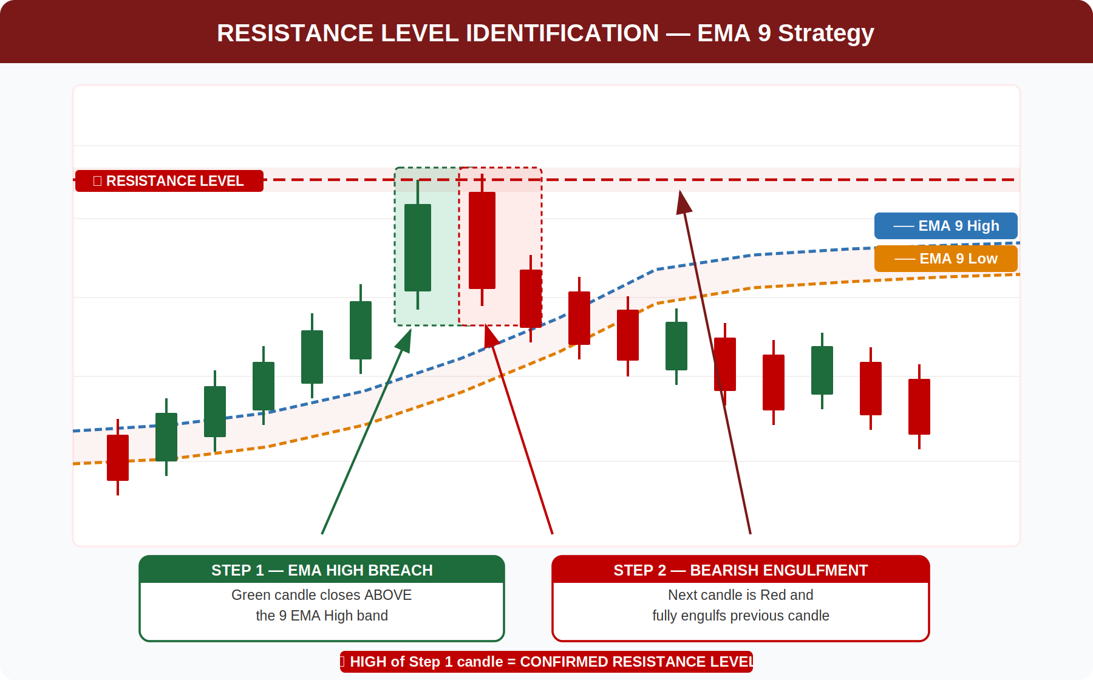
Figure 2 — Resistance Level Identification: EMA High Breach followed by Bearish Engulfment

As shown above, the green breach candle closes above the 9 EMA High band. The immediately following red candle engulfs it entirely, confirming the high of the breach candle as a valid Resistance Level. This level is then plotted as a horizontal line for future reference.

4. How to Trade Using These Levels
Once a Support or Resistance level has been confirmed by the strategy rules, it can be used in the following ways as part of a complete trading plan:

- Buy near confirmed Support levels when price revisits the zone, looking for bullish confirmation candles on re-test.
- Sell or Short near confirmed Resistance levels when price revisits the zone, looking for bearish confirmation candles.
- Use confirmed Support as a Stop-Loss reference for long trades — place stops slightly below the support level.
- Use confirmed Resistance as a Stop-Loss reference for short trades — place stops slightly above the resistance level.
- Target the next confirmed Resistance level as Take-Profit for long trades; the next confirmed Support for short trades.
- Stack multiple confirmed levels to identify high-confluence price zones where strong market reactions are most likely.

5. Glossary of Terms

Term | Definition
EMA (Exponential Moving Average) | A moving average that gives greater weight to recent prices, making it more responsive to current market conditions than a Simple Moving Average.
EMA 9 High | The 9-period EMA calculated using the High price of each candle. Forms the upper dynamic boundary of the EMA band.
EMA 9 Low | The 9-period EMA calculated using the Low price of each candle. Forms the lower dynamic boundary of the EMA band.
EMA Breach | An event where a candle closes beyond the EMA High or EMA Low band, signaling a potential shift in momentum.
Bullish Engulfment | A two-candle pattern where a green candle fully engulfs the body of the preceding red candle, indicating a bullish reversal.
Bearish Engulfment | A two-candle pattern where a red candle fully engulfs the body of the preceding green candle, indicating a bearish reversal.
Support Level | A confirmed price level where buying interest overcomes selling pressure, causing the price to bounce upward.
Resistance Level | A confirmed price level where selling interest overcomes buying pressure, causing the price to reverse downward.
Confluence | The alignment of multiple independent signals or levels at the same price zone, significantly increasing reaction probability.

