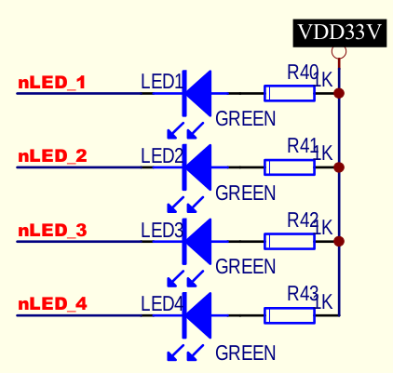

8 月26号

==========================LED======================================

(1).

led 1 2 3 4

GPB 5 6 7 8

output '0' ,led on

output '1', led off

? how to configure GPB 5-8 as output mode.

? how to output high/low electrolic level

(2).

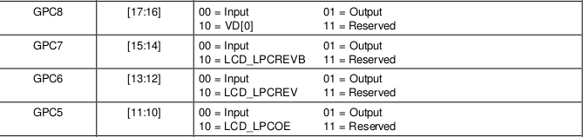

(3).

(4).