Achieving comity: disciplinary border crossings with Guy Aston

We soon learn and soon forget that academic life is inescapably fractured, with different disciplines competing for our allegiance as sharply as rival fiefdoms. Part of the painful process of growing up is recognizing which of them provides the most congenial home for us, that is, which discipline best accepts whichever of the many identities we have necessarily been experimenting with throughout our adolescence. When, on meeting a new acquaintance we ask “and what do you do?”, we expect to be told not just their hierarchical status (I’m a researcher/professor/lecturer/technician) but also their disciplinary credentials, names which are themselves signs of tribal affiliation. Only a qualified practitioner of (shall we say) “Computer-Aided Discourse Analysis” or “English for Academic Purposes” or “Computer Assisted Language Learning” can determine whether a random acquaintance is truly of the same persuasion, a dangerous radical, a would-be disciple, or merely a bluffer. But the names are what matter. Deciding what it is that you really want to do, what it is that you really think, cannot be done in isolation. You must find a distinctive name in terms of which to define yourself, making clear what you have in common with existing tribes and where you beg to differ: you must declare your allegiance, or lack of it. This is why it is difficult for truly interdisciplinary studies to gain a foothold in the academy, and also why, when they do, they risk succumbing to fossilisation as a new entrenched orthodoxy.

In this paper, I am trying to cross frontiers in various ways. I will use graphics and bullet points in my presentation, as I always do when teaching, but the bulk of my argument will be in discursive prose, of the kind I prefer to read. I will present some material as if it were part of a course in sociology or history : this is how we used to persuade people to use corpora, or the BNC, or computers more generally, and these are the tools we had at our disposal. How quaint! How naive! But I will also try to show how Guy’s attitude to that necessary pedagogy enriched and complemented the activity, and I hope persuade you that his approach has more long-lasting implications and relevance.

I first met Guy in 1965 when we were both making the transition from smart lad at a good school to idiot freshman at an Oxford college. We enjoyed a more or less continuous friendship from then until his untimely death last year, experiencing together many of the mundane but essential rituals of growing up – getting a job, finding a place to live, finding a partner, celebrating birthdays and other significant milestones, and so on, and so on. But I am going to talk more about the professional components of our relationship than the personal ones, inextricably intertwingled though the two were. As how could they not be, since, as I have remarked before, Guy made a point of transforming his professional relationships into personal ones wherever possible. I want to focus on the period from about 1992 to 2007, during which our separate academic paths converged, and some effects of that convergence.

In October 1992 I spoke at a workshop in Parma, at the invitation of John Morley but (I suspect) instigated by Guy. The gig was to talk about the wonderful new world of”Electronic Resoiurces for Textual Studies” and to explain a skeptical audience just how much fun they could be having with their computers, beyond simply writing essays on them. I recently found a write up I subsequently contributed to “Textus” from which I quote:

But this occasion was chiefly memorable to me because it was over an excellent dinner (almost certainly featuring varieties of ham) that I was made quite clearly to understand that this talk of global electronic village was all very well, but there was a professionalism in academia, that these were serious people, and you needed a doctorate to express an opinion about how language worked in their company. Fair enough, in retrospect: I was definitely guilty of a bumptious amateurism, derived from a somewhat evangelical desire to convert the world to SGML.

(ˈkɒmɪtɪ)
n, pl -ties
1. mutual civility; courtesy
2. (Government, Politics & Diplomacy) short for comity of nations
3. (Theology) the policy whereby one religious denomination refrains from proselytizing the members of another
[C16: from Latin cōmitās, from cōmis affable, obliging, of uncertain origin]
Collins English Dictionary – Complete and Unabridged, 12th Edition 2014 © HarperCollins Publishers 1991, 1994, 1998, 2000, 2003, 2006, 2007, 2009, 2011, 2014

The notion of “refraining from proselytizing” is a wonderful one

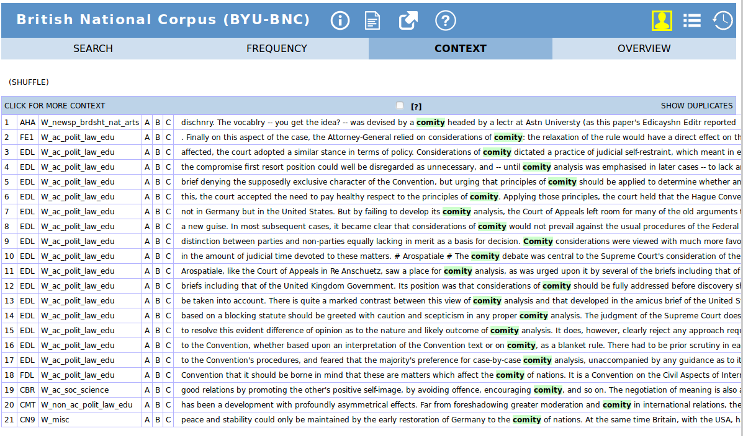
In the BNC’s 21 occurrences, only one is non-legal. And that’s a deliberate typo.

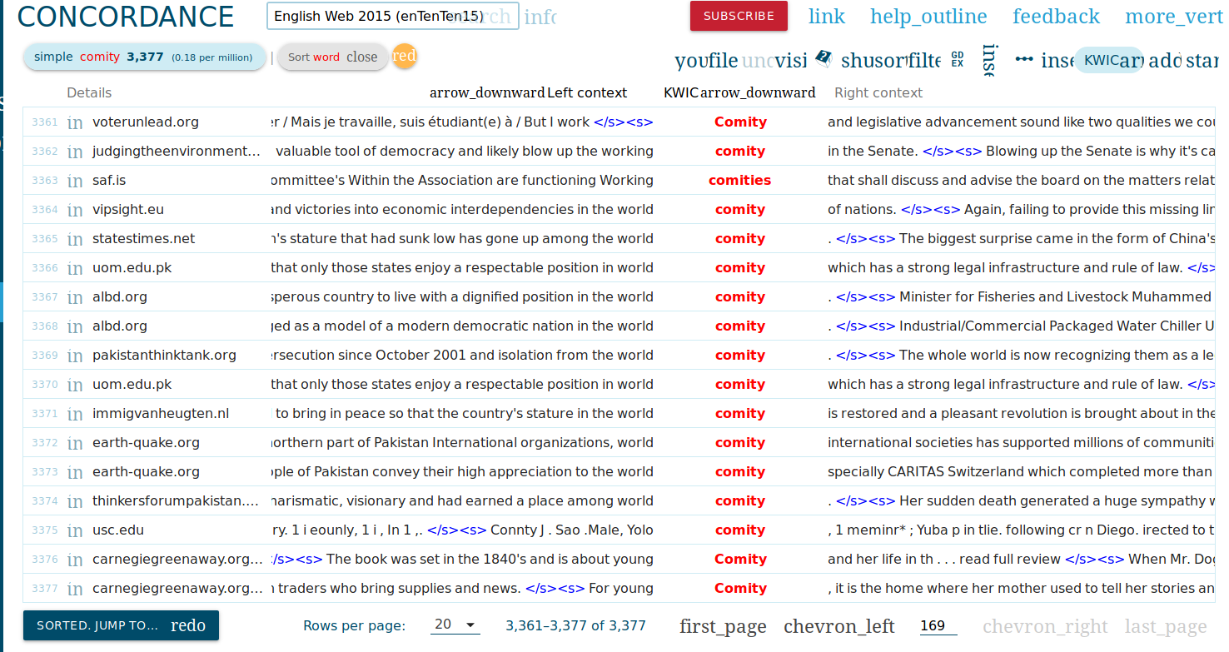
By 2015, the frequency has gone up somewhat, but in the 3k+ occurrences it’s clear that two senses predominate : the political one (“world comity”) and … the misspelling “functioning working Comities”. Oh and we have the word used as a proper name.

