**Consider the below two tables**:

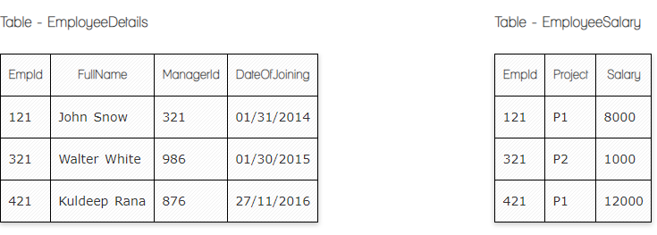

1. **Write a SQL query to fetch the count of employees working in project 'P1'.**

**Your Answer:**

**Select count(*)**

**From EmployeeSalary**

**Where Project= 'P1';**

1. **Write a SQL query to fetch employee names having salary greater than or equal to 5000 and less than or equal 10000.**

**Your Answer:**

**Select FullName**

**from EmployeeDetails**

**Inner join EmployeeSalary on EmployeeSalary.EmpId=EmployeeDetails.EmpId**

**Where Salary >=5000 and Salary <=10000**

1. **Write a SQL query to fetch count of employees sorted by project's count in descending order.**

**Your Answer:**

**Select EmployeeDetails.FullName, EmployeeSalary.Project**

**From EmployeeDetails**

**Inner join EmployeeSalary on EmployeeSalary.EmpId=EmployeeDetails.EmpId**

**Order by EmployeeSalary.Project desc**

**SELECT** Project, **count**(EmpId) EmpProjectCount

**FROM** EmployeeSalary

**GROUP** **BY** Project

**ORDER** **BY** EmpProjectCount **DESC**;

1. **Write a query to fetch employee names and salary records. Return employee details even if the salary record is not present for the employee.**

**Your Answer:**

**Select EmployeeDetails.Fullname, EmployeeSalary.Salary**

**From EmployeeDetails**

**Left Join EmployeeSalary on EmployeeSalary.EmpId=EmployeeDetails.EmpId**

1. **Write a SQL query to create an empty table with ‘Test’ name.**

**Your Answer:**

**CREATE TABLE Test (**

**ID int NOT NULL,**

**TestType varchar(255),**

**Primary Key (Id)**

**);**

1. **Write a SQL query to delete an empty table with ‘Test’ name.**

**Your Answer:**

**DROP TABLE Test**

1. **Write a SQL query to update EmployeeSalery table with setting Salary to 2000 for Project P2.**

**Your Answer:**

**Variant 1**

**Update EmployeeSalary**

**Set Salary=2000**

**Where EmpId= 321;**

**Variant 2**

**Update EmployeeSalary**

**Set Salary=2000**

**Where Project= 'P2';**

1. **Write a SQL query to right join both tables and draw the results.**

**Your Answer:**

**Select EmployeeDetails.EmpId, EmployeeDetails.FullName, EmployeeDetails.DateOfJoining, EmployeeSalary.Project, EmployeeSalary.Salary**

**From EmployeeDetails**

**Right join EmployeeSalary on EmployeeSalary.EmpId=EmployeeDetails.EmpId**

**Now take these two tables:**

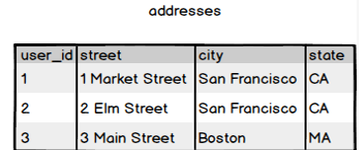

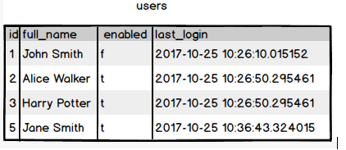

1. **Write a SQL query to fetch all users full_name, last_login who are enabled**

**Your Answer:**

**Select full_name, last_login**

**From Users**

**where enabled='t'**

1. **Write a SQL query to fetch all users full_name who are from Main street or San Francisco**

**Your Answer:**

**Select Users.full_name, Adresses.Street, Adresses.City**

**From Adresses**

**Inner join Users on Users.ID=Adresses.user_id**

**Where Street='Main Street' or City='San Francisco';**

1. **Write a SQL query to fetch user full_name who is equal to user_id from Boston (find user_id value in sub_query)**

**Your Answer:**

**Select full_name from users**

**Where id in (Select user_id from addresses Where city= ‘Boston’)**