Questions:

1. What is the mass of the spacecraft you want to use? Create the spacecraft in your code
2. Add the spacecraft in so that it’s fixed on earth! (hint: make an additional class and move the spacecraft along with the earth)
3. What is the escape velocity of an object from earth?
4. Add a basic thrust in at escape velocity
5. What is the closest that Mars and the Earth get to each other?   
   (hint: print r values for Earth and Mars and get the date that it reaches the minimum value)
6. Wait until the day that Earth and Mars are closest then add thrust in the direction of Mars. Can you get to Mars with a straight line path in any direction? If not, what is the closest you can get?
7. One of the most fuel efficient Earth-Mars-Earth maneuvers is a **Hohmann transfer**. Can you accomplish this? (hint: Nasa does it when Mars is 55 degrees ahead of Earth)  
     
   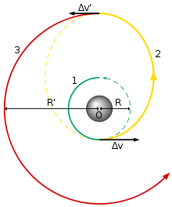
8. Can you use thrust and gravity assists to create a loop around the sun before the spacecraft approaches Mars?