|  |  |  |
| --- | --- | --- |
| **Week 34** | **Epidemiological Bulletin** | **19th - 25th, Aug, 2024** |

|  |
| --- |
|  |
| **Summary** |
|  |

**Immediately Notifiable Diseases and Events**

* **AFP** : 6 suspected cases were reported from Eastern(2), Southern(3), Western(1) provinces.
* **Anthrax** : 8 suspected cases were reported from Southern(7), Western(1) provinces.
* **Cholera** : 4 suspected cases were reported from Copperbelt(4) province.
* **Measles** : 28 suspected cases were reported from Eastern(7), Luapula(3), Lusaka(2), North-Western(1), Northern(14), Western(1) provinces.

**Other Diseases and Events**

* **Non-bloody Diarrhoea** : 35175 suspected cases were reported from Central(4568), Copperbelt(3856), Eastern(5419), Luapula(1950), Lusaka(2495), Muchinga(1465), North-Western(3828), Northern(2289), Southern(5142), Western(4163) provinces.
* **Malaria** : 144640 suspected cases were reported from Central(10517), Copperbelt(23810), Eastern(25239), Luapula(22041), Lusaka(4643), Muchinga(7282), North-Western(23453), Northern(14352), Southern(2889), Western(10414) provinces.
* **Typhoid Fever** : 33 suspected cases were reported from Central(2), Copperbelt(4), Lusaka(18), Northern(9) provinces.

|  |
| --- |
|  |
| **Summary Report Priority Diseases, Conditions and Events** |
|  |

|  | **Week 34** | | | **Week 1 to 34, Cumulative Total** | | |
| --- | --- | --- | --- | --- | --- | --- |
| **Disease/Event/Condition** | **Suspected** | **Tested** | **Confirmed** | **Suspected** | **Tested** | **Confirmed** |
| **AFP** | 6 | 4 | 1 | 318 | 259 | 1 |
| **Anthrax** | 8 | 2 | 1 | 283 | 36 | 5 |
| **Cholera** | 4 | 0 | 0 | 16,684 | 4,410 | 2,034 |
| **Non-bloody Diarrhoea** | 35,175 | 2,435 | 2,171 | 813,029 | 46,953 | 50,502 |
| **Malaria** | 144,640 | 138,717 | 40,329 | 8,011,914 | 7,570,205 | 3,693,242 |
| **Measles** | 28 | 21 | 3 | 4,360 | 1,343 | 655 |
| **Monkeypox** | 0 | 0 | 0 | 8 | 4 | 0 |
| **Plague** | 0 | 0 | 0 | 13 | 1 | 0 |
| **Typhoid Fever** | 33 | 20 | 4 | 822 | 499 | 45 |

|  |
| --- |
|  |
| **Summary of VPD Surveillance Indicators** |
|  |

|  |
| --- |
|  |
| **Measles Laboratory Test Results by Province** |
|  |

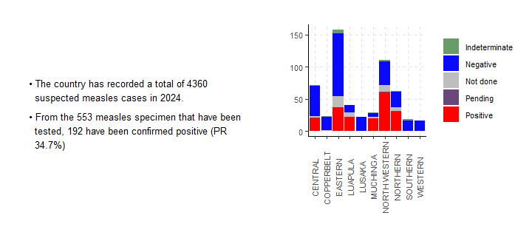

|  |
| --- |
|  |
| **Maternal Deaths** |
|  |

|  |  |
| --- | --- |
|  |  |
| **Causes of maternal death (Week 34, n=15)** | **Cumulative distribution of maternal deaths (2024) by province** |
|  |  |

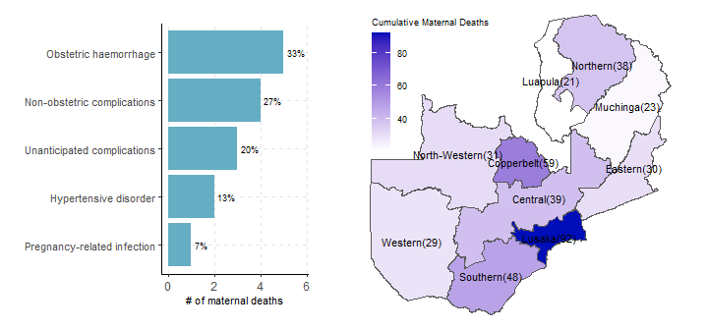

* The bar chart on the left summarizes the causes of deaths of 15 maternal deaths recorded in week 34.
* Hypertensive disorder, Non-obstetric complications, and Obstetric haemorrhage continue to be the leading causes of maternal deaths this year.
* Cumulatively, in 2024, 410 maternal deaths have been recorded across the country, as depicted on the map.
* Provinces with darker shades (Lusaka, Copperbelt, and Southern) indicate those with a higher number of reported maternal deaths.