Relative risk aversion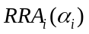. | 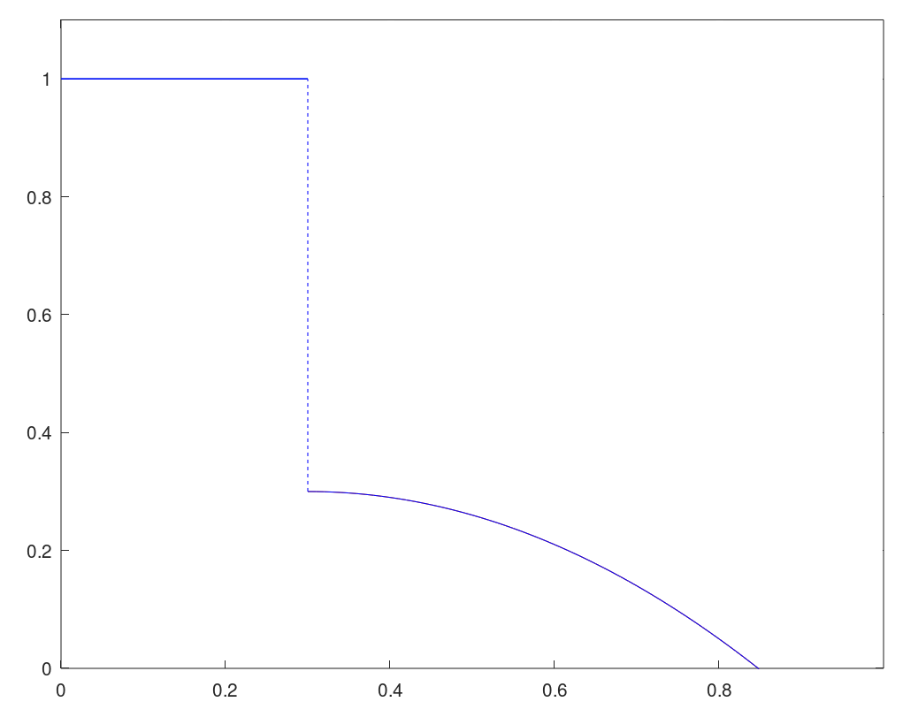
 | Intensity of altruism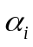.
Relative risk aversion

