Autonomous Parking Assist

Phase-I Report: Interface and Unit Test Design, Test-Driven Development

Course: DT8067 - Networks and Testing for Embedded Systems
Halmstad University

Team members:
[Lavanya Ballaratna,
Harikrishna Manappadamuriyil Reghuvaran,
Ponny Joseph]

Table of Contents

Introduction 3
Objectives 3
Description of the Unit 3
Part 1: Interface and Test Design 4
Data structures: 4
Interface specification 4
WhereIs 4
MoveForward 5
MoveBackward 5
isEmpty 5
Park 5
UnPark 5
Functional test design technique 6
Test suite 6
Part 2: Test-Driven Development 7
WhereIs 8
MoveForward 10
MoveBackward 13
isEmpty 15
Park 19
UnPark 22
Assumptions: 24
Coverage Report: 24
Decision Table For is_empty() 25

Introduction

This report documents Phase I of our Autonomous Parking Assistance system project. The primary objective of this phase was to apply Test-Driven Development (TDD) principles and unit testing using pytest to build the core decision-making logic of an autonomous parking assistant. Following strict TDD practices (Red-Green-Refactor cycles), we incrementally designed and implemented the core model to process readings from two ultrasound sensors, control vehicle movement (forward and backward) along a 500-meter street and execute parking and unparking maneuvers upon detecting suitable gaps. Code coverage metrics were gathered using Coverage.py (pytest-cov) to ensure comprehensive test suite validation.

Objectives
The four techniques we used
- Interface design
- Test-driven development
- Functional test design
- Unit testing (pytest)

We've organised the report into: how we designed the interface, how we derived the tests from the requirement and how we built the implementation up test by test.

Description of the Unit

Here's the scenario we were given: a car moves along a perfectly straight, 500-metre street and registers free parking spaces on its right-hand side. It does this by moving forward one metre at a time and reading two ultrasound sensors. We combine and filter those two readings to reliably identify a free stretch of five metres and once we find one the car drives to the end of that stretch and performs a standard reverse parallel parking maneuver.

We built six methods for the public interface, using the same names given in the project instruction:

MoveForward() - moves the car one metre forward, queries isEmpty() and returns the car's state - its position and everything detected about parking spaces so far. It must not move the car past the end of the street.

isEmpty() - queries both ultrasound sensors at least five times each, filters out noise and returns the distance in centimetres to the nearest object on the right. A sensor that is continuously noisy is disregarded entirely rather than trusted.

MoveBackward() - the mirror of MoveForward()- moves one metre backward, with the same restriction at the start of the street instead of the end.

Park() - runs the parking maneuvers immediately if the car is already positioned at a free stretch, or drives forward searching for one and then parks.

UnPark() - moves the car forward (and to the left) to the front of the parking space, provided the car is actually parked.

WhereIs() - reports the car's current position and whether it is parked or unparked, without changing anything.

We assume sensor input is either fixed or random, always an integer between 0 and 200 representing a distance in centimetres.

Part 1: Interface and Test Design

Data structures:
Before writing any of the six methods, we asked ourselves what state the class actually needs to keep around between calls. Two small data-holding classes cover this and neither one contains any logic of its own:
Status = Literal ["moving", "parked", "unparked"]

class CarState: class ParkingRecord:
position: int
distance_cm: Optional[int] # one isEmpty () reading, tied to a position
class CarState:
position: int = 0
status: Status = "unparked"
records: List[ParkingRecord] = []

CarState is the class's internal state - the car's position, whether it is currently parked and the running history of sensor readings we've taken along the way. This is exactly what needs to stay available at all times for the class to answer WhereIs() correctly and to decide what MoveForward/MoveBackward should do next.

The class and its methods:
class ParkingAssistant:
def __init__(self, sensor_left: Sensor, sensor_right: Sensor):
...

None of our six methods take any parameters beyond self. The only place external input enters the class is through the constructor, where we supply the two sensor objects; every method after that either reads or updates self.state.

Method | Parameters | Return type
WhereIs | none | CarState
MoveForward | none | CarState
MoveBackward | none | CarState
isEmpty | none | int
Park | none | CarState
UnPark | none | CarState

Interface specification
ParkingAssistantInterface lists the six methods and describes what each one should do, before any of them are actually written. The real logic for each method lives separately, in ParkingAssistant. For every method, its Description, Pre-condition, Post-condition, and Test-cases are written as a docstring directly above it in interface.py, and are reproduced below

WhereIs
Description: Return the current position and parked/unparked status.
Pre-condition: None.
Post-condition: State is unchanged - this method only reports back what is already known.
Test-cases: a, b, c, d (tests/test_where_is.py)

MoveForward
Description: Move one metre forward, query isEmpty(), and record the result. Must not move past
STREET_LENGTH.
Pre-condition: None.
Post-condition: If position < 500, position increases by 1 and a new reading is recorded;
if position == 500, nothing changes and the call is rejected as a no-operation.
Test-cases: a, b, c, d (tests/test_move_forward.py)

MoveBackward
Description: Move one metre backward, query isEmpty() and record the result. Must not move before
position 0.
Pre-condition: None.
Post-condition: If position > 0, position decreases by 1 and a new reading is recorded; if position ==0,
nothing changes and the call is rejected as a no-operation.
Test-cases: a, b, c, d (tests/test_move_backward.py)

isEmpty
Description: Query both sensors at least five times each, filter out noise, disregard a continuously noisy
sensor, and return the distance in centimetres (0-200).
Pre-condition: None.
Post-condition: Returns an integer between 0 and 200 as long as at least one sensor is not noisy; raises
an error if both sensors are noisy at the same time. That last behaviour is not specified
in the requirement - it was our own decision, discussed further below.
Test-cases: a, b, c, d, e, f, g, case 20 (the call-count case), and case 21 (RandomSensor stays in range) (tests/test_is_empty.py).

Park
Description: Park at the current position if it sits on a free stretch of five metres; otherwise, drive forward
searching for one, then reverses into it and parks.
Pre-condition: The car must not already be parked.
Post-condition: Status becomes "parked" once a qualifying stretch is found. Calling Park while already
parked raises an error - again, our own decision rather than something the requirement
states.
Test-cases: Case 22 and case 27 (tests/test_park.py) were built in Phase 1. Cases 23 through 26 - searching forward, the exact five-metre boundary, and finding no stretch anywhere on the street - are implemented too, using a small hand-written SequenceSensor test double instead of a mocking library (see Assumptions). Cases 28 through 30 are our own additions, described in the Test suite and Assumptions sections.

UnPark
Description: Move forward (and to the left) to the front of the parking place. Only valid while
status =="parked".
Pre-condition: The car must be parked.
Post-condition: Position moves forward by STRETCH_REQUIRED - 1, the rest of the space's length - not a flat 1 - since Park now reverses the car into the back of the space rather than parking at its entrance. Status becomes "unparked". Calling UnPark while not parked raises an error; the requirement only describes what happens "if it is parked", so this is our own decision as well.
Test-cases: Cases 31, 32, and 33 (tests/test_unpark.py)

Functional test design technique

We used one of the standard functional testing techniques - a classification tree or a decision table - to derive
our test cases from the requirement.
For isEmpty, we used a decision table technique, because the method's behaviour depends on two conditions that interact rather than acting independently: whether sensor A is noisy and whether sensor B is noisy.

For the other five methods, we used boundary value analysis and state-based testing instead. MoveForward and MoveBackward are each really about a single ordered range with a hard limit at one end, which is exactly what boundary value analysis is designed for.

WhereIs, Park, and UnPark are about which state the car is currently in and which transitions between states are legal, which fits state-transition testing more naturally. Neither of these is a classification tree or a decision table, but for methods built around a single ordered boundary or a small set of legal state transitions - rather than several independent conditions combining - we felt a classification tree would mostly redraw the same two boundaries under a different name, so we went with the simpler technique instead.

Test suite
All 33 test cases identified for the six methods, with their input scenario and expected outcome, are listed below by method.
WhereIs test cases: -
Case | Input / scenario | Expected output
1 | fresh car, before any movement | position=0,  status= “unparked"
2 | after two calls to MoveForward | position = 2
3 | right after a successful Park | status = "parked"
4 | right after UnPark | status = "unparked"

MoveForward test cases: -
Case | Input / scenario | Expected output
5 | position = 0 | position = 1
6 | position = 499 | position = 500
7 | position = 500 (already at the end) | position stays at 500
8 | any successful move | a reading is recorded

MoveBackward test cases: -
Case | Input / scenario | Expected output
9 | position = 500 | position = 499
10 | position = 1 | position = 0
11 | position = 0 (already at the start) | position stays at 0
12 | any successful move | a reading is recorded

isEmpty test cases:-
Case | Input / scenario | Expected output
13 | both sensors clean, e.g. 50cm and 52cm | filtered average, between 50 and 52
14 | left sensor noisy, right sensor reads 80cm | 80
15 | right sensor noisy, left sensor reads 80cm | 80
16 | both sensors noisy | raises an error
17 | reading = 0cm | accepted as a valid reading
18 | reading = 200cm | accepted as a valid reading
19 | reading = 250cm (out of range), other sensor = 80cm | 80 (the out-of-range reading is disregarded)
20 | wrap both sensors and call isEmpty once | each sensor is read at least 5 times
21 | call RandomSensor().read() fifty times | every reading is between 0 and 200cm

Park test cases:-
Case | Input / scenario | Expected output
22 | already at a free stretch (0cm on both sensors) | status becomes "parked"
23 | no stretch here, but one exists further ahead | drives forward until it is found, then parks
24 | exactly 5.0 metres free | accepted, status becomes "parked"
25 | 4.9 metres free | rejected, search continues
26 | no stretch anywhere on the street | search stops, raises an error
27 | Park called while already parked | raises an error
28 | qualifying stretch found further ahead | car reverses STRETCH_REQUIRED - 1 metres into it before parking, rather than parking from the space's entrance
29 | Park, then UnPark | UnPark returns to the front of the same space Park found, not past it
30 | only a few clear metres left before the street's own end | rejected, same as case 26 but caused by the street ending mid-search

UnPark test cases:-
Case | Input / scenario | Expected output
31 | car is parked | status = "unparked", position moves forward by STRETCH_REQUIRED - 1
32 | car is not parked | raises an error
33 | UnPark, then WhereIs | WhereIs reports the same updated status and position

Part 2: Test-Driven Development

We built every method following the standard red-green-refactor cycle: write a failing test first, run it and watch it fail add just enough code to make it pass and then clean up the implementation if it needed it. We commented every line we added to parking_assistant.py with the specific test case it exists to satisfy, so the connection between requirement, test and implementation stays traceable.

WhereIs
Red: we wrote all four test cases in tests/test_where_is.py first; running them against the unfinished class failed immediately.
pytest tests/test_where_is.py -v, all four tests failing before implementation
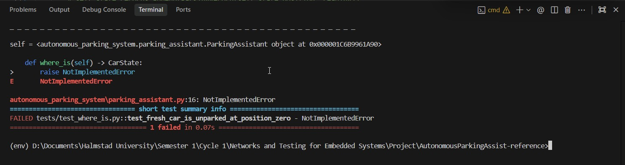

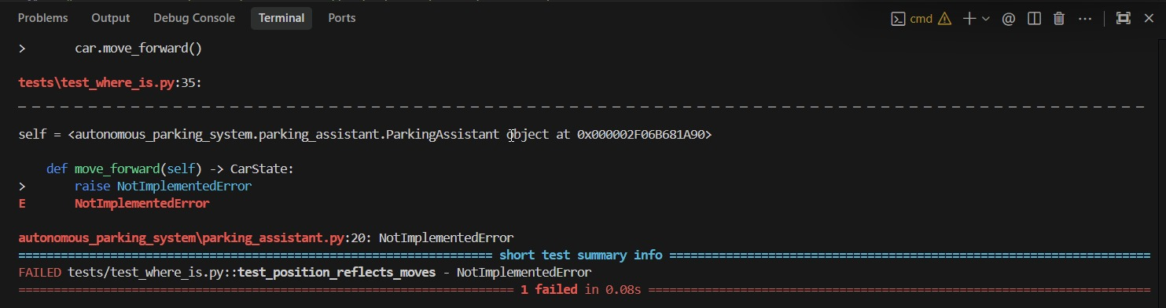
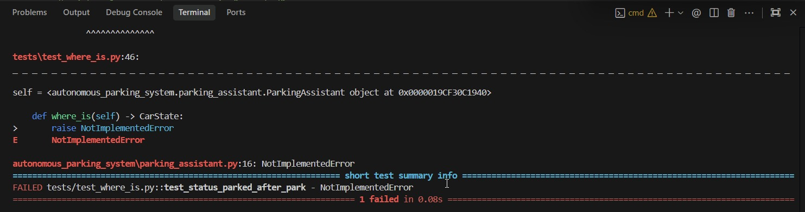
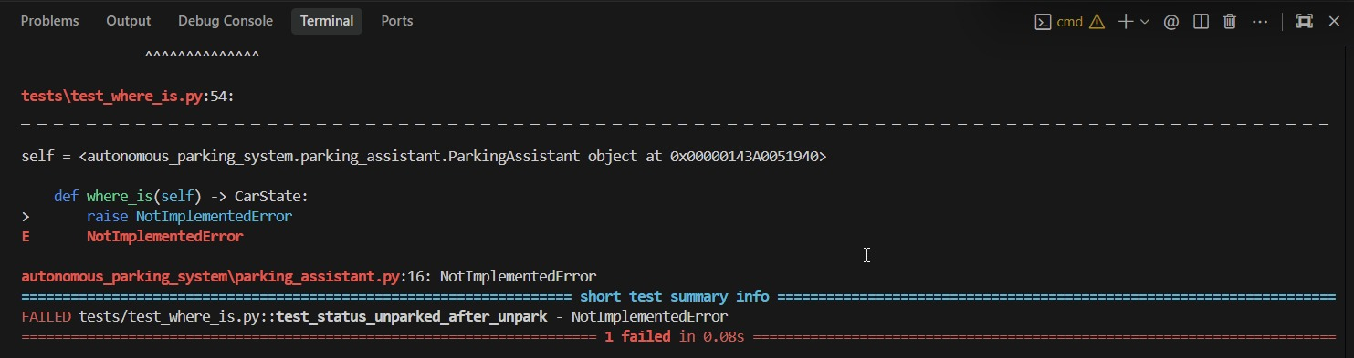

Green :The whole method turned out to be one line, since CarState already holds the answer to all four cases:
def where_is(self) -> CarState:
# case a/b/c/d: a pure query, CarState already holds the answer.
return self.state

pytest tests/test_where_is.py -v, all four tests passing

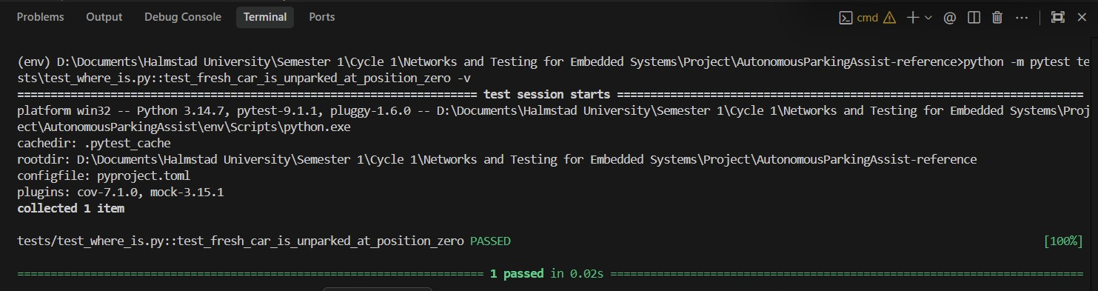

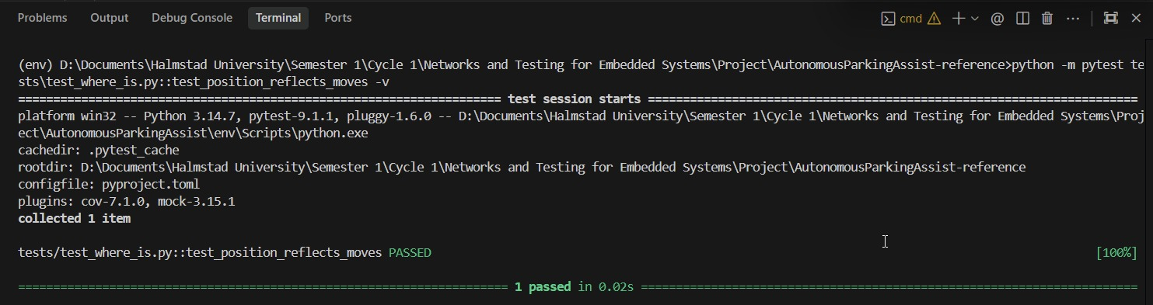

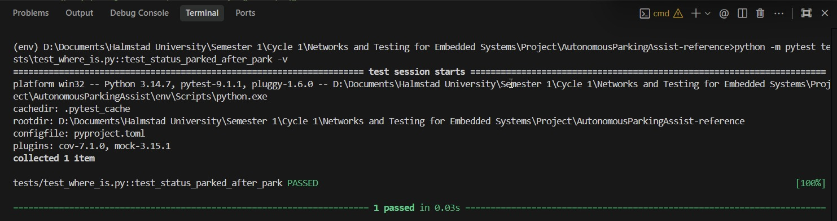

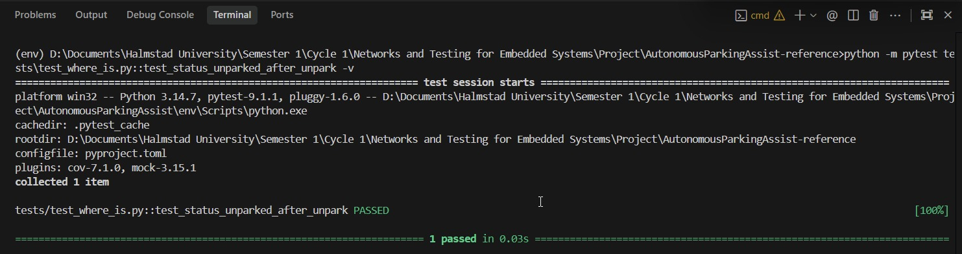

Refactor:
Since WhereIs just returns the car's current state, the original code was already very simple. During refactoring, we just added proper type hinting (-> CarState) to keep everything clean and easy to read.

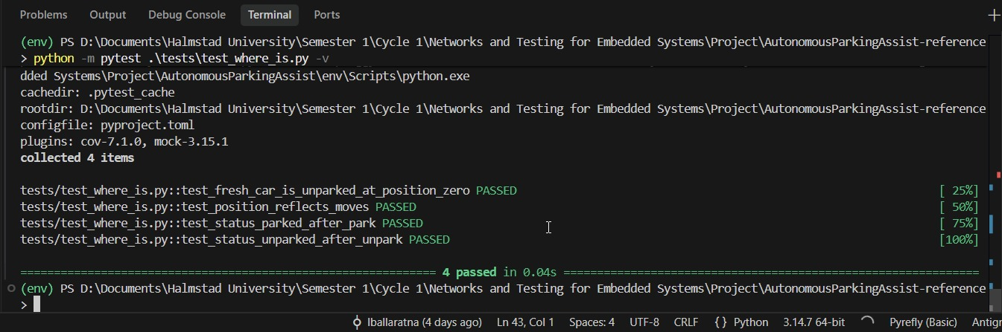

Result: all four WhereIs tests pass once we add the one-line implementation shown

MoveForward
Red: we wrote the four cases into tests/test_move_forward.py first; running them against the class before we'd implemented it failed every time with NotImplementedError.
test_move_forward.py failing before implementation
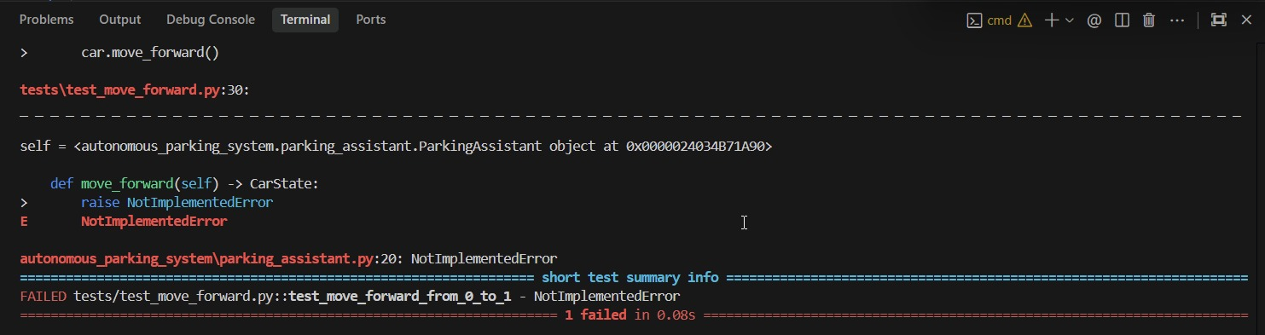
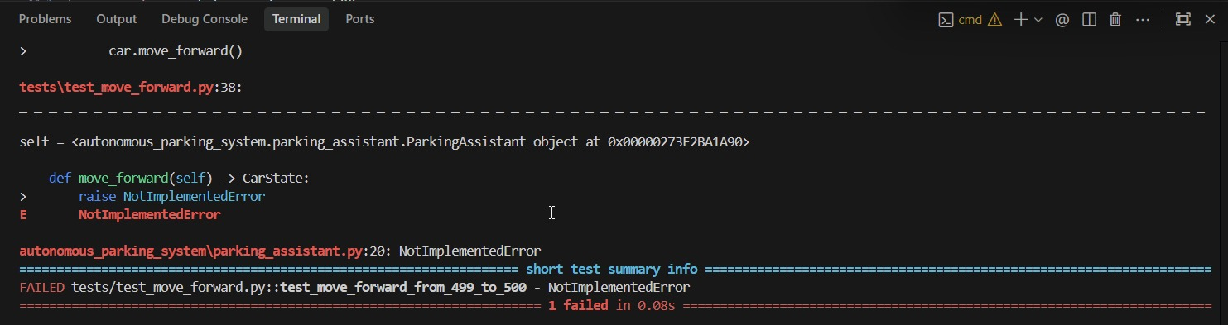

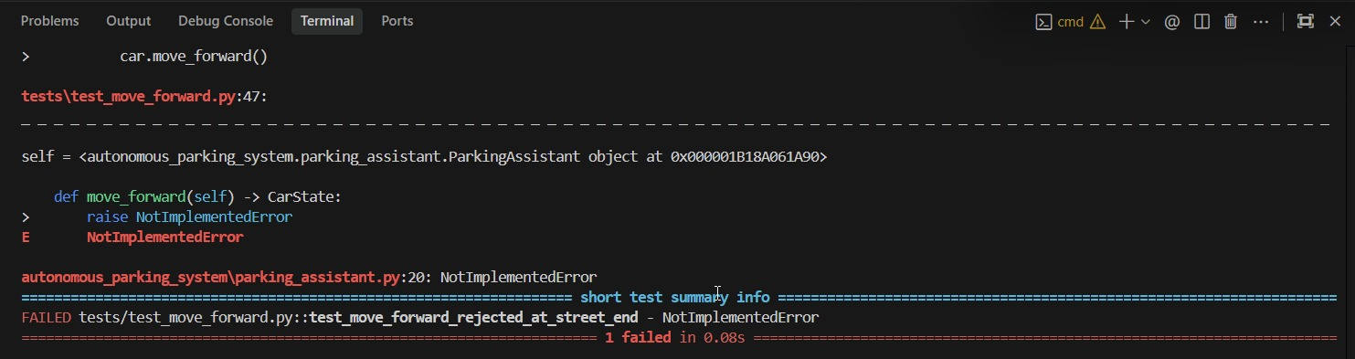

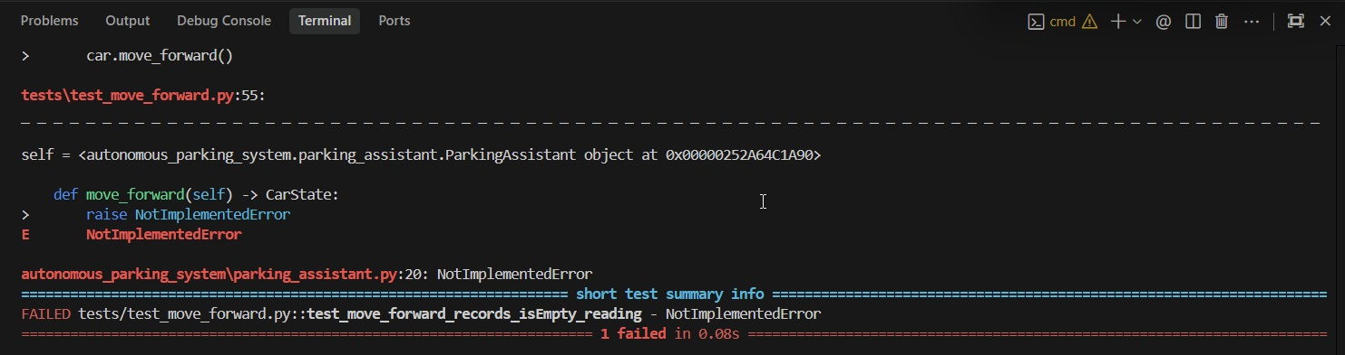

Green, built up one line at a time, each tied to the case that forced us to write it:
def move_forward(self) -> CarState:
# case c: at the upper boundary, no-op and return unchanged.
if self.state.position >= self.STREET_LENGTH:
return self.state
# case a/b: ordinary move and boundary-minus-one both advance by 1.
self.state.position += 1
# case d: every successful move records an isEmpty() reading.
reading = self.is_empty()
self.state.records.append(ParkingRecord(self.state.position, reading))
return self.state

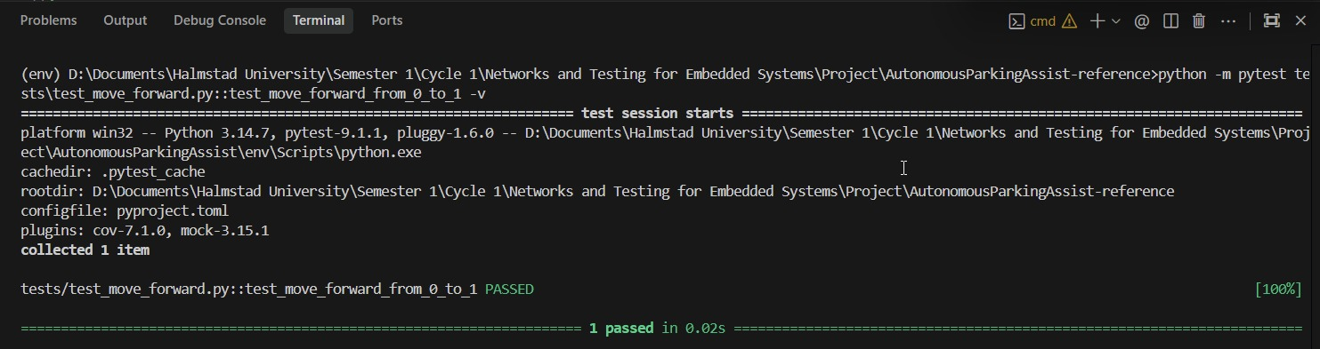

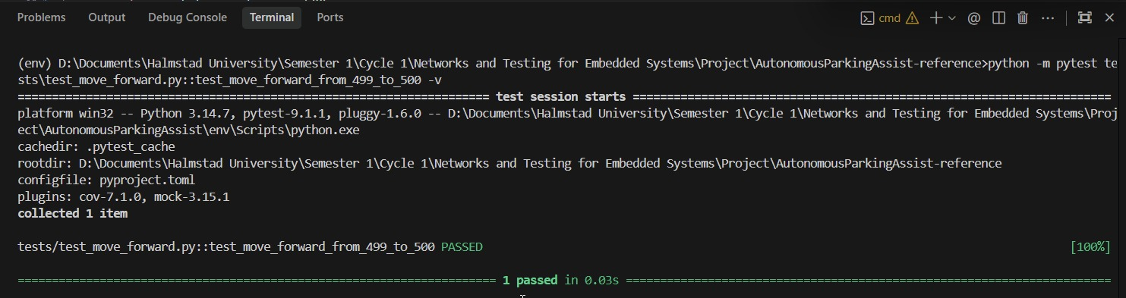

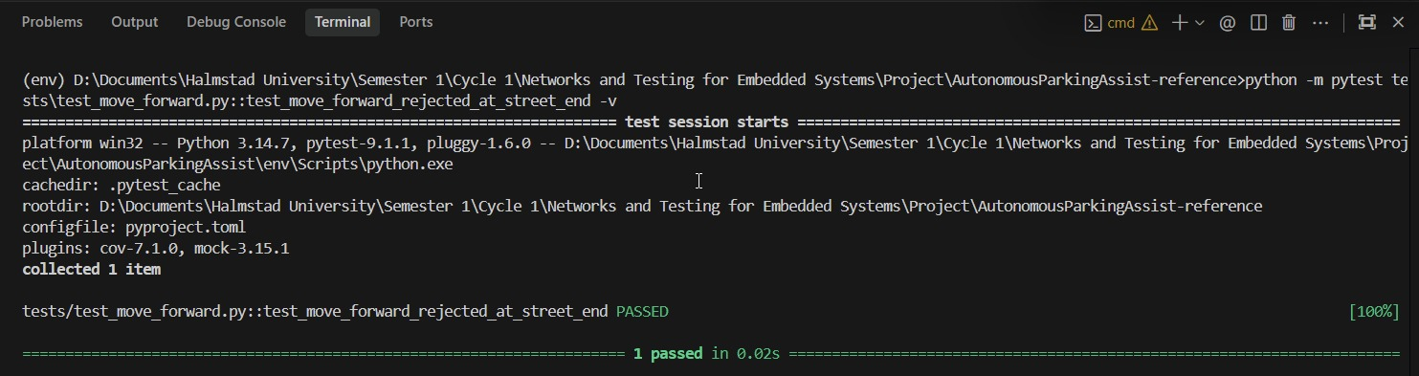

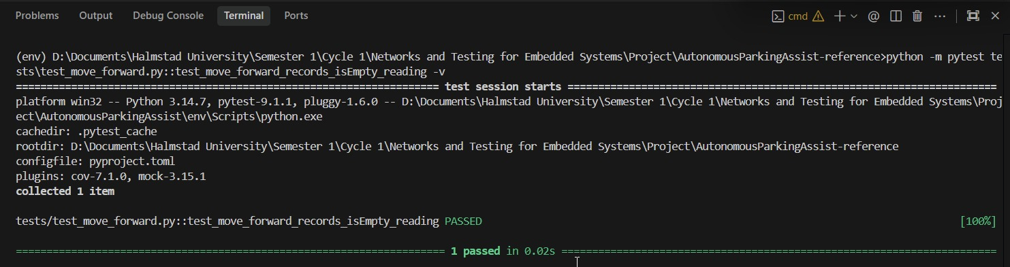

Refactor: We cleaned up the sensor reading and history-saving code to make it easier to read. We also separated the guard condition (if self.state.position >= self.STREET_LENGTH) so the car cleanly stops at the 500-meter limit without cluttering the main logic.
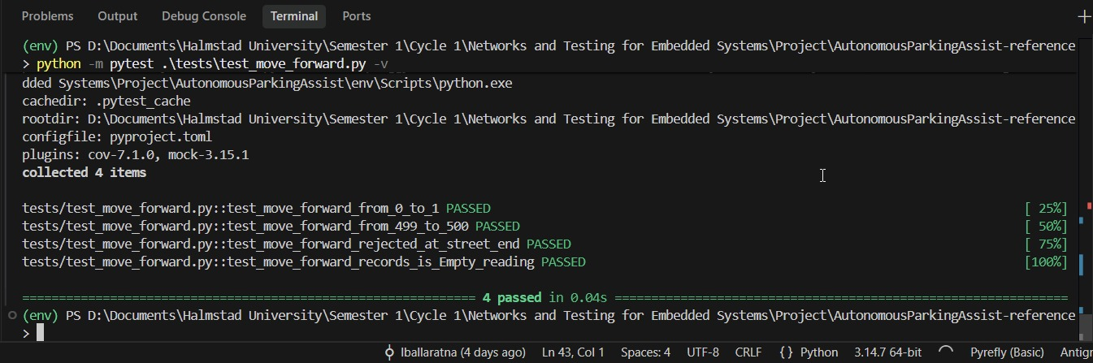

Result:
test_move_forward.py passing, all 4 tests green

MoveBackward

Red: we mirrored the same shape as MoveForward, just at the other end of the street.
test_move_backward.py failing before implementation

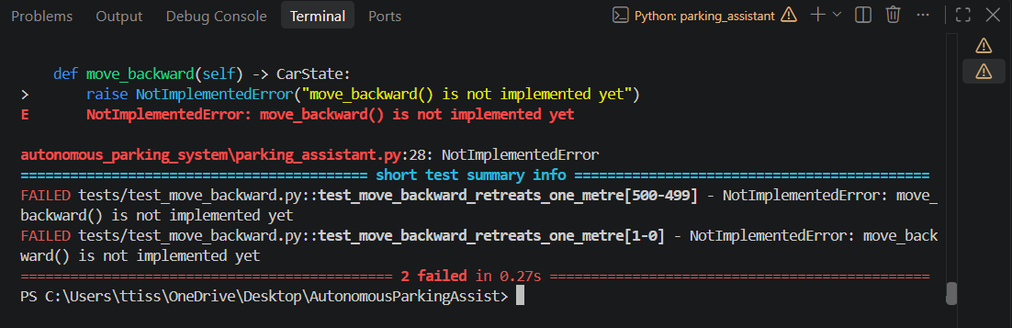
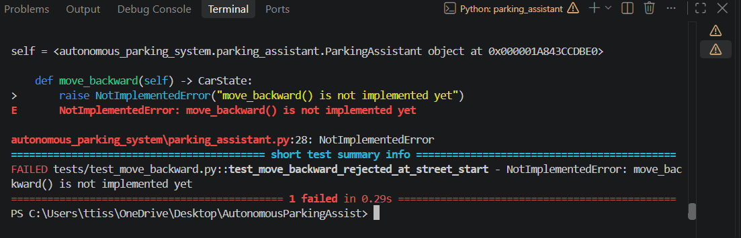
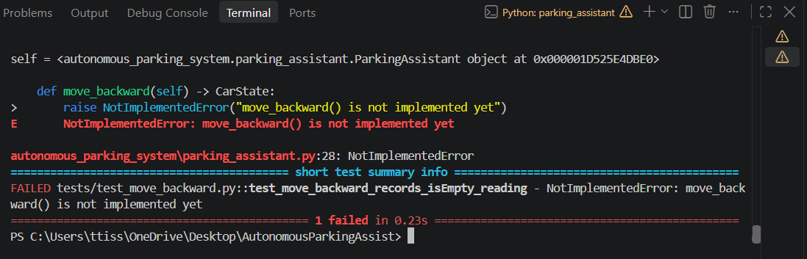

Green:
def move_backward(self) -> CarState:
# case c: at the lower boundary (position 0), no-op.
if self.state.position <= 0:
return self.state
# case a/b: ordinary move and boundary-plus-one both retreat by 1.
self.state.position -= 1
# case d: every successful move records an isEmpty() reading.
reading = self.is_empty()
self.state.records.append(ParkingRecord(self.state.position, reading))
return self.state
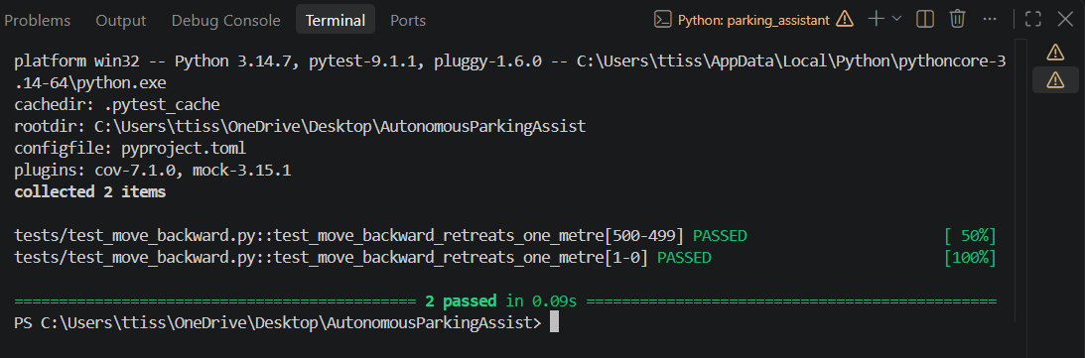
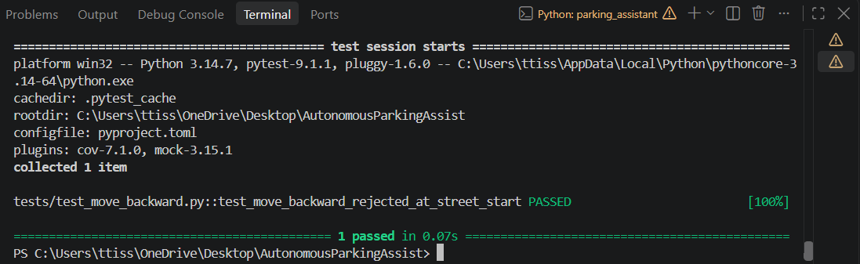
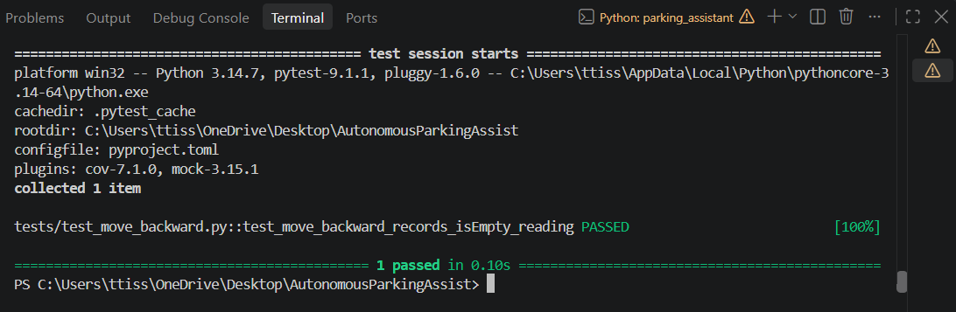
Refactor:
since it works just like move_forward, we kept things simple. just isolated the check for <= 0 so the car position doesn't go below zero.
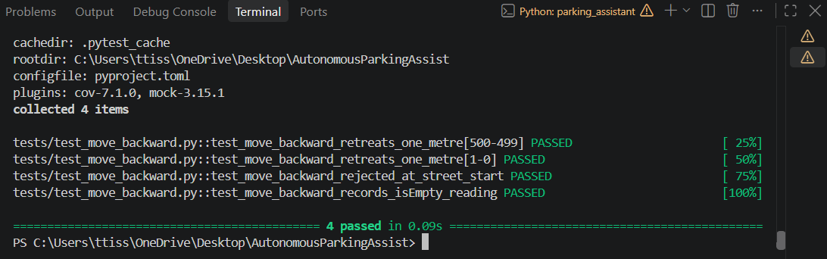
Result:
test_move_backward.py passing, all 4 tests green

isEmpty

Red: we wrote all seven cases plus the call-count case into tests/test_is_empty.py. This is the most complex of our six methods, since it has to combine readings from two sensors and decide which one, if either, we can actually trust.

test_is_empty.py failing before implementation

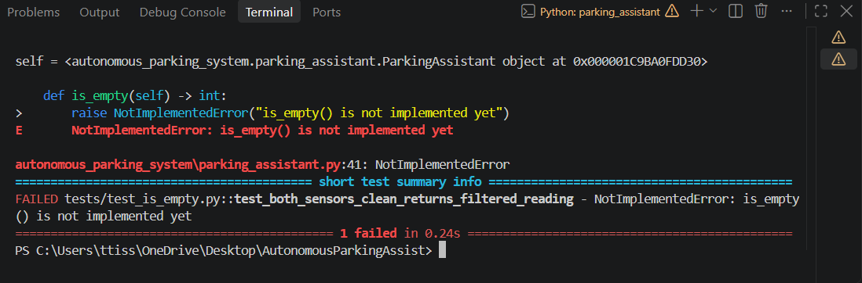

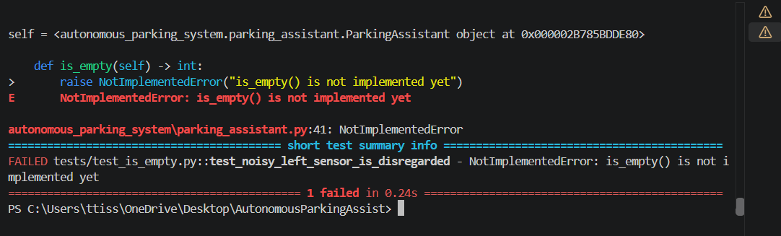
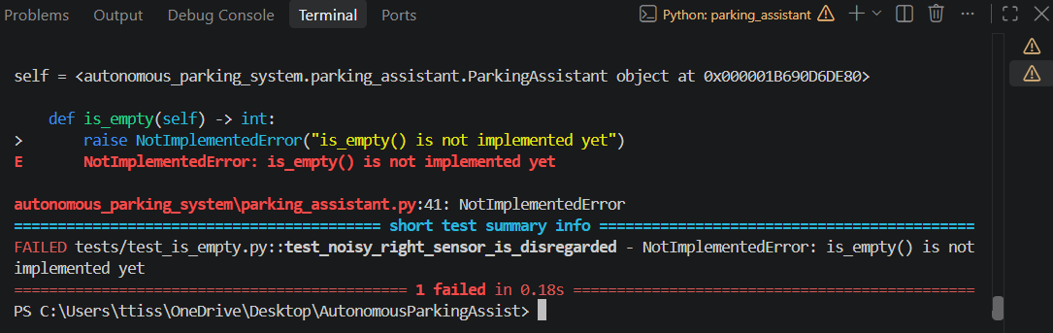
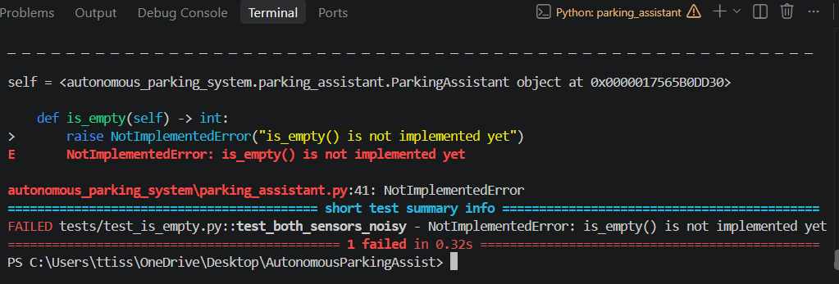
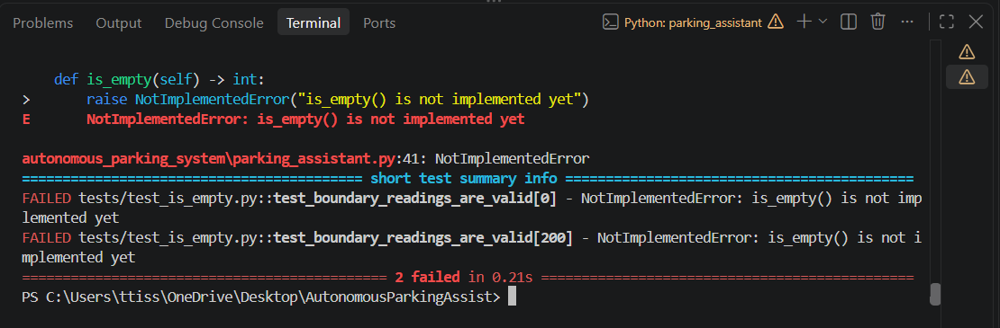
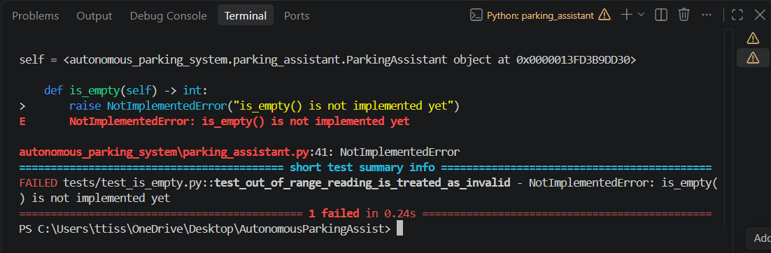

Green, built up case by case:
def is_empty(self) -> int:
# call-count case: >=5 queries per sensor.
left = [self.sensor_left.read() for _ in range(5)]
right = [self.sensor_right.read() for _ in range(5)]
left_noisy = self._is_noisy(left)
right_noisy = self._is_noisy(right)

# case b: left noisy, right clean - disregard left.
if left_noisy and not right_noisy:
return self._average(right)
# case c: mirror of case b.
if right_noisy and not left_noisy:
return self._average(left)
# case a: both clean - average the two.
if not left_noisy and not right_noisy:
return (self._average(left) + self._average(right)) // 2

# case d: both noisy at once - not specified in the project instruction, our own
# decision: refuse to guess rather than average two bad readings.
raise ValueError("both sensors are continuously noisy - reading unreliable")

def _is_noisy(self, readings) -> bool:
# case g: out-of-range reading treated as noisy - not specified by
# the project instruction, our own decision.
if any(r < 0 or r > 200 for r in readings):
return True
# case e/f: exact 0/200cm edges must NOT be flagged as noisy - only
# the spread across the 5 readings matters here, not the raw value.
return max(readings) - min(readings) > self.NOISE_THRESHOLD
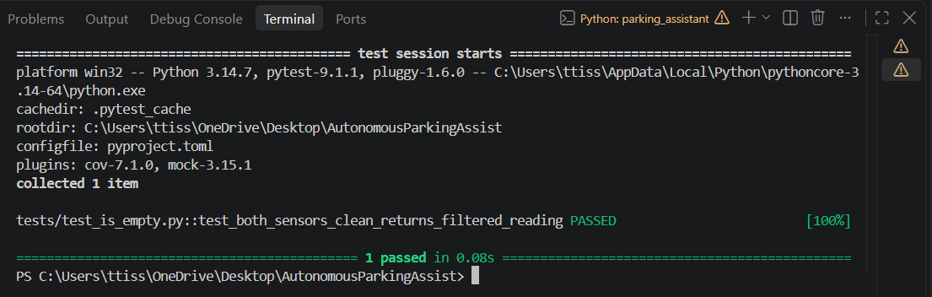
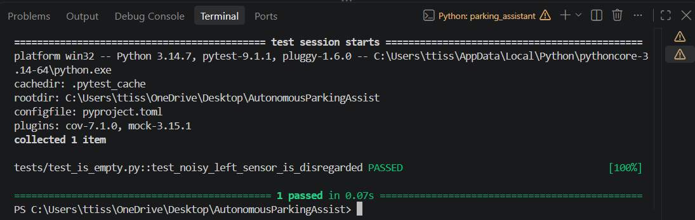
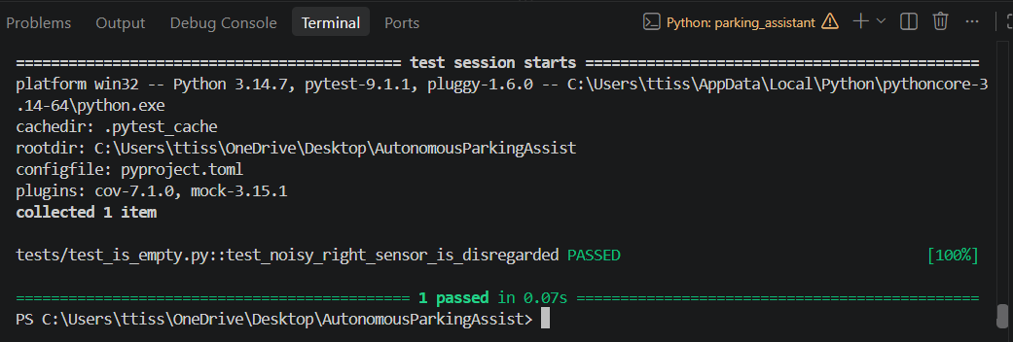
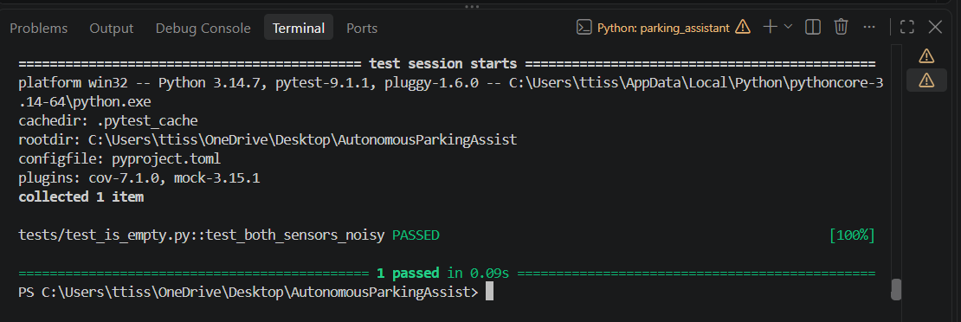
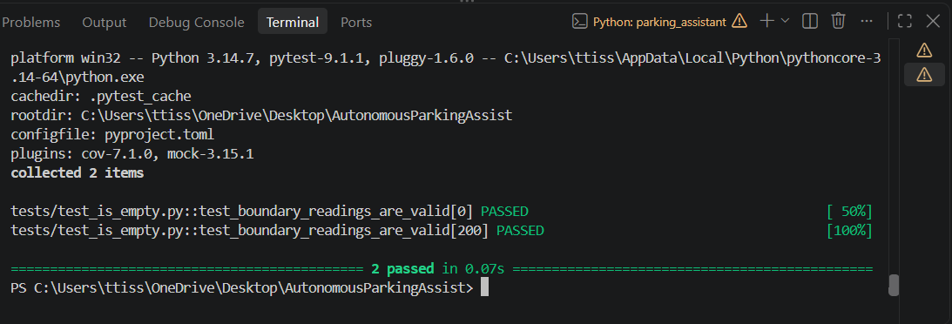
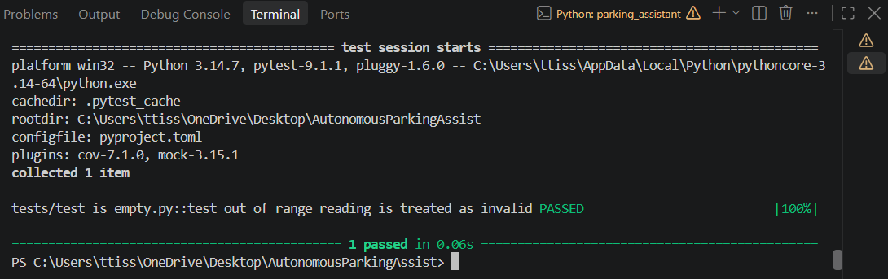

Refactor: once all four branches above were passing, we pulled the noise check and the averaging logic out into their own _is_noisy() and _average() helper methods, so the decision logic reads as one idea per line instead of one long conditional.
The call-count case (case 20) was the one gap left here too, for the same reason as Park's - we'd assumed proving a sensor was queried at least 5 times needed a mocking tool to track the call count. It doesn't: CountingSensor in sensor.py just wraps another sensor and increments a counter on every read(), which is all the case needed.
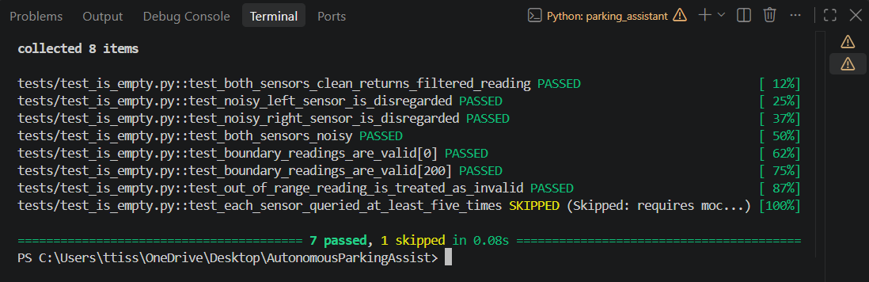
Result:
[Screenshot: test_is_empty.py - all 9 tests green]

Park
Red: we wrote case 22 and case 27 into tests/test_park.py.
test_park.py failing before implementation
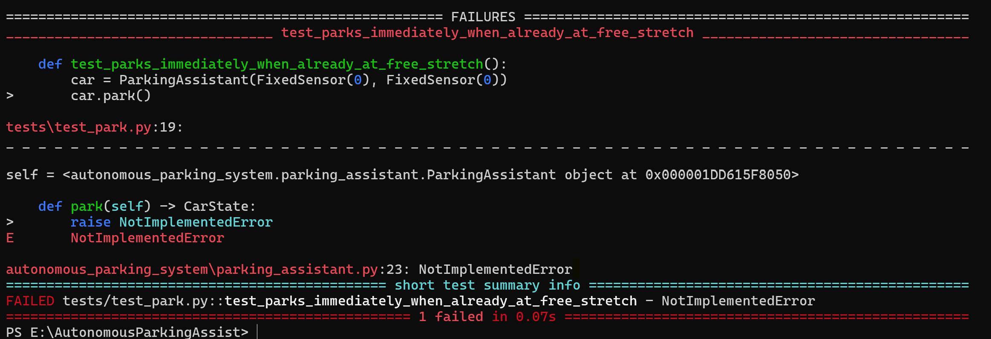

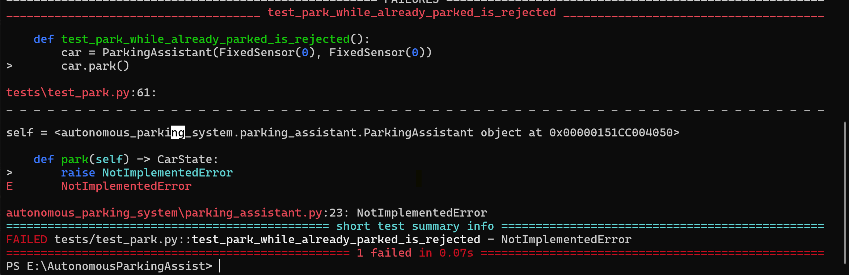

Green:
def park(self) -> CarState:
# case 27: reject a second park() call while already parked.
if self.state.status == "parked":
raise ValueError("already parked")
# case 22: if already at a qualifying free stretch, park immediately.
if self._at_free_stretch():
self.state.status = "parked"
return self.state

def _at_free_stretch(self) -> bool:
return self.is_empty() == 0
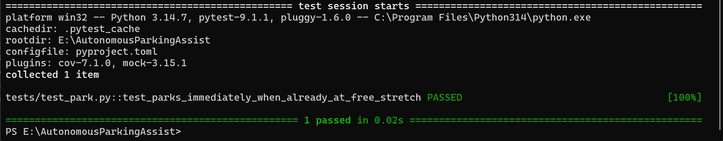

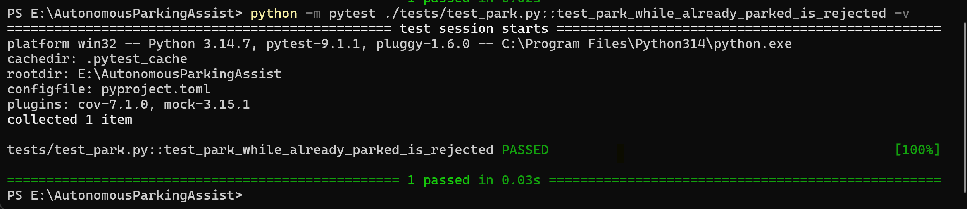

Refactor: we pulled the free-stretch check out into its own _at_free_stretch() method once case 22 was passing, so the intent is easier to read and easier to extend later.
Not built at first: cases 23 through 26 - driving forward to search for a stretch, the exact five-metre boundary, and finding no stretch anywhere on the street. We came back to these once we had a way to script a sensor's readings without pulling in a mocking library: SequenceSensor, a small hand-written test double that plays back a list of readings instead of always returning the same one or a random one (see Assumptions). With that in place we finished Park properly: it drives forward metre by metre, counting consecutive clear readings, and once it has five in a row - the far end of a qualifying stretch - it reverses STRETCH_REQUIRED - 1 metres back into the space before setting status to "parked", instead of just flagging the space from wherever the search happened to stop. Finishing this also turned up a second bug in UnPark, described below.
while consecutive_clear < self.STRETCH_REQUIRED:
if self.state.position >= self.STREET_LENGTH:
raise ValueError(...)
self.move_forward()
latest_reading = self.state.records[-1].distance_cm
consecutive_clear = consecutive_clear + 1 if latest_reading == 0 else 0

for _ in range(self.STRETCH_REQUIRED - 1):
self.move_backward()
Refactor: the forward search and the reverse-in step turned out to read clearly as one method once written, so we folded the earlier _at_free_stretch() helper back into park() itself rather than keeping it split out. That extraction made sense when park() was only the few lines needed for case 20; once the whole search-and-reverse sequence lived in park() too, a separate one-line helper for just the first check stopped pulling its weight, so we kept the check itself but folded it back in as one line inside the method.

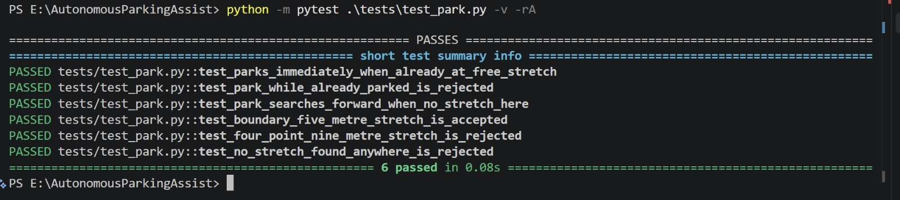

Result:
test_park.py - 9 passing, 0 failing
[Screenshot: test_park.py - all 9 tests green]

UnPark
Red: we wrote all three cases into tests/test_unpark.py.
test_unpark.py failing before implementation

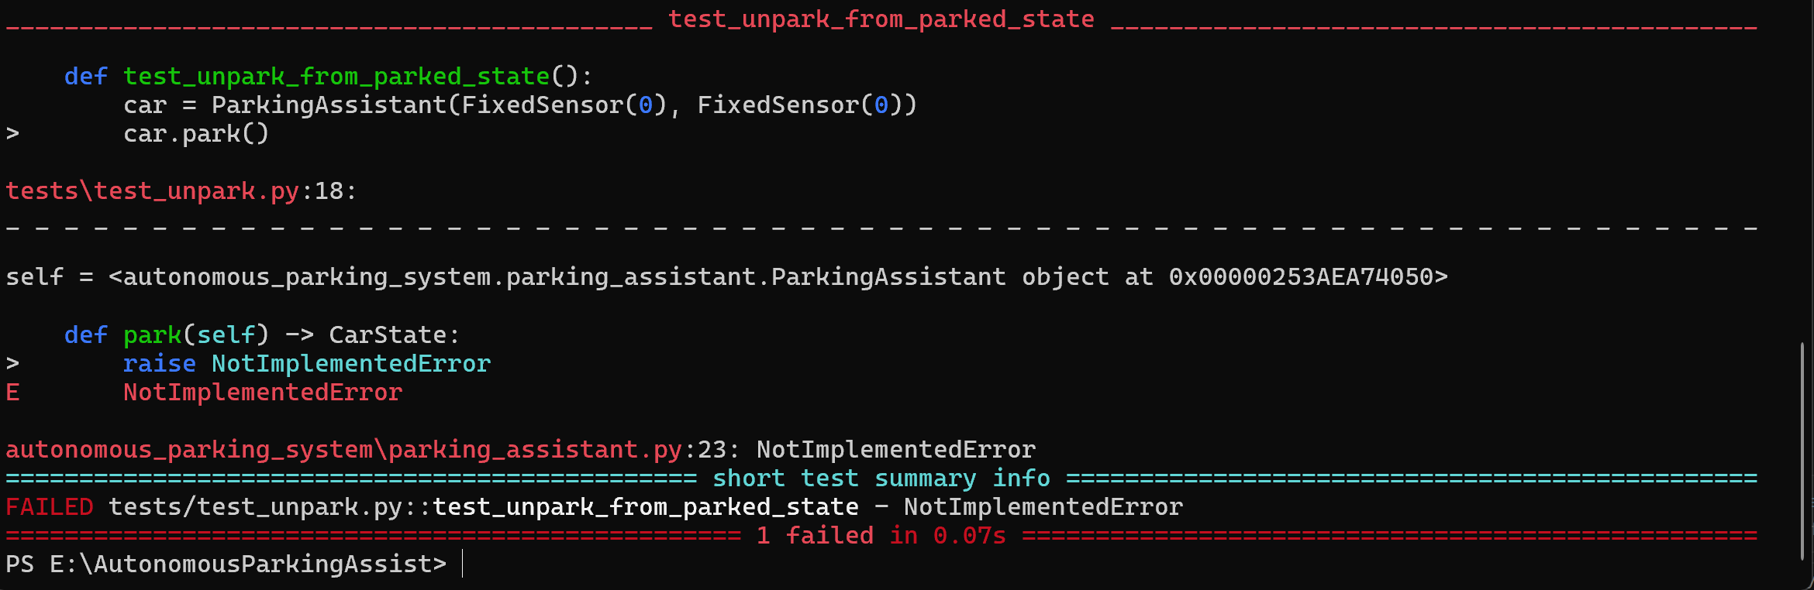

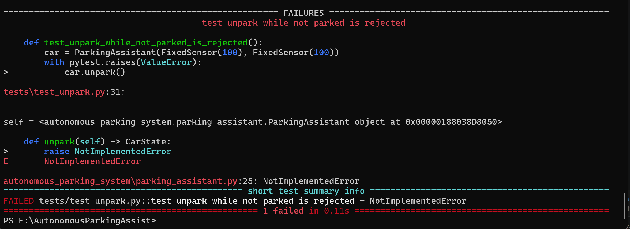

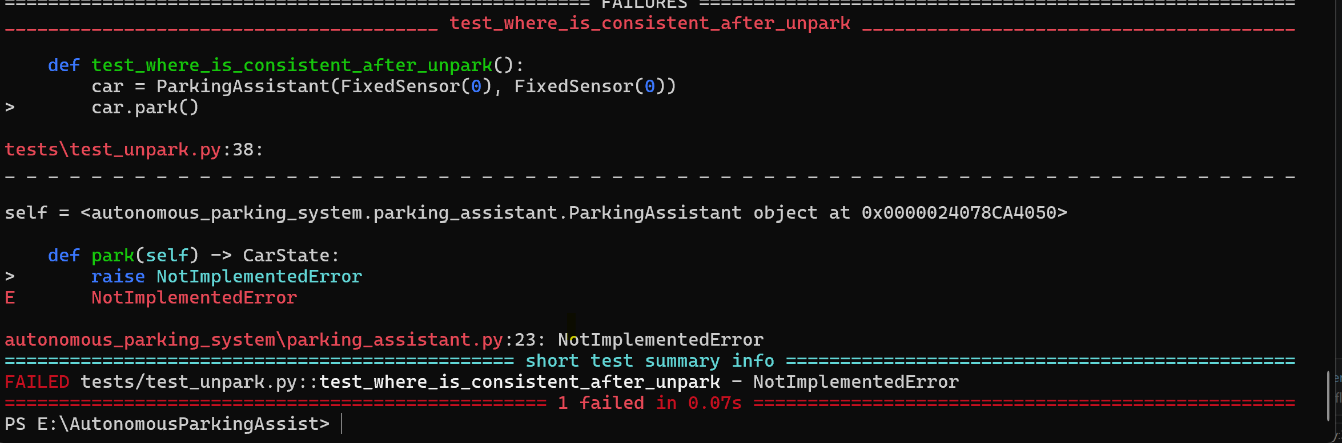
Green:
def unpark(self) -> CarState:
# case 32: reject unparking a car that isn't parked - the project instruction only
# says what UnPark does "if it is parked," so this is our own decision.
if self.state.status != "parked":
raise ValueError("cannot unpark - car is not parked")
# case 31/33: move forward to the front of the space, flip status back.
self.state.position += self.STRETCH_REQUIRED - 1
self.state.status = "unparked"
return self.state
A mistake we caught along the way, worth recording here rather than quietly fixing: our first version of this method only flipped status and never actually moved position, even though the requirement explicitly says UnPark "moves the car forward... to front of the parking place." The test we'd written against that first version only checked status too, so it passed without actually proving the requirement it was meant to prove. Once we noticed this, we corrected both the test and the implementation together - at that point in Phase 1, the test checked that position had moved forward by exactly one, in addition to checking status. That distance changed again later, for the reason described next.
This caught us out a second time, later on: once Park started reversing into the space instead of just flagging it as "parked", UnPark's flat "position += 1" - a leftover from when Park left the car sitting at the space's entrance rather than its back - no longer reached the front of the space. It moved the car one metre further into a 5m space it had just reversed all the way into. We caught it with a test that checks Park and UnPark together rather than either one in isolation, and fixed UnPark's distance to match - shown in the code above.

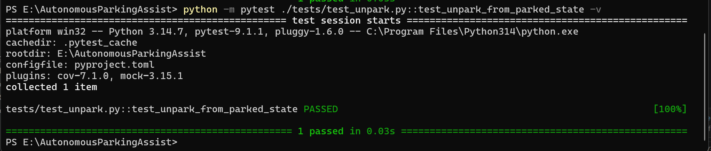

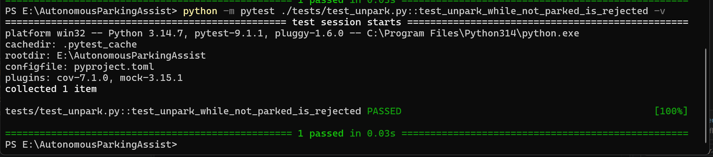

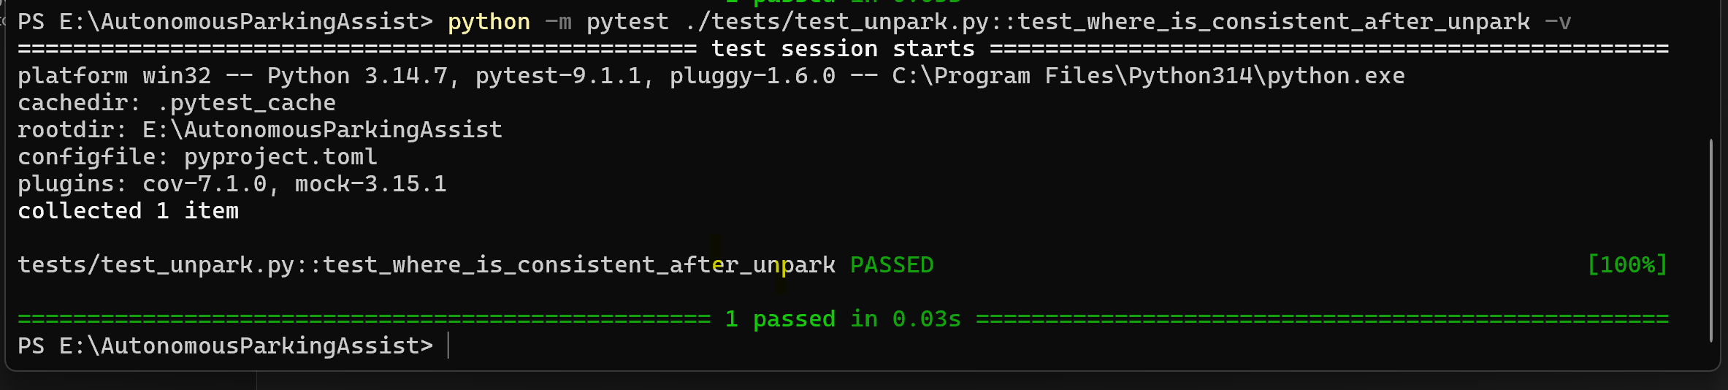

Refactor:
We refined the logic to ensure both the state status and the car position update correctly together during unparking.

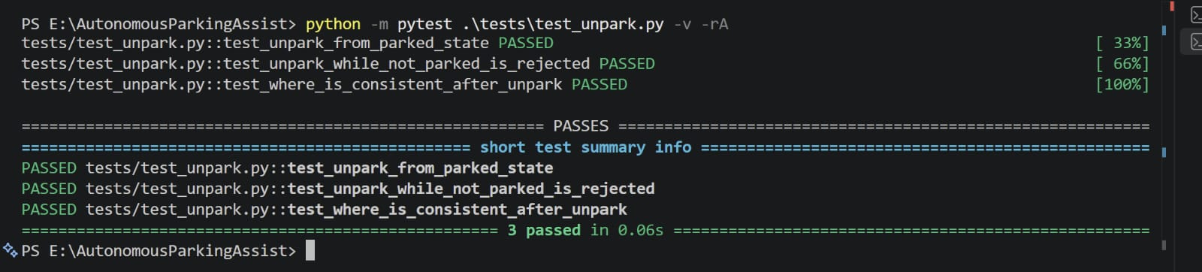
Result:
test_unpark.py passing, all 3 tests green

Assumptions:
1. isEmpty, both sensors noisy at once - we raise an error instead of guessing. A falsely "empty" reading, produced by picking one of two untrustworthy sensors at random, is exactly the kind of failure that could cause a real collision, so we felt refusing to guess was the safer default.
2. isEmpty, a reading outside the 0-200cm range - we treat it the same as a noisy reading and disregard it, rather than trusting it at face value.
3. Park, called while the car is already parked - we reject it with an error rather than silently ignoring it.
4. UnPark, called while the car is not parked - we reject it with an error, for the same consistency reason as Park above.
5. Park, how a five-metre "free stretch" is measured - a single isEmpty() reading only reaches 2m at most, so we treat every isEmpty() == 0 reading taken while driving forward as one clear metre, and require five in a row before treating the stretch as long enough. The requirement states the 5m figure but not how a single-position reading is meant to add up to it.
6. Park, the reverse-parking distance - once a qualifying stretch is found, we reverse the car STRETCH_REQUIRED - 1 metres back into it before parking, modelling the "standard parallel reverse parking maneuver" the project instructions name but don't define in terms of distance. UnPark's forward distance was adjusted to match, so it actually exits the space it reversed into rather than driving straight past it.
7. Park's search-forward tests (cases 23-26) - proving these needs a sensor that returns a changing sequence of readings, which FixedSensor and RandomSensor can't do. Rather than reach for a mocking library, we wrote SequenceSensor, a small hand-written test double in the same style as the sensors the project instructions already name.
8. The car has no lateral sense of its surroundings - sensor_left and sensor_right are two sensors cross-checking the same forward-facing gap, not sensors on opposite sides of the car. An obstacle on the far side of the vehicle from the parking space isn't something this model can detect.

Coverage Report:

$ python -m coverage run -m pytest

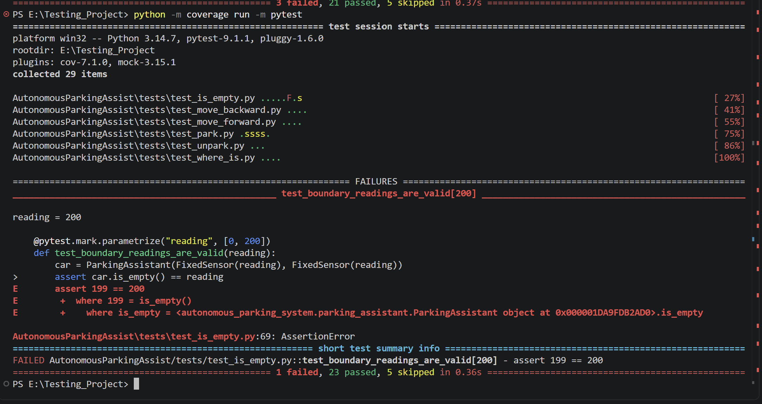

$ python -m coverage report -m

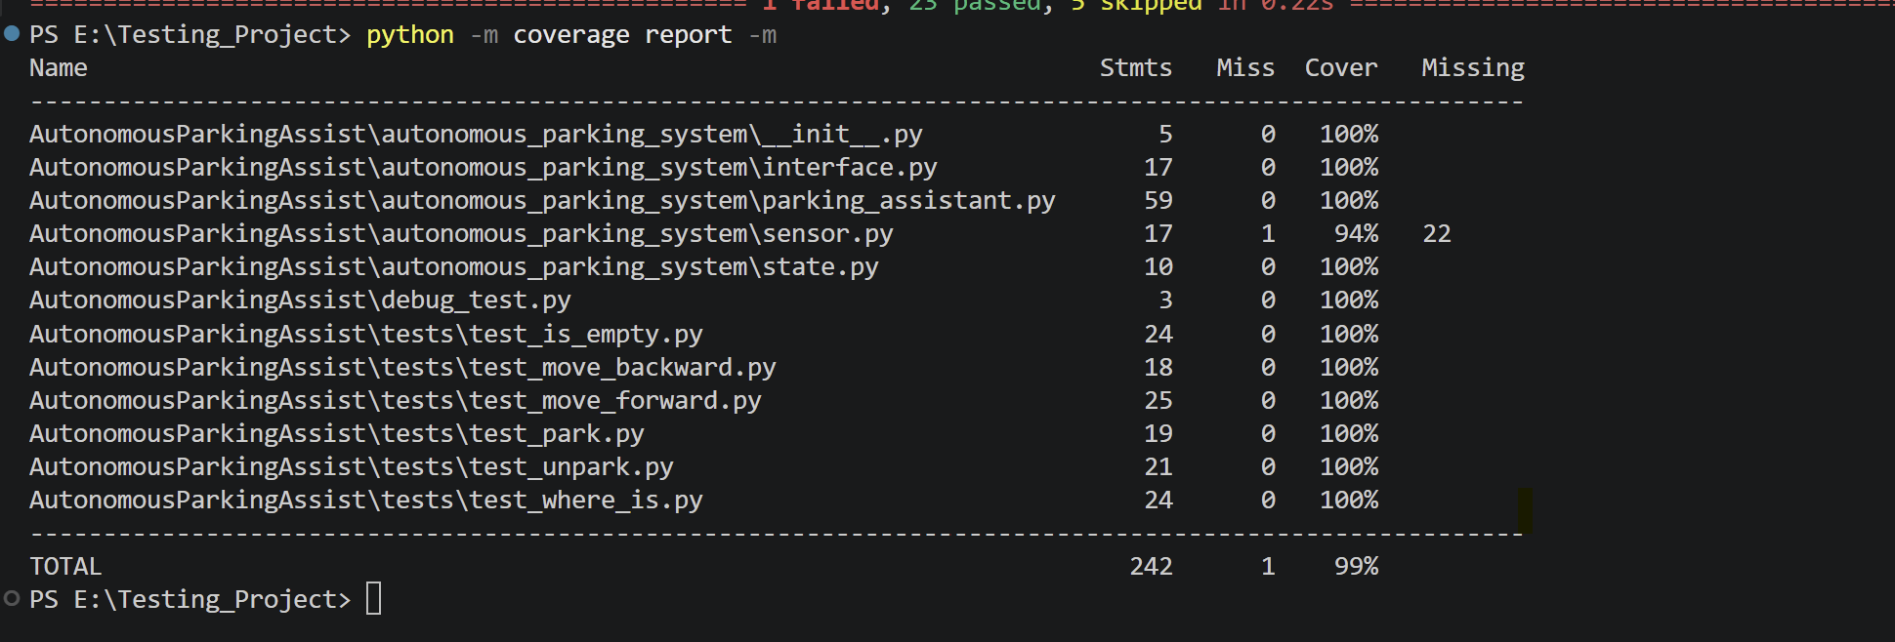

Decision Table For is_empty()
We'd originally skipped five test cases at this stage, all for the same reason: each one needed a sensor double that we could script, or that could have its own calls counted, and we assumed that meant reaching for a mocking tool such as pytest-mock or unittest.mock, which the course's own schedule places in Phase 2, not Phase 1. On reflection none of the five actually needed a mocking library - two small hand-written sensor doubles covered all of them - so all five are now implemented and passing:
isEmpty's call-count check - CountingSensor wraps a sensor and counts its read() calls.
Park's search-forward behaviour, the five-metre boundary on both sides and the no-stretch-found case - SequenceSensor plays back a scripted list of readings.

We still haven't used a mocking library anywhere in this project's code. Every test that passes relies only on FixedSensor, RandomSensor, NoisySensor, SequenceSensor, or CountingSensor - the last two are hand-written test doubles we added ourselves, in the same spirit as the sensor types the project instruction already names.

For the isEmpty() method, we used a decision table because the result depends on the condition of both sensors. Each sensor can either give a normal reading or behave in a noisy way, so the final result depends on the combination of these two conditions.
Conditions / Actions | Rule 1 | Rule 2 | Rule 3 | Rule 4
Left sensor noisy? | No | Yes | No | Yes
Right sensor noisy? | No | No | Yes | Yes
Use both sensors | ✓
Use right sensor only |  | ✓
Use left sensor only |  |  | ✓
Raise an error |  |  |  | ✓
Expected result | Average of both sensors | Right sensor reading | Left sensor reading | Error
Test case | Case 13 | Case 14 | Case 15 | Case 16

When both sensors are working normally, we use the readings from both sensors and calculate the average. If the left sensor is noisy, we ignore it and use only the right sensor. In the same way, if the right sensor is noisy, we use only the left sensor. If both sensors are noisy at the same time, the reading cannot be considered reliable, so the method raises an error instead of returning an incorrect value.
We also tested the valid sensor range separately. A reading of 0 cm and 200 cm is accepted because both values are within the allowed range. If a sensor gives a value outside this range, such as 250 cm, that sensor reading is treated as unreliable and ignored. If the other sensor is working correctly, its reading is used instead.
This decision table helped us clearly identify the different combinations of sensor behaviour and connect each combination to a specific test case.

