# Study Design

Title: Resume Comparison Analysis

Date of analysis: March 30, 2020

Purpose: Comparing reviewer impressions of 3 resumes

Data collected from: Amazon Mechanical Turk

# Frequencies

# Demographics and Exclusions

## [1] "Number of Participants: 152"

## x freq  
## 1 I consent to participate in this research study 152

## x freq  
## 1 Man 95  
## 2 Woman 57

## x freq  
## 1 Black/African American 16  
## 2 Asian/Asian American 11  
## 3 Latino/a/Hispanic/Latin American 11  
## 4 Native American/American Indian/Alaskan Native 1  
## 5 White 108  
## 6 More than one race 5

# Cronbach’s Alpha Reliability

## Americanness for each resume

Resume A Americanness: 0.7330124

Resume B Americanness: 0.784618

Resume C Americanness: 0.7158955

## Status for each resume

Resume A Status: 0.826294

Resume B Status: 0.8605769

Resume C Status: 0.9067497

# Split-Half Reliability

## Warmth for each resume

Resume A Warmth: 0.6636388

Resume B Warmth: 0.7243192

Resume C Warmth: 0.7831463

## Political orientation for each resume

Resume A Political Orientation: 0.4153807

Resume B Political Orientation: 0.0528591

Resume C Political Orientation: 0.5706107

Summary: The Americanness and status scales had high reliability (>.7) for all resumes so we will create composite (average) variables of those items (questions). The warmth and political orientation scales had low reliability (<.70) for at least 1 resume so we will analyze the items (questions) individually.

# MAIN ANALYSIS

## Americanness One-Way Between-Subjects ANOVA

Americanness of Applicants Descriptive Statistics

| Condition | N | Mean | SD | Median | Min | Max | Skew | Kurtosis | SEM |
| --- | --- | --- | --- | --- | --- | --- | --- | --- | --- |
| ConditionA | 50 | 5.68 | 0.77 | 5.67 | 4.00 | 7 | -0.15 | -0.43 | 0.11 |
| ConditionB | 51 | 5.48 | 0.88 | 5.50 | 3.67 | 7 | -0.15 | -0.82 | 0.12 |
| ConditionC | 51 | 5.56 | 0.79 | 5.67 | 3.83 | 7 | -0.27 | -0.59 | 0.11 |

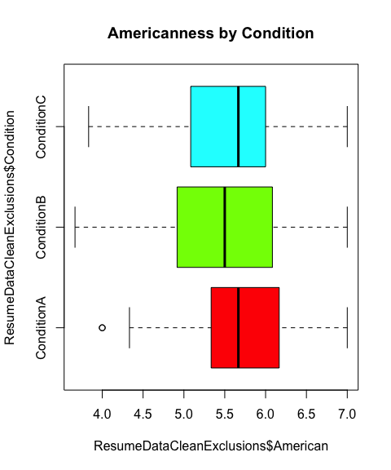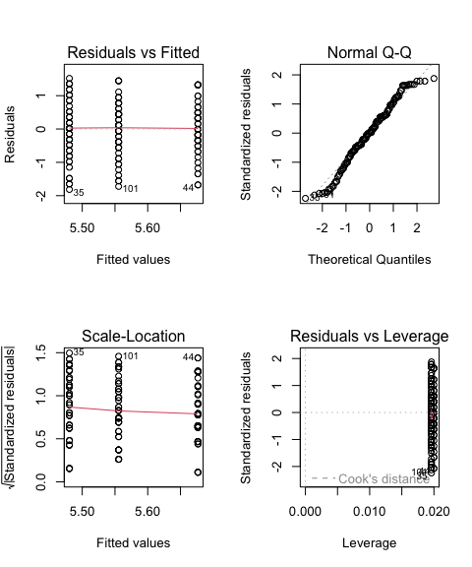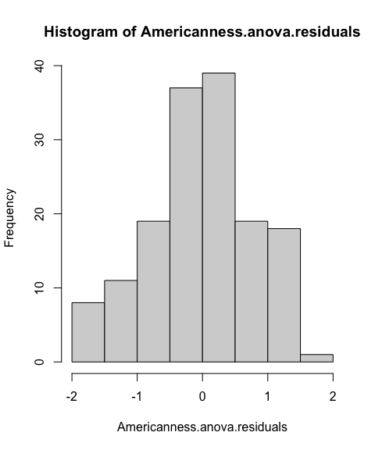

##   
## Shapiro-Wilk normality test  
##   
## data: Americanness.anova.residuals  
## W = 0.97949, p-value = 0.02281

##   
## Asymptotic one-sample Kolmogorov-Smirnov test  
##   
## data: Americanness.anova.residuals  
## D = 0.046336, p-value = 0.8999  
## alternative hypothesis: two-sided

## Levene's Test for Homogeneity of Variance (center = median)  
## Df F value Pr(>F)  
## group 2 0.5776 0.5625  
## 149

## Kruskal-Wallis rank sum test  
##   
## data: x and group  
## Kruskal-Wallis chi-squared = 1.3249, df = 2, p-value = 0.52  
##   
##   
## Comparison of x by group   
## (Holm)   
## Col Mean-|  
## Row Mean | Conditio Conditio  
## ---------+----------------------  
## Conditio | 1.149110  
## | 0.3758  
## |  
## Conditio | 0.637637 -0.514024  
## | 0.5237 0.3036  
##   
## alpha = 0.05  
## Reject Ho if p <= alpha/2

## Df Sum Sq Mean Sq F value Pr(>F)  
## Condition 2 0.99 0.4945 0.739 0.479  
## Residuals 149 99.65 0.6688

## Tukey multiple comparisons of means  
## 95% family-wise confidence level  
##   
## Fit: aov(formula = American ~ Condition, data = ResumeDataCleanExclusions)  
##   
## $Condition  
## diff lwr upr p adj  
## ConditionB-ConditionA -0.1962745 -0.5815797 0.1890307 0.4515330  
## ConditionC-ConditionA -0.1211111 -0.5064163 0.2641941 0.7376385  
## ConditionC-ConditionB 0.0751634 -0.3082296 0.4585564 0.8881540

## Bayes factor analysis  
## --------------  
## [1] Condition : 0.1221633 ±0.02%  
##   
## Against denominator:  
## Intercept only   
## ---  
## Bayes factor type: BFlinearModel, JZS

Summary: The Kruskal-Wallis test was non-significant (p>.05) and the simple effects between each condition were also non-significant (ps>.05). The ANOVA was also non-significant with non-significant simple effects (ps>.05). The Bayesian analysis indicated an odds of .1222 to 1 (very low odds) that the resumes have different perceived Americanness.

## Status One-Way Between-Subjects ANOVA

Status of Applicants Descriptive Statistics

| Condition | N | Mean | SD | Median | Min | Max | Skew | Kurtosis | SEM |
| --- | --- | --- | --- | --- | --- | --- | --- | --- | --- |
| ConditionA | 50 | 5.76 | 0.71 | 5.71 | 4.00 | 7.00 | -0.42 | -0.27 | 0.10 |
| ConditionB | 51 | 5.70 | 0.70 | 5.71 | 3.43 | 7.00 | -0.77 | 1.06 | 0.10 |
| ConditionC | 51 | 5.58 | 0.92 | 5.86 | 3.14 | 6.86 | -0.83 | -0.04 | 0.13 |

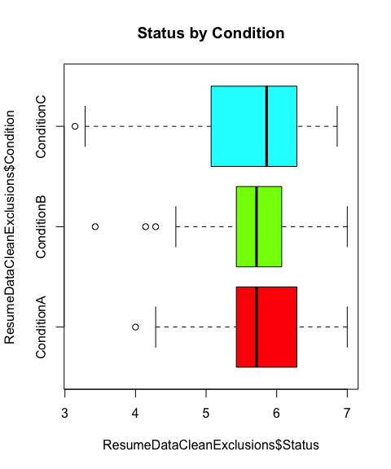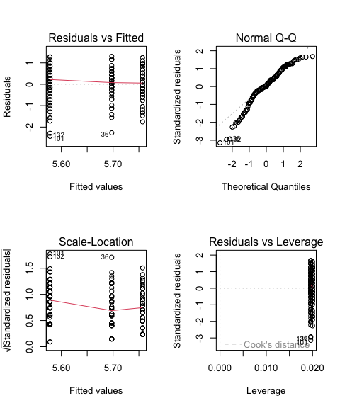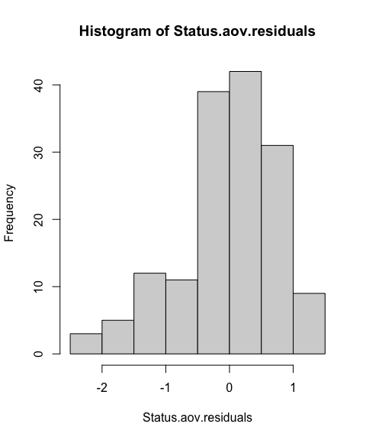

##   
## Shapiro-Wilk normality test  
##   
## data: Status.aov.residuals  
## W = 0.95486, p-value = 7.57e-05

##   
## Asymptotic one-sample Kolmogorov-Smirnov test  
##   
## data: Status.aov.residuals  
## D = 0.11615, p-value = 0.0331  
## alternative hypothesis: two-sided

## Levene's Test for Homogeneity of Variance (center = median)  
## Df F value Pr(>F)  
## group 2 2.141 0.1211  
## 149

## Kruskal-Wallis rank sum test  
##   
## data: x and group  
## Kruskal-Wallis chi-squared = 0.286, df = 2, p-value = 0.87  
##   
##   
## Comparison of x by group   
## (Holm)   
## Col Mean-|  
## Row Mean | Conditio Conditio  
## ---------+----------------------  
## Conditio | 0.309538  
## | 0.7569  
## |  
## Conditio | 0.532769 0.224343  
## | 0.8913 0.4112  
##   
## alpha = 0.05  
## Reject Ho if p <= alpha/2

## Df Sum Sq Mean Sq F value Pr(>F)  
## Condition 2 0.84 0.4214 0.688 0.504  
## Residuals 149 91.32 0.6129

## Tukey multiple comparisons of means  
## 95% family-wise confidence level  
##   
## Fit: aov(formula = Status ~ Condition, data = ResumeDataCleanExclusions)  
##   
## $Condition  
## diff lwr upr p adj  
## ConditionB-ConditionA -0.05966387 -0.4285020 0.3091743 0.9223935  
## ConditionC-ConditionA -0.17917834 -0.5480165 0.1896598 0.4849766  
## ConditionC-ConditionB -0.11951447 -0.4865222 0.2474932 0.7214166

## Bayes factor analysis  
## --------------  
## [1] Condition : 0.1169376 ±0.02%  
##   
## Against denominator:  
## Intercept only   
## ---  
## Bayes factor type: BFlinearModel, JZS

Summary: The Kruskal-Wallis test was non-significant (p>.05) and the simple effects between each condition were also non-significant (ps>.05). The ANOVA was also non-significant with non-significant simple effects (ps>.05). The Bayesian analysis indicated an odds of .1170 to 1 (very low odds) that the resumes have different perceived status.

## Morality One-Way Between-Subjects ANOVA

Morality of Applicants Descriptive Statistics

| Condition | N | Mean | SD | Median | Min | Max | Skew | Kurtosis | SEM |
| --- | --- | --- | --- | --- | --- | --- | --- | --- | --- |
| ConditionA | 50 | 5.04 | 1.05 | 5 | 3 | 7 | 0.23 | -0.76 | 0.15 |
| ConditionB | 51 | 5.00 | 1.02 | 5 | 3 | 7 | 0.33 | -0.97 | 0.14 |
| ConditionC | 51 | 5.14 | 1.15 | 5 | 3 | 7 | 0.28 | -1.25 | 0.16 |

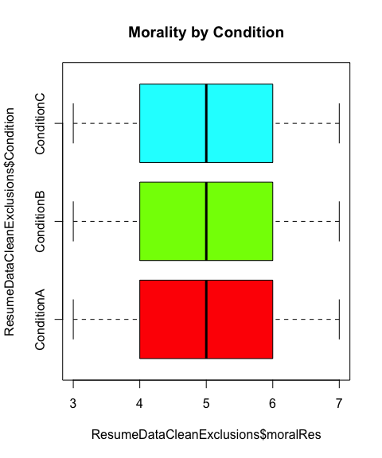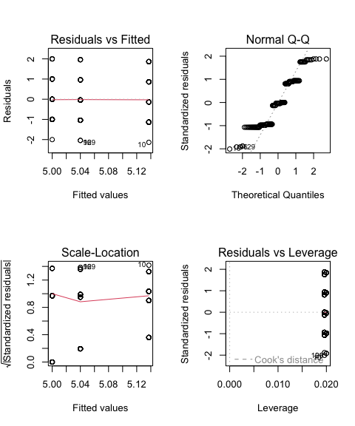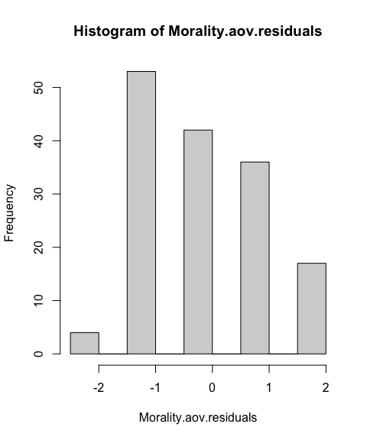

##   
## Shapiro-Wilk normality test  
##   
## data: Morality.aov.residuals  
## W = 0.9085, p-value = 3.491e-08

##   
## Asymptotic one-sample Kolmogorov-Smirnov test  
##   
## data: Morality.aov.residuals  
## D = 0.20064, p-value = 9.685e-06  
## alternative hypothesis: two-sided

## Levene's Test for Homogeneity of Variance (center = median)  
## Df F value Pr(>F)  
## group 2 0.961 0.3849  
## 149

## Kruskal-Wallis rank sum test  
##   
## data: x and group  
## Kruskal-Wallis chi-squared = 0.274, df = 2, p-value = 0.87  
##   
##   
## Comparison of x by group   
## (Holm)   
## Col Mean-|  
## Row Mean | Conditio Conditio  
## ---------+----------------------  
## Conditio | 0.231556  
## | 0.4084  
## |  
## Conditio | -0.288245 -0.522394  
## | 0.7732 0.9021  
##   
## alpha = 0.05  
## Reject Ho if p <= alpha/2

## Df Sum Sq Mean Sq F value Pr(>F)  
## Condition 2 0.51 0.2539 0.22 0.803  
## Residuals 149 171.96 1.1541

## Tukey multiple comparisons of means  
## 95% family-wise confidence level  
##   
## Fit: aov(formula = moralRes ~ Condition, data = ResumeDataCleanExclusions)  
##   
## $Condition  
## diff lwr upr p adj  
## ConditionB-ConditionA -0.0400000 -0.5461463 0.4661463 0.9808910  
## ConditionC-ConditionA 0.0972549 -0.4088914 0.6034012 0.8923084  
## ConditionC-ConditionB 0.1372549 -0.3663795 0.6408893 0.7953787

## Bayes factor analysis  
## --------------  
## [1] Condition : 0.0785973 ±0.02%  
##   
## Against denominator:  
## Intercept only   
## ---  
## Bayes factor type: BFlinearModel, JZS

Summary: The Kruskal-Wallis test was non-significant (p>.05) and the simple effects between each condition were also non-significant (ps>.05). The ANOVA was also non-significant with non-significant simple effects (ps>.05). The Bayesian analysis indicated an odds of .0786 to 1 (very low odds) that the resumes have different perceived morality.

## Friendliness One-Way Between-Subjects ANOVA

Friendliness of Applicants Descriptive Statistics

| Condition | N | Mean | SD | Median | Min | Max | Skew | Kurtosis | SEM |
| --- | --- | --- | --- | --- | --- | --- | --- | --- | --- |
| ConditionA | 50 | 5.38 | 1.03 | 5 | 4 | 7 | 0.21 | -1.14 | 0.15 |
| ConditionB | 51 | 5.08 | 1.04 | 5 | 4 | 7 | 0.38 | -1.21 | 0.15 |
| ConditionC | 51 | 5.29 | 1.19 | 5 | 2 | 7 | -0.22 | -0.40 | 0.17 |

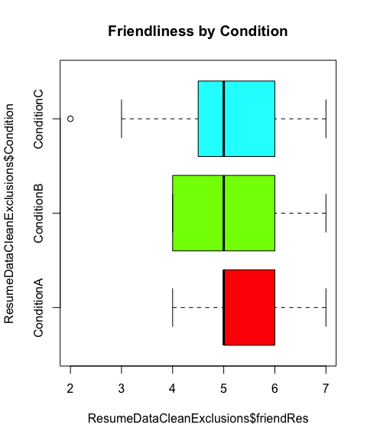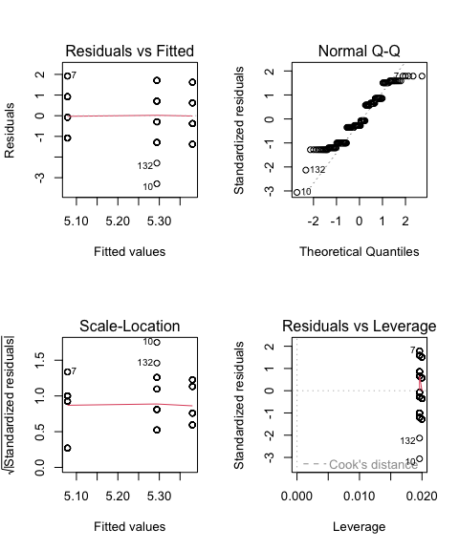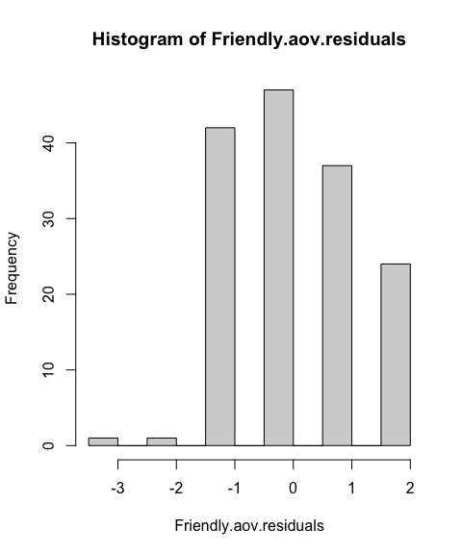

##   
## Shapiro-Wilk normality test  
##   
## data: Friendly.aov.residuals  
## W = 0.93794, p-value = 3.229e-06

##   
## Asymptotic one-sample Kolmogorov-Smirnov test  
##   
## data: Friendly.aov.residuals  
## D = 0.13052, p-value = 0.01127  
## alternative hypothesis: two-sided

## Levene's Test for Homogeneity of Variance (center = median)  
## Df F value Pr(>F)  
## group 2 0.2679 0.7653  
## 149

## Kruskal-Wallis rank sum test  
##   
## data: x and group  
## Kruskal-Wallis chi-squared = 2.3476, df = 2, p-value = 0.31  
##   
##   
## Comparison of x by group   
## (Holm)   
## Col Mean-|  
## Row Mean | Conditio Conditio  
## ---------+----------------------  
## Conditio | 1.437681  
## | 0.2258  
## |  
## Conditio | 0.268683 -1.174828  
## | 0.3941 0.2401  
##   
## alpha = 0.05  
## Reject Ho if p <= alpha/2

## Df Sum Sq Mean Sq F value Pr(>F)  
## Condition 2 2.45 1.223 1.035 0.358  
## Residuals 149 176.05 1.182

## Tukey multiple comparisons of means  
## 95% family-wise confidence level  
##   
## Fit: aov(formula = friendRes ~ Condition, data = ResumeDataCleanExclusions)  
##   
## $Condition  
## diff lwr upr p adj  
## ConditionB-ConditionA -0.30156863 -0.8137065 0.2105693 0.3466234  
## ConditionC-ConditionA -0.08588235 -0.5980203 0.4262556 0.9168499  
## ConditionC-ConditionB 0.21568627 -0.2939100 0.7252825 0.5767662

## Bayes factor analysis  
## --------------  
## [1] Condition : 0.1570633 ±0.03%  
##   
## Against denominator:  
## Intercept only   
## ---  
## Bayes factor type: BFlinearModel, JZS

Summary: The Kruskal-Wallis test was non-significant (p>.05) and the simple effects between each condition were also non-significant (ps>.05). The ANOVA was also non-significant with non-significant simple effects (ps>.05). The Bayesian analysis indicated an odds of .1571 to 1 (very low odds) that the resumes have different perceived friendliness.

## Liberal One-Way Between-Subjects ANOVA

Liberal Political Orientation of Applicants Descriptive Statistics

| Condition | N | Mean | SD | Median | Min | Max | Skew | Kurtosis | SEM |
| --- | --- | --- | --- | --- | --- | --- | --- | --- | --- |
| ConditionA | 50 | 4.52 | 1.22 | 4 | 1 | 7 | 0.09 | 0.59 | 0.17 |
| ConditionB | 51 | 4.69 | 1.17 | 4 | 2 | 7 | 0.47 | -0.68 | 0.16 |
| ConditionC | 51 | 4.73 | 1.00 | 4 | 3 | 7 | 0.67 | -0.49 | 0.14 |

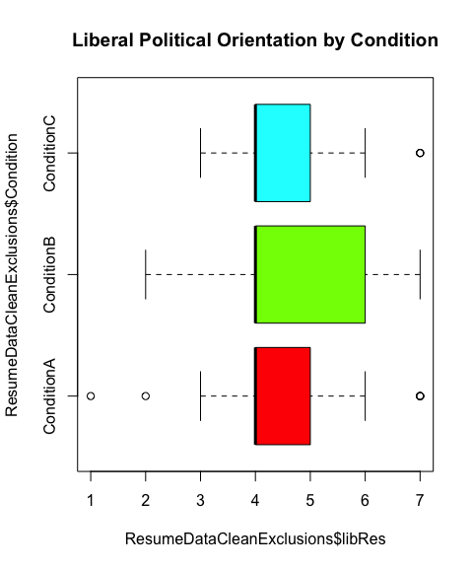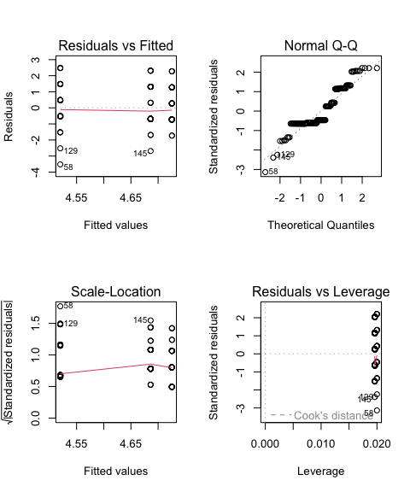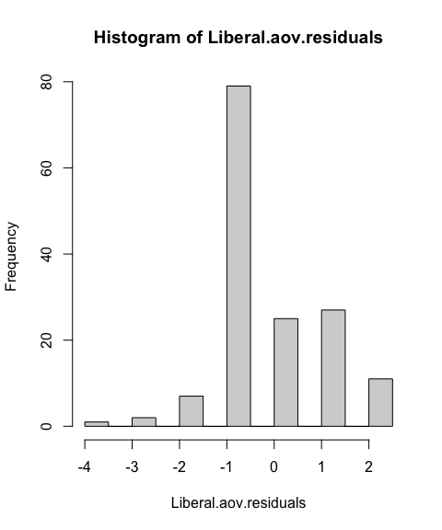

##   
## Shapiro-Wilk normality test  
##   
## data: Liberal.aov.residuals  
## W = 0.88951, p-value = 2.952e-09

##   
## Asymptotic one-sample Kolmogorov-Smirnov test  
##   
## data: Liberal.aov.residuals  
## D = 0.26335, p-value = 1.396e-09  
## alternative hypothesis: two-sided

## Levene's Test for Homogeneity of Variance (center = median)  
## Df F value Pr(>F)  
## group 2 0.0238 0.9765  
## 149

## Kruskal-Wallis rank sum test  
##   
## data: x and group  
## Kruskal-Wallis chi-squared = 0.7543, df = 2, p-value = 0.69  
##   
##   
## Comparison of x by group   
## (Holm)   
## Col Mean-|  
## Row Mean | Conditio Conditio  
## ---------+----------------------  
## Conditio | -0.420147  
## | 0.3372  
## |  
## Conditio | -0.868249 -0.450337  
## | 0.5779 0.6525  
##   
## alpha = 0.05  
## Reject Ho if p <= alpha/2

## Df Sum Sq Mean Sq F value Pr(>F)  
## Condition 2 1.2 0.5993 0.466 0.628  
## Residuals 149 191.6 1.2860

## Tukey multiple comparisons of means  
## 95% family-wise confidence level  
##   
## Fit: aov(formula = libRes ~ Condition, data = ResumeDataCleanExclusions)  
##   
## $Condition  
## diff lwr upr p adj  
## ConditionB-ConditionA 0.16627451 -0.3680199 0.7005689 0.7420736  
## ConditionC-ConditionA 0.20549020 -0.3288042 0.7397846 0.6345366  
## ConditionC-ConditionB 0.03921569 -0.4924271 0.5708585 0.9833314

## Bayes factor analysis  
## --------------  
## [1] Condition : 0.09683642 ±0.02%  
##   
## Against denominator:  
## Intercept only   
## ---  
## Bayes factor type: BFlinearModel, JZS

Summary: The Kruskal-Wallis test was non-significant (p>.05) and the simple effects between each condition were also non-significant (ps>.05). The ANOVA was also non-significant with non-significant simple effects (ps>.05). The Bayesian analysis indicated an odds of .0968 to 1 (very low odds) that the resumes have different perceived liberal political orientation.

## Conservative One-Way Between-Subjects ANOVA

Conservative Political Orientation of Applicants Descriptive Statistics

| Condition | N | Mean | SD | Median | Min | Max | Skew | Kurtosis | SEM |
| --- | --- | --- | --- | --- | --- | --- | --- | --- | --- |
| ConditionA | 50 | 4.44 | 1.50 | 4 | 1 | 7 | -0.08 | -0.72 | 0.21 |
| ConditionB | 51 | 4.18 | 1.14 | 4 | 1 | 7 | -0.26 | 1.23 | 0.16 |
| ConditionC | 51 | 4.45 | 1.32 | 4 | 2 | 7 | 0.39 | -0.47 | 0.18 |

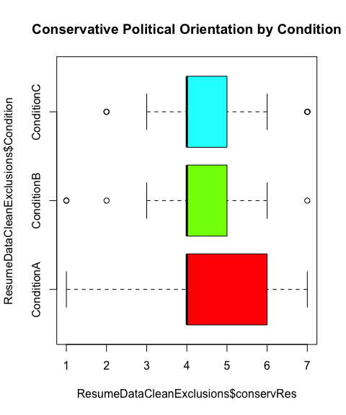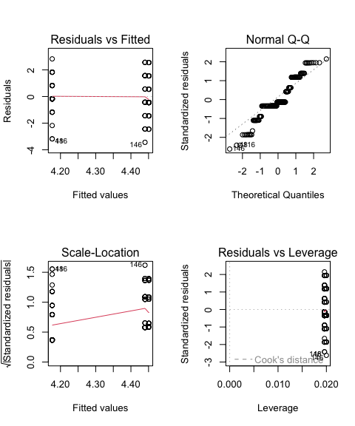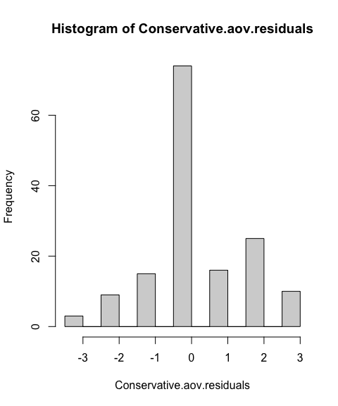

##   
## Shapiro-Wilk normality test  
##   
## data: Conservative.aov.residuals  
## W = 0.93452, p-value = 1.807e-06

##   
## Asymptotic one-sample Kolmogorov-Smirnov test  
##   
## data: Conservative.aov.residuals  
## D = 0.21772, p-value = 1.103e-06  
## alternative hypothesis: two-sided

## Levene's Test for Homogeneity of Variance (center = median)  
## Df F value Pr(>F)  
## group 2 2.3054 0.1033  
## 149

## Kruskal-Wallis rank sum test  
##   
## data: x and group  
## Kruskal-Wallis chi-squared = 0.8864, df = 2, p-value = 0.64  
##   
##   
## Comparison of x by group   
## (Holm)   
## Col Mean-|  
## Row Mean | Conditio Conditio  
## ---------+----------------------  
## Conditio | 0.854315  
## | 0.5894  
## |  
## Conditio | 0.089827 -0.768301  
## | 0.4642 0.4423  
##   
## alpha = 0.05  
## Reject Ho if p <= alpha/2

## Df Sum Sq Mean Sq F value Pr(>F)  
## Condition 2 2.46 1.228 0.698 0.499  
## Residuals 149 262.36 1.761

## Tukey multiple comparisons of means  
## 95% family-wise confidence level  
##   
## Fit: aov(formula = conservRes ~ Condition, data = ResumeDataCleanExclusions)  
##   
## $Condition  
## diff lwr upr p adj  
## ConditionB-ConditionA -0.26352941 -0.8887187 0.3616598 0.5793465  
## ConditionC-ConditionA 0.01098039 -0.6142089 0.6361697 0.9990473  
## ConditionC-ConditionB 0.27450980 -0.3475768 0.8965964 0.5499728

## Bayes factor analysis  
## --------------  
## [1] Condition : 0.1179834 ±0.02%  
##   
## Against denominator:  
## Intercept only   
## ---  
## Bayes factor type: BFlinearModel, JZS

Summary: The Kruskal-Wallis test was non-significant (p>.05) and the simple effects between each condition were also non-significant (ps>.05). The ANOVA was also non-significant with non-significant simple effects (ps>.05). The Bayesian analysis indicated an odds of .1180 to 1 (very low odds) that the resumes have different perceived conservative political orientation.

## Overall Summary:

The resumes did not significantly differ in how they were perceived along status, Americanness, friendliness, morality, and liberal and conservative political orientation scales.