ORC
PO Micro-App
Functional Design Document

Author: Reetu Muneem
Creation Date: 04/12/2016
Last Updated: 19/10/2017
Document Ref: ASOS TGR MM Enablement PO Micro-App
Version: 1.5

Approvals:
Scott McFarlane
Rhian Saint
Jo Powell
Phil Lawrence


Document Control

Change Record
3
Date | Author | Version | Change Reference
04/12/16 | Reetu Muneem | 0.1 | Initial Version
25/01/17 | Reetu Muneem | 0.2 | Updated after review comments walkthrough
28/05/2017 | Reetu Muneem | 1.0 | Enablement phase changes
14/06/2017 | Reetu Muneem | 1.1 | Updated after Review comments session walk through
18/07/2017 | Reetu Muneem | 1.2 | Updated for Code Drop 2
07/09/2017 | Reetu Muneem | 1.3 | Updated for Code Drop3
02/10/2017 | Reetu Muneem | 1.4 | Updated with review comments for Drop 3
19/10/2017 | Reetu Muneem | 1.5 | Updated after change log review for Release 3

Reviewers
Name | Position
Kerry Moran | TGR MM Subject Matter Expert
JO Powell | TGR MM Subject Matter Expert
Lucy Partridge | TGR MM Subject Matter Expert
Rhian Saint | Lead Business Analyst – Retail
Aurelie Seth | Senior Business Analyst – Retail
Lynda Golding | TGR MM Business Analyst
Mark O’Connell | TGR MM Solution Architect
Sue Leach | TGR Data Migration Business Analyst
Derek Bretzke | TGR MP Business Analyst
Marc Skinner | TGR MP Solution Architect
Magendiran Srinivasan | TGR Test Lead
Prashant Gamji | TGR MM Test Consultant

Contents
1 Document Control ii
1.1 Change Record ii
1.2 Reviewers ii
1.3 Contents iii
2 Introduction 1
2.1 Purpose 1
2.2 Definitions, Acronyms, and Abbreviations 1
2.3 References 2
2.4 Change Requests 2
3 Solution Overview 3
3.1 Overview 3
3.2 Key Functional Requirements 4
3.3 Design Assumptions 4
3.4 Integration Requirements 5
3.5 Data Requirements 6
3.6 Operational Reporting requirements 8
3.7 Dependencies 8
4 Solution Functional Design 10
4.1 Modification Overview 15
4.2 User Interface Design 22
4.3 Behaviour Design 55
5. Open and Closed Issues 58
5.1 Open Issues 58
5.2 Closed Issues 59

Introduction

The Requirments Specification captures the complete software requirements for the system, or a portion of the system. Following is a typical outline for a project using use case 0rtefact0. This 0rtefact consists of a package containing use cases of the use case model and applicable Supplemental Specifications and other supporting information.

Purpose
The purpose of this document is to provide a specification of the requirements in scope for this project but not supported by the Oracle Retail base functionality:
The ASOS Micro-Apps have the objective of simplifying and enriching the user experience for ASOS Buying and Merchandising (B&M) team, by creating a layer on top of Oracle Retail suite of products.
This document was originally created during the Prototype phase but was carried forward into Enablement Phase where it is reviewed and updated to cover the details from Enablement phase. This document is specific to one of the micro apps being built for ASOS, i.e., PO Micro app. The entire PO micro app will be built for Release 3 but it will be delivered into system testing in several code drops.

.

Definitions, Acronyms, and Abbreviations
Acronym/Abbreviation | Position
ADF | Oracle Application Development Framework
ASN | Advance Shipment Notification
AP | Assortment Planning
ASOS | As seen on screen
CFA | Custom Flex Attributes
CVB | Computation Value Basis
CY | Container Yard
DB | Data Base
DDP | Delivered Duty paid
FC | Fulfilment Centre
FCL | Full Container Load
FDD | Functional Design Document
FOB | Free on Board
FPT | Freight Product Type
HTS | Harmonized Tariff Schedule
ICT | Inter Company Transfers
LCL | Low Container Load
MDA | Merchandise Delivery Agreement
OR | Oracle Retail
PO | Purchase Order
ReIM | Oracle Retail Invoice Matching System
RIB | Oracle Retail Integration Bus
RMS | Oracle Retail Merchandising System
RPM | Oracle Retail Price Management System
SKU | Stock Keeping Unit
SME | Subject Matter Expert
WAC | Weighted Average Cost
WH | Warehouse
WIP | Work in progress
WMS | Warehouse Management System

References
Document | Location
3 ASOS Conceptual Solution Document Master | ASOS SharePoint
5 ASOS RD.140 Micro-App Requirements Specification | ASOS SharePoint
TGR MM ORC Delivery Phase Plan Overview 20160914 v2.pptx | ASOS SharePoint
ASOS PO Micro-App Sprint 1 Show and Tell Workshop v1 | ASOS SharePoint
ASOS PO Micro-App Sprint 2 Show and Tell Workshop v1 | ASOS SharePoint
ASOS PO Micro-App Sprint 3 Show and Tell Workshop v1 | ASOS SharePoint
CSD | ASOS SharePoint
Integration Catalogue | ASOS SharePoint
Enablement workshop- PO-set-up.pptx | ASOS SharePoint
Enablement workshop - PO-Creation.pptx | ASOS SharePoint
Enablement workshop - PO-Creation-2.pptx | ASOS SharePoint
Enablement workshop - PO-Maintenance-1.pptx | ASOS SharePoint
Enablement workshop - PO-Maintenance-2.pptx | ASOS SharePoint
ASOS MC050 Application Setup Spreadsheet | ASOS SharePoint
ASOS RPM 16 Configuration Data Migration Mapping | ASOS SharePoint
ASOS RSM 16 Security Data Migration Mapping | ASOS SharePoint
ASOS Security Matrix – PO Micro App | ASOS SharePoint
Requirement Traceability matrix for Merch Management | ASOS SharePoint
JIRA – Merchandise Management issues | https://tgretail.atlassian.net/projects/MM/summary

Change Requests
All the change requests captured in Enablement phase are available on ASOS SharePoint.
https://asos1.sharepoint.com/sites/tgr-programme/TGR%20Documents/Shared%20Documents/Forms/AllItems.aspx?RootFolder=%2Fsites%2Ftgr%2Dprogramme%2FTGR%20Documents%2FShared%20Documents%2F03%20Merchandise%20Management%2F03%20Enablement%2F03%20Business%20Workshops&FolderCTID=0x012000F399222F7DAEB94EA2A05C826DE61B03&View=%7B20CE8337%2D1B15%2D4D4B%2D9A76%2D42C142D72EC7%7D

Solution Overview

Overview

With the introduction of a new Merchandise system (Oracle Retail), ASOS business users have expressed concerns over the usability and time necessary to create data in the Oracle Retail base screens to support the Buying and Merchandising processes.
Therefore, a set of Micro-Apps have been identified to support the ASOS processes, focusing on the following areas and all these Micro apps are part of Release 3 in TGR program:
- Item Creation and Maintenance
  - Create/edit Items
  - Maintain Item Groupings (Styles/Super Styles)
  - Mass Changes
  - Upload Items
  - Create Item Lists
  - Gold Seal
  - Buyrarchy Maintenance and reclassification
- Purchase Order Creation and Maintenance
  - Create and maintain different type of POs based on delivery destination and delivery dates.
  - Mass PO Maintenance
  - Upload POs recommendation from spreadsheet (Interim Range Plan)
  - Replenishment PO recommendations (Shape the Offer)
  - Upload PO recommendation from planning and complete PO in micro app
  - Create new PO using an existing PO
  - Generate SKUs while applying sizing on PO for items where SKU does not exist
- Pricing
- Initial Price Setup
- Price Changes

- ASOS Net
- Creating ASNs or MDAs
- Creating Invoices

The scope of this document is to describe the functional design for the PO Micro-app which will be for Purchase Order Creation and Maintenance.

The functionality of PO micro app is being delivered in multiple code drops and following section reflects the details of functionality that was built as part of Code Drop2. These functionalities are mentioned at high level. However, the details of each of them are provided in the relevant sections of the document.
Code Drop 2 Functionalities –
- Restricting PO creation to specific buying group.
- To calculate Handover window on PO using a configurable column in micro app system options. This will provide the Retail team the flexibility to change the default no. of days for Handover window calculation, as per their business need.
- Copy PO functionality which will allow the Retail team to create a PO with more ease by using an existing PO.
- Creating PO using replenishment recommendations.
- Creating PO using Planning recommendations.
- Use consolidated exchange rate to calculate Planned Buy margin and operational exchange rate to calculate the Exp. Buy margin on PO micro app.
- Allow user to apply same sizing curve to all the options coming to a FC.
- Allow user to open PO in view mode from Order search screen.

In the following section, the functionalities for code drop 3 are mentioned at high level. The details of each functionality are described in the relevant sections of the document.
However, please note that several new requirements with MoSCoW status of ‘Must’ have been added to change log after the code drop 3 scoping. Some of these requirements are already added in this FDD, however few of them are marked as not in scope for code drop 3. Kindly refer to the change log maintained on SharePoint, for more details. Based on the ongoing discussions with SMEs major ‘must’ requirement might be added to a separate CR and this document will be released again with those changes.
Code Drop 3 Functionalities –
- Amendment requirements on PO.
- Cancellation requirement for PO.
- Preferential rate indicator amendment on PO. Implementing duty calculation on PO based on each importing country.
- PO creation logic to include factory, so that each PO should belong a single factory.
- Allow user to edit or remove expenses in cost summary screen.
- ‘Move to new PO’ functionality.
- Allow user to apply a reason code against PO amendments and PO cancellation.
- PO Mass maintenance screen functionality.
- Change in screen layout for sizing screen.
- Create PO with ‘TBC’ country and dummy factory code.
- To handle specific business scenario where user want to have Direct, Split and Automated lines for the same option with different FCs.
- To calculate dates on a PO when the Expected Delivery date on First Destination or Final Destination is modified by user in PO creation process.
- To generate the SKUs on an approved PO, in sizing screen.
- Implement PO approval limits..

Key Functional Requirements
A new module will be built that will allow users to support the ASOS process of creating and maintaining POs - this new module will co-exist with base functionality as a bolt on solution and will be called as PO micro app in ASOS terminology.
This module will provide multiple functionalities:
    - Manually Creating and Maintaining POs.
    - Allow user to easily search a PO and edit it.
    - Mass Maintenance of PO including mass cancellation.
    - Applying approval limits set for the user during PO approval process.
    - Creating a new PO from an existing PO using Copy PO functionality.
    - To upload POs recommendations from interim range plan into PO micro app.
    - To upload PO recommendation from planning and allow user to complete the PO in micro app.
    - Allow user to complete the PO recommendations generated from replenishment cycle, in PO micro app.
    - Allow user to manually apply sizing in micro app.
    - Allow user to select a sizing curve in micro app.
    - To maintain PO revisions and reason codes for PO amendments and cancellation.
    - Allow user to move from PO micro app to Item micro app to create new item.
    - Allow user to view the shipment and receipt information of the PO.

Design Assumptions
The following design assumptions have been considered while devising the solution described in this document and these design assumptions are common across all ASOS micro apps. Functional Design assumptions specific to PO micro app are mentioned later in the document.
- All Micro-Apps will be built using Oracle Application Development Framework (ADF) technology
- All Micro-Apps will have the same look and feel and user experience, following the template used for all ADF Oracle Retail applications. However, when needed, this template will be “tweaked” to support ASOS specific requirements.
- Application look and feel will be consistent for all users (except for few fields or actions being disabled for them based on their user role)).
- The Micro-Apps will be built on a common ADF foundation framework and will be integrated between themselves to offer a seamless experience to the users. As part of the Micro-App workflow, users may be required to jump from application to application (for example, from Item to PO). These moves will be done transparently, without users noticing it (if they have permissions). The apps will also be built in a modular way, to facilitate future enhancements or disabling features in the future.
- Application security will be:
  - Role-based. What each role will have access to will be discussed during the Enablement phase and will be in line with the to-be business process diagrams.
  - Control user access to data. Based on filtering mechanisms, and where required, users will have access to the data they need. It’s not going to be implemented as pure security, but will control user access. However, users will not be prevented to access other data if they want to see it.
- No offline capabilities will be included in the current phase.
- Any requirements not listed in this document or not captured in Issue log, are considered out of scope for Release 3.

Integration Requirements
- Integrating PO and related information to downstream systems, suppliers and partners.
- Integration of PO recommendations from planning to PO micro app (without sizing tool).
- Integration of PO recommendations from planning to PO micro app via sizing tool.
- Integration of Sizing curve libraries from sizing tool into PO Micro app.

Interface Number | Interface Name | Source System | Target System
INT031 | PO Recommendation directly from AP to PO Micro app. | AP | PO Micro-App
INT072 | Purchase Order (PO) Spreadsheet | Spreadsheets | PO Micro-App
INT033n | Purchase Order (PO) | PO Micro-App | RMS
INT031a | PO Recommendation | Sizing Tool | PO MicroApp
INT090 | Size Curves | Sizing Tool | PO MicroApp
INT033a | Purchase Order (PO) from Oracle RMS to Oracle RPAS | RMS | AP
INT050 | Inventory from Oracle RMS to Oracle RPAS | RMS | AP

There are several change requests that have been added to the Integration Change log. Thus, the above list represents the only the confirmed requirements. For the new requirements please refer to the Integration change log on ASOS SharePoint –
https://asos1.sharepoint.com/sites/tgr-programme/TGR%20Documents/_layouts/15/WopiFrame.aspx?sourcedoc=%7BAD94CC96-4278-43DF-9593-A9AAD354278A%7D&file=Integration%20and%20Data%20Migration%20Change%20Log.xlsx&action=default

Data Requirements
Below diagram represent the necessary data requirement for creating a PO-

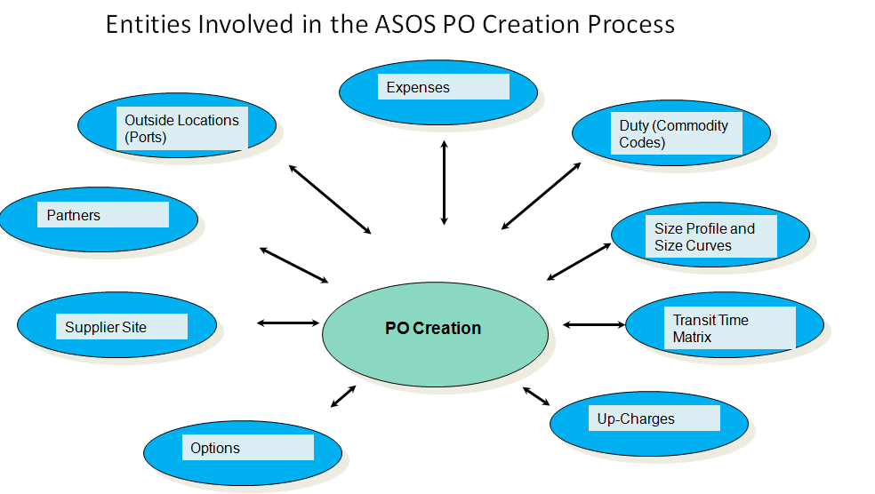
Entities involved in PO Creation - Fig 1.0

Following is a list of data entities that impacts PO Micro app and needs to be populated/created before creating a PO:
- Options – Options should exist with all relevant attributes.
- Supplier site – Supplier site should exist with relevant information and supplier site import attributes – Shipping method, Shipping Point and Freight forwarder etc.
- Partners – Following three partners will be used while creating PO-
- Factory- Factories will be set up as partners in RMS and will be selected by the user on PO. Based on the factory’s CFAs/attributes this information will be defaulted on PO- Shipping Method, Shipping Point, Ex-factory days and Freight Forwarder. In absence of a setup on factory, these values will be defaulted from supplier site import attributes setup, except for Ex-factory days. If the factory will be a dummy factory, then the ex-factory date on PO will be same as Exp. Handover Date. These factory CFAs/ attributes would come from the retail team, but must be validated via sourcing/Inbound supply chain as per factory creation business process and then created by the Retail Systems Admin. For import attributes setup for supplier site these values will come from the Retail team after validation via sourcing/ Inbound supply chain and would be used by the AP team while creating supplier and supplier sites.
- Freight Forwarders – They will be defaulted on PO either from Factory CFAs/attributes or from supplier site import attributes.
- Labelon – Labelon will be setup as partner in RMS and will be associated to respective suppliers. There is no requirement to show the Labelon partner id on PO; however, the Labelon cost should be defaulted on PO, whenever the supplier site attached to the PO has Labelon set as a partner against it. However, 99% of ASOS suppliers pay for their labels thus there is very small number of suppliers for whom ASOS pays for the labels. Thus, very few POs will incur this cost.
- Outside Locations – All the shipping Point (lading ports) and Receiving Points (Discharge Ports) should be setup as outside locations in RMS and will be used while raising PO. In case of ASOS their receiving warehouses will be configured as discharge port as well because ASOS does not have separate discharge ports as part of their supply chain process.
- Expenses – Following costs will attribute to the Expenses captured on a PO. Details on these costs are mentioned in the ‘Cost summary’ section of this document-
- Freight Cost – Cost incurred by ASOS for the movement of goods from lading port to ASOS warehouses. This cost will be maintained by the Inbound supply chain team.
- Re-processing Cost – Cost incurred by ASOS for any re-processing work that needs to be done on the PO items. This cost will be maintained by Inbound Supply Chain team. Only planned re-processing cost will be captured as an expense on PO.
- Labelon Cost – Cost incurred by ASOS with Labelon for generating Labels.
All the re-processing and Labelon costs will be maintained in base expense profiles and these expense profiles will be maintained by the AP team. However, the actual costs of Labelon will be maintained by Retail team and re-processing cost will be maintained by the Inbound Supply chain team. Both these teams will provide these costs to the AP team so that they can use it in respective expense profiles, as these expense profiles will be created as part of supplier creation process which is owned by AP.

- Duty – Duty cost will be captured on PO based on the commodity code/HTS setup in base RMS. However, the commodity code will be captured in Item micro app against an option-FC combination along with preferential rate attribute. PO micro app will use this information from option setup and will calculate the duty cost based on the commodity code and preferential rate attribute set on the option. The setup of commodity codes and their maintenance will be done by ASOS custom team.
- Size Profile and Size curves – As part of Release 3 size curve libraries will be interfaced from Sizing tool to RMS. PO micro app will allow user to use these size curves for sizing the options selected on PO.
- Transit Time matrix – There will be following, two type of transit matrix that PO micro app will use. For details please refer to ‘Purchase Order’ section in this document-
- Transit Time matrix for PO – This matrix will be used to calculate the respective dates on the PO. This will be maintained by Inbound supply chain team.
- Transportation Time matrix between FCs – This matrix will be used to calculate the dates on Expected delivery dates on Final Locations in case of Split/Automated PO. Details of these PO are defined later in the document.
- Up-Charges - Following costs will attribute to the Up-charges captured on an Automated/Split PO. Details on these costs are motioned in the ‘Cost summary’ section of this document-
- Transportation cost – Cost incurred by ASOS for transferring goods from one ASOS warehouse to the other ASOS warehouse. This cost will be maintained by the Inbound supply chain team.
- Handling Cost – Cost incurred by ASOS for packaging the transferred goods between ASOS warehouses. This cost will be maintained by Logistics Team.
- The security and access information will be maintained in custom admin tables. The requirements for user roles and relevant access are captured in a User Role Matrix maintained at the TGR program level for Oracle Retail applications, which includes details for micro apps as well.
- To support Replenishment PO, relevant replenishment parameters setup will be required in base along with the replenishment parameters being attached to the options in item micro app.

Operational Reporting requirements
No operational reports have been identified, however several dashboard requirements have been identified which will support the ‘Order to Receipt’ functionality in conjunction with PO Micro app. These requirements and their solution are defined in a separate FDD.

Dependencies
List of known dependencies:
- To get the size breakdown available in the Micro-App, there is a dependency with the Sizing Tool. The current expectation is that it will be implemented in Release 3 along with the Micro-Apps.
- Dependencies with ASOS Net app to be available along with PO micro app for downloading the POs.
- Dependencies with ReIM to cater the invoicing solution in-line with ASOS to be business process for Orders.
- Dependencies with dash board requirements to be available along with PO micro app, to cover and support complete POs operational business process for ASOS. The list dash board requirement for POs are captured in a separate FDD for dashboards and are referred in the PO micro app CSD.

The intent of this section is to record the Technical Architecture requirements. Reference the Architecture Requirements and Strategy (TA.020).

Solution Functional Design
This section will provide a detailed view of the solution design to support the functional requirement(s) as stated previously in the document.
The PO micro app will co-exist with base RMS and will provide ASOS a quick and efficient way of raising purchase orders. However, this will not limit ASOS from raising PO in base RMS, in future, if needed. But the additional features and ASOS specific business processes supported in micro app will not be available in base. Thus, for Release 3 the PO creation and maintenance screen in base RMS application will not be shown to the user.
The PO micro app consists of several screens, details of each screen and its supported functionality is provided later in the document.
The below diagram represents the high-level depiction of Order to Receipt business process, to which PO Micro app belongs.

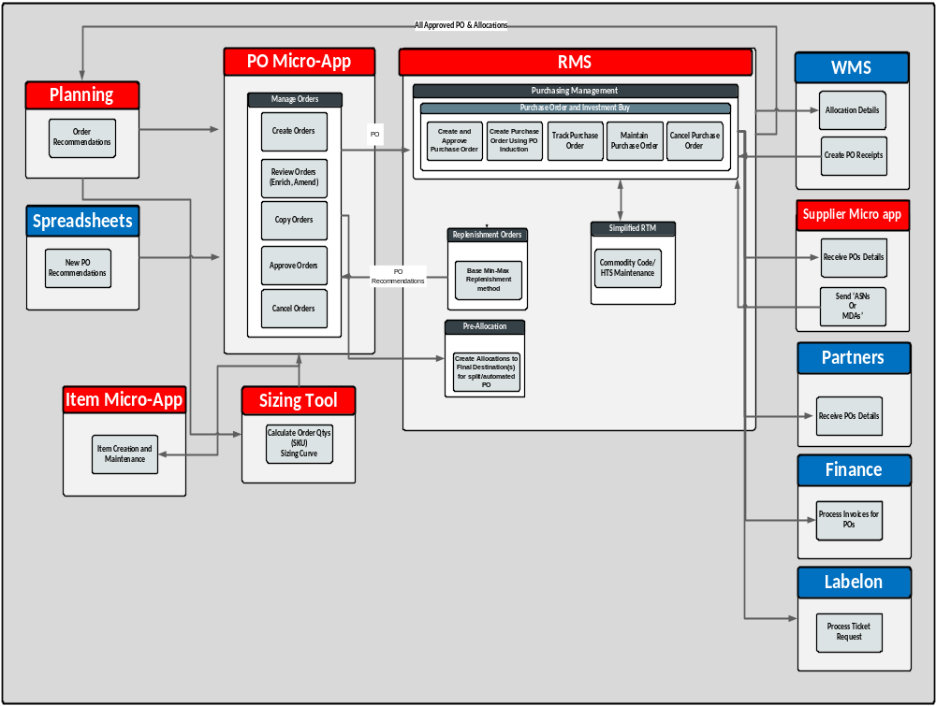

der to Receipt Business Process –
Order to Receipt Business Process- Fig 1.1

ASOS has a requirement to support PO creation from four different sources:
- PO Micro app
- Replenishment
- Spreadsheet (Interim Range Plan)
- Planning (Shape the offer)

All the PO created from these four sources will be completed and maintained in PO Micro app.
Details for each of the sources are mentioned below:
- PO Micro app –
- User will be able to create PO manually in PO micro app with the flexibility to select different options (i.e., items), Warehouses/Fulfilment centres (FCs), Delivery dates etc. in worksheet status. User will be able to act on a worksheet PO by either Submitting, Approving, Rejecting or Deleting it. For details on the different status of the PO, please refer to ‘PO Action’ section in the document.
- User will be able to amend PO in Approved status. However, these amendments will be restricted to certain attributes of PO – dates, options and quantities, SKU and quantities, unit cost, expenses, duty, factories, Freight Forwarder and Delivery Method etc. All the amendment requirements are captured in change log, available on SharePoint and they are currently under review with other business groups in ASOS and Retail team.
- User must associate a reason code for the amendments. A single reason code will be associated to PO even if multiple updates are done on PO.
- Replenishment –
- As part of Release 3, ASOS will go live with Min- Max replenishment supported by Oracle Retail. Thus, the base RMS replenishment batches will generate the Purchase Order recommendations at SKU level for relevant FCs in with required quantities.
- These PO recommendations will be accessible in the PO micro app and user would be able to combine these recommendations into a PO. User would have the flexibility to add any other options as well in this PO.
- Spreadsheet (Interim Range Plan) –
- ASOS needs the flexibility to create PO via spreadsheet also known as Interim range plan. ASOS will use a single spreadsheet to upload the options and PO. This spreadsheet will be used for new buys as an interim solution primarily between Release 3 and Release 4, but it can continue to be used post Release 4. Any re-buys PO will be both created directly in PO micro app or via sizing tool and then interfaced to PO micro app as recommendations. However, for the new buy, user could create future recommendations in interim range plan. These future recommendations will appear as separate rows under the same option details in the range plan. The upload process will not work offline.
- The details of PO lines from this spreadsheet will be translated into PO recommendations, only after the successful creation of the associated option in item micro app.
- Design details for spreadsheet PO will be captured in a separate FDD – Spreadsheet Upload.
- For post Release 3 retail team want to explore a similar capability for re-buys/new-buys, where buyer could capture information offline on excel (when being on a trip etc.) with minimum required details and later upload it in system as PO recommendations. This excel would be different from interim range plan.
- Planning (Shape the Offer)–
- As an end state, ASOS will use AP (Oracle Assortment Planning) also known as ‘Shape the Offer’ in ASOS terminology to provide them with necessary buying recommendations for the merchandise. Thus, ASOS wants to integrate these recommendations generated in planning application to the PO Micro app.
- The PO recommendations will have relevant quantities against each size, if the recommendation was enriched in sizing tool.
- The recommendation can also be interfaced directly from planning to PO micro app especially for those options that will have a single size for e.g., watches. In these cases, sizing tool, will not be leveraged for PO recommendations.
- User will be able to add these recommendations to an existing worksheet PO in micro app.

In Prototype phase the concept of Global PO, Local PO, Master PO and drops was discussed. But in Enablement phase these terminologies have been changed and below is a diagrammatic representation of this terminology shift-
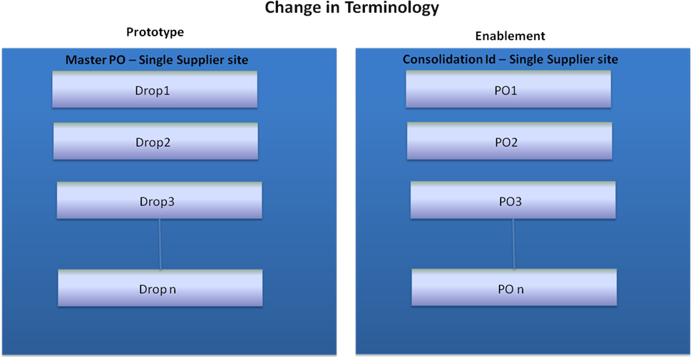
Change in Terminology - Fig 1.2

Thus, in the To-Be World Master PO will be known as ‘Consolidation Id’ and all the drops in the Master PO will be known as ‘PO’ under that ‘Consolidation Id’. The change in terminology has originated from the concern of suppliers creating Invoices against the Master PO instead of the drops. Thus, this new term for Consolidation Id will not confuse the supplier and they will use the PO number for invoicing and generating ASNs.
Also, all the PO created under one Consolidation Id will only belong to one Buying Group and business model combination.

Along with this change, the Global and Local PO concept has been removed in Enablement phase and now both will be called as Direct PO.

Thus, as per ASOS business requirement PO micro app will support following types of POs:
Direct -This type of PO will not have any cross docking. The PO will be raised with supplier and will be delivered by the supplier directly into the warehouse or Shipping point (against which PO was raised).
Split – One purchase order with a single warehouse as first destination, but cross-docked to additional warehouse which was selected as final destinations, while raising PO. Suppliers will prepare already the cartons per the final destinations, but the total quantity will be delivered in the first destination warehouse. Warehouse will know they need to ship to the Final Destination warehouse. For this purpose, an allocation will be raised in the RMS system when Split PO will be approved.
Automated – One purchase order with a single warehouse as first destination but cross docked to additional warehouse which was selected as Final Destination, but supplier has no visibility about the split. Purchase orders will be split during creation, and first destination warehouse will receive the stock, prepare it and ship to the Final Destination warehouse. For this purpose, an allocation will be raised in the RMS system when Automated PO will be approved.
PO micro app also must support following two business scenarios while creating POs-
- One option per PO. The rationale behind having one option per PO is to minimize the chances of delaying a complete PO or re-creating a new PO, if the supplier gets delayed for one option on PO and many of the B&M teams currently use this mode of operation.
- Multiple options per PO. The rationale behind having multiple options per PO is due to some of the brands in ASOS who combines multiple options per PO and for the ease of supplier to get more information on supply for him in one go rather than raising it at different intervals of time, which will result in more paper work.

The below diagram depicts each of the business scenarios for respective PO types, explained
with the help of a Business scenario.
Business Scenario - Options to be ordered –
Option 1 with one SKU as SKU-1
Option 2 with one SKU as SKU-2
For fulfilment centres – FC1 and FC2

Direct POs-
- Multiple options per PO business scenario- In this case both options will be sent directly to FC01 and FC02. Each FC will have its own PO containing both the options, thus total no. of POs will be 2.

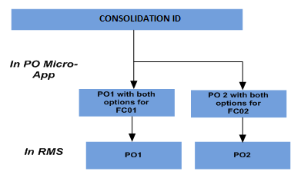
Direct Order - Fig 1.3

- One option per PO business scenario- In this case both options will be sent directly to FC01 and FC02. But each FC will have its own POs with single options, thus total no. of POs will be 4.

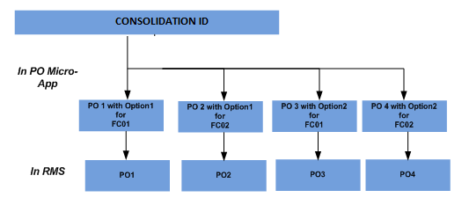
Direct Order - Fig 1.4

Split or Automated POs-
- Multiple options per PO business scenario- In this case both options will be sent directly to FC01. Then from FC01 the designated quantity of both options for FC02 will be sent as part of onward Allocations. Allocations will allow the quantity to be shipped between FCs. Allocations will be created based on the no. of SKUs for that option on PO. Each SKU will result in one Allocation. But in this case no. of PO created, will be 1.

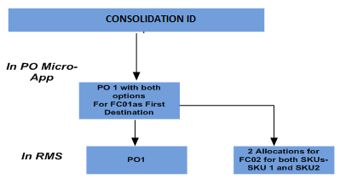
Split / Automated Order - Fig 1.5

- One option per PO business scenario- In this case both options will be sent directly to FC01.But each FC will have its own PO with single option. Then from FC01 the designated quantity of respective option for FC02 will be sent as part of onward Allocation. Allocations will allow the quantity to be shipped between FCs. Allocations will be created based on the no. of SKUs for that option on PO. Each SKU will result in one Allocation. But in this case no. of POs created, will be 2.
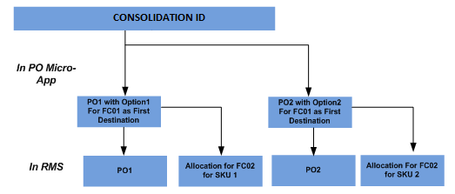
Split / Automated Order- Fig 1.6

Modification Overview

Solution Approach
The intent of this section is to list the building blocks that are required to design the designated component. This includes classes, objects, modules, etc. Reference the Module View of the Architecture Description (RD.130) and appropriate Software Component Design (DS.080) to derive the list of classes and their relationships.

All the new Micro apps (Item, Order, and Pricing) will co-exist with RMS and will be accessible from the same link.

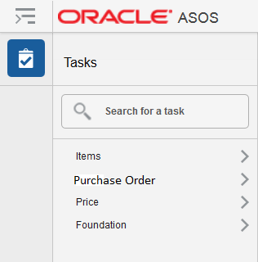
Task Bar- Fig 1.7

Once the user will select the Purchase Order link under Tasks bar, it will take them to the link for all screens related to PO Creation and Maintenance.

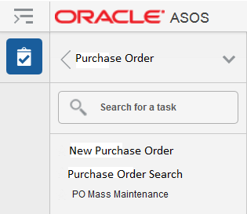
Order Task Bar- Fig 1.8
For raising a new PO, user will select the ‘New Purchase Order’ link. For viewing or editing an existing PO user will select ‘Purchase Order Search’ link and will search for the order to view or edit it.
For mass cancellation and mass amendments on PO user will select ‘PO Mass Maintenance’ link.
The PO micro app will provide user with a workflow experience to create a PO. This workflow methodology will help user to easily complete the PO and move across different screens. Thus, when a user selects to create ‘New Order’, they will see a train structure for different screens in PO creation process.

Train Structure for PO Micro app- Fig 1.9

Each tab on the train structure represents individual screens and actions a user will take while raising a PO. Details for each of the screen are described later in the document.

To compliment this work flow structure for PO creation, a Contextual area will also be available in each screen of PO creation process on right hand side. This Contextual area will be enriched with data in line with the completion of each step in the workflow, e.g. when user selects the options on PO, the item section in this area will be populated with data. Similarly, when user completes the fulfilment centre details, the Purchase Order and Final Destination section will get populated. With this Contextual area user, will always have relevant details of PO presented to him even though he has moved to other screens to complete the PO.
This Contextual area will be non-editable.
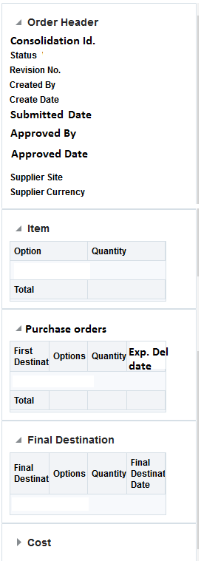
Contextual Area- Fig 1.10
Note: The content of this side bar must be discussed and finalized with Retail team. The FDD as of now represent the Contextual Area that has been used in demos for Enablement phase.

Below is a list of important decisions that play a significant role in designing the solution for PO Micro app.
Functional Solution Decisions-
Decision | Description
1 | PO micro app must support the PO creation of following cases-  1. One option per PO – In this case each Consolidation Id will have all the POs with single options. Thus, the number of PO raised in this case would be more.  2. Multiple options per PO- In this case each Consolidation Id will have POs created with multiple options in each of them. Thus, the number of PO raised in this case would be less compared to first case.
2 | PO will be created for a single factory. The earlier design assumption of having multiple factories on PO has been removed.
3 | Users are expected to create all Purchase Orders in the PO Micro-App. However, there’s is no restriction in using base screens, so if a specific user role requires using the base PO screens, it will be possible. However, for consistency purposes, and as per business process, users should maintain POs in the screens they created them. Any PO created in base screens will not be accessed in PO micro app.
4 | When creating a new order, users would be able to add sizes that haven’t been created yet for a certain option within its size group. The PO Micro-App will create those additional SKUs without requiring the user to create them first in the Item Micro-App.
5 | Total margin will always be calculated with Buy value excluding VAT. In this document, the total Margin calculation formula is assumed to have the VAT excluded Buy value.
6 | The term ‘Option’ in ASOS terminology refers to the ‘item’ in base RMS terminology. In RMS, operational transaction happens at transaction level item also known as SKUs, thus an option is parent item for the SKUs.
7 | Spreadsheet upload of PO will be combined process that will create item and POs; details of this process flow will be captured in a separate FDD – Upload Spreadsheet. Thus, in this FDD the details for Spreadsheet PO creation will not be captured.
8 | A PO could only have planned re-processing cost. Un-planned re-processing cost will not be captured on POs.
9 | Single Transportation cost matrix will be used for both Automated and Split PO thus there will be no separate line for each of these order type in the matrix.
10 | Expenses and duty cost will be reflected on PO only if the supplier site attached to PO has shipping terms as ‘FOB’ or ‘Ex-works’. The only expense for DDP suppliers could be the planned re-processing (if the PO from the specific DDP suppliers goes via re-processing).
11 | The options on a PO would belong to a single Buying Group and business model combination, however they could belong to multiple Product Groups. Thus, a PO would always be for a specific buying group and business model only.
12 | Custom team will be responsible for overriding/change the preferential rate selection on PO micro app (which would be defaulted on PO from option setup done in item micro app).
13 | In the ASOS to-be world there will be only three types of PO-  1. Direct 2. Automated 3. Split
14 | User would be able to download the PO from PO micro app only in PDF format. This format will be consistent with the PO format used in ASOS Net. User would be able to download the PO once it has been Approved.
15 | Insurance cost will be not tracked on PO for Release 3.
16 | For DDP suppliers, respective commodity code will be captured against the option on PO. But the duty cost will not be calculated on PO. There is a design requirement from Custom team to capture the commodity code on PO with DDP suppliers so that it can be reported on Intrastat report. This is an existing report to capture the, movements of goods within EU.
17 | The scope of Release 3 is restricted to simplified RTM.
18 | Planning recommendations from AP is part of Release 4.
19 | ASNs and invoices cannot be created against the Consolidation Id.
20 | There will be no cost limit while creating the PO however there will be limitations on the Approval limit for the PO.
21 | Spreadsheet Upload process will not be used for re-buys. However future recommendations for new buy would be created through excel upload.
22 | Options on partially received PO would not be re-classified
23 | Final Location on an Approved PO cannot be amended
24 | The reason codes for the PO amendments will be stored in comments field in RMS database. This decision is made to support the integration of reason code to downstream system without any modification on vanilla integration interface for PO. The reason codes will be prefixed in comments field in RMS database in this format - [REASON_CODE:XYZ]
25 | Following decisions are made for migrated PO and their Consolidation Ids-  Migrated PO will be of 11 digits (MERRET NO. PLUS DROP NO)  CID for migrated PO will be New, using the aggregator of the Merret PO and will follow the same principal of combining PO which belong to same supplier site and buying group.  Following decisions are made for migrated PO and their Consolidation Ids-  CID for new POs will be 8 digits, starting with 2  New POs will be 12 DIGITS, starting with 5
26 | POs will be purged after 2 years from their close date.
27 | As user would be able to combine recommendations from planning and upload process in one PO and can also add more options while creating the PO thus, the source of PO would not be identified on the PO.
28 | In Edit mode for ‘Approved PO’ the ‘Save’ button will not show to the user and Save and Next will appear as Next.

The intent of this section is to list the building blocks that are required to design the designated component. This includes classes, objects, modules, etc. Reference the Module View of the Architecture Description (RD.130) and appropriate Software Component Design (DS.080) to derive the list of classes and their relationships.

Below is a list of important assumptions that play a significant role in designing the solution for PO Micro app.
Functional Solution Assumptions-
Assumption | Description
1 | The calculation of PO dates will be dependent on transit time matrix that will be maintained in a custom table and will be owned by the Inbound Supply chain team. The trigger for calculating all the dates on PO would be the Handover date, which would be either entered by the user or would be derived from Handover window.
2 | To calculate the Handover window system will use the handover date and will apply a default no. of days on top of this handover date to calculate the handover window. This default no. of weeks would be configurable and ASOS could change it in the future. However different brands operating on different window would be able to manually overwrite this system calculated window as per their business requirement, in PO micro app.
3 | Assumptions with Expense and Up-charge Costs-  1. All freight and transportation costs will be maintained by the Inbound supply chain team and will be uploaded into a custom table.  2. All handling costs will be maintained by the Logistics team and will be uploaded into a custom table.  3. All the re-processing and Labelon costs will be maintained in base expense profiles and these expense profiles will be maintained by the AP team. However, the actual costs of Labelon will be defined by Retail team and re-processing cost will be defined by the Inbound Supply chain team. Both these teams will provide these costs to the AP team so that they can use it in respective expense profiles, as these expense profiles will be created as part of supplier creation process which is owned by AP.
4 | PO micro app will always default the commodity code from the option. This commodity code will be linked to the option in Item micro app, along with preferential rate attribute. In absence of any relevant commodity code or country of manufacture not being known or the fabric composition of the option is not known, a dummy code will be attached to the option in item micro app and PO micro app will default this dummy commodity code.  PO Micro app will use the commodity code and preferential rate attribute from item micro app to calculate the duty against the option on PO.  A PO can be created and receipted with a dummy commodity code. But the option cannot go-live on website with dummy commodity code.
5 | Any comments captured on PO will not be interfaced to the supplier. This assumption could change based on the design decisions made on ASOS Net.
6 | Revisions will be created for PO only after it has been amended in Approved status.
7 | PO revisions will be linked with reason codes.
8 | If the country of manufacture is not known during option creation, user could create the option with country of manufacture as ‘TBC’ and will apply a dummy commodity code to the option. When this option will be used on PO, this TBC country and dummy commodity code will be defaulted on PO. The PO can be approved with TBC country and dummy commodity code.
9 | In PO, micro app on Purchase Order Screen user would be provided with a radio button selection, for selecting ‘One option Per PO’ or ‘Multiple Option per PO’ to decide how they want to raise the PO. But by default– One option Per PO, radio button would be selected, which user can change on the screen.
10 | For Release 3 in the transportation transit matrix there will be only one row with each FC combination. As the expectation is there will only be one freight method available between specific FCs combinations.
11 | The Transit time matrix will be based on FCL (Full Container Load) thus there will be no separate lines for LCL (Low Container Load) and FCL.
12 | The Freight Cost Matrix would be based on Carton Fill rate and there will be no concept of FPT (Freight Product Type) in future.
13 | All the cost on PO apart from Unit cost and total unit cost will be displayed in FC currency. Unit Cost and Total Unit Cost will be displayed in Supplier currency.
14 | For Release 3 Min-max replenishment method will be used and PO recommendations will be generated as part of the base replenishment process.
15 | PO micro app must show two different margins –  1. Exp.Buy Margin – calculated based on operational exchange rate stored in RMS.  2. Plan Margin – calculated based on planning exchange rate stored in RMS as Consolidated rate. This will be operational with Release4.
16 | DDP suppliers (14 specific ones) for whom ASOS incur the freight cost will be moved to ‘FOB’ or DDP supplier setup. Thus, the freight cost for these suppliers will not be added onto the PO.
17 | For purchase order recommendations created through AP/IP, the assumption is that the Sizing tool is what’s going to initiate the PO in the Micro-App (already with quantities broken down by SKU) and for any PO recommendations that will not go via sizing tool will have the SKU selection and distribution process in PO micro app.  The exception to above process would be the specific options that would be created in planning as un-sized or one size for e.g., watches. PO recommendation for such options will come directly from planning to PO micro app, instead of coming via sizing tool.
18 | Consolidation id will be used as an aggregator; this term has replaced the Master Purchase order. It supports planning processes for the Retail team, as they could raise several POs at the same time. Operational execution will happen at PO level (previously named Drops).
19 | For Release 3 Sizing tool will provide PO micro app with Curve libraries.
20 | Vendor funded and Bill back deals will be used by ASOS but as these deals will not be calculated up-front while raising the order, thus there will be no deals section on the PO micro app.
21 | Re-approval of PO would be handled through a dashboard requirement; details are mentioned in MM-428.

User Interface Design
For supporting PO Micro app following screens are designed-
- Following screens will be used for PO creation and maintenance in PO micro app-
- Option-Supplier Selection – User will select the relevant Options and supplier site details in this screen.
- Purchase Orders – User will select the relevant warehouse/Fulfilment centres and their respective dates in this screen.
- Sizing – User will select the appropriate sizing for the options placed on PO in this screen.
- Cost Summary – User will be able to view the cost summary and its details in this screen, with the flexibility to update the expenses and preferential rate selection on PO.
- PO Action – User will take relevant actions on PO in this screen based on their user profile.
- Shipment and Receipts – User will be able to view the shipment and receipt information of the PO, as well as the Allocation status for the Split and Automated PO.

- Following screen will be used for searching any specific or group of POs using different filter criteria’s-
- Order Search – User will be able to search a specific PO or multiple PO through this screen. This screen will also support the ‘Copy PO’ functionality defined later in this document.

- This screen will be used to do mass maintenance of the POs-
- PO Mass Maintenance – User will be able to mass maintain certain attributes on the PO through this screen. This screen will also allow users for mass cancellations of the POs.

Details for each of the screen follow in next section.

PO Creation can be accessed for taking following three actions on PO-
- Create a New PO
- View an existing PO – For this action all screens will be shown in non-editable mode.
- Edit an existing PO

Screen Logic – Option-supplier selection

The below screenshot is updated with Label changes and re-ordering-
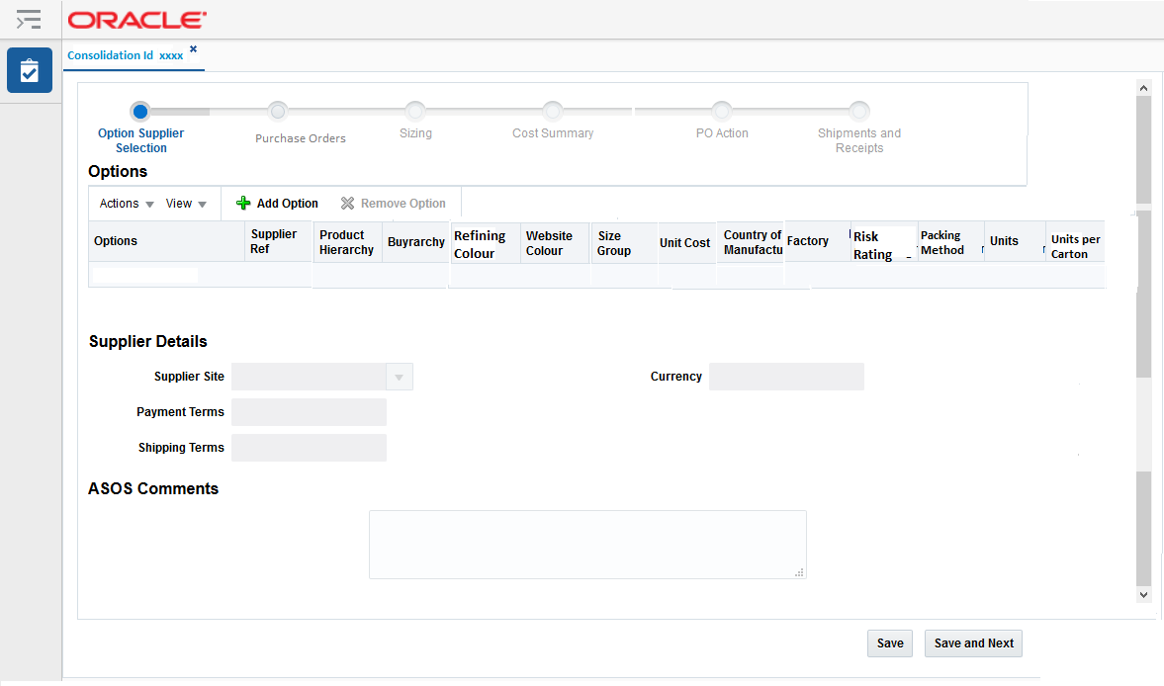
Option-Supplier Selection screen- Fig 1.11
Option-Supplier screen will be composed of 5 main areas:
    - Options – Table to add options to the order
    - Supplier site Details – Supplier site details that will default based on options selected.
    - ASOS Comments – In this section any ASOS internal comments associated with the PO can be entered.
    - Contextual Area (This has been already explained in the earlier section of the document).
    - Actions –Buttons

Options

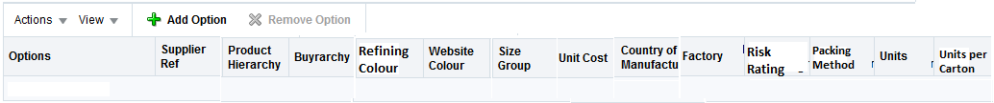
Options Panel – Fig 1.12

    - Functionality- When user will enter this screen to create a New PO then in this section user will select options to be placed on PO. User will be able to select at –
      - Options or Supplier Ref level.
      - In the result table options field, will have the option Id followed by the option description.
    - Based on selected option or supplier ref below fields will be defaulted in the table and would be non-editable-
      - Size Group
      - Country of Manufacture – If the Country of Manufacture was not known while creating an option, user would select ‘TBC’ on item micro app and this ‘TBC’ country will be defaulted on PO.
      - Product Hierarchy– An example of Product hierarchy could be –Day Dresses/Casual/Midi
      - Buyrarchy– An example of Buyrarchy could be – Womenswear Own Buy/ Core Knitwear/ Core Knitwear/NA
      - Refining Colour
      - Website Colour
      - Packing Method
      - Units per carton – This is defined for each option during the option creation process in item micro app.
- Below fields will be editable in this section-
      - Unit cost will be defaulted from item-supplier setup
      - Units – this field will be manually entered by the user. If the option has come from any recommendation it would have the units pre-populated. If user will try to edit this recommended units they will be get a message that they are modifying a recommended quantity. Do they want to continue? If the user selects to continue system will allow them to change he quantity.
      - This check will be performed only in PO creation process.
      - Factory- user would select an active factory associated to the supplier site from a drop down. The same factory could be associated with other supplier sites but the drop down will filter only those factories that are linked to the supplier site. The factory selection will further populate the following field and it will be non-editable-
- Factory Risk Rating
If the Country of Manufacture on option will be ‘TBC’ then user should select the dummy factory for that option. This dummy factory will also have its country set as ‘TBC’. However, for certain brands the country of manufacture could be correct on options but the factory would not have been identified. For supporting this business scenario, the dummy factory id will be set up as a column in system option table for micro apps. So that system will not run the validation of matching countries on factory and option.
Once the first option is selected then system will restrict the selection of next options to only
those options that has the same supplier site as the first option. System will also restrict the
option selection to the buying group and business model of the first selected option.
Thus, all the POs under one Consolidation Id will belong to same buying group.

Following rules/validation will be applied by the system when user will select a factory –
- System should check the risk rating of the selected factory from the CFAs/attributes held against the factory for risk rating. If the rating is Red Critical Prohibited, or Red Prohibited– then there should be an error which tells user that they can’t continue to raise a PO with this factory. The factory should also be in ’active’ status.
- User would be displayed with list of all factories belonging to that supplier. Based on user selection of factory system will validate if the country of Factory is same as that of option’s country of manufacture setup defaulted from item micro app. If these countries will not match, an error will be shown to the user and the user could not continue the PO creation process. User must either select a Factory that belong to the Country Of manufacture of the Option or user must go to item micro app to correct the Country of manufacture based on the country of selected factory.

The action bar will support below mentioned functionality.

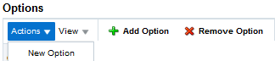
Options Panel Action Bar- Fig 1.13

- The ‘New Option’ under Actions tab will open Item Micro app, so that user can create a new option and add it to the PO.
- The ‘View’ tab in Action menu will allow user to re-order the columns, hide or unhide columns from the table.
- ‘+ Add Option’ will allow user to create a new row in the table.
- ‘X Remove Option’ will allow user to remove any selected option from the PO.

Supplier Details

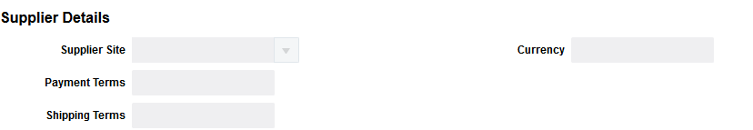
Supplier Details Panel – Fig 1.14

    - Functionality- When user selects the first option in Options section the following details will be defaulted in Supplier Site details section-
      - Supplier Site (defaulted from primary supplier but user can select another supplier site from drop down, if dual sourced). As there is no dual sourcing for Release 3, thus this field is disabled. The supplier site should be in Active status to be used on PO.
      - Payment Terms (non-editable)
      - Shipping terms (non-editable)
      - Currency – defaulted to the selected supplier currency (non-editable)

    - Based on first option selected in Options section, following rules will apply on further option selection-
      - Any other option that is added after first option should always be against the same supplier, as of the first option. If user will try to add any option that fails this validation, the option will not be added and following error will be shown to the user-
‘Selected Option does not belong to the defaulted supplier site’.

–ASOS Comments
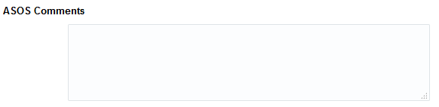
PO Comments Panel – Fig 1.15

Functionality-
    - User will be able to associate some comments as additional commentary on PO. These comments will be used internally within ASOS.
    - This comment will not be interfaced to the Supplier or other downstream applications.

Contextual Area

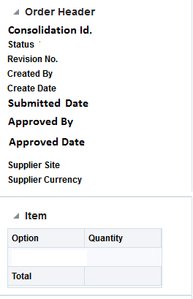
Contextual Area – Fig 1.16

Functionality-
    - When user will enter this screen to create a New PO then in this section Order Summary part will be populated for these fields based on the selected options and supplier details –
      - Consolidation id.
      - Status – Defaulted to Worksheet.
      - Created By
      - Create Date
      - Supplier Site
      - Supplier Currency

    - For new PO, Items section in Side Bar will be populated for these fields –
      - Options (the option no. here will appear as a link, by selecting on this link user will move the item micro app and can edit the option in item micro app).
      - Quantity Ordered
      - Total (Sum of quantity ordered for all options in the PO).

Actions – Push Button
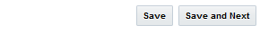
Push Buttons – Fig 1.17

Functionality-
    - When User will select the Save button the data present on the form will be saved.
    - When user will select Save and Next while creating a New PO the data present on screen will be saved and user will move to the next screen- ‘Purchase Orders’.

When user select the ‘Purchase Orders’ tab in the train structure, the user will be prompted to save the data in Option-Supplier selection screen

Following amendments will be allowed on this screen -
1. User would be able to update the unit cost of the option in this screen until any receipts exists on one of the PO. If any receipts exist, then user would not be allowed to change the unit cost. The change in unit cost on the option will result in recalculation of PO’s Duty, total landed cost and margins.
User would be displayed with a YES/NO message that if they would like to update the unit cost, as this action will update the cost on all POs for that option, under the consolidation id.
2. User would not be allowed to add or remove any new option on this screen, once PO is approved. Thus ‘+Add/Remove option’ icon on the screen will be disabled once the PO has been approved.
3. Change in factory and units will only be allowed in ‘Purchase Order’ screen, once a PO is in approved status. Thus, these fields will be non-editable in the screen once PO is approved.

Screen Logic – Purchase Orders

The below screenshot is updated with Label changes and re-ordering-

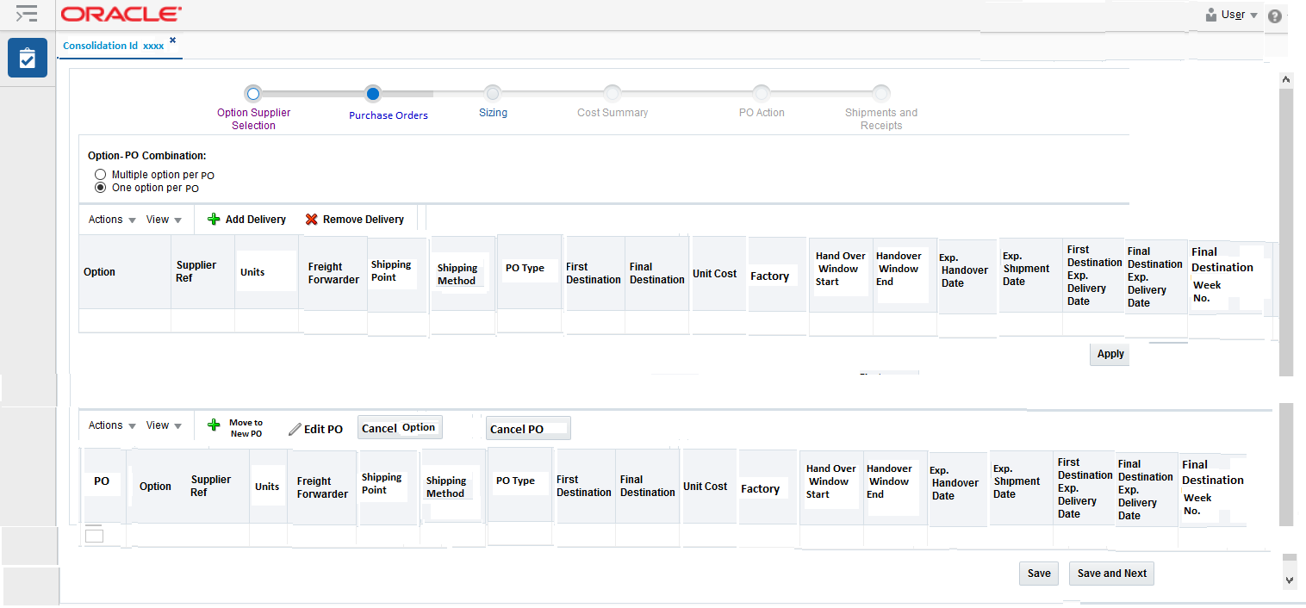
Purchase Orders screen – Fig 1.18

The Purchase Orders screen will be composed of 5 main areas:
    - Option-PO combination
    - PO Selection
    - PO
    - Contextual Area
    - Action – Push Buttons

Option-PO Combination
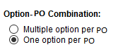
Option-PO Combination – Fig 1.19
User will have the option to either create PO with one option or with multiple options. By default, one option per PO radio button will be selected.
This section will be disabled once a PO is in Approved status.

PO Selection

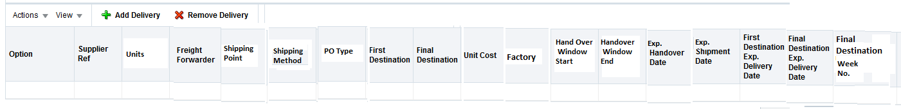
PO Selection Panel – Fig 1.20

In this section user, will see each option that he has selected in Option-Supplier’ screen. This table would be a tree table with Option as the drill down column. For each of these options this section would already have the 3 Fulfilment Centres/warehouse line created. User can add more lines by selecting the ‘+ Add Delivery icon’ or can remove an existing line by selecting ‘X Remove Delivery’ icon.
    - These fields will be pre-populated in the header line and child lines of the tree table based on the Option-Supplier Selection Screen-Options
    - Supplier Ref
    - Units
    - Unit Cost

Following fields on the child line will be pre-populated based on the CFAs/attributes set at factory level and if the CFAs/attributes are not set at factory level, these fields will be populated based on the supplier site import attributes-
    - Freight Forwarder
    - Shipping method (for first destination)
    - Shipping Point

This table or section will be disabled once a PO is in Approved status.

Order_type will be defaulted to ‘Direct’ in all the child lines but user would be able to change it Split or Automated as per their PO creation requirement.
Freight method for Destination (in case of split/automated POs) will also be fetched in this table but will be not be visible to the user in default view. However, user can view it by selecting on the ‘View’ drop down and selecting ‘All Columns’ from drop down.
For Release 3 the assumption is there will be single Freight method between FCs. In future if multiple freight methods will be supported then this will require a change in PO micro app to always show this field to the user on screen and allow them to select a specific freight method in case of split/automated POs.
Similarly, Ex-factory date will be calculated by subtracting from Exp. Handover date, the default days’ setup on factory as a CFA/attribute. The Ex-factory date will also not be visible in the default view. If there will be no factory assigned, then Exp. Handover Date = Ex-Factory date.
User would be able to select the Exp. Handover date in child line, which will calculate following dates in child line based on the Transit Time matrix and calculate the Handover window based on the handover days setting in the micro app system options -
    - Handover Window Start
    - Handover Window End
    - Ex-Factory Date (This date will be calculated but would remain hidden, if user wish to see it they can click on ‘View’ icon that will allow them to view this hidden column’
    - Exp. Shipment Date
    - First Destination Expected Delivery Date
    - Final Destination Expected Delivery Date

As part of code drop 3, user would be able to modify the Expected Delivery date on First or destination as explained below-
If the user, then changes the calculated First Destination Exp. Delivery Date then all these date fields will be calculated using Transit Time Matrix and calculate the Handover window based on the handover days setting in the micro app system options -
    - Handover Window Start
    - Handover Window End
    - Exp. Handover Date
    - Exp. Shipment Date
    - Final Destination Expected Delivery Date
    - Ex- factory Date
Similarly, if the Final Destination Expected delivery date is changed by the user then above-mentioned dates will be recalculated, including First Destination Exp. Delivery date.
If user has specified only the Handover window i.e., Handover window Start and Handover Window End, then the Exp. Handover Date = Handover window start and the logic to calculate rest of the dates will be driven as usual from Exp. Handover Date,
Week no. would be calculated and displayed as non-editable field for Final Destination Exp. Delivery date.
Transit Time matrix template for PO- (data entry in the template is just provided as an example). This template will be maintained by Inbound Supply chain team.
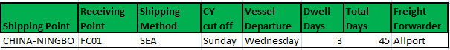
Transit time Matrix – Fig 1.21
Details of the fields in this template is provided below-
- Shipping point – Lading Port where supplier will hand over the goods to carrier.
- Receiving point – ASOS warehouse where goods are received.
- Shipping Method – Freight method used for shipping the goods.
- CY Cut off - Cut off day of the week by when supplier should deliver the goods to make to on the up-coming vessel departure.
- Vessel Departure – Day of the week when vessel depart the port.
- Dwell Days – No. of days between CY cut off and vessel departure
- Total Days – Total no. of days from the time supplier hand over the goods and goods are received in warehouse. Please note that this no. is just a projection for calculating expected dates on PO. This total no. of days is inclusive of dwell days.

The Inbound supply chain team has confirmed that; they will include the re-processing days in the same transit matrix.

Transportation Time matrix between FCs- (data entry in the template is just provided as an
example). This template will be maintained by Inbound Supply chain team.

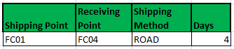
Transportation time Matrix between FCs – Fig 1.22

Details of the fields in this template is provided below-
- Shipping point – First Destination warehouse from where goods are being shipped.
- Receiving point – Final Destination warehouse to where goods are shipped.
- Shipping Method – Freight method used for shipping the goods.
- Days – Total no. of days from the time goods leave First destination and are received at Destination.

In following diagram represent the flow of calculation of dates on PO from Exp. handover date-
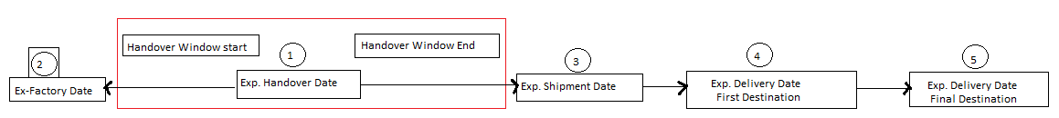
Date calculation Flow – Fig 1.23

An example on date calculation on PO-
- If the Exp. Hand over date is provided by the user as 03-Apr-2017
- System should identify which days of the week is Exp. Handover date (03-Apr-2017 which is – a Monday)
- Handover window start = Exp. Hand over date (Exp. Hand over date will be copied to Handover window start)
- Handover window end = Handover window start + handover days defined in micro app system options (in this example defined as 7 days)
- Ex-factory date = Exp. Handover Date – Ex. Factory days set as CFA/attribute against the factory. If no factory is specified, then Ex-factory date = Exp. Handover Date.
- System will then select the CY cut off, dwell days from Transit Time Matrix by matching the following fields from PO-
- Shipping point
- First destination
- Freight method
- Freight forwarder

Then it will calculate the shipment date as follows-
Exp. Shipment Date = Exp. Hand over date + (no. of days required to meet the coming
CY_cut_off
day) + dwell days

So, in our example it would be –
Shipment date = 03-APR-2017 + 6 days (between Monday i.e. our Exp. Handover Date day to
coming cy cut off day which is Sunday) + 3 days = 12-APR-2017

If in the above example the exp. hand over date day would have been Sunday which matches
with CY cut off day then the value of no. of days required to meet the coming CY_cut_off day
would have been 0.

- First Destination Expected delivery date = shipment date + (total days – dwell days) = 24-May-2017

- If PO_TYPE = ‘Direct’ then First Destination Expected delivery date = Final Destination expected delivery date

- If PO_TYPE have been Automated/Split, then fetch ‘days’ from Transit time matrix between FCs by matching the following fields on PO-
- First Destination
- Final Destination
- Final Destination shipping method

So, the Destination expected delivery date = First destination expected delivery date +
‘Days’ from Transportation Time matrix = ’24-May-2017’ + 4 = 28-May-2017.

Please note that the transit time matrix will be used for all suppliers independent of their shipping terms.

PO

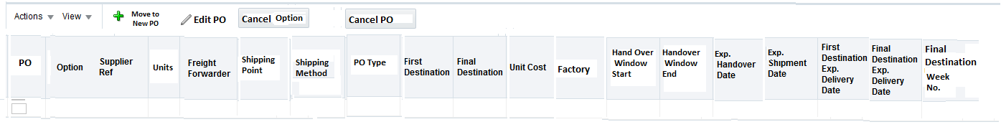
PO Panel – Fig 1.24

This table will be populated with the PO details that are created after user has filled all the details in PO selection section and has hit the Apply button. Details of the Apply button are mentioned in Action-Push Button this table will be a tree table with drill down at PO column. The header line will represent the PO information while child line will represent the information at option level in that PO. However please note that all the date fields will be defaulted from header line to child lines and these dates will only be tracked at PO level not at individual option level under a PO.
Order Type will be populated for both header and child lines; however, the Order Type at header line will dictate the Order Type at order level and will be stored in RMS against PO. The Order Type ate child level will not drive any functionality; it is just for visibility purpose to Retail team.
All the fields in this table are same as in the ‘PO Selection’ section, only new field in this table is the PO. This will be the PO number generated by the system.

Functionality of ‘Edit PO’ icon –
This icon will be enabled while amending/editing a PO. Any cancelled PO could not be amended. Thus, the icon will be disabled when user will select any cancelled PO for editing. All the cancelled PO will appear on ‘Purchase Order’ screen with units as 0. During creation of PO, this icon will be disabled. When user will select this icon, following pop-up will be shown to user for amending PO-
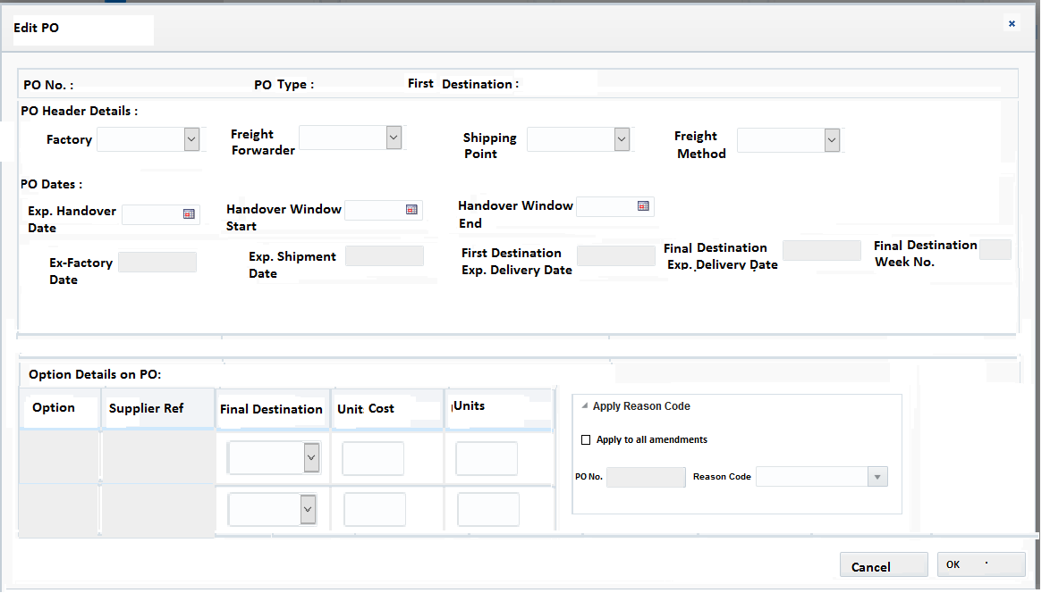
PO Edit Pop-up – Fig 1.25

Following Amendments will be allowed on PO-
- Amending Factory-
Change factory on PO – In this case user would update the Factory value directly on the pop-up. Based on the updated factory the relevant shipping point, freight method and freight forwarder will be updated on PO from factory setup. If the factory does not have this setup, then the defaulting of all these fields will happen from supplier site import attributes. These changed attributes on PO must trigger the PO Expenses, Duty, Total Landed Cost and margin re-calculation. Also, the ex-factory date and other PO dates will get recalculated based on revised shipping point, freight method and freight forwarder. User would be able to amend these defaults however, system will check if the combination of shipping point, freight method and freight forwarder will exist on transit time matrix. The update on factory will be allowed only if the PO does not have any associated shipment record. System will also apply the factory validation rules that are already explained in section 4.2.1.1, when user will amend the factory on a PO.

- User would be allowed to amend the quantity of the option on PO, this would also result in recalculation of Expenses, Duty, Total Landed Cost and margin. However, the update should meet following criteria’s-
- This updated quantity should qualify the ‘minimum order quantity’ and ‘supplier order multiple’ set for the option.
- User would be able to increase the quantity of the option provided the options has not been fully shipped as per the original PO quantity.
- User would be able to decrease the quantity of the option, provided this quantity is more than the sum of all ASNed quantity of this option on this PO.
- User would have to distribute the option quantity for each Final Destination in case of split/automated POs.

- User would be allowed to change the Exp. Handover date of PO until no ‘Carrier Booking Date’ exist for the PO. This should re-calculate the other dates on PO.

- User would be allowed to change the Handover Window End date. This update will not result in any re-calculation of other PO’s dates. As of now there is no business rule defined for updating this handover window end date. Thus, PO micro app will allow updating this date until the PO is closed.

- Allow user to change the Final Destination on PO if the PO Type is Automated or Split. User would be able to update the Final Destination in ‘Options Detail Section in PO’. For split PO user, would be able to update final location only if no shipment exists against the PO for Final Destination. For Automated PO user, would be able to update the Final Destination if there is no receipt against PO.
This update on Final Destination will result in following actions-
- The allocation existing for the original Final Destination location will be closed.
- A new allocation will be created for the new Final Destination location.
System will not support changing the location on a PO, only the location of Final
Destination (Allocations) can be amended as per point a and b mentioned above. New
Allocation numbers will be generated for the new Final Destination.

- User would be allowed to update the unit cost of the option on PO until its first receipt. This will also result in re-calculation of duty, total landed cost and margin.

- Whenever a user will amend a PO and select OK button without attaching a reason code, they will be prompted to select a reason code and system will not allow them to go any further. If at this stage user will press Cancel, then no amendments will be saved for the PO. Otherwise, user would select a relevant reason code and can press OK to save the amendments on the PO along with reason code. Please note if user wish to make further amendments on PO in next screens, then it would be better for them to select the check box – ‘Apply to all amendments’ so that they will not be prompted to apply a reason code again in next screens. The expectation is if user would intend to change multiple fields on PO then they should use a more generic reason code and select this check box. Otherwise system will capture the latest reason code user has put against the PO and will store it against the PO revision.

Functionality of ‘+Move to New PO’ icon –
This icon will be enabled while amending a PO. During creation of PO, this icon will be disabled. User would be able to select any specific option line/lines from existing PO and could click on this icon to move these specific options to a new PO. This action will be allowed only if no shipment information exists for the option/options on that PO. User would not be able to select a Cancelled option on a PO to move into a New PO. Thus, for such options this icon will be disabled.
When user will select this icon, following pop-up will be shown to the user-
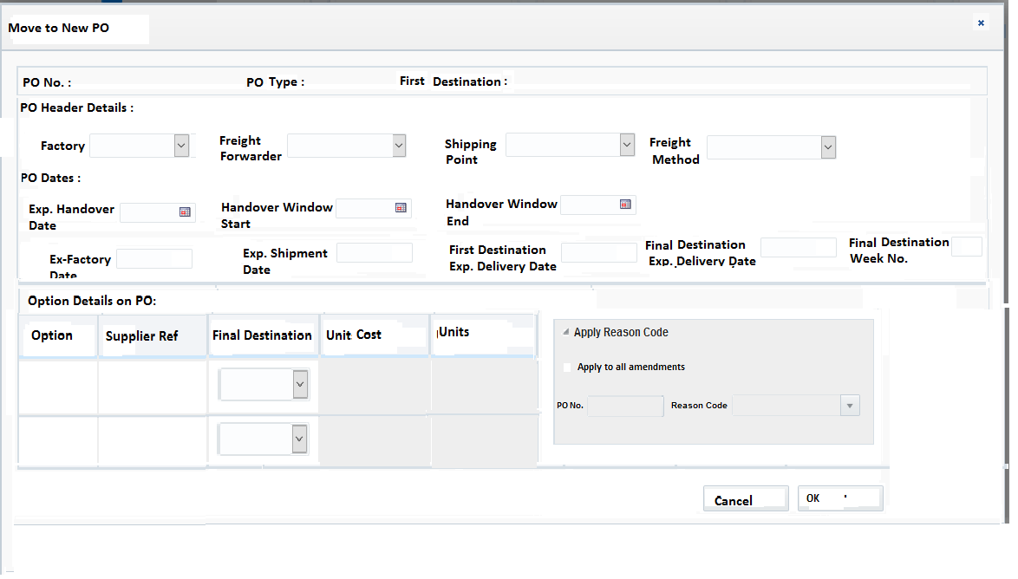
Move to New PO Pop-up – Fig 1.26
Change factory on option - If user want to update the factory of a specific option under a PO, then also user would have to move this option to a new PO using ‘+Move to New PO’ icon. This is due to the business rule that a PO would belong to a single factory. This action would copy the factory from original PO to new PO, however user would be able to override it with the factory of their choice, which would then apply the same system logic to re-calculate dates and cost and other attributes on PO (as explained in Editing PO section specifically for factory). This action would be allowed only if no shipment record exists for that option-PO combination. The option/options that are moved to new PO will be cancelled from original PO and their any onward allocation will be closed. New Allocations will be created for newly created PO in case of split/automated PO. System will also apply the factory validation rules that are already explained in section 4.2.1.1, when user will amend the factory on this new PO.

- In some business scenarios if the option/options production is delayed or any other reason due to which user would like to move the options from a PO to new PO, they would use this functionality. All relevant details will be copied over from original PO to new PO except for the dates (if the Exp. Handover Date on original PO is in past) and user would have to define an Exp. Handover Date. The option/options that are moved to new PO will be cancelled from original PO and their any onward allocation will be closed. New Allocations will be created for newly created PO in case of split/automated PO.
- This new PO would be created with the same Consolidation Id and would be created in Approved status.
- User would not be able to select multiple options from different POs to be added in a new PO.
- User would not be able to modify the copied unit quantity and unit cost of the option on new PO. As this new PO would already be created in Approved status thus it will not reflect on PO Re-Approval Dashboard. Thus, this restriction on unit qty and unit cost will ensure that if user would like to amend the units or qty on this new PO, they will amend it only after the PO is created, in this way that amendment will reflect on PO Re-Approval dashboard.
- New PO would be added at the end of PO table in Purchase Order screen and would copy all details from original PO except for PO dates, if the Exp. Handover date of the copied option is in the past. If the Exp. Handover date is in future, all dates would be copied over but they would remain editable for user. User would have to select an Exp. Handover date to calculate rest of the dates on this new PO, if the dates are not copied.
- Apply reason code section will be disabled in the pop-up, as user is creating a completely new PO.

Functionality of ‘Cancel option’ Push Button –
- User would be able to select any specific option line/lines under a PO and can cancel these options from PO by pushing the Cancel Option button. This will be allowed only if no shipment exists for that option/PO combination.
- With the above action of user, the cancelled options line would show units as 0. However please note that in base RMS this will update the cancelled qty bucket against the PO/option combination.
- Once an option is cancelled from PO, its associated allocation will also be closed. This will apply to both Automated and split POs.

Functionality of ‘Cancel PO’ Push Button –
- User would be able to select any specific PO and can cancel it by pushing the Cancel PO button. This will be allowed only if no shipment exists for that PO. For cancelling the partially shipped or partially receipted PO, user would use the PO Mass Cancellation screen. As they would view this information of shipment and receipts via PO dashboard and they would select the list of POs from dashboard and would load this list in PO Mass maintenance screen, to take necessary action.
- If the cancelled PO was of PO type Split or automated, then it’s all corresponding allocations will be closed.
- With the above action of user, the cancelled PO would show all options with units as 0. However please note that in base RMS this will update the cancelled qty bucket against the PO/options combination.
- When user will select the ‘Cancel PO’ button following pop-up will be shown to user to attach the reason code for the PO cancellation.
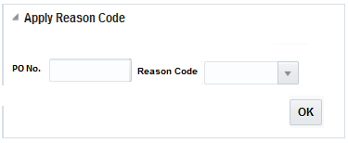
Apply Reason Code Pop-up – Fig 1.27

Contextual Area
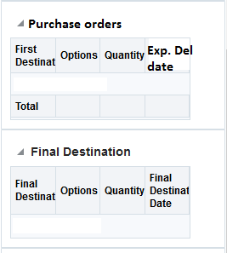
Contextual Area – Fig 1.28

The contextual area will be updated with relevant details in Purchase Orders and Final Destination section.

Action Push buttons
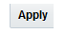
Push Buttons – Fig 1.29

- Save button – The functionality of Save button will remain same as explained in the Action Push buttons section in ‘Option-Supplier selection’ screen.
- Save and Next – The functionality of Save button will remain same as explained in the Action Push buttons section in ‘Option-Supplier selection’ screen.
- Apply Button – This button will run the logic to create the POs and other important validations as mentioned below-
- It will check if the units at header line do not match with the sum of child lines.
- It will check if the units at child line met the criteria of minimum order quantity and order multiple set for the option.
- It will combine the different child lines based on one option Vs multiple option per PO combination and will create the PO on basis of these fields-
      - PO Type
      - First Destination
      - Exp. Handover Date
      - Shipping Method
      - Freight Forwarder
      - Shipping Point
      - Factory
- If the one option per PO was selected, then in PO section will have entries of only one option under each PO. If multiple options per PO were selected, then in PO section each PO will have rows for all options that belong to the PO.
- User could choose any of these combinations on respective options before hitting the apply button-
a. Direct +Split
b. Direct + Automated
c. Direct +Automated +Split – In this specific case the Direct and Automated line of options will be clubbed under one PO (with PO Type as ‘Automated’) if all the criteria mentioned in point 3 are matched for both lines. However, the split line of the option will become a PO on its own with PO type as split. This split PO would be created with a 100% onward allocation from First Destination to Final Destination.
The business reason for combining a Direct and automated line is- An Automated PO cannot exist on its own because the supplier has no visibility for the Final Destination.
However, in case of split they know the Final Destination. Thus, it is easier to have a split PO on its own as a 100% cross dock compared to an automated PO.
Also, the three different types cannot be combined in one PO as the downstream systems for e.g., warehouse have different processes for split and automated PO. Thus, keeping them separate will be in-line with warehouse functionality.

Screen Logic – Sizing

The below screenshot is updated with Label changes and re-ordering-

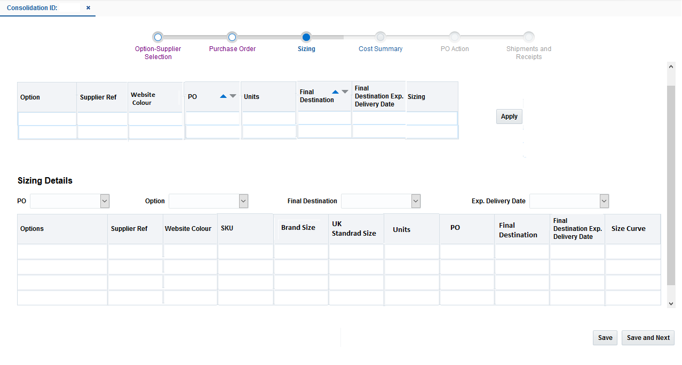
Sizing Screen – Fig 1.30

Sizing screen will be composed of 3 main areas:
    - Apply Size Curve
    - Sizing Details
    - Actions – Push Buttons
The Contextual area does not have any specific information on sizing.

Apply Size Curve

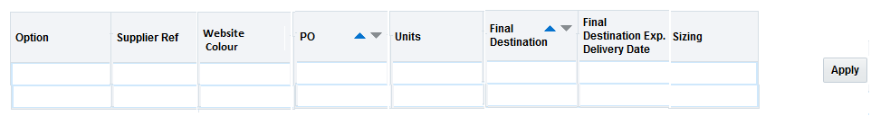
Apply Size Curve Panel – Fig 1.31

User will always apply sizing for Final Destinations independent of PO type. Thus, in this section user will be displayed with all the Options /FCs (Final Destination)/ Final Destination Exp. Delivery Date combination. All these columns will be carried over from Purchase Order screen to the Sizing screen. An additional column ‘Sizing’ is present on this section. This column will show the user if they have done the sizing for that specific line or not. For the rows where user has applied any sizing will have ‘Sizing’ column as ‘Y’ otherwise it will be ‘N’.
All the fields in the table shown in above table will be pre-populated. The quantity ordered field will be populated with the actual quantity that needs to be received and kept in the specific destination fulfilment centre.
When user will select a specific line in above table and click on Apply Button, following pop-up will be shown to the user, where they would have the flexibility to either apply Manual Sizing or select a size curve for the option.
Website colour will also be shown to the user in this table.

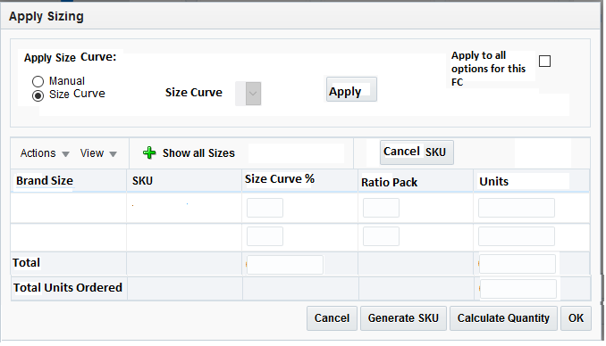
Apply Sizing Pop-up – Fig 1.32

Functionality:
    - When user enters this pop-up to apply Sizing, they will be able to apply it in two ways–
      - Manually
      - By Size Curve
    - When User will select the Manual radio button and select Apply, the pop will be updated as mentioned below-–

      - If the selected option already has sizes defined along with SKU numbers, they will appear in the Sizes and SKU column.
      - If the selected option does not have any SKUs (new buy) then all the sizes related to the size group of the options will be displayed in the Sizes column. User could then split the total quantity of the option manually on these sizes by either percentage or ratio or quantity. User will then select on ‘Generate SKU’ push button to generate the SKUs for these sizes. If user will not allocate any quantity on a specific size, then its associated SKU will not be generated. User would be able to generate the SKUs on an approved PO.

      - If the option already has SKUs for some sizes, then by default all these sizes will be shown in the pop-up. But if user want to see the sizes that does not have any SKUs generated yet, they will select the +Show all sizes icon, this will refresh the result in pop-up and will show all the sizes in the result table. The current working assumption is the sizes with already existing SKUs will be in the top followed by sizes without a SKU.
      - Once user has reviewed all the details on this pop up they can select ‘OK’, this will populate the table in Sizing Details section.
‘Total’ row in the table shown in above table will sum all the quantity across different sizes, this sum should match with the ‘Total Units Ordered’ in the row below. If based on the rounding rules (any value greater or equal to x.5 would be rounded to x+1 and any values less, then x.5 will be rounded to x). the total qty becomes less or more then the order qty, system will update the Order qty with this revised Total quantity, so that user does not have to do any re-distribution.
Total row in the table will also show the total of % that user would have assigned to the sizes. The Total % will be shown to the user when user will press the ‘OK’ button or ‘Recalculate Quantity’ button. System will validate if the % user has allocated is 100% or not. If not, system will not calculate the quantity distribution unless user will make the total as 100%.
    - When User will select the radio button of ‘Size Curve’, the drop down for Size Curve will be enabled. This drop down will be show a filtered list of size curve that will belong to the size group of the selected option and the FC combination in size curve tables interfaced from Sizing tool as size curve libraries.
      - Once user will select an appropriate Sizing curve from drop down and select the Apply push button. in this pop up window based on the sizing curve the Sizes and quantities will be already filled. If the SKU number for these sizes already exists they will also be displayed. But if the SKU number does not exist (new buy), user can generate the SKUs by selecting ’Generate SKU’ push button.
      - When user would have selected the size curve then system will first show those sizes in Brand Size column that belong to the curve. If user then wish to see other sizes as well that belong to the size group of the option but not present in size curve then they will press the ‘+Show all sizes’ button.
      - User would be able to the edit the % against any size that is being defaulted from the curve. But this will mean that user is overriding the curve thus this size curve will not be stored against the option and it will be treated like a manual sizing. The updated % on size curve distribution on any size would be systematically prorated to other sizes in the curve.

      - Total row in the table will sum all the quantity across different sizes, this sum should match with the Qty Ordered in Header section. If based on the rounding rules the total qty becomes less or more then the order qty, system will update the Order qty with this revised Total quantity, so that user does not have to do any re-distribution. The check box on sizing pop up – ‘Apply to all options for this FC’ will only be enabled when user has done the size distribution using size curve. If user has done it via manual sizing, then this check box will be disabled. Total row in the table will also show the total of % that user would have assigned to the sizes. Usually in case of size curve this total would be 100% but if user will amend the size curve by changing the % then this Total row will be populated with updated value. The Total % will be shown to the user when user will press the ‘OK’ button or ‘Recalculate Quantity’ button. System will validate if the % user has allocated is 100% or not. If not, system will not calculate the quantity distribution unless user will make the total as 100 %.

      - The check box for ‘apply to all options for this FC’ will only be displayed to user when they choose to do sizing via size curve instead of manual. If the ‘Apply to all options for this FC’ will be selected by the user then following business rules will apply –
- The size curve selected by the user will only be applied to those options coming to that FC, which have same size group as that of the size curve.
- The next check system will do is to see if the sizes of such options exactly matches with the sizes defined in curve.

      - For all the options that will match the above two business rules, system will automatically do the size distribution and will mark the ‘Sizing Applied’ column as ‘Y’ for the options-FC combinations.
      - For those options, which will fail the above business rules, user should select them individually to do the size distribution.

    - When user has not applied the sizing to the option/Exp. Delivery Date/FC combination, that line will have ‘Sizing’ column set as ‘N’ and it will be highlighted to the user. Once the sizing is applied for that specific line, the Sizing column will be changed to ‘Y’ and it will not be highlighted anymore.
    - User would be able to Cancel a specific SKU on this pop-up if no ASN exists for that SKU on the PO.
    - User would be able to use the tab in the pop-up to move vertically between the rows.

Sizing Details

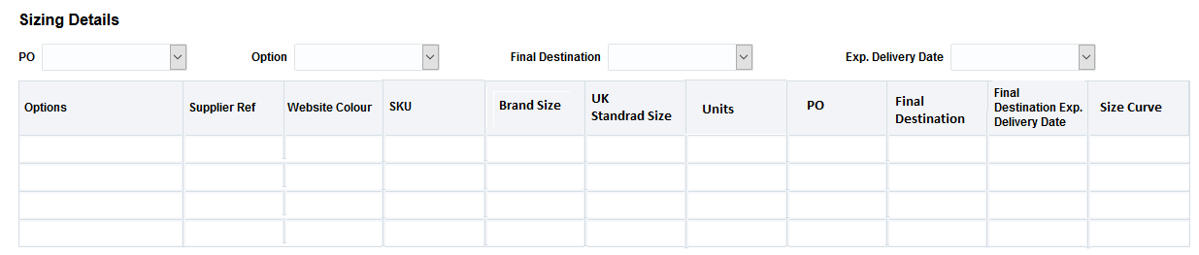
Sizing Details Panel – Fig 1.33
Functionality:
    - When user selects the OK button in the ‘Apply Sizing’ pop up it will populate the details shown in the above table.
    - This table will be non-editable.
    - This table will be drilled down at option level. When user will select the relevant option in the table, all the sizes selected by the user on PO will be shown under that option.
    - By default, all the Options /Final Destination/Exp. Delivery Date will be displayed in this table but if user wants to look at a specific option or FC or their combination with Exp. Delivery date, they will be able to select them in the drop down. Since it’s a tree table thus query by search functionality is very difficult to implement so the filters are provided.

–

Actions – Push Button
Push Buttons – Fig 1.34
Below section describes the functionality of the push buttons-

- Save button – The functionality of Save button will remain same as explained in the Action Push buttons section in ‘Option-Supplier selection’ screen.
- Save and Next – The functionality of Save button will remain same as explained in the Action Push buttons section in ‘Option-Supplier selection’ screen.

Following amendments will be allowed on this screen -
Amending Quantity -
- If user would have amended the option quantity in ‘PO’ screen, then for that option, the Sizing column will become ‘N’ in Sizing screen. User would not be able to Save his changes on PO screen, if they have not applied the sizing on the modified quantity. The system will force them to follow the train structure. Thus, user should have to re-distribute the modified quantity to all SKUs in following ways-
- If user had applied the manual sizing earlier for that option, then system would not recalculate the SKU distribution for the modified option qty and user would do the distribution manually.
- If user had applied a size curve earlier, then system will retain that size curve in the pop up window with the distribution and when user will hit the ‘Recalculate Quantity’ button it will re-apply the sizing curve on modified option quantity.
- In the condition mentioned in above point 2, if user would remove a SKU from previous curve distribution or add a new SKU to the distribution then system would not re-calculate the quantity based on the size curve, as the original size curve has been modified and user should do the sizing distribution manually.
In all the above three cases if the quantity amendments are being done after ASNs
exists on the PO, then on the click of OK button of the pop-up, system must check if
the updated SKU quantity has not become less then the ASNed SKU quantity. User
would not be allowed to proceed further unless they fix the distribution.

- User can come to sizing screen directly and can update a SKU quantity on the pop up as well. When user will click OK on the pop up, system must check if the updated SKU quantity has not become less then the ASNed SKU quantity. Also, this change in SKU quantity will update the total quantity of the option on the PO. If this amendment was done on a size curve distribution then the original size curve will not be retained, as it has been now modified by the user.

Whenever a user will amend a PO, below pop up will be shown to the user to apply a reason code for the amendments on click of OK button. User would not be allowed to go further unless they select a reason code. User would select a relevant reason code and can press OK to save the amendments on the PO along with reason code. Please note if user wish to make further amendments on PO in next screens, then it would be better for them to select the check box – ‘Apply to all amendments’ so that they will not be prompted to apply a reason code again in next screens. The expectation is if user would intend to change multiple fields on PO then they should use a more generic reason code and select this check box. Otherwise system will capture the latest reason code user has put against the PO and will store it against the PO revision.
Please note if user have made earlier amendments on PO in previous screens, then the latest reason code they would select against the PO in this screen, will be stored in RMS database for that PO revision. The expectation is if user would intend to change multiple fields on PO then they should use a more generic reason code. The list of reason codes is defined by the Retail team.

Reason Code pop up – Fig 1.35

Screen Logic – Cost Summary

The below screenshot is updated with Label changes and re-ordering-

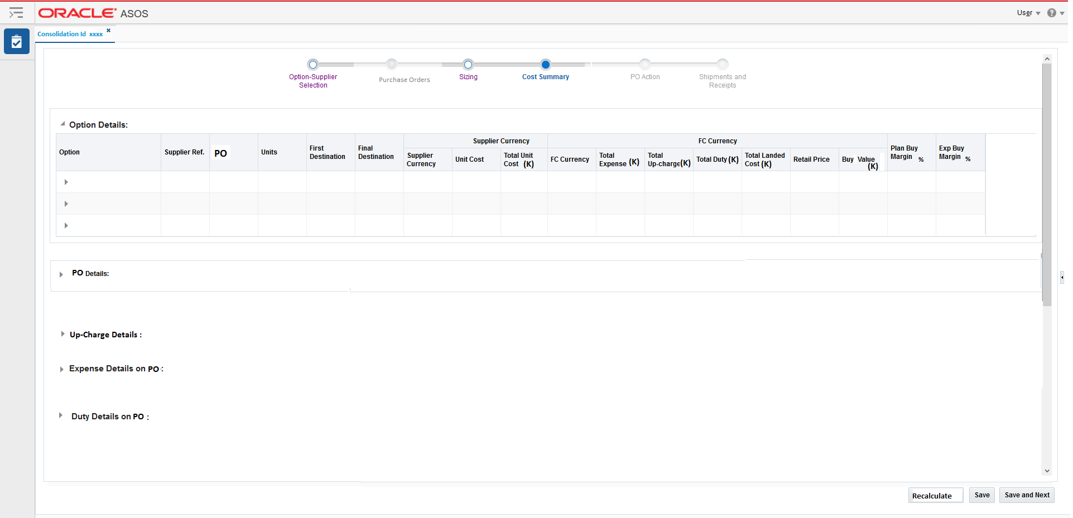
Cost Summary Screen – Fig 1.36

User will be able to review the cost break down for the PO in this screen. The details for cost will be available at option level and PO level as well.
Cost Summary screen will be composed of 6 main areas:
    - Option Details
    - Up-charge details
    - PO Details
    - Expense Details on PO
    - Duty Details on PO
    - Actions- Push Buttons

Option Details

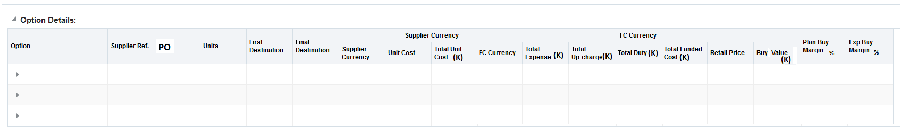
Option Details Panel – Fig 1.37
Functionality:

- This section will be non-editable for the user. This table will be a tree table with drill down at Option level. When user will select the option level on header line, it will unfold or show all the child line with details of this option included in different PO. By default, on this table only the Option header line will be visible. If user wants to see the details of this option against each PO they would have to select the Option drill down.
- All the fields in this section with (k) will be displayed in thousands with two decimal places.
- All other cost or retail related values will also be shown up till two decimal places.
- All the currency fields in the above table are kept under two sections-
- Supplier Currency – Unit Cost, Total Unit Cost
- FC Currency – Total expenses (K), Total Up-charges (K), Total Duty (K), Total landed Cost(K), Retail price and Buy Value (K)
- Retail price would be VAT inclusive and its value would be the price set for the Final Destination warehouse based on the RPM zone it belongs to. The concept of brining it from dominant store is now changed to warehouse retail price fetched from RPM zone to which warehouse belong.
- There will be two separate margin fields and they are always displayed in % –
- Plan Buy Margin%
- Exp. Buy Margin %

- Details of each of the currency fields are mentioned below –
- Unit Cost – Unit cost of the option on PO.
- Total Unit Cost (K) – Unit Cost * No. of units of the option on PO.
- Total Expense (K) – Sum of all the expenses attached to the option in respective PO * No. of units of the option on PO. Expenses will be calculated only if the supplier shipping terms are in ‘FOB’ or ‘Ex-Works’. For DDP suppliers it would be only re-processing cost if they have re-processing freight forwarder attached.

Below section provides a detail view on the Expenses on PO-
The Expenses on a PO will be calculated from following three costs-
- Freight Cost
- Labelon Cost
- Re-processing Cost
The defaulting of above cost on PO will depend on the supplier site import attribute setup. The data setup of supplier should be done in such a way that the respective Freight Forwarder is attached to the supplier site Import attribute as Partner Type 1 and Labelon should be attached as Partner Type 2. Please note that there will very few suppliers who would have Labelon attached as partner. In the to-be world Re-processors would still be configured as ‘Freight Forwarder’, this process remains same, as it is in as-is world. Thus, any re-processing on a PO would be identified based on the Freight forwarder attached to it.
Freight cost will be defaulted from Freight cost matrix. Please note that apart from FOB and Ex-works supplier, there are 14 DDP suppliers for whom ASOS incurs the freight cost. But, (as per the information from Inbound Supply Chain team) these 14 DDP suppliers will be moved to ‘FOB’ or ‘DDP’.

Freight Cost Matrix Template – (data entry in the template is just provided as an example). This template will be maintained by Inbound Supply chain team.

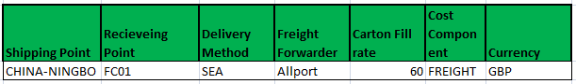
Freight Cost Matrix – Fig 1.38

Carton fill rate will be used to calculate the freight cost on each unit. This carton fill rate defines the rate of shipping one carton from Shipping Point to Receiving Point. This carton fill rate will be divided by the ‘Units Per carton’ attribute setup against the option in item micro app, to provide the freight cost for each unit of the option. The carton fill rate will be picked up based on the matching- Shipping Point, Receiving Point, Delivery method and Freight Forwarder from PO.

Labelon Cost – This cost will be setup in Base Expense Profile. Labelon will be set up as a partner and will be attached to supplier, as explained in above section. This cost will be a flat rate, thus can be applied directly on each unit of the option on PO.

Re-processing cost – This cost will be setup in Base Expense Profile and will be maintained by the Inbound Supply Chain Team. Re-processors will be set up as Freight forwarders and will be attached to supplier, as explained in above section. Each supplier could have different re-processing cost which would be identified in the expense profile by matching the supplier site on PO and the supplier site on expense profile.
- Total Up-charge (K) – This field will be populated only for those options which are part of split or automated PO. This field would be the sum of all the up-charges attached to the option in respective PO * No. of units of the option on PO.
Below section provides a detail view on the Up-Charges on PO-
The Up-charges on a PO will be calculated from following two costs-
- Transportation cost
- Handling Cost
The defaulting of above cost on PO will depend on type of PO as being Split or automated. The transportation cost would be defaulted from Transportation Cost Matrix and handling cost from Handling Cost Matrix.

Transportation Cost Matrix Template – (data entry in the template is just provided as an example). This template will be maintained by Inbound Supply chain team.

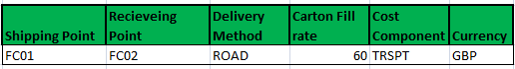
Transportation Cost Matrix – Fig 1.39

Carton fill rate will be used to calculate the transportation cost on each unit. This carton fill rate defines the rate of shipping one carton from Shipping Point to Receiving Point. This carton fill rate will be divided by the ‘Units Per carton’ attribute setup against the option in item micro app, to provide the transportation cost for each unit of the option. The carton fill rate will be picked up based on the matching- First Destination with Shipping Point, Final Destination with Receiving Point and Final Destination Delivery Method with Delivery method between PO and this matrix.
There is a request from the Retail team to rename the following field, subject to the Inbound Supply chain team approval-
Delivery Method to Freight Method.
Carton fill rate to ‘Freight Cost per carton’

Handling Cost Matrix Template – (data entry in the template is just provided as an example). This template will be maintained by Logistics Team.

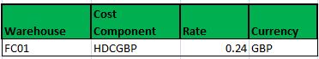
Handling Cost Matrix – Fig 1.40

‘Rate’ column will be used to calculate handling cost on each unit. This rate will be a flat rate that could be used on any option. This rate will be picked up based on the matching- First Destination with Warehouse between PO and this matrix.
There is a request from the Retail team to rename the following field, subject to the Logistics team approval-
Rate to ‘Rate per Unit’

- Total Duty (k)– This column will be populated only if the supplier shipping terms are in FOB and Ex-works. This column will be calculated as the duty cost on the option in the PO* Units of the option on PO.

The total duty will be calculated as mentioned below-
- System will get the commodity code and the duty rate from base HTS setup based on the commodity code and preferential rate attribute setup at the option in item micro app.
- Then system will calculate the total duty as –
Total Duty (K) = SUM (Total unit cost(k) + Total Expense (K)) * Duty Rate %
This is the general formula for duty calculation. The calculation will vary based on the importing country of the warehouse. This variation in calculation of duty is mentioned under section 4.2.4.5. Thus, kindly refer to this section for more details.
- Total Landed Cost (K) – This column will represent the total landed cost and will be calculated as mentioned below-
The Total Landed Cost = Total Unit Cost + Total Expense + Total Up-Charge +Total Duty

- Buy value(K) – This field will be calculated as –> Units * Retail Price

- Exp. Buy Margin % - This field will be calculated as –

(Buy Value (K) VAT exclusive – Total Landed Cost (K))/ Buy Value (K) VAT exclusive
The Buy value will be VAT inclusive and the formula will use the RMS operational exchange rate.

- Plan Buy Margin % - This field will be calculated as –
(Buy Value (K) VAT exclusive– Total Landed Cost (K))/ Buy Value (K) VAT exclusive
The Buy value will be calculated as VAT exclusive and the formula will use the consolidated exchange rate, stored in RMS. In Code Drop 2 this field will be calculated as per the formula mentioned above.

- Rest of the fields in this section are self-explanatory or have been explained in other screen details. Thus, not repeating them in this section.

Up-Charge Details

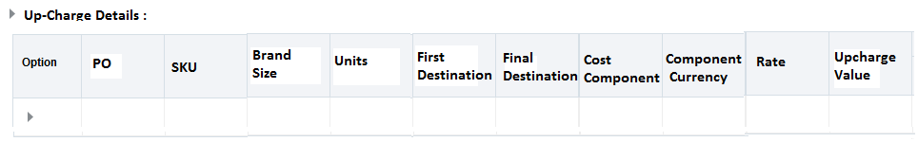
Up-Charge Detail Panel – Fig 1.41
Functionality:

- This panel will be enabled when user will select a line on ‘Option-Details’ panel where First Destination <> Final Destination (i.e., options on automated /split POs). When user will then select UP-Charge Details tab, the table shown in above diagram will be visible to the user with relevant details.
- This section will be non-editable. This will be a tree table at Option level. Each option will have two separate lines (one for Transportation cost and one for Handling cost).
- Thus, this table will provide the user with Up-charge break down for each of the option line on ‘Option-Details’ section.
- The cost component field will show the corresponding cost component for Transportation cost or the Handling cost.
- For Handling Cost line, ‘Rate’ column will represent the ‘Rate’ from Handling cost matrix in FC currency. This rate will be picked up based on the matching- First Destination with Warehouse between PO and this matrix.
- For Transportation Cost line ‘Rate’ will represent the per unit rate of transportation cost and it will be calculated as explained in earlier section. At option level line rate will not be shown.
- Upcharge Value column will be calculated as – Rate * Units
- Rest of the fields in this section are self-explanatory or have been explained in other screen details. Thus, not repeating them in this section.
- The upcharge value will be displayed up till two decimal places in FC currency. At option level line it will show a summed-up value from all the SKUs under that option.

Please note the up-charge details mentioned here will be used on Automated/Split POs which
would have an onward allocation attached to them. For ICTs (Inter Company Transfer) these
up-charges will not be used. Please refer to the FDD for ‘Receipt to Sell’ Business process for
details in this area.

PO Details

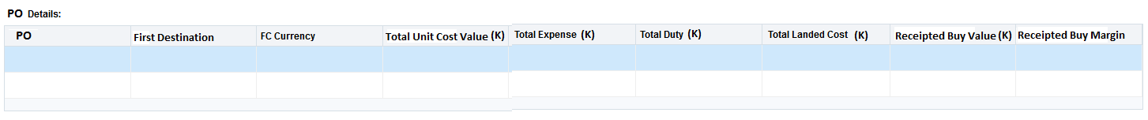
PO Details Panel – Fig 1.42

Functionality:

- This section will provide the user the cost distribution per PO. The values shown in this table for each PO will be used in WAC re-calculation on the First Destination. As first Destination will be the receiving location of the PO in all type of POs (Direct or Automated or Split). This section will be non-editable.
- Total Unit Cost Value in Supplier Currency– Sum of (unit cost of each option * total units of the option on PO) for all the options on PO. Total expense – Sum of ((freight cost + re-processing cost + Labelon cost of each option options) * Total Units of each option on PO) for all the options on PO.
Calculation of freight, re-processing and Labelon cost has been explained in previous sections.
- Total Duty in FC currency – Sum of (duty cost on each options * Total units of each options on PO) for all options on PO. Duty cost calculation has been explained in the previous sections.
- Total landed Cost in FC currency– Total Unit Cost + Total expense cost + Total Duty Cost
- Receipted Buy Value in FC currency– Sum of (retail price of each option * total units of each option on PO) for all options on PO.
- Receipted Buy Margin - (Total Buy value VAT exclusive – Total Landed Cost)/ Total Buy value VAT exclusive
- All the fields in this section with (k) will be displayed in thousands with two decimal places.

Expense Details on PO

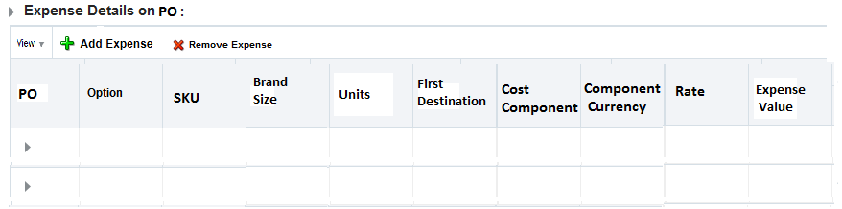
Expense Details Panel – Fig 1.43
- This section will provide the user with details of expense breakdown on each PO. This table will be a tree table with drill down available at PO column.
- User would be able to drill down to the expenses break down of each option/SKU under a specific PO.
- The cost component field will show the corresponding cost component for Freight Cost or Re-processing cost or Labelon cost.
- The ‘rate’ for each of these cost components will be derived on the option, as explained in the previous sections in FC currency. At option level line rate will not be shown.
- Expense Value column will be calculated as – Rate * Units
- The expense value will be displayed up till two decimal places in FC currency. At option level line it will show a summed-up value from all the SKUs under that option.

User would have the flexibility to Add and Remove Expenses. This functionality will be restricted with user roles security. As the rates for the expenses will be defaulted from the freight cost and expense profile setups thus, the user should not be allowed to change this rate as any wrong input of rate will impact the Total Landed Cost and WAC.

Remove expense functionality will be used to cater edge cases, for e.g., where any re-processing cost should be removed, if supplier has agreed to pay for it. User would select a line on the Expense Details on PO section and would click on ‘Remove Expense’ icon. The user would always be prompted with a Yes/No selection dialog box when they try to remove an expense. If they select ‘Yes’ the expense line will be deleted and if they select ‘No’, expense line will not be removed.

When user will click on ‘+Add Expense’ icon following pop up will be shown to user where they would be able select the cost component they want to add as expense on the PO. Based on the selected cost component from the drop down, component currency and rate fields will be defaulted and remain un-editable.

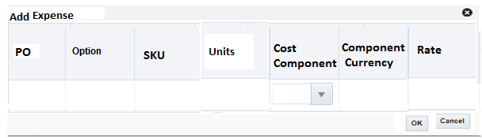
Add Expense pop up – Fig 1.45

The system will do the following checks if user will select the cost component from drop down to fetch the correct rate-
- System will check if the selected cost component exists on Freight cost matrix. If it exists, system will fetch the rate from freight cost matrix by matching the relevant PO attributes like shipping point, freight method, freight forwarder and receiving point between PO and Freight cost matrix. Then this fetched rate must be divided by the ‘Units per carton’ field to calculate the actual rate that will be displayed on this pop-up. The expense added in this pop-up will be added on all option-SKU combination on the PO but the rate will vary for each option based on the ‘Unit per carton’ setup for the option.
- If the cost component will not exist on Freight cost matrix, system will check if it exists on expense profile. If the cost component will exist on expense profile then either it would be either a Labelon cost or Re-processing cost.
- System will check if the supplier site on the PO matches with the supplier site mentioned against the expense profile with module_type=’SUPP’ then the rate from expense profile will be used to populate the re-processing cost.
- If the above condition is not satisfied then system will check if the module_type for that expense profile is ‘PTNR’ and the partner value on the expense profile is same as the partner type 2 field on the supplier import attributes. If the above check is successful then the rate from expense profile will be used to populate the Labelon cost.
- If the selected cost component will not satisfy any of the above points then rate will be fetched from the cost component setup in base RMS table- elc_comp.
Whenever user will add, edit or remove an expense, they will be prompted to click the Recalculate button, so that revised expenses, duty and total landed cost and margins are recalculated on PO.

Duty Details on PO

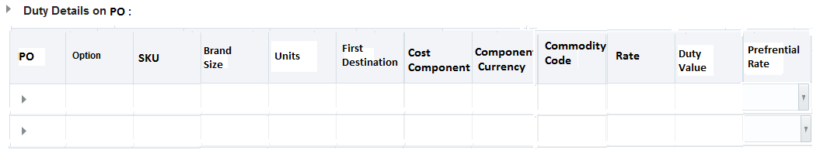
Duty Details Panel – Fig 1.46
- This section will provide the user with details of duty cost on each PO. This table will be a tree table with drill down available at PO column.
- User would be able to drill down to the duty of each option/SKU under a specific PO.
- The Duty value will be displayed up till two decimal places in FC currency.
- The cost component field will show the corresponding cost component for Duty.
- The ‘rate’ in FC currency for the duty cost components will be derived on the option, as explained in the previous sections. The fetched rate would be either standard rate or preferential rate based on the commodity setup of the option in item micro app.
- Duty Value column will be calculated as – Rate * Units
- Preferential Rate column will be a dropdown, only this column will be editable in the section. Valid values for the column will be ‘Y’ and ‘N’. This drop down will be available only at the option level. If it will be set for the option that means it would be applicable for the all SKUs for that option on PO.
- By default, this Preferential rate indicator will be copied over from option setup done in item micro app and accordingly the duty rate will be fetched for the option.
- This column would be edited by the custom team to handle specific business scenarios where they should update the preferential rate indictor directly on PO as part of exceptions. This access will be restricted with user role security.
- Whenever user will change the preferential rate indictor, they would be prompted to click the Recalculate button. This action will recalculate the duty, total landed cost and margins for the updated POs.

The duty on PO will be calculated for each importing warehouse as follows-
1. If the PO is being raised for UK or Germany then duty will be calculated using below formula -
Duty for the option = (Supplier unit cost of the option + Freight Cost on the option) *Duty Rate %
2. If the PO is being raised for US then duty will be calculated using below formula -
Duty for the option = (Supplier unit cost of the option) *Duty Rate %

To make the duty calculation configurable CVBs will be used in RMS, so that PO micro app could identify what cost component it should use for calculating duty on each warehouse. This will avoid any hardcoding in PO micro app logic to calculate duty for each warehouse (Importing Country).
For e.g., for UK the CVB for DUTY could be defined as follows-
VFDGB = ORDCST + FRTGB (this would sum up the supplier unit cost on PO and freight cost in duty calculation).
While in case of US, a CVB could be defined as follows-
VFDUS = ORDCST (this would only include supplier unit cost on PO in duty calculation).

Actions – Push Button
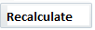
Push Buttons – Fig 1.47

Functionality-
    - When User will select the Save button the data present on the form will be saved.
    - When user will select Save and Next while creating a New PO the data present on the screen will be saved and user will move to the next screen- ‘Order Review’.
    - User would be prompted to click on the recalculate button if they have made any updates to the expense or duty or in both sections for the PO. When user will click on Recalculate button the expense, duty, total landed cost and margin will be re-calculated for the updated POs.

Whenever a user will amend a PO, below pop up will be shown to the user to apply a reason code for the amendments. Please note if user have made earlier amendments on PO in previous screens, then the latest reason code they would select against the PO in this screen, will be stored in RMS database for that PO revision. The expectation is if user would intend to change multiple fields on PO then they should use a more generic reason code. The list of reason codes is defined by the Retail team.

Apply Reason Code pop up – Fig 1.48

Screen Logic – PO Action

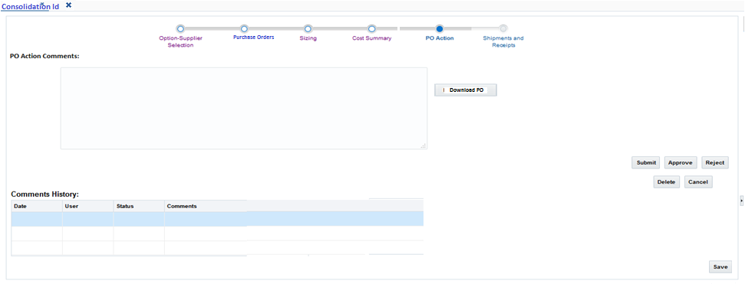
PO Action Screen – Fig 1.49
Functionality:

- Independent of the PO source (i.e., Replenishment, Micro app or Planning) and create or edit action on PO, this section will always be in worksheet status before being Submitted.
- The screen will allow user to take necessary actions on a PO based on the roles assigned to their user id.
- Below are the rules that will dictate the actions a user can take on PO based on the status:
- A worksheet PO can only be set to ‘Submitted’ status.
- A submitted PO can only be set to either ‘Approved’ or Rejected using the PO micro app. When a PO will be Rejected it will be moved to ‘Worksheet’ status.
- If the PO is Rejected by the user, then in the comment section ‘Rejected to Worksheet’ will be prefixed in front of the comments entered by user for Rejection. This will provide clarity to the user that if they ‘Reject’ a PO its status will change to Worksheet. As there is no separate status as ‘Reject’.
- If a PO is in approved status it cannot be put back to Worksheet, Submit and Delete status. An Approved PO cannot be Rejected.
- A PO can only be Deleted if the status of the PO is worksheet.
- A PO can only be cancelled if the status of the PO is approved.
- When user will select the Approve button, system will check which PO under the consolidation id has the highest PO cost. The PO cost will be sum of – (unit cost on PO*total units) for each option. If this PO cost fits in the approval limit for the user, then user would be able Approve the POs under consolidation Id. If the user would not have the relevant approval limit they will get an error message that the PO costs is outside their approval limit.
The approval limit will be defined in GBP and system will use operational rate for
calculating it.
The approval limit will be based on user roles and will be maintained in custom tables.
The tables will be header and detail table with following major columns –
Header table Columns-
- Level
- Approval Limit

Detail table columns-
- Level
- User Role

The approval limit will be associated with each level and a user role will only be assigned to one level.

- When user will select the Cancel button, following pop will be shown to user to attach a reason code for the cancellation and all the PO under the consolidation Id will be cancelled-
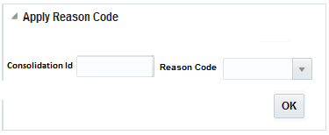
Apply Reason Code pop up – Fig 1.51

- When user will press the cancel button they will be prompted with a message that-
They are about to cancel ‘X’ number of orders under the Consolidation, do they want to continue’. Here ‘X’ will represent the total no. of POs that are not closed or Cancelled under that Consolidation Id. If the user will prompt to continue, system will validate if each of the POs does not have any open ASN against them, if not then system will cancel those POs. But if an ASN exists then system will not cancel those POs. Please note that this Cancellation will not cater to ‘Cancel Balance’ functionality. For that user will go to Mass Maintenance screen via ‘Action ASN’ dashboard.
- User can enter comments against each of the action he has taken on the PO. However, these comments are not mandatory.
- The history of all these comments will be visible on this screen in descending order by Date in following table-
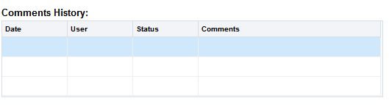
Comments History Panel – Fig 1.52

- By selecting the Save button user will save the data.
- In this screen, all the sections in Side Bar will already be filled with the details entered in other preceding screen of PO creation process.
- Once User will approve the PO from Micro app, the PO will also be created in the base RMS.
- For a split and automated PO when user will approve the PO, Allocations will be created for the respective option-SKU and Final destination combination, also the PO will be created in RMS in approved status. These Allocations can be viewed in the ‘Shipment and Receipt’ screen in PO Micro app.
- Download PO button will allow user to download the all the POs of the Consolidation Id in one pdf. This functionality is being built in ASOS Net, once it is ready in ASOS Net, it will be added to the PO micro app as well.
- Download PO button will not be enabled for PO in Worksheet and Submitted status.
- While Amending a PO in Approved status user must be instructed to follow the train structure and will come to PO-Action screen for saving all the changes they have done on previous screens. They would not be able to save the changes they have made in previous screens unless they come on PO-Action screen and press ‘Save’ button. This restriction will help in keeping the data integrity for the PO across screen and finally save the data in RMS database.

Screen Logic – Shipments and Receipts
Please note that this screen is re-designed as part of Shipment Tracker CR, thus in this document only the screen layout is shown below. For the details of this screen please refer to the Shipment Tracker FDD on SharePoint. The SharePoint path is mentioned below-
https://asos1.sharepoint.com/sites/tgr-programme/TGR%20Documents/Shared%20Documents/Forms/AllItems.aspx?RootFolder=%2Fsites%2Ftgr%2Dprogramme%2FTGR%20Documents%2FShared%20Documents%2F03%20Merchandise%20Management%2F03%20Enablement%2F04%20Deliverables%2F17%20CR45%20Shipment%20Tracking&FolderCTID=0x012000F399222F7DAEB94EA2A05C826DE61B03&View=%7B20CE8337%2D1B15%2D4D4B%2D9A76%2D42C142D72EC7%7D

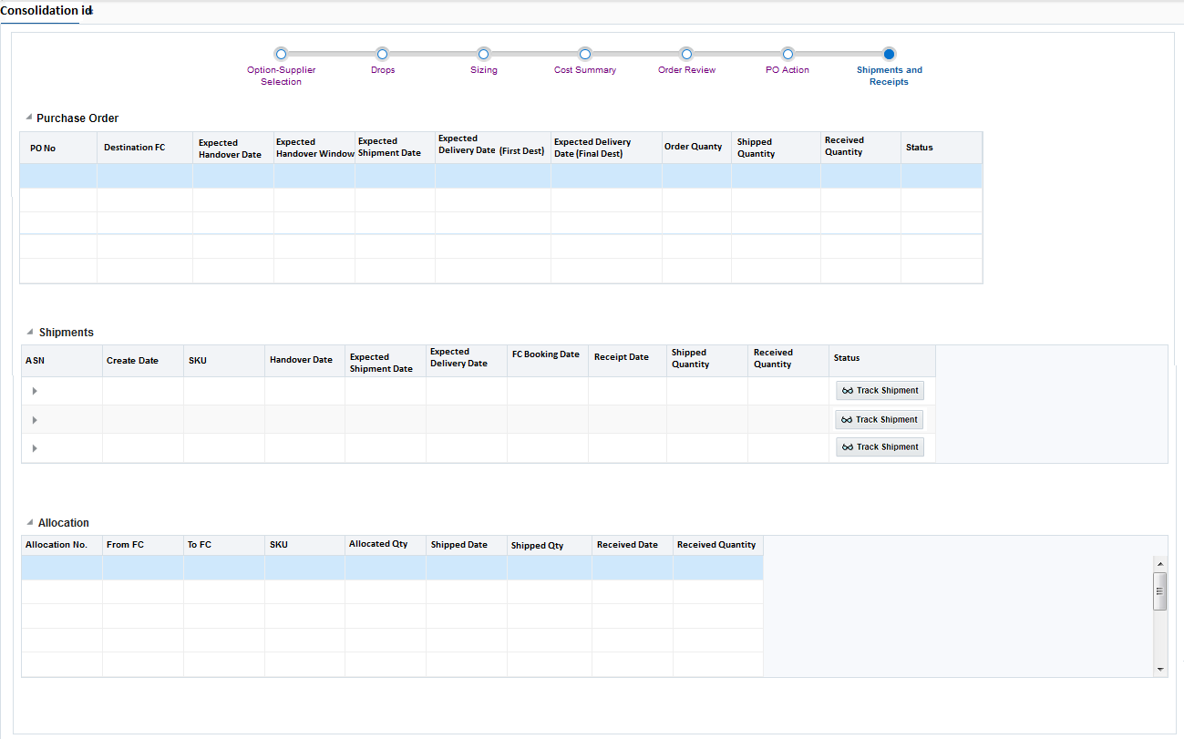
Shipments and Receipts Screen – Fig 1.53

Screen Logic – PO Mass Maintenance
PO Mass maintenance screen will be delivered as part of code drop 3 of PO micro app.
This screen will be used by the Retail team for following purposes-
- Mass maintenance of the POs.
- Mass Cancellation of the POs.

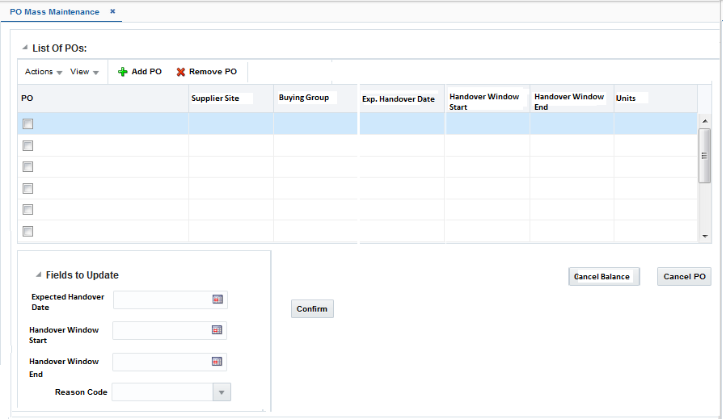

PO Mass Maintenance Screen – Fig 1.56

PO Mass Maintenance screen will be composed of 6 main areas:
    - Search PO – Section to search and select PO for Mass Maintenance.
    - List of POs section
    - Fields to update section

    - Actions – Push Buttons

Search PO
The following search panel will be displayed to user when they will click on the ‘+Add PO’ icon on main screen.

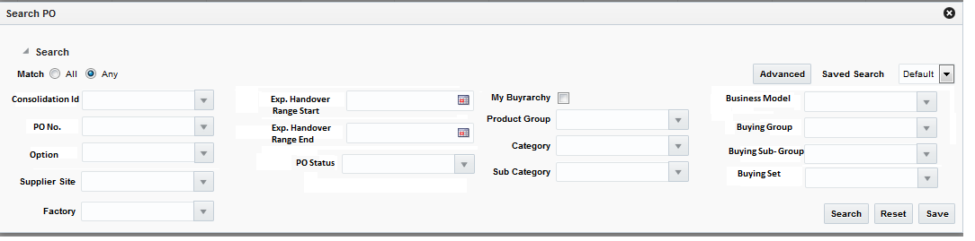
Search PO Panel – Fig 1.57

    - User will be able to Search POs based on following search criteria:
      - Consolidation id
      - PO No.
      - Option
      - Supplier Site
      - Factory
      - The below two fields will help the user to search multiple POs that could have their Exp. Handover Window between the dates specified by the user for these fields -
Exp. Handover Range Start
Exp. Handover Range End
PO Status
      - My Buyrarchy check box- All Buyrarchies to which user belongs- An example of Buyrarchy could be – Womenswear Own Buy/ Core Knitwear/ Core Knitwear/NA. If the user will have multiple Buyrarchy assigned, then the PO belonging to these multiple buyrarchy will be displayed to the user.
      - Product Hierarchy – Product Group, Category, Sub-Category An example of Product hierarchy could be –Day Dresses/Casual/Midi
      - All the fields of Buyrarchy

- User will be able to save his search criteria and name them. Thus, when user will return to this screen later they can select their search criteria from the drop down shown in below diagram-
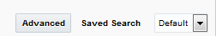
Save Search Section – Fig 1.58
- By using the ratio button ‘All’ or ‘Any’ user will be able to search the PO in a specific way. All- Will allow user to specify criteria which will bring all PO that will meet all the criteria specified by the user. Any – Will allow user to specify criteria which will bring all approved POs that will meet any of the criteria specified by the user.
- When user wants to refresh the screen, they can select the ‘Reset’ Push button.
- When user has specified the required search criteria, they can select the ‘Search’ push button which will populate the search result in the table of ‘List of POs’ section. When the search criteria will fail to find any corresponding PO, an error will be thrown to the user-
‘No Result Found for the specified criteria’.

List of POs

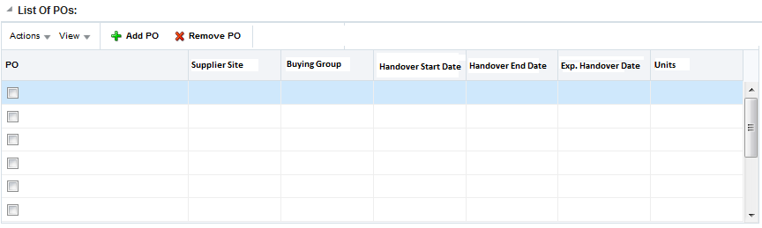
List of POs Panel – Fig 1.59
    - This table in Fig 1.50 will be populated with list of PO and relevant details based on the search criteria used by the user.
    - User has the flexibility to remove any specific PO from the search result by selecting the ‘Remove PO’ icon on the screen.
    - Following fields will be displayed to the user in this table:
      - PO
      - Supplier Site
      - Buying Group
      - Handover Start Date
      - Handover End Date
      - Exp. Handover Date
      - Units

- User will be able to select several POs together through the check box against each PO number. And then can select ‘Cancel PO’ for the Mass cancellation of the PO.
- User will be able to select several POs together through the check box against each PO number. And then can select the ‘Exp. Handover Date field in ‘Fields to update’ section, to update this Exp. Handover Date on all selected POs.

Fields to Update

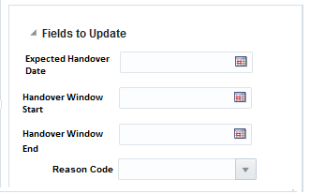
Fields to Update Panel – Fig 1.60
    - User can do mass update on the selected PO on following fields:
      - Exp. Handover Date
      - Handover Window Start
      - Handover Window End

- All other relevant dates on the PO will be re-calculated based on the updated Exp. handover date or Handover Window Start By default all three date fields will be enabled for user. If user will select Exp. Handover Date the Handover Window start and End field will be disabled. If the user selects the Handover Window Start or Handover Window End date, then Exp. Handover Date will be disabled.
- User would be allowed to update these fields on worksheet and approved POs.In case of ‘Worksheet’ POs system will not prompt the user to add a Reason code, as no revisions will be created for worksheet POs amendments.
- User will be prompted to attach a reason code when they will update any of the fields on PO. Once user will hit the ‘Confirm’ button the Expected Handover Date will be updated on POs in background along with the re-calculation of rest of the dates on POs.
- User would be able to update the Exp. Handover date or Exp. Handover Window Start only for those POs that does not have a ‘Carrier booking date’ for the POs. If the carrier booking date will exist, then those PO will not be updated.

Actions – Push Button
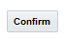
Push Buttons – Fig 1.61

    - When User will select the Confirm button all the selected POs will be updated with the modified Exp. Handover Date or Exp. Handover Window.
    - When User will click the Cancel PO button following action will be taken by the Screen- It would Cancel all the options on the PO, if no open ASN exists for the PO. User should be displayed with the list of POs that were not cancelled.
    - ‘Cancel Balance’ button will only be enabled when the POs will be interfaced through dashboard. These POs would represent that list of POs that would have pending un-ASNed quantities and no open ASNs. Thus, by selecting the ‘Cancel Balance’ button all these pending quantities on POs will be cancelled in the back ground.
    - When user will press any of the Cancel buttons they will be prompted with an action message– ‘Do you want to cancel the selected POs. Please confirm’. The user will have options as ‘Yes’ or ‘No’. If user will press Yes, system will cancel all the selected POs which will meet the cancellation criteria. If user will press ‘No’ the system will not cancel the PO.

Screen Logic – Order Search

The below screenshot is updated with Label changes and re-ordering-

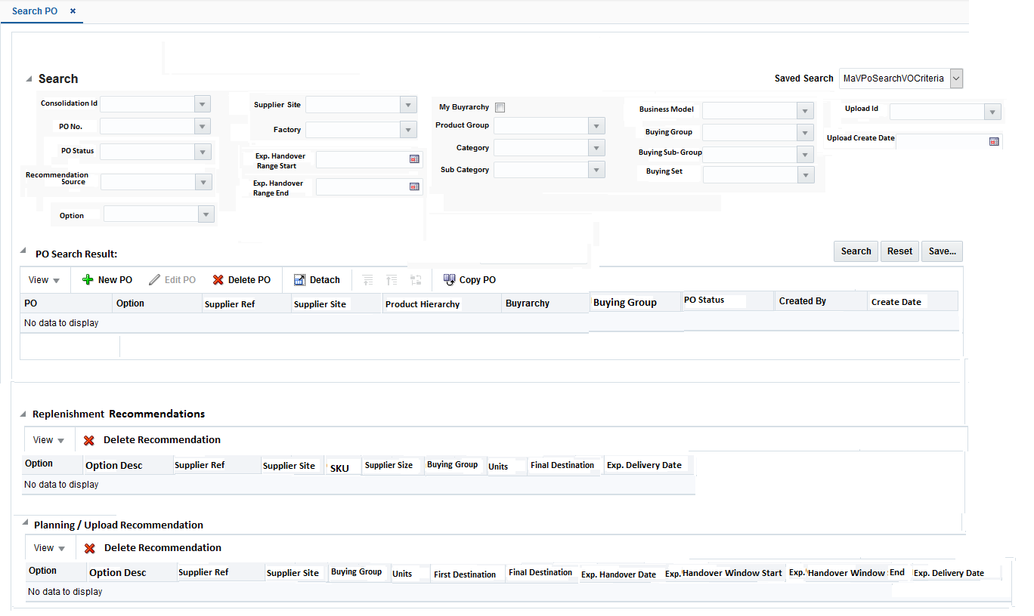
Order Search screen – Fig 1.62
Order Search screen will be composed of 4 main areas:
    - Search PO
    - PO Search Result
    - Replenishment Recommendations
    - Planning /Upload Recommendations

Search PO

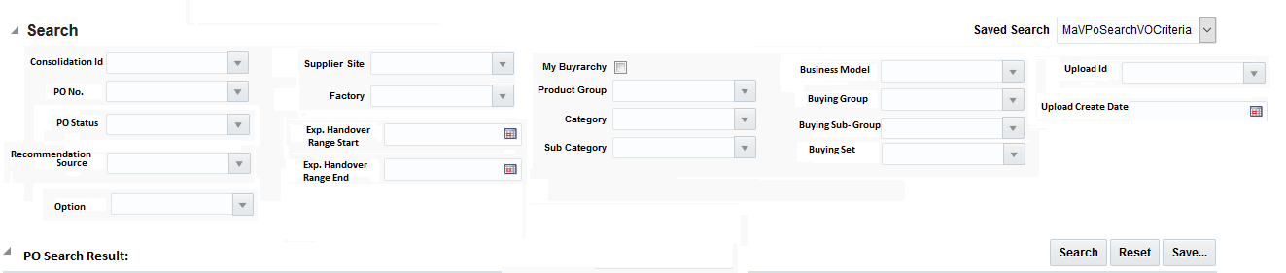
Search PO Panel – Fig 1.63
    - User will be able to Search POs based on following search criteria:
      - Consolidation Id
      - PO No.
      - Option
      - Factory

      - PO status
      - Supplier Site
      - The below two fields will help the user to search multiple POs that could have their Exp. Handover Window between the dates specified by the user for these fields -
Exp. Handover Range Start
      - Exp. Handover Range End

      - Recommendation Source

      - My Buyrarchy checkbox –All the buyrarchies that are attached to the User- An example of Buyrarchy could be – Womenswear Own Buy/ Core Knitwear/ Core Knitwear/NA. If the user will have multiple Buyrarchy assigned, then the PO belonging to these multiple buyrarchy will be displayed to the user.
      - Product Hierarchy – Product Group, Category, Sub Category. An example of Product hierarchy could be –Day Dresses/Casual/Midi
      - Upload Id – This field will be used when PO recommendations from excel upload should be searched.
      - Upload Create Date – This field will be used when PO recommendations from excel upload should be searched.
      - Business Model
      - Buying Group
      - Buying Sub-Group
      - Buying Set

- User will be able to save his search criteria and name them. Thus, when user will return to this screen later they can select their search criteria from the drop down shown in below diagram.
- User would be able to use the ‘Advanced’ function which will allow them for better filtering for e.g. to search for ‘Not equal to’ or ‘In between’ etc.
Search Section – Fig 1.64
- By using the radio button ‘All’ or ‘Any’ user will be able to search the PO in a specific way. All- Will allow user to specify criteria which will bring all PO that will meet all the criteria specified by the user. Any – Will allow user to specify criteria which will bring all POs that will meet any of the criteria specified by the user.
- When user wants to refresh the screen, they can select the ‘Reset’ Push button.
- When user has specified the required search criteria, they can select the ‘Search’ push button which will populate the search result in the table of ‘PO Search Result’ section. When the search criteria will fail to find any corresponding PO, an error will be thrown to the user-
‘No Result Found for the specified criteria’.

PO Search Result

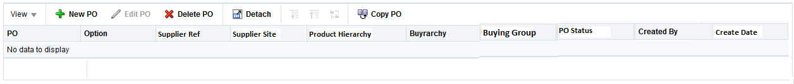
PO Search Result Panel – Fig 1.65
    - This above table will be populated with list of PO and relevant details based on the search criteria used by the user.
    - By selecting Detach user would be shown just the result table on the complete screen and thus the search panel will disappear. If user will again select Detach on full table screen, the screen will resume its normal view of both Search panel and Result table displayed in same screen.
    - User has the flexibility to remove any specific PO from the search result.
    - Following fields will be displayed to the user in this table:
      - PO
      - PO Status
      - Created By
      - Option
      - Buyrarchy- An example of Buyrarchy could be – Womenswear Own Buy/ Core Knitwear/ Core Knitwear/NA
      - Product Hierarchy. An example of Product hierarchy could be –Day Dresses/Casual/Midi
      - Supplier Site
      - Supplier Ref
      - Create date
      - Buying Group

- + Add icon will allow user to Open PO micro app for creating a new PO.
- X Delete PO – Will allow user to Delete the PO from search result.
- View PO icon - This icon will help the user to view the PO in PO micro app in read only mode. User could select a specific PO or a Consolidation Id and can click on this icon but the PO micro app will always open the details at the Consolidation Id level.
- Copy PO icon- This icon will be enabled only if the user has selected a PO line in the PO Search Result table (not the Consolidation Id line). The status of the selected PO should be in worksheet or approved status. By selecting this icon user would be able to create a new PO in PO micro app with following attributes being copied over from the selected PO-
- Options/SKU/Qty
- Size curve
- Factory
- First and Final Locations
- Supplier Site
However, a new CID will be generated for this PO. In case of Split/Automated PO being copied, the original allocations associated with the PO will not be copied. However, the distribution of quantity for each final location will be copied and once user will approve the PO from PO micro app relevant allocations will be generated by the system.

Replenishment Recommendations
The following diagram represents the high-level depiction of how replenishment recommendations will be generated and will be used in PO micro app to create POs.

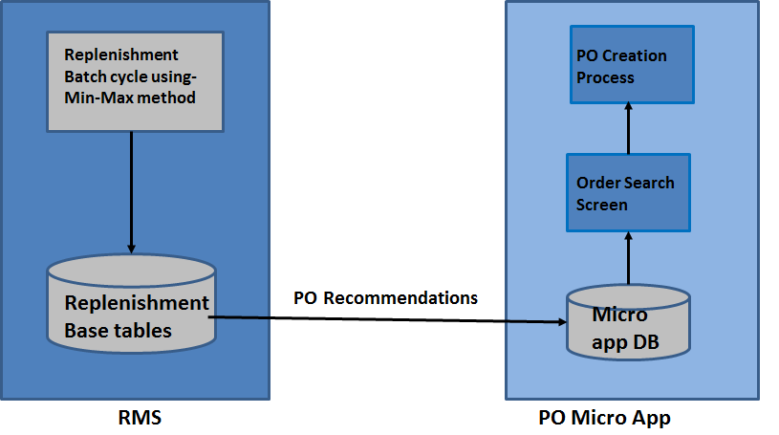
Replenishment PO recommendation Flow– Fig1.66

Replenishment base batches will be run with Min-Max method to generate the PO recommendations. The replenishment parameters that are required to run the batches will be attached to the option through Item micro app. For details on these attributes please refer to the FDD of Item micro app. As covered in the business process for Supplier Creation, all the suppliers set for Replenishment will need Lead Time setup. This lead time will be based on the time taken from supplier to ready the goods and deliver them to the FC. This setup will help in calculation of expected delivery date in the replenishment recommendation. However, user has the flexibility to change this date in PO micro app during PO creation process. Replenishment base purging will be used to remove the un-used recommendations after a period.

In the order Search screen user, will select the Source as ‘Replenishment’ and will click on the search button. This will display all the replenishment recommendations in the system. User can narrow down their search result by using necessary filleting criteria, for e.g., supplier site or options or expected delivery date field in the search criteria.
The result of the user search will be displayed in following Replenishment Recommendation tables.

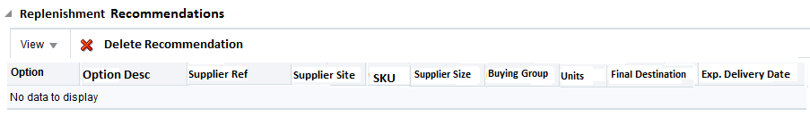

Replenishment PO recommendation Panel – Fig1.67

This table will be a tree table at the option level, when user will click on the option, it will
display all the SKUs for which recommendation was generated. Following fields will be
populated in this table-

      - Option ID– This field will show the option id for the SKU on which recommendation was generated.
      - Option Id Disc – This field will show the description of the option id.
      - Supplier Reference – Supplier reference attached to the option.
      - SKU – SKU number for which recommendation was generated.
      - Buying Group – Buying group of the option
      - Supplier Size – Associated supplier size of the SKU.
      - Units – The quantity generated by the replenishment process for the FC.
      - Supplier Site – Supplier site attached to the option
      - Final Destination – Fulfilment centre for which recommendation was generated.
      - Expected Delivery Date – Date by which option/SKU combination is expected to be arriving at the Final Destination.

After reviewing the results displayed to the user in above table, they could select the
recommendations for which they want to create PO. System will validate if the selected
recommendations have matching supplier site and buying group and business model
combination. After selecting the recommendations, they will select ‘Create PO’ icon. This action
will take user to the PO micro
app Option-supplier selection screen with relevant details on the screen pre-populated. Thus
user can then continue the PO creation process. The expectation from the system is to
calculate all other PO dates on recommendations using Expected Delivery date and the transit
time matrix.
If user wish to delete a recommendation they could do it by clicking the ‘Delete
Recommendation’ icon. This action will completely delete the recommendation and user would
not be able to access it again.

Planning/Upload recommendations
The following diagram represents the high-level depiction of how planning recommendations will be interfaced to PO micro app and how the PO creation process then can continue.

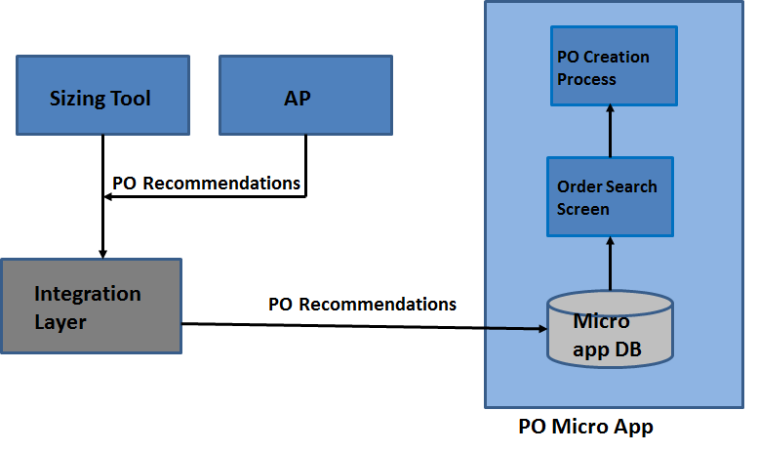
Planning PO recommendation Flow– Fig1.68

Planning recommendations can either come via Sizing tool which will be live in Release 3 along with PO micro app or they can come from AP in Release 4. However please note that the integration interface for both these recommendations source is common. There has been a data agreement on what fields will come from Sizing tool. Thus, any change to this data agreement in Release 4 will require change in Integration layer as well as in PO micro app.
Upload recommendations will be interfaced via integration layer and via batch process the recommendations will be loaded into a staging table. Each upload will have its own id and user could select the upload id from Order search screen. The search will bring all the recommendations that are created as part of that specific upload id.

In the order Search screen user, will select the Recommendation Source as ‘Planning’ and ‘Upload’ and will click on the search button. This will display all the planning and upload recommendations in the system. User can narrow down their search result by using necessary filleting criteria, for e.g., supplier site or options or Handover date field in the search criteria.
The result of the user search will be displayed in following Planning /Upload Recommendation tables.

Planning PO recommendation Panel – Fig1.69

This table will not be a tree table. It will display information at option level. Please note that upload recommendation and planning recommendation have different sets of information interfaced. For e.g., planning recommendations will have sizing information and upload recommendations will have additional fields like factory etc. But in this search result table most of the overlapping fields between these two sources of recommendations will be shown. This will help the user to select recommendations from these two sources and combine them on POs.

Following fields will be populated in this table-

      - Option ID– This field will show the option id
      - Option Id Disc – This field will show the description of the option id.
      - Supplier Reference – Supplier reference attached to the option.

      - units – The quantity generated by the planning/upload process for the Final Destination.
      - Supplier Site – Supplier site attached to the option.
      - First Destination – This field will be populated only for Upload recommendations.
      - Final Destination – This field will be populated for both planning and upload recommendations.
      - Exp. Handover Date – This field will be populated if interfaced in upload recommendation, the planning recommendation will not have this field populated.
      - Exp. Handover Window Start – This field will be populated if interfaced in upload recommendation, the planning recommendation will not have this field populated.
      - Exp. Handover Window – This field will be populated if interfaced in upload recommendation, the planning recommendation will not have this field populated.
      - Exp. Delivery date - This field will be populated for planning recommendation; the upload recommendation will not have this field populated.

After reviewing the results displayed to the user in above table, they could select the
recommendations for which they want to create PO. System will validate if the selected
recommendations have matching supplier site and buying group and business model
combination. After selecting the recommendations, they will select ‘Create PO’ icon. This action
will take user to the PO micro
app Option-supplier selection screen with relevant details on the screen pre-populated. User
can then continue the PO creation process.
If user wish to delete a recommendation they could do it by clicking the ‘Delete
Recommendation’ icon. This action will completely delete the recommendation and user would
not be able to access it again.

Error Handling
Error handling should follow ADF standards.

Security Requirements
The security requirement for the PO Micro app will be tracked in a User Role Matrix which will be a common document for Oracle Retail implementation.

Behaviour Design

Batch Processes
No vanilla batch processes will be impacted – the new batch processes will have dependencies with base processes which will be described in the Enablement phase.

Base Module
Please refer to Batch Schedule document that will be delivered in Embalmment phase for details and scheduling of base batches.

New/Custom Modules
Please note that these following batches will be delivered in a later drop. They are not part of code drop1.
Name | New  Mod | Description
NBpocostrecalc.pc | New | This batch will recalculate the POs cost based on following updates-  - When a commodity code is updated on existing option through item micro app then this relevant option and commodity code will be captured in a custom table. This batch will use the data from this table to recalculate the PO cost and duty in all open POs that are related to this option.  This batch should be scheduled to run every day using an external scheduling framework.
NBpocostrecalc_adhoc.pc | New | This batch will recalculate the POs cost based on following updates-  - When a commodity code rate is changed, this change should be captured in some custom table. The batch will use this data to recalculate the duty and total PO cost on all open POs that are associated with this commodity code.  - Whenever freight rates, expense cost, up charge cost or re-processor cost will change it will be captured in a custom table. This batch will use this custom table to recalculate the expenses, duty and total PO cost for all open POs that are linked to these cost components.  This batch should be run on adhoc basis and the IT support team should be requested to run this adhoc batch. The validation should be done between Inbound supply chain team and IT support team if the updates were made successfully or not.
NBtransitmatrix.ksh | New | This custom script will be used to maintain the custom table that will maintain the details of transit time matrix. The details for this transit time matrix will be maintained and provided by Inbound Supply chain team. IT support team should be requested to run this script whenever a revised transit time matrix is available from Inbound supply chain team. The validation should be done between Inbound supply chain team and IT support team if the updates were made successfully or not.
NBtransitupdate.pc | New | This custom batch will be run on adhoc basis when there is an update on the transit time matrix from Inbound supply chain. The batch will recalculate the PO dates on Open POs. And the IT support team should be requested to run this adhoc batch. The validation should be done between Inbound supply chain team and IT support team if the updates were made successfully or not.
NBexpensematrix.ksh | New | This custom script will be used to maintain the custom table that will maintain the expenses, up-charges etc. The details for this table will be maintained and provided by Inbound Supply chain team/Logistics team. IT support team should be requested to run this script whenever a revised transit time matrix is available from Inbound supply chain team. The validation should be done between Inbound supply chain team and IT support team if the updates were made successfully or not.
NBpurgepoma.pc | New | This batch will purge the PO Micro App tables that store data for PO.  This batch should be scheduled to run every day using an external scheduling framework immediately after running the base Oracle purge batches.  This batch will pick up the pre-configured no. of days from a custom table and will purge only those PO which are older than that number.

Performance Considerations
As most of the custom batches will update all the open POs either for date updates or cost update, thus they need to be run overnight, so that no users are impacted while accessing PO micro apps.
All the batches which will re-calculate cost on PO would have potential performance consideration based on the volume of open POs.

Data Purge and Archive
A custom purge batch will be responsible to purge all the un-wanted worksheet/submitted PO from PO micro app. However, all the PO created in base would be purged with the help of base purge process based on the data retention requirement /rules of ASOS.
The intent of this section is to record the Technical Architecture requirements. Reference the Architecture Requirements and Strategy (TA.020).
The intent of this section is to record the Testing requirements. Reference the Testing Requirements (TE.005).

Open and Closed Issues

Add open issues that you identify while writing or reviewing this document to the open issues section. As you resolve issues, move them to the closed issues section and keep the issue ID the same. Include an explanation of the resolution.
When this work product is complete, any open issues should be transferred to the project- or process-level Issue Log (Manage focus area) and managed using a project level Issue Form (Manage focus area). In addition, the open items should remain in the open issues section of this work product, but flagged in the resolution column as being transferred.

Open Issues

ID | Issue | Resolution | Responsibility | Target Date | Impact Date
MM-426 | There is an issue that onward allocation duty calculation is not formally agreed yet | WIP | Wendy Wright
MM-439 | Process for Cost Changes | WIP | Pedro
MM-699 | Planning recommendation fields for Release 4 | Deferred | Sonny
MM-775 | Order Search screen result for recommendation from different sources | WIP | Lynda
MP-46 | PO level decision in Planning | WIP | Amol

Closed Issues

ID | Issue | Resolution | Responsibility | Target Date | Impact Date
MM-61 | ASOS need to start working on the list of cost components. Also, a discussion needed to understand what cost components should be sent to Planning | As per the meeting minutes with Kerry Moran, Jo Powell, and Lynda Golding from Pedro Pacheco on 29-June, this issue has been closed. | Lynda
MM-139 | ASOS requires visibility of cost components in the stock ledger. This will require a custom report | As per the meeting minutes with Kerry Moran, Jo Powell, and Lynda Golding from Pedro Pacheco on 29-June, this issue has been closed. | Lynda
MM-176 | Countries Associated with Items / Suppliers | Recommended for closure with following resolution-  1.TBC changed to a country - always allowed  2.Country changed to TBC - not allowed  3.Change to a country BEFORE stock received - allowed | Rhian Saint
MM-184 | One option vs. Multiple option per drop | ASOS has confirmed their requirement to allow both one option per drop as well as multiple  options per drop PO creation. | Venky
MM-185 | Expense and up-charges set up | The templates for expense and up-charges are discussed and agreed with respective business teams. | Natalie & Venky
MM-186 | Transit Time matrix | It has been agreed with the Inbound supply chain team that they will maintain the transit time matrix and the template have been agreed with them. | Venky
MM-193 | PO recommendations from planning. | This issue is tracked under planning issue log under issue number MP-46. | Venky
MM-203 | Contracts and deals requirements | Closed with below updates-  ASOS will not be using Contracts functionality.  Vendor Funded Promotions, Vendor Funded Markdown, Bill Back and Bill Back Rebates Deal types will be used.  The fundamentals RTM is yet to be updated with the business requirements. | Lynda
MM-211 | Conclusion of drops screen | The screen design is agreed with the Retail Team. | Pedro/Reetu
MM-212 | Order Cancellation Requirements | Cancellation Requirements are captured. | Venky
MM-214 | Review of following screens- 1.Cost Summary  2.Order Review  3.Shipment & Receipt | Closed with below update-please close this issue as Retail and Finance have agreed that the ORDER REVIEW screen is not required | Venky
MM-216 | Template for different type of PO that could be downloaded from Supplier and PO Micro app | This issue is being tracked for ASOS Net app as well as MM-369 thus duplicating the issue. | Venky
MM-178 | Commodity code selection and preferential rate selection | A TBC country will be manually assigned to the Option when users are not sure about the final manufacturing country this will be used by PO Micro app to derive the dummy commodity code | Natalie & Venky
MM-205 | Options & PO upload. | PO will be created as PO recommendations via upload process. | Venky
MM-213 | Linking PO comments and Reason codes | This requirement has been cancelled | Venky
MM-215 | Sending Submitted PO to Planning application | This requirement has been cancelled | Venky
MM-217 | Requirement to club different PO Type as well as similar PO under one master PO | This requirement has been included in the Purchase Order screen. | Venky
MM-225 | Re-print button on PO micro app | This requirement has been cancelled | Venky
MM-916 | Insurance costs as independent RMS cost component | Insurance cost is out of scope for Release3.setup for Release 3 | Lynda
MM-192 | Using full sizing tool from PO Micro App | This requirement has been cancelled | JO Powell
MM-171 | Transformable Items | Agreed that ASOS will not proceed with any non-base functionality to support this process for R3. This will continue to be managed via business process. | Rhian Saint
MM204 | Order amendment requirements | Most of the orders Amendment requirements are captured in Change log present in SharePoint, only the amendment requirement post ASN receipt are yet to be discussed. | Venky
MM-179 | Single factory on PO | As agreed with Jo P, a PO would be raised only for a single factory. | Venky
MM-209 | ASOS to clarify what is expected from PO micro app to flow back to Item Micro app and vice versa in case of Factory OR country of manufacture updates | Closed as its duplicate of Issue 176. | Venky
MM-427 | The Inbound Supply chain team to confirm if the re-processing days will already be included in the transit matrix or not | Closed with following decision-  Inbound Supply chain team will maintain the re-processing days in transit time matrix | Venky/Inbound Supply chain team
MM-424 | There is an issue that Replenishment approach is not yet finalized | Closed with following decision- Min-Max replenishment method will be used by ASOS to generate PO recommendations. These recommendations will be shown to the user in PO micro app and user would be able to create a PO using these recommendations. | Venky
MM-428 | Need confirmation from business if a re-approval process is required for PO amendments | All the requirements for this process have been captured in the change log. | Venky
MM-429 | Retail team to define the approval limit for PO based on user roles | Closed as this can be provided by the retail team at some later stage. | Sharlene
MM-431 | There is an issue that PO Amendment rules have not been agreed yet | The amendment rules are agreed with Retail team. | Venky
MM-462 | Custom team to confirm the duty calculation | Duty to be applied on PO based on importing country of warehouse with following logic-  For UK and Germany - Duty will be calculated on top of (Supplier cost + Freight Cost)  For US - Duty will be calculated on top of Supplier Cost only, no freight. | Jo P
MM-510 | Different dates on PO for DDP suppliers | No change required in transit time matrix for DDP suppliers | Jo Powell
MM-595 | Business to confirm if freight cost matrix has different cost for FOB and ex-work suppliers | Added to the change log | Lynda
MM-774 | Expense and duty break up at SKU level on PO Micro app | Agreement to show sum at option level and user can expand the details to see the break up at SKU level. | Lynda

