

Quick start guide

Révision | V1.1
Date | 2016/10/04
Contact | Louis BAYLE  lbayle.work@gmail.com

Revision history

Revision n° | Date | Modification (Type and modified chapters) | Auteur
1.0 | 2016/06/30 | Initial version | Sabrina BAUDART
1.1 | 2016/10/04 | Update technical vocabulary & screenshots | Louis BAYLE

References

Element | Description
http://codevtt.org/ | CodevTT official website (news, doc, forum, download, ...)
http://codevtt.org/codev | Online demo
http://www.mantisbt.org | Mantis BT official website
https://github.com/lbayle/codev/blob/master/doc/en/CodevTT_Quick_start_guide.pdf?raw=true | Last update of this document

Table des matières
Glossary 4
About this document 4
CodevTT Presentation 5
Basic concepts 5
Mantis & CodevTT 5
Specific fields 6
Tasks type 6
Bugs and tasks 6
Side tasks 6
External tasks 7
User roles 8
Settings 8
Team creation 8
Team description 9
Additional tasks project 9
Team configuration 9
General 10
Team members 10
Projects 11
Preferences 12
Timetrack durations 12
OnDuty tasks 12
Timetracking 13
Activity report entry 13
Activity tracking 15
Weekly activity 15
Monthly activity 15
Projects activity 16
Projects progress tracking 16
Detailed workloads 16
Commands & Service contract 17
Service contract and additional tasks 17
Commands are managed separately 17
Commands are continuous 17
Provisions 18

Glossary

Designation | Origin | Definition
Task | CodevTT | A task is an action in which time will be consumed. The tasks are grouped by projects and have attributes such as : description , priority, severity , effort estimation, backlog, deadlines , etc.  The tasks follow the project workflow, and are represented by Mantis issues.
Bug | Mantis | A Mantis bug is the counterpart, in Mantis, to the CodevTT Task.
Project | Mantis | A bug/task container which have common characteristics and a same workflow.
Timesheet | CodevTT | Activity report
Timetrack | CodevTT | A time entry on a task. This is part of the timesheet
Manager | CodevTT | User role: Project manager or project master.
Developer | CodevTT | User role: Team member without any management responsibility.
Observer | CodevTT | User role: external people who has a say in the team activities.
Backlog |  | Estimated time (in days) to complete a task

About this document
This document is intended for people with no experience with CodevTT and wishing to implement the tool in their team. It will not deal with the installation, or advanced features or the indicators offered by the tool.

CodevTT configuration for a new team takes approximately 15 minutes.
A good knowledge of the Mantis database is mandatory to fully understand this document.

CodevTT Presentation

CodevTT is a project management tool, allowing a detailed tracking of the progress of projects and team activities.
Its main characteristic is its direct link with MantisBT – a bug tracker system – which we will expand the scope of activities.
Drawing information in MantisBT database and highly simplifying the entry of the user activity report, CodevTT significantly reduces the number of manual operations required to generate reports, statistics, alerts, Gantt chart and other production and monitoring indicators.
MantisBT data being constantly updated by the developers, the project manager can have a real time view of project progress without creating extra work for the team.
Information sent by CodevTT allows the project manager to identify more quickly the hard points of the project. The reduction of a large number of recurring tasks allows him to focus more on areas requiring the most attention and analysis.
Statistics help to identify actions to undertake to improve team productivity and will measure their effectiveness in a short / medium / long term.
The 'Contracts and Command' section provides a 'client' view of the progress status, and offers indicators that can be traced back to him.
CodevTT is thus a reactive project management tool, directly linked with development, and binds the main objective of monitoring and reducing management costs by simplifying and automating processes.

Basic concepts

Mantis & CodevTT

The first feature of CodevTT is to provide a simple and effective interface to establish the activity reports (timesheets). It will thus be possible to entry as varied tasks as “Fix issue n° X”, “Develop feature n° Y”, “Workshop”, “Wiki update”, “leave” etc.
Mantis was first conceived to manage issues, but it can perfectly be used to manage any type of development tasks, or any other daily activity.
CodevTT will thus rely on Mantis to manage the whole daily tasks. This requires adding some more fields in sheets, but Mantis allows that thanks to the “custom-fields”.
It is important to notice that CodevTT uses the same database than Mantis and adds some more tables in it.
However, CodevTT is a non-intrusive tool, and, in that way, doesn’t modify any existing mantis table in the databasee. This point is important because it ensures that Mantis can be independently updated at any time, and that CodevTT can be unplugged if necessary.

Specific fields
To manage an activity tracking, some fields must be added to sheets.
- Manager Effort Estimation
It’s the estimated workload (in man/days) to complete the task. This field is not shown to developers. It can be set to 0 if the task was not charged to the custommer or not scheduled in the initial estimation.
- Effort Estimation
It’s the workload (in man/days) which is available for the developer to complete the task. It should not be 0.
- Backlog
The estimated time to complete (in man/days), estimated and updated by developers.
- Deadline
Date for which the task must be completed. If not set, “Target version” date will be used. If the target version has no associated date, then this task has no deadline.
Note: Other fields, defined by CodevTT, exist, but only those mandatory to the understanding of the concepts are presented here.

Tasks type
During the conception of the tool, four types of tasks have been identified: bugs, tasks, side tasks and external tasks.

Bugs and tasks
There is no technical difference between a bug and a task, but you may want to make a difference between bugs that need to be fixed, and new functionalities to be developped. Bugs & tasks belong to a same project and share the same Mantis workflow. Some CodevTT indicators, will provide statistics based on the 'CodevTT_Type' custom-field which proposes the following values: [Bug / Task].

Side tasks
If bugs and tasks are effective work tasks included in the project's progress, there are many activities that do not fall into this category but must nevertheless be considered in the consumed budget of the project.
The additional tasks have no effort estimation, are persistent tasks (without life cycle) and we will try to limit their number by giving them a sufficiently generic description. It is of course possible to create an additional task dedicated to a specific activity in order to trace it and estimate its cost (eg Quality audit on the project).

CodevTT sorts those additional tasks in several categories:
- Management
Two tasks are generally enough in this category: “Project Management” and “Meeting” (it would be indeed counter-productive to create a new task for each meeting). Other will come depending on the project manager needs (“presale”, “administration & logistic”, “Weekly meeting”, “Customer meeting”…).

- Tools
e.g.: « Compilation scripts », « workstation set up », « Mantis/CodevTT administration »
- Workshop
Gathers internal activities of the team, having no direct link with production tasks.
e.g.: « Wiki Update », « Production tools learning », « Growing competence »
- Incident
Used to manage any unexpected events slowing production. Indicators will measure the impact to decide on action.
e.g.: "Network Unavailability ", " Blocking production account ", " non-operational build environment ", " platform intervention"
All of those tasks are gathered in a « Side tasks project » which is specific to each team and will be add by CodevTT during the new team creation.

External tasks
External tasks stand for tasks that are not linked to team activities, and not charged on your project.
There are two categories of those tasks:
- Leaves
Usually, only one « leave » task is mandatory, but for logistic needs, we shall need to create some others like « illness »…
- Other activity
Contrary to leaves, those activities are done at the office. It allows to declare time on projects that are not managed by CodevTT, like individual formations. Except specific need, only one task is mandatory: “Other external task”.
Those tasks are gathered in an “External tasks project” which is common for all teams.

User roles
In order to manage authentication rights, 3 user profiles are defined in a team:
- Manager
The manager has a full view of the team, he’s the only one who can access all the indicators, the “manager Effort Estimation” and the “service contract”. He can add timetracks on his team projects and create/modify contracts and commands.
- Developer
The developer has only a partial view: the management part is hidden. He can enter timetracks on his team projects.
- Observer
The observer has a full view of the activity and team contracts, but he will not be able to enter timetracks nor modify the team parameters.

Each team has a «team Administrator » which is usually one of the team manager. He’s the only one to have the administration rights on the team.
A “CodevTT Admin” team allows identifying members having an administration right on all the CodevTT parameters as well as all the teams.

Settings
The first thing to do is to create a team so as to add users and Mantis projects. This simple action can be completed in 15 minutes and allows team members updating their activity report, and manager tracking activity.
The rest of the setting (command creation, service contracts, indicators customizations) can be completed in a second part, and will be briefly described in this document.

Team creation
To create a new team, go to the « Admin/Create team » menu
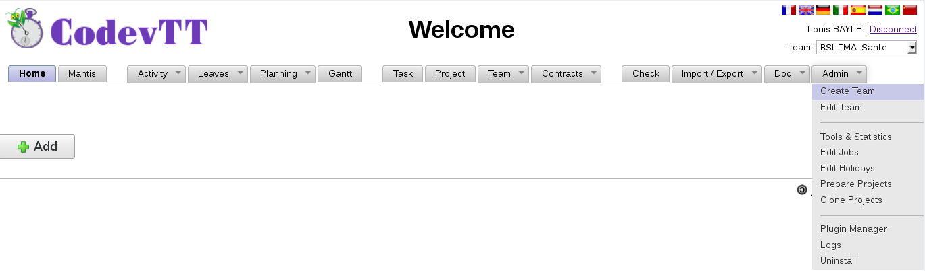
Creation page is parted in two sections:

Team description
All fields are mandatory, the « Team Administrator » will have the administration rights on this team.
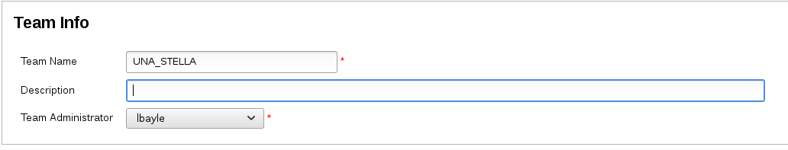
Please note: If you select another team administrator than yourself, and if you are not a member of the « CodevTT Admin » team, then you won’t be able to access the team configuration section.

Additional tasks project
The second section deals with the creation of the additional tasks projects which are linked to the team.
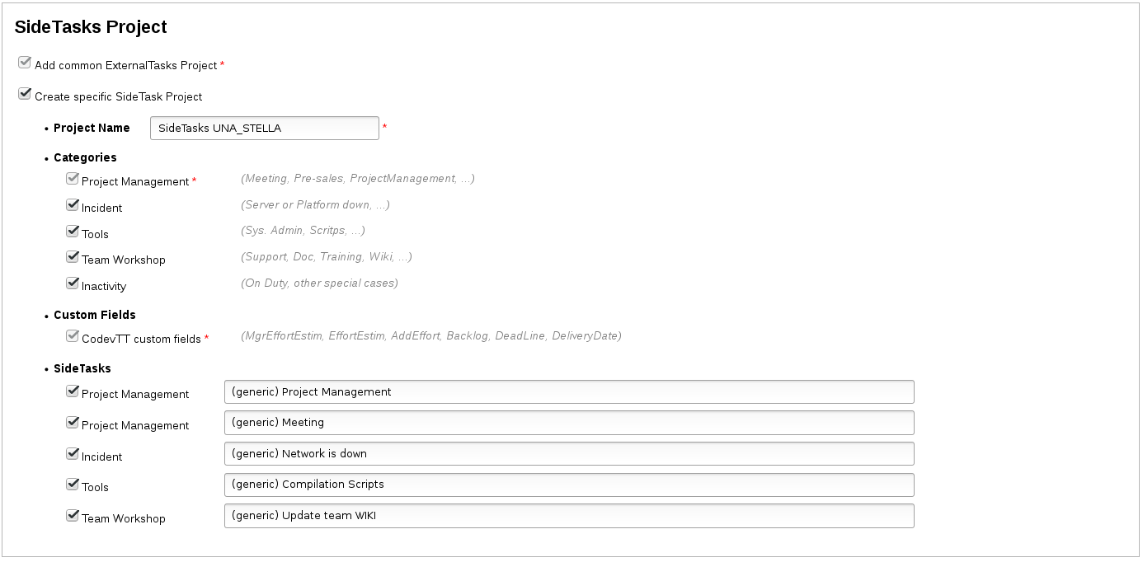
- Categories
Different categories have been described on the Side tasks section, except the « inactivty » category which can be used in rare leave case of the team.
- Side-tasks
For convenience, CodevTT suggests here to create some side-tasks. It’s up to you to define the one you will need; you’ll be allowed to create some more using the “Report issue” menu of Mantis.

Team configuration
Once the team created, the edition page of the team is automatically loaded.

General

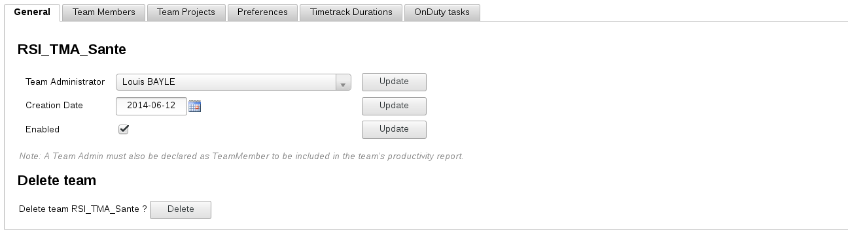
The Team Administrator has administration rights, and is the only one who can modify the list of members and projects of the team. However, he has no specific role among the team, so if the team administrator is an active member then he has to be added in the members list.
The “Enabled” attribute allows not displaying team in the CodevTT pages. Uncheck this box if the team is disbanded, but you want to keep the possibility of displaying its statistics.

Team members
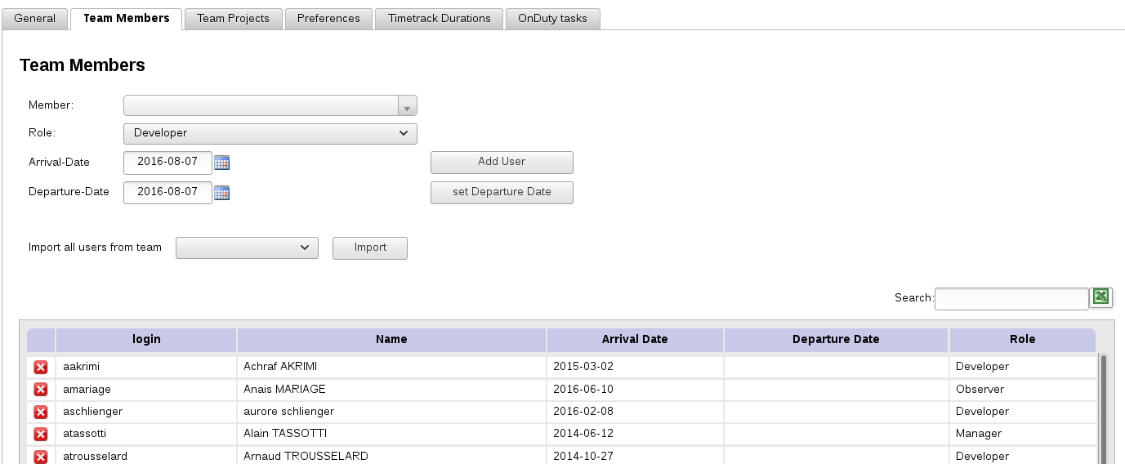

Role list has been described on the User roles section.
To add a user, select its login in the dropdown list, provide its beginning date as a team member and validate using the “Add user” button.
When a team member leaves the team, select its login in the dropdown list, provide its ending date as a team member and validate with the “Set departure date” button.
ATTENTION: Removing a member from the team modifies every indicator ! Nevertheless, it's timetracks are not deleted, and setting the user back will restore all team statistics.

Projects

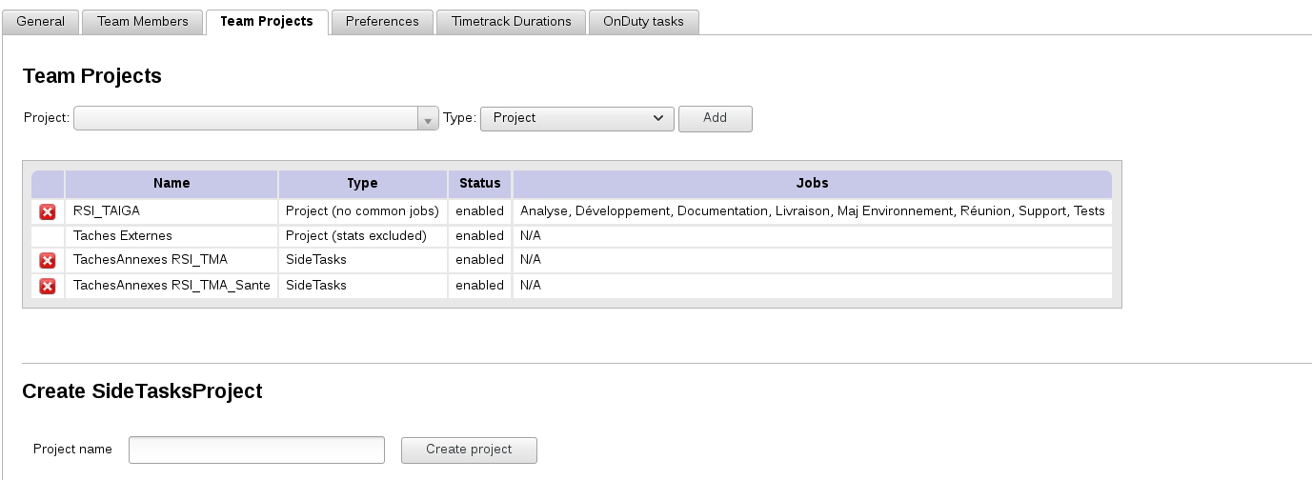
Select the Mantis projects on which the team is going to work.
There are several kinds of projects which are linked to the tasks type as described in the Tasks type section, but there are others:
- Project
Normal project having bus and tasks
- SideTasks
side-tasks project. (defined during team creation)
- Project (no common jobs)
Normal project, having bugs and tasks, but having its own “job” list (see user’s manual).
- Project (stats excluded)
Timetracks on the tasks of this project are not taken into account in the statistics. This can be useful if container projects in Mantis are used, which tasks must not be taken into account (e.g.: delivery tasks having sub-tasks).

Preferences
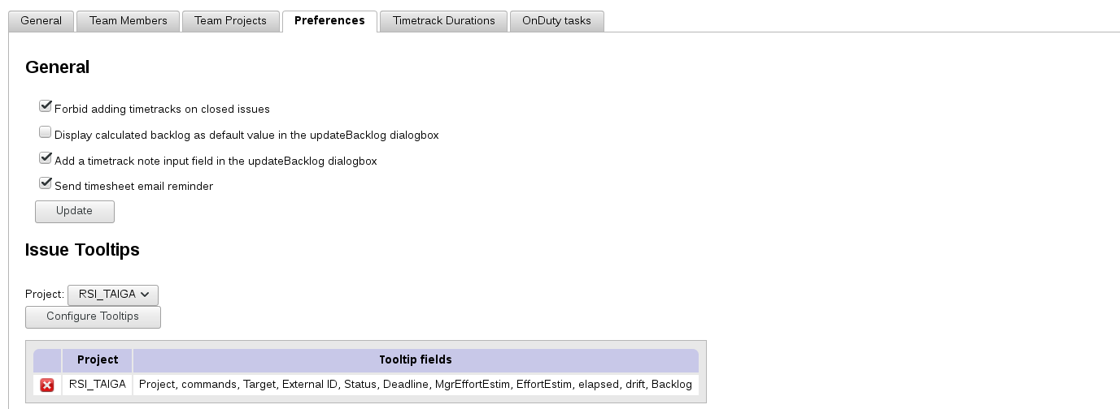
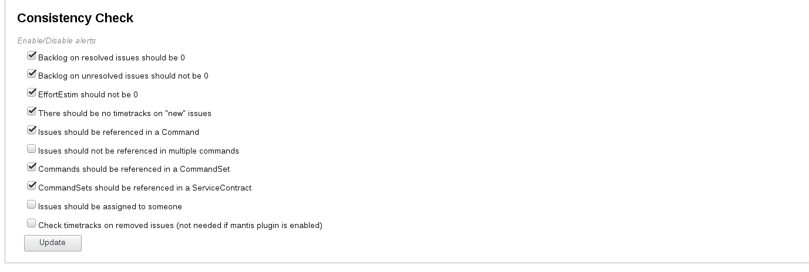

Timetrack durations
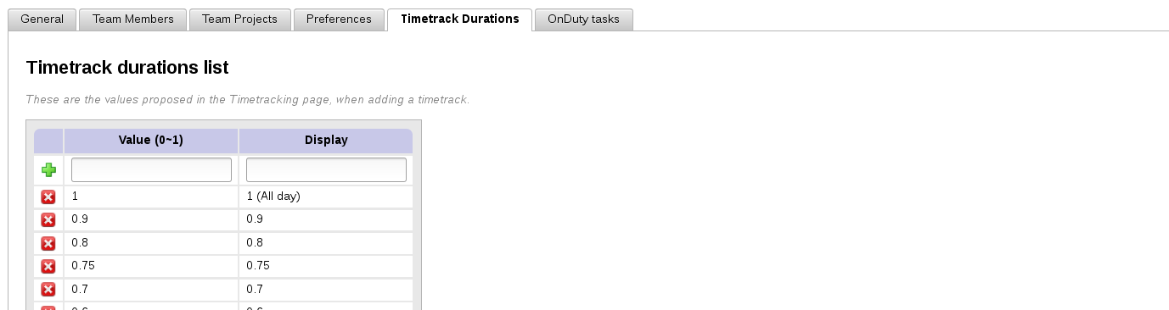
Allows to specify the available values (and displayed text) when adding a new timetrack in the timesheet.

OnDuty tasks
At this point of CodevTT (v1.1.0), onDuty tasks are nothing but leaves, identified by a specific color in the 'leaves' view.

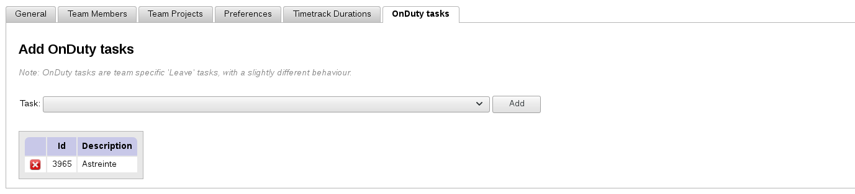
To add an onDuty task, create a mantis bug with « inactivity » category in the additional tasks project. Then, reload the page.
Select the task and validate with the « add » button.

Timetracking
The setting phase is over. It is now possible to use CodevTT to track activity.
This feature allows substituting traditional « Excel activity reports » suggesting a very similar entry form.
The main feature is that the charges are made exclusively on Mantis issues.
This allows better control of the activity for the manager (no ‘wild’ timetracks on unidentified tasks), and on the other part – the perimeter of a Mantis issue being well defined – to get a more accurate backlog from the developers.
The entry of the timesheet is very well accepted by developers because it drastically simplifies the timetracks entry. And as everything is done to have a daily entry of the timetracks, manger is informed in real time of the project progress.

Activity report entry
To enter activity report, open the « Activity / Time Tracking » menu
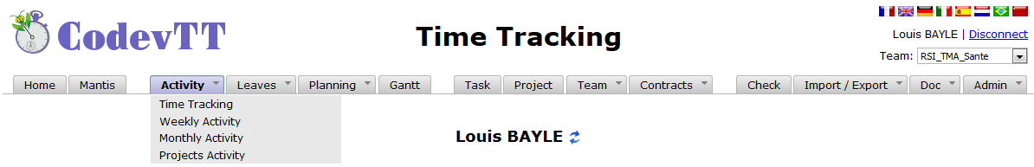
If you are a manager, an icon next to the user name allows selecting one of the team member.

The activity report entry has two parts: an entry form and a summary table of the weekly entries.
The form has five fields:
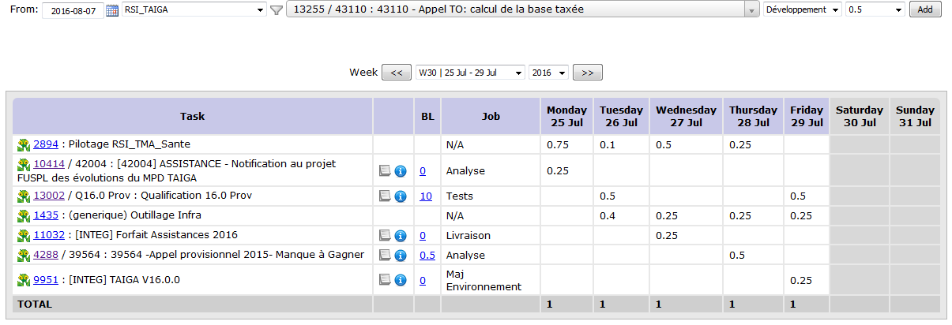
- Date
Date of the timetrack
- Project
Selecting the Mantis project filters the tasks displayed in the task combobox
- Task
List of available tasks (depends on mantis project and filters)
- Job
Defines the type of activity which is done on this task (study, analysis, development, tests, documentation…). This list is customizable in the “Admin/Edit jobs” menu.
- Duration (day)
The unit which is used is the day. ‘0.5’ represents half a day. It has been decided, on purpose, not to use the hour as time unit because the number of worked hours in a day may vary depending on users contracts.
Days having entry errors are displayed in a red color. After each entry, a dialog box is automatically opened to enter the backlog. Indeed, it must be re-evaluated after each entry.
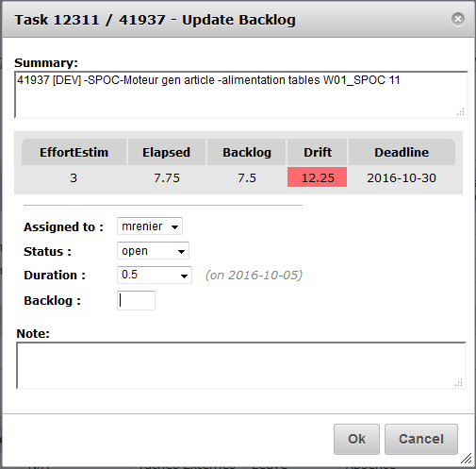

Activity tracking
The activity reports being entered, the manager can consult them from three different ways: « weekly activity », « monthly activity » and « projects activity ».

Weekly activity
This page has two sections. The first one gathers the whole team activity reports as entered by users. The second one shows an exhaustive list of completed tasks during the week with its relative past time.
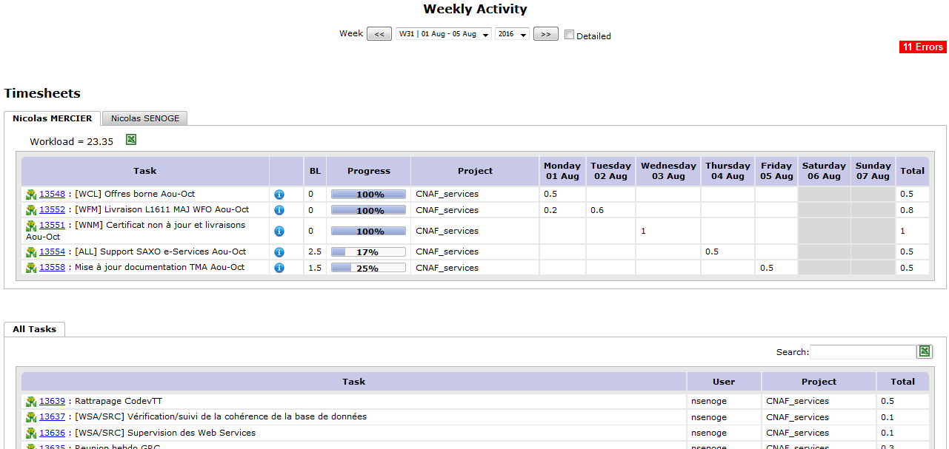

Monthly activity
This page allows displaying the tasks list sorted by user, on a specific period.
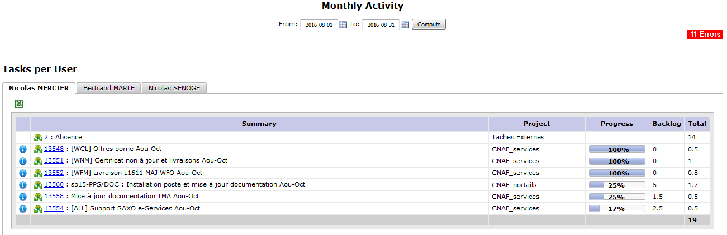
The clickable zone opens a dialog box displaying errors/omissions on timesheets over the specific period.

Projects activity
This page allows displaying the tasks list sorted by project, over a specific period.
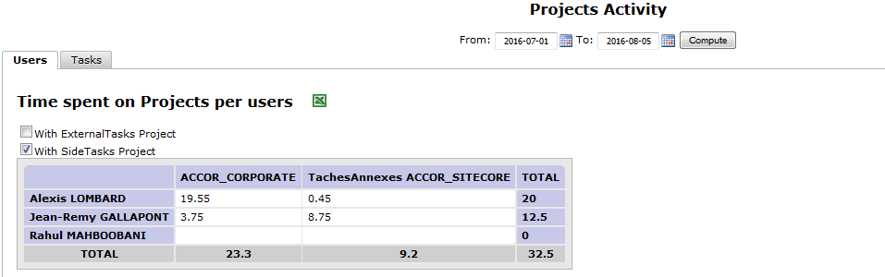

Projects progress tracking
CodevTT suggests several views to track the progress of a project.
In the main menu, “Project” allows displaying a page having two sections.

Detailed workloads
The first section gives the standard indicators about progress tracking: % progress, workload, re-estimated, past time, Estimation to complete and leeway.
Some filters are available. In the below snapshot, only the filter “Project Category” has been applied.
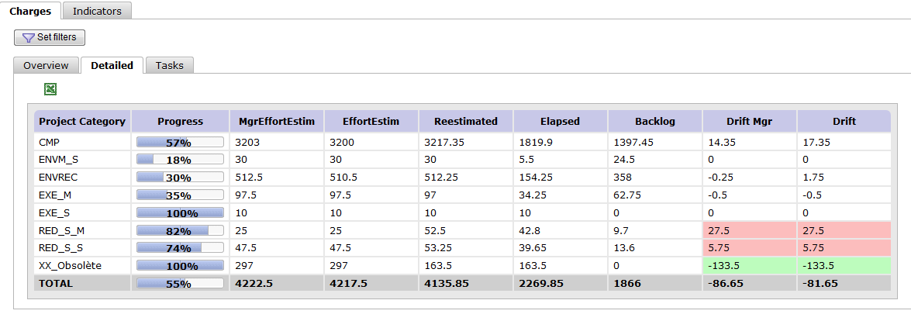
The ‘Indicators’ tab will provide many plugins. Choose the ones you need for your project.

Commands & Service contract
To manage contracts, CodevTT suggests three abstraction levels: Service contract, macro-command, and commands.
- The command
Allows gathering together a set of tasks, associate a budget to those tasks, and define provisions (risk leeway, guarantee, quality …).
- The Macro-Command
A macro-command is a set of commands.
- The service contract
It’s the highest level, it allows gathering the whole commands of a team, the additional tasks, provisions and displaying a global progress on the activity.

Service contract and additional tasks
There are two ways of managing the additional tasks:
- Either they are managed separately in each command.
- Either, orders are supposed to be continuous (especially for application management) and additional tasks (which are not visible from the client) must be treated at a higher level.

Commands are managed separately
This method must be applied when you want a strong partitioning between commands. It consists in not using macro-commands and service contract.
In that case, tasks related to management, as well as other additional tasks, must be included in the command.
- The benefit is that the past time on the additional tasks is mastered at the command level, and thus, a direct link with the sold workload.
- The drawback of this method lays on the fact that it is tedious to implement. There will be a replication process of the additional tasks for each new command (e.g. : “project management cmd1”, “Project management cmd2” “Wiki update cmd1”,”Wiki update cmd2”...).
Operation is simple, but the implementation is relatively heavy and constraining on the long term. This method will be used only if a real drift risk on the additional tasks is sensed.
It could also be chosen by project managers who would want to see the whole activities in the WBS (small projects having only one command).

Commands are continuous
In this model, additional tasks will be considered as not directly linked to commands: Wiki update, tools, test platform settings, growing competence and internal support, fall within team capitalization.
These tasks have no defined workload, nor deadline. Nevertheless, they have a cost and this one is “absorbed” by provisions. Provisions are sold at orders level, but generally don’t deal with production tasks. They are part of a global process.
We consider management the same way: a provision is sold in each order, but the project management activity is beyond its scope and balances at the highest level only: the service contract.
To simply sum-up: service contract links production tasks (commands) with additional tasks and provisions.
- Benefits: It is no more mandatory to have additional tasks specific to each command. Activity reports entry is simple and CodevTT use is much more fluid.
- Drawbacks: Additional tasks have to be watched so that they are not abusively used so as to hide a drift on a given command.
Abuses being rare and easy to detect, this method is recommended in most cases.
Note: it is mandatory to link the Side Tasks project of the team to the service contract.

Provisions
In commercial offers, in addition to development workload that is sold, there is also risk, management, documentation, quality provisions…..
CodevTT allows adding those provisions at each order level. They allow absorbing additional tasks and/or drifts on production tasks.

Let’s take the example of a command whose workload is estimated to 100 man/days. We sell as operation cost the following workloads:
+ 15 % Project management
+ 10 % Risk
+ 10 % Guarantee
+ 5 % Integration support
+ 5 % Other

That is to say 145 days will be charged to the customer.
The 100 days of development will be divided on the tasks (manager’s workloads), and the 45 days left will be defined as provisions on the command.
Budget tracking indicators will take into account those provisions for the tracking.

