Green Energy Fee Grant Program Dashboards Project

Overview
From the Green Energy Fee Grant Program's webpage on Western's website (http://www.wwu.edu/sustain/programs/gef/):
The Green Energy Fee (GEF) is a student-initiated, quarterly fee paid by all Western Washington University students to reduce the campus' environmental impact and engage the campus community in environmental awareness.
The GEF Grant Program provides funding to innovative, student-driven projects focused on promoting experiential learning opportunities and sustainable practices at Western Washington University. The GEF Grant Program is managed by the Office of Sustainability and supported by the AS Environmental and Sustainability Programs. Students, staff and faculty are all eligible to apply for grant funding. Projects funded through the GEF Grant Program aim to:
- Increase Student Involvement and Education
- Reduce the University's Environmental Impact
- Create an Aware & Engaged Campus Community
From the Dashboard's Project Description in the GEF (Green Energy Fee) web page (http://www.wwu.edu/sustain/programs/gef/projects/):
A proposal to pilot interactive campus energy consumption displays—"Dashboards" that will receive data from an expanded remote utility reading network on campus that captures near real time energy consumption information.

Summary
The Dashboard's project's goal as of November 2013 is to use the tech resources on campus to collect and store general information that can be used in various ways to show how green each of the buildings on campus are. The goal of the project is to provide a foundation for future projects of the Green Energy Fee where this information can be used to help raise student awareness of how green their campus is.

Software Packages Used
Here is a list of the software packages used by the team as of November 2013:
- Python 2.7 – Older version of Python that received its last service update. Chosen for initial development because all required packages needed for development have a 2.7 release.
- xlrd (http://www.python-excel.org/, BSD license) – python package providing basic opening and reading of Excel files (both 'xls' and 'xlsx') files in memory.
- MySQL Python Connector (http://dev.mysql.com/downloads/connector/python/, GPLv2.0) – python package for connecting, querying and using MySQL databases.
- xml.dom (http://docs.python.org/2/library/xml.dom.html#module-xml.dom, included in standard Python 2.7 runtime) – Used for querying of XML files for their data based off the name of tags provided.

Source Code
The source code for the project is hosted in GitHub under Jordan Baker's personal repository: https://github.com/bakerj32/gef. Currently the project doesn't have an organization tied to it and all pull requests will need to be accepted by Jordan. Alternatively a fork of the project can be made and the maintainer for that fork can accept all pull requests.

Design Diagram
Here is a diagram of the current project's architecture design:
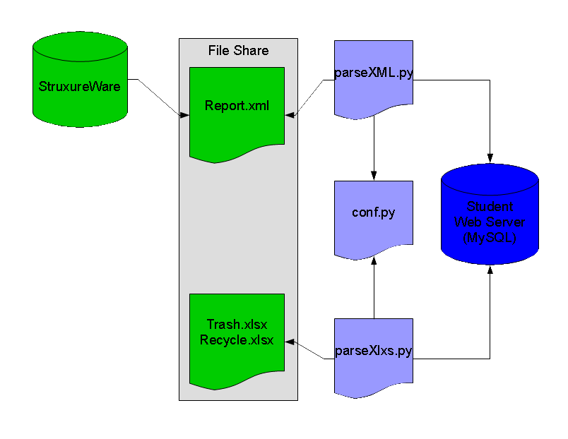
The diagram has three components: Our data sources from Facility's Management (green), the Student Web Server MySQL Database (blue) and the Python middle-ware (light blue). This project is working with the Python middle-ware.

Diagram Components
- Data Sources (Green):
  - StruxureWare – Facility's Management database that receives data from hardware sensors across campus and stores the data. It collects data on electricity, water and steam useage. StruxureWare will automatically generate these reports in the future and save them on the file share.
  - Trash.xlsx and Recycle.xlsx – Facility's Management excel files that contain information on how much trash and recycle each building on campus produces and how much it cost for a given month or 2 month period. The names of the xlsx files are symbolic and don't reflect actual names that will be used. These files will be stored on a network file share that can be accessed by Facility's Management and they will update the data needed by hand.
- Middle-Ware (Light-blue):
  - parseXML.py – written by Jordan Baker, parseXML.py takes an XML report file generated by StruxureWare and parse the required information from it and inserts it into the database.
  - parseXlxs.py – written by Tim Feierabend, parseXlsx.py opens and pulls the required information from an Excel file and stores it into the database.
  - conf.py – configuration file containing database login information.
- Student Web Server Database (Blue):
  - MySQL database that the Computer Science department uses for the web scripting classes and CSCI 330 (Databases I). Phil Nordwall has created a special database for the Green Energy Fee project for the team to work with until it gets to a point where it can be deployed on a WWU database and server.

Project Goal
Here is a diagram of a possible future for this project with other GEF projects and the initial goal for the dashboards project:
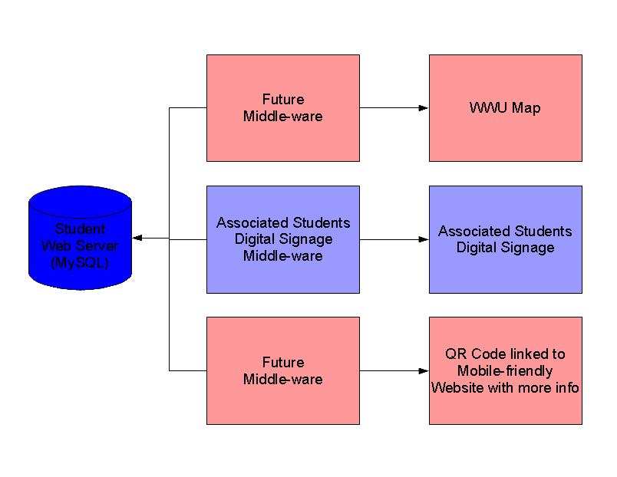

Diagram Description
- Future Middle-ware (Light Red):
  - Future middle-ware needed to read data from Student Web Server Database and create information for the end projects.
- Associated Students Digital Signage Middle-Ware (Light Blue):
  - Middle-ware software written to query the database and generate data and images that Associated Students will use on their digital signage around campus.

